Supplementary Information (SI)

Fungi enhance chlorine resistance via binding metal ions in drinking water systems: A novel phenomenon and underlying mechanisms

Nature Water

Ge-Hui Wu^{1,3}, Qi-Qi Wan^{1,3}, Ting-Lin Huang^{1,3}, Zheng-Yang Huo⁴, Gang Liu⁵, and Gang Wen^{1,2,3,}*

¹ Shaanxi Provincial Field Scientific Observation and Research Station of Water Quality in Qinling Mountains, Xi'an University of Architecture and Technology, Xi’an 710055, China.
² Institute for Interdisciplinary and Innovate Research, Xi'an University of Architecture and Technology, Xi'an, 710055, PR China.
³ Shaanxi Key Laboratory of Environmental Engineering, Xi’an University of Architecture and Technology, Xi'an, 710055, PR China.
⁴ School of Chemistry and Life Resource, Renmin University of China, Beijing, 100872, PR China.
⁵ University of Chinese Academy of Sciences, Beijing, China.

* Corresponding authors.
Email: hitwengang@163.com (Gang Wen)

Table of Contents

Texts
Supplementary Text 1. Preparation of fungal spore and bacterial suspensions.
Supplementary Text 2. Metal ion adsorption by fungal spores.
Supplementary Text 3. Disinfection experiments.
Supplementary Text 4. Extraction of melanin and chitosan from A. niger.
Supplementary Text 5. Assessment of membrane integrity, intracellular ROS, and structural damage.
Supplementary Text 6. Proteomic analysis.
Supplementary Text 7. 2D-COS analysis.
Supplementary Text 8. Density functional theory (DFT) calculations.

Figures
Supplementary Fig. 1. Procedures for disinfection experiments.
Supplementary Fig. 2. Time-dependent adsorption efficiency of A. niger and P. polonicum spores.
Supplementary Fig. 3. Effects of 100 μM metal ions on the culturability of fungal spores.
Supplementary Fig. 4. Effects of metal ion concentration on spore surface zeta potential.
Supplementary Fig. 5. Effects of 100 μM metal ions on spore surface hydrophobicity.
Supplementary Fig. 6. Particle size changes of A.niger spores following metal ion complexation.
Supplementary Fig. 7. Chlorine inactivation kinetics of A. niger spores, and E. coli after complexation with metal ions.
Supplementary Fig. 8. Chlorine inactivation kinetics of P. polonicum spores after complexation with metal ions.
Supplementary Fig. 9. Inactivation kinetics and resistance of metal-complexed P. polonicum spores under different disinfection treatments.
Supplementary Fig. 10. Inactivation of A. niger spores under varying initial metal ion concentrations.
Supplementary Fig. 11. Inactivation of P. polonicum spores under varying initial metal ion concentrations.
Supplementary Fig. 12. Analysis of metal ion complexation capacity and chlorine resistance of P. polonicum spores.
Supplementary Fig. 13. Two-dimensional scatter plots of SG/PI staining for A.niger spores at different chlorine exposure times.
Supplementary Fig. 14. Two-dimensional scatter plots of SG/PI staining for E.coli at different chlorine exposure times.
Supplementary Fig. 15. Impact of metal ion complexation on the proportion of high ROS level A.niger spores after chlorine disinfection.
Supplementary Fig. 16. MA plots of differentially expressed proteins in A.niger spores before and after metal ion complexation under chloramine treatment.
Supplementary Fig. 17. KEGG pathway analysis of A.niger spores under chlorine treatment before and after metal ion complexation.
Supplementary Fig. 18. KEGG enrichment analysis of A.niger spores under chlorine treatment before and after metal ion complexation.
Supplementary Fig. 19. FTIR spectral characterization of A. niger spores complexed with different metal ions at varying concentrations.
Supplementary Fig. 20. Two-dimensional synchronous and asynchronous correlation spectroscopy of A. niger spores under metal ion complexation.

Tables
Supplementary Table 1. Physicochemical properties of four metal ions.
Supplementary Table 2. Inactivation kinetic parameters of fungal spores under different disinfectants before and after metal ion complexation.
Supplementary Table 3. Water quality parameters of surface water and groundwater.
Supplementary Table 4. Secondary inactivation kinetic parameters of A.niger spores at different metal ion complexation capacities.
Supplementary Table 5. Secondary inactivation kinetic parameters of P.polonicum spores at different metal ion complexation capacities.
Supplementary Table 6. Assignments of FTIR peaks to functional groups and vibrational modes.
Supplementary Table 7. Calculated synchronous and asynchronous 2D correlation spectra of A.niger spores after Co(II) complexation.
Supplementary Table 8. Calculated synchronous and asynchronous 2D correlation spectra of A.niger spores after Cu(II) complexation.
Supplementary Table 9. Calculated synchronous and asynchronous 2D correlation spectra of A.niger spores after Fe(II) complexation.
Supplementary Table 10. Calculated synchronous and asynchronous 2D correlation spectra of A.niger spores after Mn(II) complexation.
Supplementary Table 11. Fukui functions of 1,8-dihydroxynaphthalene.
Supplementary Table 12. Fukui functions of D-glucosamine.
Supplementary Table 13. Binding energies of 1,8-dihydroxynaphthalene and D-glucosamine with Cu(II).

Texts

Supplementary Text 1. Preparation of fungal spore and bacterial suspensions.
A severe fungal proliferation issue was encountered at a groundwater treatment plant in Northwest China, significantly affecting water quality. A total of 148 fungal species were isolated from the contaminated water samples, and two dominant strains were selected for study: Aspergillus niger (A.niger) and Penicillium polonicum (P.polonicum). These two fungi were inoculated onto DRBC agar plates and incubated in a constant-temperature incubator for three weeks until they reached the stationary phase.
Following incubation, 5 mL of phosphate-buffered saline (PBS) was added to each Petri dish. Fungal spores were scraped off with a sterile glass rod and filtered through a three-layer sterile lens cleaning paper to remove mycelium and residual culture medium. The filtered spores were washed three times with sterile PBS (centrifuged at 8000 rpm for 10 minutes at 4 ℃), and then resuspended in an appropriate amount of PBS. Spore counts were performed using an optical microscope (BX51, Olympus, Japan), and the final spore suspension was stored at 4℃.
Escherichia coli (E.coli) was chosen as the bacterial representative for comparative experiments. The bacteria were first activated in LB liquid medium and then transferred to fresh medium for an 18-hour incubation. After culturing, the bacterial suspension was transferred to a centrifuge tube and centrifuged at 10,000 rpm for 10 minutes at 4 ℃. The supernatant was discarded, and the bacterial pellet was washed three times with phosphate-buffered saline (PBS). Finally, the bacteria were resuspended in PBS. The concentration of the bacterial suspension was determined using flow cytometry (Accuri C6, BD, USA) and SYBR Green I (SG, 10,000×) staining method.

Supplementary Text 2. Metal ion adsorption by fungal spores.
Four representative metal ions, Cu(II), Fe(II), Mn(II), and Co(II), were selected based on their environmental relevance and distinct coordination behaviors. Cu and Fe are the most common corrosion-derived ions in water distribution systems, originating from pipe materials and dissolution processes¹. Mn occurs widely in groundwater and sediments, while its release from pipe deposits also contributes to elevated concentrations². Although Co is less abundant, it frequently coexists with Fe–Mn minerals and can enter water through geochemical mobilization and microbial interactions³.
From a chemical reactivity perspective, these ions exhibit distinct complexation preferences governed by the hard–soft acid–base (HSAB) principle. Mn(II), a hard acid, predominantly coordinates with oxygen-containing groups such as carboxyl and hydroxyl moieties⁴. Cu(II) and Co(II) act as borderline acids, capable of forming stable bonds with both oxygen and nitrogen donors (e.g., amino or amide groups)⁴. Co(II) also exhibits notable catalytic activity, potentially affecting disinfection efficiency. Fe(II), with variable oxidation states and redox activity, interacts with carboxyl and phenolic hydroxyl groups, altering the surface chemistry of fungal spores⁵. Consequently, variations in ionic radius, electrophilicity, and electronic configuration among these metals are expected to differentially influence their binding strength with melanin and chitosan components in fungal cell walls, thereby modulating chlorine decay dynamics and chlorine resistance.
Finally, copper, iron, and manganese are listed as routine monitoring indicators in the Chinese Standards for Drinking Water Quality (GB 5749-2022), with concentration limits of 1.0 mg/L, 0.3 mg/L, and 0.1 mg/L, respectively. Exceeding these limits can lead to “red water” and odor problems in distribution systems. In contrast, cobalt is considered an emerging environmental contaminant, and its interactions with microorganisms remain poorly understood.
For adsorption experiments, fungal spores were incubated with 100 μM of each metal ion in a thermostatic shaker at 150 rpm for 96 h. Samples were withdrawn at predefined intervals and filtered through 0.22 μm membranes. Residual metal concentrations in the filtrates were determined using an atomic absorption spectrophotometer (Analytik Jena ZEEnit 700P). All experiments were performed in biological triplicate (n ≥ 3).
To approximate real water distribution conditions, a CDC biofilm reactor was employed to simulate dynamic hydrodynamic and compositional conditions. The system was operated at a flow velocity of 0.8 m/s using tap water collected from a terminal point of the distribution network as the background matrix. Residual metal concentrations were measured by atomic absorption spectroscopy. The adsorption capacity and removal efficiency were calculated as follows:
$$\begin{aligned}{\text{q}}_{\text{e}}\text{=}\frac{\left({\text{C}}_{\text{0}}\text{-}{\text{C}}_{\text{e}}\right)\text{∙}\text{V}}{\text{M}}\end{aligned}$$
$$\begin{aligned}{\text{W}}_{\text{e}}\text{=}\frac{\left({\text{C}}_{\text{0}}\text{-}{\text{C}}_{\text{e}}\right)}{{\text{C}}_{\text{0}}}\text{×100\%}\end{aligned}$$

Supplementary Text 3. Disinfection experiments.
The concentration of sodium hypochlorite (Shanghai Pharmaceutical Group Chemical Reagents Co., Ltd.) was determined using the N,N-diethyl-1,4-phenylenediamine (DPD) spectrophotometric method. Monochloramine (NH₂Cl) was prepared by slowly adding a free chlorine solution into a rapidly stirred ammonium chloride solution, maintaining a chlorine-to-nitrogen (Cl:N) mass ratio of 4:1 and a pH above 8.5. The solution was stirred continuously for 40-60 minutes to ensure complete reaction. The concentration of chloramine was measured using the DPD method in the presence of potassium iodide (KI).
Chlorine dioxide (ClO₂) was generated through the reaction of potassium persulfate (K₂S₂O₈) with sodium chlorite (NaClO₂). Specifically, 40 g/L of K₂S₂O₈ was mixed with 80 g/L of NaClO₂, and the resulting mixture was purged with nitrogen gas to volatilize the produced ClO₂. The gas was then captured and dissolved in ice-cold ultrapure water to obtain a chlorine dioxide stock solution. The ClO₂ concentration was quantified spectrophotometrically at 358 nm using an extinction coefficient of ε = 1200 M⁻¹·cm⁻¹.
The irradiation intensity of the 254 nm low-pressure UV lamp was determined using the potassium iodide–iodate (KI-KIO₃) chemical actinometry method. The measurement results indicated that the irradiation intensity of the low-pressure ultraviolet (LPUV) was 0.1132 mW/cm².
As shown in Supplementary Figure 1, fungal spores were mixed with metal ions at specified initial concentrations and incubated in a constant-temperature shaker to ensure continuous agitation (T=30±2 ℃). This ensured that metal ions fully reacted with fungal spores to reach a state of complexation equilibrium. After complexation, the system was divided into two treatment conditions. The first condition is the non-centrifuged system, which simulates actual water quality conditions. The complexed spore suspension was directly used for chlorine inactivation experiments. In this system, metal ions complexed with the spore surface coexisted with free or weakly bound metal ions, reflecting the combined impact of metal ions on fungal spore inactivation in real water treatment processes.
The second condition is the centrifuged system, where the spore suspension underwent high-speed centrifugation (8000 rpm for 10 minutes) to remove free or weakly bound metal ions from the solution, leaving only the metal ions tightly bound to the fungal spore surface. This system aimed to investigate the actual regulatory effect of metal complexation on fungal spore chlorine resistance, after eliminating the interference of free metal ions, to reveal the underlying mechanism of how complexed metal ions influence the chemical reactivity of fungal spores.
Subsequently, Cl₂ (or NH₂Cl, ClO₂, and UV) was added to both treatment systems for inactivation experiments (T=25±2 ℃). It is important to note that, to ensure the effectiveness of NH₂Cl, the inactivation experiment was conducted at pH 8.0 ± 0.2, while the adsorption experiment was performed at pH 7.0 ± 0.2. During the experiment, samples were collected at regular intervals, and the survival of fungal spores was measured using the plate count method (HPC) to calculate the log inactivation value and assess the disinfectant’s effectiveness in inactivating the fungal spores. Additionally, the decay curve of disinfectant concentration in the solution was monitored to analyze the impact of metal complexation on the disinfectant consumption rate.

Supplementary Text 4. Extraction of melanin and chitosan from A. niger.
Melanin was extracted by mixing 5 mL of A. niger spore suspension with 5 mL of 1 mol/L NaOH, followed by autoclaving at 121 ℃ for 20 minutes. After cooling, the mixture was centrifuged at 8000 rpm for 10 minutes. The supernatant was acidified to pH 2.5 with HCl and centrifuged again to collect the melanin precipitate, which was washed three times with ultrapure water and freeze-dried.
Chitosan was obtained by mixing the same volume of spore suspension with 1 mol/L NaOH and autoclaving under identical conditions. The cooled mixture was centrifuged at 8000 rpm for 10 minutes at 4 ℃. The supernatant was discarded, and the pellet was washed 3–4 times with ultrapure water to yield deacetylated chitosan.
FTIR spectroscopy (4000–400 cm⁻¹) was used to characterize A. niger spores, as well as the extracted melanin and chitosan, before and after complexation with metal ions.

Supplementary Text 5. Assessment of membrane integrity, intracellular ROS, and structural damage.
SYBR Green I (SG) is a membrane-permeable fluorescent dye that binds to nucleic acids in viable cells and emits green fluorescence. In contrast, propidium iodide (PI) is membrane-impermeable and only penetrates spores with compromised membranes, binding to nucleic acids and emitting red fluorescence. For staining, 160 μL of spore suspension was mixed with 30 μL of EDTA solution (0.5 M, pH 8.0) and 10 μL of SG/PI dye mixture in a 1.5 mL microcentrifuge tube. The mixture was incubated in a thermostatic metal bath (HDB-smart, DHS, China) at 35 ℃ for 20 minutes in the dark. Membrane permeability was subsequently assessed using flow cytometry (FCM, Accuri C6, BD, USA).
Intracellular reactive oxygen species (ROS) levels in fungal spores were quantitatively assessed using flow cytometry (FCM) with dihydroethidium (DHE) as the fluorescent probe (Sigma Merck, USA). DHE is a membrane-permeable dye that selectively reacts with intracellular ROS to emit fluorescence. Spores exhibiting fluorescence intensities greater than 9 × 10³ were classified as having high ROS levels. To perform the assay, 197 μL of spore suspension was mixed with 5 μL of DHE solution in a 1.5 mL microcentrifuge tube. The mixture was incubated at 35 ℃ for 20 minutes in the dark using a thermostatic metal bath (HDB-smart, DHS, China), followed by flow cytometric analysis.
A 1 mL aliquot of the fungal spore suspension was transferred into a 1.5 mL microcentrifuge tube and centrifuged at 10,000 rpm for 15 minutes. The supernatant was discarded, and the pellet was fixed with 1 mL of 3% glutaraldehyde at 4 ℃ overnight. After fixation, the supernatant was removed, and the pellet was sequentially washed with sterile phosphate-buffered saline (PBS) and a graded ethanol series (10%, 30%, 50%, 80%, and 100%) to remove residual glutaraldehyde. Following dehydration, 1 mL of isoamyl acetate was added, and the sample was allowed to air-dry in a fume hood. The bottom of the centrifuge tube was then cut open, and the dried pellet was mounted onto an SEM stub using conductive adhesive. Finally, the sample was sputter-coated with gold and examined using a scanning electron microscope (Quanta 600F, FEI, USA).

Supplementary Text 6. Proteomic analysis.
Protein extraction. All frozen samples were retrieved and transferred to grinding tubes, followed by the addition of an appropriate volume of borax/PVPP/phenol (BPP) extraction buffer. Samples were ground three times using a mechanical grinder, each for 180 seconds. The homogenates were then centrifuged at 14,000×g for 15 minutes at 8 ℃, and the supernatants were collected. An equal volume of Tris-saturated phenol was added to each supernatant, vortexed vigorously for 5–10 seconds, and centrifuged again under the same conditions. The phenolic phase was collected and mixed with an equal volume of BPP buffer, followed by vortexing for 5–10 seconds and centrifugation at 14,000×g for 15 minutes at 8 ℃. The resulting phenolic phase was collected once more. Four volumes of pre-chilled methanol containing 100 mM ammonium acetate were added to the phenolic phase to precipitate proteins overnight at −20 ℃. The next day, the samples were centrifuged at 14,000×g for 15 minutes at 8 ℃, and the supernatant was discarded. The protein pellet was washed with 90% pre-chilled acetone, vortexed, and centrifuged to remove residual contaminants. This acetone wash step was repeated twice. The resulting protein pellet was dissolved in lysis buffer containing 8 M urea, 1% SDS, and a protease inhibitor cocktail. The suspension was subjected to low-temperature non-contact ultrasonication for 30 minutes to ensure complete dissolution. Finally, the mixture was centrifuged at 14,000×g for 15 minutes at 8 ℃, and the supernatant containing solubilized proteins was collected for subsequent analyses.
Sample concentration detection (BCA method). Using the standard protein provided in the Thermo Scientific Pierce BCA Protein Assay Kit, different concentrations of bovine serum albumin (BSA) were prepared according to the kit's protocol. The standard concentration range was from 0 to 2 μg/μl, including 0, 0.125, 0.25, 0.5, 0.75, 1, 1.5, and 2 μg/μl. The absorbance at 562 nm was measured using the SPECTRA MAX microplate reader, and a standard curve was generated. The protein concentration and total protein content of the samples were determined based on the standard curve.
SDS-PAGE electrophoresis. An aliquot of 10 μl of the sample was loaded for SDS-PAGE electrophoresis to assess the protein quality. Based on the total protein amount and band clarity, a total protein content of over 50 μg with clear bands was considered sufficient for subsequent experiments.
Protein digestion. Take 100 μg of the protein sample and add lysis buffer. Then, add 100 mM triethylammonium bicarbonate (TEAB) buffer to reach a final concentration of 100 mM. Add 10 mM TCEP to achieve a final concentration of 10 mM and incubate at 37°C for 60 minutes. Next, add 40 mM iodoacetamide (final concentration) and incubate in the dark at room temperature for 40 minutes. To precipitate proteins, add precooled acetone (acetone:sample v:v = 6:1), and incubate at -20°C for 4 hours. Centrifuge at 10,000×g for 20 minutes and collect the precipitate. Dissolve the sample thoroughly in 100 μL of 100 mM TEAB. Add trypsin at a mass ratio of 1:50 (enzyme:protein) and digest overnight at 37°C.
Peptide desalting and quantification. After trypsin digestion, equal volumes of the sample were vacuum concentrated to remove solvents and dry the peptides. The dried peptides were then re-dissolved in 0.1% trifluoroacetic acid (TFA). Peptide quantification was performed using the Thermo Fisher Scientific peptide quantification kit. Peptides were desalted using an HLB (Hydrophilic-Lipophilic Balance) column, and then dried again using a vacuum concentrator.
DIA quantification and analysis.
- DDA library construction (reference library for DIA data analysis):
Equal amounts of the digested peptide samples were mixed, vacuum-concentrated, and re-dissolved in UPLC loading buffer. High pH liquid phase separation was performed using a reverse-phase C18 column (e.g., ACQUITY UPLC BEH C18 Column) with a Thermo SCIENTIFIC Vanquish F UHPLC system. Solvent A was 2% acetonitrile (adjusted to pH 10 with ammonium hydroxide), and solvent B was 80% acetonitrile (adjusted to pH 10 with ammonium hydroxide). UV detection was set to 214 nm with a flow rate of 200 μL/min. Based on peak shape and retention time, 20 fractions were collected, vacuum-concentrated, and re-dissolved in mass spectrometry loading buffer.
Peptide fractions were analyzed by mass spectrometry using a Q-Exactive HF-X mass spectrometer and EASY-nLC 1200 chromatography system. In DDA mode, the top 20 most abundant ions from the full MS scan were selected for fragmentation. The MS1 resolution was set to 70,000 with a scanning range of m/z 350-1300, while MS2 resolution was set to 17,500, with HCD fragmentation. Chromatographic separation time was 120 minutes.
Raw files were submitted to the server for database search using Proteome DiscovererTM software, with a locally established species-specific database for identification.
- Sample DIA mass spectrometry detection:
Equal amounts of peptides were re-dissolved in mass spectrometry loading buffer, and 10× iRT peptides were added and mixed before performing DIA analysis. Data acquisition was conducted using the same software and gradient conditions as the DDA method. In DIA mode, the MS1 resolution was 70,000 with a scanning range of m/z 350-1300, and MS2 resolution was 17,500. The HCD fragmentation method was used.
- DIA data analysis:
The spectral library generated from the DDA-based search was used for database search in Spectronaut software. Spectronaut software extracted peaks from the DIA raw data based on the ion pairs from the spectral library, using default settings and iRT calibration. Up to 6 specific peptides were selected per protein, with a maximum of 6 fragment ions per peptide, and quantitative analysis was performed by summing their areas. A list of proteins with both qualitative and quantitative data was generated.
Bioinformatics analysis. Gene Ontology (GO) and Kyoto Encyclopedia of Genes and Genomes (KEGG) pathway analyses were performed on the differentially expressed proteins to gain insights into their functional annotations and associated metabolic pathways.

Supplementary Text 7. 2D-COS analysis.
Metal ions at concentrations of 5, 10, 20, 40, 60, 80, and 100 μM were added to the fungal spore suspension and allowed to complex under constant agitation in a thermostatic shaker until saturation was achieved. Unbound metal ions were then removed, and the spore samples were thoroughly dried using a vacuum freeze dryer. The dried samples were prepared into solid pellets using the potassium bromide (KBr) pressing method for Fourier transform infrared (FTIR) spectroscopy analysis. The spectral range was set from 4000 to 400 cm⁻¹ with a resolution of 4 cm⁻¹, and each spectrum was obtained by averaging at least 32 scans. The obtained FTIR data were subjected to baseline correction, smoothing, and normalization prior to further analysis. Two-dimensional correlation spectroscopy (2D-COS) was then employed to investigate the variations in functional groups under external perturbation conditions.
A dynamic spectral matrix, $\text{X}\text{(}\text{v}\text{,}{\text{t}}_{\text{j}}\text{)}$, was constructed by arranging a series of spectra measured under varying perturbations, where v represents the wavenumber and t denotes the external perturbation condition (e.g., metal ion concentration). The mean spectrum,$\overline{\text{X}}\text{(}\text{v}\text{)}$, was calculated across all conditions. The differential spectra, $\text{ΔX(}\text{v}\text{,}{\text{t}}_{\text{j}}\text{)}$, were obtained by subtracting the mean spectrum from each individual spectrum:
$$\text{ΔX(}\text{v}\text{,}{\text{t}}_{\text{j}}\text{)=}\left\{\begin{aligned}\text{X}\text{(}\text{v}\text{,}{\text{t}}_{\text{j}}\text{)-}\overline{\text{X}}\text{(}\text{v}\text{) for 1≤j≤m} \\ \text{0 otherwise}\end{aligned}\right.$$
The synchronous 2D correlation spectrum, $\text{ϕ(ν₁,ν₂)}$, was calculated based on the auto- and cross-correlations of these differential spectra to evaluate the simultaneous intensity changes at different wavenumbers.
$$\text{ϕ(ν₁,ν₂)=}\frac{\text{1}}{\text{m-1}}\sum_{\text{j=1}}^{\text{m}}{\text{ΔX(}{\text{v}}_{\text{1}}\text{,}{\text{t}}_{\text{j}}\text{)∙ΔX(}{\text{v}}_{\text{2}}\text{,}{\text{t}}_{\text{j}}\text{)}}$$
To generate the asynchronous spectrum, the differential spectral data $\text{ΔX(ν,t)}$ were subjected to Hilbert transformation to yield the quadrature spectra ${\text{ΔX}}_{\text{H}}\text{(ν,t)}$. The asynchronous 2D correlation spectrum, $\text{ψ(ν₁,ν₂)}$, was then computed to reveal sequential and out-of-phase changes among spectral variables.
$$\text{ψ(ν₁,ν₂)=}\frac{\text{1}}{\text{m-1}}\sum_{\text{j=1}}^{\text{m}}{\text{ΔX(}{\text{v}}_{\text{1}}\text{,}{\text{t}}_{\text{j}}\text{)∙}{\text{ΔX}}_{\text{H}}\text{(}{\text{v}}_{\text{2}}\text{,}{\text{t}}_{\text{j}}\text{)}}$$
$${\text{ΔX}}_{\text{H}}\text{(}{\text{v}}_{\text{2}}\text{,}{\text{t}}_{\text{j}}\text{)=}\sum_{\text{l=1}}^{\text{m}}{{\text{N}}_{\text{jl}}\text{∙ΔX(}\text{v}\text{,}{\text{t}}_{\text{l}}\text{)}}$$
$${\text{N}}_{\text{jl}}\text{=}\left\{\begin{aligned}\text{0 j=l} \\ \frac{\text{1}}{\text{π}\left(\text{l-j}\right)}\text{ otherwise}\end{aligned}\right.$$
According to Noda’s rules, the sequential order of spectral intensity changes can be determined by analyzing the sign relationship of cross-peaks in the synchronous and asynchronous 2D correlation spectra. If the cross-peaks at the same spectral coordinates $\text{(}{\text{v}}_{\text{1}}\text{,}{\text{v}}_{\text{2}}\text{)}$ exhibit the same sign (both positive or both negative) in both the synchronous and asynchronous spectra, the change in spectral intensity at ${\text{v}}_{\text{1}}$ precedes that at ${\text{v}}_{\text{2}}$. Conversely, if the cross-peaks at the same coordinates have opposite signs (one positive and the other negative), the change at ${\text{v}}_{\text{2}}$ occurs before the change at ${\text{v}}_{\text{1}}$.

Supplementary Text 8. Density functional theory (DFT) calculations.
The molecular structures of the selected compounds were retrieved from the PubChem database (CIDs: 439213 and 68438) and converted to 3D using GaussView. Geometry optimization and frequency analysis were performed using density functional theory (DFT) at the B3LYP level with the 6-311G(d,p) basis set. The SMD solvation model (with water as the solvent) was employed to simulate the aqueous environment, and the Grimme D3 dispersion correction with Becke–Johnson damping (GD3BJ) was applied to accurately account for long-range dispersion interactions. All quantum chemical calculations were carried out using the Gaussian 16 software package. Key electronic properties, including the HOMO–LUMO energy gap and dipole moment, were obtained from the optimized geometries. Based on the electron density differences between the neutral, anionic (N−1), and cationic (N+1) states, the electrostatic potential (ESP) distributions and Fukui functions (f⁺, f⁻, and f⁰) were computed using Multiwfn 3.8 according to the condensed-to-atom scheme. In the subsequent metal-binding analysis, the binding energy between the coordination sites on the fungal spore cell wall and the metal ions was calculated according to the following equation:
$${\text{Δ}\text{E}}_{\text{binding}}\text{=}{\text{Δ}\text{E}}_{\text{complex}}\text{-}{\text{Δ}\text{E}}_{\text{Me(II)}}\text{-}{\text{Δ}\text{E}}_{\text{ligand}}$$

Figures

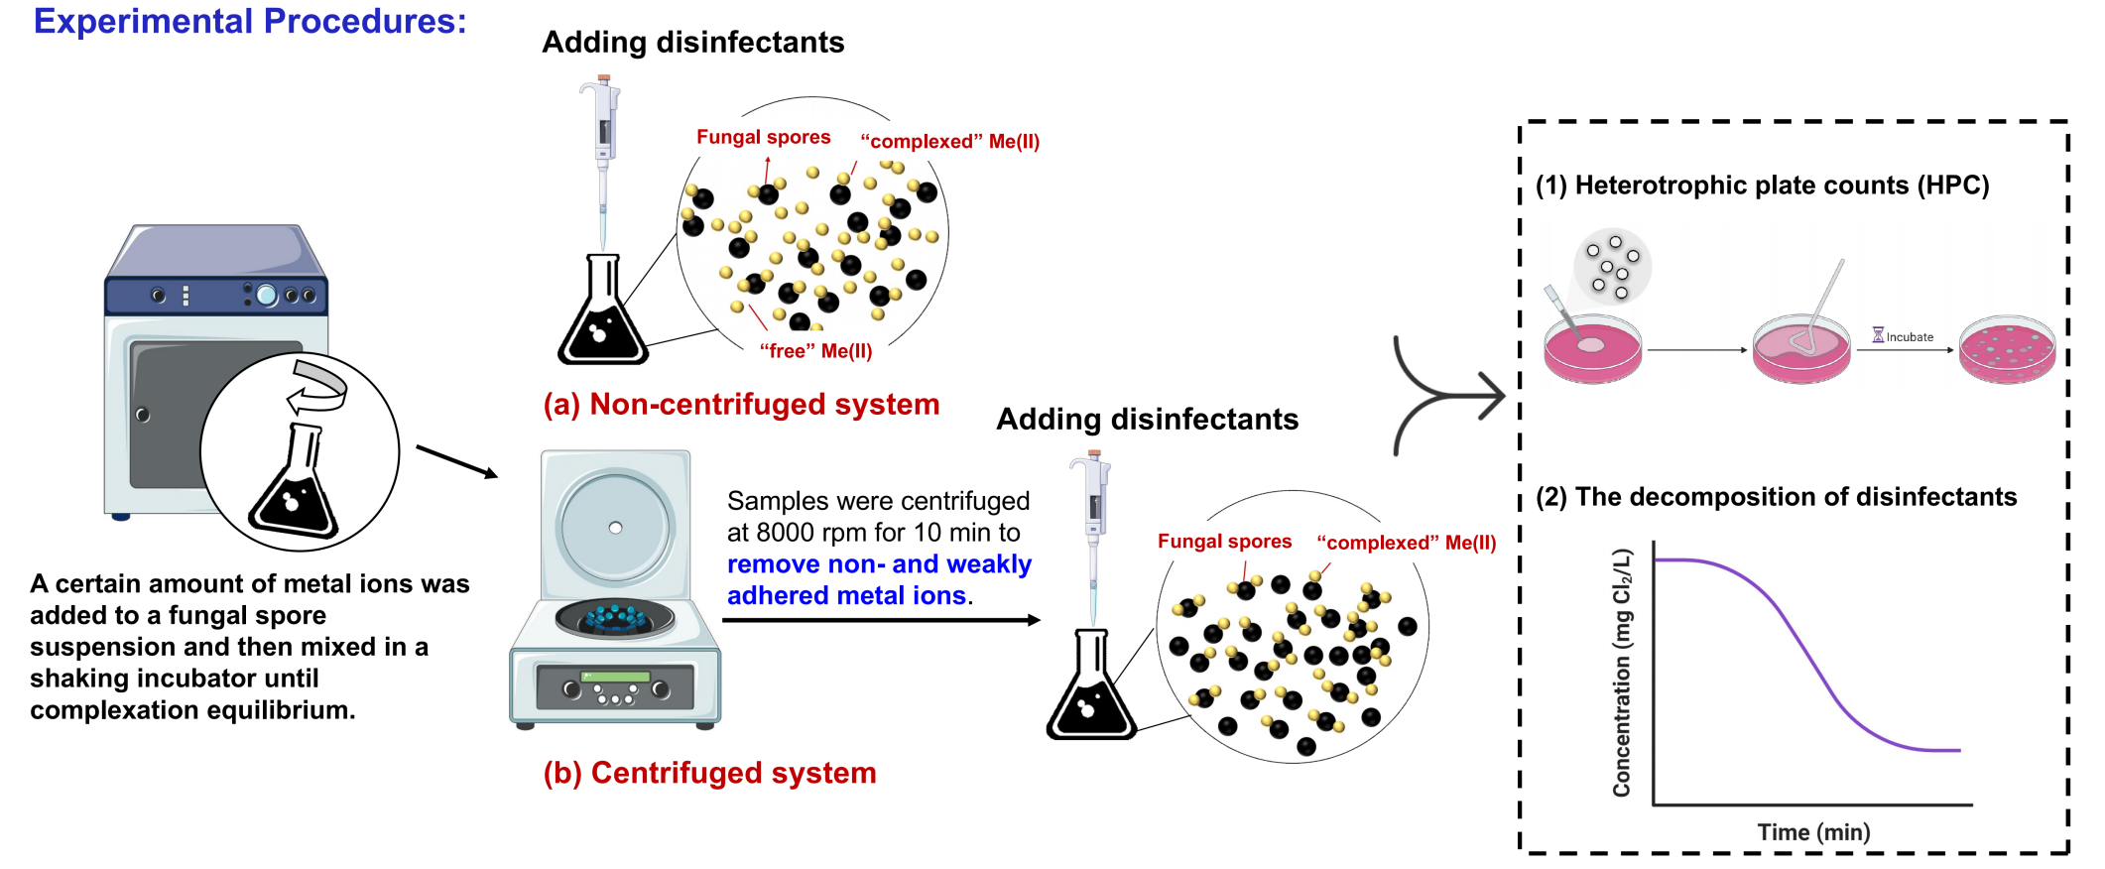Supplementary Fig. 1. Procedures for disinfection experiments.

Supplementary Fig. 2. Time-dependent adsorption efficiency of A. niger and P. polonicum spores. Experimental conditions: Initial spore concentration: 3.5×10⁵ CFU/mL; initial metal ion concentration: 100 μM ([Co(II)]=5.89 mg/L, [Cu(II)]=6.35 mg/L, [Fe(II)]=5.58 mg/L, [Mn(II)]=5.49 mg/L); pH = 7.0 ± 0.2, T=30 ±2 ℃; shaking speed: 150 rpm; until the maximum adsorption equilibrium (9 h).

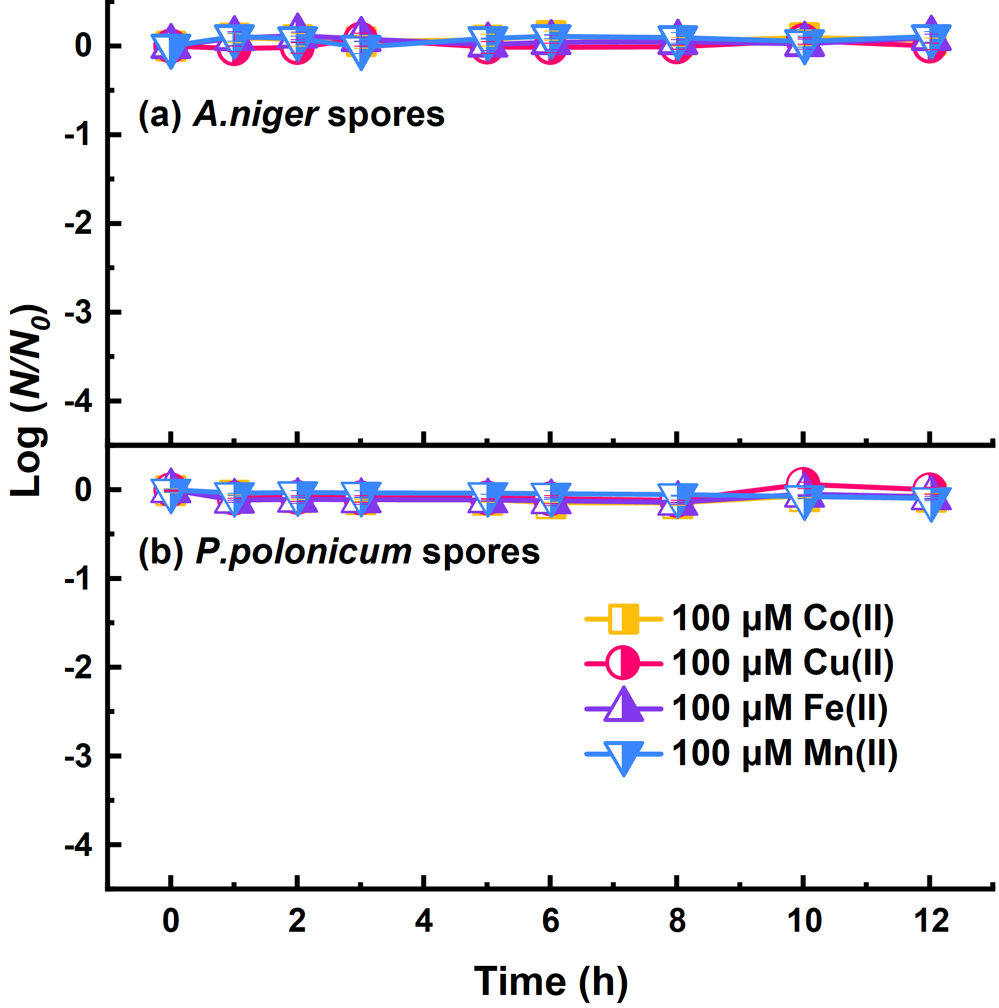

Supplementary Fig. 3. Effects of 100 μM metal ions on the culturability of fungal spores. (a) A.niger and (b) P.polonicum spores (without centrifugation). Experimental conditions: Initial spore concentration: (2-4)×10⁵ CFU/mL; initial metal ion concentration: 100 μM ([Co(II)]=5.89 mg/L, [Cu(II)]=6.35 mg/L, [Fe(II)]=5.58 mg/L, [Mn(II)]=5.49 mg/L); pH = 7.0 ± 0.2, T=30 ±2 ℃; shaking speed: 150 rpm; until the maximum adsorption equilibrium (9 h).

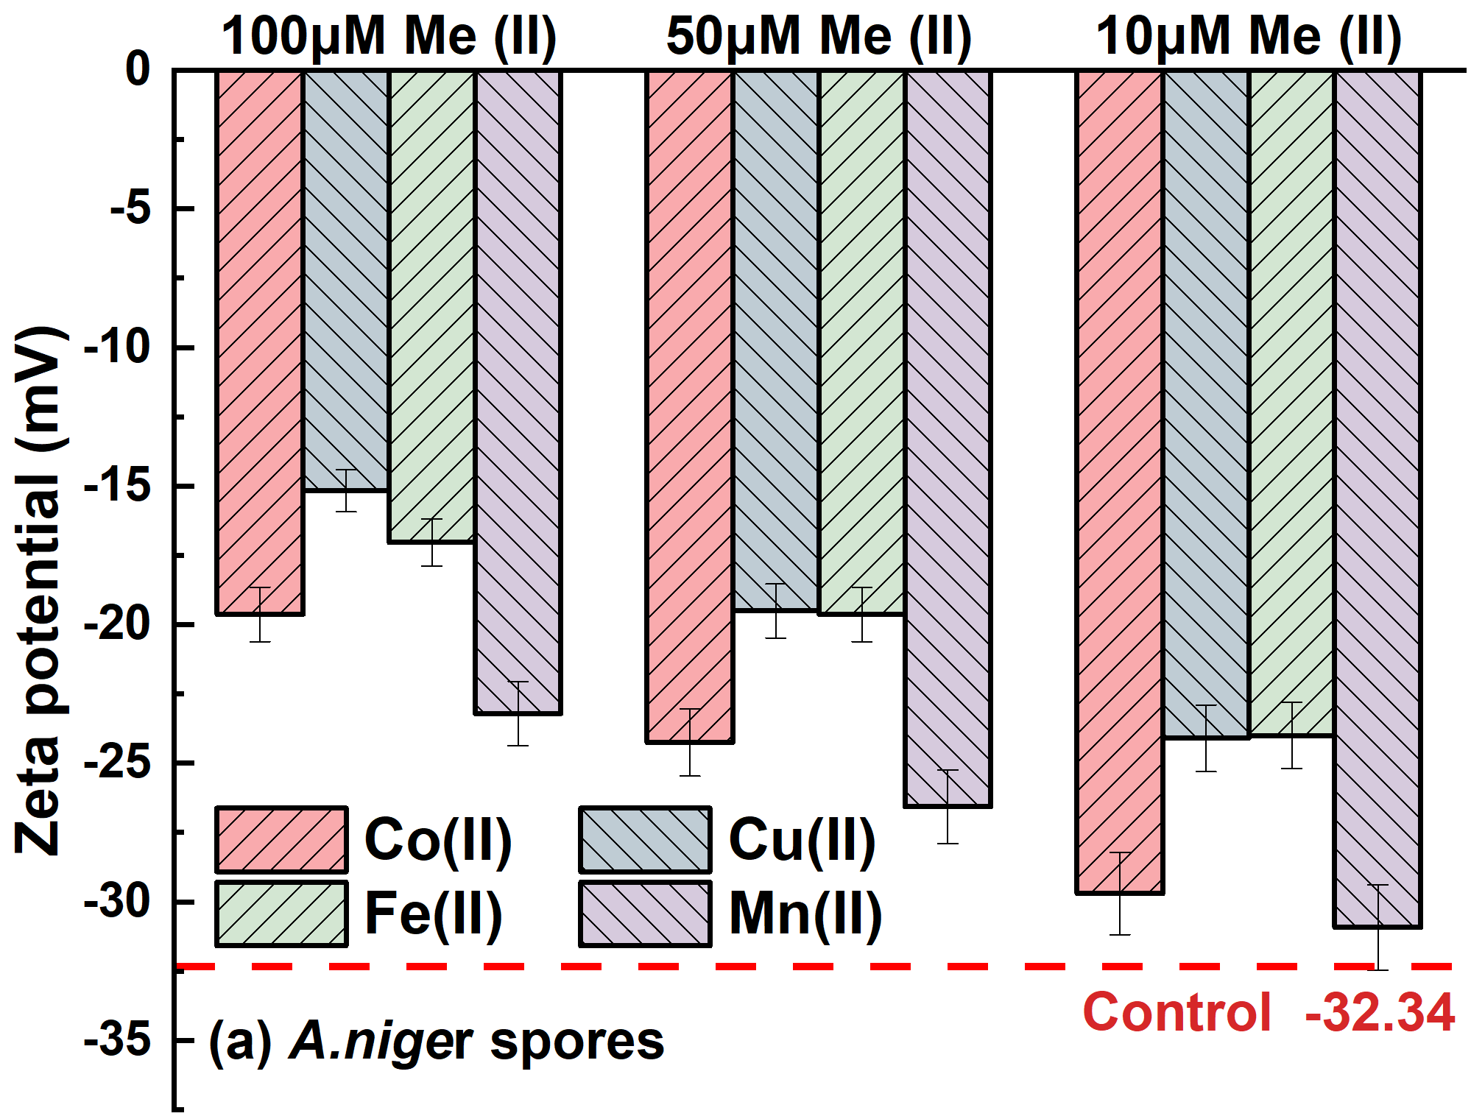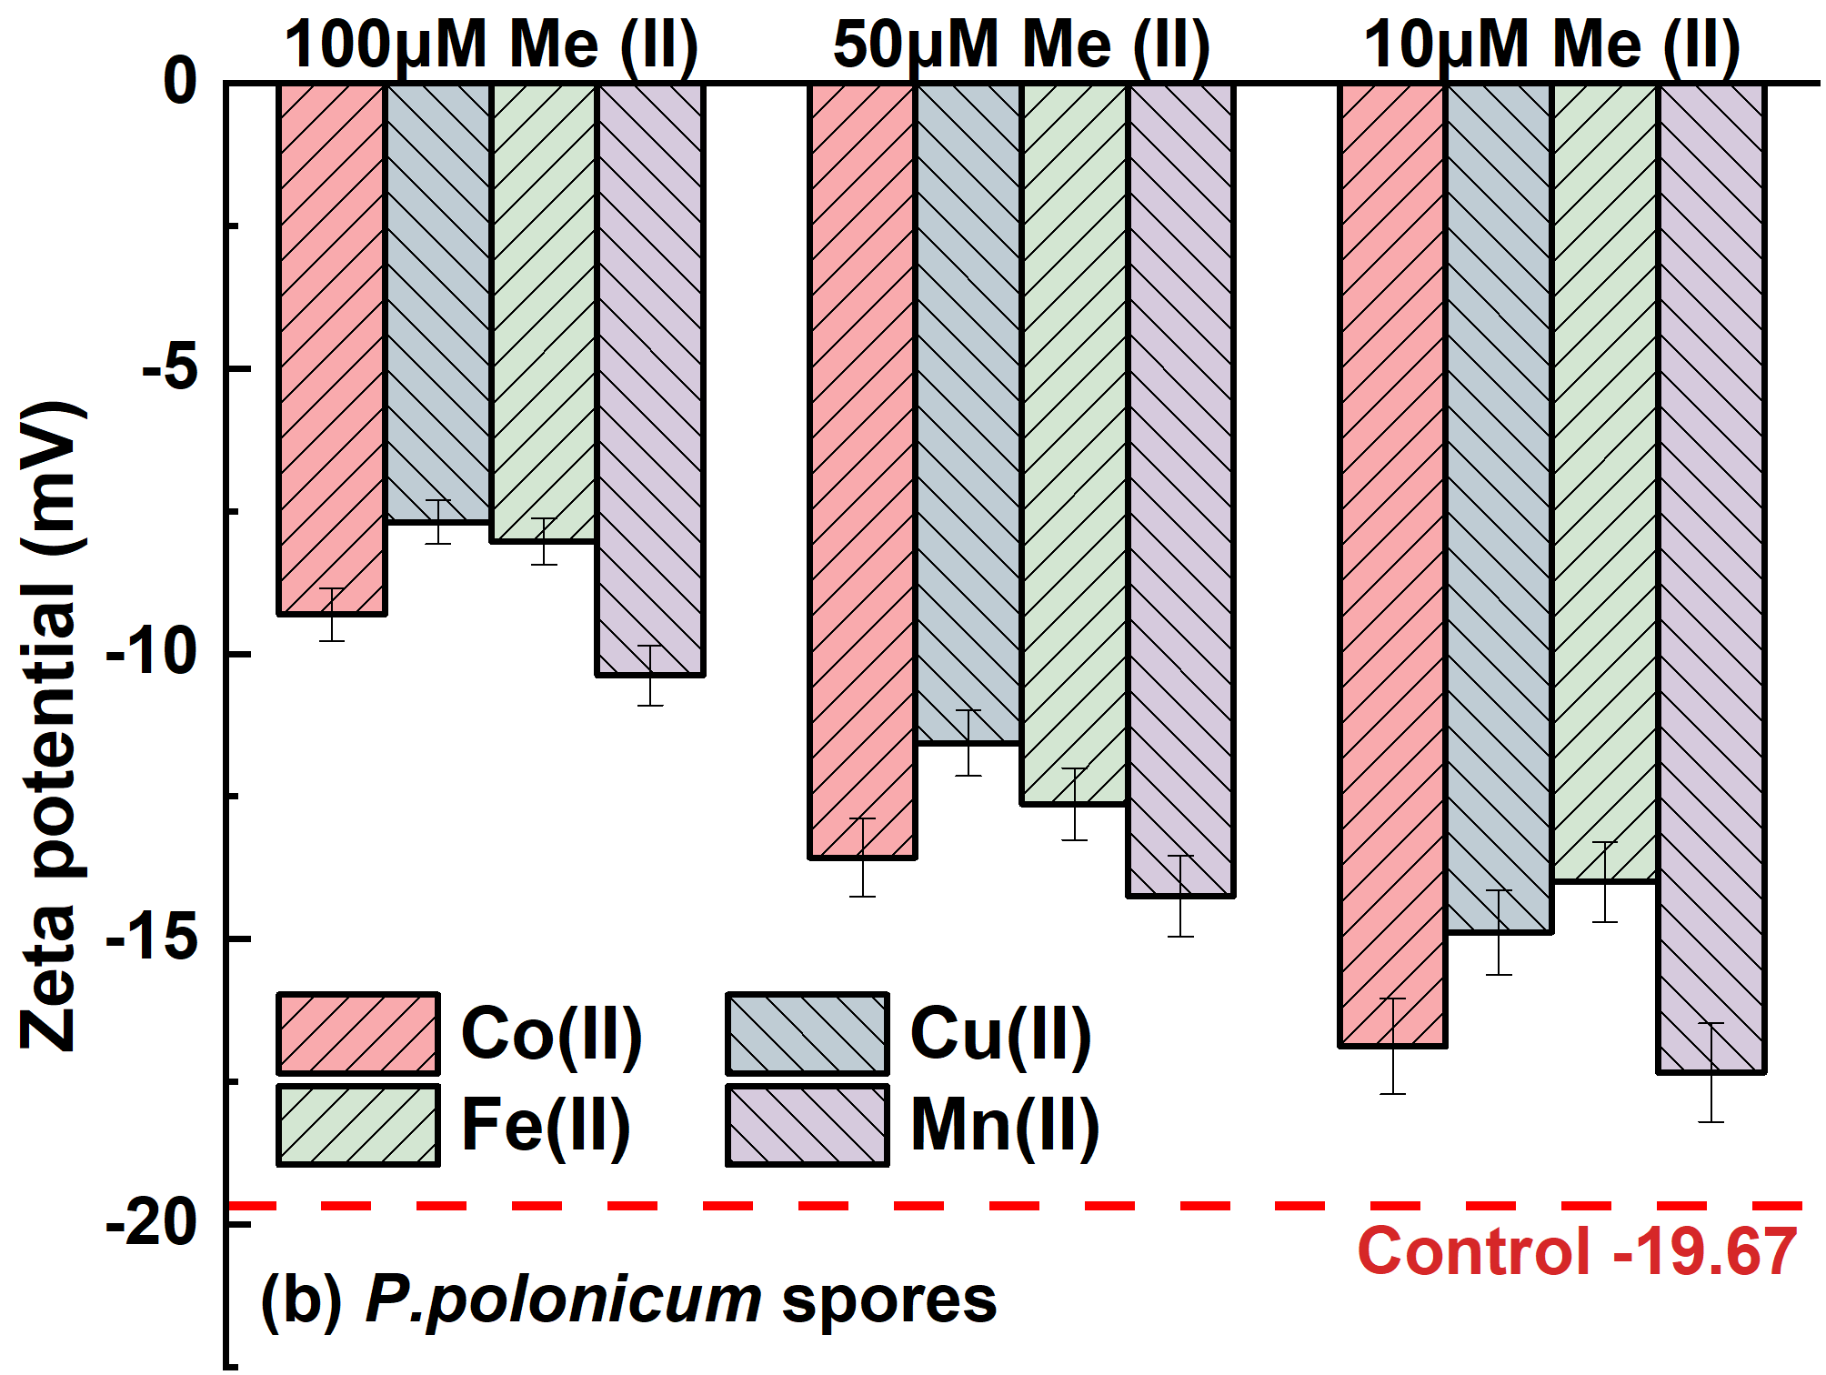

Supplementary Fig. 4. Effects of metal ion concentration on spore surface zeta potential. (a) A.niger and (b) P.polonicum spores. Experimental conditions: Initial spore concentration: (2-4)×10⁵ CFU/mL; initial metal ion concentration: 10, 50, 100 μM; pH = 7.0 ± 0.2, T=30 ±2 ℃; shaking speed: 150 rpm; contact time: until the maximum adsorption equilibrium (9 h).

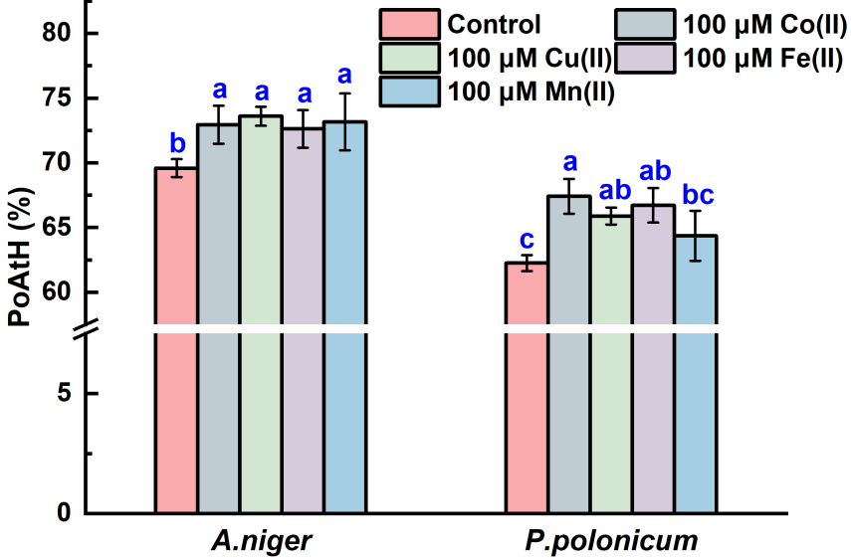

Supplementary Fig. 5. Effects of 100 μM metal ions on spore surface hydrophobicity. A.niger and P.polonicum spores measured by microbial adhesion to hydrocarbons (MATH) assay. Experimental conditions: Initial spore concentration: (2-4)×10⁵ CFU/mL; initial metal ion concentration: 100 μM ([Co(II)]=5.89 mg/L, [Cu(II)]=6.35 mg/L, [Fe(II)]=5.58 mg/L, [Mn(II)]=5.49 mg/L); pH = 7.0 ± 0.2, T=30 ±2 ℃; shaking speed: 150 rpm; until the maximum adsorption equilibrium (9 h).

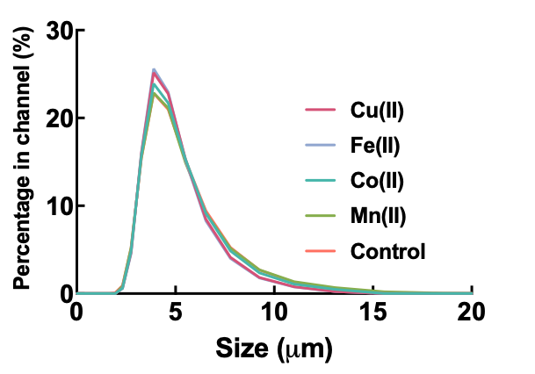

Supplementary Fig. 6. Particle size changes of A.niger spores following metal ion complexation. Experimental conditions: Initial spore concentration: (2-4)×10⁵ CFU/mL; initial metal ion concentration: 10 μM ([Co(II)]=0.589 mg/L, [Cu(II)]=0.635 mg/L, [Fe(II)]=0.558 mg/L, [Mn(II)]=0.549 mg/L); pH = 7.0 ± 0.2, T=30 ±2 ℃; shaking speed: 150 rpm; until the maximum adsorption equilibrium (9 h).

Supplementary Fig. 7. Chlorine inactivation kinetics of A. niger spores, and E. coli after complexation with metal ions (without centrifugation). Experimental conditions: initial fungal spores concentration=(2-4)×10⁵ CFU/mL; initial bacteria concentration=(2-4)×10⁷ CFU/mL; [chlorine]₀=2.0 mg/L (for E.coli), 3.0 mg/L(for A.niger); [Me(II)]=10 μM ([Co(II)]=0.589 mg/L, [Cu(II)]=0.635 mg/L, [Fe(II)]=0.558 mg/L, [Mn(II)]=0.549 mg/L); pH=7.2±0.2, T=25±2 ℃. Error bars represent the standard deviation (n = 3).

Supplementary Fig. 8. Chlorine inactivation kinetics of P. polonicum spores after complexation with metal ions. (a) Without centrifugation and (b) After centrifugation. Experimental conditions: initial fungal spores concentration=(2-4)×10⁵ CFU/mL; initial bacteria concentration=(2-4)×10⁷ CFU/mL; [chlorine]₀=2.0 mg/L; [Me(II)]=10 μM ([Co(II)]=0.589 mg/L, [Cu(II)]=0.635 mg/L, [Fe(II)]=0.558 mg/L, [Mn(II)]=0.549 mg/L); pH=7.2±0.2, T=25±2 ℃. Error bars represent the standard deviation (n = 3).

Supplementary Fig. 9. Inactivation kinetics and resistance of metal-complexed P. polonicum spores under different disinfection treatments. (a) Inactivation kinetics under Cl₂, NH₂Cl, ClO₂, and UV treatments (after centrifugation); (b) Comparative assessment of microbial resistance across disinfection methods (after centrifugation). Experimental conditions: initial fungal spores concentration=(2-4)×10⁵ CFU/mL; [Cl₂]₀=[NH₂Cl]₀=[ClO₂]₀=2.0 mg/L; irradiation intensity of the LPUV was 0.1132 mW/cm²; [Me(II)]=10 μM ([Co(II)]=0.589 mg/L, [Cu(II)]=0.635 mg/L, [Fe(II)]=0.558 mg/L, [Mn(II)]=0.549 mg/L); pH=7.2±0.2, T=25±2 ℃.

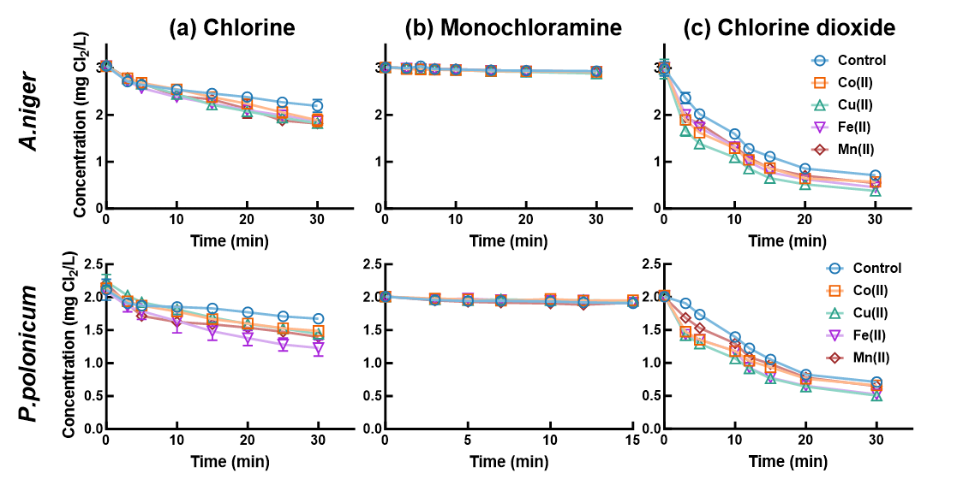

Supplementary Fig. 10. Decay profiles of disinfectant residuals in the presence of metal-ion–complexed fungal spores. (a) Chlorine, (b) Monochloramine, and (c) Chlorine dioxide decay (after centrifugation). Experimental conditions: initial fungal spores concentration=(2-4)×10⁵ CFU/mL; [Cl₂]₀=[NH₂Cl]₀=[ClO₂]₀=2.0 mg/L (for P.polonicum), 3.0 mg/L (for A.niger); [Me(II)]=10 μM ([Co(II)]=0.589 mg/L, [Cu(II)]=0.635 mg/L, [Fe(II)]=0.558 mg/L, [Mn(II)]=0.549 mg/L); pH=7.2±0.2, T=25±2 ℃.

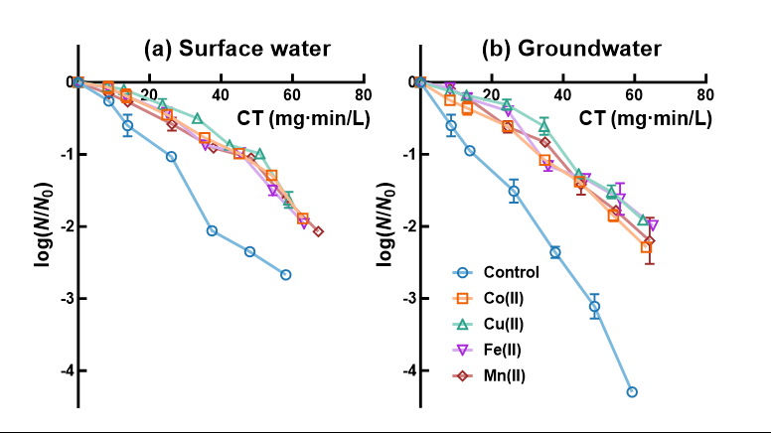

Supplementary Fig. 11. Inactivation of metal-ion–complexed A. niger spores in actual water samples. (a) Surface water and (b) Groundwater (without centrifugation). Experimental conditions: initial fungal spores concentration=(2-4)×10⁵ CFU/mL; [Cl₂]₀=3.0 mg/L; [Me(II)]=10 μM ([Co(II)]=0.589 mg/L, [Cu(II)]=0.635 mg/L, [Fe(II)]=0.558 mg/L, [Mn(II)]=0.549 mg/L);T=25±2 ℃.

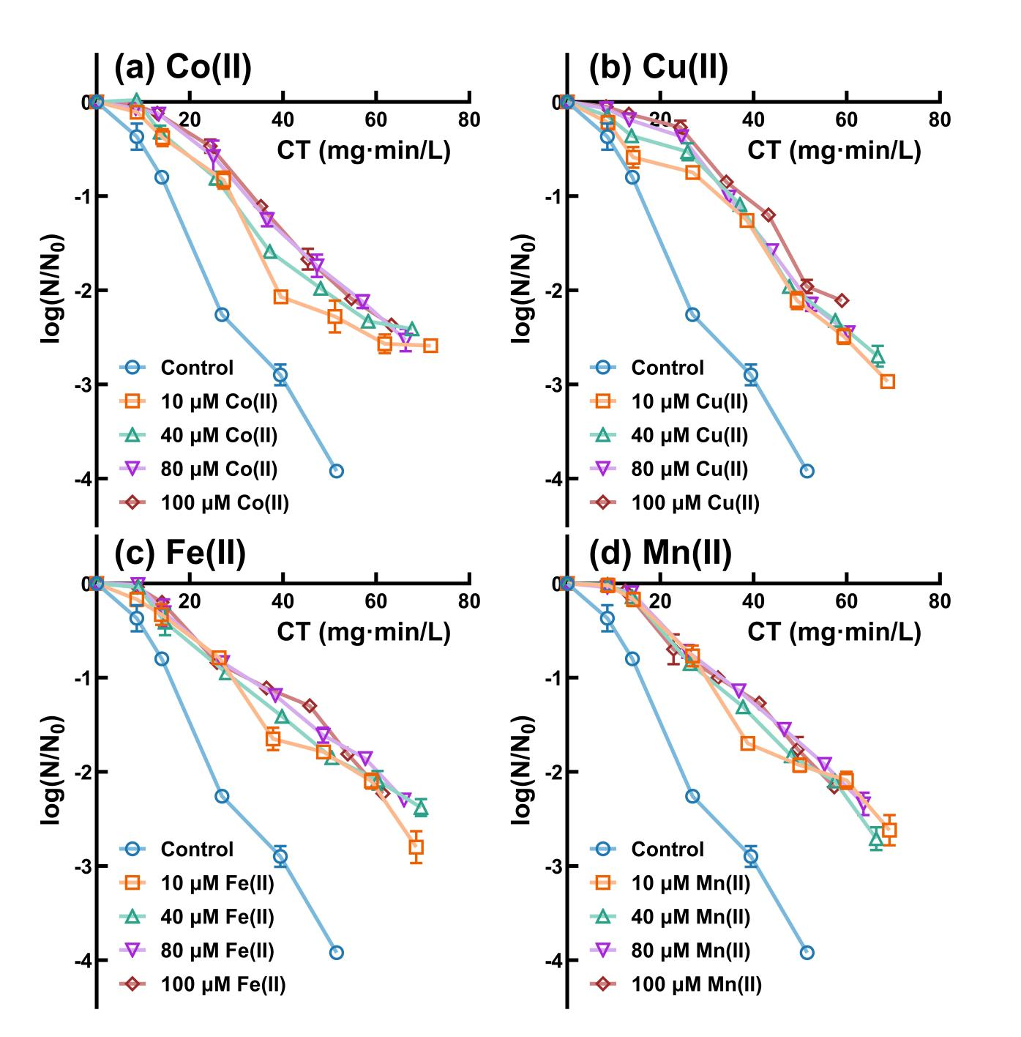

Supplementary Fig. 10. Inactivation of A. niger spores under varying initial metal ion concentrations. (a) Co(II), (b) Cu(II), (c) Fe(II), and (d) Mn(II). Experimental conditions: initial fungal spores concentration=(2-4)×10⁵ CFU/mL; [Cl₂]₀=3.0 mg/L; [Me(II)]=10, 40, 80, 100 μM; pH=7.0±0.2, T=25±2 ℃.

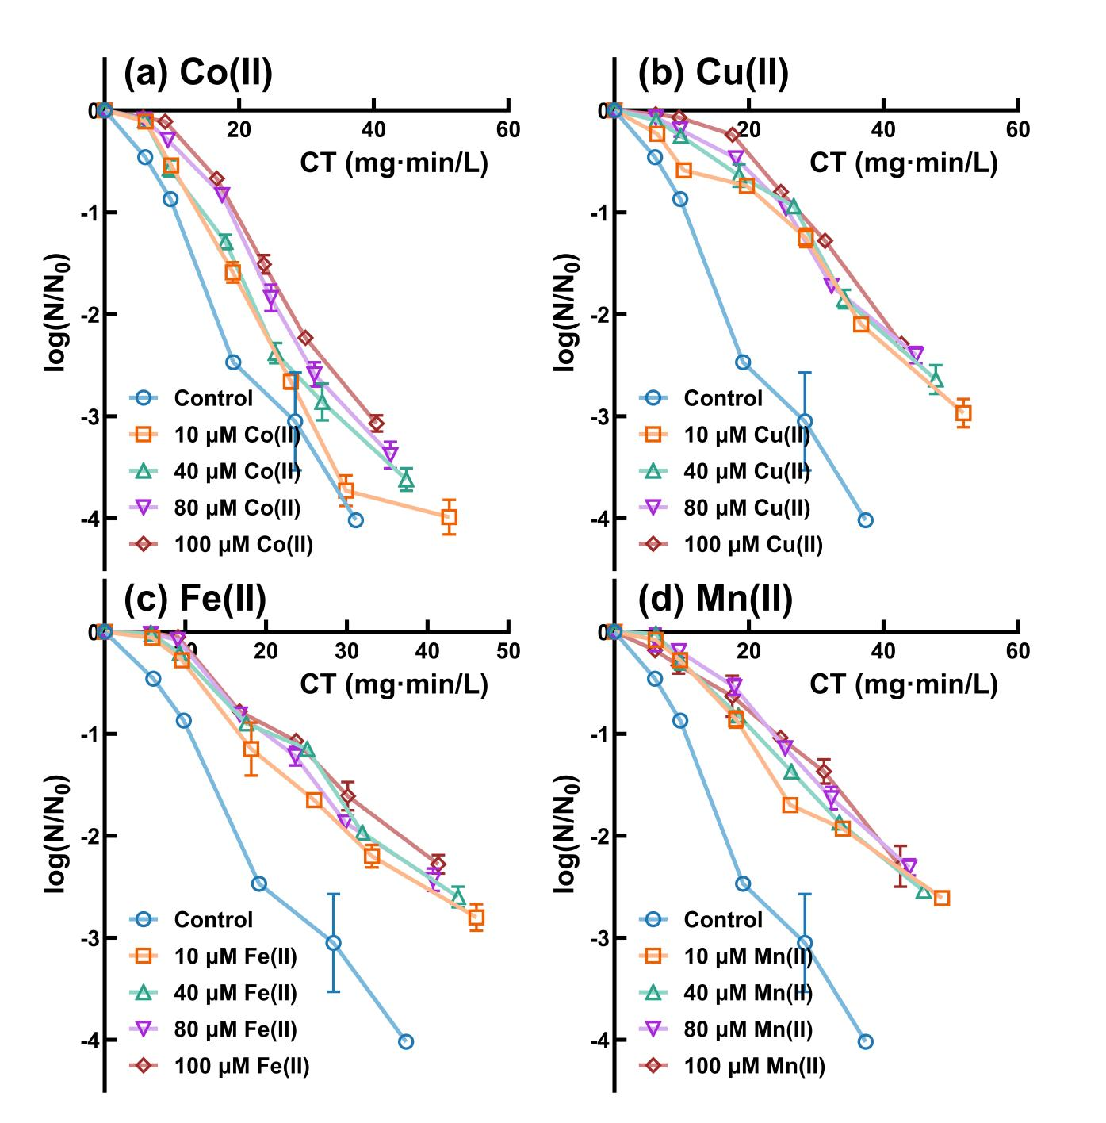

Supplementary Fig. 11. Inactivation of P. polonicum spores under varying initial metal ion concentrations. (a) Co(II), (b) Cu(II), (c) Fe(II), and (d) Mn(II). Experimental conditions: initial fungal spores concentration=(2-4)×10⁵ CFU/mL; [Cl₂]₀=2.0 mg/L; [Me(II)]=10, 40, 80, 100 μM; pH=7.0±0.2, T=25±2 ℃.

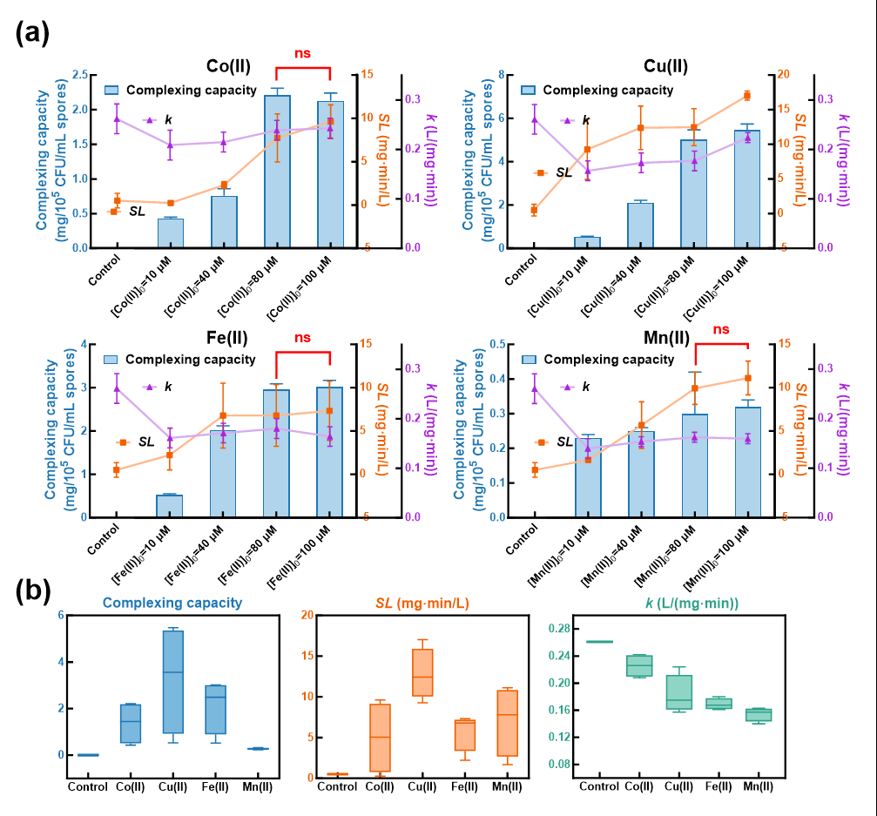

Supplementary Fig. 12. Analysis of metal ion complexation capacity and chlorine resistance of P. polonicum spores. (a) Analysis of metal ion complexation capacity and chlorine resistance; (b) Comparative analysis of the complexation levels of four metal ions and their effects on chlorine inactivation rate and shoulder length. Experimental conditions: initial fungal spores concentration=(2-4)×10⁵ CFU/mL; [Cl₂]₀=2.0 mg/L; [Me(II)]=10, 40, 80, 100 μM; pH=7.0±0.2, T=25±2 ℃.

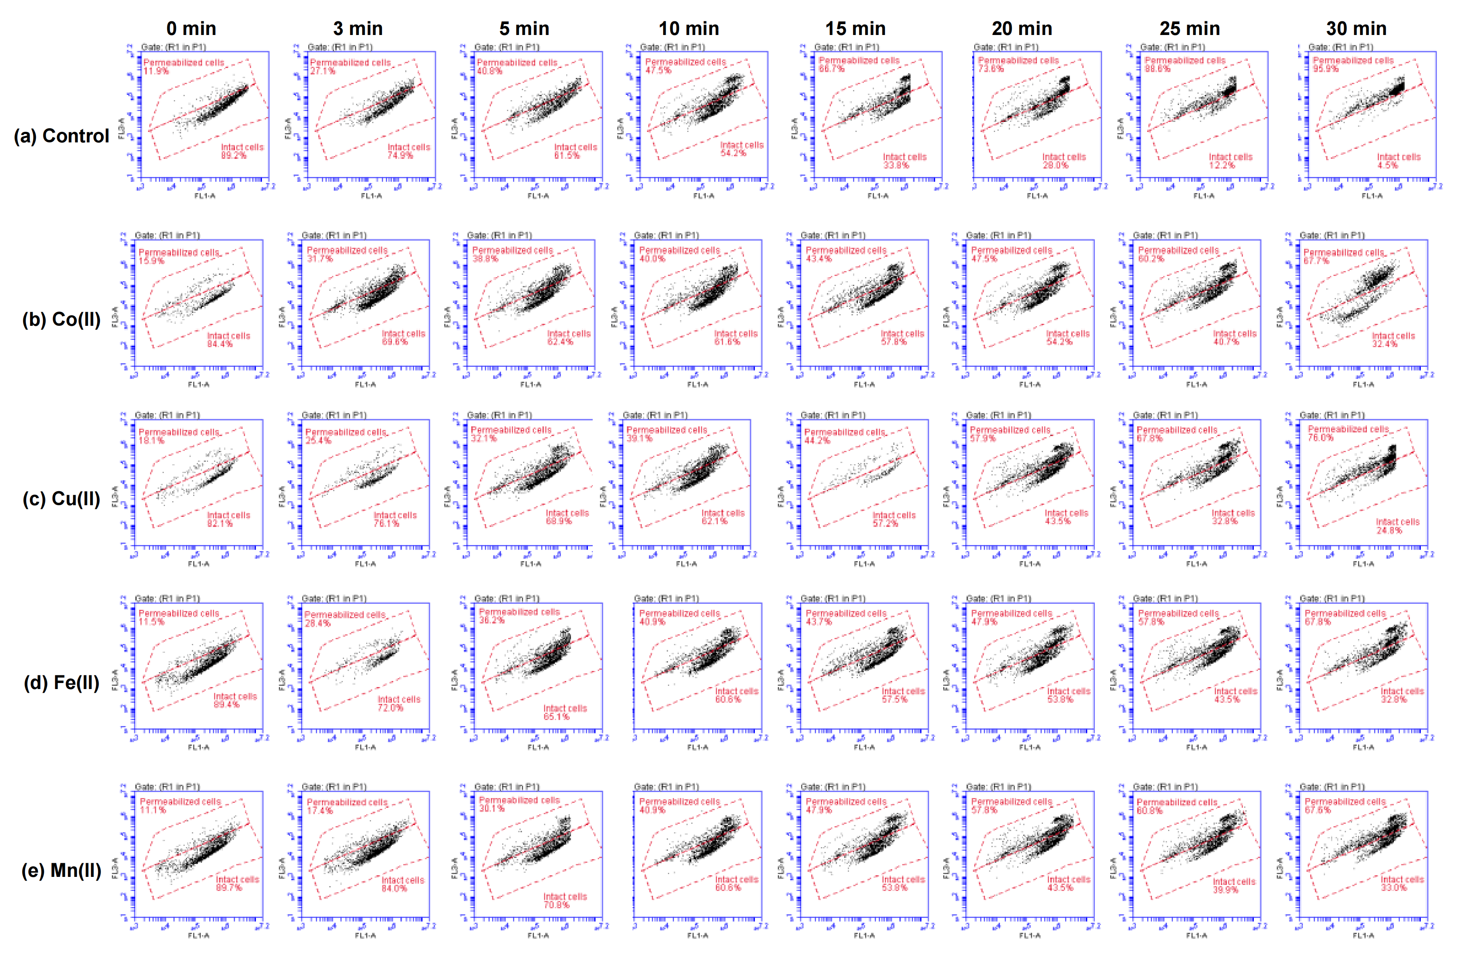

Supplementary Fig. 13. Two-dimensional scatter plots of SG/PI staining for A.niger spores at different chlorine exposure times. Experimental conditions: initial fungal spores concentration=(2-4)×10⁵ CFU/mL; [Cl₂]₀=3.0 mg/L; [Me(II)]=10 μM; pH=7.0±0.2, T=25±2 ℃.

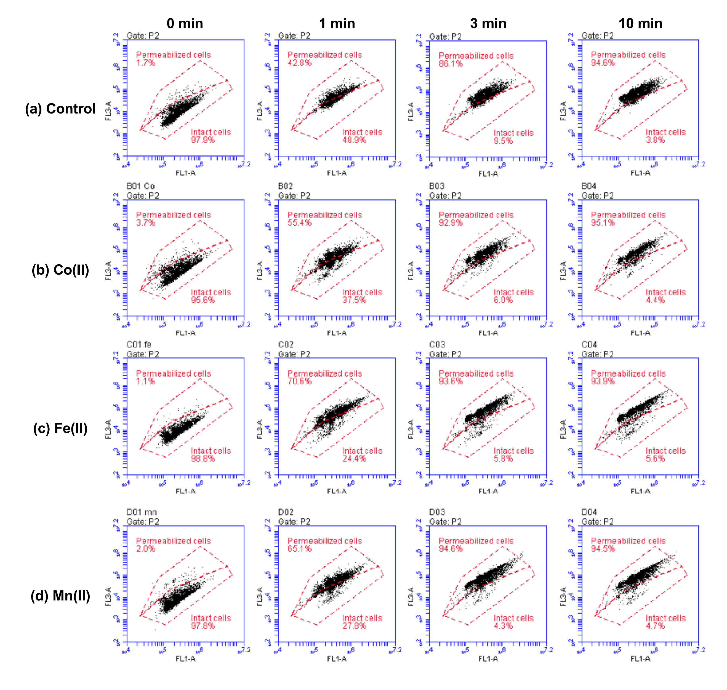

Supplementary Fig. 14. Two-dimensional scatter plots of SG/PI staining for E.coli at different chlorine exposure times. Experimental conditions: initial bacteria concentration=(2-4)×10⁷ CFU/mL; [Cl₂]₀=2.0 mg/L; [Me(II)]=10 μM; pH=7.0±0.2, T=25±2 ℃.

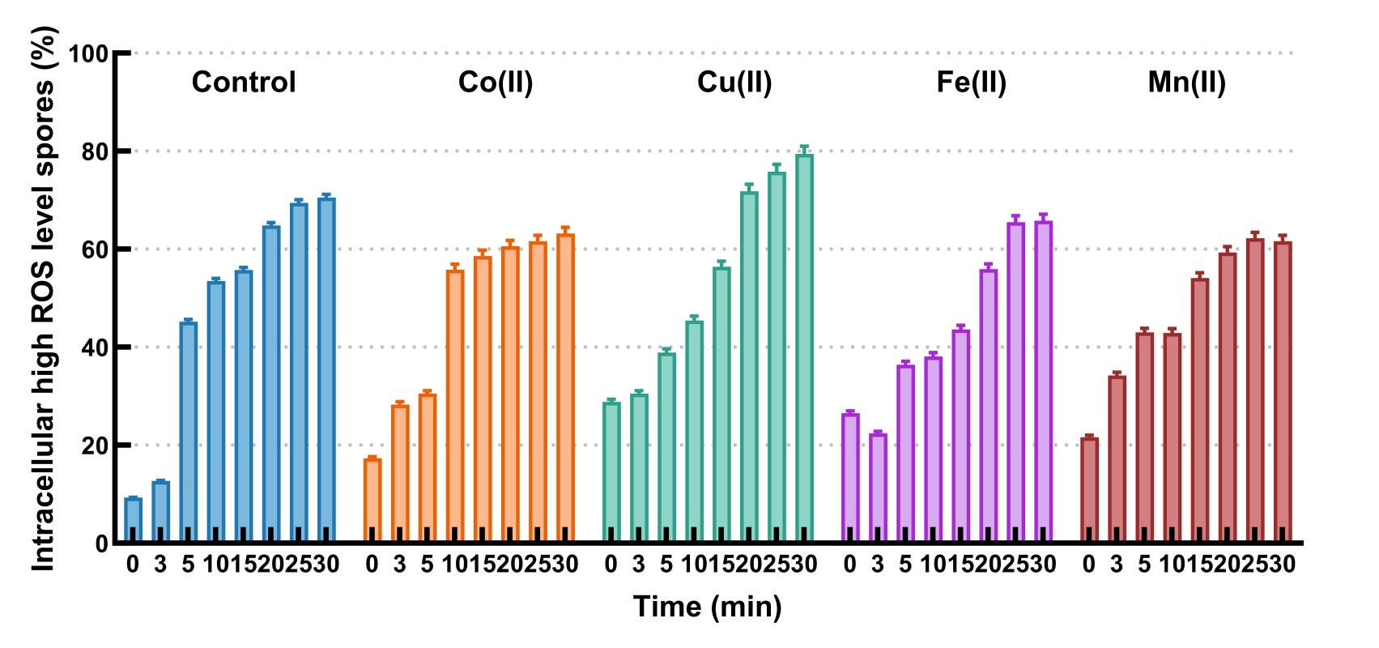

Supplementary Fig. 15. Impact of metal ion complexation on the proportion of high ROS level A.niger spores after chlorine disinfection. Experimental conditions: initial fungal spores concentration=(2-4)×10⁵ CFU/mL; [Cl₂]₀=2.0 mg/L; [Me(II)]=10 μM; pH=7.0±0.2, T=25±2 ℃.

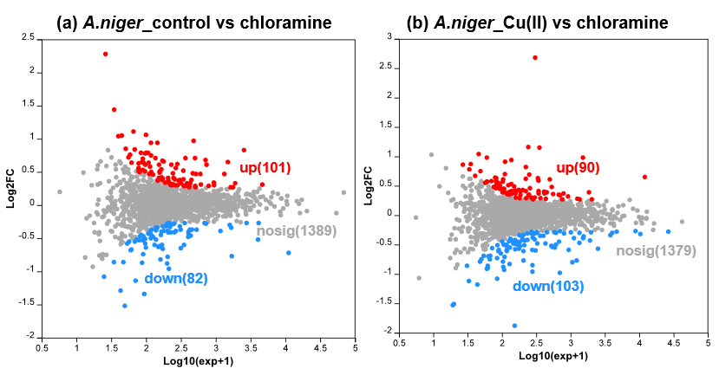

Supplementary Fig. 16. MA plots of differentially expressed proteins in A.niger spores before and after metal ion complexation under chloramine treatment. Experimental conditions: initial fungal spores concentration=(2-4)×10⁵ CFU/mL; [NH₂Cl]₀=3.0 mg/L; [Me(II)]=10 μM; pH=7.0±0.2, T=25±2 ℃.

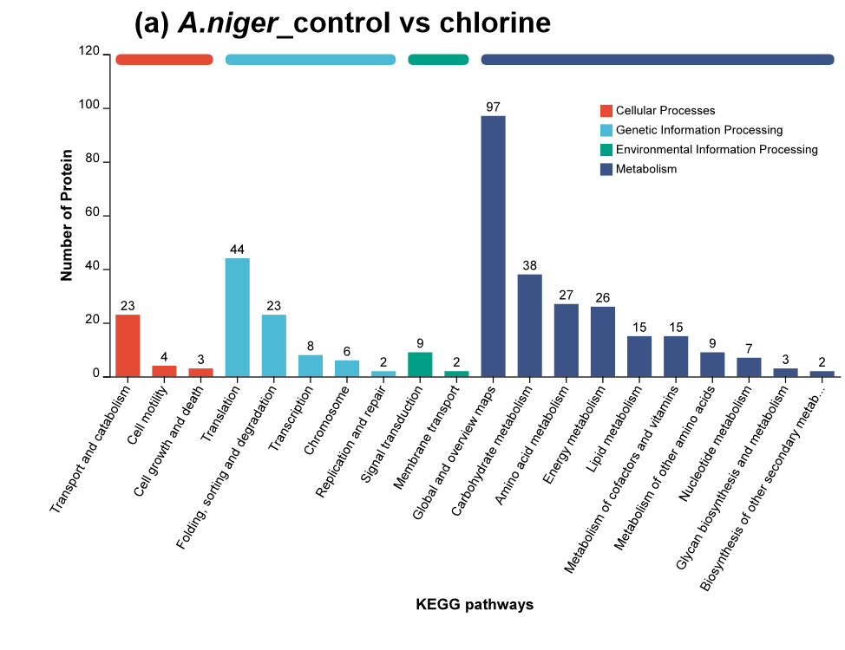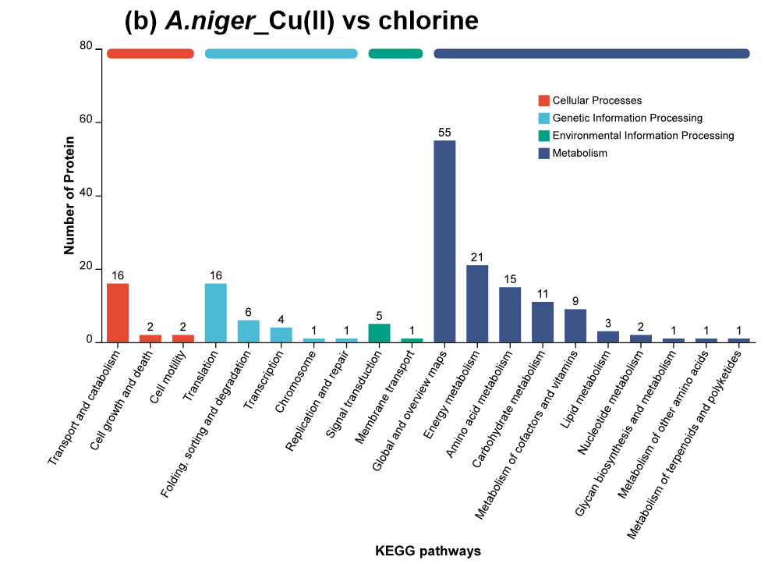

Supplementary Fig. 17. KEGG pathway analysis of A.niger spores under chlorine treatment before and after metal ion complexation. Experimental conditions: initial fungal spores concentration=(2-4)×10⁵ CFU/mL; [Cl₂]₀=3.0 mg/L; [Me(II)]=10 μM; pH=7.0±0.2, T=25±2 ℃.

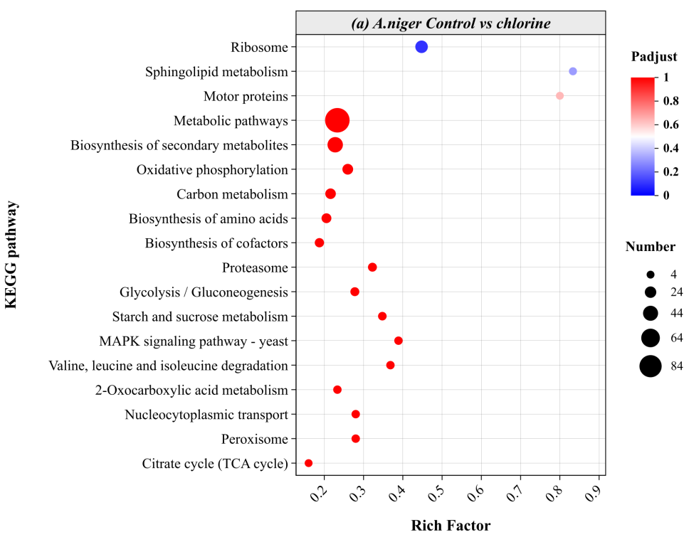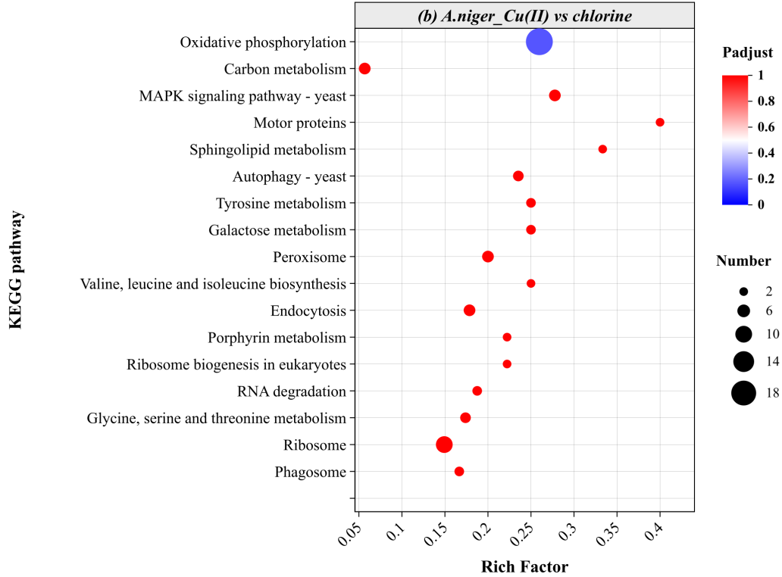

Supplementary Fig. 18. KEGG enrichment analysis of A.niger spores under chlorine treatment before and after metal ion complexation. Experimental conditions: initial fungal spores concentration=(2-4)×10⁵ CFU/mL; [Cl₂]₀=3.0 mg/L; [Me(II)]=10 μM; pH=7.0±0.2, T=25±2 ℃.

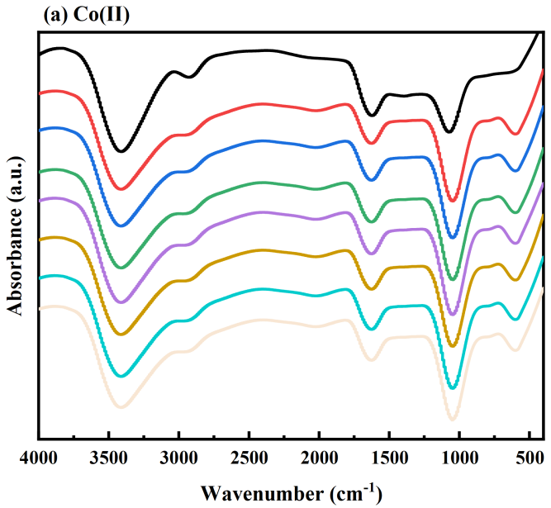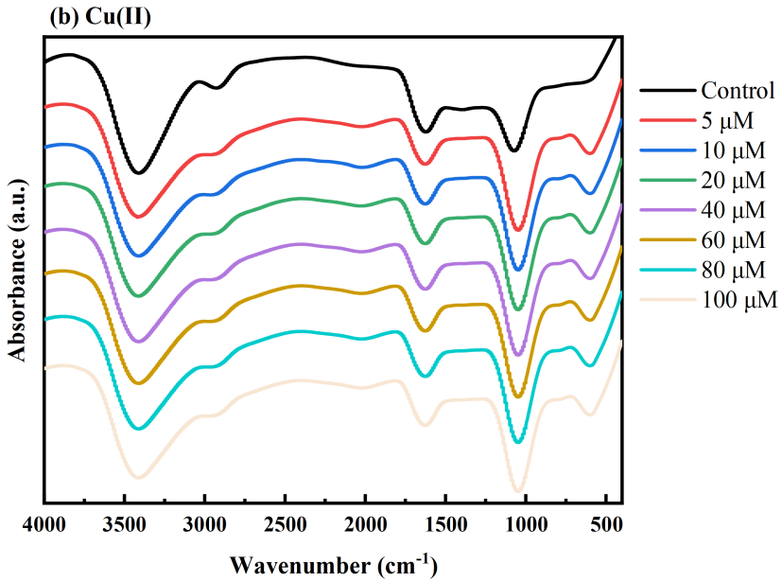
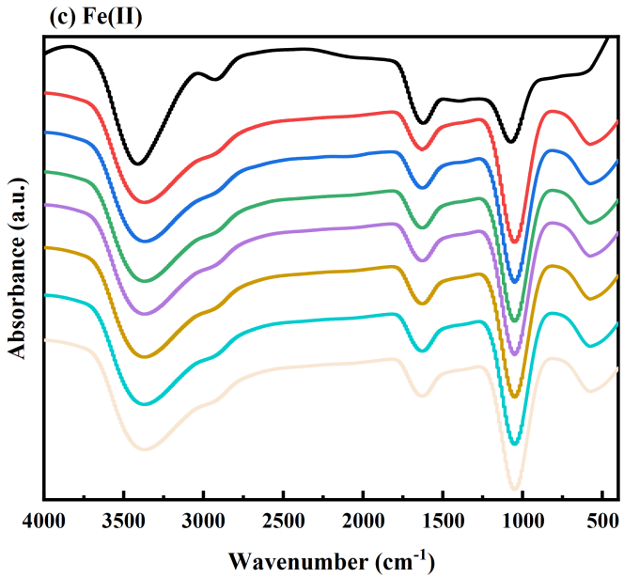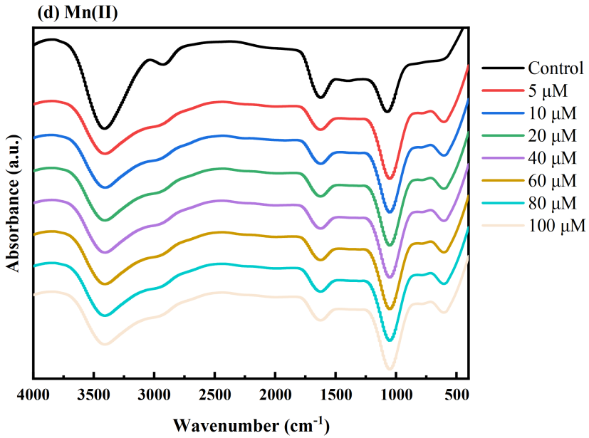

Supplementary Fig. 19. FTIR spectral characterization of A. niger spores complexed with different metal ions at varying concentrations. (a)Co(II), (b)Cu(II), (c)Fe(II), and (d)Mn(II) at different metal ion concentrations. Experimental conditions: initial fungal spores concentration=(2-4)×10⁵ CFU/mL; pH=7.0±0.2, T=25±2 ℃.
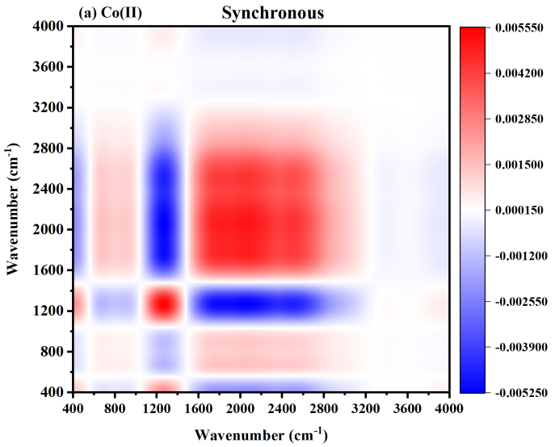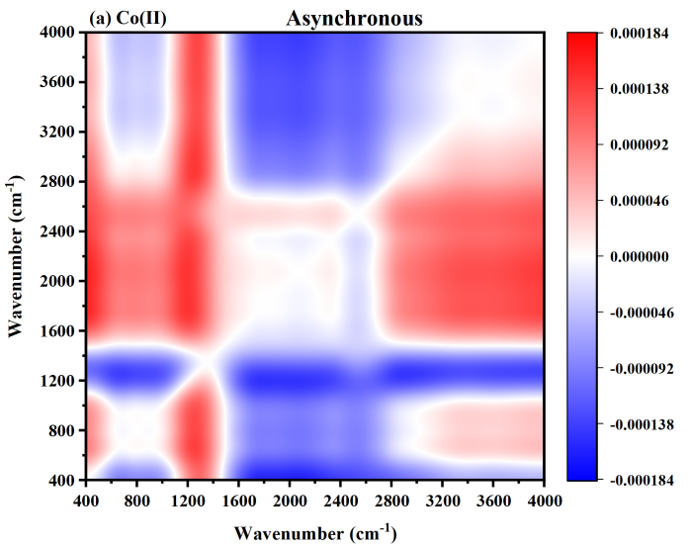
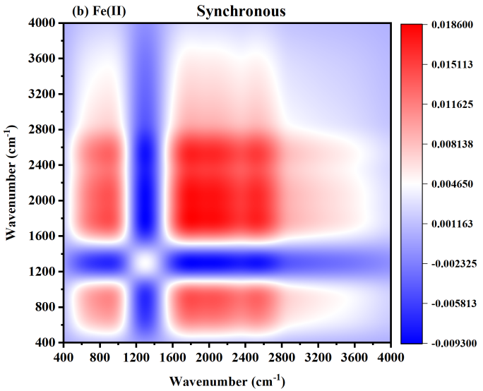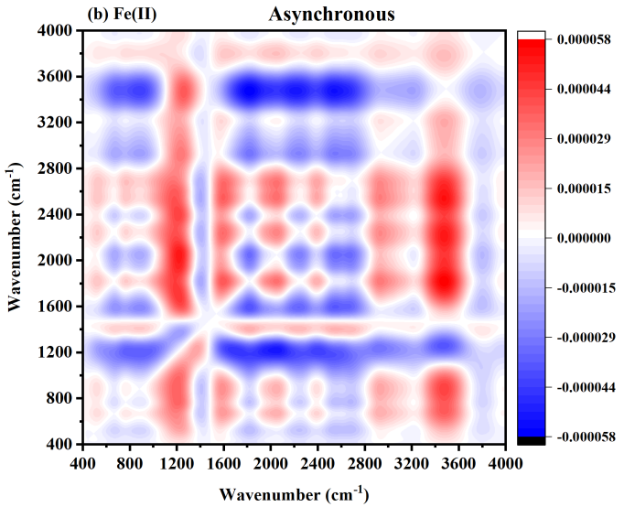
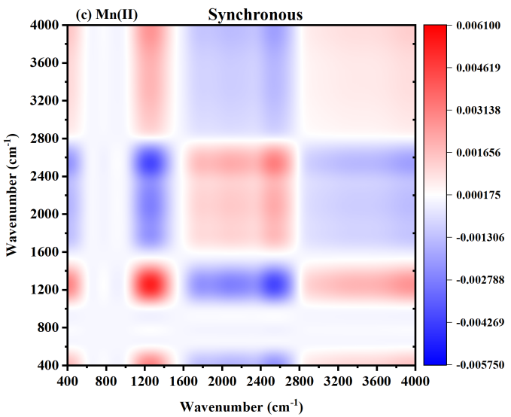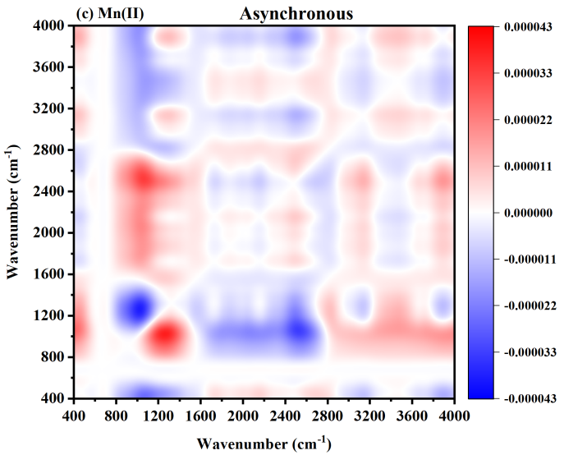

Supplementary Fig. 20. Two-dimensional synchronous and asynchronous correlation spectroscopy of A. niger spores under metal ion complexation. (a) Co(II), (b) Fe(II), and (c) Mn(II). Experimental conditions: initial fungal spores concentration=(2-4)×10⁵ CFU/mL; pH=7.0±0.2, T=25±2 ℃.

Tables:

Supplementary Table 1. Physicochemical properties of four metal ions.
Metal ion properties | Co(II) | Cu(II) | Fe(II) | Mn(II)
Molar mass (g/mol) | 58.93 | 63.55 | 55.84 | 54.94
Electronegativity (Pauling) | 1.88 | 1.90 | 1.83 | 1.55
Electron orbital configuration | [Ar] 3d⁷ | [Ar] 3d⁹ | [Ar] 3d⁶ | [Ar] 3d⁵
Ionic radius (nm) | 0.074 | 0.072 | 0.078 | 0.083
Hydrated ionic radii (nm) | 0.65 | 0.419 | 0.428 | 0.67
Van der Waals Atomic Radius (pm) | 192 | 140 | / | /
Covalent Radius (pm) | 126 | 132 | 132 | 139
Electron Affinity (kJ/mol) | 63.7 | 118.4 | 15.7 | 0
Ionization (eV) | 7.881 | 7.7264 | 7.9024 | 7.434
Softness (Å) | 2.96 | 2.89 | 3.09 | 3.03
log K_{MeOH} | -9.697 | -7.497 | -9.397 | -10.597

Supplementary Table 2. Inactivation kinetic parameters of fungal spores under different disinfectants before and after metal ion complexation.
Disinfection system | P.polonicum |  |  | A.niger
Chlorine
 | k(L/(mg•min)) | SL((mg•min)/L) | R² | k(L/(mg•min)) | SL((mg•min)/L) | R²
Control | 0.261±0.03ª | 0.51±0.84^{b} | 0.98 | 0.191±0.02ª | 2.90±0.14^{cd} | 0.99
Co(II) | 0.208±0.03^{b} | 0.25±0.04^{b} | 0.95 | 0.099±0.02^{b} | 1.07±0.88^{d} | 0.94
Cu(II) | 0.157±0.02^{c} | 9.28±4.36ª | 0.98 | 0.121±0.01^{b} | 13.76±2.11ª | 0.99
Fe(II) | 0.161±0.02^{c} | 2.22±1.72^{b} | 0.98 | 0.102±0.01^{b} | 6.28±1.96^{b} | 0.98
Mn(II) | 0.140±0.02^{c} | 1.67±0.12^{b} | 0.97 | 0.101±0.01^{b} | 5.66±1.84^{bc} | 0.97
Chloramine
 | k(L/(mg•min)) | SL((mg•min)/L) | R² | k(L/(mg•min)) | SL((mg•min)/L) | R²
Control | 0.730±0.02ª | 7.41±0.73ª | 0.99 | 0.271±0.02ª | 10.57±2.27^{ab} | 0.99
Co(II) | 0.703±0.02ª | 6.94±0.19ª | 0.99 | 0.261±0.03ª | 9.41±3.85^{ab} | 0.98
Cu(II) | 0.711±0.01ª | 6.43±1.02ª | 0.99 | 0.252±0.02ª | 8.23±3.20^{b} | 0.99
Fe(II) | 0.736±0.01ª | 7.20±1.34ª | 0.99 | 0.272±0.02ª | 11.15±2.95^{ab} | 0.99
Mn(II) | 0.696±0.01ª | 7.15±0.54ª | 0.99 | 0.276±0.01ª | 14.07±1.37ª | 0.99
Chlorine dioxide
 | k(L/(mg•min)) | Log10(N_{res}) | R² | k(L/(mg•min)) | Log10(N_{res}) | R²
Control | 0.596±0.03ª | -4.20±0.27^{ab} | 0.98 | 0.568±0.02ª | -4.20±0.27ª | 0.98
Co(II) | 0.437±0.07^{b} | -4.67±1.33^{ab} | 0.96 | 0.374±0.10^{b} | -4.67±1.33ª | 0.96
Cu(II) | 0.411±0.09^{b} | -4.99±0.94^{b} | 0.92 | 0.302±0.04^{b} | -4.77±1.15ª | 0.92
Fe(II) | 0.468±0.02^{b} | -3.63±0.48^{ab} | 0.94 | 0.360±0.04^{b} | -3.63±0.48ª | 0.94
Mn(II) | 0.447±0.05^{b} | -3.41±0.25ª | 0.95 | 0.401±0.04^{b} | -3.341±0.25ª | 0.95
UV
 | k(min⁻¹) | SL((mg•min)/L) | R² | k(min⁻¹) | SL((mg•min)/L) | R²
Control | 0.930±0.07ª | 2.97±0.67ª | 0.99 | 0.342±0.03ª | 2.97±0.08^{b} | 0.98
Co(II) | 0.949±0.06ª | 3.24±0.51ª | 0.99 | 0.354±0.04ª | 2.81±0.19^{b} | 0.98
Cu(II) | 0.881±0.06ª | 3.06±0.65ª | 0.99 | 0.347±0.05ª | 3.90±0.68^{b} | 0.97
Fe(II) | 0.8928±0.02ª | 2.94±0.24ª | 0.99 | 0.315±0.02ª | 2.45±0.27ª | 0.99
Mn(II) | 0.901±0.05ª | 3.30±0.51ª | 0.99 | 0.313±0.03ª | 2.57±0.67^{b} | 0.99

Supplementary Table 3. Water quality parameters of surface water and groundwater.
Parameter | Surface water | Groundwater
pH | 7.7 | 7.5
TN (mg/L) | 1.12 | 0.32
TP (mg/L) | 0.187 | 0.078
DOC (mg/L) | 2.43 | 0.53
DO (mg/L) | 9.51 | 8.67
Turbidity (NTU) | 2.2 | 1.3
NH₄⁺-N (mg/L) | 0.121 | 0.073
Fe²⁺ (mg/L) | 0.023 | 0.083
Mn²⁺ (mg/L) | 0.011 | 0.057

Supplementary Table 4. Secondary inactivation kinetic parameters of A.niger spores at different metal ion complexation capacities.
 | Complexation capacity | SL ((mg•min)/L) | k (L/(mg•min))
Control | 0.00 ± 0.00^{d} | 2.90 ± 0.14^{b} | 0.19 ± 0.02ª
[Co(II)]₀=10 μM | 0.48 ± 0.02^{c} | 1.07 ± 0.88^{b} | 0.10 ± 0.02^{c}
[Co(II)]₀=40 μM | 1.07 ± 0.08^{b} | 2.22 ± 0.82^{b} | 0.10 ± 0.01^{c}
[Co(II)]₀=80 μM | 2.25 ± 0.09ª | 12.45 ± 3.02ª | 0.11 ± 0.01^{bc}
[Co(II)]₀=100 μM | 2.36 ± 0.12ª | 14.32 ± 2.87ª | 0.13 ± 0.01^{b}
Control | 0.00 ± 0.00^{d} | 2.90 ± 0.14^{c} | 0.19 ± 0.02ª
[Cu(II)]₀=10 μM | 0.38 ± 0.02^{d} | 13.76 ± 2.11^{b} | 0.12 ± 0.01^{c}
[Cu(II)]₀=40 μM | 2.09 ± 0.10^{c} | 16.93 ± 4.23^{ab} | 0.13 ± 0.01^{bc}
[Cu(II)]₀=80 μM | 4.84 ± 0.44^{b} | 19.68 ± 2.39ª | 0.14 ± 0.01^{bc}
[Cu(II)]₀=100 μM | 5.64 ± 0.28ª | 21.70 ± 3.23ª | 0.15 ± 0.01^{b}
Control | 0.00 ± 0.00^{d} | 2.90 ± 0.14ª | 0.19 ± 0.02ª
[Fe(II)]₀=10 μM | 0.75 ± 0.04^{c} | 6.28 ± 1.96ª | 0.10 ± 0.01^{b}
[Fe(II)]₀=40 μM | 2.16 ± 0.11^{b} | 1.96 ± 0.66^{b} | 0.09 ± 0.01^{b}
[Fe(II)]₀=80 μM | 3.72 ± 0.17ª | 7.34 ± 1.37^{b} | 0.09 ± 0.01^{b}
[Fe(II)]₀=100 μM | 3.93 ± 0.20ª | 10.52 ± 2.86ª | 0.10 ± 0.01^{b}
Control | 0.00 ± 0.00^{c} | 2.90 ± 0.14^{c} | 0.19 ± 0.02ª
[Mn(II)]₀=10 μM | 0.29 ± 0.01^{b} | 5.66 ± 1.84^{bc} | 0.10 ± 0.01^{b}
[Mn(II)]₀=40 μM | 0.48 ± 0.02ª | 10.42 ± 4.11^{ab} | 0.11 ± 0.01^{b}
[Mn(II)]₀=80 μM | 0.43 ± 0.13ª | 12.30 ± 3.03ª | 0.11 ± 0.01^{b}
[Mn(II)]₀=100 μM | 0.49 ± 0.02ª | 11.53 ± 4.27^{ab} | 0.11 ± 0.01^{b}

Supplementary Table 5. Secondary inactivation kinetic parameters of P.polonicum spores at different metal ion complexation capacities.
 | Complexation capacity | SL ((mg•min)/L) | k (L/(mg•min))
Control | 0.00 ± 0.00^{d} | 0.51 ± 0.84^{b} | 0.26 ± 0.03ª
[Co(II)]₀=10 μM | 0.43 ± 0.02^{c} | 0.25 ± 0.04^{b} | 0.21 ± 0.03^{b}
[Co(II)]₀=40 μM | 0.76 ± 0.10^{b} | 2.32 ± 0.39^{b} | 0.21 ± 0.02^{ab}
[Co(II)]₀=80 μM | 2.21 ± 0.10ª | 7.75 ± 2.78ª | 0.24 ± 0.02^{ab}
[Co(II)]₀=100 μM | 2.13 ± 0.11ª | 9.62 ± 1.95ª | 0.24 ± 0.02^{ab}
Control | 0.00 ± 0.00e | 0.51 ± 0.84^{c} | 0.26 ± 0.03ª
[Cu(II)]₀=10 μM | 0.53 ± 0.03^{d} | 9.28 ± 4.36^{b} | 0.16 ± 0.02^{c}
[Cu(II)]₀=40 μM | 2.10 ± 0.11^{c} | 12.38 ± 3.14^{ab} | 0.17 ± 0.02^{c}
[Cu(II)]₀=80 μM | 5.02 ± 0.45^{b} | 12.49 ± 2.67^{ab} | 0.18 ± 0.02^{c}
[Cu(II)]₀=100 μM | 5.47 ± 0.27ª | 17.03 ± 0.66ª | 0.22 ± 0.01^{b}
Control | 0.00 ± 0.00^{d} | 0.51 ± 0.84^{b} | 0.26 ± 0.03ª
[Fe(II)]₀=10 μM | 0.52 ± 0.03^{c} | 2.22 ± 1.72^{ab} | 0.16 ± 0.02^{b}
[Fe(II)]₀=40 μM | 2.02 ± 0.10^{b} | 6.78 ± 3.75ª | 0.17 ± 0.02^{b}
[Fe(II)]₀=80 μM | 2.96 ± 0.13ª | 6.79 ± 3.55ª | 0.18 ± 0.02^{b}
[Fe(II)]₀=100 μM | 3.02 ± 0.15ª | 7.33 ± 3.41ª | 0.16 ± 0.02^{b}
Control | 0.00 ± 0.00^{b} | 0.51 ± 0.84^{c} | 0.26 ± 0.03ª
[Mn(II)]₀=10 μM | 0.23 ± 0.01ª | 1.67 ± 0.12^{c} | 0.14 ± 0.02^{b}
[Mn(II)]₀=40 μM | 0.25 ± 0.01ª | 5.68 ± 2.69^{b} | 0.15 ± 0.01^{b}
[Mn(II)]₀=80 μM | 0.30 ± 0.12ª | 9.92 ± 1.85ª | 0.16 ± 0.01^{b}
[Mn(II)]₀=100 μM | 0.32 ± 0.02ª | 11.13 ± 1.95ª | 0.16 ± 0.01^{b}

Supplementary Table 6. Assignments of FTIR peaks to functional groups and vibrational modes.
Wavenumber (cm⁻¹) | Functional Group | Vibrational Mode
3420 | Hydroxyl (O–H) | O–H stretching (hydrogen-bonded alcohols or phenols)
3035 | Aromatic hydrocarbons (Ar–H) | Aromatic C–H stretching
2927 | Aliphatic hydrocarbons (C–H) | CH₂/CH₃ symmetric and asymmetric stretching
1803 | Carbonyl (C=O) | C=O stretching
1628 | Carbonyl (C=O) or C=C | C=O stretching (amide I band) or C=C stretching
1502 | Aromatic ring (C=C) | Aromatic C=C skeletal vibration
1395 | Carboxylic acid (O–H) or CH₃ deformation | O–H in-plane bending or CH₃ symmetric deformation
1260 | Ether (C–O–C) or ester (C–O) | C–O stretching (ethers or esters)
1063 | Ether (C–O–C) or alcohol (C–O) | C–O stretching (aliphatic ethers or alcohols)
947 | Carboxylic acid (O–H) | O–H out-of-plane bending
878 | Aromatic hydrocarbons (C–H) | Aromatic C–H out-of-plane bending
800 | Aromatic hydrocarbons (C–H) | Aromatic C–H out-of-plane bending
720 | Aliphatic hydrocarbons (C–H) | CH₂ rocking (long-chain alkanes)
680 | Aromatic hydrocarbons (C–H) | Aromatic C–H out-of-plane bending
559 | Metal–oxygen bond (M–O) | M–O stretching
400 | Metal–oxygen bond (M–O) | M–O stretching

Supplementary Table 7. Calculated synchronous and asynchronous 2D correlation spectra of A.niger spores after Co(II) complexation.
 | ν₁(cm⁻¹) | Functional Group | ν₂(cm⁻¹)
 | ν₁(cm⁻¹) | Functional Group | 400 | 559 | 680 | 720 | 800 | 878 | 947 | 1063 | 1260 | 1395 | 1502 | 1628 | 1803 | 2009 | 2018 | 2927 | 3035 | 3420
Co(II) | 400 | Metal–oxygen bond (M–O) | +
Co(II) | 559 | Metal–oxygen bond (M–O) | + (-) | +
Co(II) | 680 | Aromatic hydrocarbons (C–H) | + (+) | + (-) | +
Co(II) | 720 | Aliphatic hydrocarbons (C–H) | - (+) | + (+) | - (+) | +
Co(II) | 800 | Aromatic hydrocarbons (C–H) | + (+) | - (+) | - (+) | + (+) | +
Co(II) | 878 | Aromatic hydrocarbons (C–H) | + (+) | + (+) | - (+) | + (+) | + (-) | +
Co(II) | 947 | Carboxylic acid (O–H) | + (-) | + (+) | - (+) | + (+) | + (-) | + (-) | +
Co(II) | 1063 | Ether (C–O–C) or alcohol (C–O) | + (-) | + (-) | + (-) | - (-) | - (-) | - (-) | - (-) | +
Co(II) | 1260 | Ether (C–O–C) or ester (C–O) | - (+) | + (-) | + (-) | - (-) | - (-) | - (-) | - (-) | + (-) | +
Co(II) | 1395 | Carboxylic acid (O–H) or CH₃ deformation | - (+) | - (+) | - (+) | + (+) | + (+) | + (+) | + (+) | - (+) | - (+) | +
Co(II) | 1502 | Aromatic ring (C=C) | - (+) | - (+) | - (+) | + (+) | + (+) | + (+) | + (+) | - (+) | - (+) | + (+) | +
Co(II) | 1628 | Carbonyl (C=O) or C=C | - (+) | - (+) | - (+) | + (+) | + (+) | + (+) | + (+) | - (+) | - (+) | + (-) | + (-) | +
Co(II) | 1803 | Carbonyl (C=O) | - (+) | - (+) | - (+) | + (+) | + (+) | + (+) | + (+) | - (+) | - (+) | + (+) | + (+) | + (+) | +
Co(II) | 2009 | Unassigned | + (+) | - (+) | - (+) | + (+) | + (+) | + (+) | + (+) | - (+) | - (+) | + (-) | + (-) | + (-) | + (-) | +
Co(II) | 2018 | Unassigned | + (+) | + (+) | + (+) | + (-) | + (-) | + (-) | + (-) | + (+) | + (+) | - (-) | - (-) | - (-) | - (-) | + (-) | +
Co(II) | 2927 | Aliphatic hydrocarbons (C–H) | + (-) | + (+) | + (+) | + (-) | + (-) | + (-) | + (-) | + (+) | + (+) | - (-) | - (-) | - (-) | - (-) | + (-) | + (-) | +
Co(II) | 3035 | Aromatic hydrocarbons (Ar–H) | + (-) | + (-) | + (+) | - (-) | - (-) | - (-) | - (-) | + (+) | + (+) | - (-) | - (-) | - (-) | - (-) | - (-) | + (-) | + (-) | +
Co(II) | 3420 | Hydroxyl (O–H) | - (+) | + (-) | + (-) | - (-) | - (-) | - (-) | - (-) | + (+) | + (+) | - (-) | - (-) | - (-) | - (-) | - (-) | + (-) | + (-) | + (-) | +

Supplementary Table 8. Calculated synchronous and asynchronous 2D correlation spectra of A.niger spores after Cu(II) complexation.
 | ν₁(cm⁻¹) | Functional Group | ν₂(cm⁻¹)
 | ν₁(cm⁻¹) | Functional Group | 400 | 559 | 680 | 720 | 800 | 878 | 947 | 1063 | 1260 | 1395 | 1502 | 1628 | 1803 | 2009 | 2018 | 2927 | 3035 | 3420
Cu(II) | 400 | Metal–oxygen bond (M–O) | +
Cu(II) | 559 | Metal–oxygen bond (M–O) | + (-) | +
Cu(II) | 680 | Aromatic hydrocarbons (C–H) | + (+) | + (-) | +
Cu(II) | 720 | Aliphatic hydrocarbons (C–H) | - (+) | + (+) | - (+) | +
Cu(II) | 800 | Aromatic hydrocarbons (C–H) | + (+) | - (+) | - (+) | + (+) | +
Cu(II) | 878 | Aromatic hydrocarbons (C–H) | + (+) | + (+) | - (+) | + (+) | + (-) | +
Cu(II) | 947 | Carboxylic acid (O–H) | + (-) | + (+) | - (+) | + (+) | + (-) | + (-) | +
Cu(II) | 1063 | Ether (C–O–C) or alcohol (C–O) | + (-) | + (-) | + (-) | - (-) | - (-) | - (-) | - (-) | +
Cu(II) | 1260 | Ether (C–O–C) or ester (C–O) | - (+) | + (-) | + (-) | - (-) | - (-) | - (-) | - (-) | + (-) | +
Cu(II) | 1395 | Carboxylic acid (O–H) or CH₃ deformation | - (+) | - (+) | - (+) | + (+) | + (+) | + (+) | + (+) | - (+) | - (+) | +
Cu(II) | 1502 | Aromatic ring (C=C) | - (+) | - (+) | - (+) | + (+) | + (+) | + (+) | + (+) | - (+) | - (+) | + (+) | +
Cu(II) | 1628 | Carbonyl (C=O) or C=C | - (+) | - (+) | - (+) | + (+) | + (+) | + (+) | + (+) | - (+) | - (+) | + (-) | + (-) | +
Cu(II) | 1803 | Carbonyl (C=O) | - (+) | - (+) | - (+) | + (+) | + (+) | + (+) | + (+) | - (+) | - (+) | + (+) | + (+) | + (+) | +
Cu(II) | 2009 | Unassigned | + (+) | - (+) | - (+) | + (+) | + (+) | + (+) | + (+) | - (+) | - (+) | + (-) | + (-) | + (-) | + (-) | +
Cu(II) | 2018 | Unassigned | + (+) | + (+) | + (+) | + (-) | + (-) | + (-) | + (-) | + (+) | + (+) | - (-) | - (-) | - (-) | - (-) | + (-) | +
Cu(II) | 2927 | Aliphatic hydrocarbons (C–H) | + (-) | + (+) | + (+) | + (-) | + (-) | + (-) | + (-) | + (+) | + (+) | - (-) | - (-) | - (-) | - (-) | + (-) | + (-) | +
Cu(II) | 3035 | Aromatic hydrocarbons (Ar–H) | + (-) | + (-) | + (+) | - (-) | - (-) | - (-) | - (-) | + (+) | + (+) | - (-) | - (-) | - (-) | - (-) | - (-) | + (-) | + (-) | +
Cu(II) | 3420 | Hydroxyl (O–H) | - (+) | + (-) | + (-) | - (-) | - (-) | - (-) | - (-) | + (+) | + (+) | - (-) | - (-) | - (-) | - (-) | - (-) | + (-) | + (-) | + (-) | +

Supplementary Table 9. Calculated synchronous and asynchronous 2D correlation spectra of A.niger spores after Fe(II) complexation.
 | ν₁(cm⁻¹) | Functional Group | ν₂(cm⁻¹)
 | ν₁(cm⁻¹) | Functional Group | 400 | 559 | 680 | 720 | 800 | 878 | 947 | 1063 | 1260 | 1395 | 1502 | 1628 | 1803 | 2009 | 2018 | 2927 | 3035 | 3420
Fe(II) | 400 | Metal–oxygen bond (M–O) | +
Fe(II) | 559 | Metal–oxygen bond (M–O) | + (-) | +
Fe(II) | 680 | Aromatic hydrocarbons (C–H) | + (+) | + (-) | +
Fe(II) | 720 | Aliphatic hydrocarbons (C–H) | - (+) | + (+) | - (+) | +
Fe(II) | 800 | Aromatic hydrocarbons (C–H) | + (+) | - (+) | - (+) | + (+) | +
Fe(II) | 878 | Aromatic hydrocarbons (C–H) | + (+) | + (+) | - (+) | + (+) | + (-) | +
Fe(II) | 947 | Carboxylic acid (O–H) | + (-) | + (+) | - (+) | + (+) | + (-) | + (-) | +
Fe(II) | 1063 | Ether (C–O–C) or alcohol (C–O) | + (-) | + (-) | + (-) | - (-) | - (-) | - (-) | - (-) | +
Fe(II) | 1260 | Ether (C–O–C) or ester (C–O) | - (+) | + (-) | + (-) | - (-) | - (-) | - (-) | - (-) | + (-) | +
Fe(II) | 1395 | Carboxylic acid (O–H) or CH₃ deformation | - (+) | - (+) | - (+) | + (+) | + (+) | + (+) | + (+) | - (+) | - (+) | +
Fe(II) | 1502 | Aromatic ring (C=C) | - (+) | - (+) | - (+) | + (+) | + (+) | + (+) | + (+) | - (+) | - (+) | + (+) | +
Fe(II) | 1628 | Carbonyl (C=O) or C=C | - (+) | - (+) | - (+) | + (+) | + (+) | + (+) | + (+) | - (+) | - (+) | + (-) | + (-) | +
Fe(II) | 1803 | Carbonyl (C=O) | - (+) | - (+) | - (+) | + (+) | + (+) | + (+) | + (+) | - (+) | - (+) | + (+) | + (+) | + (+) | +
Fe(II) | 2009 | Unassigned | + (+) | - (+) | - (+) | + (+) | + (+) | + (+) | + (+) | - (+) | - (+) | + (-) | + (-) | + (-) | + (-) | +
Fe(II) | 2018 | Unassigned | + (+) | + (+) | + (+) | + (-) | + (-) | + (-) | + (-) | + (+) | + (+) | - (-) | - (-) | - (-) | - (-) | + (-) | +
Fe(II) | 2927 | Aliphatic hydrocarbons (C–H) | + (-) | + (+) | + (+) | + (-) | + (-) | + (-) | + (-) | + (+) | + (+) | - (-) | - (-) | - (-) | - (-) | + (-) | + (-) | +
Fe(II) | 3035 | Aromatic hydrocarbons (Ar–H) | + (-) | + (-) | + (+) | - (-) | - (-) | - (-) | - (-) | + (+) | + (+) | - (-) | - (-) | - (-) | - (-) | - (-) | + (-) | + (-) | +
Fe(II) | 3420 | Hydroxyl (O–H) | - (+) | + (-) | + (-) | - (-) | - (-) | - (-) | - (-) | + (+) | + (+) | - (-) | - (-) | - (-) | - (-) | - (-) | + (-) | + (-) | + (-) | +

Supplementary Table 10. Calculated synchronous and asynchronous 2D correlation spectra of A.niger spores after Mn(II) complexation.
 | ν₁(cm⁻¹) | Functional Group | ν₂(cm⁻¹)
 | ν₁(cm⁻¹) | Functional Group | 400 | 559 | 680 | 720 | 800 | 878 | 947 | 1063 | 1260 | 1395 | 1502 | 1628 | 1803 | 2009 | 2018 | 2927 | 3035 | 3420
Fe(II) | 400 | Metal–oxygen bond (M–O) | +
Fe(II) | 559 | Metal–oxygen bond (M–O) | + (-) | +
Fe(II) | 680 | Aromatic hydrocarbons (C–H) | + (+) | + (-) | +
Fe(II) | 720 | Aliphatic hydrocarbons (C–H) | - (+) | + (+) | - (+) | +
Fe(II) | 800 | Aromatic hydrocarbons (C–H) | + (+) | - (+) | - (+) | + (+) | +
Fe(II) | 878 | Aromatic hydrocarbons (C–H) | + (+) | + (+) | - (+) | + (+) | + (-) | +
Fe(II) | 947 | Carboxylic acid (O–H) | + (-) | + (+) | - (+) | + (+) | + (-) | + (-) | +
Fe(II) | 1063 | Ether (C–O–C) or alcohol (C–O) | + (-) | + (-) | + (-) | - (-) | - (-) | - (-) | - (-) | +
Fe(II) | 1260 | Ether (C–O–C) or ester (C–O) | - (+) | + (-) | + (-) | - (-) | - (-) | - (-) | - (-) | + (-) | +
Fe(II) | 1395 | Carboxylic acid (O–H) or CH₃ deformation | - (+) | - (+) | - (+) | + (+) | + (+) | + (+) | + (+) | - (+) | - (+) | +
Fe(II) | 1502 | Aromatic ring (C=C) | - (+) | - (+) | - (+) | + (+) | + (+) | + (+) | + (+) | - (+) | - (+) | + (+) | +
Fe(II) | 1628 | Carbonyl (C=O) or C=C | - (+) | - (+) | - (+) | + (+) | + (+) | + (+) | + (+) | - (+) | - (+) | + (-) | + (-) | +
Fe(II) | 1803 | Carbonyl (C=O) | - (+) | - (+) | - (+) | + (+) | + (+) | + (+) | + (+) | - (+) | - (+) | + (+) | + (+) | + (+) | +
Fe(II) | 2009 | Unassigned | + (+) | - (+) | - (+) | + (+) | + (+) | + (+) | + (+) | - (+) | - (+) | + (-) | + (-) | + (-) | + (-) | +
Fe(II) | 2018 | Unassigned | + (+) | + (+) | + (+) | + (-) | + (-) | + (-) | + (-) | + (+) | + (+) | - (-) | - (-) | - (-) | - (-) | + (-) | +
Fe(II) | 2927 | Aliphatic hydrocarbons (C–H) | + (-) | + (+) | + (+) | + (-) | + (-) | + (-) | + (-) | + (+) | + (+) | - (-) | - (-) | - (-) | - (-) | + (-) | + (-) | +
Fe(II) | 3035 | Aromatic hydrocarbons (Ar–H) | + (-) | + (-) | + (+) | - (-) | - (-) | - (-) | - (-) | + (+) | + (+) | - (-) | - (-) | - (-) | - (-) | - (-) | + (-) | + (-) | +
Fe(II) | 3420 | Hydroxyl (O–H) | - (+) | + (-) | + (-) | - (-) | - (-) | - (-) | - (-) | + (+) | + (+) | - (-) | - (-) | - (-) | - (-) | - (-) | + (-) | + (-) | + (-) | +

Supplementary Table 11. Fukui functions of 1,8-dihydroxynaphthalene.
 | Structure | Atom | Site | f⁻ | f⁺ | f⁰
 | 1,8-dihydroxynaphthalene | C | 1 | 0.062 | 0.072 | 0.067
 |  | C | 2 | 0.073 | 0.088 | 0.080
 |  | C | 3 | 0.017 | 0.019 | 0.018
 |  | C | 4 | 0.013 | 0.019 | 0.016
 |  | C | 5 | 0.051 | 0.081 | 0.066
 |  | C | 6 | 0.069 | 0.064 | 0.067
 |  | C | 7 | 0.066 | 0.069 | 0.067
 |  | C | 8 | 0.084 | 0.058 | 0.071
 |  | C | 9 | 0.055 | 0.070 | 0.063
 |  | C | 10 | 0.098 | 0.073 | 0.085
 |  | O | 11 | 0.089 | 0.054 | 0.071
 |  | O | 12 | 0.044 | 0.042 | 0.043
 |  | H | 13 | 0.036 | 0.042 | 0.039
 |  | H | 14 | 0.034 | 0.043 | 0.039
 |  | H | 15 | 0.037 | 0.040 | 0.038
 |  | H | 16 | 0.041 | 0.038 | 0.039
 |  | H | 17 | 0.037 | 0.041 | 0.039
 |  | H | 18 | 0.041 | 0.038 | 0.039
 |  | H | 19 | 0.026 | 0.019 | 0.022
 |  | H | 20 | 0.028 | 0.030 | 0.029

Supplementary Table 12. Fukui functions of D-glucosamine.
Structure | Atom | Site | f⁻ | f⁺ | f⁰
D-glucosamine | O | 1 | 0.019 | 0.014 | 0.017
 | O | 2 | 0.066 | 0.039 | 0.052
 | O | 3 | 0.045 | 0.056 | 0.050
 | O | 4 | 0.024 | 0.046 | 0.035
 | O | 5 | 0.101 | 0.035 | 0.068
 | N | 6 | 0.215 | 0.020 | 0.117
 | C | 7 | 0.035 | 0.010 | 0.023
 | C | 8 | 0.024 | 0.031 | 0.027
 | C | 9 | 0.031 | 0.010 | 0.020
 | C | 10 | 0.015 | 0.013 | 0.014
 | C | 11 | 0.008 | 0.028 | 0.018
 | C | 12 | 0.025 | 0.019 | 0.022
 | H | 13 | 0.024 | 0.026 | 0.025
 | H | 14 | 0.020 | 0.068 | 0.044
 | H | 15 | 0.032 | 0.025 | 0.029
 | H | 16 | 0.018 | 0.029 | 0.024
 | H | 17 | 0.016 | 0.059 | 0.038
 | H | 18 | 0.029 | 0.028 | 0.028
 | H | 19 | 0.022 | 0.029 | 0.026
 | H | 20 | 0.063 | 0.024 | 0.044
 | H | 21 | 0.061 | 0.017 | 0.039
 | H | 22 | 0.028 | 0.082 | 0.055
 | H | 23 | 0.028 | 0.136 | 0.082
 | H | 24 | 0.025 | 0.110 | 0.067
 | H | 25 | 0.027 | 0.047 | 0.037

Supplementary Table 13. Binding energies of 1,8-dihydroxynaphthalene and D-glucosamine with Cu(II).
Model compound | Binding site | Binding energy with Cu(II) (Hartree)
1,8-Dihydroxynaphthalene | O11_O12 | –0.43
1,8-Dihydroxynaphthalene | O12 | –0.44
D-Glucosamine | N6 | –0.42
D-Glucosamine | O1 | –1.02
D-Glucosamine | O2 | –0.43
D-Glucosamine | O2_O3 | /
D-Glucosamine | O3 | –0.44
D-Glucosamine | O4 | –0.45
D-Glucosamine | O5 | –0.43
D-Glucosamine | O1_O5 | –0.43

