Additional file 1
Supplementary material for: Heo S, Choi T, Choi W. Trends in psychosocial risk factors and musculoskeletal disorders among Korean workers, 2010–2023: the autonomy paradox in a changing labour market. BMC Public Health.
Contents: Figure S1 (study participant flow); Table S1 (industry-stratified estimates); Table S2 (non-reverse-coded demand sensitivity); Table S3 (2017-wave anomaly); Table S4 (interaction estimates: multiplicative ratio and RERI with 95% CI); Table S5 (wave-stratified autonomy prevalence ratios); Table S6 (missing-data sensitivity).

Figure S1. Study participant flow
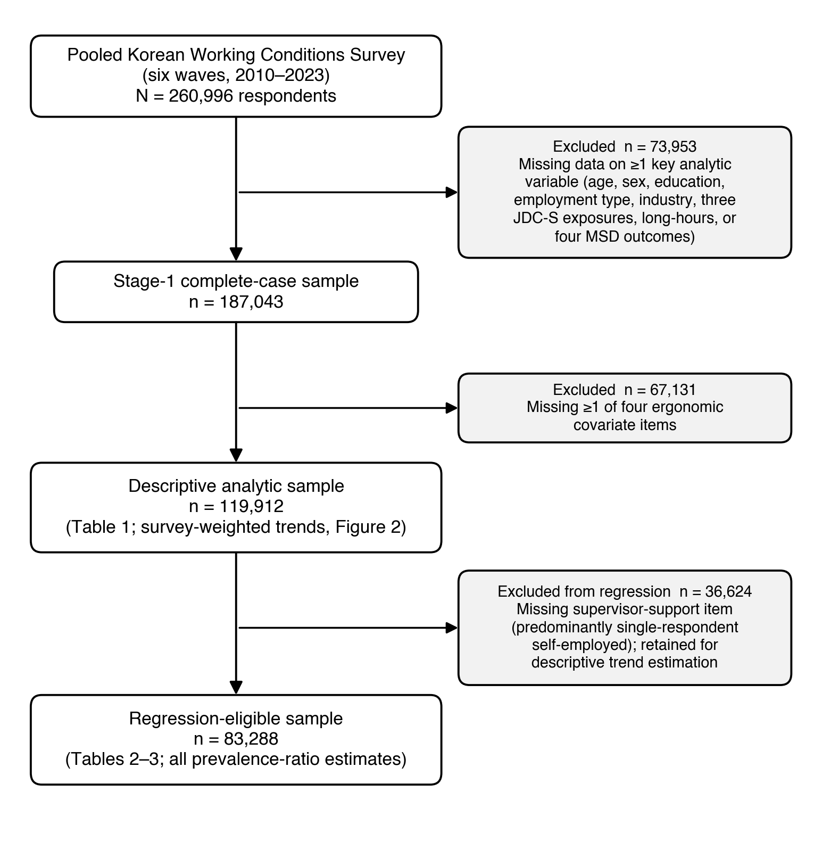
Figure S1. Flow of respondents through the two-stage complete-case exclusion. The descriptive analytic sample (n=119,912) underlies Table 1 and the survey-weighted trends in Fig. 2; the regression-eligible sample (n=83,288) underlies all prevalence-ratio estimates in Tables 2–3.

Table S1 Industry-stratified adjusted prevalence ratios for low decision latitude and any MSD
KSIC sector | n | Any-MSD, % | Adjusted PR (95% CI)* | p
Wholesale and retail trade (7) | 15,879 | 36.7 | 0.85 (0.81–0.89) | <0.0001
Manufacturing (3) | 12,325 | 37.3 | 0.83 (0.80–0.87) | <0.0001
Accommodation and food service (9) | 10,917 | 50.3 | 0.89 (0.85–0.93) | <0.0001
Human health and social work (17) | 7,096 | 43.0 | 0.81 (0.76–0.85) | <0.0001
Construction (6) | 5,695 | 46.0 | 0.91 (0.86–0.96) | 0.0002
MSD=musculoskeletal disorder. PR=prevalence ratio. KSIC=Korean Standard Industrial Classification. *Modified Poisson regression adjusted for age, sex, education, employment type, four ergonomic exposures, long working hours, and wave (corresponds to Fig. 4B). The inverse association holds within every one of the five largest sectors.
Table S2 Psychological-demand prevalence ratios in the original (non-reverse-coded) item orientation
Outcome | n | Adjusted PR (95% CI)* | p
Any MSD | 83,288 | 1.02 (1.01–1.02) | <0.0001
Back pain | 83,288 | 1.02 (1.01–1.02) | <0.0001
Upper limb | 83,288 | 1.03 (1.02–1.03) | <0.0001
Lower limb | 83,288 | 1.01 (1.00–1.01) | 0.077
*Identical Model A to Table 2 (modified Poisson regression, survey-weighted; adjusted for age, sex, education, employment type, four ergonomic exposures, long working hours, industry, and wave; n=83,288). Psychological demand is entered in its original orientation so that a per-unit increase denotes higher demand; the resulting prevalence ratios are the exact reciprocals of the reverse-coded estimates in Table 2 (PR>1 indicates higher MSD risk under higher demand), confirming identical inference. Autonomy and support estimates are unchanged from Table 2.
Table S3 Wave-specific unweighted descriptive statistics around the 2017 (W5) anomaly
Wave (year) | n | Any-MSD, %† | Female, % | Mean age, years | Long working hours, %
W4 (2014) | 24,146 | 50.1 | 50.6 | 47.8 | 34.0
W5 (2017) | 30,752 | 36.0 | 51.1 | 49.6 | 28.5
W6 (2020) | 21,164 | 48.7 | 51.0 | 49.8 | 20.7
†Unweighted prevalence in the descriptive sample (cf. survey-weighted estimates in Fig. 2). The 14-percentage-point drop in any-MSD prevalence at W5 (2017) is not explained by the modest demographic shift across waves; sensitivity analysis S5 excluding W5 confirmed persistence of the autonomy paradox (PR 0.87, 0.86–0.89).

Table S4 Interaction between decision latitude and ergonomic exposure (any MSD)
Quantity | Estimate | 95% CI | p
Multiplicative interaction (ratio of PRs) (modified Poisson, HC1) | 1.169 | 1.114–1.226 | <0.0001
RERI (additive interaction) (delta method) | 0.054 | 0.012–0.095
RERI (additive interaction) (parametric bootstrap 20k) | 0.054 | 0.011–0.095
Modified Poisson regression, adjusted as in the primary model. The multiplicative interaction is the ratio of prevalence ratios for the autonomy × ergonomic-exposure product term; RERI is the relative excess risk due to interaction, with 95% CIs by the delta method and by a 20,000-draw parametric bootstrap.

Table S5 Wave-stratified adjusted prevalence ratios for low decision latitude and any MSD
Wave (year) | n | Autonomy PR | 95% CI
W2 (2010) | 2,605 | 0.94 | 0.87–1.02
W3 (2011) | 15,701 | 0.92 | 0.89–0.96
W4 (2014) | 16,417 | 0.93 | 0.90–0.96
W5 (2017) | 22,137 | 0.76 | 0.73–0.80
W6 (2020) | 14,004 | 0.80 | 0.77–0.83
W7 (2023) | 12,424 | 0.80 | 0.77–0.83
Modified Poisson regression within each wave, adjusted for age, sex, education, employment type, four ergonomic exposures, long working hours, and industry. The autonomy × wave interaction was significant (p<0.0001).

Table S6 Missing-data sensitivity for the low-decision-latitude and any-MSD association
Analysis | n | Autonomy PR | 95% CI
Primary complete-case (support = colleague+supervisor) | 83,288 | 0.84 | 0.83–0.86
Support-omitted (retains support-missing self-employed) | 118,673 | 0.85 | 0.84–0.86
Multiple imputation of support (M=10, Rubin-pooled) | 118,673 | 0.85 | 0.84–0.86
The primary complete-case model drops workers with structurally undefined supervisor support (predominantly solo self-employed). A support-omitted model and multiple imputation (m=10, Rubin's rules) retain them (both n=118,673 vs 83,288 in the primary model); both reproduce the primary estimate.

