Training detail of ultrasound model
VGG-19 exceled in capturing intricate hierarchical features through its deep uniform architecture. ResNet-50 effectively mitigated vanishing gradient problems via its residual connections. DenseNet-121 maximized feature reuse and enhanced parameter efficiency through dense inter-layer connections. For the US-based deep learning model, all ultrasound images were preprocessed prior to model training. Specifically, images were resized to 224 × 224 pixels to match the input requirements of the backbone networks, and pixel intensities were normalized to the range [0, 1] using min-max normalization. To mitigate overfitting and enhance model generalization, online data augmentation was applied during training. Each deep learning model was initialized with ImageNet pre-trained weight. To prevent overfitting, we applied L2 weight regularization (decay = 1 × 10⁻⁴) and adopted an early stopping strategy, in which training was terminated if the validation loss did not decrease for 10 consecutive epochs. The maximum number of training epochs was set to 100. Hyperparameter tuning (including learning rate, batch size and weight decay) was performed using random search.

Training detail of MRI model
Prior to feature extraction from MRI images, standardized preprocessing was performed. All images were resampled to isotropic voxel size (1×1×1 mm³) using linear interpolation to eliminate spatial resolution discrepancies arising from different acquisition parameters. Gray-level discretization was then applied using a fixed bin width of 25 to map raw gray values into discrete integers, thereby reducing noise and registration errors. Then, we utilized pyradiomics (version 2.27) to extract image features from T1 MRI sequences. Subsequently, consistency assessment was performed, features with intraclass correlation coefficient (ICC) > 0.8 were selection. Then, these features were conducted using LASSO (Least Absolute Shrinkage and Selection Operator). Multiple machine learning algorithms were then applied and compared to build the MRI-based model. The machine algorithms included Random Forest (RF), Support Vector Machine (SVM), and XGBoost (XGB). For each machine learning algorithm, we conducted systematic hyperparameter tuning using random search combined with 5‑fold cross‑validation on the training set. For Random Forest, we optimized the number of trees (100–500), maximum depth (10–50), and minimum samples per leaf (1–10). For SVM, we tuned the regularization parameter C (0.1–10), kernel type (linear, RBF), and gamma (scale, auto). For XGBoost, we optimized the learning rate (0.01–0.3), maximum depth (3–10), subsample ratio (0.6–1.0), and number of boosting rounds (100–1000).

Table S1: Performance of multimodal model in internal test set
Metric | Value | 95% CI
AUC | 0.802 | 0.689 - 0.901
Accuracy | 0.829 | 0.757 - 0.901
Specificity | 0.833 | 0.75 - 0.908
Sensitivity | 0.815 | 0.652 - 0.957
Precision | 0.611 | 0.436 - 0.767
F1 Score | 0.698 | 0.549 - 0.817
PPV | 0.611 | 0.45 - 0.765
NPV | 0.933 | 0.868 - 0.986
PLR | 4.889 | 3.206 - 9.565
NLR | 0.222 | 0.057 - 0.419
Cohen’s Kappa | 0.582 | 0.395 - 0.736
MCC | 0.594 | 0.427 - 0.742
DOR | 22 | 8.421 - 110.5
Youden’s J | 0.648 | 0.483 - 0.803
Brier Score | 0.162 | 0.12 - 0.21
Balanced Accuracy | 0.824 | 0.733 - 0.904
Note:
AUC = Area Under Curve; PPV = Positive Predictive Value; NPV = Negative Predictive Value; PLR = Positive Likelihood Ratio; NLR = Negative Likelihood Ratio; MCC = Matthews Correlation Coefficient; DOR = Diagnostic Odds Ratio; CI = Confidence interval.

Table S2: Performance of multimodal model in external test set
Metric | Value | 95% CI
AUC | 0.797 | 0.689 - 0.888
Accuracy | 0.806 | 0.731 - 0.880
Specificity | 0.825 | 0.733 - 0.909
Sensitivity | 0.75 | 0.600 - 0.909
Precision | 0.6 | 0.432 - 0.756
F1 Score | 0.667 | 0.516 - 0.800
PPV | 0.6 | 0.438 - 0.760
NPV | 0.904 | 0.829 - 0.968
PLR | 4.286 | 2.724 - 7.950
NLR | 0.303 | 0.126 - 0.537
Cohen’s Kappa | 0.532 | 0.358 - 0.700
MCC | 0.538 | 0.350 - 0.704
DOR | 14.143 | 5.606 - 55.00
Youden’s J | 0.575 | 0.393 - 0.745
Brier Score | 0.174 | 0.135 - 0.217
Balanced Accuracy | 0.788 | 0.692 - 0.876
Note:
AUC = Area Under Curve; PPV = Positive Predictive Value; NPV = Negative Predictive Value; PLR = Positive Likelihood Ratio; NLR = Negative Likelihood Ratio; MCC = Matthews Correlation Coefficient; DOR = Diagnostic Odds Ratio; CI = Confidence interval.

Supplementary figures:
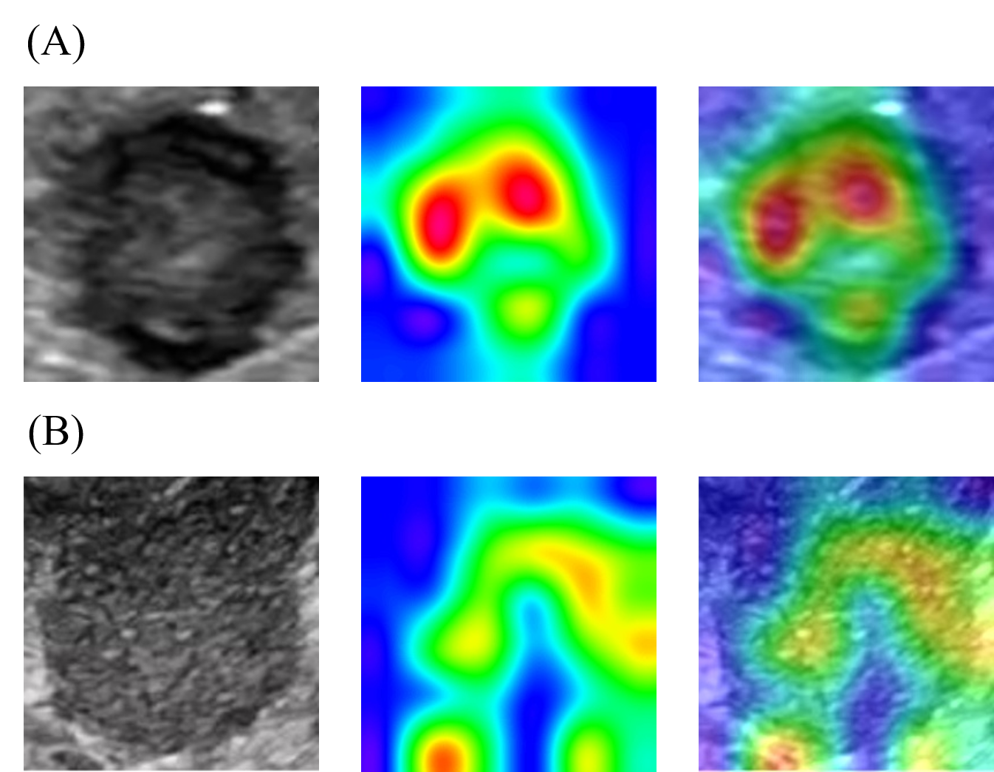
Figure S1: The class activation heatmap reflected the regions of attention of the US‑based model.
(A) For cases predicted as positive by the model, the attention regions were relatively concentrated and focused on the central area of the tumor.
(B) For cases predicted as negative, the attention regions were dispersed and relatively focused on the tumor margin.
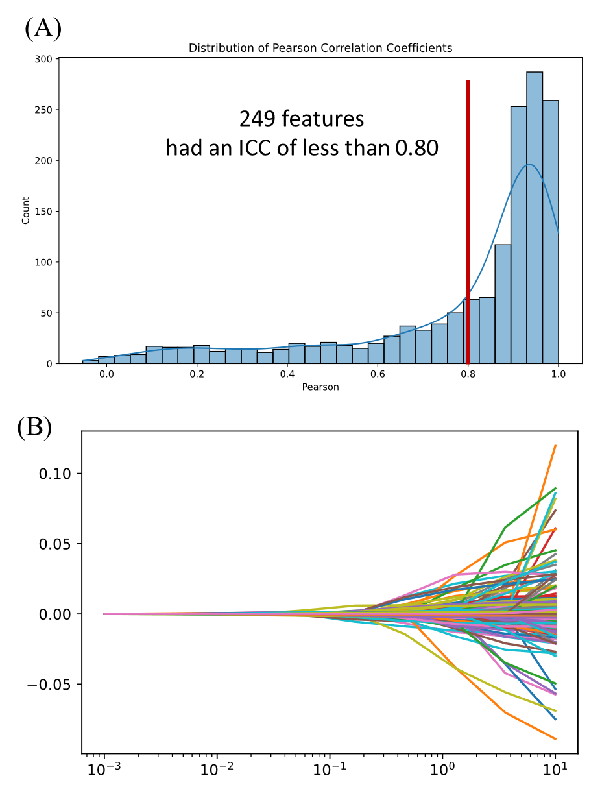
Figure S2: Consistency and feature selection of MRI-based model
(A) We conducted a consistency assessment on the MRI features extracted by pyradiomics, and the features with an ICC greater than 0.8 were included in the screening. (B) The features were screened using LASSO and were used to establish the MRI model.

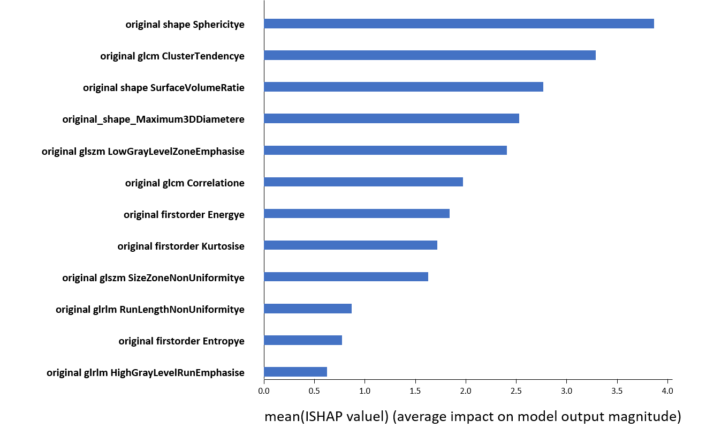
Figure S3: SHAP plot reflected the contributions of 12 radiomic features in the MRI-based model

