Supporting Information

Extended Cognitive Recovery in Down Syndrome Mice
via Sustained Release of AM404 from microPLates

Corinne Portioli¹, Denise Murgia¹, Raffaele Spanò¹, Stefania Mamberti¹, Bianca Martins Estevão¹, Greta Avancini¹, Sine Bertozzi², Andrea Armirotti², Laura Cancedda^{3*} and Paolo Decuzzi^{1,4 *}

¹ Laboratory of Nanotechnology for Precision Medicine, Italian Institute of Technology, Via Morego 30, 16163, Genoa, Italy.
² Analytical Chemistry Facility, Italian Institute of Technology, Via Morego 30, 16163, Genoa, Italy.
³ Laboratory of Brain Development and Disease, Italian Institute of Technology, Via Morego 30, 16163, Genoa, Italy.
⁴ School of Medicine/Division of Oncology, Center for Clinical Sciences Research, Stanford University, 269 Campus Drive, Stanford, CA 94305 - USA

* Sharing senior authorship

Corresponding author: Paolo Decuzzi, PhD; paolo.decuzzi@iit.it

Supporting Results and Figures
Dimensional characterization of PLGA-μPL. The average size and size distribution of PLGA-μPL were systematically assessed using Multisizer Coulter counter system.

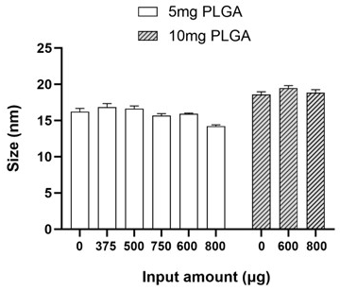
Supporting Figure 1. Dimensional characterization of PLGA-μPL. The average size of the particles obtained with Multisizer measurement is plotted for the different preparations: empty particles, AM404 (5 mg-PLGA with 375 μg-AM404, 500 μg-AM404, or 750 μg-AM404; and 10 mg-PLGA with 600 μg-AM404 or 800 μg-AM404). Bars represent the average of at least three different replicates ± SEM. One-way ANOVA followed by Šídák's multiple comparisons test gives non-significant results.

Degradation of PLGA-μPL. Biodegradation of PLGA-μPL was assessed via scanning electron microscopy at different time points and under different conditions.

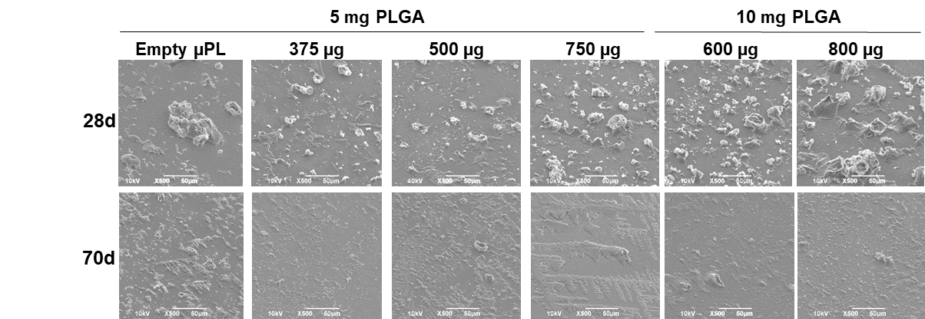
Supporting Figure 2. Degradation of PLGA-μPL at 28 and 70 days. Representative SEM images at lower magnification (X500) were collected from samples incubated for 28 days and 70 days in PBS, consisting of 5 mg-PLGA μPL configurations, either empty or loaded with input amounts of AM404 (375 μg, 500 μg, 750 μg), and 10 mg-PLGA μPL configurations, AM404-loaded with input amounts of 600 μg or 800 μg.

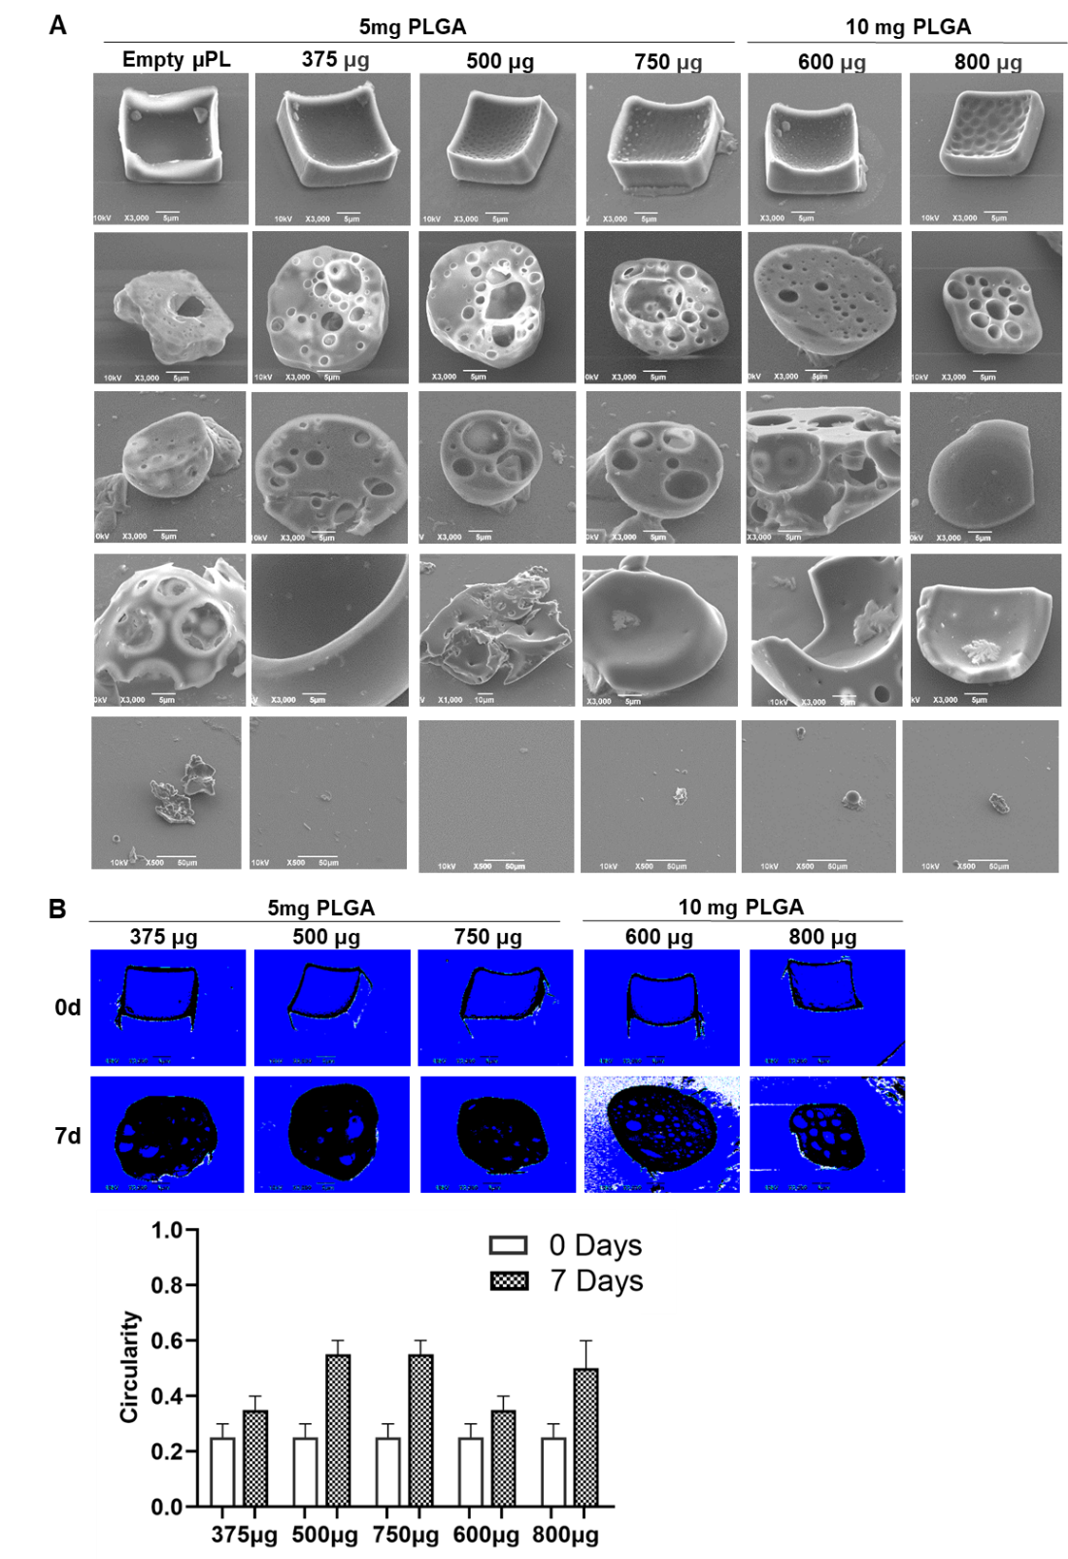
Supporting Figure 3. Degradation of PLGA-μPL in DI water. A. Representative SEM images of 5 mg PLGA μPL configurations, either empty or loaded with the specified amounts of AM404 (375 μg, 500 μg, 750 μg), as well as 10 mg PLGA μPL configurations, empty or loaded with AM404 amounts (600 μg, 800 μg), are displayed after 4 weeks in water. B. Representative images were utilized to calculate the circularity, along with a plot showing all preparations and the circularity values ranging from 0 to 1, where 1 indicates a perfect circle.

Morphological changes of μPL happened slowly under physiological conditions but occurred rapidly in water. Regarding multisizer Coulter counter analyses (Supporting Figure 4), with time, we observed the curves become flatter with a peak moving towards larger characteristic sizes until complete degradation occurred, manifested by the appearance of microscopic and submicroscopic debris (i.e., peak moved to the left). The initial increase in particle characteristic size is likely connected to structural alterations and possible particle aggregation. The reduction in peak value is associated with an overall decrease in particle count. Throughout all μPL configurations, we noticed a slight increase in size up to 14 days before sharply decreasing after day 21. This trend was especially pronounced for the 10 mg PLGA configurations, which exhibited broader peaks even at day 0 and produced larger peaks at larger sizes (~ 35 μm) at 14 days for the AM404 600 μg configuration or larger peaks at smaller sizes (~ 5 μm) at 21 days for the AM404 800 μg configuration. In contrast, the 5 mg PLGA configurations displayed similar particle degradation from day 0 to day 21 in the Multisizer counter. Notably, the AM404 500 μg configuration yielded the highest peak at day 0, signaling a more effective polymer-drug combination. Measurements at subsequent time points proved unfeasible due to morphological changes in μPL that rendered the samples unsuitable for analysis. The degradation of PLGA μPL is vital, especially in drug-loaded particles. The degradation of the polymer matrix influences drug delivery and correlates directly with drug release kinetics.
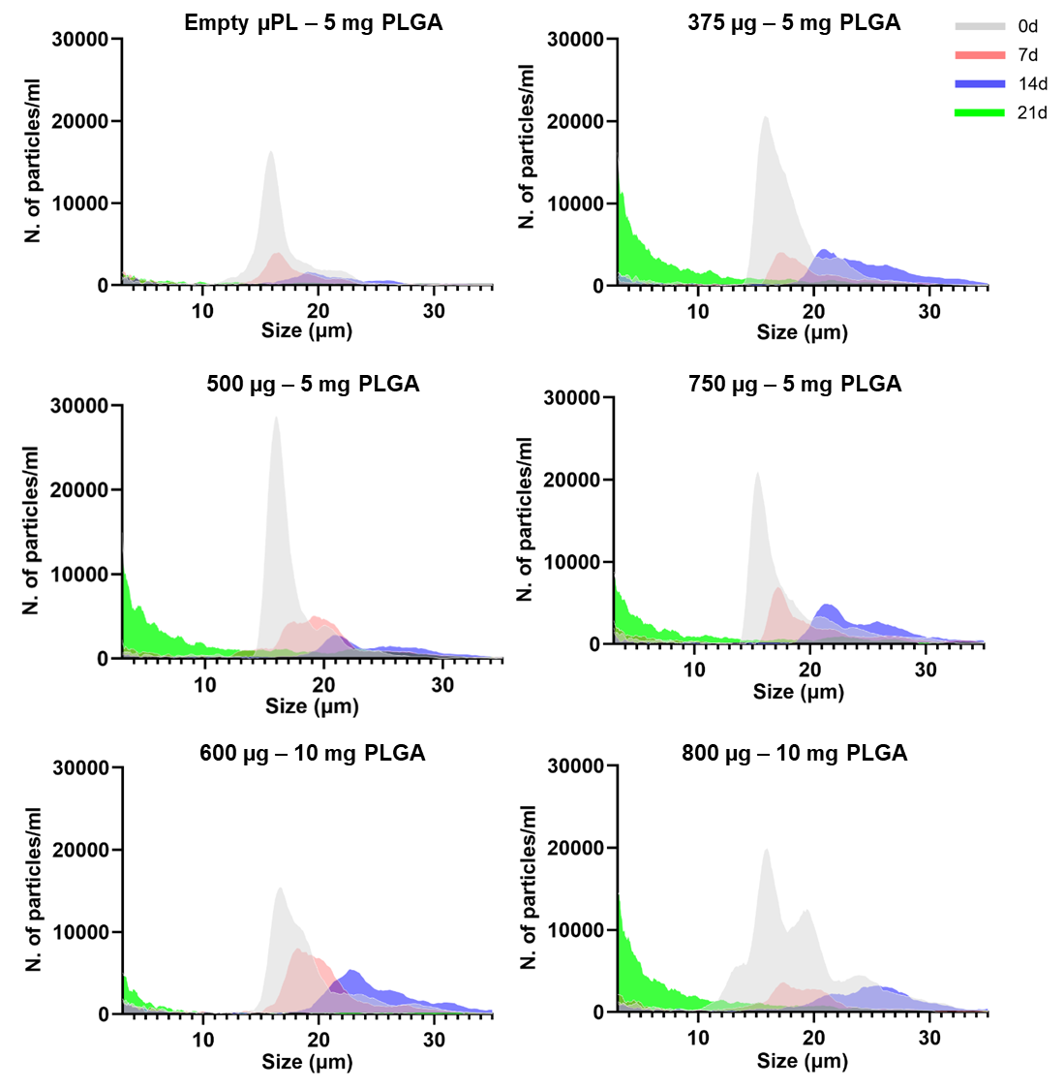
Supporting Figure 4. Multisizer analysis of PLGA-μPL over time incubated in DI water. Representation of multisizer analysis for 5 mg-PLGA μPL configurations, either empty or AM404-loaded with input amounts of 375 μg, 500 μg, or 750 μg, and 10 mg-PLGA μPL configurations, AM404-loaded with input amounts of 600 μg or 800 μg, observed over a period of up to 21 days in water.
Quantification of AM404 loading in PLGA-μPL. Liquid chromatography was employed to assess the loading of AM404 into PLGA-μPL.
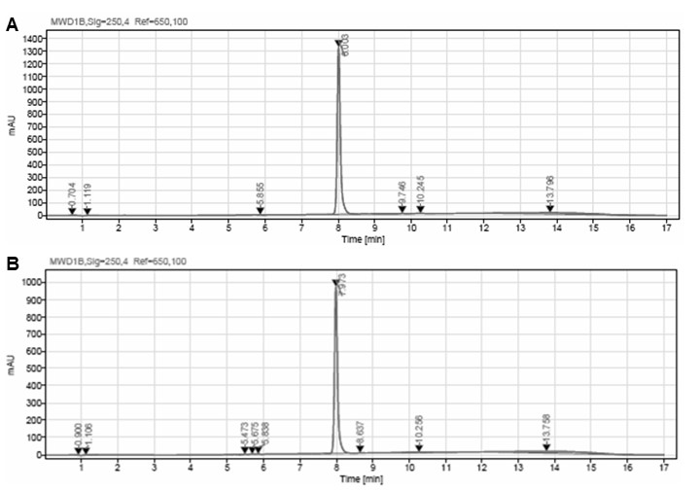
Supporting Figure 5. Quantification of AM404 loading in PLGA-μPL. Representative HPLC detection plots from μPL configurations: A. 500 μg AM404-5 mg PLGA configuration and B. 800 μg AM404-5 mg PLGA configuration.

Release of AM404 from PLGA-μPL. Liquid chromatography was employed to quantify the release of AM404 from PLGA-μPL. The resulting release kinetics were fitted with a standard Korsmeyer-Peppas model.

Loading of AM404 decreased with higher PLGA content, with release observed for 70 days from 5 mg PLGA configurations.
The Korsmeyer-Peppas model equation is Q_{t}/Q∞ = Kt^{n}, where Q_{t}/Q∞ represents the fraction of drug permeated, t is the time, Q_{t} is the amount of drug released at time t, Q∞ is the total amount of drug, K is the release rate constant, and n is the diffusional exponent or drug release exponent. This model describes drug release from polymeric systems and is particularly useful for understanding the release mechanism (Fickian or non-Fickian). We observed the highest coefficient of determination (R² ≈ 0.95) for the 500 μg formulation, whereas the fit was slightly lower for the other doses (Supporting Figure 6C). This may be attributed to the release kinetics of the 500 μg configuration being more consistent with the assumptions underlying the model, such as a well-defined diffusion process through a polymeric matrix, compared to the more variable or overlapping mechanisms potentially occurring at lower or higher loadings. In the Korsmeyer–Peppas model, n plays a critical role in elucidating the underlying drug release mechanism, as both the structural characteristics and the geometry of the delivery system influence it. When modeling the μPL as cylindrical structures, the n value can be interpreted as follows: for n ≈ 0.45, the release follows a Fickian diffusion mechanism, where concentration gradients primarily drive drug transport; for 0.45 < n < 0.89, the release is governed by non-Fickian (anomalous) transport, indicating a combination of diffusion and other mechanisms such as polymer swelling or degradation; for n > 0.89, the system exhibits a case II or super case II transport, typically involving swelling-controlled release with possible polymer relaxation phenomena. In our study, n was found to be approximately 0.5 for the 375 μg and 500 μg configurations, indicating a quasi-Fickian or borderline anomalous diffusion mechanism, where diffusion remains the dominant process, with minor contributions from matrix relaxation or degradation. In contrast, for the 750 μg configuration, we obtained an n value closer to 0.45, suggesting a more purely Fickian diffusion profile (Supporting Figure 6C). This may reflect the higher drug loading leading to a more compact matrix structure or reduced swelling, thus favoring diffusion-driven release.
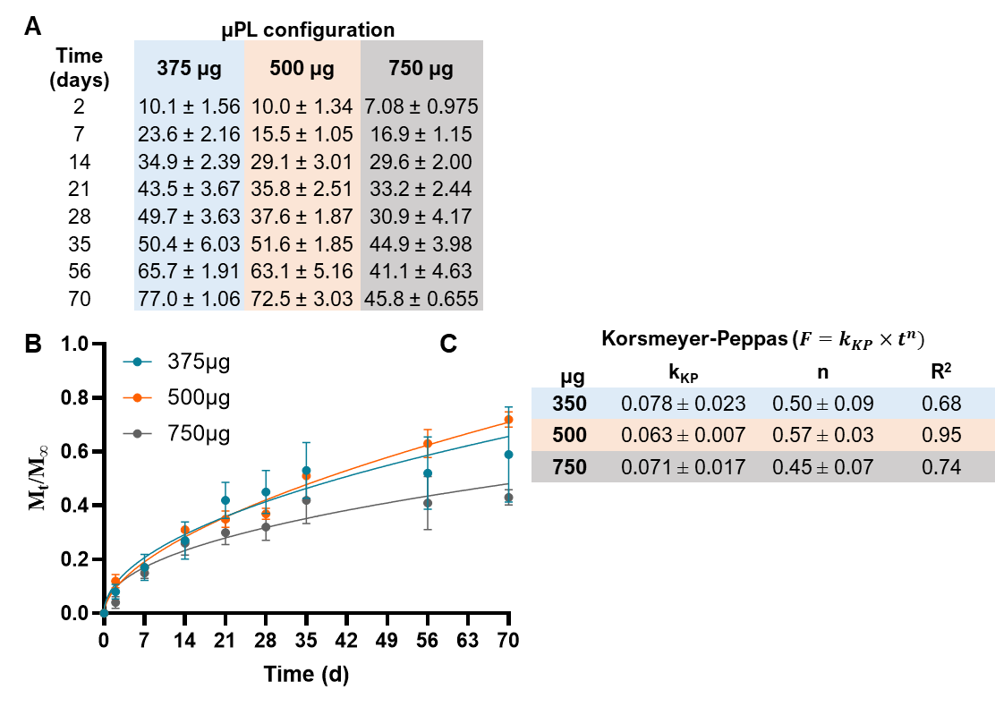
Supporting Figure 6. Drug release values and kinetics for PLGA-μPL. A. Each system's average value is depicted versus the time (days) ± SEM of at least three replicates. B. Experimental data (colored dots) are fitted to Korsmeyer-Peppas (dashed lines) up to 60% of drug release. C. Values of the fitting parameters for the release kinetic model of Korsmeyer-Peppas. Mt/M∞ equals the fraction of released drug within the time t; k_{KP} is the release constant based on the drug-dosage form's structural characteristics (here considered cylinders); n is the diffusional exponent indicating the drug-release mechanisms. Results are presented as the average ± SD (n = 6).

Therapeutic efficacy of AM404 in DS mice. The therapeutic efficacy of free AM404 and a single AM404-μPL administration in Dp(16) mice was assessed via NOR and compared to vehicle.
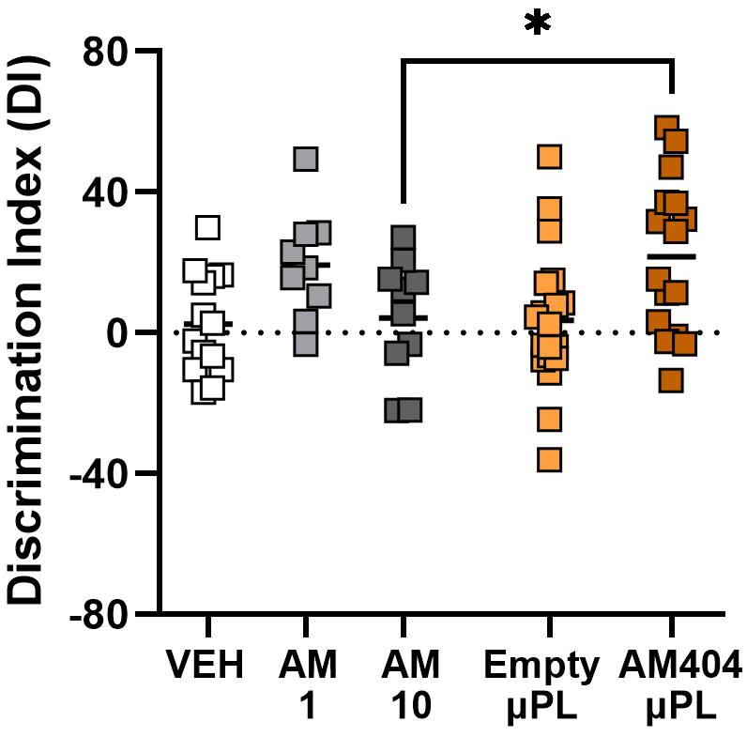
Supporting Figure 7. Therapeutic efficacy of vehicle, free AM404, and a single AM404-μPL administration in Dp(16) mice. Evaluation of three injections of free AM404 (1 mg/kg – AM 1 or 10 mg/kg – AM 10) or vehicle (VEH) at P20-P22 and a single injection of AM404-loaded μPL at P20 in Dp(16) mice. The discrimination index (DI), after performing NOR test at P22, was determined. Bars indicate the average DI of all analyzed mice ± SEM, while symbols represent individual data points for each animal (Unpaired t test: *p=0.0434 AM 10 vs. AM404-μPL).

