Graphical Abstract
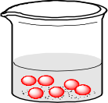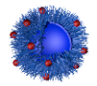
AlO₄³⁻
OP
WP-2
OP
WP-2
W/O emulsion
W/O/W emulsion
Transport of reverse micelles
Formation of hollow structure
WP-2
AACH
Calcine
Reverse micelles
WP-1
Al₂O₃
Added into
AsO₄³⁻ solution
Al₂O₃
AsO₄³⁻

CLH-Al₂O₃ nano-adsorbent was prepared by a facile double reversed-phase microemulsion method. As the ions diffuse through the oil layer and encounter counteracting ions in the second aqueous phase, they will precipitate along the spherical interface and form AACH nanospheres, the precursor calcined to yield CLH-Al₂O₃ NSs, the target product Al₂O₃ nano-adsorbent. The removal of As(V) by CLH-Al₂O₃ adsorption is driven by hydroxyl complexation and ion exchange mechanisms, enhanced through hierarchical porosity.

