Framework-stabilized multistage transition in antiferroelectric ceramics for high-energy storage
Xing Zhao^{1, †}, Yan Yan^{1, †, *}, Xiaonan Kang^{1, †}, Haoyu Wang¹, Qing Li², Yang Li³, Chao Sun⁴, Kun Yu¹, Quan Li¹, Leiyang Zhang³, Li Jin³, Jiwei Zhai⁴, Mao-Hua Zhang^{2 *}, Gang Liu^{1 *}, Ke Wang⁵
1 Southwest Mountain Regions Intelligent Agricultural Machinery Equipment Innovation Center, School of Materials and Energy, Southwest University, Chongqing, 400715, China
2 Wuzhen Laboratory, Jiaxing, 314500, China
3 Electronic Materials Research Laboratory, Key Laboratory of the Ministry of Education &International Center for Dielectric Research, School of Electronic Science and Engineering, Xi’an Jiaotong University, Xi’an, 710049, China
4 Key Laboratory of Advanced Civil Engineering Materials of Ministry of Education, Functional Materials Research Laboratory, School of Materials Science and Engineering, Tongji University, Shanghai, 201804, China
5 State Key Laboratory of New Ceramics and Fine Processing, School of Materials Science and Engineering, Tsinghua University, Beijing,100084, China

*Corresponding author to yanyan2013@swu.edu.cn (Y. Y.); zhangmh@wuzhenlab.com (M. H.)
liugang13@swu.edu.cn (G. L.)
† These authors contributed equally to this work

Finite Simulation
To investigate the dielectric breakdown behavior of ceramics, finite-element simulations were performed using COMSOL Multiphysics to resolve the electric potential distribution and the dynamic evolution of electrical treeing. A two-dimensional simulation domain was reconstructed directly from representative SEM images, in which the selected region reflects the average grain morphology of the ceramic. The extracted microstructure was scaled to a width-to-height ratio of 3:4 and further processed using CAD software to ensure geometric fidelity for numerical implementation. Under an applied electric field, electrical tree branches preferentially nucleate at regions of enhanced local electric-field intensity, typically associated with geometric singularities, and subsequently propagate along grain boundaries and domain interfaces. Progressive growth of these conductive paths toward the opposite electrode ultimately signifies dielectric breakdown of the ceramic. To quantitatively evaluate the degree of breakdown damage, a scalar damage factor, η, ranging from 0 to 1 was introduced. Here, η = 1 corresponds to an intact, undamaged state, whereas η = 0 represents complete dielectric failure. The governing equations describing the electrostatic field and damage evolution are provided in Equations (1)-(4):
$$\begin{aligned}\frac{∂}{∂x_{i}}\left[ε\left(η\right)\frac{∂ϕ}{∂x_{i}}\right]=0\#\left(1\right)\end{aligned}$$
$$\begin{aligned}\frac{1}{m}\frac{∂s}{∂t}=\frac{ε^{'}\left(η\right)}{2}{\left(\frac{∂ϕ}{∂x_{i}}\right)}^{2}+\frac{Γ}{l^{2}}f^{2}\left(η\right)+\frac{Γ}{2}\frac{∂^{2}η}{∂^{2}x_{i}}\#\left(2\right)\end{aligned}$$
$$\begin{aligned}ε\left(η\right)=\frac{ε_{ini}}{f\left(η\right)+u}\#\left(3\right)\end{aligned}$$
$$\begin{aligned}ε_{ini}=\left\{\begin{aligned}\frac{ε_{g}}{{\left(1+k{\left(\frac{∂ϕ}{∂x_{i}}\right)}^{2}\right)}^{\frac{1}{3}}} \\ ε_{gb}\end{aligned}\right.\#\left(4\right)\end{aligned}$$
Among them, ε_{g}​ and ε_{gb}​ represent the dielectric constants of the grains and grain boundaries, respectively, as determined from the initial-state dielectric temperature spectrum; k = 0.01; u = 0.001; f(η)=4η³-3η⁴; Γ is associated with the breakdown energy, with a predefined ratio of Γ_{g} : Γ_{gb} = 1/10. The mobility parameter m governs the propagation speed of the breakdown process, while L, known as the regularization length, determines the width of the transition region between fully damaged and undamaged states in the phase-field order parameter. In the breakdown simulation, quadratic Lagrange interpolation is applied to the electric potential ϕ(x,t), while linear Lagrange interpolation is used for the damage parameter η(x,t). By controlling the evolution of time t, the dynamic behavior of the externally applied electric field is effectively introduced.

Supplementary Fig. 1 Bipolar hysteresis loop of a ZS0, b ZS15, c ZS30, d ZS35, e ZS40 and f ZS45 at room temperature.

Supplementary Fig. 2 Differential of PL(ZS)_{x}T P with respect to E as a function of electric field. a ZS15, b ZS30, c ZS35 and d ZS40.

Supplementary Fig. 3 The unipolar polarization hysteresis loops of ZS0. Evolution of unipolar P-E loop of ZS0 under 18 kV cm⁻¹, 24 kV cm⁻¹, 32 kV cm⁻¹, and 34 kV cm⁻¹ electric field.

Supplementary Fig. 4 Rietveld refinement of the high-energy XRD pattern of the ZS0 sample using the Pbam structural model. a Full pattern, magnified views of b representative superlattice reflections and c-d high-angle main reflections.

Supplementary Fig. 5 Rietveld refinement of the high-energy XRD pattern of the ZS45 sample using the Pbam structural model. a Full pattern, magnified views of b representative superlattice reflections and c-d high-angle main reflections.

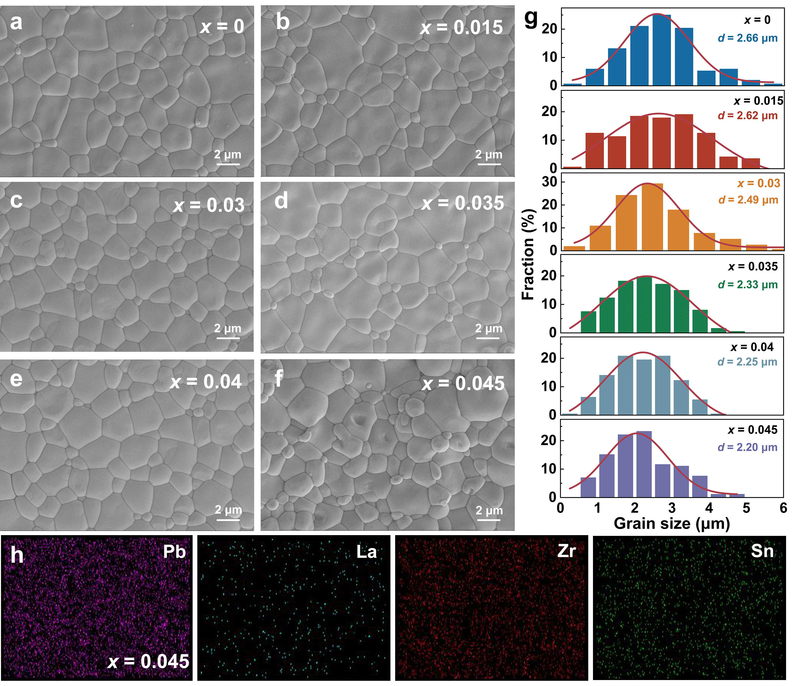
Supplementary Fig. 6 SEM morphology, grain size statistics and element distribution maps of PL(ZS)_{x}T ceramics. SEM morphology of a ZS0, b ZS15, c ZS30, d ZS35, e ZS40, and f ZS45 ceramics. g Grain size statistics of ZS0-45 ceramics. h Element distribution maps of ZS45 ceramics.

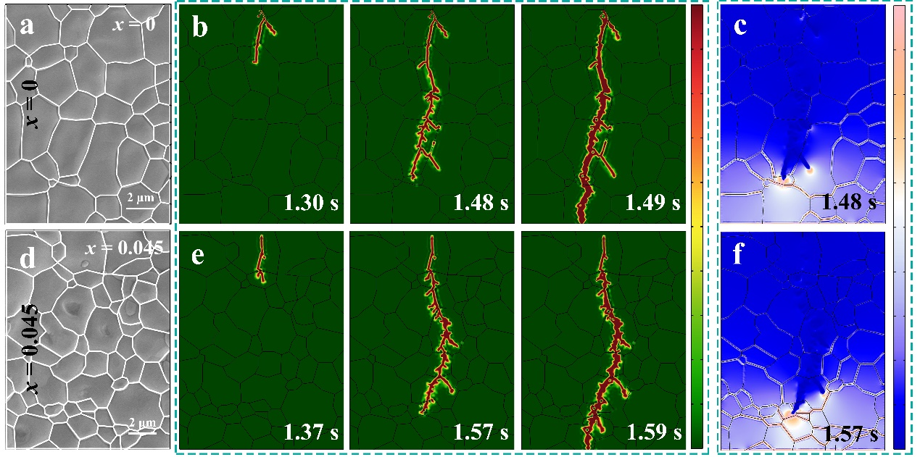
Supplementary Fig. 7 Breakdown simulation of ZS0 and ZS45 ceramics. SEM images used for extracting two-dimensional models a ZS0 and d ZS45. Phase-field simulation of an electrical tree evolution for b ZS0 and e ZS45. Electric field distribution for c ZS0 and f ZS45 ceramics.

Supplementary Fig. 8 Dielectric performance of PL(ZS)_{x}T ceramics. Dielectric constant and tanδ as a function of temperature for a ZS0, b ZS15, c ZS30, d ZS35 and e ZS40 ceramics.

Supplementary Fig. 9 In situ XRD and Raman spectra testing of ZS45 ceramic. a XRD pattern and b Raman spectra with temperature variation.

Supplementary Table 1
Figure | Reference
Fig. 1f | ¹⁻³⁴
Fig. 1i | 1-3,5-9,11,14,17,22,23,26,27,30,32

Supplementary Table 2
Sample | Phase | Element | x | y | z | fraction | Uiso
ZS0 | O | Pb(1)+2 | 0.722879 | 0.129297 | 0 | 0.98 | 0.03853
ZS0 | O | Pb(2)+2 | 0.741365 | 0.12166 | 0.5 | 0.98 | 0.0188
ZS0 | O | La(1)+3 | 0.722879 | 0.129297 | 0 | 0.02 | 0.06353
ZS0 | O | La(2)+3 | 0.741365 | 0.12166 | 0.5 | 0.02 | 0.04738
ZS0 | O | Zr+4 | 0.229892 | 0.120982 | 0.251543 | 0.6 | 0
ZS0 | O | Sn+4 | 0.24916 | 0.127508 | 0.243941 | 0.4 | 0
ZS0 | O | O(1)-2 | 0.299537 | 0.15864 | 0 | 1 | 0.00216
ZS0 | O | O(2)-2 | 0.185222 | 0.14248 | 0.5 | 1 | 0.00216
ZS0 | O | O(3)-2 | 0.08075 | 0.14832 | 0.231165 | 1 | 0.00216
ZS0 | O | O(4)-2 | 0 | 0.5 | 0.247393 | 1 | 0.00216
ZS0 | O | O(5)-2 | 0 | 0 | 0.186477 | 1 | 0.00216
ZS45 | O | Pb(1)+2 | 0.719388 | 0.126508 | 0 | 0.98 | 0.02605
ZS45 | O | Pb(2)+2 | 0.722549 | 0.125088 | 0.5 | 0.98 | 0.01791
ZS45 | O | La(1)+3 | 0.719388 | 0.126508 | 0 | 0.02 | 0.05105
ZS45 | O | La(2)+3 | 0.722549 | 0.125088 | 0.5 | 0.02 | 0.04291
ZS45 | O | Zr+4 | 0.243628 | 0.125581 | 0.249048 | 0.6 | 0
ZS45 | O | Sn+4 | 0.235454 | 0.123091 | 0.247689 | 0.4 | 0
ZS45 | O | O(1)-2 | 0.295181 | 0.064838 | 0 | 1 | 0.0015
ZS45 | O | O(2)-2 | 0.249219 | 0.131597 | 0.5 | 1 | 0.0015
ZS45 | O | O(3)-2 | 0.059482 | 0.260808 | 0.218031 | 1 | 0.0015
ZS45 | O | O(4)-2 | 0 | 0.5 | 0.204647 | 1 | 0.0015
ZS45 | O | O(5)-2 | 0 | 0 | 0.216281 | 1 | 0.0015

Sample | R_{wp} (%) | R_{P}  (%) | Phase | Space  group | a[Å] | b[Å] | c[Å]
ZS0 | 2.76 | 1.97 | O | Pbam | 5.817626 | 11.634752 | 8.213701
ZS45 | 2.83 | 1.98 | O | Pbam | 5.829927 | 11.659741 | 8.217455

Supplementary References
1 Guo, J. et al. Achieving Excellent Energy Storage Properties in Fine‐Grain High‐Entropy Relaxor Ferroelectric Ceramics. Advanced Electronic Materials 8 (2022).
2 Hu, J. et al. Achieving exceptional energy storage performance in PbHfO₃ antiferroelectric ceramics through defect engineering design. Mater Horiz (2025).
3 Liu, X., Yang, T. & Gong, W. Achieving ultrahigh energy-storage capability in PbZrO₃-based antiferroelectric capacitors based on optimization of property parameters. Journal of Materials Chemistry A 10, 4137-4145 (2022).
4 Yan, F. et al. Boosting Energy Storage Performance of Lead-Free Ceramics via Layered Structure Optimization Strategy. Small 18, e2202575 (2022).
5 Yan, F. et al. Composition and Structure Optimized BiFeO₃ -SrTiO₃ Lead-Free Ceramics with Ultrahigh Energy Storage Performance. Small 18, e2106515 (2022).
6 Jiang, S. et al. Delayed phase switching field and improved capacitive energy storage in Ca²⁺-modified (Pb,La)(Zr,Sn)O₃ antiferroelectric ceramics. Scripta Materialia 235, 115602 (2023).
7 Zhou, Y. et al. Design of antiferroelectric polarization configuration for ultrahigh capacitive energy storage via increasing entropy. Nat Commun 16 (2025).
8 Li, C. J., Yao, M. W. & Yao, X. An effective strategy for enhancing energy storage density in (Pb_{1-1.5x}Gd_{x})(Zr_{0.87}Sn_{0.12}Ti_{0.01})O₃ antiferroelectric ceramics. Journal of Materials Chemistry A 11, 18689-18701 (2023).
9 Zhou, J. et al. Excellent energy storage performance of lead-based antiferroelectric ceramics via enhancing dielectric breakdown mechanism. Chem Eng J 487, 150476 (2024).
10 Chai, Q. et al. Excellent energy storage properties in lead-free ferroelectric ceramics via heterogeneous structure design. Nat Commun 16, 1633 (2025).
11 Yang, J. et al. Field-induced strain engineering to optimize antiferroelectric ceramics in breakdown strength and energy storage performance. Acta Materialia 257, 119186 (2023).
12 Yan, F. et al. Gradient-Structured Ceramics with High Energy Storage Performance and Excellent Stability. Small 19, e2206125 (2023).
13 Kong, X. et al. High-entropy engineered BaTiO₃-based ceramic capacitors with greatly enhanced high-temperature energy storage performance. Nat Commun 16, 885 (2025).
14 Li, D. et al. A high-temperature performing and near-zero energy loss lead-free ceramic capacitor. Energ Environ Sci 16, 4511-4521 (2023).
15 Li, J., Li, F., Xu, Z. & Zhang, S. Multilayer Lead-Free Ceramic Capacitors with Ultrahigh Energy Density and Efficiency. Adv Mater 30, e1802155 (2018).
16 Yan, F. et al. Optimization of polarization and electric field of bismuth ferrite-based ceramics for capacitor applications. Chem Eng J 417 (2021).
17 Li, C., Yao, M., Yang, T. & Yao, X. Optimizing energy storage performance of lead zirconate-based antiferroelectric ceramics by a phase modulation strategy. Chem Eng J 497, 154913 (2024).
18 Ge, G. et al. Optimizing the energy storage properties of antiferroelectric ceramics by modulating the phase structure via constructing a novel binary composite. Journal of Materials Chemistry A 9, 11291-11299 (2021).
19 Yan, F. et al. Realizing superior energy storage properties in lead-free ceramics via a macro-structure design strategy. Journal of Materials Chemistry A 8, 11656-11664 (2020).
20 Yan, F. et al. Sandwich structured lead-free ceramics based on Bi_{0.5}Na_{0.5}TiO₃ for high energy storage. Chem Eng J 425 (2021).
21 Yan, F. et al. Significantly enhanced energy storage density and efficiency of BNT-based perovskite ceramics via A-site defect engineering. Energy Storage Mater 30, 392-400 (2020).
22 Wu, S. Y. et al. Superb Energy Storage Capability for NaNbO₃-Based Ceramics Featuring Labyrinthine Submicro-Domains with Clustered Lattice Distortions. Small 19, 2303915 (2023).
23 Li, S. et al. Superior energy storage and discharge performance achieved in PbHfO₃-based antiferroelectric ceramics. Journal of Applied Physics 135 (2024).
24 Yan, F. et al. Superior energy storage properties and excellent stability achieved in environment-friendly ferroelectrics via composition design strategy. Nano Energy 75 (2020).
25 Ge, G. L. et al. Synergistic optimization of antiferroelectric ceramics with superior energy storage properties via phase structure engineering. Energy Storage Mater 35, 114-121 (2021).
26 Liu, J. et al. A synergistic two-step optimization design enables high capacitive energy storage in lead-free Sr_{0.7}Bi_{0.2}TiO₃-based relaxor ferroelectric ceramics. Journal of Materials Chemistry A 11, 609-620 (2023).
27 Yan, F. et al. Tape‐Casting Lead‐Free Dielectrics Permit Superior Capacitive Energy Storage Performance. Advanced Energy Materials 15 (2024).
28 Ge, G. et al. Tunable Domain Switching Features of Incommensurate Antiferroelectric Ceramics Realizing Excellent Energy Storage Properties. Advanced Materials 34, 2201333 (2022).
29 Liu, X., Zhao, Y., Sun, N., Li, Y. & Hao, X. Ultra-high energy density induced by diversified enhancement effects in (Pb_{0.98−x}La_{0.02}Ca_{x})(Zr_{0.7}Sn_{0.3})_{0.995}O₃ antiferroelectric multilayer ceramic capacitors. Chem Eng J 417, 128032 (2021).
30 Yan, F. et al. Ultrahigh Energy Storage Density and Efficiency of Lead-Free Dielectrics with Sandwich Structure. Small 20, e2306803 (2024).
31 Zhang, M. et al. Ultrahigh energy storage in high-entropy ceramic capacitors with polymorphic relaxor phase. Science 384, 185-189 (2024).
32 Liu, X., Li, Y. & Hao, X. Ultra-high energy-storage density and fast discharge speed of (Pb_{0.98−x}La_{0.02}Sr_{x})(Zr_{0.9}Sn_{0.1})_{0.995}O₃ antiferroelectric ceramics prepared via the tape-casting method. Journal of Materials Chemistry A 7, 11858-11866 (2019).
33 Wang, H., Liu, Y., Yang, T. & Zhang, S. Ultrahigh Energy‐Storage Density in Antiferroelectric Ceramics with Field‐Induced Multiphase Transitions. Adv Funct Mater 29, 1807321 (2019).
34 Zhang, L. et al. Ultra‐Weak Polarization‐Strain Coupling Effect Boosts Capacitive Energy Storage. Advanced Materials 36, 2406219 (2024).

