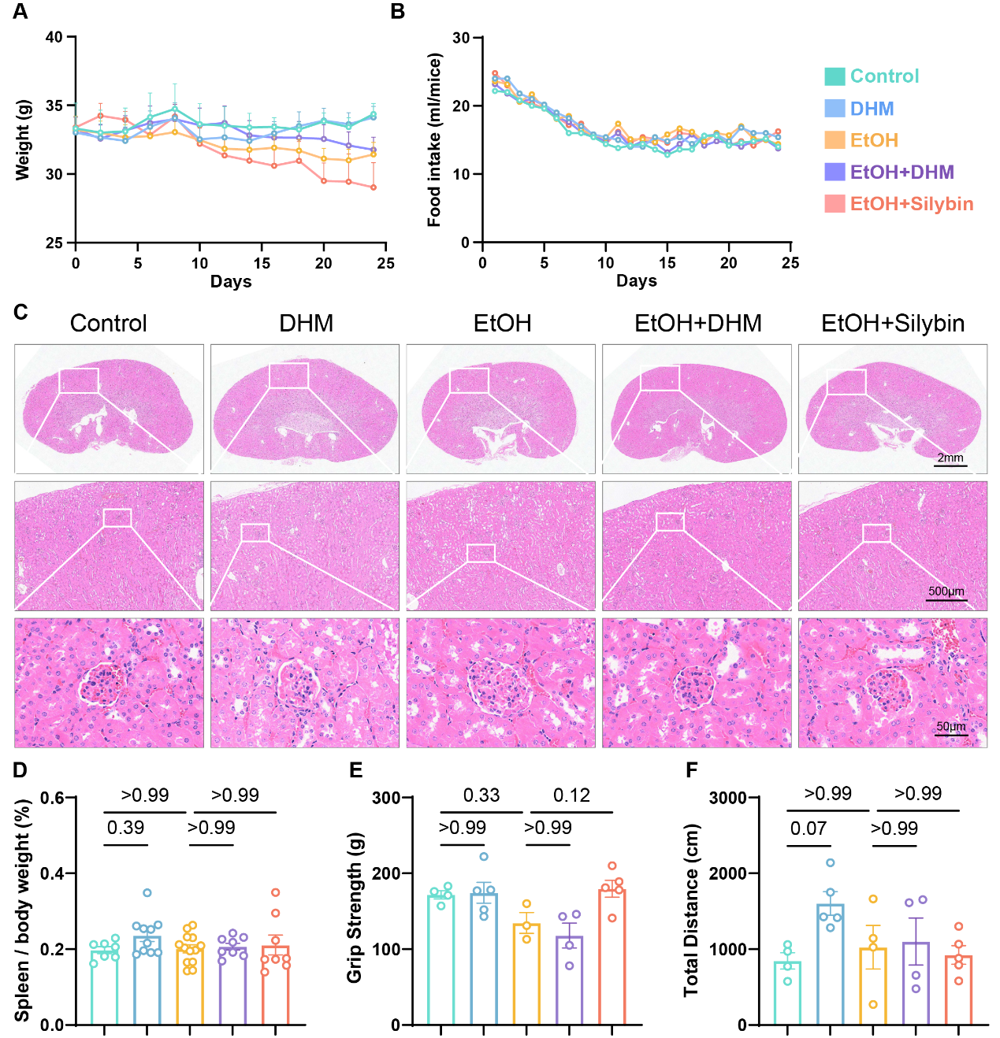
Supplementary Figure 1. Supplementary physiological, behavioral and safety-related assessments in middle-aged alcohol-fed mice. (A,B) Dynamic monitoring of body weight (A) and food intake (B) during the experimental period. (C) Representative H&E staining images of kidney sections across groups to evaluate potential systemic toxicity. Scale bars are indicated in the images. (D) Spleen/body weight ratio at the endpoint. (E,F) Assessment of physical performance and locomotor activity, including grip strength (E) and total distance in the open-field test (F). Data are presented as mean ± SEM. Statistical significance was evaluated using one-way ANOVA followed by the Bonferroni post hoc test for selected comparisons.
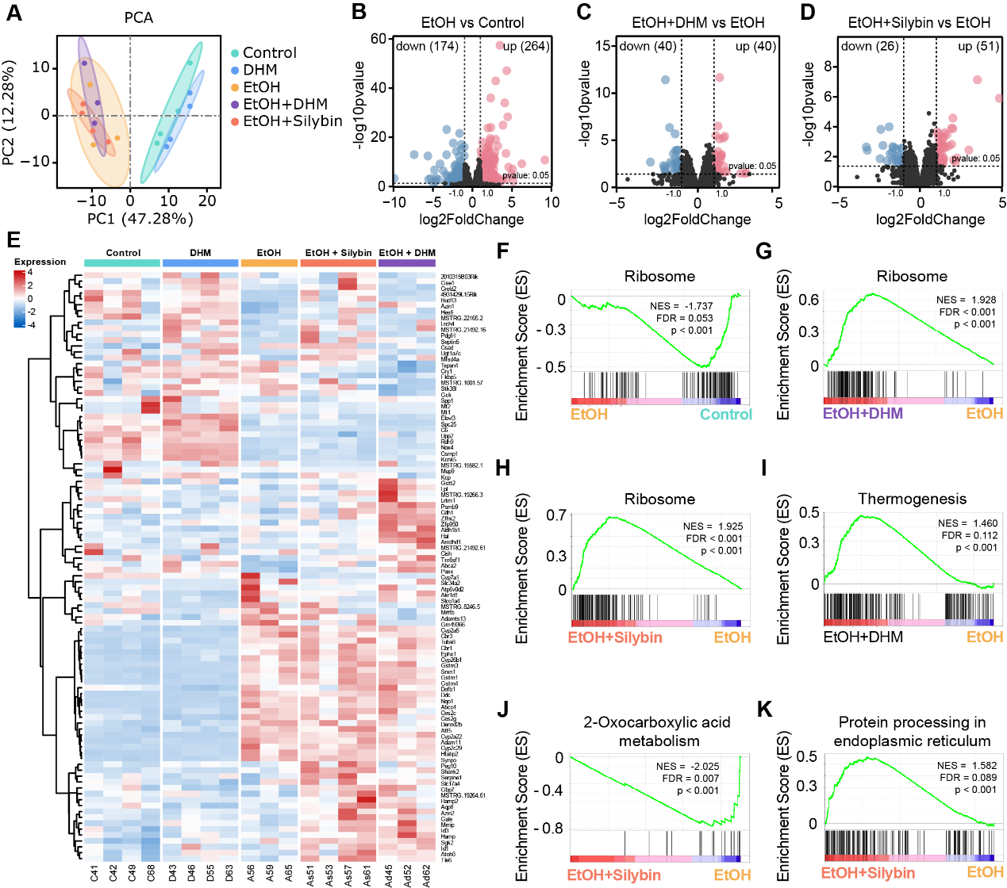
Supplementary Figure 2. Global hepatic transcriptomic landscape and shared recovery of protein translation. (A) Principal component analysis (PCA) plot of liver transcriptomes across Control, DHM, EtOH, EtOH+Silybin and EtOH+DHM groups. (B–D) Volcano plots showing DEGs for EtOH vs. Control (B), EtOH+DHM vs. EtOH (C) and EtOH+Silybin vs. EtOH (D). Numbers of upregulated (red) and downregulated (blue) genes are indicated. (E) Hierarchical clustering heatmap of top DEGs across all experimental groups, showing global expression patterns. (F–H) GSEA plots highlighting ribosome-related pathway changes. Alcohol exposure was associated with negative enrichment of the ribosome pathway (F), whereas DHM (G) and Silybin (H) showed positive enrichment of this pathway. (I–K) Additional GSEA plots for selected pathways: DHM upregulated thermogenesis (I), whereas Silybin downregulated 2-oxocarboxylic acid metabolism (J) and upregulated protein processing in the endoplasmic reticulum (K). NES, normalized enrichment score; FDR, false discovery rate.
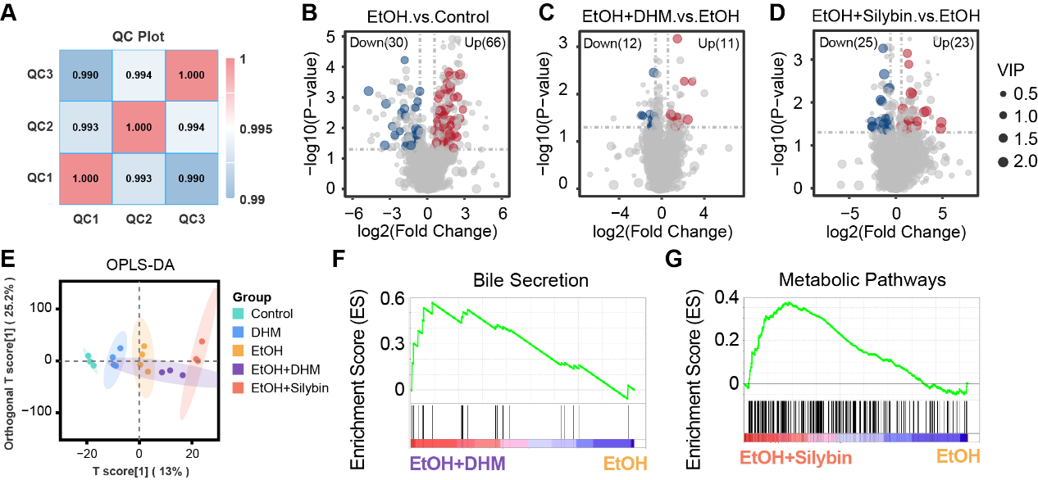
Supplementary Figure 3. Quality control and differential metabolite screening for serum metabolomics. (A) Quality control (QC) correlation plot showing high reproducibility among QC samples (r > 0.99). (B–D) Volcano plots for EtOH vs. Control (B), EtOH+DHM vs. EtOH (C) and EtOH+Silybin vs. EtOH (D). Red and blue dots represent metabolites increased or decreased in the first group of each comparison, respectively (VIP > 1.0, P < 0.05). (E) Orthogonal projections to latent structures-discriminant analysis (OPLS-DA) score plot showing distinct metabolic separation between groups. (F,G) Gene set enrichment analysis (GSEA) for metabolomics data. DHM intervention enriched the bile secretion pathway (F), whereas Silybin was associated with broader metabolic pathways (G).
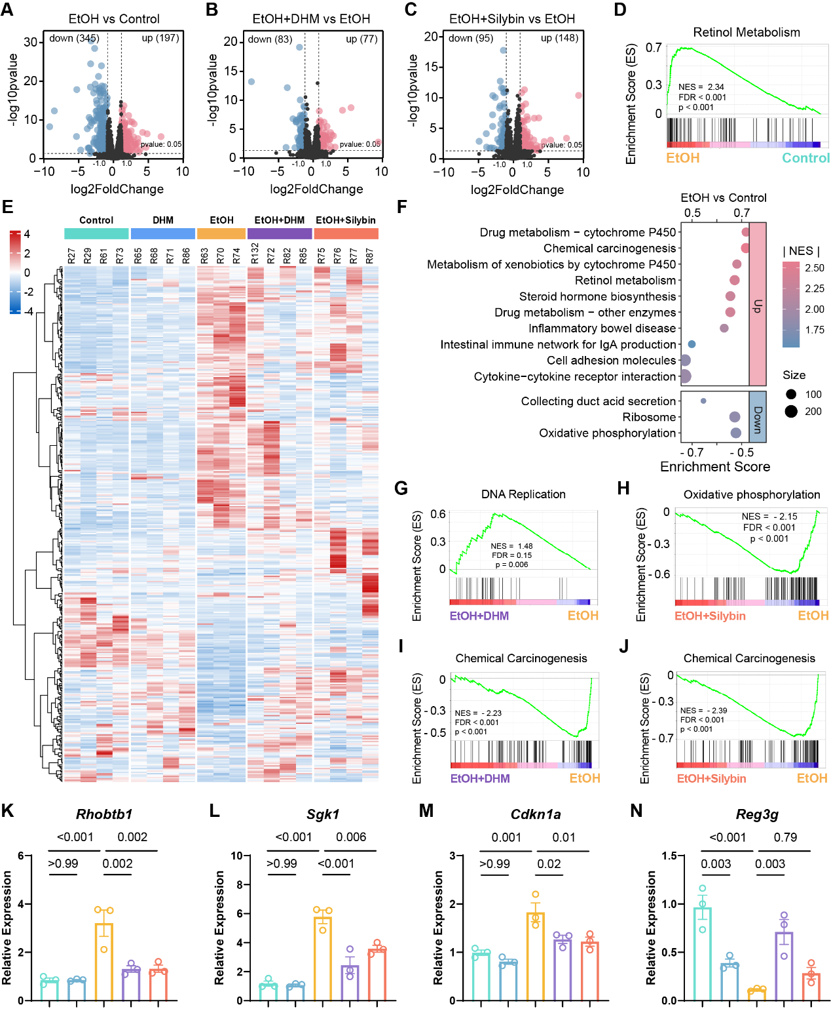
Supplementary Figure 4. Supplementary jejunal transcriptomic analyses associated with Figure 5. (A–C) Volcano plots showing differentially expressed genes in EtOH vs. Control (A), EtOH+DHM vs. EtOH (B) and EtOH+Silybin vs. EtOH (C) comparisons. (D) GSEA showing enrichment of the retinol metabolism pathway in the EtOH group compared with the Control group. (E) Global heatmap of jejunal transcriptomic profiles across all experimental groups. (F) KEGG enrichment analysis of differentially expressed genes in the EtOH vs. Control comparison. (G,H) GSEA showing enrichment of the DNA replication pathway in the EtOH+DHM group (G) and suppression of the oxidative phosphorylation pathway in the EtOH+Silybin group (H), compared with the EtOH group. (I,J) GSEA showing suppression of the chemical carcinogenesis pathway in the EtOH+DHM group (I) and EtOH+Silybin group (J), compared with the EtOH group. Differentially expressed genes were identified based on P-value and fold-change thresholds as described in Methods. NES, normalized enrichment score; FDR, false discovery rate. (K–N) Relative mRNA expression of selected genes, including Rhobtb1 (K), Sgk1 (L), Cdkn1a (M), and Reg3g (N), was measured by quantitative real-time PCR in the mouse jejunal tissues. Data are presented as mean ± SEM. Statistical significance was evaluated using one-way ANOVA followed by the Bonferroni post hoc test for selected comparisons. Exact P-values are indicated in the figures.

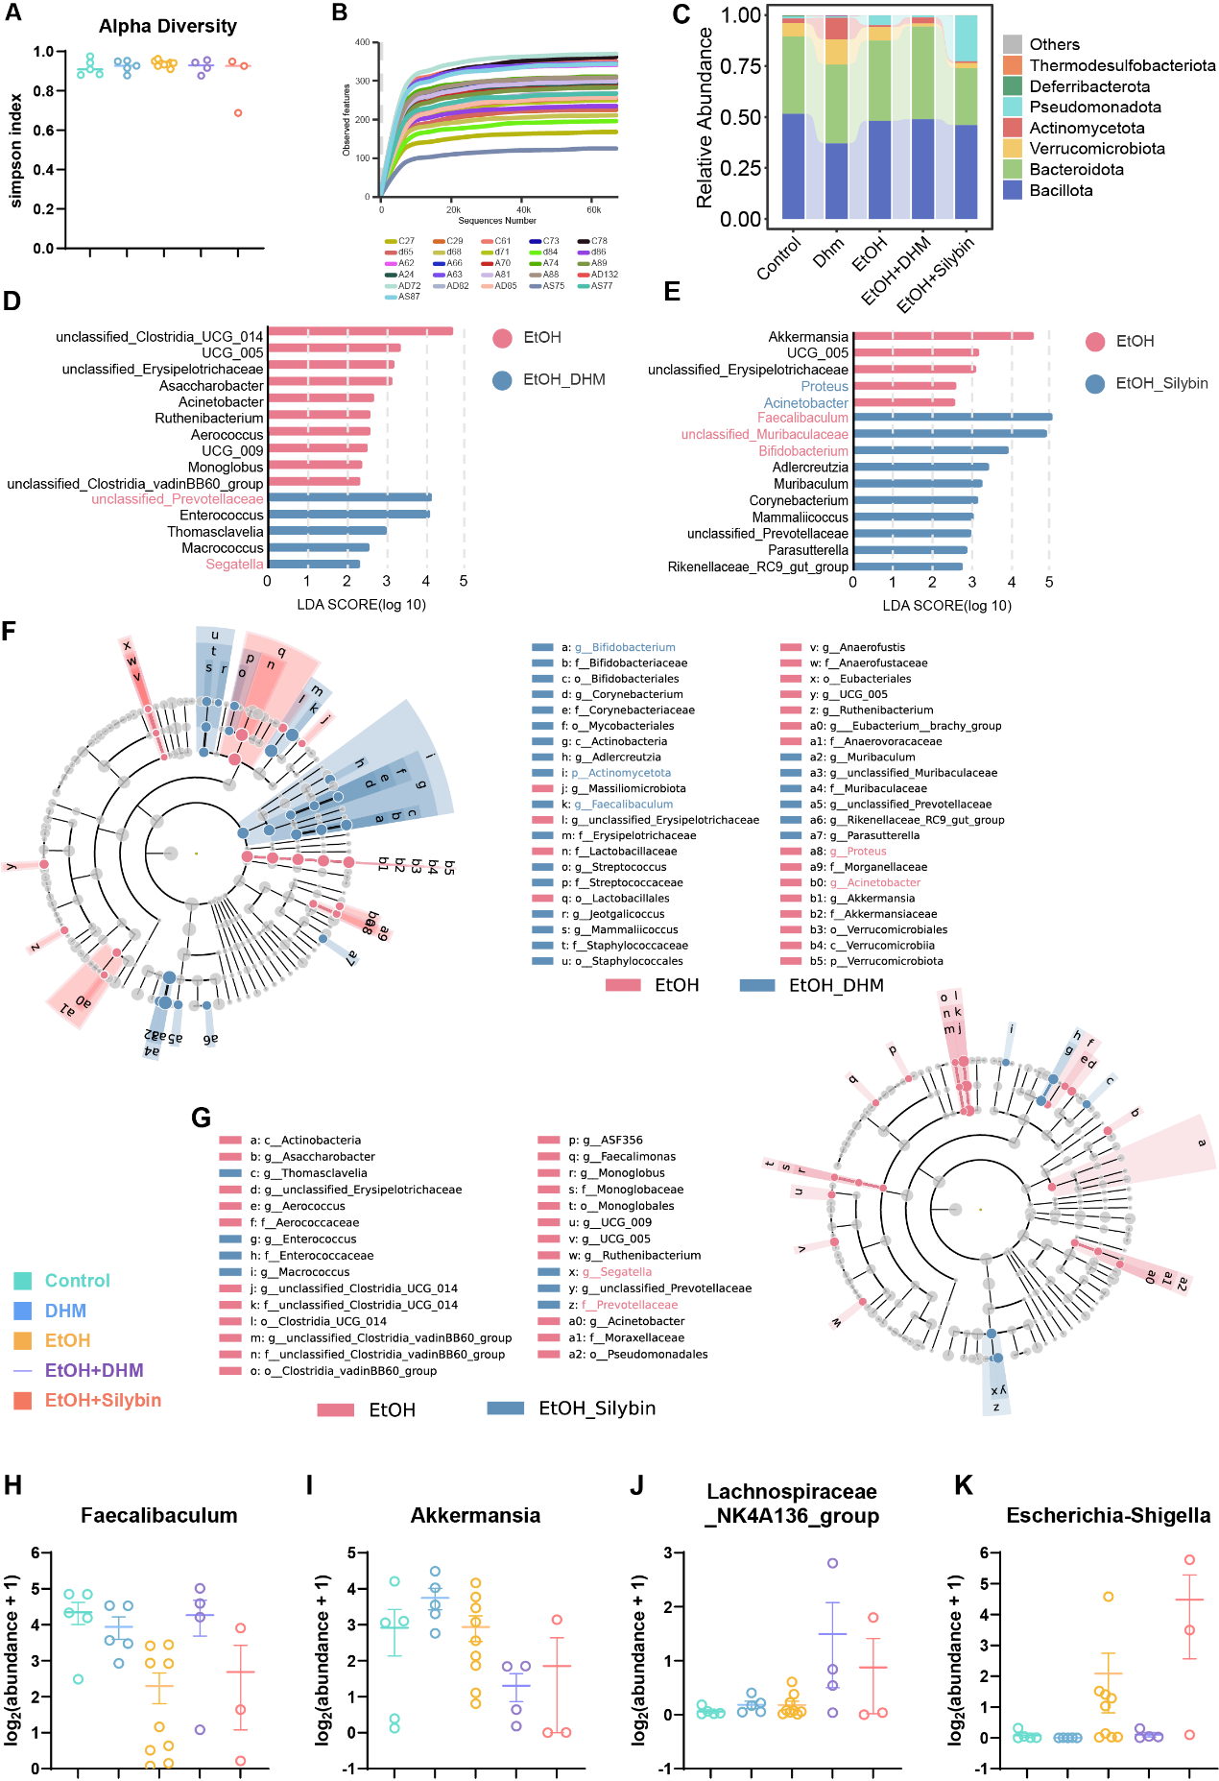
Supplementary Figure 5. Supplementary microbiome profiling, LEfSe analysis and key genus-level abundance patterns in middle-aged alcohol-fed mice. (A,B) Simpson alpha diversity (A) and rarefaction curves (B). (C) Phylum-level microbial composition across groups. (D,E) LEfSe analysis identifying discriminative bacterial taxa between EtOH+DHM vs. EtOH (D) and EtOH+Silybin vs. EtOH (E). Taxa with LDA score > 2 are displayed. Red bars indicate taxa enriched in EtOH groups, whereas blue bars indicate taxa enriched after intervention. (F,G) Cladograms showing phylogenetic distributions of differentially enriched microbial taxa identified by LEfSe in DHM-treated (F) and Silybin-treated (G) mice relative to EtOH controls. Differentially enriched clades are highlighted according to group-specific abundance patterns. (H–K) Log-transformed relative abundance of selected genera, including Faecalibaculum (H), Akkermansia (I), Lachnospiraceae_NK4A136_group (J) and Escherichia-Shigella (K). Data are presented as mean ± SEM.

