Supplementary Information
Lumbar Vacuum Phenotypes in Degenerative Spondylolisthesis: Distinct Instability Signatures of Intradiscal and Facet Joint Gas
Xianyi Zhang, QiRui Zhu, Tianci Fang, Jie Shang, Lei Liu, Guizhu Ji, Ziwei Xia, Youdi Xue, Hengcai Zhou, Meng Han, Chao Ma
Supplementary Fig. S1. Disc and facet structural degeneration across VP phenotypes.
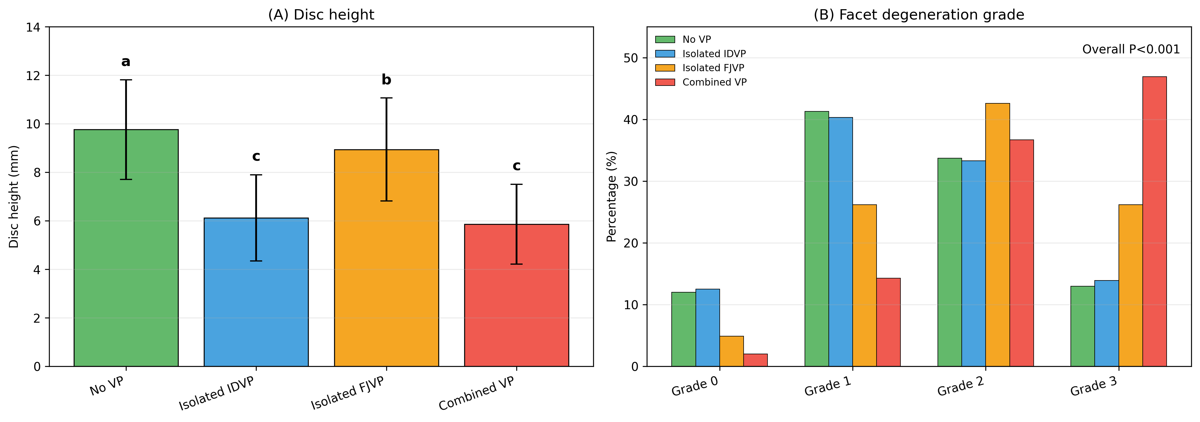
(A) Disc height comparison among four VP phenotypes. Bars sharing the same letter are not significantly different after adjustment for multiple comparisons (adjusted P>0.05). (B) Facet degeneration grade distribution among four VP phenotypes. Error bars represent standard deviations. Between-group comparisons were performed using one-way ANOVA or chi-square tests, with Tukey/Bonferroni adjustment for pairwise comparisons where appropriate.
Supplementary Fig. S2. Dynamic stabilizer and posterior element changes across VP phenotypes.
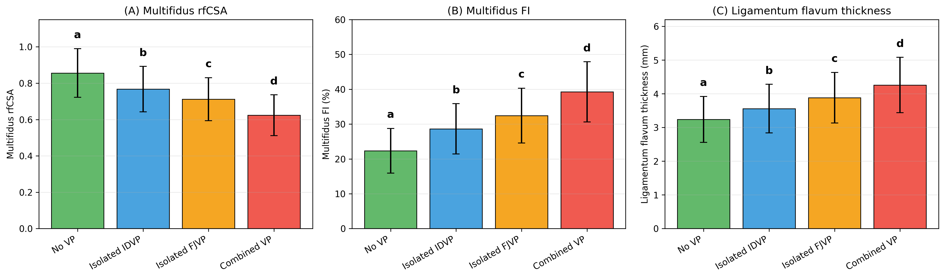
(A) Multifidus relative functional cross-sectional area (rfCSA) comparison. (B) Multifidus fatty infiltration (FI) comparison. (C) Ligamentum flavum thickness comparison. Error bars represent standard deviations. Bars sharing the same letter are not significantly different after Tukey/Bonferroni post hoc adjustment (adjusted P>0.05).
Supplementary Fig. S3. Radiographic instability parameters across VP phenotypes.
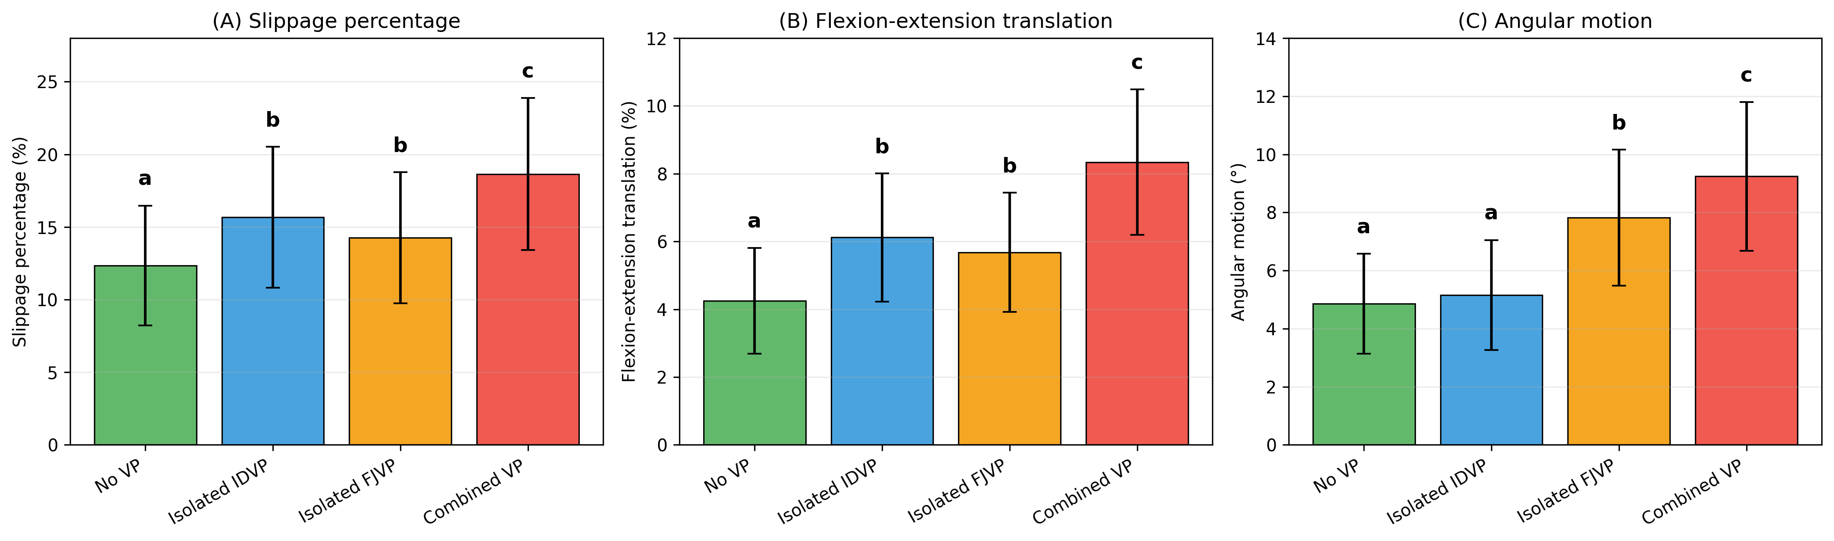
(A) Slippage percentage comparison. (B) Flexion-extension translation comparison. (C) Angular motion comparison, expressed in degrees. Error bars represent standard deviations. Bars sharing the same letter are not significantly different after Tukey/Bonferroni post hoc adjustment (adjusted P>0.05).
Supplementary Table S1. Univariable logistic regression analyses for IDVP and FJVP.
BMI, body mass index; BMD, bone mineral density; CI, confidence interval; FI, fatty infiltration; FJVP, facet joint vacuum phenomenon; IDVP, intradiscal vacuum phenomenon; OR, odds ratio; PI, pelvic incidence; PMI, psoas muscle index; rfCSA, relative functional cross-sectional area.
Variable | IDVP OR (95% CI) | IDVP P value | FJVP OR (95% CI) | FJVP P value
Age (per 5-year increase) | 1.189 (1.023-1.382) | 0.024 | 1.256 (1.078-1.463) | 0.003
Female sex | 1.112 (0.723-1.712) | 0.628 | 1.098 (0.702-1.715) | 0.685
BMI (per 1 kg/m² increase) | 1.089 (1.012-1.172) | 0.023 | 1.156 (1.072-1.247) | <0.001
Disease duration (per 12 months) | 1.045 (0.978-1.117) | 0.189 | 1.034 (0.965-1.108) | 0.324
BMD T-score (per 1 SD decrease) | 1.156 (0.923-1.447) | 0.206 | 1.123 (0.895-1.409) | 0.318
Diabetes mellitus | 1.234 (0.689-2.212) | 0.478 | 1.256 (0.695-2.269) | 0.448
Smoking history | 0.987 (0.578-1.685) | 0.962 | 1.123 (0.654-1.928) | 0.678
Disc height (per 1 mm decrease) | 3.876 (2.654-5.662) | <0.001 | 1.567 (1.098-2.237) | 0.013
Pfirrmann grade (per grade increase) | 2.567 (1.876-3.512) | <0.001 | 1.567 (1.145-2.143) | 0.005
Facet degeneration grade (per grade increase) | 1.456 (1.123-1.889) | 0.005 | 3.245 (2.345-4.492) | <0.001
Moderate/severe facet effusion | 1.678 (1.123-2.509) | 0.012 | 5.234 (3.721-7.362) | <0.001
Slippage percentage (per 5% increase) | 1.876 (1.365-2.578) | <0.001 | 1.567 (1.134-2.165) | 0.006
Flexion-extension translation (per 2% increase) | 1.567 (1.234-1.990) | <0.001 | 1.678 (1.312-2.147) | <0.001
Angular motion (per 2° increase) | 1.567 (1.165-2.109) | 0.003 | 2.876 (2.056-4.023) | <0.001
Multifidus rfCSA (per 0.1 decrease) | 1.567 (1.123-2.187) | 0.008 | 2.234 (1.587-3.147) | <0.001
Multifidus FI (per 5% increase) | 1.456 (1.234-1.718) | <0.001 | 1.789 (1.456-2.198) | <0.001
Goutallier grade (per grade increase) | 1.456 (1.165-1.820) | 0.001 | 1.876 (1.487-2.367) | <0.001
PMI (per 1 cm²/m² decrease) | 1.123 (0.923-1.367) | 0.245 | 1.089 (0.892-1.329) | 0.412
Ligamentum flavum thickness (per 1 mm increase) | 1.567 (1.165-2.109) | 0.003 | 1.876 (1.387-2.537) | <0.001
Lumbar lordosis (per 5° decrease) | 1.123 (0.923-1.367) | 0.245 | 1.056 (0.867-1.287) | 0.578
Pelvic incidence (per 5° increase) | 1.056 (0.876-1.273) | 0.567 | 1.034 (0.856-1.249) | 0.734
PI-LL mismatch (per 5° increase) | 1.345 (1.098-1.648) | 0.005 | 1.234 (1.005-1.515) | 0.045

