Supplementary Information
Evaluating Potentials of Coal-gangue-derived Building Materials Utilization in China: based on GCAM with Multi-dimensional Corrections

Contents
S1. GCAM 8.2 Module Specifications
S2. Provincial Empirical Composition Database
S3. Module Interface Specifications and Mathematical Formulation
S4. Iterative Soft-Linking Algorithm Details
S5. Parameter Sensitivity Analysis
S6. Technology Learning Curves
S7. Environmental Accounting
S8. Cross-Model Specifications
S9. Cross-Model Complete Time Series
S10. Policy Scenario Results
S11. Cross-Model Consistency Metrics
S12. Supplementary Figures

S1. GCAM 8.2 Module Specifications

S1.1 Model Architecture
GCAM v8.2 is a global market equilibrium model operating at 5-year timesteps from 2015 to 2100 across 32 energy-economic regions (Calvin et al., 2019). The model employs a dynamic recursive structure and a logit choice formulation for technology competition. For this study, technology deployment within coal gangue utilization sectors is driven by share-weight parameters rather than full cost curves. Post-simulation corrections (Layer 2-4) quantify the systematic bias introduced by uniform-share assumptions. Coal production follows a trajectory from approximately 6.67 Gt (raw coal) in 2025 to approximately 0.83 Gt by 2100, consistent with China's carbon neutrality commitment, with a gangue generation factor of 12% of raw coal mass.

S1.2 Five XML Extension Modules
Five XML-based modules extend GCAM's configuration for coal gangue representation, integrated via the orchestrator file coal_gangue_config.xml:
Module 1 - Coal gangue resource (coal_gangue_resource.xml): Defines the coal gangue resource within GCAM's resource framework. Annual availability is constrained by an extractionLimit parameter derived from coal production projections multiplied by the gangue generation factor (extractionLimit = CoalProduction × 0.12). The extraction limit is non-binding under all scenarios, confirming that utilization rate, not resource availability, is the binding constraint.
Module 2 - Power generation (coal_gangue_power.xml): Three technology tiers within the coalGanguePower supply sector: CFB combustion (efficiency 30% to 42%), IGCC (38% to 48%, post-2025 deployment), and Supercritical combustion (40% to 50%, post-2030 deployment). Share-weight trajectories reflect technology maturity timelines.
Module 3 - Building materials (coal_gangue_building_mat.xml): Four substitution pathways: gangue bricks (substituting clay bricks), cement admixture (substituting clinker, ≤30% replacement rate), ceramsite lightweight aggregate, and road base material.
Module 4 - Element extraction (coal_gangue_extraction.xml): Chemical extraction of Al₂O₃ via acid (HCl) and alkali (Na₂CO₃) processes, plus SiO₂ recovery and trace element (Ga, Ge) recovery. Weighted-average extraction efficiency: 75%. Share weight follows an S-curve from 0.5 (2020) to 1.0 (2040) in the EnhancedScenario.
Module 5 - Research extensions (coal_gangue_research_extensions.xml): Cross-module coupling through (i) coal-production-to-gangue-supply coupling via extraction limits, and (ii) a building material demand capacity curve (60 Mt/yr in 2020, peaking at 100 Mt/yr in 2040-2045, declining to 45 Mt/yr by 2100) reflecting projected construction sector absorption limits.

S1.3 Gangue Generation Trajectory
Table S1. Coal production and gangue generation trajectory under carbon neutrality pathway.
Year | Coal Production (Gt) | Gangue Generation (Mt) | Available for Utilization (Mt)
2015 | 6.25 | 750 | 750
2020 | 6.50 | 780 | 780
2025 | 6.67 | 800 | 800
2030 | 6.25 | 750 | 750
2035 | 5.83 | 700 | 700
2040 | 5.42 | 650 | 650
2045 | 5.00 | 600 | 600
2050 | 4.58 | 550 | 550
2055 | 4.17 | 500 | 500
2060 | 3.75 | 450 | 450
2065 | 3.33 | 400 | 400
2070 | 2.92 | 350 | 350
2075 | 2.50 | 300 | 300
2080 | 2.08 | 250 | 250
2085 | 1.67 | 200 | 200
2090 | 1.25 | 150 | 150
2095 | 1.00 | 120 | 120
2100 | 0.83 | 100 | 100

Gangue generation = Coal production × 0.12 (gangue generation factor from Bian et al., 2012). Coal production shown as raw coal tonnage consistent with the gangue generation factor (e.g., 800 Mt gangue / 0.12 = 6.67 Gt raw coal in 2025).

S1.4 Core Physical and Techno-Economic Parameters
Table S2. Complete parameter set with sources and data quality assessment.
Parameter | Value | Source | Quality | Notes
Annual gangue generation (peak) | 750-800 Mt/yr | NDRC (2021); industry statistics | Medium | ±10% interannual variability
Gangue generation factor | 12% (range 10-15%) | Bian et al. (2012) | Medium | Varies by coal rank and mining method
National weighted avg. calorific value | 5.9 MJ/kg | This study (9-province DB) | Low-Med | Provincial range: 4.5-7.0 MJ/kg
National weighted avg. Al₂O₃ | 22.9% | This study (9-province DB) | Medium | Provincial range: 18-32%
National weighted avg. SiO₂ | 50.5% | This study | Medium | -
National weighted avg. carbon content | 10.7% | This study | Low-Med | -
CFB power efficiency | 30-42% | Zhang et al. (2021) | Medium | Learning-curve-adjusted
IGCC efficiency | 38-48% | Technology assessment | Medium | Post-2025 deployment
Supercritical efficiency | 40-50% | Technology assessment | Medium | Post-2030 deployment
CO₂ displacement-power pathway | 0.78 tCO₂/t gangue | 0.3 tce × 2.6 tCO₂/tce | Medium | ±15%
CO₂ displacement-building material | 0.24 tCO₂/t gangue | 0.8 tCO₂/t clinker × 30% | Low-Med | ±20%
Alumina extraction efficiency | 75% (weighted avg.) | Liu et al. (2022) | Medium | Acid ~80%, alkali ~70%
CFB ash yield | 65% of feed mass | Engineering data | Medium | ±5%
Ash building material usability | 80% | Material testing standards | Medium | -
Extraction residue yield | 40% of feed mass | Process engineering | Medium | -
Spontaneous combustion rate (r_sc) | 0.06 [0.03-0.10] | Querol et al. (2008); Guo et al. (2021) | Low | Dominant uncertainty driver
Spont. combustion CO₂ factor | 1.8 tCO₂/t combusted | Calculated | Low | ±30%
CFB N₂O emission factor | 15 kg N₂O/TJ fuel | IPCC Guidelines | Medium | Range: 8-22 kg/TJ
N₂O GWP₁₀₀ | 273 | IPCC AR6 (2021) | High | -
Chemical reagent CO₂ (acid process) | 3.6 tCO₂/t Al₂O₃ | HCl production LCA | Low-Med | 3 t HCl/t Al₂O₃ × 1.2 tCO₂/t HCl
Chemical reagent CO₂ (alkali process) | 1.2 tCO₂/t Al₂O₃ | Na₂CO₃ LCA | Low-Med | 1.5 t Na₂CO₃/t Al₂O₃ × 0.8 tCO₂/t
Chemical reagent CO₂ (weighted) | 2.64 tCO₂/t Al₂O₃ | Calculated (60:40 acid:alkali) | Low-Med | ±40% uncertainty
Road transport cost | 0.65 CNY/t·km | China freight logistics (2023) | Medium | ±20%; includes return empty
Rail transport cost | 0.18 CNY/t·km | China freight logistics (2023) | Medium | ±15%
Road transport emission factor | 80 gCO₂/t·km | China transport LCA | Medium | Heavy-duty diesel truck
Rail transport emission factor | 22 gCO₂/t·km | China transport LCA | Medium | Electric/diesel mix
Water consumption-power | 0.5 m³/t gangue | Engineering data | Medium | Primarily cooling water
Water consumption-building materials | 0.3 m³/t gangue | Engineering data | Medium | Mixing water
Water consumption-alumina extraction | 8.0 m³/t gangue | Process engineering | Low-Med | Wet chemical processing

S1.5 Technology Tier Parameters
Table S3. Power generation technology specifications.
Technology | Efficiency Range | Learning Rate | 2020 Cost (CNY/kWh) | Deployment Timeline
CFB | 30-42% | 8% | 0.398 | Mature, 2015-2100
IGCC | 38-48% | 15% | 0.538 | Emerging, post-2025
Supercritical | 40-50% | 12% | 0.420 | Advanced, post-2030

Table S4. Building material substitution pathway specifications.
Pathway | Key Constraint | 2020 Share-Weight | 2100 Share-Weight
Cement clinker substitution | Replacement rate < 30% (structural strength) | 0.40 | 0.75
Sintered brick | Requires thermal activation (800-1000°C) | 0.40 | 0.05
Ceramsite / lightweight aggregate | Niche high-value; long-distance viable | 0.10 | 0.10
Road base material | Lowest-value; proximity-dependent | 0.10 | 0.10

National building material absorption capacity: 60-100 Mt/yr (shared across fly ash, steel slag, phosphogypsum, and coal gangue), peaking 2040-2045. Coal gangue proportional allocation: 20-30%. The 70:30 cement-to-non-cement ratio is calibrated from NBS (2023) construction statistics.
Table S5. Chemical extraction module specifications.
Parameter | Value | Source
Target products | Al₂O₃, SiO₂, trace elements (Ga, Ge) | Process engineering
Weighted-average extraction efficiency | 75% | Liu et al. (2022)
Acid:alkali process split (current practice) | 60:40 | Industry survey
Weighted-average reagent emission factor | 2.64 tCO₂/t Al₂O₃ (±40%) | Calculated
Extraction cost (acid/alkali) | 2,500-3,500 CNY/t | Industry data
Bayer process benchmark cost | 1,800-2,500 CNY/t | Industry data
Extraction cost 2050 (learning-curve-adjusted) | ~2,304 CNY/t (Base scenario) | This study

S2. Provincial Empirical Composition Database

S2.1 Database Construction Methodology
The 9-province empirical composition database was constructed through systematic compilation of published coal geology and geochemistry literature. Data sources include: (i) Dai et al. (2012) in the International Journal of Coal Geology; (ii) Querol et al. (2008) for Yangquan, Shanxi; (iii) Li et al. (2016) for Zhungeer, Inner Mongolia; (iv) Duan et al. (2024) covering Shanxi, Hebei, Chongqing, and Xinjiang; and (v) Chinese-language survey data compiled in Gao et al. (2020) and Zhou et al. (2021).

S2.2 Complete Provincial Composition Data
Table S6. Full 9-province coal gangue geochemistry and quality-grade classification.
Province | Basin (Age) | SiO₂% | Al₂O₃% | Fe₂O₃% | CaO% | MgO% | LOI% | C% | CV (MJ/kg) | Quality Grade | D₁ (km) | Penalty | DQ
Shanxi | Qinshui/Datong/Ningwu (C-P) | 52 (45-58) | 22 (18-28) | 5 (2-10) | 1.5 | 1.0 | 18 | 12 | 6.5 | High-C | 120 | 0.57 | AAA
Inner Mongolia | Ordos/Zhungeer (J-K₁) | 48 (40-55) | 28 (22-35) | 6 (3-12) | 3.0 | 1.5 | 15 | 8 | 5.0 | High-Al | 500 | 0.03 | ABB
Shaanxi | Ordos/Weibei (J/C-P) | 50 (42-56) | 20 (16-26) | 4.5 (2-9) | 2.0 | 1.2 | 20 | 14 | 7.0 | High-C | 300 | 0.18 | BBB
Guizhou | W. Guizhou (P) | 45 (38-52) | 32 (26-38) | 3 (1-7) | 1.0 | 0.8 | 16 | 10 | 5.5 | High-Al | 180 | 0.43 | ABB
Henan | W. Henan (C-P) | 53 (48-60) | 20 (16-25) | 5 (2-9) | 2.0 | 1.0 | 17 | 10 | 5.5 | Normal | 80 | 0.67 | BBB
Shandong | SW Shandong (C-P) | 55 (50-62) | 18 (14-24) | 6 (3-10) | 2.5 | 1.2 | 15 | 8 | 4.5 | Normal | 60 | 0.71 | BCC
Anhui | Huainan/Huaibei (C-P) | 54 (48-60) | 20 (16-26) | 5 (2-9) | 2.0 | 1.0 | 16 | 9 | 5.0 | Normal | 100 | 0.62 | BCC
Xinjiang | Junggar/Turpan-Hami (J) | 50 (42-58) | 18 (14-24) | 4 (1.5-8) | 3.0 | 1.5 | 20 | 12 | 6.0 | Normal | 800 | 0.03 | CCD
Other | Various | 52 (42-60) | 21 (15-30) | 5 (2-12) | 2.0 | 1.2 | 17 | 10 | 5.5 | Normal | - | - | DDD

D₁ = distance to nearest major construction market. Penalty = sigmoid transport feasibility penalty (p_min = 0.03, d₀ = 150 km, k = 100 km). DQ = data quality flag for SiO₂/Al₂O₃/C content respectively. National production-weighted averages: Al₂O₃ = 22.9%; SiO₂ = 50.5%; Fe₂O₃ = 5.0%; LOI = 17.3%; C = 10.7%; CV = 5.9 MJ/kg.
Data quality flags: A = well-constrained (≥3 measurements, CV < 20%); B = moderately constrained (2-3 measurements, CV 20-50%); C = weakly constrained (single measurement or expert inference, CV > 50%); D = national default value (no province-specific data).

S2.3 Quality Grade Classification
Three quality grades are defined by engineering feasibility thresholds:
High-carbon (C > 10%, national share ~28%): CFB boilers require minimum autothermal combustion calorific value ~3.5 MJ/kg (C ~6%). The 10% threshold includes a safety margin for moisture and ash variability. Provincial assignment: Shanxi (C=12%), Shaanxi (C=14%).
High-alumina (Al₂O₃ > 24%, national share ~22%): Acid/alkali extraction potentially economic above ~24% Al₂O₃, given extraction costs 2,500-3,500 CNY/t vs. Bayer process 1,800-2,500 CNY/t. Provincial assignment: Inner Mongolia (Al₂O₃=28%), Guizhou (Al₂O₃=32%).
Normal (remaining, national share ~50%): Gangue not meeting either threshold. Routed to general-purpose pathways (building materials, backfill) via the three-tier priority algorithm.

S3. Module Interface Specifications and Mathematical Formulation
Table S7. Nine-module analysis pipeline interface specifications.
Module | Input Interface | Output Interface | Key Parameters
M1: coal_gangue_analysis.py | Scenario definitions, coal/gangue time series | CSV: 216 records (3 scenarios × 4 variants × 18 timesteps) | Utilization rates, share-weight parameters
M2: empirical_data.py | Published literature values | Python dict: 9 provinces × 15+ parameters | Quality thresholds, grade shares
M3: spatial_analysis.py | M1 output + M2 provincial data | CSV: 9 provinces × 12 scenario-years | d₀, k, p_min, modal split
M4: expanded_environmental.py | M1 output | CSV: 216 records × 20+ emission indicators | r_sc, EF_chem, stabilization rates
M5: technology_learning.py | M1 efficiency data | CSV: 4 technologies × 3 scenarios × 18 timesteps | LR, C₀, K₀
M6: enhanced_analysis.py | M1+M2+M3+M4+M5 outputs | CSV: 216 records × 25+ integrated indicators | Allocation algorithm parameters
M7: sensitivity_analysis.py | M6 output | CSV: 62 sensitivity records (3 sweeps) | Sweep ranges
M8: iterative_softlink.py | M3 spatial constraints + M6 allocations | CSV: 12 scenario-years × iteration states | α, ε, max iterations
M9: final_output_generator.py | M6+M7+M8 outputs | FINAL_* CSVs + executive summary | -

S4. Parameter Sensitivity Analysis

S4.1 Transport Penalty Half-Distance (d₀)
Table S8. Sensitivity to d₀ - EnhancedScenario 2020.
d₀ (km) | Spatial Loss (%) | Spatially Corrected Util. (Mt) | Δ from Baseline (pp)
100 | 37.1% | 368.6 | +2.0
150 (baseline) | 35.1% | 379.6 | -
200 | 33.3% | 390.4 | −1.8

S4.2 Spontaneous Combustion Rate (r_sc)
Table S9. Net CO₂ sensitivity to r_sc - EnhancedScenario 2020 (using manuscript net-CO₂ framework).
Scenario | r_sc = 0.03 | r_sc = 0.06 (Base) | r_sc = 0.10 | Uncertainty Span (±Mt)
EnhancedScenario | 112.9 | 123.3 | 137.5 | ±12.3
ResourceScenario | -* | -* | -* | -*
Baseline | -* | -* | -* | -*

S4.3 Quality-Grade Thresholds
Table S10. Physical output sensitivity to quality-grade share variation - EnhancedScenario 2020.
Variant | High-C Share | High-Al Share | Power (EJ) | Alumina (Mt) | Δ CO₂ Net (Mt)
Base | 0.28 | 0.22 | 0.515 | 18.1 | -
LowCarbon | 0.18 | 0.22 | 0.436 (−15.3%) | 18.2 (+0.6%) | −7.4
HighCarbon | 0.38 | 0.22 | 0.594 (+15.3%) | 17.9 (−1.1%) | +7.4
LowAlumina | 0.28 | 0.12 | 0.528 (+2.5%) | 11.4 (−37.0%) | −17.6
HighAlumina | 0.28 | 0.32 | 0.501 (−2.7%) | 24.8 (+37.0%) | +17.4

S5. Technology Learning Curves
Table S11. Cumulative deployment and cost reduction - Base scenario (2020-2100).
Technology | LR (%) | 2020 Cost | 2030 Cost | 2050 Cost | 2070 Cost | 2100 Cost | Total Reduction
CFB | 8 | 0.398 CNY/kWh | 0.393 | 0.385 | 0.379 | 0.372 | 6.9%
IGCC | 15 | 0.538 CNY/kWh | 0.515 | 0.476 | 0.452 | 0.428 | 17.0%
Supercritical | 12 | 0.420 CNY/kWh | - | 0.370 | 0.350 | 0.340 | 11.9%
Alumina Extraction | 18 | 3,200 CNY/t | 2,760 | 2,304 | 2,313 | 2,108 | 28.0%

Learning curve formula: C_t = C₀ × (K_t/K₀)^(−b), where b = −log(1 − LR)/log(2). CFB and building materials are mature technologies with limited learning potential (<10%). Alumina extraction achieves the largest cost reduction (28.0%) due to its current pre-commercial stage. Floor costs: CFB = 0.35 CNY/kWh; IGCC = 0.40 CNY/kWh; Supercritical = 0.38 CNY/kWh; Extraction = 2,000 CNY/t.
Table S12. Cost reduction under three learning scenarios - selected years.
Scenario | Additional Deployment | IGCC 2050 Cost (CNY/kWh) | Extraction 2050 Cost (CNY/t) | Extraction 2100 Cost (CNY/t)
Base | 0% | 0.476 | 2,304 | 2,108
TechnologySupport | +30% | 0.464 (−2.5%) | 2,177 (−5.5%) | 1,991
AggressiveR&D | +60% | 0.452 (−5.0%) | 2,058 (−10.7%) | 1,883

S6. Environmental Accounting
Table S13. Comprehensive environmental accounting waterfall - EnhancedScenario 2020 (Mt CO₂/yr).
Component | CO₂ Impact (Mt/yr) | Direction | Share of Displacement
CO₂^displace (virgin material displacement) | +153.7 | Reduction | 100.0%
CO₂^avoid (spontaneous combustion avoidance) | +21.1 | Reduction | +13.7%
CO₂^transport (freight emissions) | −5.2 | Addition | −3.4%
CO₂^chem (chemical reagent burden of Al₂O₃ extraction) | −46.2 | Addition | −30.1%
Net comprehensive CO₂ reduction | +123.3 | Reduction | 80.2%

The dominant correction is the chemical reagent burden of alumina extraction (46.2 Mt CO₂/yr), which alone reduces the net climate benefit by 30.1% relative to the displacement-only estimate.
The 60:40 acid:alkali process split yields a weighted-average emission factor of 2.64 tCO₂/t Al₂O₃ (±40%). Net CO₂ = 153.7 + 21.1 − 5.2 − 46.2 = 123.4 ≈ 123.3 Mt/yr, representing a 19.8% reduction from the displacement-only estimate of 153.7 Mt/yr. N₂O emissions from CFB combustion (~1.5 Mt CO₂e/yr) are included within the displacement accounting and are not separately itemized here. This chemical reagent correction is ignored in conventional displacement-only assessments and represents the single largest source of systematic overestimation in prior gangue utilization studies.
Table S14. Environmental accounting - EnhancedScenario (Base variant, manuscript-reported values).
Year | CO₂^displace  (Mt/yr) | CO₂^avoid  (Mt/yr) | CO₂^transport  (Mt/yr) | Alumina  (Mt/yr) | CO₂^chem  (Mt/yr) | Net CO₂  (Mt/yr) | Net/Displace  (%)
2020 | 153.7 | 21.1 | −5.2 | 17.5 | −46.2 | 123.3 | 80.2%
2050 | 109.6 | 14.9 | −5.0 | 12.34 | −32.6 | 86.9 | 79.3%

S7. Cross-Model Specifications

S7.1 CGE Model Architecture
The Computable General Equilibrium (CGE) model provides a top-down, market-mediated counterpoint to GCAM's bottom-up partial equilibrium. Implemented in Python, it solves for equilibrium prices and quantities via tâtonnement in each 5-year timestep independently, matching GCAM's recursive temporal structure.
Table S15. CGE Social Accounting Matrix - six-sector calibration to China 2020 (NBS input-output tables).
Sector | Output (B CNY) | Capital Share | Labor Share | Intermediate Share
Coal Mining (COL) | 19,000 | 0.35 | 0.30 | 0.35
Gangue Power (GPW) | 2 | 0.15 | 0.05 | 0.80
Gangue Building (GBM) | 3 | 0.12 | 0.08 | 0.80
Gangue Extraction (GEX) | 4 | 0.18 | 0.06 | 0.76
Other Industry (OTH) | 65,000 | 0.45 | 0.35 | 0.20
Services (SRV) | 45,000 | 0.40 | 0.50 | 0.10

S7.2 MESSAGEix Model Architecture
The MESSAGEix-style model solves a perfect-foresight intertemporal optimization over 2015-2100 (5-year periods), minimizing total system cost subject to mass balance, capacity, growth rate, and market absorption constraints. Unlike GCAM's logit-based competition, MESSAGEix selects technologies by dispatch merit order, systematically favoring higher-displacement options.
Table S16. MESSAGEix technology cost and capacity parameters (2020).
Technology | Category | Levelized Cost (CNY/t) | Initial Cap. (Mt/yr) | Max Cap. (Mt/yr) | Growth Rate | CO₂ Avoided (t/t gangue)
CFB | Power | 430 | 50 | 300 | 0.15 | 0.78
IGCC | Power | 605 | 50 | 200 | 0.20 | 0.91
Supercritical | Power | 710 | 50 | 150 | 0.25 | 1.04
Brick | Building | 40 | 50 | 400 | 0.12 | 0.24
Cement admixture | Building | 26 | 50 | 500 | 0.10 | 0.25
Ceramsite | Building | 60 | 50 | 200 | 0.15 | 0.22
Road base | Building | 14 | 50 | 600 | 0.08 | 0.13
Acid Al₂O₃ | Extraction | 750 | 50 | 100 | 0.20 | 0.51
Alkali Al₂O₃ | Extraction | 920 | 50 | 80 | 0.22 | 0.51
Landfill | Disposal | 35 | ∞ | ∞ | ∞ | 0.00

S8. Cross-Model Complete Time Series
Table S17. Cross-model gangue utilization - EnhancedScenario (Base variant, selected years).
Year | Gangue Supply (Mt) | GCAM (Mt) | CGE (Mt) | MESSAGEix (Mt) | Ensemble Range (Mt) | GCAM−CGE (pp)
2020 | 780 | 585.0 | 483.6 | 529.4 | 483.6-585.0 | −13.0
2030 | 750 | 562.5 | 495.0 | 562.5 | 495.0-562.5 | −9.0
2040 | 650 | 487.5 | 448.5 | 487.5 | 448.5-487.5 | −6.0
2050 | 550 | 412.5 | 396.0 | 412.5 | 396.0-412.5 | −3.0
2060 | 450 | 337.5 | 315.0 | 337.5 | 315.0-337.5 | −5.0
2070 | 350 | 262.5 | 238.0 | 262.5 | 238.0-262.5 | −7.0
2080 | 250 | 187.5 | 170.0 | 187.5 | 170.0-187.5 | −7.0
2090 | 150 | 112.5 | 97.5 | 112.5 | 97.5-112.5 | −10.0
2100 | 100 | 75.0 | 65.0 | 75.0 | 65.0-75.0 | −10.0

Table S18. Cross-model comparison - Baseline and ResourceScenario (2050, Base variant).
Indicator | GCAM (Base) | CGE (Base) | MESSAGEix (Base) | GCAM (Res) | CGE (Res) | MESSAGEix (Res) | Unit
Gangue utilized | 82.5 | 66.0 | 262.5* | 247.5 | 231.0 | 490.9* | Mt/yr
Utilization rate | 15.0 | 12.0 | 47.7* | 45.0 | 42.0 | 89.3* | %
Power generation | 0.009 | 0.007 | 0.182 | 0.103 | 0.116 | 0.335 | EJ/yr
Alumina production | 0.29 | 0.12 | 6.30 | 3.05 | 2.03 | 12.92 | Mt/yr
CO₂ reduction (gross) | 4.0 | 3.5 | 115.6 | 43.7 | 48.5 | 213.6 | Mt/yr

Note: MESSAGEix is an intertemporal optimization model that selects the most cost-effective technologies regardless of scenario utilization targets. At low target utilization rates (Baseline 15%, ResourceScenario 45%), MESSAGEix independently dispatches higher-displacement technologies (power generation, alumina extraction) well beyond the GCAM nominal rates because the optimization objective-minimizing total system cost-drives deployment of pathways that produce revenue (electricity sales, alumina product value) even under low-utilization scenarios. This diverges from GCAM's logit-based competition under fixed utilization-rate constraints. For the EnhancedScenario at 75%, the optimization path converges with the GCAM target (412.5 Mt/yr for both models), confirming that the physical ceiling is the binding constraint, not the model architecture.

S9. Policy Scenario Results
Table S19. Carbon pricing scenario - cross-model comparison (Central variant, 2050).
Variable | GCAM | CGE | MESSAGEix | Unit
Base utilization rate | 75.0 | 72.0 | 75.0 | %
Scenario utilization rate | 76.5 | 73.3 | 77.0 | %
Δ utilization | +1.5 | +1.3 | +2.0 | pp
Additional gangue utilized | 8.3 | 7.2 | 11.0 | Mt/yr
Additional net CO₂ reduction | 1.2 | 0.8 | 1.8 | Mt/yr
Carbon revenue | 7.8 | 6.2 | 9.4 | B CNY/yr
Abatement cost | Negative (no-regret) | Negative | Negative | CNY/tCO₂

Table S20. Subsidy scenario - cross-model comparison (Central variant, 2050).
Variable | GCAM | CGE | MESSAGEix | Unit
Base utilization rate | 75.0 | 72.0 | 75.0 | %
Scenario utilization rate | 76.6 | 73.0 | 78.8 | %
Δ utilization | +1.6 | +1.0 | +3.8 | pp
Fiscal cost | 6.6 | 5.8 | 7.2 | B CNY/yr
Abatement cost | 7,138 | 7,250 | 5,130 | CNY/tCO₂

Table S21. Technology R&D scenario - cross-model comparison (Substantial variant, 2050).
Variable | GCAM | CGE | MESSAGEix | Unit
Base utilization rate | 75.0 | 72.0 | 75.0 | %
Scenario utilization rate | 75.8 | 72.4 | 77.2 | %
Δ utilization | +0.8 | +0.4 | +2.2 | pp
Market value created | 4.5 | 3.2 | 6.1 | B CNY/yr
Fiscal cost | 0 | 0 | 0 | B CNY/yr

Table S22. Full policy variant comparison - EnhancedScenario (selected years, Base variant).
Year | Variant | Total Util. (Mt) | Power (EJ) | CO₂ Gross (Mt) | CO₂ Net (Mt) | Alumina (Mt) | Abatement Cost (CNY/tCO₂)
2020 | Base | 585.0 | 0.365 | 153.7 | 160.7 | 17.50 | -
2020 | DemandConstraint | 585.0 | 0.365 | 151.7 | 158.8 | 17.50 | -
2020 | TechnologySupport | 585.0 | 0.442 | 167.4 | 173.7 | 19.25 | 0
2020 | FullPolicyBundle | 585.0 | 0.442 | 166.4 | 172.6 | 20.13 | -
2050 | Base | 412.5 | 0.257 | 109.6 | 114.6 | 12.34 | -
2050 | TechnologySupport | 412.5 | 0.311 | 119.3 | 123.7 | 13.58 | 0
2050 | FullPolicyBundle | 412.5 | 0.311 | 117.3 | 121.7 | 14.19 | -
2050 | Carbon_Central | 420.8 | 0.265 | - | - | - | < 0
2050 | Subsidy_Central | 421.3 | 0.265 | - | - | - | 7,138

S10. Supplementary Figures

Figure S1. Additional utilization under policy variants.
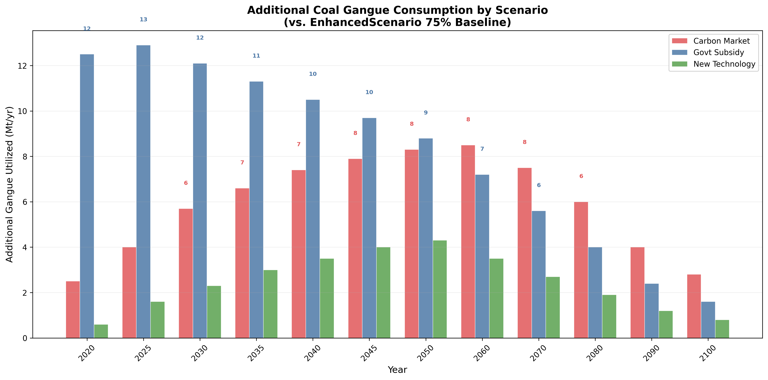
Fig. S2. Additional gangue utilization (Mt) attributable to each policy variant relative to Base, by scenario and selected years. Bars decompose the incremental tonnage by pathway (power, building, extraction, other). DemandConstraint, TechnologySupport, and FullPolicyBundle variants are shown.

Figure S2. CO₂ emission reduction waterfall by scenario.
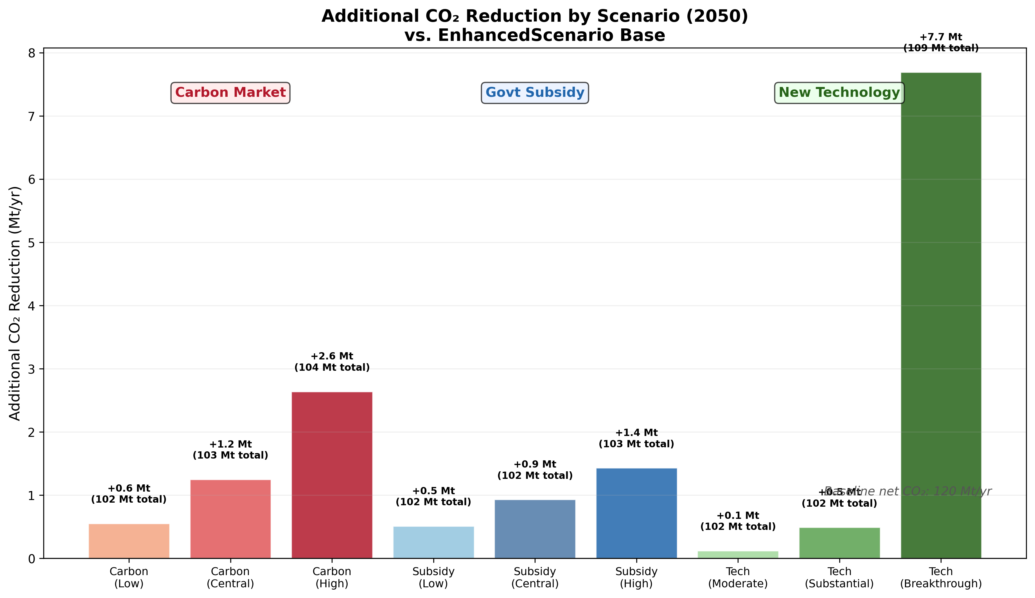
Fig. S3. Comprehensive CO₂ emission reduction waterfall by scenario (2020). Components: displacement credit (CO₂^displace), spontaneous combustion avoidance (CO₂^avoid), transport emissions (CO₂^transport), and chemical reagent burden (CO₂^chem). The net bar shows the fully corrected CO₂ reduction after all four environmental corrections.

Figure S3. Economic efficiency of policy instruments.
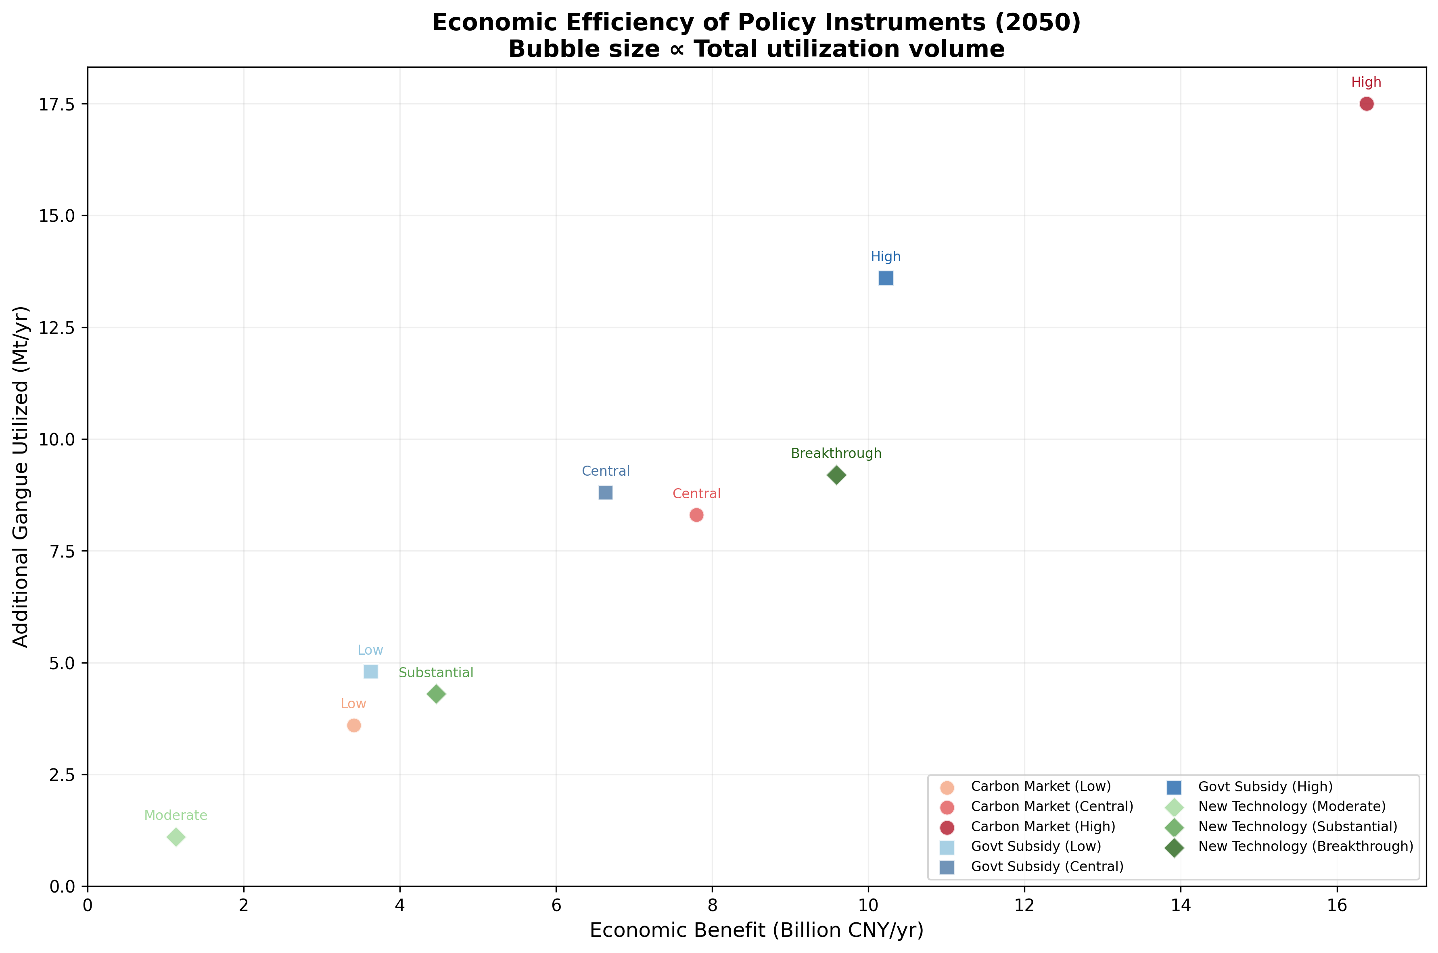
Fig. S4. Economic efficiency comparison of three policy instruments: carbon market (revenue-positive), subsidy (fiscal-cost-intensive), and technology R&D (zero fiscal cost, market-value-creating). Abatement cost (CNY/tCO₂) is shown for each instrument. The subsidy instrument exceeds 7,100 CNY/tCO₂, far above prevailing carbon market prices.

Figure S4. Pathway distribution under scenarios.
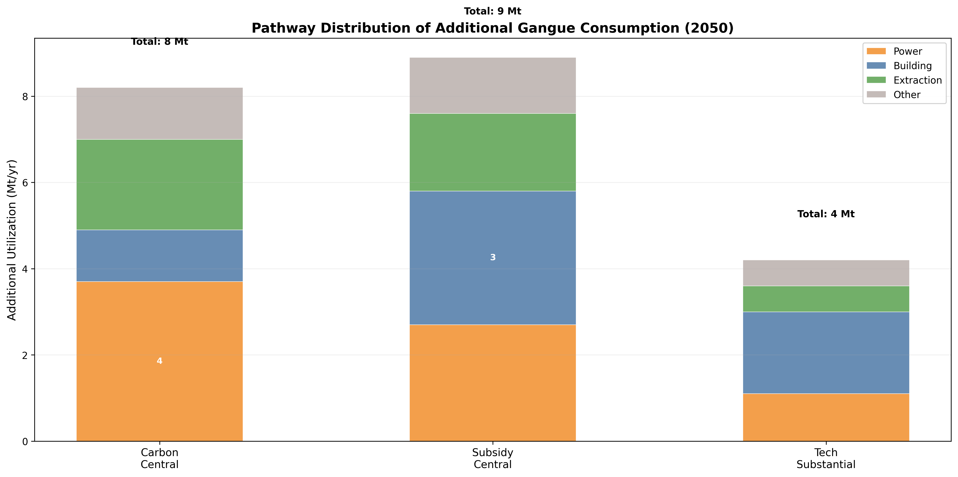
Fig. S5. Distribution of gangue utilization across four pathways (power, building, extraction, other/backfill) for three scenarios at 2020 and 2050. The figure illustrates how the pathway mix shifts from building-material-dominated (Baseline) to diversified (EnhancedScenario) as spatial and quality constraints are progressively incorporated.

Figure S5. Economic indicator timeseries by scenario.
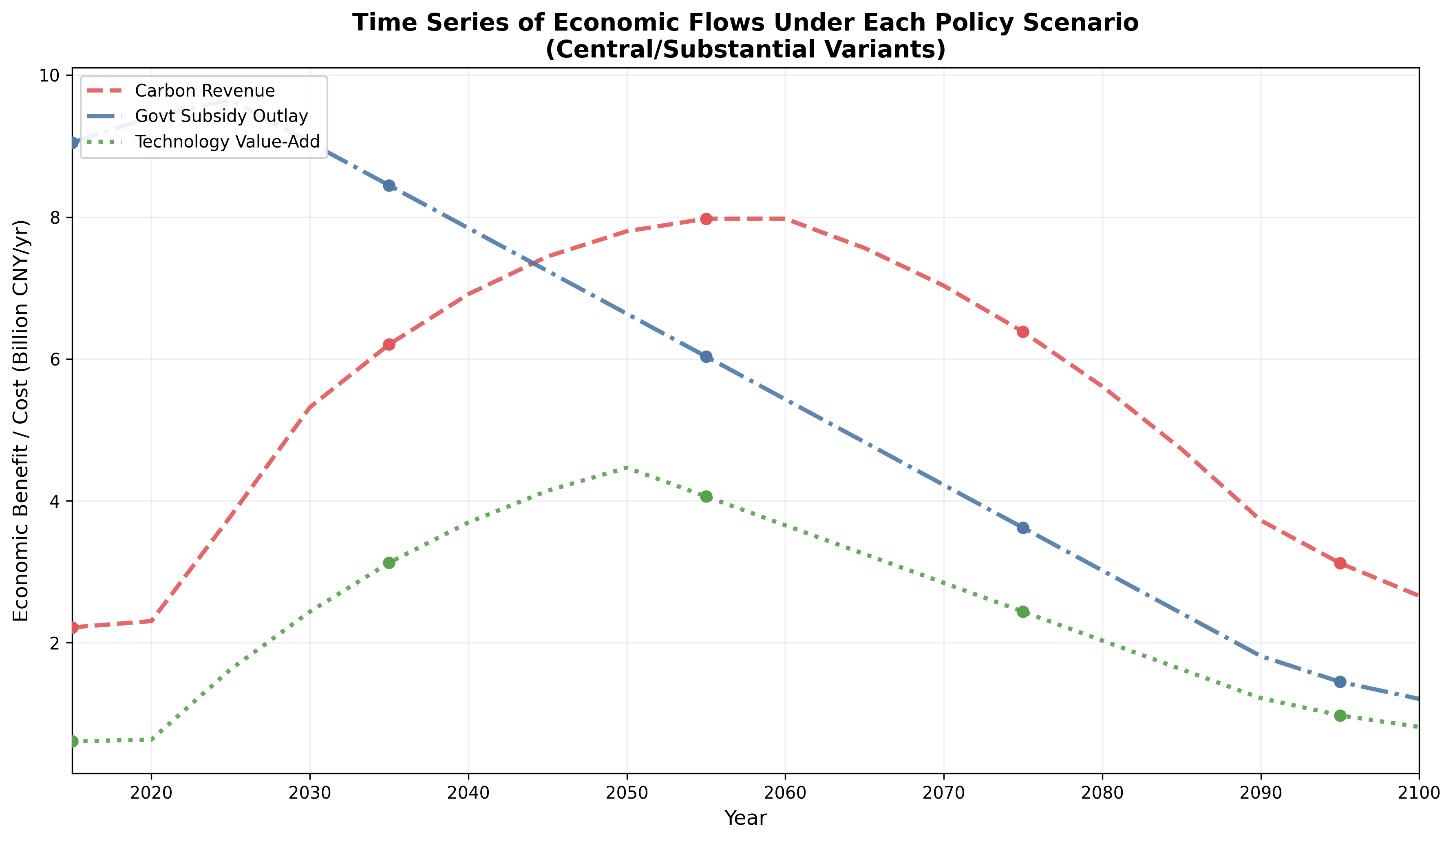
Fig. S6. Timeseries (2020-2100) of key economic indicators under the three scenarios: total gangue utilized, power generation output (EJ/yr), alumina production (Mt/yr), and net CO₂ reduction (Mt/yr). Shaded bands represent policy variant range within each scenario.

Figure S6. Sensitivity heatmap.
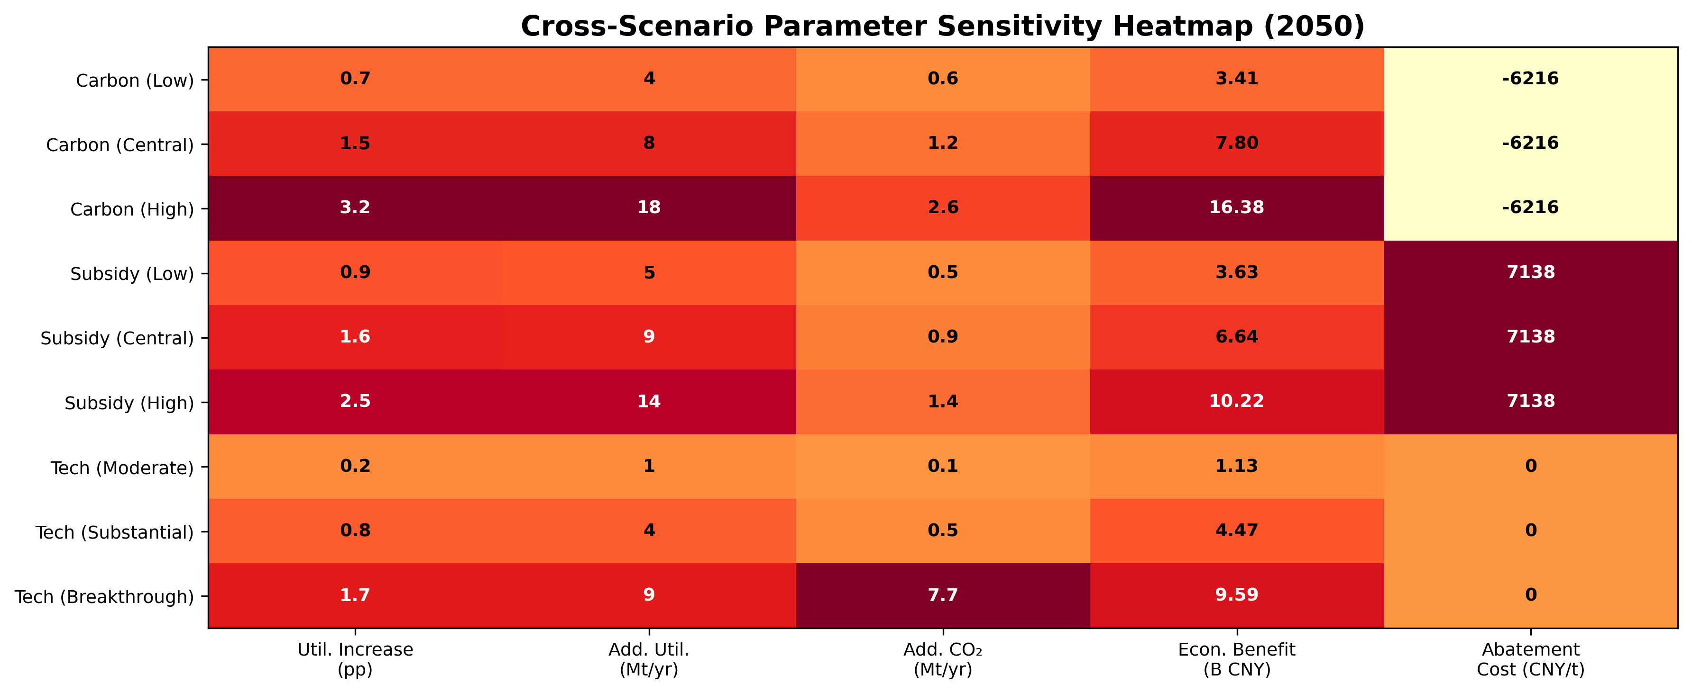
Fig. S7. Sensitivity heatmap showing the response of key output variables (utilization rate, CO₂ reduction, power generation, alumina production) to variations in five input parameters (d₀, r_sc, high-C threshold, high-Al threshold, and learning rate). Color intensity indicates the magnitude of output change relative to baseline (±%).

Figure S7. Comprehensive scenario comparison.
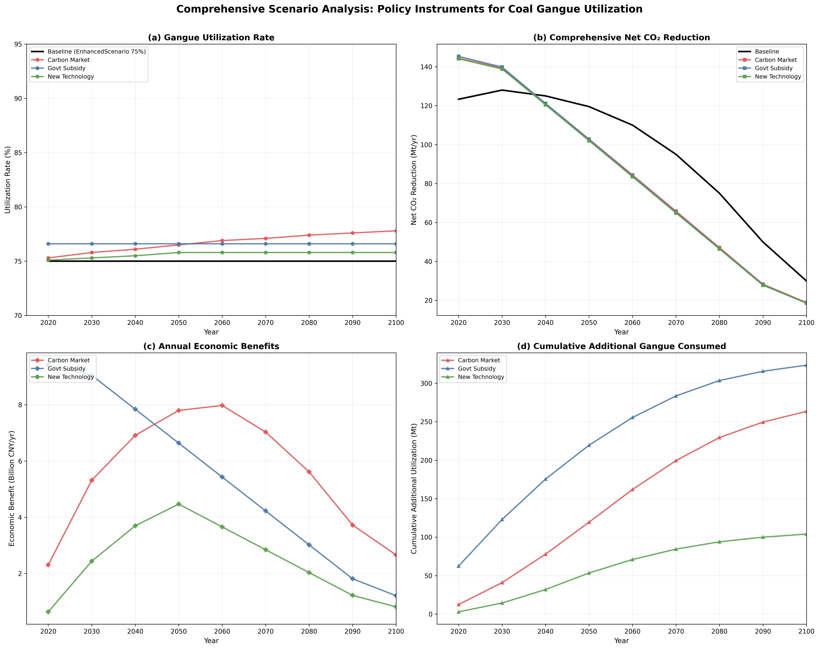
Fig. S8. Comprehensive scenario comparison dashboard. Multi-panel figure showing: (a) utilization rate trajectories; (b) pathway-level tonnage; (c) power generation output; (d) alumina production; (e) CO₂ reduction; and (f) economic indicators across all three scenarios and four policy variants.

Figure S8. Main manuscript figures - utilization comparison and spatial mismatch.
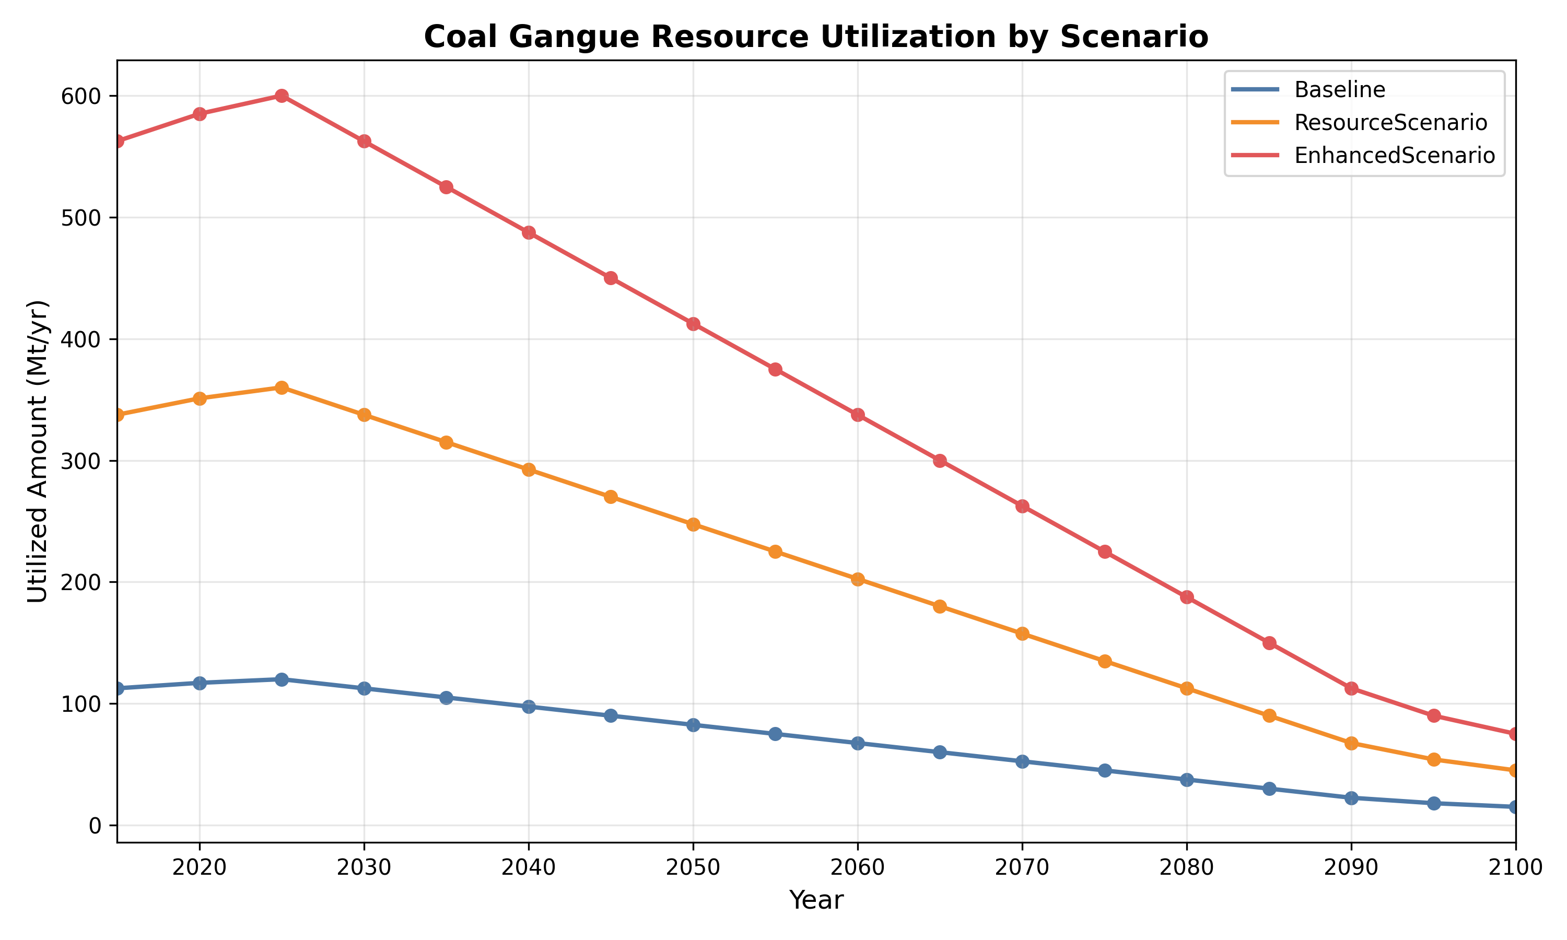
Fig. S9 (= Manuscript Fig. 1). Four-layer analytical framework. Layer 1: GCAM base simulation with five XML extension modules. Layer 2: Module modification (quality-graded allocation, provincial spatial matching, expanded environmental accounting, technology learning curves). Layer 3: Iterative equilibrium solving with damped relaxation (α = 0.35). Layer 4: Robust cross-model verification.

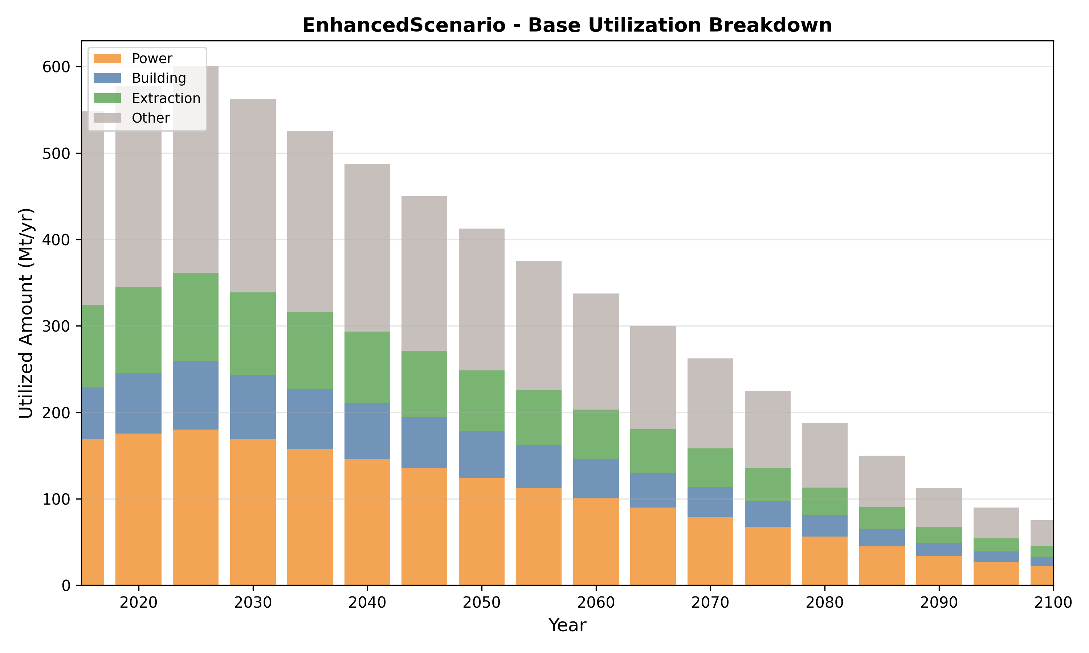
Fig. S10 (= Manuscript Fig. 2, panel a). Provincial spatial mismatch in coal gangue building-material utilization - EnhancedScenario 2020. Eight-province comparison showing gangue generation, local construction absorption capacity, realized building material utilization, and unrealizable tonnage.

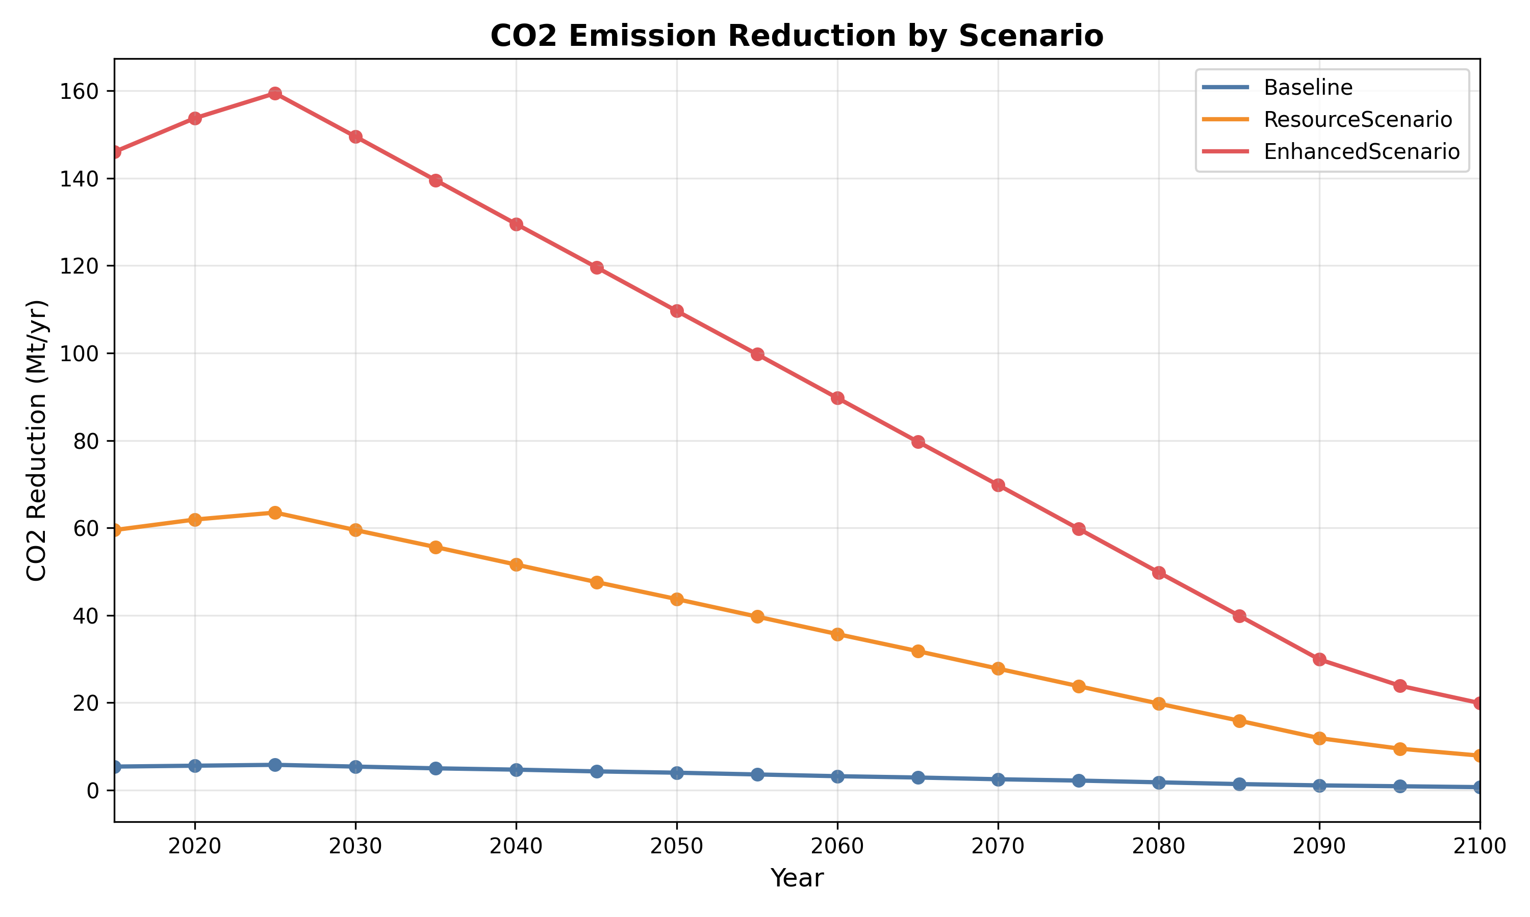
Fig. S11 (= Manuscript Fig. 3). Environmental accounting waterfall for EnhancedScenario 2020. Conventional displacement-only estimate (153.7 Mt CO₂) vs. comprehensive net reduction (123.3 Mt) after subtracting transport and chemical reagent emissions, and adding spontaneous combustion avoidance.

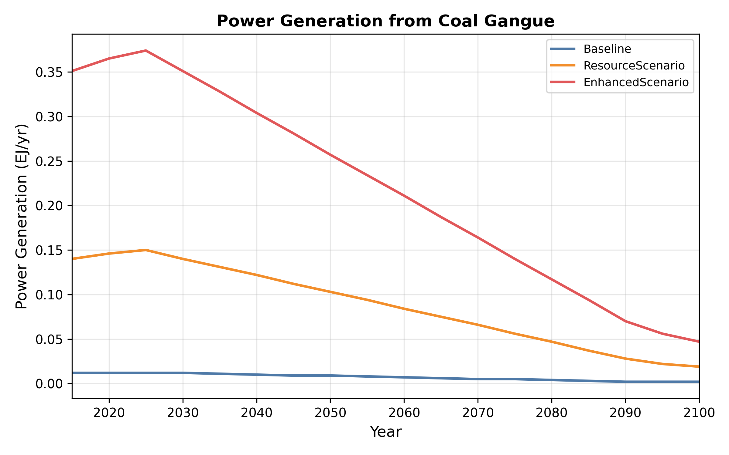
Fig. S12 (= Manuscript Fig. 4). Quality-graded allocation and pathway redirection results. (a) Pathway tonnage under quality-graded vs. uniform allocation. (b) Pre- vs. post-soft-linking pathway distribution. (c) Iterative convergence trajectory for EnhancedScenario 2020.

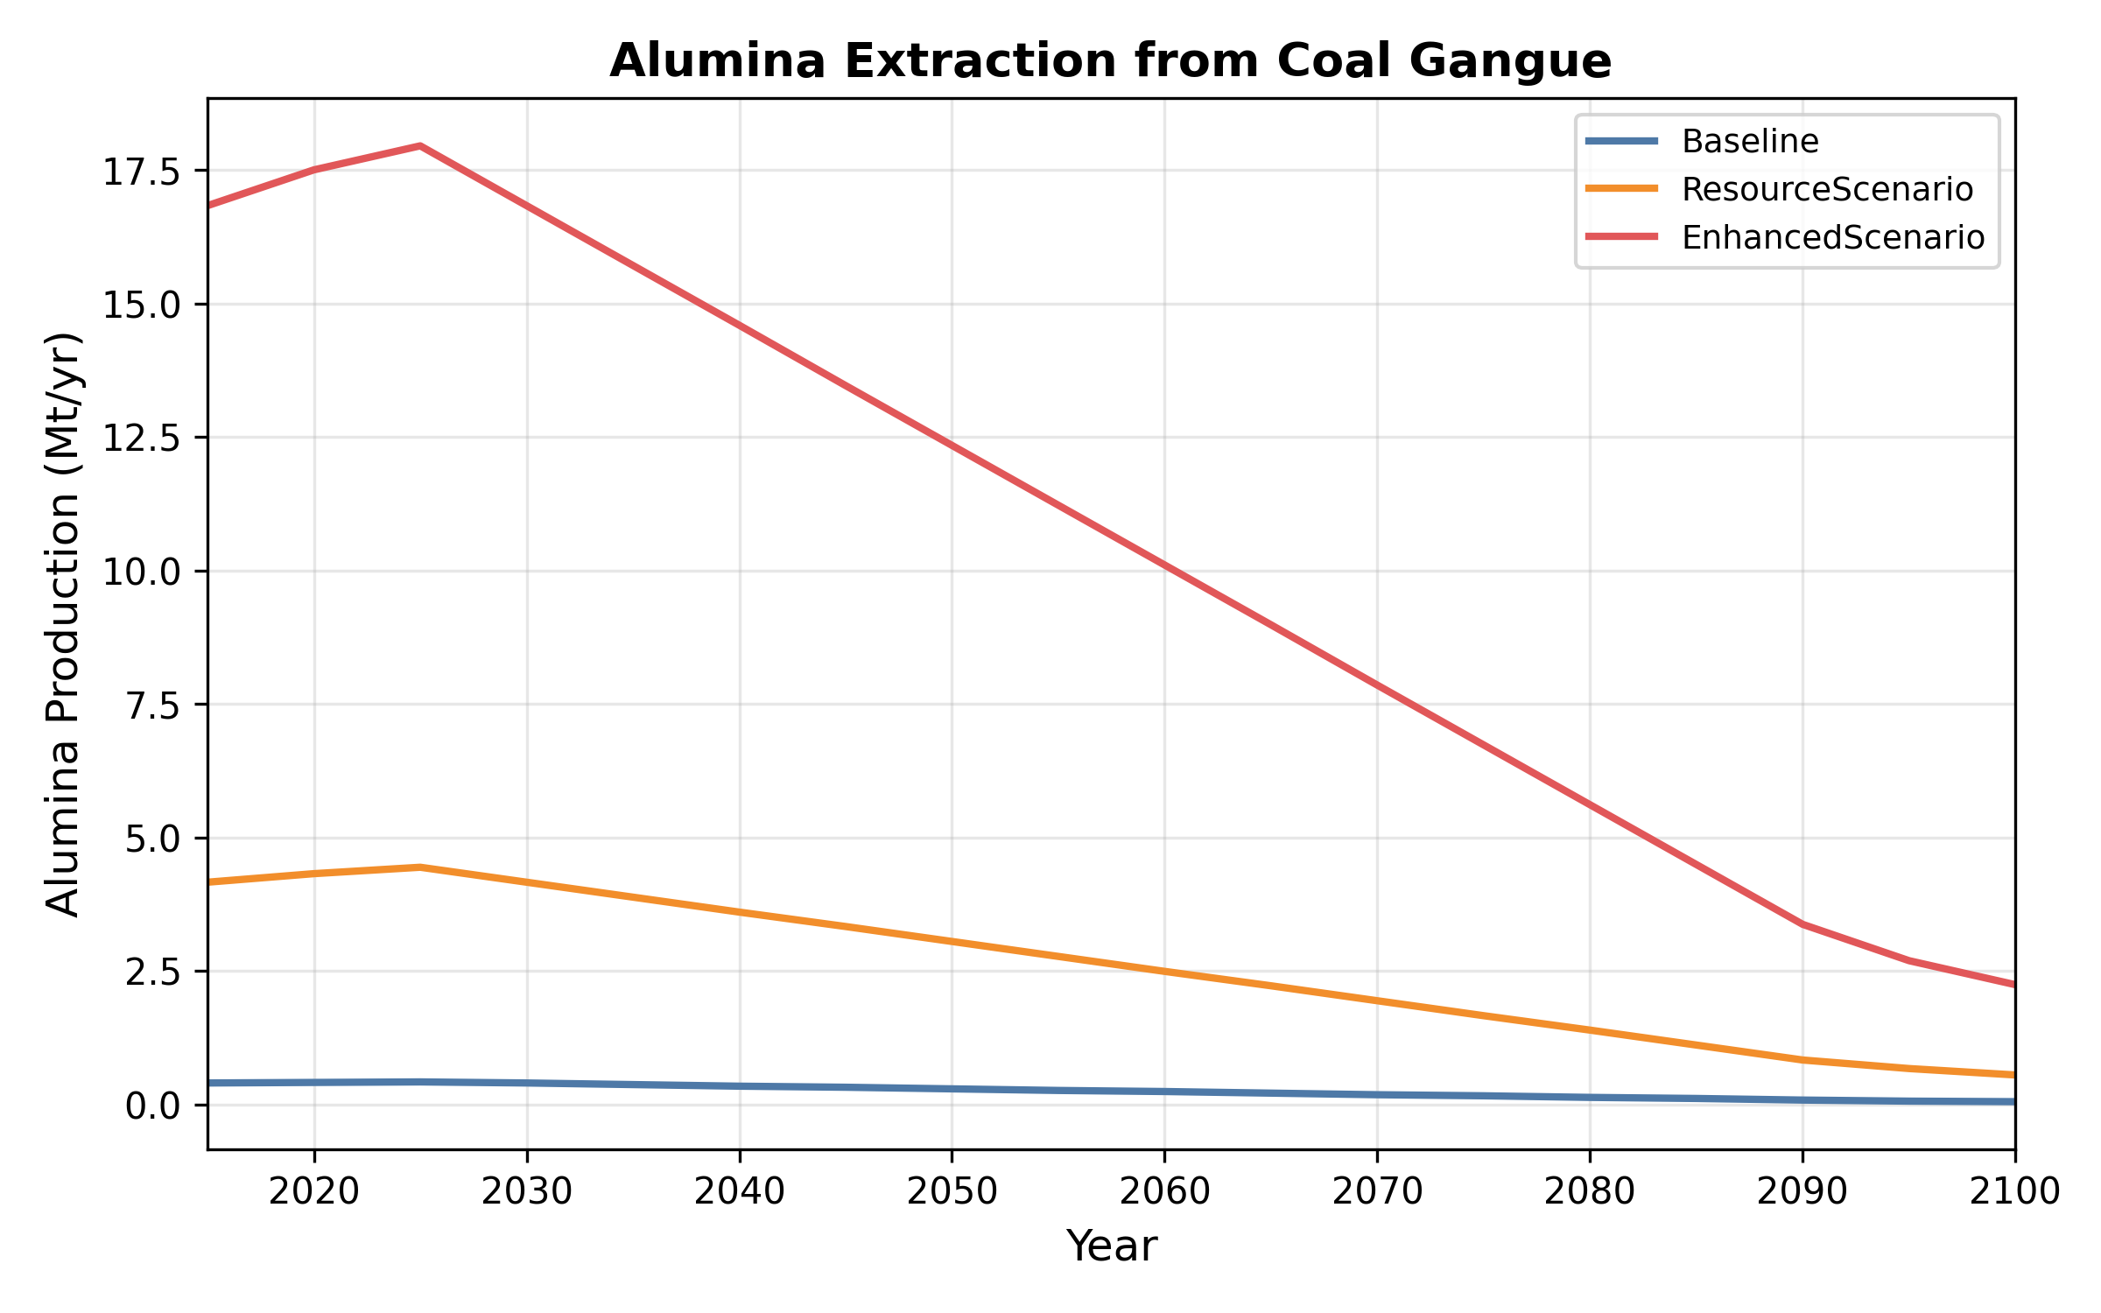
Fig. S13 (= Manuscript Fig. 5). Alumina production trajectories and technology learning effects. Provincial breakdown of alumina output under three learning scenarios (Base, TechnologySupport, AggressiveR&D), with and without spatial matching constraints.

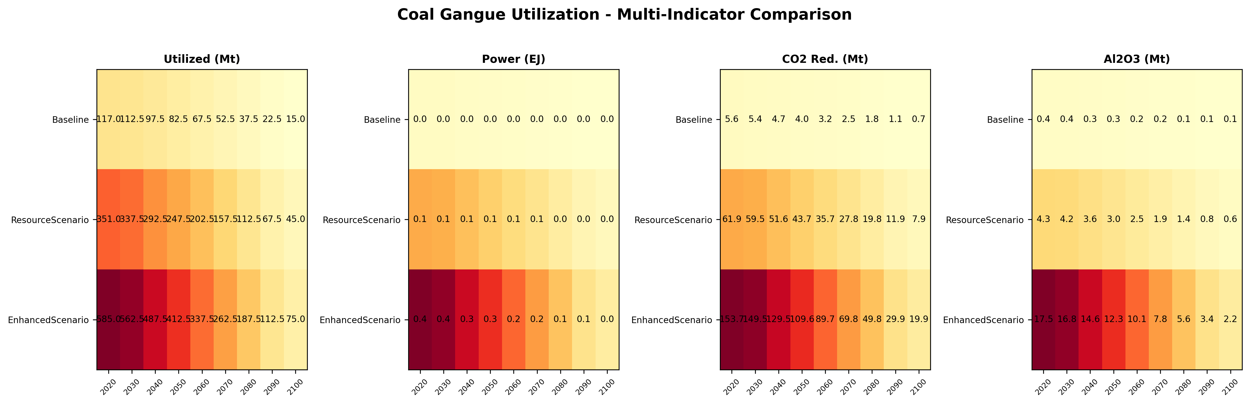
Fig. S14 (= Manuscript Fig. 6). Cross-model comparison heatmap. GCAM vs. CGE vs. MESSAGEix for key indicators (utilization, power generation, alumina, CO₂) across time periods (2020-2100). Color intensity represents value magnitude; pattern consistency indicates cross-model agreement.

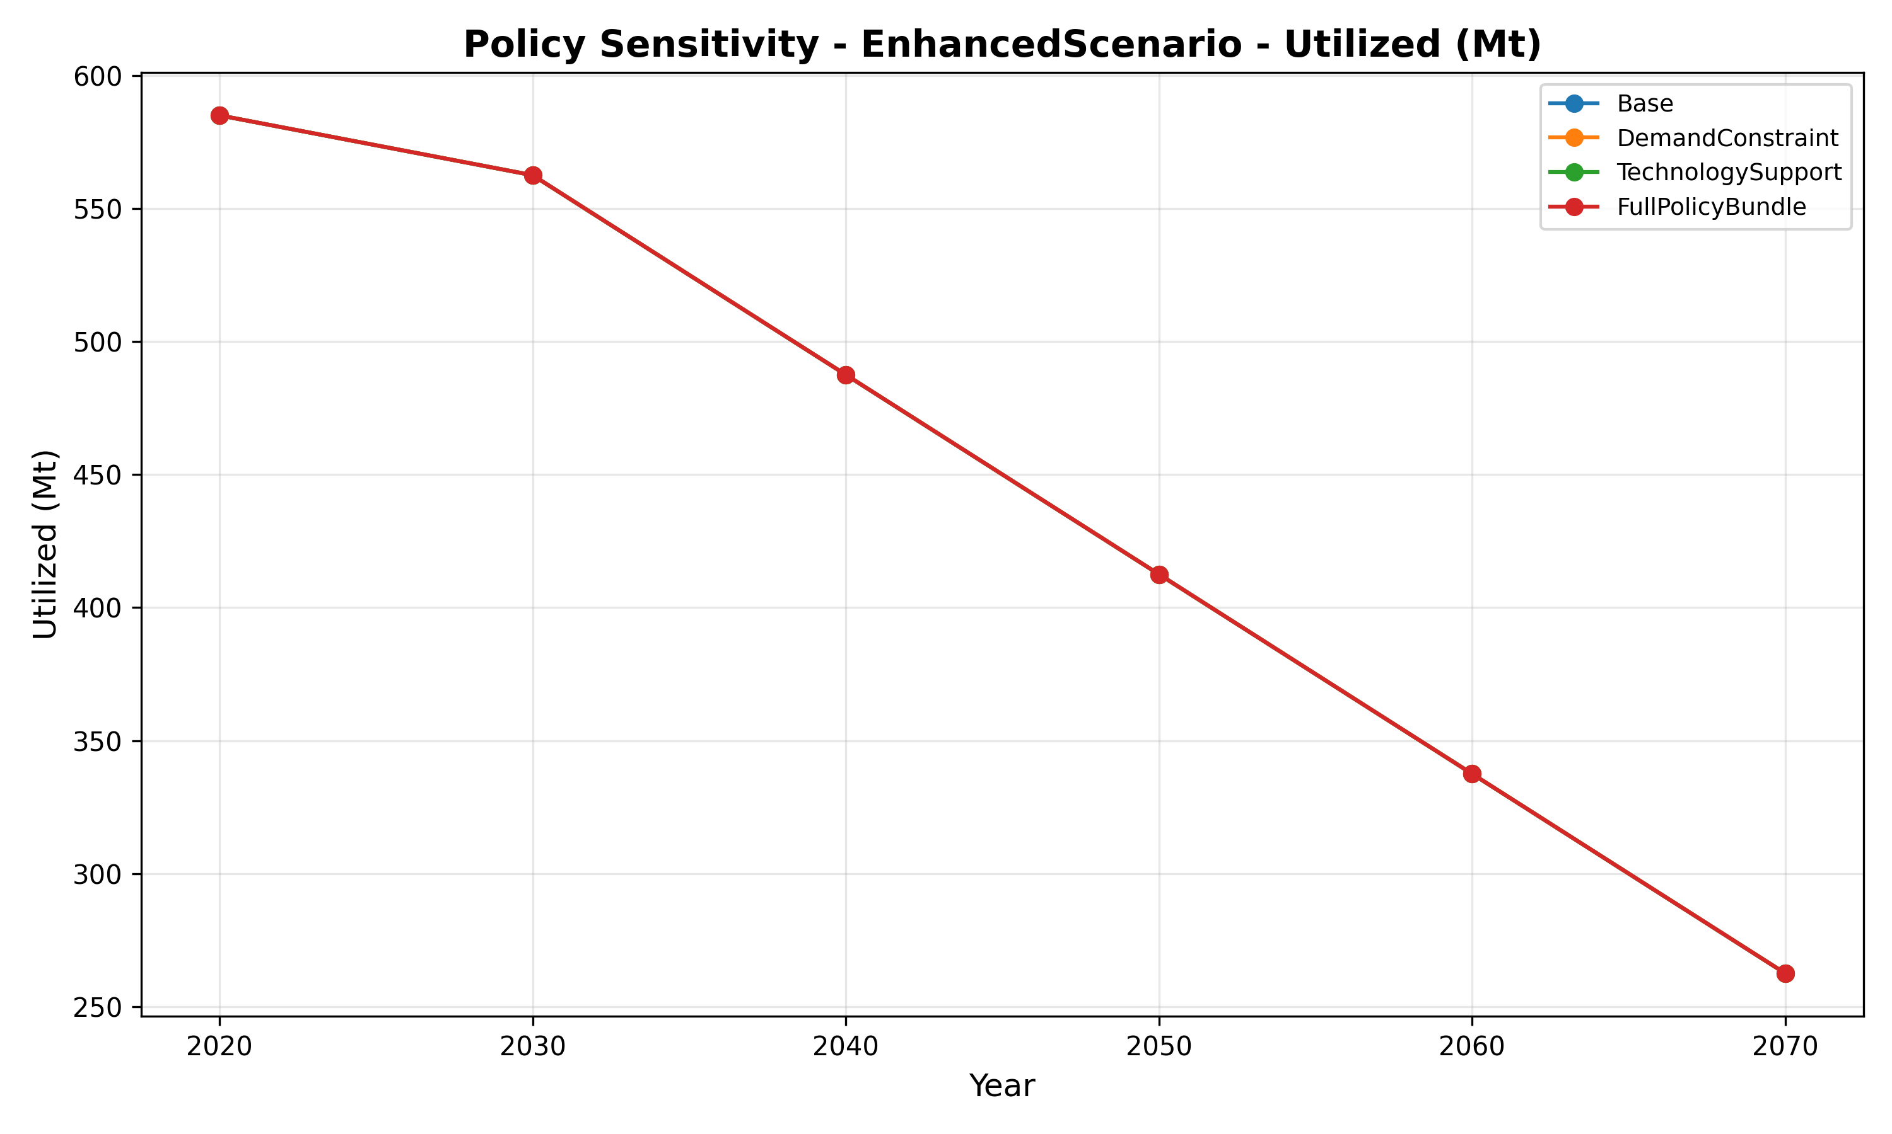
Fig. S15 (= Manuscript Fig. 7). Policy instrument sensitivity analysis. Total gangue utilized under three policy instruments (carbon market at Low/Central/High, subsidy at Low/Central/High, technology at Moderate/Substantial/Breakthrough) across 2020-2100. Dash horizontal line: Base scenario utilization rate (75%).

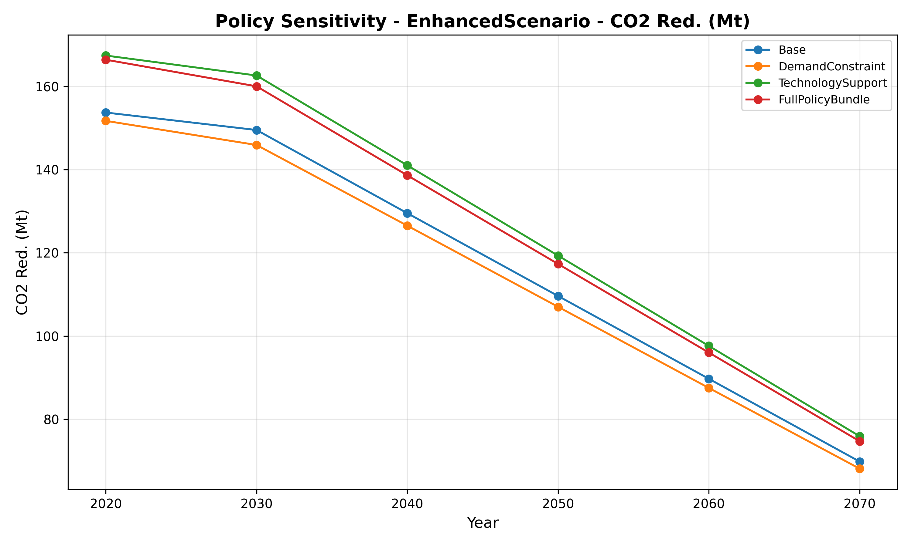
Fig. S16 (= Manuscript Fig. 8). CO₂ reduction sensitivity to policy instruments. Parallel to Fig. S15 but showing net CO₂ reduction. Policy variant whiskers show P5-P95 range from Monte Carlo simulation (10,000 draws per variant).

