Tabel s1 Missing data on covariates

Variables | N | Missing data | Mean | Median | Min | Max | Percent%
BMI | 44157 | 95 | 27.83837 | 27.0995 | 13.6061 | 67.3334 | 0.22
Townsend Deprivation Index | 44203 | 49 | -1.80567 | -2.53 | -6.26 | 9.99 | 0.11
Educational attainment | 43853 | 399 | 14.42414 | 13 | 0 | 30 | 0.91
Race and ethnicity | 44241 | 11 | 1.057209 | 1 | 1 | 4 | 0.02
Tobacco use | 44132 | 120 | 2.490778 | 3 | 1 | 3 | 0.27
Self-reported health | 44148 | 104 | 2.076244 | 2 | 1 | 4 | 0.24

Table s2 subgroups analysis
Subgroups | All-cause-death |  |  | Incident_CVD |  |  | Incident_MI |  |  | Incident_Stroke
Subgroups | HR (95% CI) | P value | P for interaction | HR (95% CI) | P value | P for interaction | HR (95% CI) | P value | P for interaction | HR (95% CI) | P value | P for interaction
Blood pressure control well |  |  | 0.3445 |  |  | 0.6114 |  |  | 0.3447 |  |  | 0.5833
Yes(n=6754)
Moring | 0.53(0.38-0.74) | 0.0002 |  | 0.95(0.70-1.29) | 0.7249 |  | 0.95(0.65-1.38) | 0.7693 |  | 0.94(0.56-1.56) | 0.8058
Afternoon | 0.72(0.56-0.92) | 0.0097 |  | 0.85(0.64-1.11) | 0.2245 |  | 0.73(0.52-1.03) | 0.0739 |  | 1.03(0.67-1.59) | 0.8950
Evening | 0.65(0.24-1.76) | 0.3970 |  | 0.63(0.20-1.98) | 0.4285 |  | 0.30(0.04-2.14) | 0.2288 |  | 1.25(0.30-5.18) | 0.7568
Mixed | 0.83(0.58-1.19) | 0.3066 |  | 0.82(0.55-1.23) | 0.3397 |  | 0.70(0.42-1.16) | 0.1651 |  | 0.99(0.52-1.88) | 0.9769
Inactive | 1.00(Reference) | - |  | 1.00(Reference) | - |  | 1.00(Reference) | - |  | 1.00(Reference) | -
No(n=36767)
Moring | 0.83(0.73-0.94) | 0.0047 |  | 0.81(0.70-0.94) | 0.0055 |  | 0.77(0.64-0.93) | 0.0067 |  | 0.82(0.65-1.04) | 0.0996
Afternoon | 0.74(0.66-0.83) | <0.0001 |  | 0.79(0.70-0.90) | 0.0003 |  | 0.76(0.64-0.89) | 0.0006 |  | 0.79(0.65-0.96) | 0.0205
Evening | 0.58(0.35-0.97) | 0.0392 |  | 1.05(0.70-1.57) | 0.8125 |  | 1.17(0.74-1.87) | 0.5009 |  | 0.82(0.39-1.75) | 0.6099
Mixed | 0.70(0.59-0.83) | <0.0001 |  | 0.93(0.79-1.10) | 0.3966 |  | 0.80(0.64-1.00) | 0.0465 |  | 1.12(0.87-1.44) | 0.3772
Inactive | 1.00(Reference) | - |  | 1.00(Reference) | - |  | 1.00(Reference) | - |  | 1.00(Reference) | -
Medication |  |  | 0.1144 |  |  | 0.0013 |  |  | 0.0023 |  |  | 0.2173
Yes(n=10455)
Moring | 0.75(0.62-0.91) | 0.0031 |  | 0.74(0.60-0.91) | 0.0045 |  | 0.66(0.50-0.86) | 0.0019 |  | 0.89(0.64-1.22) | 0.4553
Afternoon | 0.79(0.68-0.93) | 0.0041 |  | 0.81(0.68-0.96) | 0.0155 |  | 0.75(0.60-0.93) | 0.0084 |  | 0.89(0.68-1.17) | 0.4005
Evening | 0.63(0.30-1.33) | 0.2243 |  | 0.81(0.40-1.64) | 0.5663 |  | 0.77(0.32-1.86) | 0.5555 |  | 0.85(0.27-2.68) | 0.7840
Mixed | 0.78(0.61-1.00) | 0.0483 |  | 0.84(0.65-1.09) | 0.1995 |  | 0.73(0.52-1.02) | 0.0655 |  | 1.08(0.73-1.60) | 0.6907
Inactive | 1.00(Reference) | - |  | 1.00(Reference) | - |  | 1.00(Reference) | - |  | 1.00(Reference) | -
No(n=29466)
Moring | 0.80(0.68-0.93) | 0.0050 |  | 0.91(0.76-1.08) | 0.2915 |  | 0.92(0.74-1.15) | 0.4820 |  | 0.81(0.61-1.07) | 0.1388
Afternoon | 0.70(0.61-0.80) | <0.0001 |  | 0.80(0.69-0.94) | 0.0051 |  | 0.77(0.63-0.94) | 0.0090 |  | 0.79(0.62-1.00) | 0.0466
Evening | 0.58(0.33-1.03) | 0.0637 |  | 1.09(0.70-1.72) | 0.6960 |  | 1.20(0.71-2.02) | 0.5056 |  | 0.91(0.40-2.07) | 0.8284
Mixed | 0.68(0.56-0.83) | 0.0001 |  | 0.97(0.80-1.18) | 0.7601 |  | 0.83(0.64-1.08) | 0.1635 |  | 1.11(0.83-1.49) | 0.4893
Inactive | 1.00(Reference) | - |  | 1.00(Reference) | - |  | 1.00(Reference) | - |  | 1.00(Reference) | -
Sex |  |  | 0.9098 |  |  | 0.8397 |  |  | 0.1691 |  |  | 0.2999
Female (n =21737)
Moring | 0.79(0.63-0.97) | 0.0282 |  | 0.86(0.67-1.10) | 0.2364 |  | 0.70(0.48-1.01) | 0.0538 |  | 1.00(0.72-1.38) | 0.9865
Afternoon | 0.75(0.63-0.89) | 0.0012 |  | 0.83(0.68-1.01) | 0.0658 |  | 0.79(0.60-1.05) | 0.0994 |  | 0.85(0.64-1.12) | 0.2408
Evening | 0.78(0.42-1.47) | 0.4498 |  | 1.57(0.92-2.69) | 0.0994 |  | 1.34(0.63-2.85) | 0.4548 |  | 1.99(0.97-4.08) | 0.0592
Mixed | 0.67(0.50-0.89) | 0.0055 |  | 1.15(0.87-1.50) | 0.3263 |  | 0.97(0.65-1.43) | 0.8633 |  | 1.29(0.89-1.86) | 0.1794
Inactive | 1.00(Reference) | - |  | 1.00(Reference) | - |  | 1.00(Reference) | - |  | 1.00(Reference) | -
Male (n = 21784)
Moring | 0.77(0.67-0.89) | 0.0005 |  | 0.81(0.69-0.95) | 0.0094 |  | 0.81(0.67-0.99) | 0.0350 |  | 0.75(0.57-0.98) | 0.0361
Afternoon | 0.73(0.64-0.83) | <0.0001 |  | 0.78(0.67-0.89) | 0.0004 |  | 0.73(0.62-0.87) | 0.0004 |  | 0.79(0.63-1.00) | 0.0533
Evening | 0.47(0.24-0.91) | 0.0254 |  | 0.69(0.40-1.17) | 0.1679 |  | 0.88(0.50-1.54) | 0.6476 |  | 0.16(0.02-1.13) | 0.0658
Mixed | 0.73(0.61-0.88) | 0.0009 |  | 0.82(0.68-0.99) | 0.0386 |  | 0.72(0.57-0.91) | 0.0068 |  | 0.98(0.73-1.33) | 0.8988
Inactive | 1.00(Reference) | - |  | 1.00(Reference) | - |  | 1.00(Reference) | - |  | 1.00(Reference) | -
Age |  |  | 0.4605 |  |  | 0.1652 |  |  | 0.0801 |  |  | 0.9999
< 65 years (n = 17527)
Moring | 0.80(0.60-1.08) | 0.1525 |  | 1.05(0.79-1.39) | 0.7553 |  | 1.09(0.78-1.53) | 0.6217 |  | 0.84(0.50-1.41) | 0.5029
Afternoon | 0.77(0.60-0.97) | 0.0284 |  | 0.92(0.73-1.17) | 0.4857 |  | 0.88(0.66-1.17) | 0.3832 |  | 0.91(0.61-1.35) | 0.6341
Evening | 0.62(0.31-1.27) | 0.1947 |  | 1.12(0.66-1.91) | 0.6742 |  | 1.16(0.62-2.15) | 0.6499 |  | 0.90(0.32-2.49) | 0.8398
Mixed | 0.76(0.57-1.03) | 0.0741 |  | 1.01(0.76-1.32) | 0.9688 |  | 0.88(0.62-1.24) | 0.4541 |  | 1.15(0.74-1.80) | 0.5369
Inactive | 1.00(Reference) | - |  | 1.00(Reference) | - |  | 1.00(Reference) | - |  | 1.00(Reference) | -
≥65 years (n = 25994)
Moring | 0.78(0.68-0.89) | 0.0002 |  | 0.79(0.68-0.91) | 0.0018 |  | 0.73(0.60-0.88) | 0.0013 |  | 0.84(0.67-1.06) | 0.1470
Afternoon | 0.74(0.66-0.82) | <0.0001 |  | 0.77(0.68-0.88) | <0.0001 |  | 0.72(0.60-0.85) | 0.0001 |  | 0.81(0.66-0.99) | 0.0386
Evening | 0.60(0.33-1.08) | 0.0881 |  | 0.90(0.52-1.56) | 0.7055 |  | 0.96(0.50-1.87) | 0.9143 |  | 0.89(0.37-2.17) | 0.8007
Mixed | 0.71(0.59-0.85) | 0.0002 |  | 0.88(0.73-1.07) | 0.2044 |  | 0.74(0.57-0.96) | 0.0218 |  | 1.09(0.83-1.44) | 0.5257
Inactive | 1.00(Reference) | - |  | 1.00(Reference) | - |  | 1.00(Reference) | - |  | 1.00(Reference) | -

Table s3 sensitive analysis
Outcome | Model 1 ª |  | Model 2 ^{b} |  |  | Model 3 ^{c}
Outcome | HR (95% CI) | P value | HR (95% CI) |  | P value | HR (95% CI) |  | P value
All-Cause-Death
Morning | 0.77(0.68-0.87) | <.0001 | 0.78(0.69-0.88) |  | <.0001 | 0.80(0.70-0.91) |  | 0.0006
Afternoon | 0.73(0.66-0.81) | <.0001 | 0.74(0.67-0.82) |  | <.0001 | 0.74(0.66-0.83) |  | <0.0001
Evening | 0.58(0.37-0.92) | 0.0203 | 0.6(0.38-0.94) |  | 0.0266 | 0.62(0.39-1.01) |  | 0.0554
Mixed | 0.71(0.61-0.82) | <.0001 | 0.71(0.61-0.83) |  | <.0001 | 0.75(0.64-0.89) |  | 0.0007
Inactive |  |  | 1.00(Reference) |  | - | 1.00(Reference) |  | -
Incident_Cvd
Morning | 0.83(0.73-0.95) | 0.0054 | 0.83(0.73-0.95) |  | 0.0062 | 0.83(0.72-0.97) |  | 0.0184
Afternoon | 0.80(0.71-0.89) | <.0001 | 0.8(0.71-0.9) |  | 0.0001 | 0.81(0.71-0.92) |  | 0.0010
Evening | 0.96(0.65-1.40) | 0.8136 | 0.98(0.67-1.43) |  | 0.901 | 1.11(0.74-1.67) |  | 0.6031
Mixed | 0.90(0.77-1.05) | 0.1952 | 0.91(0.78-1.06) |  | 0.2332 | 0.93(0.78-1.10) |  | 0.4031
Inactive |  |  | 1.00(Reference) |  | - | 1.00(Reference) |  | -
Incident_Mi
Morning | 0.79(0.67-0.94) | 0.0061 | 0.8(0.67-0.94) |  | 0.0075 | 0.74(0.61-0.90) |  | 0.0021
Afternoon | 0.75(0.65-0.86) | <.0001 | 0.75(0.65-0.87) |  | 0.0001 | 0.72(0.61-0.85) |  | 0.0001
Evening | 1.00(0.64-1.56) | 0.9894 | 1.02(0.65-1.6) |  | 0.9361 | 1.21(0.76-1.93) |  | 0.4180
Mixed | 0.77(0.63-0.95) | 0.0125 | 0.78(0.63-0.95) |  | 0.0149 | 0.72(0.57-0.91) |  | 0.0060
Inactive |  |  | 1.00(Reference) |  | - | 1.00(Reference) |  | -
Incident_Stroke
Morning | 0.84(0.69-1.04) | 0.1097 | 0.84(0.68-1.04) |  | 0.1072 | 0.93(0.74-1.17) |  | 0.5478
Afternoon | 0.82(0.69-0.98) | 0.0325 | 0.83(0.69-0.99) |  | 0.035 | 0.89(0.73-1.09) |  | 0.2687
Evening | 0.87(0.45-1.69) | 0.6781 | 0.89(0.45-1.73) |  | 0.7236 | 0.89(0.42-1.90) |  | 0.7689
Mixed | 1.09(0.86-1.37) | 0.4774 | 1.1(0.87-1.39) |  | 0.4121 | 1.26(0.98-1.63) |  | 0.0711
Inactive |  |  | 1.00(Reference) |  | - | 1.00(Reference) |  | -
Model 1: Missing values for covariates were handled using multiple imputation with 25 imputed datasets generated.
Model 2: A Fine-Gray competing risks model was employed, with all-cause death treated as the competing event.
Model 3: Participants who experienced the outcome event within the first 2 years of follow-up were excluded from the analysis.
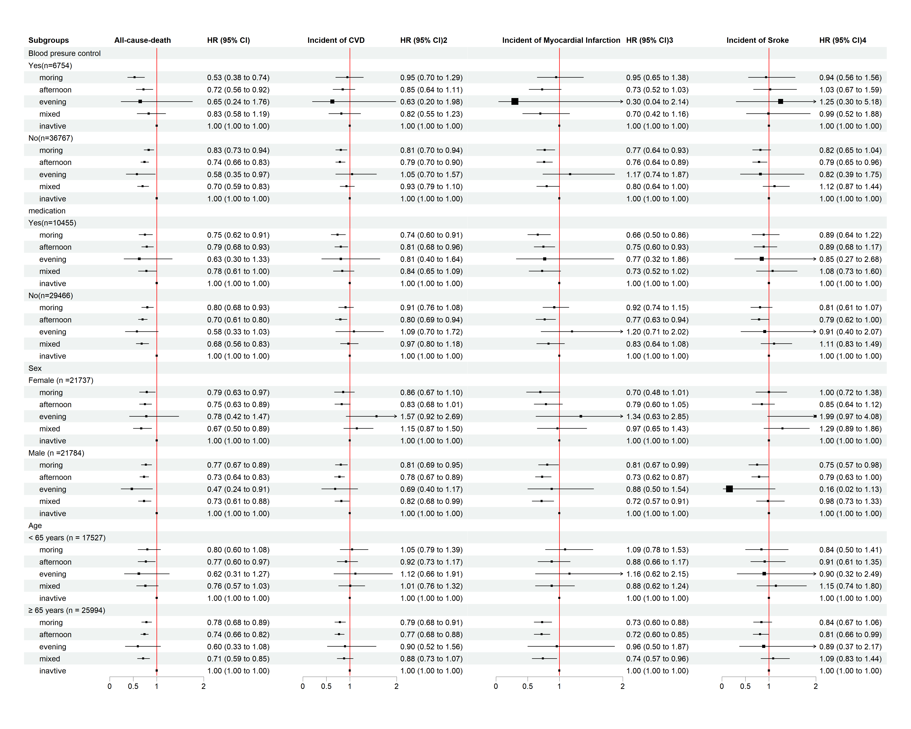
Figure s1 Subgroup analysis forest plot

