Figure S1. Geographic distribution of predictive modelling studies for stillbirths and neonatal deaths.
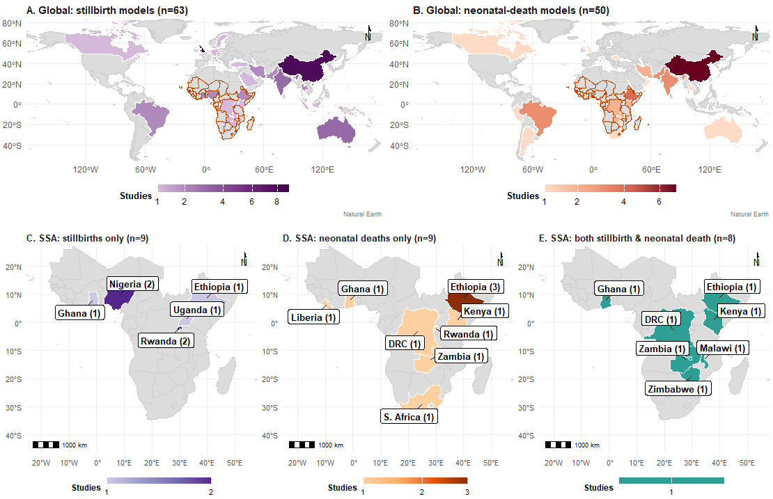
Panel A: Global distribution, stillbirths. Panel B: Global distribution, neonatal deaths. Panel C: Sub-Saharan Africa, stillbirths. Panel D: Sub-Saharan Africa, neonatal deaths.
Figure S2: Algorithm frequency by model family, outcome and region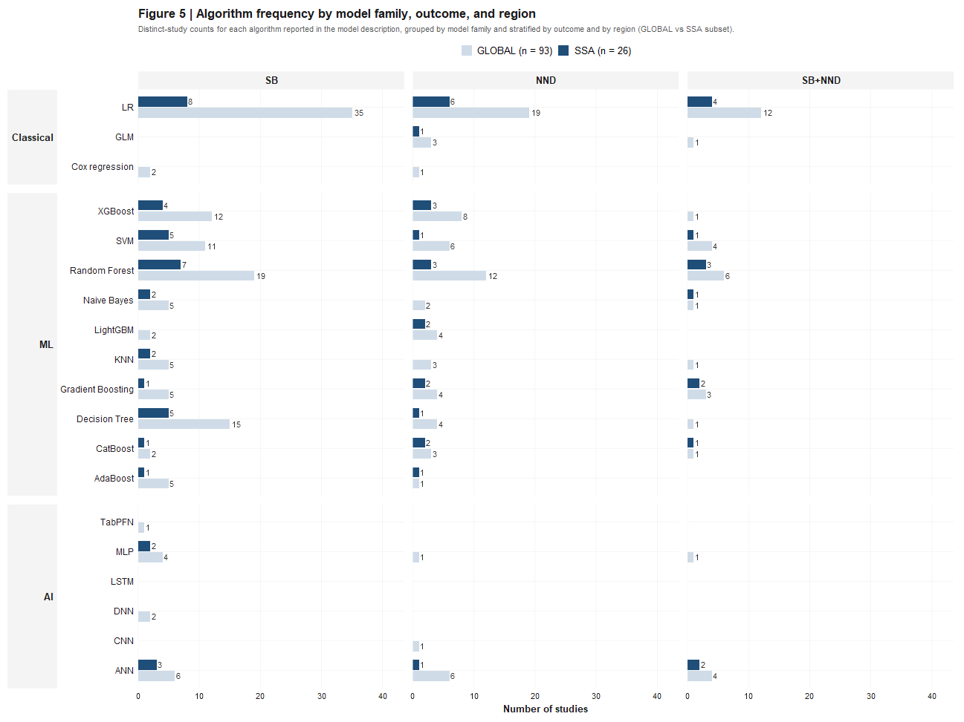
SB is stillbirths and NND is neonatal deaths, SB+NND is both stillbirth and neonatal deaths. Distinct study counts for each algorithm reported in the model description, grouped by model family and stratified by outcome and region (GLOBAL vs SSA). SSA is a subset of GLOBAL
Figure S3. Reporting performance metrics across model families, regions (SSA vs Non-SSA) and outcomes. 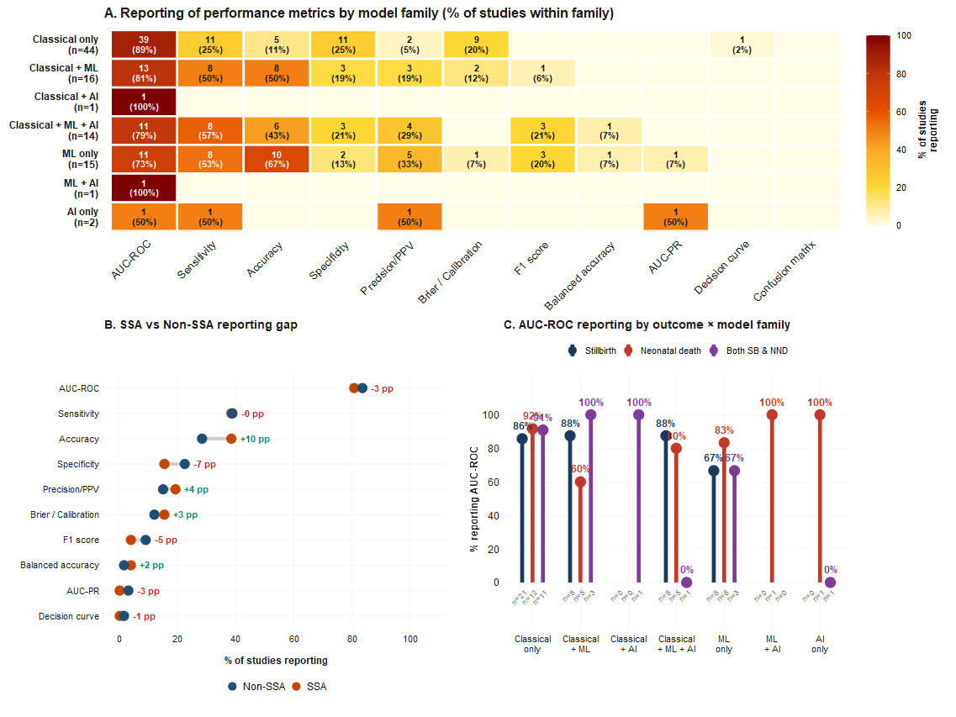
Percentages computed over studies with at least one performance metric reported, pp = percentage points

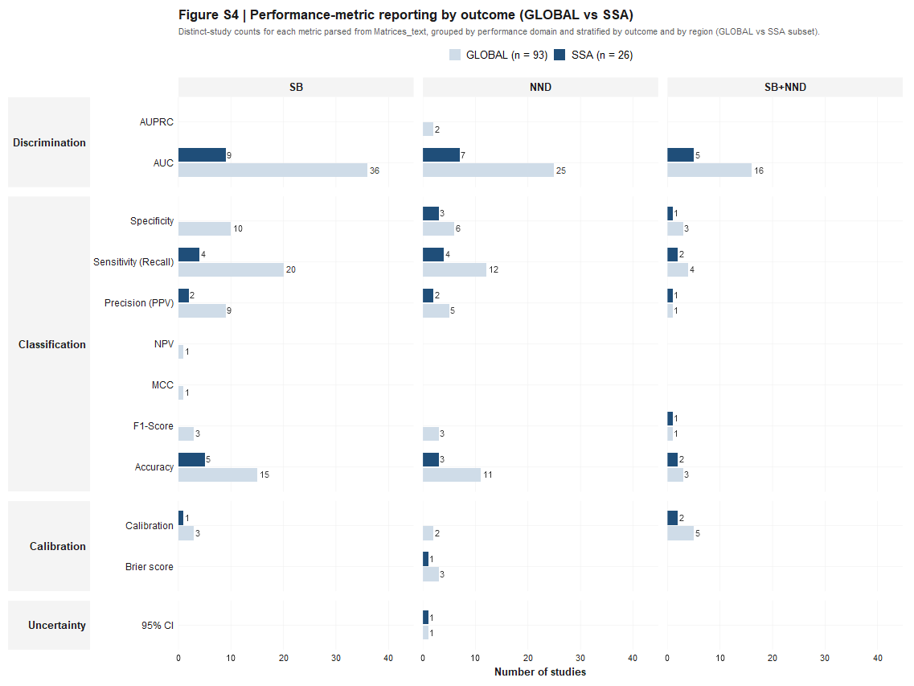
Figure S4: Performance metric reporting by outcome (Global vs SSA) and outcomes.
SB is stillbirths and NND is neonatal deaths, SB+NND is both stillbirth and neonatal deaths

