Supplementary Information
Steam Cracking of Plastics-waste Naphtha through Retrofitting
Arnav Mittal¹, Vaibhav Kelkar², Pankaj S. Gautam², Marianthi Ierapetritou^{1,3,*}, and Dionisios G. Vlachos^{1,3, *}
¹ Department of Chemical and Biomolecular Engineering, 150 Academy St., University of Delaware, Newark, DE 19716, United States
² Saudi Basic Industries Corporation, Sugar Land, TX 77478, United States
³ Delaware Energy Institute, 221 Academy St., University of Delaware, Newark, DE 19716, United States
*Corresponding author: mgi@udel.edu and vlachos@udel.edu

S1. TEA Assumptions
The equipment (Total Bare-Module Cost) and operating costs were estimated using the Aspen Economic Analyzer V12. Heat integration was performed using the Aspen Energy Analyzer. 10-17 heat exchangers were reported by Aspen Energy Analyzer across all cases. The key assumptions applied in the techno-economic analysis are as follows:
- The plant capacity ($m_{C_{2}H_{4}}$ + $m_{C_{3}H_{6}}$) was around 1.8 MT/yr. The study was based on fixed naphtha flow rate of 488 t/hr.
- The market price of conventional naphtha was assumed to be 636 USD/ton.
- The cost of water was assumed to be 0.2 USD/ton.
- The cost of H2 was assumed to be 2100 USD/ton.
- Wastewater treatment costs were assumed to be 1.0 USD/m³.
- The minimum selling price of olefins was calculated by assuming byproduct credits for BTX and fuel gas at 1000 USD/ton and 200 USD/ton, respectively.
- Type 3A molecular sieve was used for water removal.
- Selective hydrogenation catalyst cost was obtained using CatCost.
- Labor cost was assumed to be 5,000,000 USD.
- Maintenance cost was assumed to be 2.5 % of the total overnight cost (TOC).
- Insurance was assumed to be 5% of TOC.
- TOC was assumed to be 2.5 times the total bare module cost.
- The furnace is powered using natural gas. This study is also based on the costing of one big furnace; the MSP of olefins would increase if the costs of multiple small furnaces are considered. However, the key qualitative results of this study won’t change.
- Cost of olefin (COO) is calculated using
$$COO=\frac{CAPEX+OPEX+C_{O\&M}}{m_{C_{2}H_{4}}+ m_{C_{3}H_{6}}}$$ | (S1)
$$CAPEX=TOC ×CCF$$ | (S2)
$CAPEX$ is the capital expenditure per year, $OPEX$ is the operating expenditure per year, $C_{O\&M}$ is the maintenance, insurance, and labor cost per year. $CCF$ is the capital charge factor assumed to be 0.1 based on our economic assumptions.
- Utility costs were taken from Sieder et al.²⁷
- The furnace train was assumed to operate with 80% energy efficiency.
- The upper limit of 25% plastic naphtha integration was found by assuming complete recycling of produced plastics.

S2. Kinetic modeling assumptions and validation
- The microkinetic model was solved using a 0D plug-flow reactor representation implemented in OpenMKM.
- All hydrocarbon components were represented as normal alkanes. When a specific carbon-number alkane was not available in the microkinetic mechanism, its mass fraction was assigned to the nearest lower carbon-number alkane present in the model.
- Helium was used as a surrogate for steam in the microkinetic simulations, with the same mole-fraction dilution level applied.
- For each temperature, the residence time was selected based on the reactor length that maximized olefin yield. This choice was consistent with the industrial data used for model validation.
- Experimental data were obtained from the literature for validation and shown in Table S1.^{22,26}
Table S1: Steam cracker product yield as obtained from the microkinetic model and literature.²⁶ Naphtha composition from Spallina et al.²⁶ ($T = 850 ℃$, SDR = 0.5 kg_{steam}/kg_{naphtha}, all values reported in dry wt%)
 | $$C_{2}H_{4}$$ | $$C_{3}H_{6}$$ | $$CH_{4}$$ | $$C_{4}H_{6}$$ | $$C_{6}H_{6}$$ | $$C_{4}H_{8}$$ | $$C_{7}H_{8}$$ | $$C_{8}H_{8}$$ | $$C_{3}H_{8}$$ | $$C_{2}H_{6}$$
Literature | 32.4 | 14.5 | 16.3 | 5.4 | 9.6 | 3.3 | 3.4 | 1.2 | 0.3 | 3
MKM | 32.4 | 16 | 13.6 | 7.7 | 8.4 | 7.5 | 2.8 | 1.9 | 1.2 | 1.9
 | $$H_{2}$$ | $$C_{8}H_{10}$$ | $$C_{4}H_{10}$$ | $$C_{2}H_{2}$$ | $$C_{3}H_{4}$$ | $$C_{5}H_{12}$$ | $$C_{5}H_{10}$$ | $$C_{9}H_{12}$$ | $$C_{12}H_{26}$$ | $$C_{9}H_{20}$$
Literature | 0.4 | 2.2 | 0.1 | 1.2 | 1.5 | - | - | 0.3 | 3.3 | 0.3
MKM | 0.7 | 0.8 | 0.5 | 0.3 | 0.3 | 2.4 | 0.6 | 0.2 | - | -

S3. Benchmark Key operating parameters
Table S2: Key operating parameters of the main units in the naphtha cracking process.
 | Temperature | Pressure | Reflux ratio | Feed-to-distillate ratio | Number of stages
Demethanizer | 6 $℃$ | 31 bar | 2.7 | 0.48 | 20
Deethanizer | 77 $℃$ | 26 bar | 1.4 | 0.74 | 28
Depropanizer | 103 $℃$ | 16 bar | 1.9 | 0.73 | 50
Debutanizer | 124 $℃$ | 3 bar | 0.3 | 0.86 | 14
C2-seperator | -12 $℃$ | 18 bar | 3.9 | 0.92 | 64
C3-seperator | 59 $℃$ | 21 bar | 16.5 | 0.97 | 254

S4. Temperature sensitivity of plastics-derived naphtha
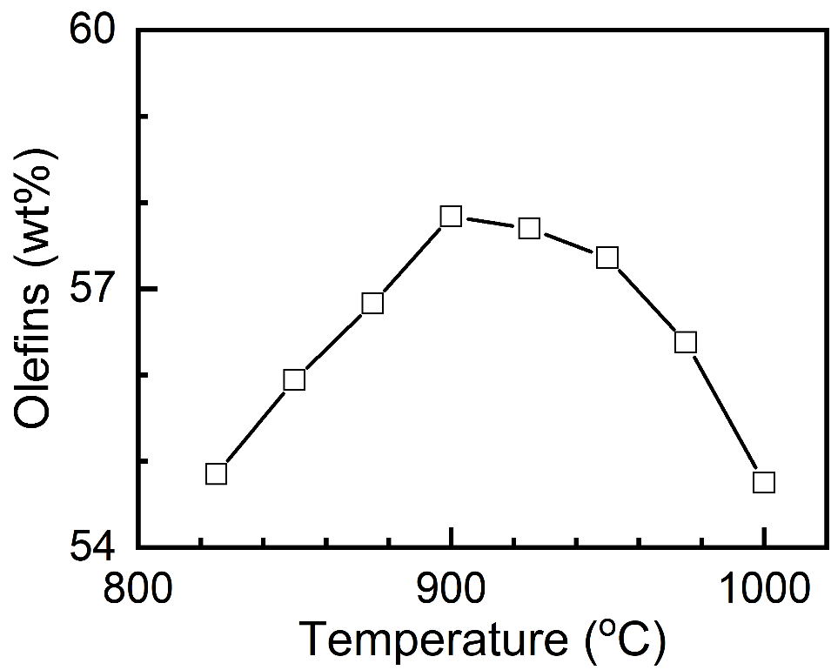
Figure S1: Cracking temperature vs maximum olefin production, assuming the PW naphtha composition obtained from Sun et al.⁸

S5. Impact of the population density on the PW naphtha production state
A modified version of the equation reported by Hernandez et al.,¹¹ was used to relate the population density to plastic collection and separating cost.
$$Cost_{USA,2026}(\$/t)=0.4426×Pop density {\left(\frac{inhab}{km^{2}}\right)}^{-0.142}×\frac{GDP_{USA}}{GDP_{Italy}}×\frac{PI_{2026}}{PI_{2009}}$$ | (S3)
Here, Pop density is the population density, GDP is gross domestic product per person, and PI is the price index.
The plastic collection and sorting cost was related to PW naphtha MSP ($MSP_{PNaphtha}$), assuming a linear fit as shown in Vance et al.¹³
$$MSP_{PNaphtha}(\$/t)=1.2×Cost_{USA,2026}(\$/t)+260$$ | (S4)
Linear fit was also done for each scenario discussed in this work to relate olefins MSP to PW naphtha MSP. Slopes and constants are reported in Table S3.
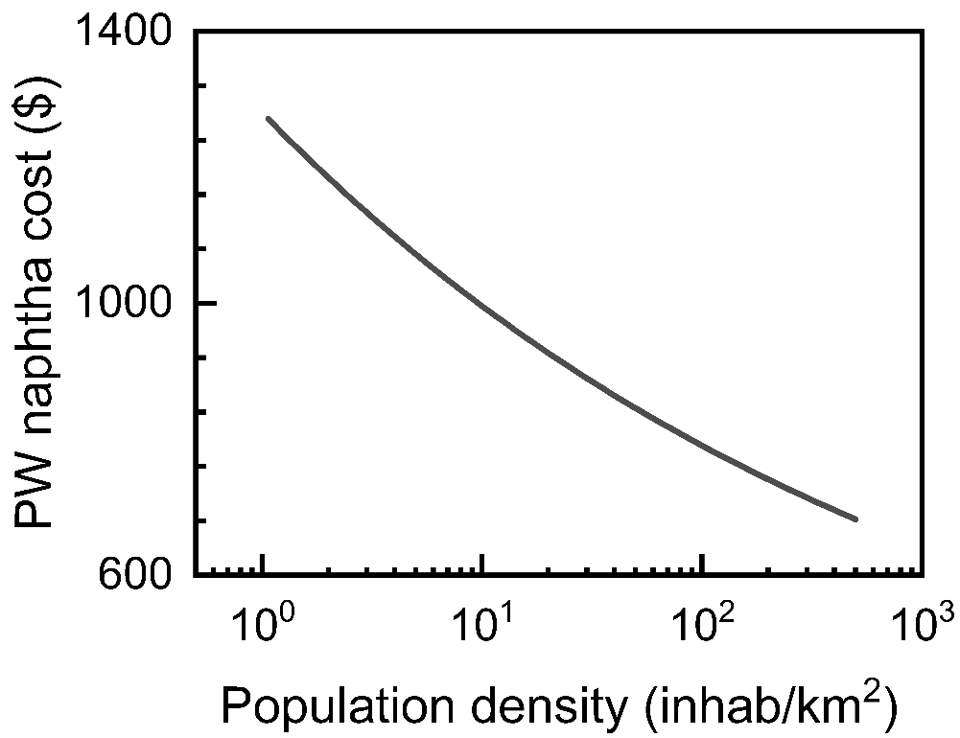
Figure S2: PW naphtha cost vs. population density.
Table S3: Linear fit for respective scenarios.
 | Slope | Constant
Scenario 1 | 0.12 | 1311.3
Scenario 2 | 0.56 | 1405.1
Scenario 3 | 0.11 | 1252
Scenario 4 | 0.55 | 977.6
Scenario 5 | 0.53 | 956.7

S6. Optimal key operating variables
Table S4: Key operating parameters of the main units in the optimal PW naphtha integrated cracking process.
 | Temperature | Pressure | Reflux ratio | Feed-to-distillate ratio | Number of stages
Demethanizer | 5 $℃$ | 31 bar | 2.7 | 0.45 | 20
Deethanizer | 79 $℃$ | 26 bar | 1.1 | 0.74 | 28
Depropanizer | 102 $℃$ | 16 bar | 1.8 | 0.70 | 50
Debutanizer | 124 $℃$ | 3 bar | 0.3 | 0.89 | 14
C2-seperator | -12 $℃$ | 18 bar | 3.4 | 0.93 | 64
C3-seperator | 59 $℃$ | 21 bar | 14.3 | 0.96 | 254

S7. Impact of steam dilution ratio
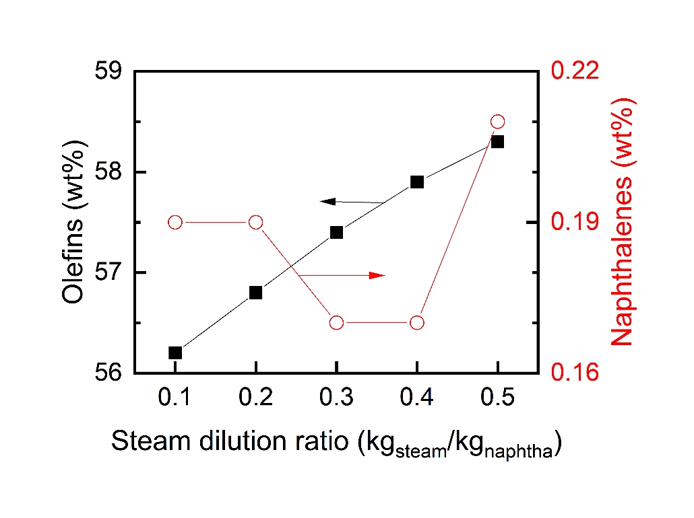
Figure S3: Impact of steam dilution ratio on olefins and naphthalene (coke surrogate). Olefin production decreases with decreases in steam dilution, while minimal naphthalene is seen around 0.3-0.4 SDR.

