SUPPLEMENT DATA 1: IMViC test done for all 120 isolates, confirming the Genus level identification of the Isolates
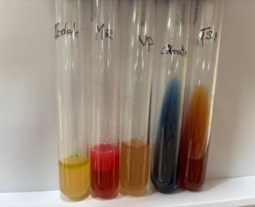
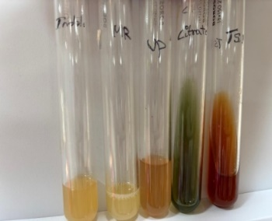
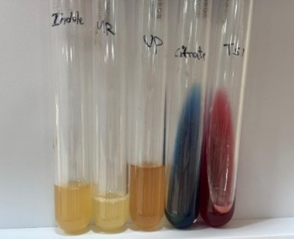
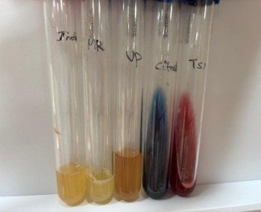
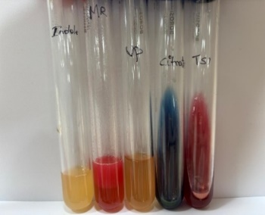
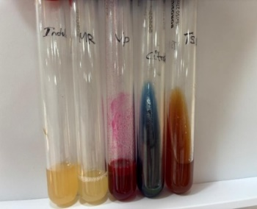
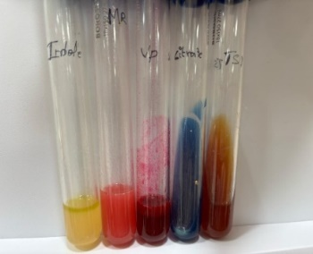
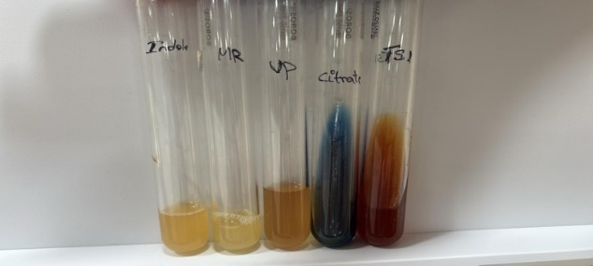
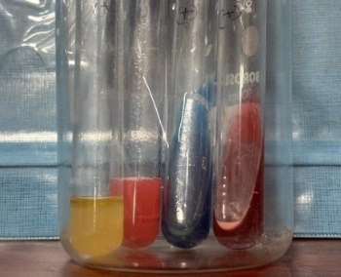
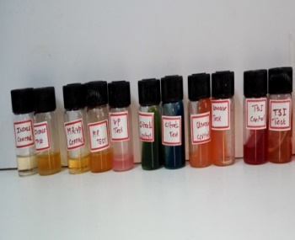
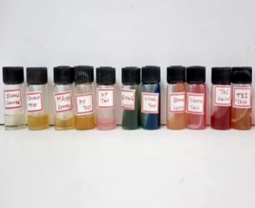

SUPPLEMENT DATA 2: 1.2% AGAROSE GEL AND CHROMATOGRAM OF SANER SEQUENCING

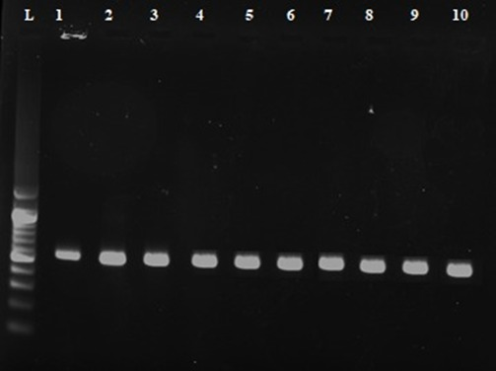
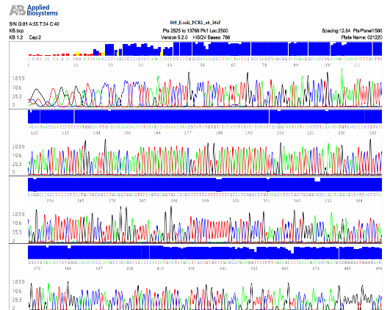
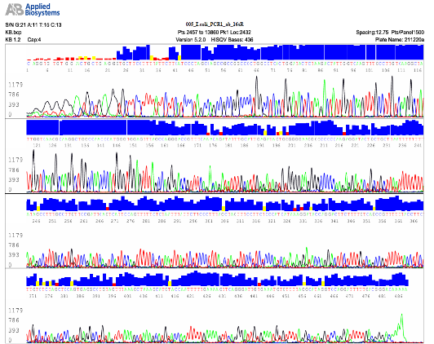
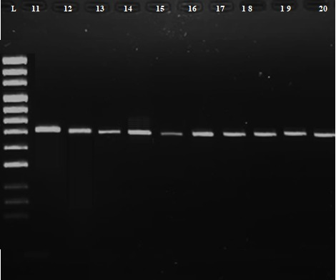
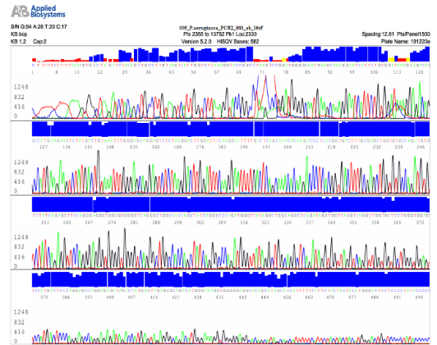
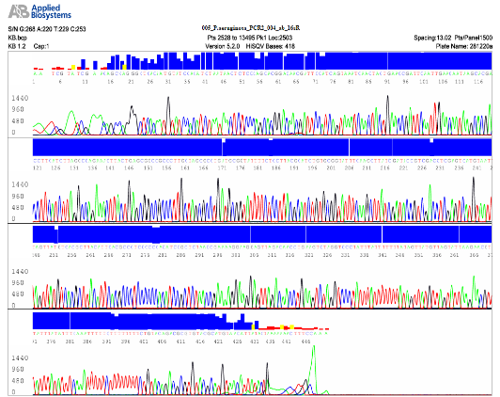

SUPPLEMENT DATA 3
Table 1 Antimicrobial resistance of clinically isolated GNB
S.No. | CIP | COT | CTR | GEN | MRP | IPM
1 | - | 19mm | - | - | 13mm | -
2 | - | 20mm | - | 14mm | 16mm | -
3 | 19mm | 09mm | - | - | - | 11mm
4 | - | - | - | - | 16mm | 21mm
5 | 17mm | - | - | - | 14mm | -
6 | 20mm | - | 19mm | - | 18mm | -
7 | 14mm | - |  | 11mm | 13mm | -
8 | - | - | 14mm | - | 17mm | -
9 | - | - | - | 21mm | 19mm | -
10 | - | 16mm | - | - | 23mm | -
11 | - | - | - | - | - | 16mm
12 | - | 13mm | - | 18mm | - | -
13 | - | - | - | 11mm | - | -
14 | - | 15mm | 13mm |  | - | -
15 | - | 14mm | - | 18mm | - | 11mm
16 | - | 11mm | - | - | - | 16mm
17 | - | 13mm | 15mm | 11mm | 16mm | -
18 | - | - | - | 13mm | 11mm | -
19 | 11mm | - | - | - | - | -
20 | - | - | 16mm | 13mm | - | -
21 | - | - | - | - | 15mm | -
22 | - | - | 11mm | - | 21mm | -
23 | - | - | 25mm | - | 18mm | -
24 | - | - | - | 19mm | - | -
25 | - | - | - | 16mm | 14mm | -
26 | 13mm | - | - | - | 11mm | -
27 | 16mm | - | 18mm | 21mm | - | -
28 | - | 12mm | - | 15mm | - | 11mm
29 | - | - | - | - | - | 20mm
30 | 15mm | - | - | 12mm | 16mm | -
31 | 13mm | - | - | - | 14mm | -
32 | - | - | 19mm | 11mm | 13mm | -
33 | - | - | - | - | 19mm | 23mm
34 | - | - | - | - | 15mm | -
35 | - | - | - | 13mm | 11mm | -
36 | - | - | - | 16mm | 18mm | -
37 | - | - | 16mm | - | - | 11mm
38 | 19mm | - | - | 18mm | - | 16mm
39 | 09mm | 15mm | - | 17mm | - | -
40 | 13mm | - | - | - | - | -
41 | - | 15mm | - | - | - | -
42 | - | 11mm | - | 16mm | - | -
43 | - | - | 12mm | - | 14mm | 09mm
44 | - | 14mm | - | - | 13mm | 15mm
45 | 11mm | 17mm | - | - | - | -
46 | - | - | - | 18mm | - | -
47 | - | - | - | - | 12mm | -
48 | 17mm | 15mm | 11mm | - | - | -
49 | - | - | 19mm | - | - | 11mm
50 | - | - | 22mm | 18mm | - | 16mm
51 | 12mm | - | - | - | 16mm | -
52 | - | 13mm | - | - | - | 14mm
53 | - | - | - | 13mm | 15mm | -
54 | 14mm | - | 16mm | - | - | -
55 | 13mm | - | - | - | 11mm | -
56 | 11mm | 15mm | - | 14mm | - | -
57 | - | 17mm | - | 13mm | - | -
58 | 19mm | 17mm | 15mm | 18mm | - | -
59 | 11mm | 14mm | 18mm | - | - | 19mm
60 | 13mm | 18mm | 14mm | 16mm | - | -
61 | - | 12mm | - | - | 15mm | -
62 | 11mm | 16mm | - | 18mm | - | -
63 | 13mm | - | 16mm | - | 14mm | -
64 |  | - | - | - | 13mm | 16mm
65 | 23mm | - | - | - | - | -
66 | 21mm | - | - | - | - | -
67 | - | - | 19mm | 16mm | - | -
68 | 16mm | - | 11mm | 17mm | 15mm | -
69 | - | - | 19mm | - | - | -
70 | 11mm | - | 13mm | - | 17mm | -
71 | - | - | 16mm | - | - | 11mm
72 | - | 11mm | - | - | - | 17mm
73 | 12mm | - | - | 15mm | - | -
74 | 14mm | - | - | - | 18mm | -
75 | - | 12mm | 17mm | - | - | 16mm
76 | - | - | - | - | 13mm | 17mm
77 | - | - | - | - | 15mm | -
78 | - | - | - | - | 13mm | -
79 | - | - | - | - | 11mm | 15mm
80 | 12mm | - | 13mm | - | 16mm | -
81 | - | - | - | 12mm | - | 17mm
82 | 14mm | - | 13mm | - | 16mm | -
83 | - | - | - | - | 11mm | 13mm
84 | - | - | - | 17mm | - | -
85 | - | 15mm | - | - | - | 17mm
86 | 15mm | - | - | - | 11mm | -
87 |  | - | - | 13mm |  | 17mm
88 | 11mm | - | - | 15mm |  | -
89 | 21mm | - | 16mm |  | 22mm | -
90 | - | - | - | 13mm | 17mm | -
91 | - | - | - | 11mm | 15mm | 17mm
92 | - | - | 19mm | - | 18mm | -
93 | - | 18mm | - | - | - | -
94 | 21mm | - | 18mm | - | 19mm | -
95 | 15mm | - | 11mm | 14mm | - | -
96 | - | 13mm | - | - | 11mm | 13mm
97 | - | - | - | - | - | -
98 | - | - | - | 1mm | 19mm | -
99 | - | - | 11mm | - | - | -
100 | 13mm | - | - | - | 15mm | 16mm
101 | 19mm | - | - | - | 12mm | -
102 | 22mm | - | 19mm | - | 11mm | 18mm
103 | - | - | - | - | 16mm | -
104 | 11mm | - | - | - | - | -
105 | 13mm | - | - | - | - | 19mm
106 | - | 12mm | - | 16mm | - | -
107 | 14mm | - | 18mm | - | - | 13mm
108 | - | - | 17mm | - | 19mm | -
109 | 11mm | - | - | 16mm | - | -
110 | - | 14mm | - | - | - | 13mm
111 | - | 15mm | - | - | 17mm | -
112 | 15mm | - | 14mm | 13mm | 17mm | -
113 | - | - | - | - | 11mm | 13mm
114 | 16mm | - | 11mm | 18mm | - | -
115 | - | - | - | - | - | -
116 | - | - | 18mm | - | 19mm | -
117 | - | 15mm | - | - | - | -
118 | 11mm | 18mm | - | - | -
119 | - | - | - | - | - | 11mm
120 | - | 12mm | - | 18mm | - | -
- Indicates no zone of inhibition

SUPPLEMENT DATA 4: AST profiles of LF and NLF bacterial isolate set-1 by disc diffusion method
