Supplementary Information (SI): Esketamine for treatment-resistant depression: Comparing two maintenance schedules in an observational real-world study.

- Supplementary Methods
Assumptions
t-tests: Assumptions were assessed by inspecting the distribution of within-participant difference scores using Q–Q plots. On the MADRS scores were approximately normally distributed. On the BDI, there was some deviation in the tails of the distribution (see Figure S1 below). Given the sample size and the robustness of the paired t-test to moderate non-normality, the analysis was retained.
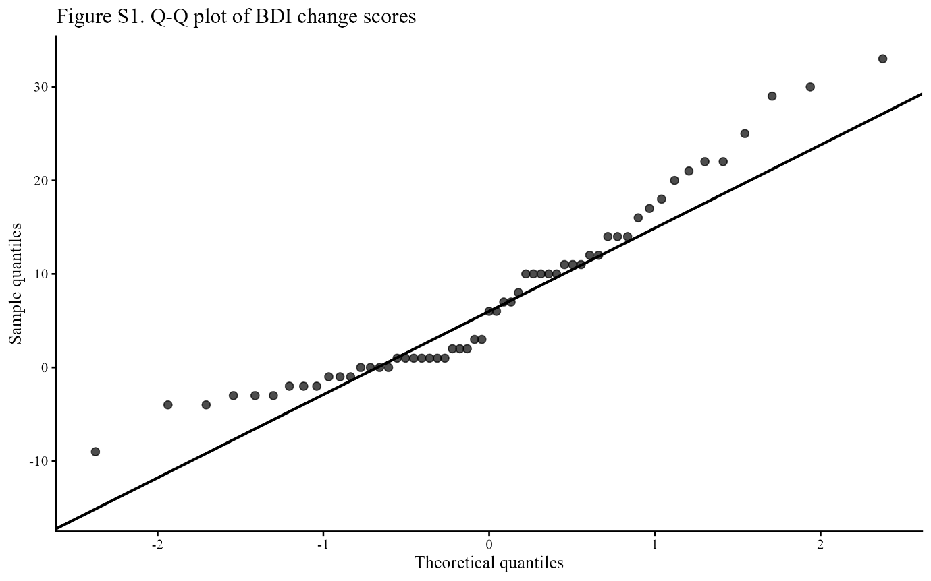
Figure S1. Q-Q plot of BDI change scores
Linear mixed-effects models: Normality of the residuals was assessed by inspection of residual Q-Q plots. On the MADRS, residuals appeared normally distributed. For the BDI model, however, the residual Q-Q plot indicated some deviation from normality, particularly in the tails of the distribution (see Figure S2 below). Nevertheless, the central part of the residual distribution followed the expected normal pattern reasonably well. Normality of the random effects was assessed by inspecting the Q-Q plot of the estimated random effects. Homoscedasticity was assessed by plotting residuals across time points and maintenance schedules to verify approximately constant variance across levels. Potentially influential patients were examined using Cook’s distance. Models were refitted excluding potentially influential patients, with no meaningful changes in the interpretation of the results.
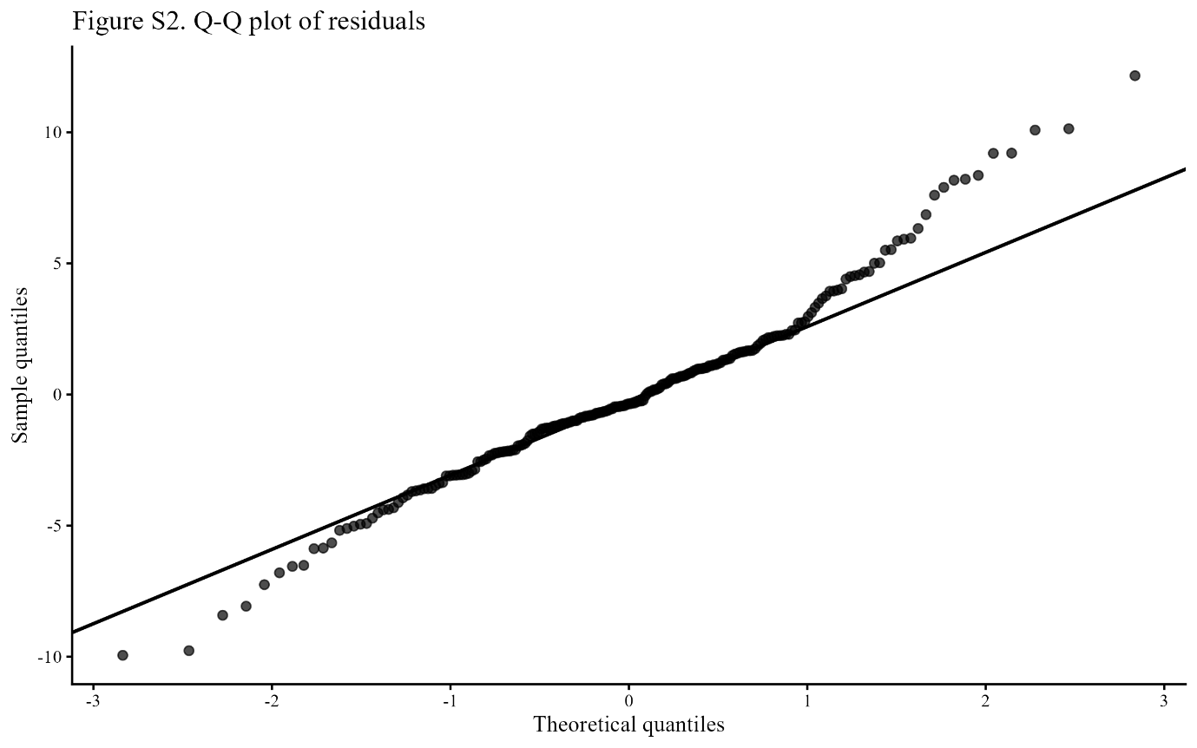
Figure S2. Q-Q plot of residuals
ANCOVA: Scatterplots of baseline and T13 scores suggested an approximately linear relationships for both instruments. Homogeneity of regression slopes was assessed by refitting each model with an interaction between baseline score and maintenance; no significant covariate and group interaction was observed for either instrument. Q-Q plots of the residuals indicated approximate normality, and residuals-versus-fitted plots did not suggest heteroscedasticity. Potentially influential observations were examined using standardized residuals and Cook’s distance. Models were refitted excluding influential observations, with no meaningful changes in the interpretation of the results.

- Supplementary Results
Figures
Figure S3. STROBE Patient-Flow Diagram for drop-out analysis
Note. CGI-I=Clinical Global Impression–Improvement; MADRS=Montgomery-Åsberg Depression Rating Scale; BDI=Beck Depression Inventory-II. Allocation to maintenance schedules was non-randomised (by clinical availability). Dropout reasons reported were: unknown (n = 10), increased panic attacks (n = 1), intense suicidal ideation with plan (n = 1), and death by suicide (n = 1)*.
*Suicide was committed five days post session 10 (MS 1). The Naranjo Adverse Drug Reaction Probability Scale (39) was used to determine the likelihood of esketamine contributing to the patient`s suicide. The 10-question survey was answered independently by two raters. revealing a “possible” (score = 3) probability of esketamine contributing to the patient`s death (total score of 3 out of 13 (+1 for previous conclusive reports on this reaction, +2 for adverse event appearing after suspected drug was administered, -1 for potential alternative causes of the adverse event, and +1 for the adverse event being confirmed by objective evidence).

Tables
Table S1. Descriptives of the induction phase
 | MADRS |  |  |  | BDI
T | n | mean | SD | 95% CI |  | n | mean | SD | 95% CI
T0 | 65 | 26.65 | 7.86 | [24.70, 28.59] |  | 65 | 31.48 | 9.39 | [29.15, 33.81]
T1 | 65 | 23.45 | 8.26 | [21.40, 25.49] |  | 65 | 28.34 | 10.43 | [25.76, 30.92]
T2 | 63 | 22.92 | 8.42 | [20.80, 25.04] |  | 61 | 26.85 | 10.79 | [24.09, 29.62]
T3 | 64 | 22.80 | 9.60 | [20.40, 25.19] |  | 61 | 27.54 | 11.28 | [24.65, 30.43]
T4 | 64 | 22.20 | 9.21 | [19.90, 24.50] |  | 64 | 25.72 | 10.84 | [23.01, 28.43]
T5 | 61 | 19.75 | 9.25 | [17.38, 22.12] |  | 61 | 24.41 | 10.61 | [21.69, 27.13]
T6 | 61 | 19.77 | 9.06 | [17.45, 22.09] |  | 61 | 24.61 | 11.09 | [21.77, 27.45]
T7 | 60 | 19.10 | 8.49 | [16.91, 21.29] |  | 61 | 23.48 | 11.05 | [20.65, 26.30]
T8 | 57 | 17.72 | 7.84 | [15.64, 19.80] |  | 57 | 23.60 | 10.92 | [20.65, 26.50]
Note. T = Time point.

Table S2. Complete case analysis: F-test linear mixed effects models
Measure | Variable | SS | df | MS | F |  | p
MADRS | T | 41.29 | 3, 150 | 13.76 | 0.74 |  | .530
 | Maintenance | 0.02 | 1, 50 | 0.02 | < 0.01 |  | .978
 | T × Maintenance | 98.75 | 3, 150 | 32.92 | 1.77 |  | .155
BDI | T | 55.06 | 3, 150 | 18.35 | 1.11 |  | .347
 | Maintenance | 1.12 | 1, 50 | 1.12 | 0.07 |  | .796
 | T × Maintenance | 73.10 | 3, 150 | 24.37 | 1.47 |  | .224
Note. SS = Sum of squares, MS = Mean square, T = Time points, Maintenance = Maintenance schedule.
Table S3. Complete case analysis: Contrast Maintenance Schedules
 | MADRS |  |  |  | BDI
Predictors | Estimate | SE | 95% CI | p | Estimate | SE | 95% CI | p
T8: MS1-MS2 | .89 | 2.64 | -4.37, 6.15 | .738 | 3.09 | 3.48 | -3.88, 10.05 | .379
T9: MS1-MS2 | - 2.02 | 2.64 | -7.28, 3.24 | .447 | - 0.32 | 3.48 | -7.29, 6.64 | .926
T10: MS1- MS2 | 2.04 | 2.64 | -3.22, 7.30 | .443 | .51 | 3.48 | -6.45, 7.48 | .883
T11: MS1- MS2 | - 0.64 | 2.64 | -5.90, 4.62 | .810 | .16 | 3.48 | -6.80, 7.12 | .963
Note. T = Timepoint, MS = Maintenance schedule.

