MP-fw_HindIII | GACCAAGCTTTGTCAGGCAACCAACCGTATTCACC
MP-rev_XhoI | TAAGCTCGAGCGTCAGATGTCCGAGTAGAGG
RT-tRF | TGTCAGGCAACCGTATTCACCGTGAGTGGTTGGTGG
Short tRF | CGTTCAGATGTCCGAGTAGAGGGGGAACGGCGATCCCACCG
18sRNA_F | GTAACCCGTTGAACCCCATT
18sRNA_R | CCATCCAATCGGTAGTAGCG
MP-fw | TGTCAGGCAACCGTATTCACC
MP Rev | CGTCAGATGTCCGAGTAGAGG
Β-actin_F | GAGCCTCGCCTTTGCCGATCC
B-actin_R | GACCCATGCCCACCATCACGC
CCND2_F | CAGCCGTCCACTTCAGC
CCND2_R | TGCCTTTGGGTCTTCC
Ki-67_F | TCCTTTGGTGGGCACCTAAGACCTG
Ki-67_R | TGATGGTTGAGGTCGTTCCTTGATG
TNKS_F | CGCGTGTCTGTTGTAGATA
TNKS_R | GGAGCTTGCAGATTTCATAC
LDHA_F | ATGGCAACTCTAAAGGATCAGC
LDHA_R | CCAACCCCAACAACTGTAATCT
STMN1_F | AAGGATCTTTCCCTGGAGGA
STMN1_R | CATTTGTGCCTCTCGGTTCT
IGFBP7_F | TGGGTGCTGGTATCTCCTCT
IGFBP7_R | TATAGCTCGGCACCTTCACC
APAF1_F | CACGTTCAAAGGTGGCTGAT
APAF1_R | TGGTCAACTGCAAGGACCAT
XIAP_F | CGTCGATTTTTGTGATGCTCGTCAG
XIAP_R | GAAGCATTTATCAGGGTTATTGTCTCATG
Table S1: List of primers used for the study.

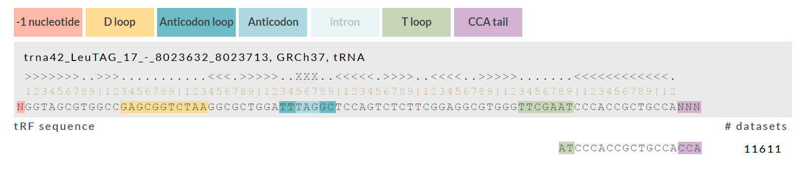
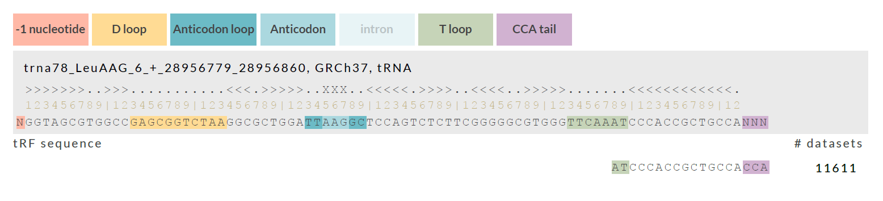

Fig. S1 (a): Origin of tRF-3001a from tRNA-Leu isoacceptors. tRF-3001a was identified to originate from two distinct leucine tRNA isoacceptors. The tRF-3001a sequence was used as the query to retrieve its parental tRNA sequences. Data retrieved from MINTbase v2.0.

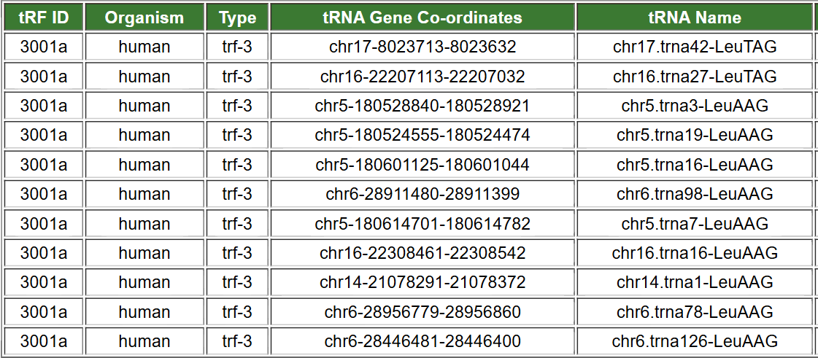
Fig. S1 (b): tRF-3001a mapping to human tRNA genes. The table lists the genomic coordinates and corresponding tRNA genes from which tRF-3001a is derived. tRF-3001a originates from multiple tRNA-Leu isoacceptors across different chromosomes, indicating its biogenesis from diverse parental tRNA genes in the human genome.
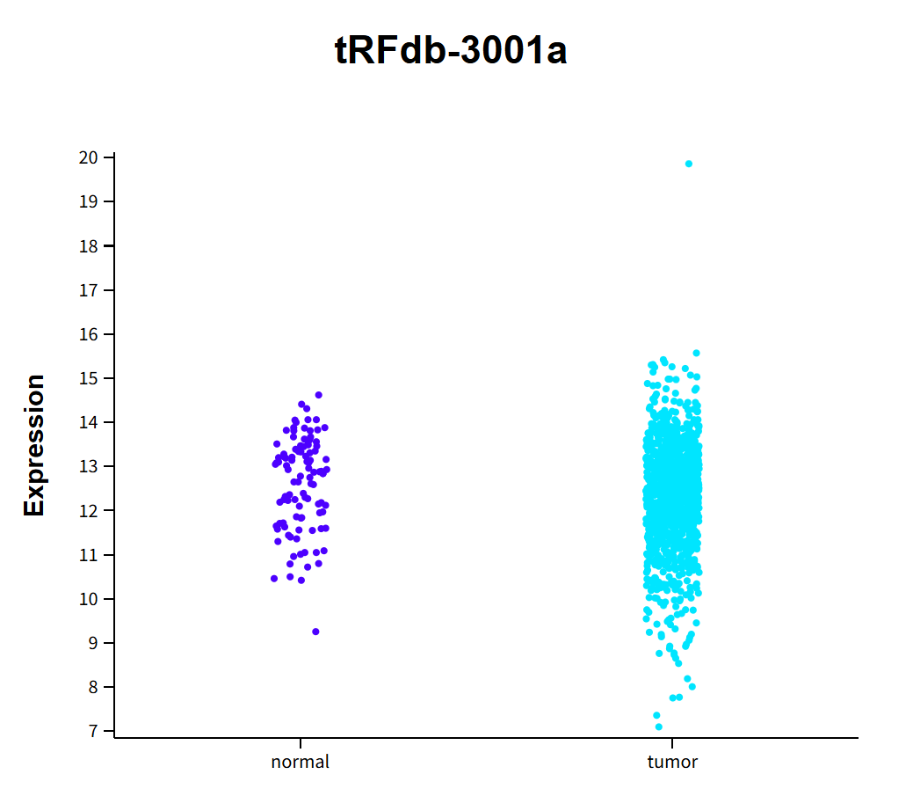
Fig. S2: Expression of tRF-3001a in normal and tumor samples. The scatter plot shows individual expression levels of tRF-3001a in normal (purple) and tumor (cyan) tissues. Each dot represents a single sample, indicating that tRF-3001a expression is higher and more variable in tumor samples compared to normal samples (adjusted P value = 0.02933). Data retrieved from tRFexplorer. tRF ID: tRFdb-3001a.
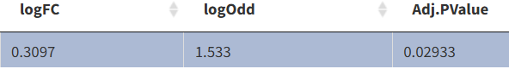

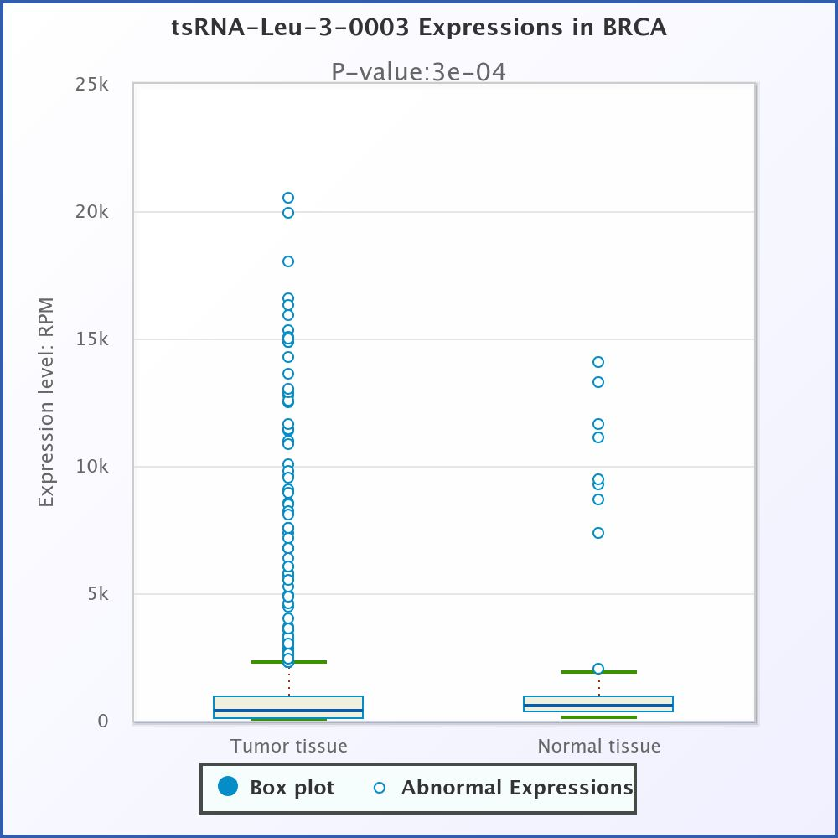
Fig. S3: Expression of tsRNA-Leu-3-0003 in BRCA. Box plots show expression levels (RPM) of tsRNA-Leu-3-0003 in BRCA tumor and normal tissues. Tumor tissues display significantly higher expression compared to normal tissues (P = 0.0003). Data retrieved from tsRFun. tRF ID: tsRNA-Leu-3-0003.
Fig. S4: Comparative expression of tRF-3001a across different cell lines. The relative expression of tRF-3001a was analysed in 5 different cell lines-A549, HeLa, HepG2, MDA-MB-231 and MCF-7. The expression was found to be higher in breast cancer cell lines, especially in MCF-7 cells. β-actin was used as the reference gene.
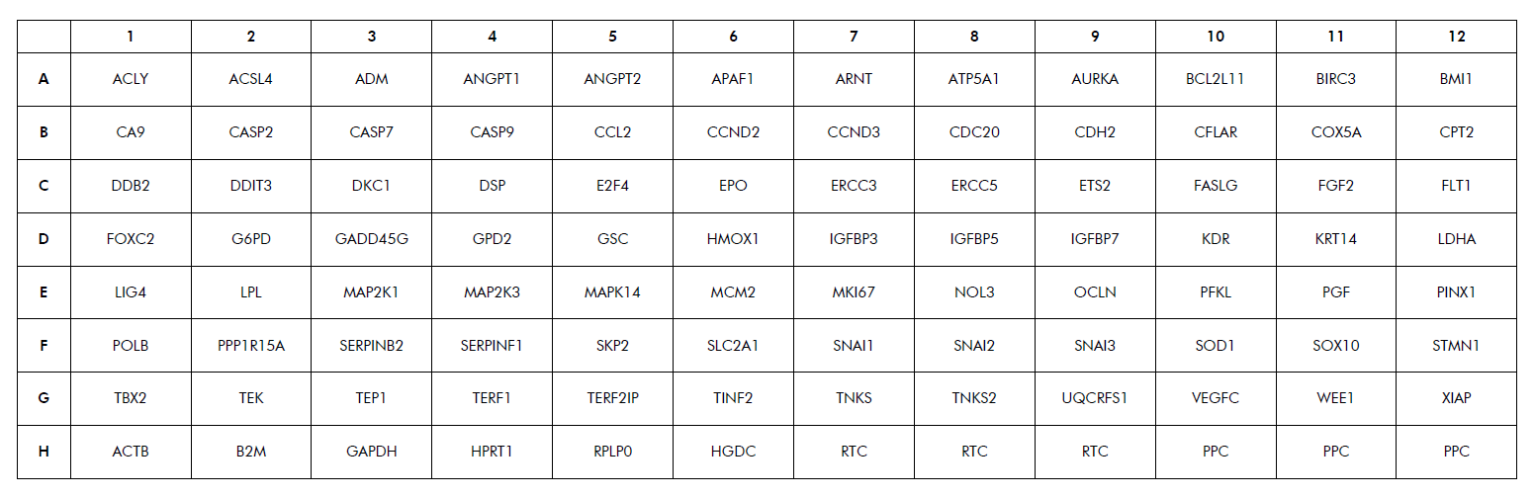
Fig. S5: Human Cancer PathwayFinder™ PCR Array layout. The 96-well RT2 profiler plate contained primers for 84 Human cancer pathway genes, 5 housekeeping genes (ACTB, B2M, GAPDH, HPRT1, RPLP0), 1 Human Genomic DNA Contamination, 3 reverse transcription control, 3 positive PCR control wells.

