Metric | Derivation Cohort | Independent Holdout Cohort
Area Under ROC Curve (AUC) | 0.907 | 0.717
Accuracy | 0.809 | -
Balanced Accuracy | - | 0.687
Optimal Classification Threshold | 0.742 | Applied from derivation cohort
G-mean | 0.808 | -
Sensitivity | 0.862 | 0.700
Specificity | 0.757 | 0.674
Supplementary Table S1. Performance metrics of the ensemble machine learning model in the derivation and independent holdout cohorts. The optimal classification threshold in the derivation cohort was selected using the maximum geometric mean (G-mean) criterion and subsequently applied to the holdout cohort for external evaluation.

Risk Score | Dysphagia Cases (Positive) | No Dysphagia (Negative) | Total Patients | Proportion Dysphagia (%)
-12 | 0 | 1 | 1 | 0.0
-10 | 1 | 3 | 4 | 25.0
-9 | 0 | 1 | 1 | 0.0
-7 | 2 | 9 | 11 | 18.2
-5 | 0 | 5 | 5 | 0.0
-4 | 0 | 2 | 2 | 0.0
-1 | 3 | 8 | 11 | 27.3
0 | 3 | 3 | 6 | 50.0
2 | 7 | 30 | 37 | 18.9
3 | 5 | 7 | 12 | 41.7
4 | 2 | 1 | 3 | 66.7
5 | 18 | 24 | 42 | 42.9
6 | 2 | 0 | 2 | 100.0
7 | 3 | 5 | 8 | 37.5
8 | 4 | 8 | 12 | 33.3
9 | 4 | 1 | 5 | 80.0
10 | 2 | 3 | 5 | 40.0
11 | 43 | 19 | 62 | 69.4
12 | 16 | 2 | 18 | 88.9
13 | 0 | 7 | 7 | 0.0
14 | 60 | 32 | 92 | 65.2
16 | 0 | 4 | 4 | 0.0
17 | 6 | 3 | 9 | 66.7
19 | 0 | 3 | 3 | 0.0
Supplementary Table S2. Distribution of postoperative dysphagia outcomes across cumulative risk score categories in the derivation cohort. The proportion dysphagia (%) represents the percentage of patients within each score category who developed new-onset postoperative dysphagia following anti-reflux surgery.

Risk Score | Dysphagia Cases (Positive) | No Dysphagia (Negative) | Total Patients | Proportion Dysphagia (%)
-10 | 7 | 4 | 11 | 63.6
-7 | 0 | 1 | 1 | 0.0
-5 | 0 | 3 | 3 | 0.0
-1 | 1 | 0 | 1 | 100.0
0 | 1 | 0 | 1 | 100.0
2 | 2 | 6 | 8 | 25.0
3 | 3 | 1 | 4 | 75.0
4 | 0 | 5 | 5 | 0.0
5 | 1 | 1 | 2 | 50.0
7 | 1 | 2 | 3 | 33.3
8 | 1 | 2 | 3 | 33.3
11 | 1 | 12 | 13 | 7.7
12 | 0 | 2 | 2 | 0.0
13 | 0 | 1 | 1 | 0.0
14 | 0 | 1 | 1 | 0.0
17 | 2 | 4 | 6 | 33.3
19 | 0 | 1 | 1 | 0.0
Supplementary Table S3. Distribution of postoperative dysphagia outcomes across cumulative risk score categories in the independent validation cohort. The proportion dysphagia (%) represents the percentage of patients within each score category who developed new-onset postoperative dysphagia following anti-reflux surgery.

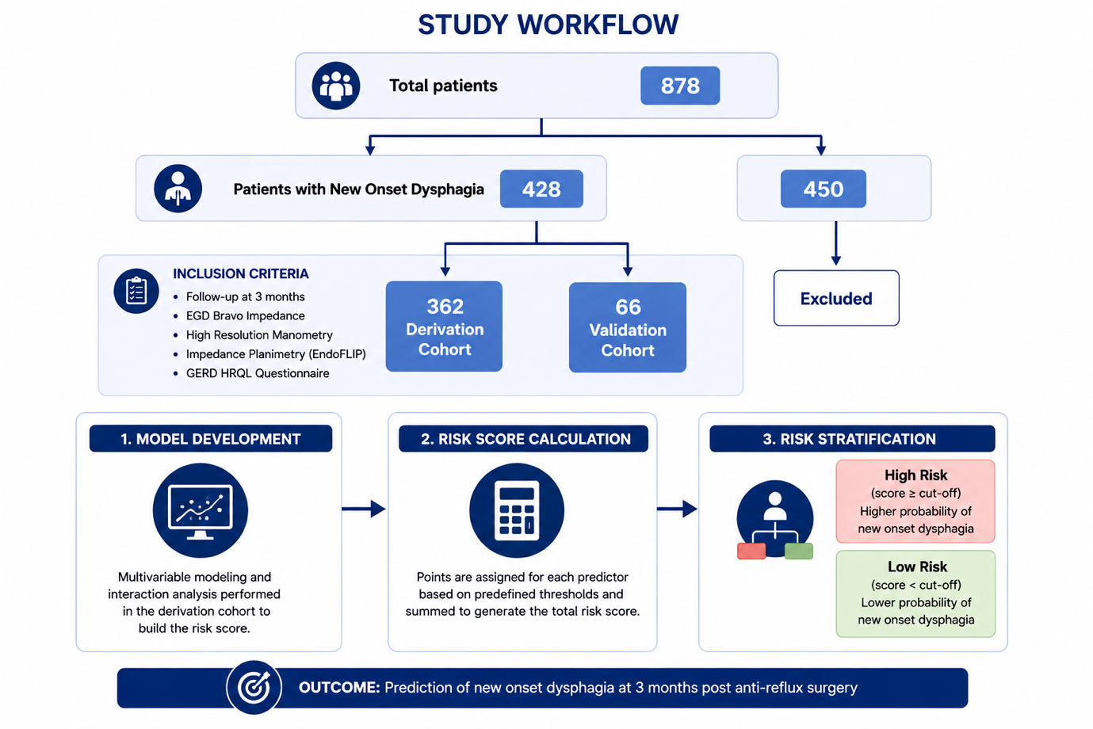
Supplementary Figure S1.
Overview of study design and workflow for development of the interpretable machine learning derived dysphagia risk score. A total of 878 patients undergoing anti-reflux surgery were screened, of whom 428 patients met inclusion criteria and were divided into derivation (n=362) and independent validation (n=66) cohorts. Preoperative physiologic assessment included Bravo pH impedance monitoring, high-resolution manometry (HRM), impedance planimetry (EndoFLIP), and GERD-HRQL symptom assessment. Multivariable modeling and interaction analysis were performed in the derivation cohort to construct a threshold-based point scoring system, which was subsequently applied for postoperative dysphagia risk stratification.

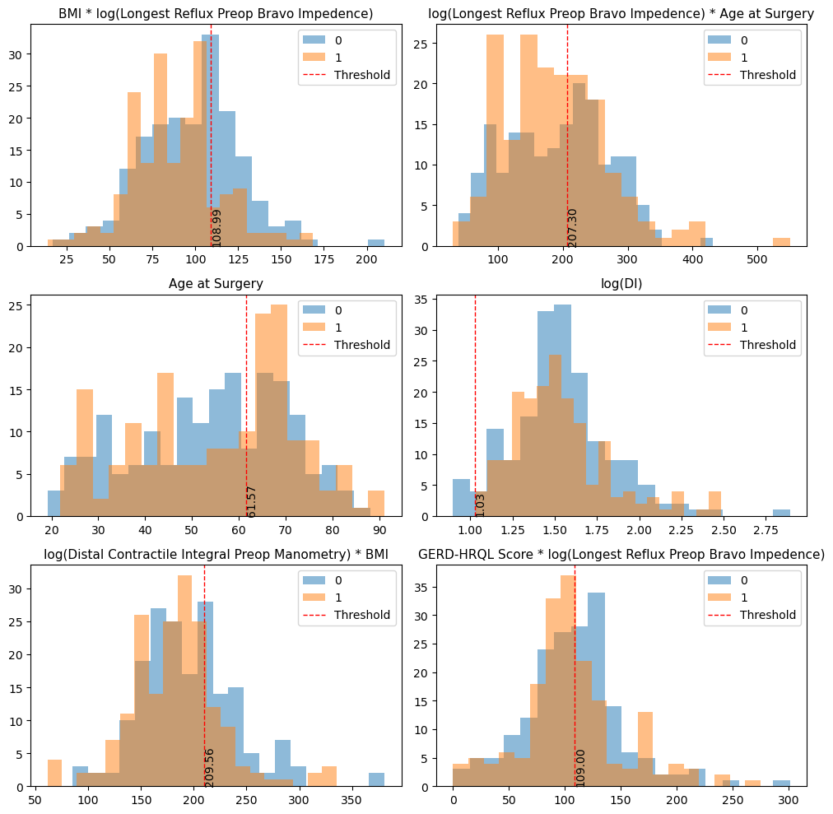
Supplementary Figure S2.
Distribution histograms demonstrating model-derived thresholds for key physiologic and interaction-based predictors incorporated into the dysphagia risk score. Blue distributions represent patients without postoperative dysphagia (class 0), whereas orange distributions represent patients who developed postoperative dysphagia (class 1). Red dashed lines indicate optimized classification thresholds derived during model development. Features shown include interaction terms between reflux burden, esophageal contractility, body mass index, age, and EndoFLIP-derived distensibility metrics.

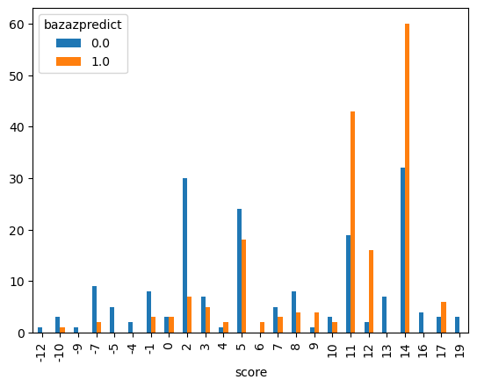
Supplementary Figure S3.
Bar plot demonstrating the distribution of postoperative dysphagia outcomes across cumulative risk score categories in the derivation cohort. Blue bars represent patients without postoperative dysphagia (Bazaz score negative), whereas orange bars represent patients who developed new-onset postoperative dysphagia (Bazaz score positive). Increasing risk scores were associated with progressive enrichment of dysphagia cases, supporting the discriminatory capacity of the interpretable scoring framework.

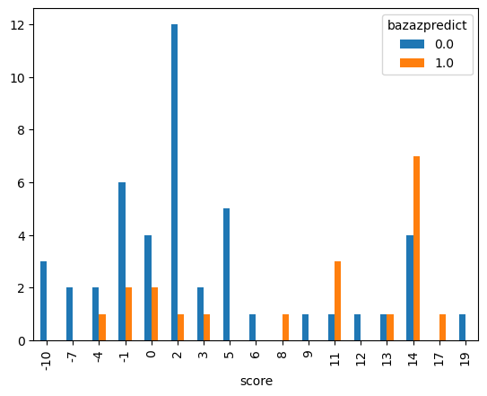
Supplementary Figure S4.
Bar plot demonstrating the distribution of postoperative dysphagia outcomes across cumulative risk score categories in the independent validation cohort. Blue bars represent patients without postoperative dysphagia (Bazaz score negative), whereas orange bars represent patients who developed new-onset postoperative dysphagia (Bazaz score positive). Despite reduced cohort size, higher cumulative risk scores remained associated with enrichment of dysphagia cases, supporting preservation of risk stratification performance in the holdout dataset.

