Supplementary Information for “Nature-dependent lifeways are widely exposed to ecological novelty”
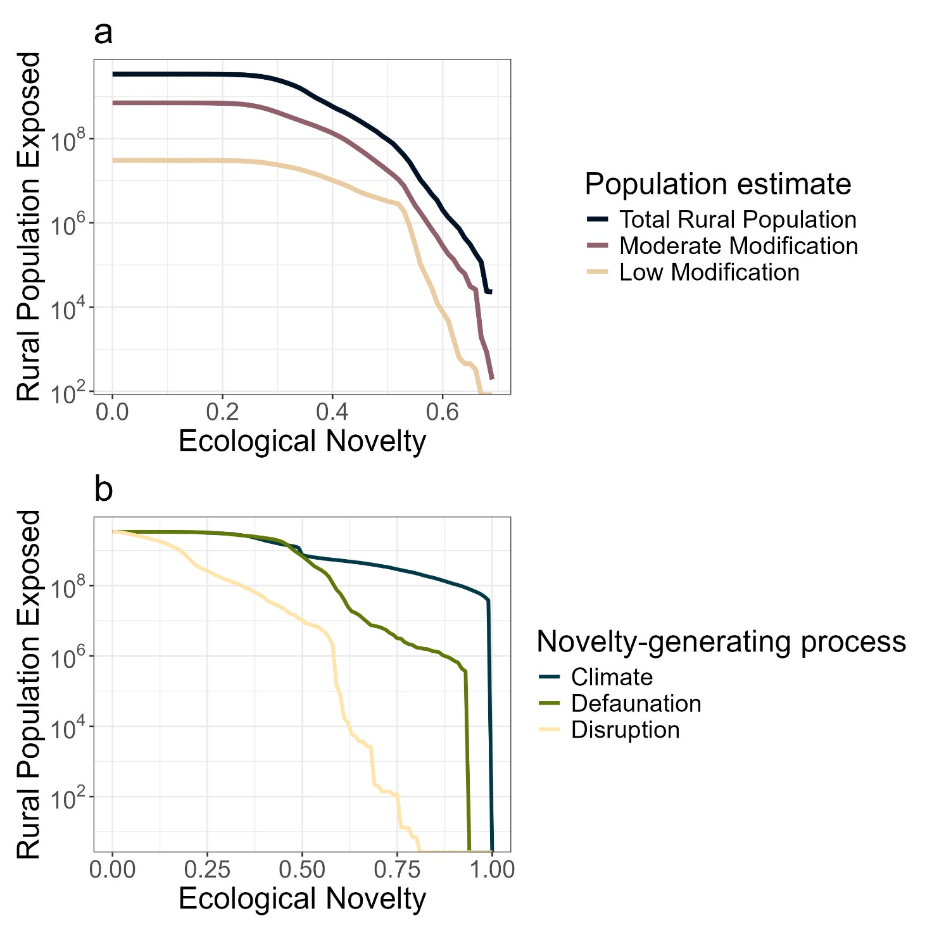
Supplementary Figure 1 | Rural populations are differentially exposed to ecological novelty. a, the total rural population exposed to different levels of total ecological novelty is shown for the total population and two different levels of human modification, “moderate” (<0.4 human modification index) and “low” (<0.1 human modification index). b, the number of rural people exposed at different levels of three different novelty-generating processes: climate, mammal defaunation, and floristic disruption. Populations are highly exposed to climate and defaunation novelty at all levels, with disruption novelty falling more quickly, reflecting the global distribution of novelty-generating processes.
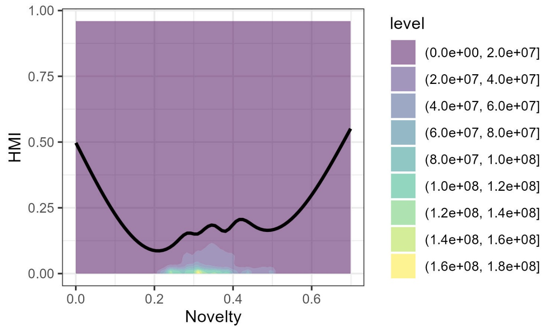
Supplementary Figure 2 | The human modification index (HMI) has a weak relationship with ecological novelty. Ecological novelty is most concentrated in areas with low human modification index, highlighted by the density plot. Levels in the density plot show the number of cells out of a 10x10km resolution global map of terrestrial novelty (see Figure 1). The fitted line is the result of a generalised additive model with the formula HMI ~ Novelty, where novelty is smoothed using a cubic spline.

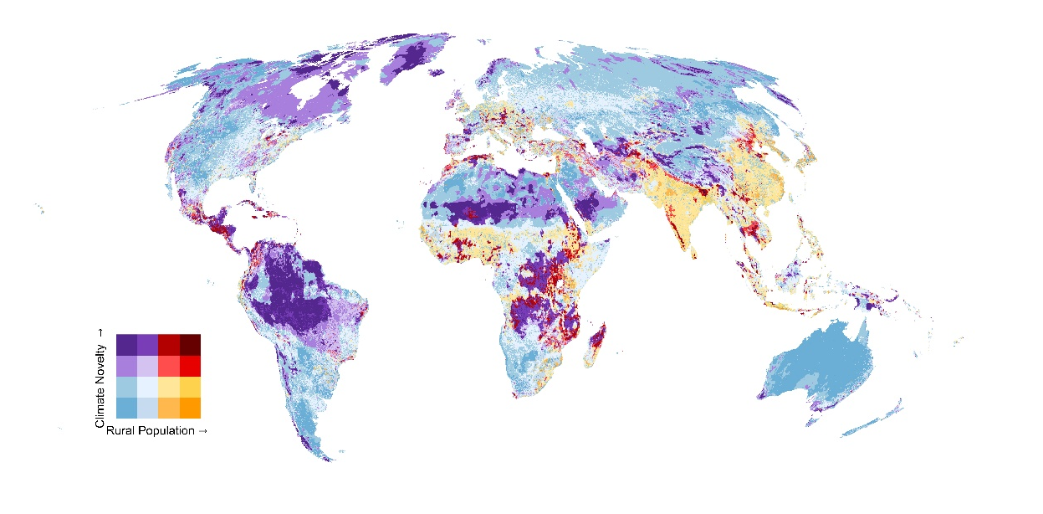
Supplementary Figure 3 | Rural populations are widely exposed to novel climate conditions. The degree to which modern climates are novel is plotted alongside the total rural population, shown on a log scale. The colour scheme (legend) is divided into four quadrants: low novelty-low rural population (blue colours), high novelty-low rural population (purple), low novelty-high rural population (orange), and high novelty-high rural population (red). There are 742 million rural people in the two high novelty quadrants, representing 21.8% of the total rural population.

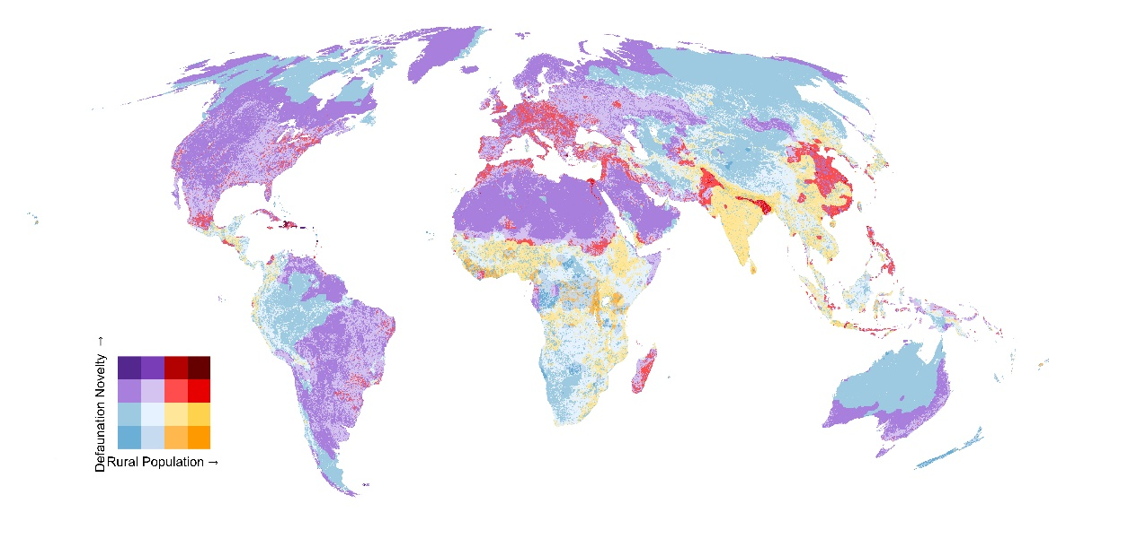
Supplementary Figure 4 | Rural populations are widely exposed to highly defaunated conditions. The degree to which mammals have been locally defaunated is plotted alongside the total rural population, shown on a log scale. The colour scheme (legend) is divided into four quadrants: low novelty-low rural population (blue colours), high novelty-low rural population (purple), low novelty-high rural population (orange), and high novelty-high rural population (red). There are 690 million rural people in the two high novelty quadrants, representing 20% of the total rural population.

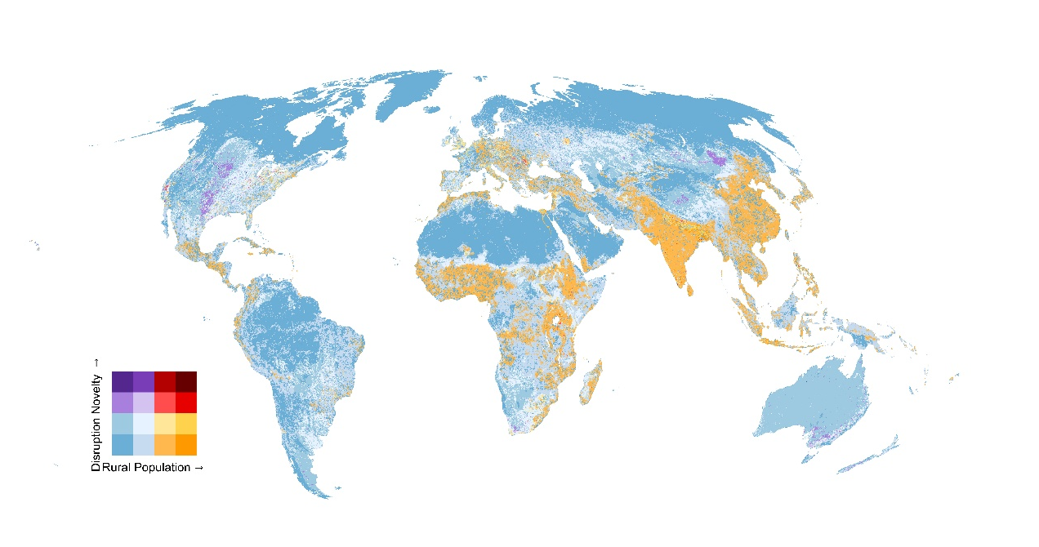
Supplementary Figure 5 | Rural populations are exposed to low levels of floristic disruption. The degree of floristic disruption is plotted alongside the total rural population, shown on a log scale. The colour scheme (legend) is divided into four quadrants: low novelty-low rural population (blue colours), high novelty-low rural population (purple), low novelty-high rural population (orange), and high novelty-high rural population (red). There are 10.4 million rural people in the two high novelty quadrants, representing <1% of the total rural population.

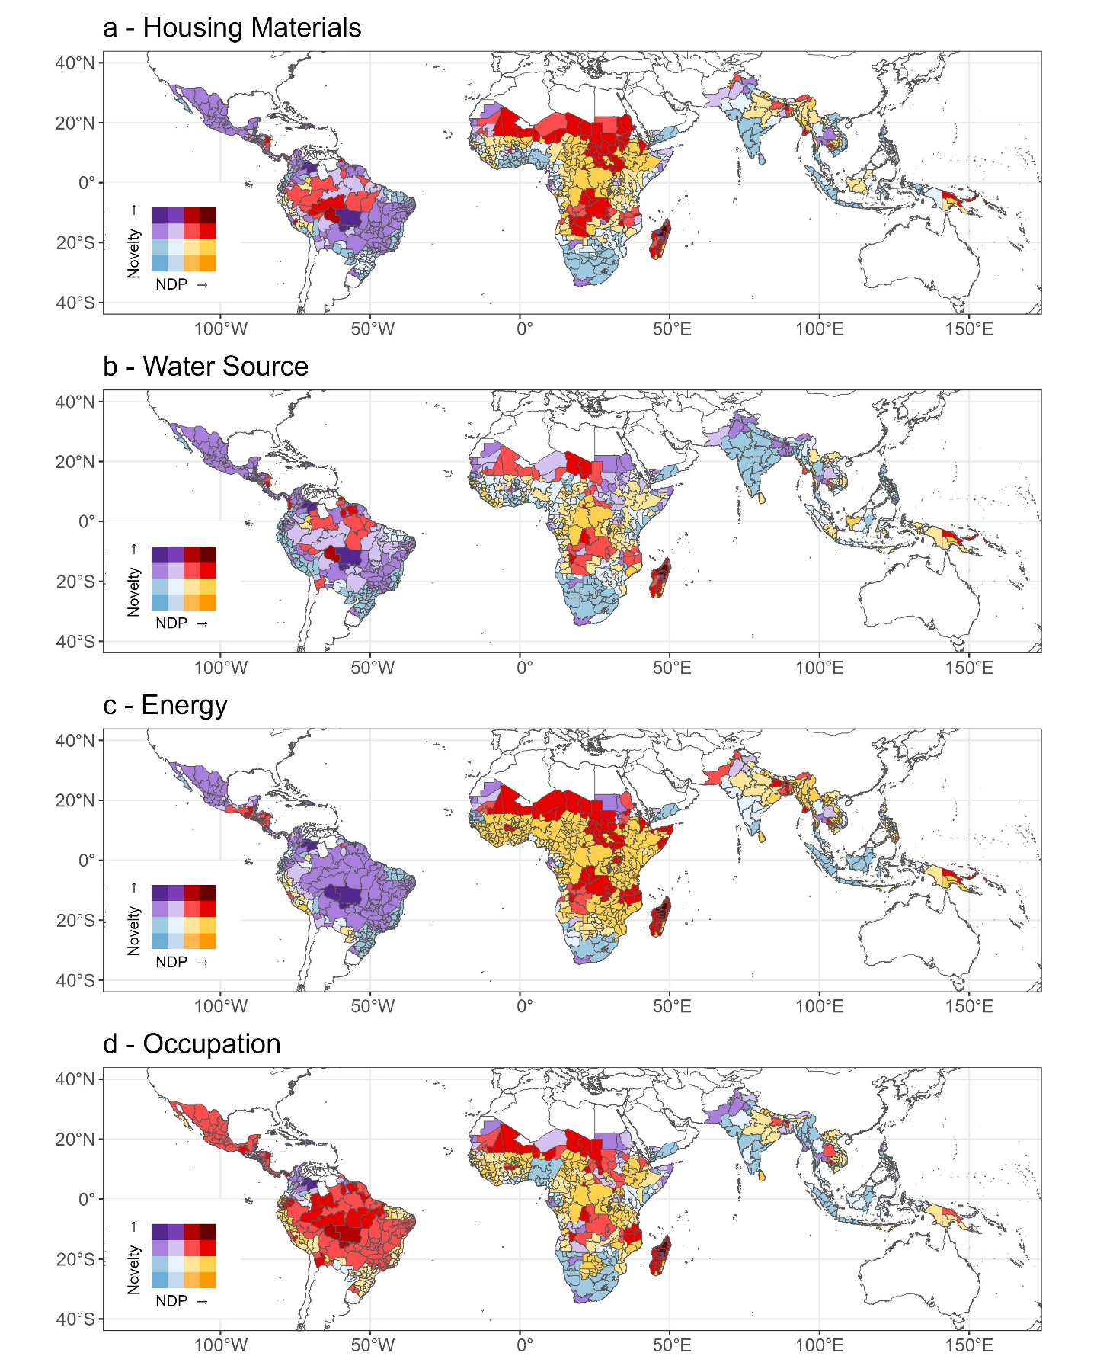
Supplementary Figure 6 | Basic needs derived from nature are exposed to highly novel ecological conditions. The percentage of people in an area who rely on nature for one of four basic needs are shown, plotted against total novelty exposure. The four basic needs are: a, natural housing materials (e.g. wood or bamboo); b, water from a local natural source (e.g. rivers or springs); c, energy from a local natural source (e.g. wood or straw); d, an occupation which directly involves nature (e.g. agriculture or fishing). Individual novelty-generating processes are shown in the following figures (Supplementary Figures 7-9).
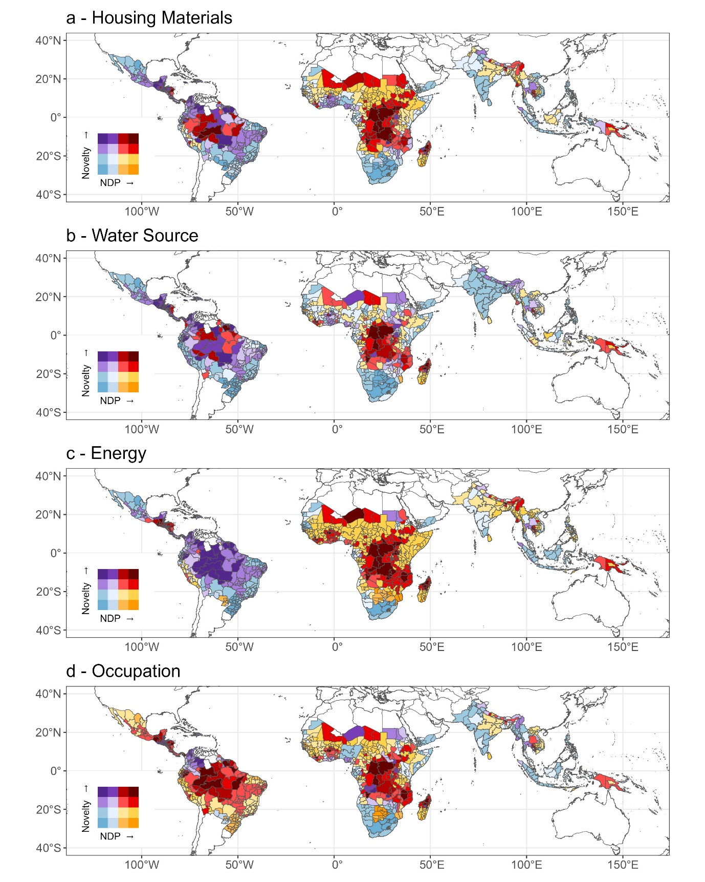
Supplementary figure 7 | Nature dependent people across the tropics are living in novel climates. The percentage of people in an area who rely on nature for one of four basic needs are shown, plotted against climate novelty. The four basic needs are: a, natural housing materials (e.g. wood or bamboo); b, water from a local natural source (e.g. rivers or springs); c, energy from a local natural source (e.g. wood or straw); d, an occupation which directly involves nature (e.g. agriculture or fishing).
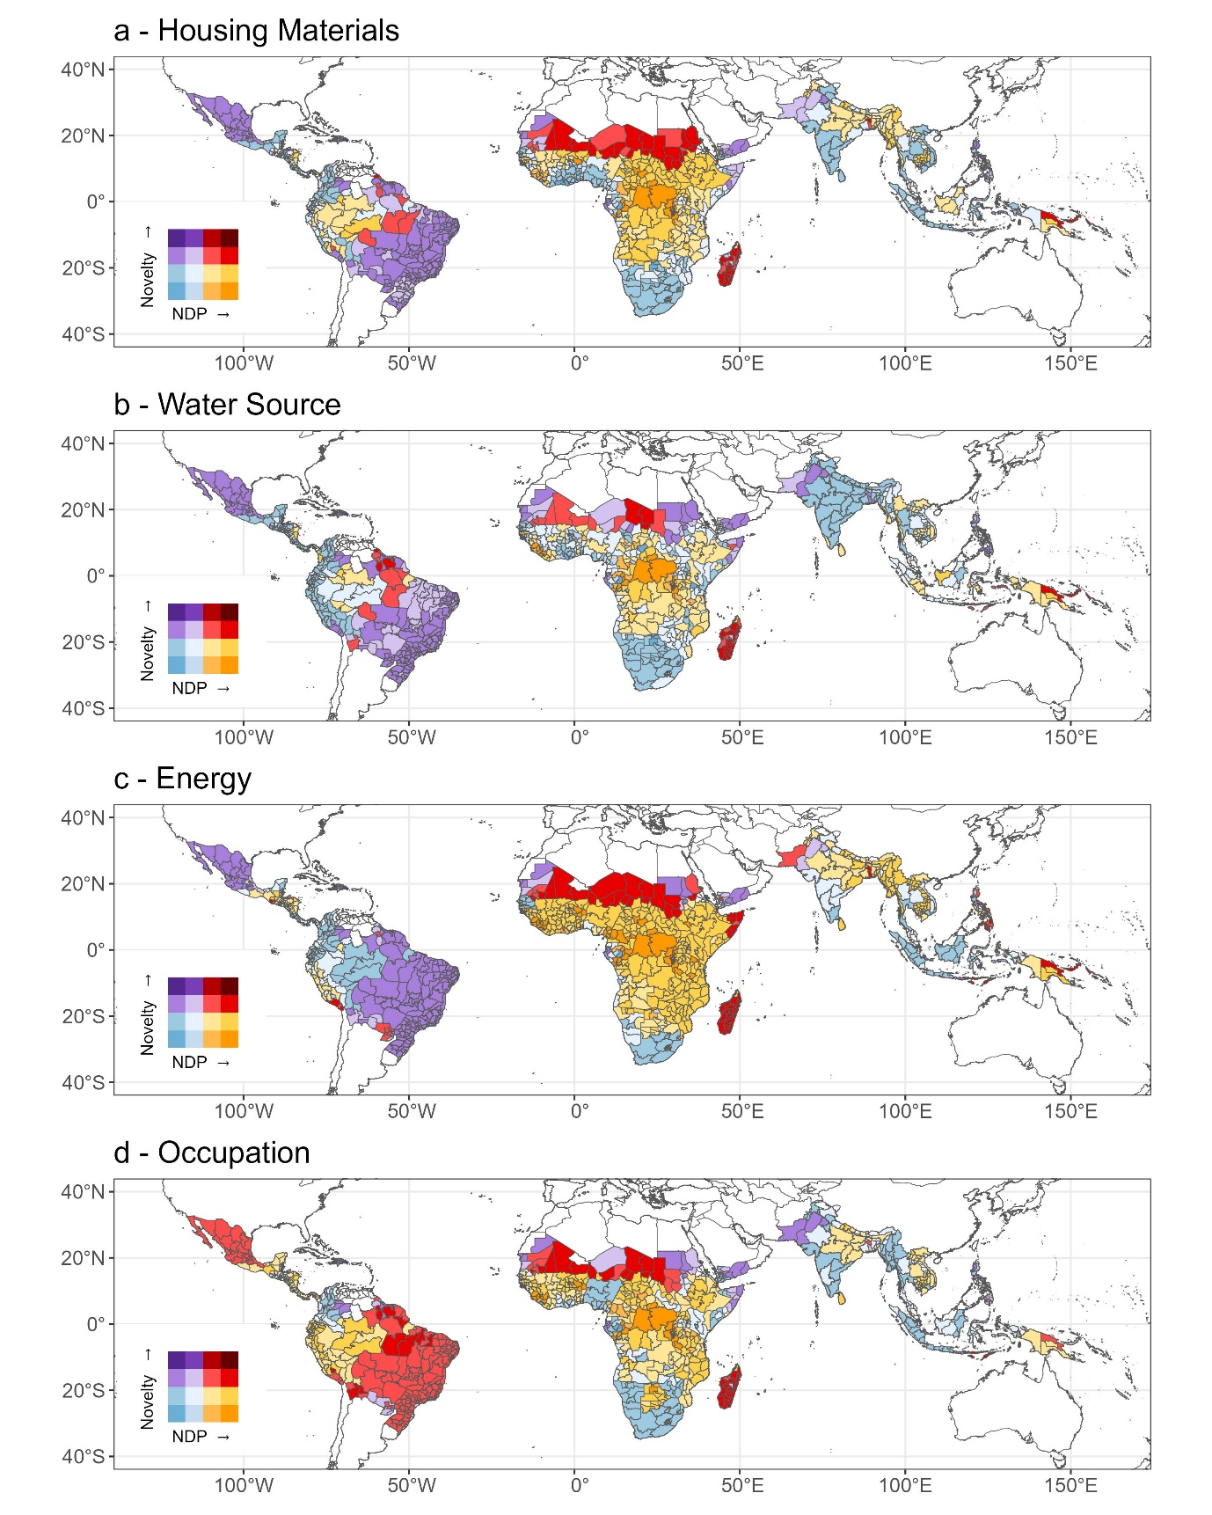
Supplementary figure 8 | Nature dependent people across the tropics are living in defaunated nature. The percentage of people in an area who rely on nature for one of four basic needs are shown, plotted against historic mammal defaunation. The four basic needs are: a, natural housing materials (e.g. wood or bamboo); b, water from a local natural source (e.g. rivers or springs); c, energy from a local natural source (e.g. wood or straw); d, an occupation which directly involves nature (e.g. agriculture or fishing).
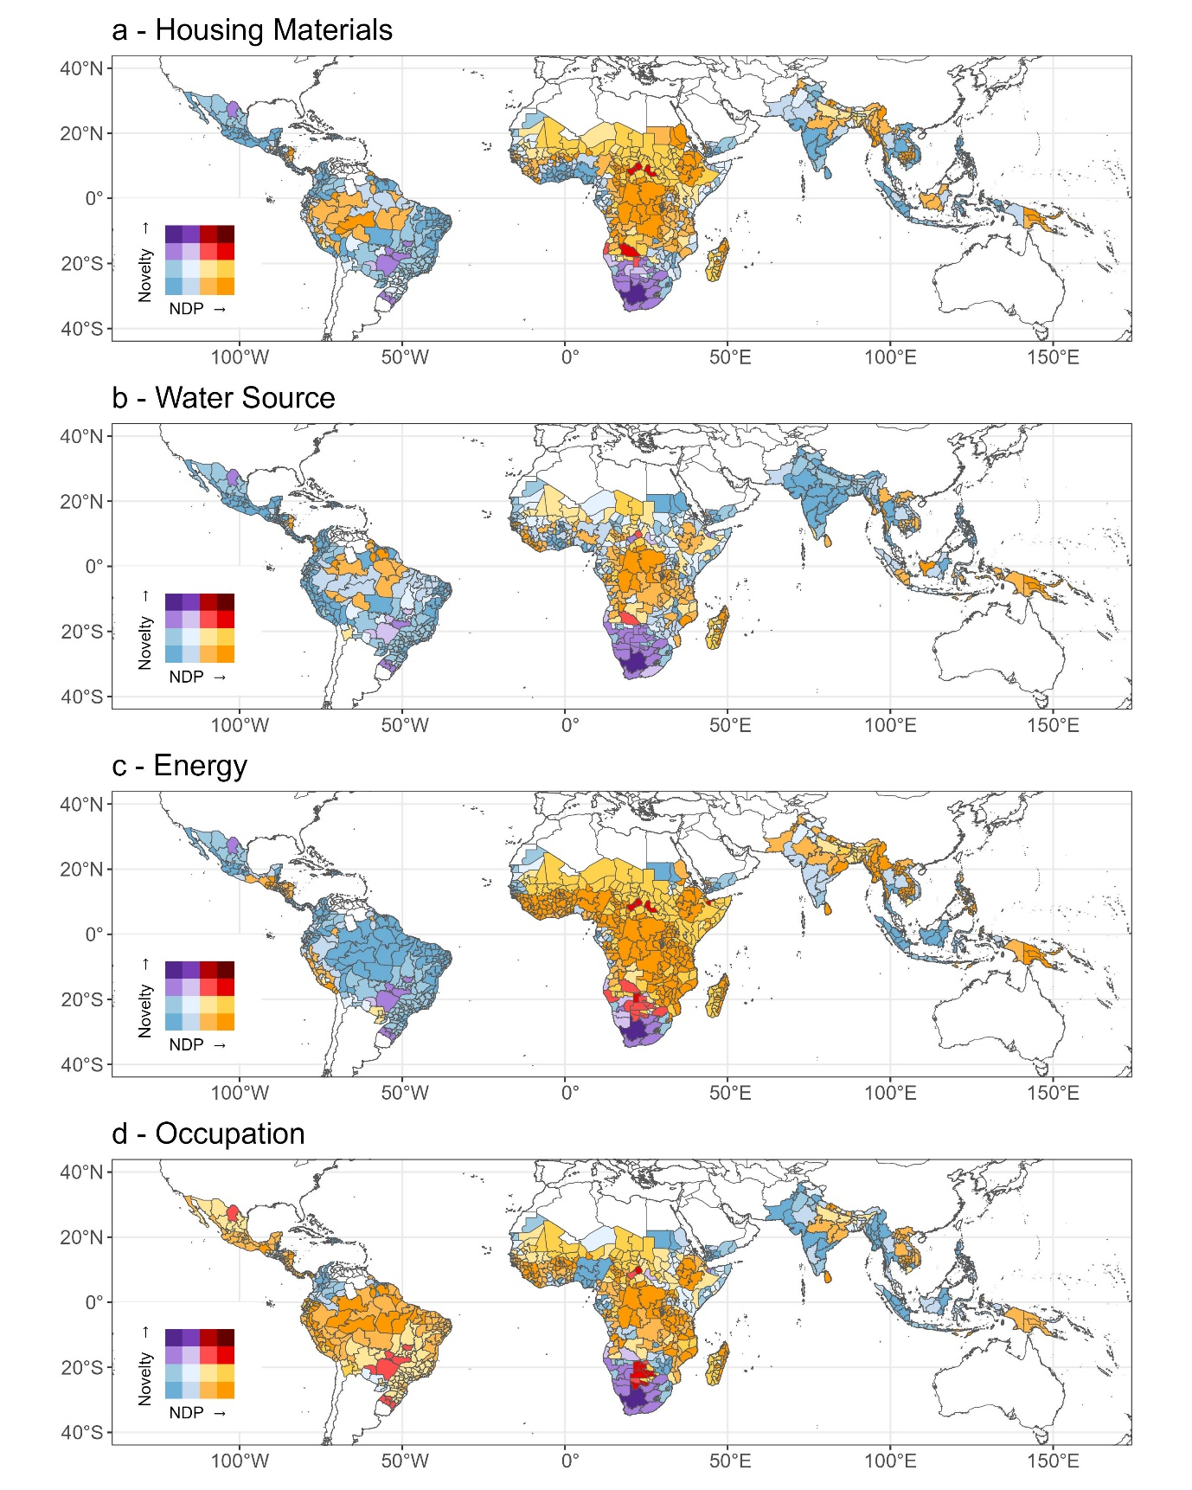
Supplementary Figure 9 | Nature dependent people across the tropics are living in disrupted nature. The percentage of people in an area who rely on nature for one of four basic needs are shown, plotted against floristic disruption. The four basic needs are: a, natural housing materials (e.g. wood or bamboo); b, water from a local natural source (e.g. rivers or springs); c, energy from a local natural source (e.g. wood or straw); d, an occupation which directly involves nature (e.g. agriculture or fishing).

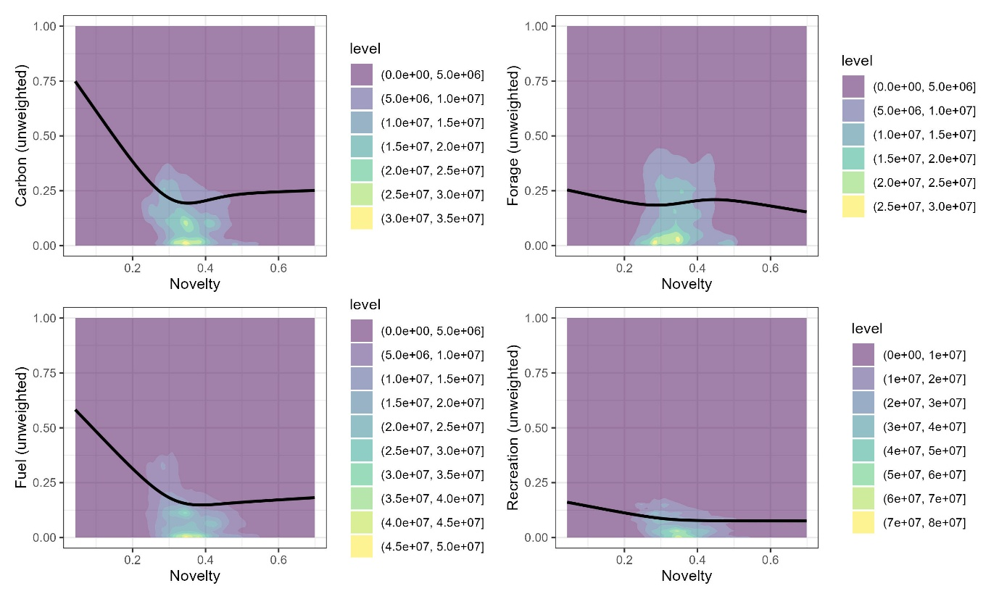
Supplementary Figure 10 | Expected ecosystem service provisioning is lower in areas with higher ecological novelty. Ecosystem service provisioning for four key ecosystem services is shown plotted against the level of total ecological novelty exposure in the same cell. Ecosystem service provisioning is scaled between 0-1 and is the product of an ensemble modelling approach. Levels in the density plot show the number of cells out of a 10x10km resolution global map of terrestrial novelty (see Figure 1). The fitted line is the result of a generalised additive model with the formula EcosystemService ~ Novelty, where novelty is smoothed using a cubic spline.
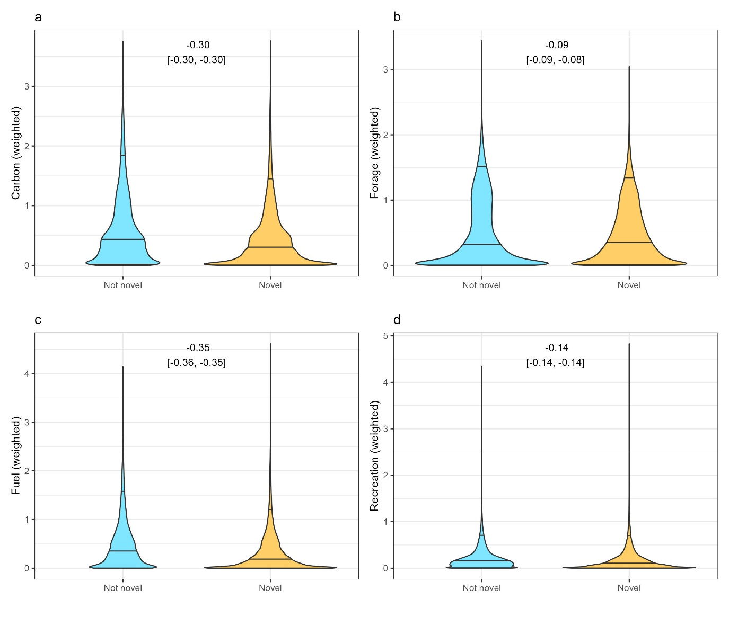
Supplementary Figure 11 | Expected ecosystem service provisioning, weighted by the rural population, is lower in highly novel areas. Ecosystem service provisioning, weighted by the rural population present in the same cell, for four key ecosystem services is shown for areas that are considered “highly novel” (a novelty score of 0.33 or above) and “lower novelty” (a novelty score below 0.33). Ecosystem service provisioning is the product of an ensemble modelling approach and is originally scaled 0-1 before being multiplied by the logged rural population in the cell. Horizontal lines on each plot mark the 95th, 50th, and 5th quantile. Labels at the top of each panel show the effect size (Hedge’s G) for each comparison (not novel against novel). Violin plots for individual novelty-generating processes are shown as supplemental information (Supplementary Figures 10-12).
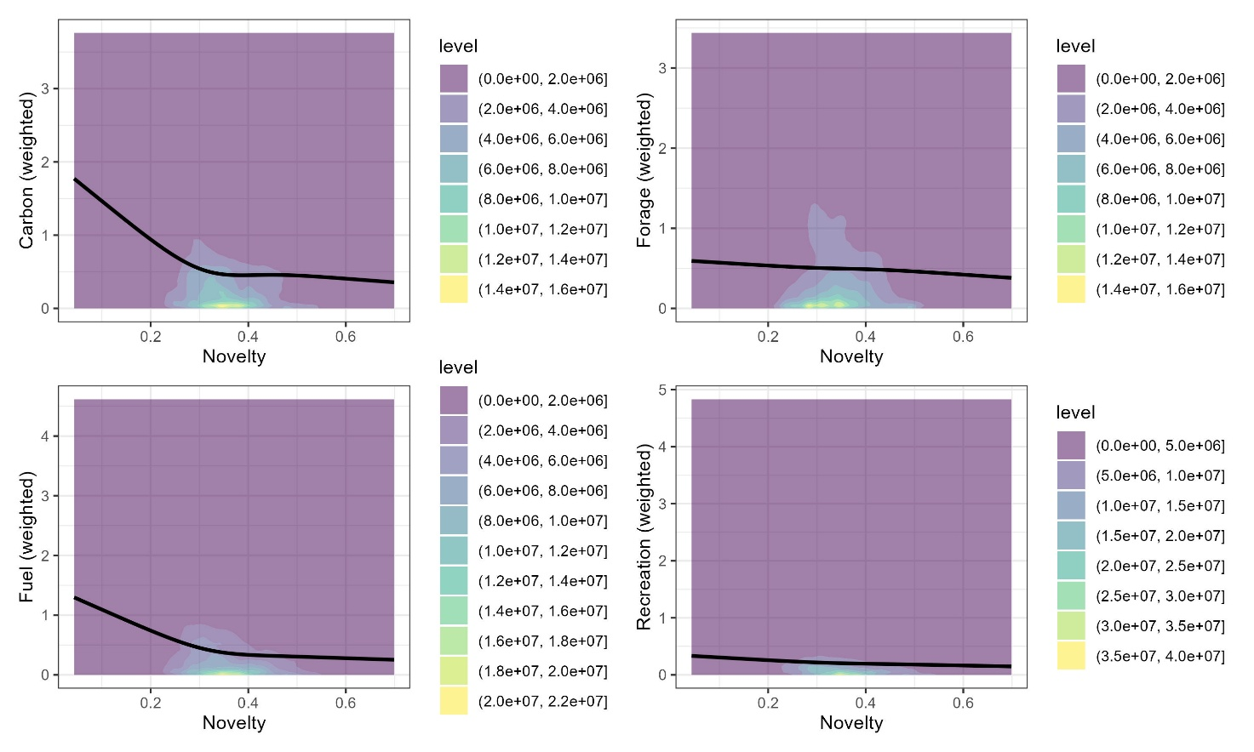
Supplementary Figure 12 | Expected ecosystem service provisioning, weighted by the rural population, is lower in areas with higher ecological novelty. Ecosystem service provisioning, weighted by the rural population present in the same cell,m for four key ecosystem services is shown plotted against the level of total ecological novelty exposure in the same cell. Ecosystem service provisioning is the product of an ensemble modelling approach and is originally scaled 0-1 before being multiplied by the logged rural population in the cell. Levels in the density plot show the number of cells out of a 10x10km resolution global map of terrestrial novelty (see Figure 1). The fitted line is the result of a generalised additive model with the formula EcosystemService ~ Novelty, where novelty is smoothed using a cubic spline.

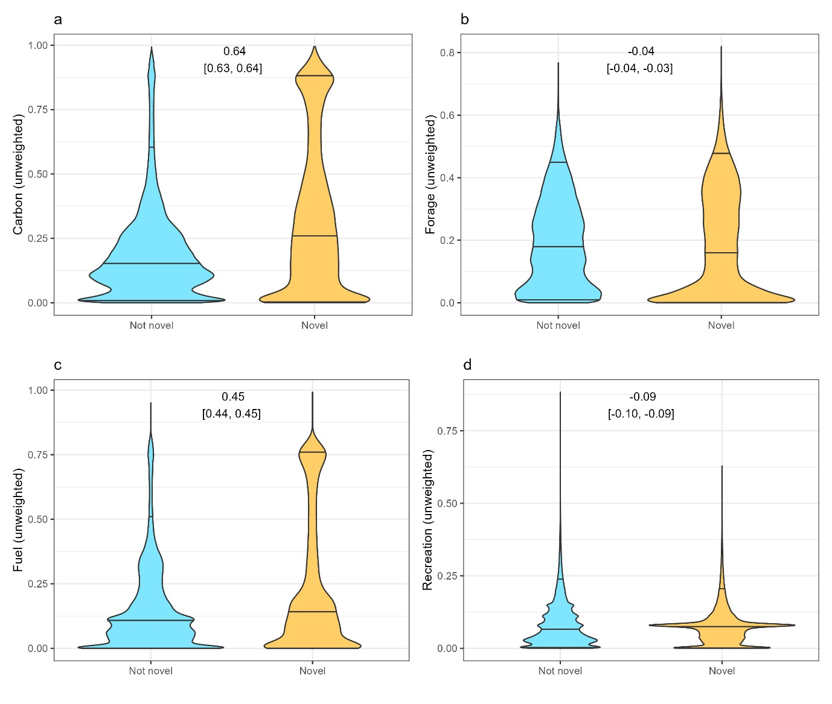
Supplementary figure 13 | Some expected ecosystem services provisioning is higher in areas with very high climate novelty. Ecosystem service provisioning for four key ecosystem services is shown for areas that are considered “highly novel” (a novelty score of 0.66 or above) and “lower novelty” (a novelty score below 0.66) with respect to climate novelty only. Ecosystem service provisioning is scaled between 0-1 and is the product of an ensemble modelling approach. Horizontal lines on each plot mark the 95th, 50th, and 5th quantile. Labels at the top of each panel show the effect size (Hedge’s G) for each comparison (not novel against novel).
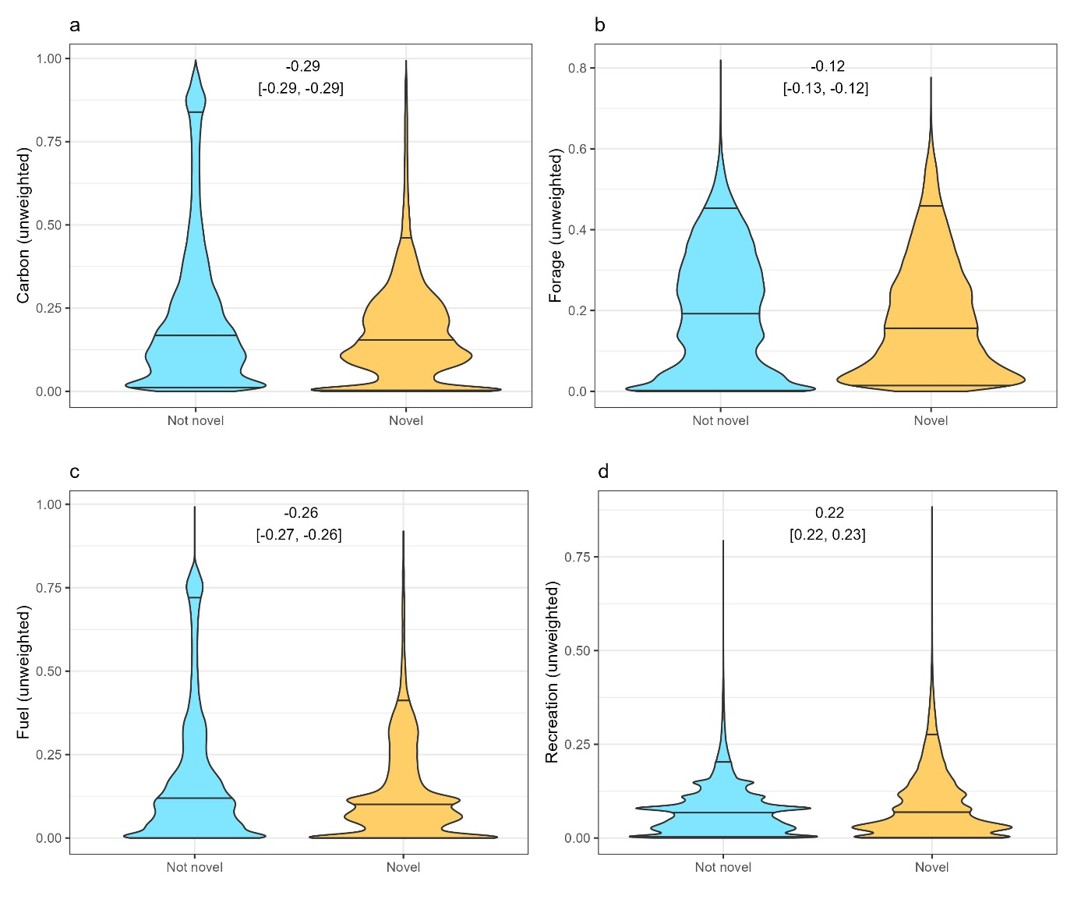
Supplementary figure 14 | Expected ecosystem services provisioning is lower in areas with very high mammal defaunation novelty. Ecosystem service provisioning for four key ecosystem services is shown for areas that are considered “highly novel” (a novelty score of 0.5 or above) and “lower novelty” (a novelty score below 0.5) with respect to defaunation novelty only. Ecosystem service provisioning is scaled between 0-1 and is the product of an ensemble modelling approach. Horizontal lines on each plot mark the 95th, 50th, and 5th quantile. Labels at the top of each panel show the effect size (Hedge’s G) for each comparison (not novel against novel).

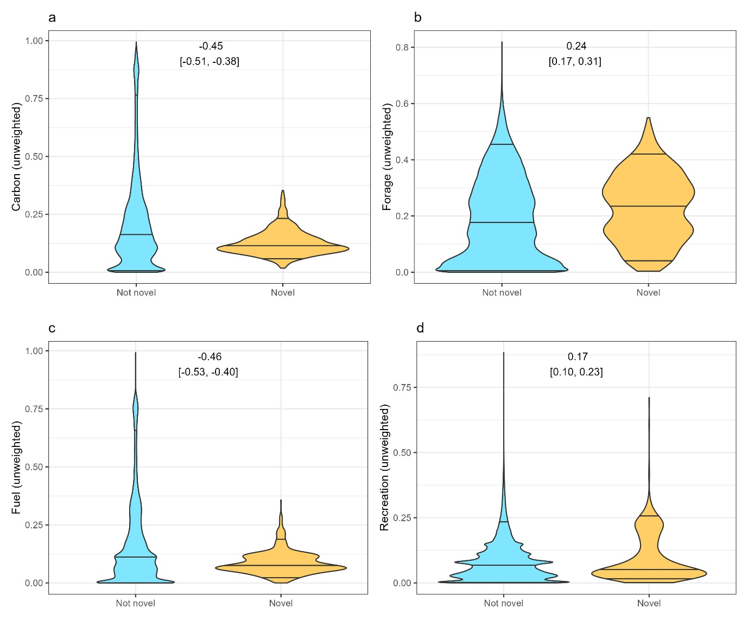
Supplementary figure 15 | Expected ecosystem services provisioning is lower in areas with very high floristic disruption novelty. Ecosystem service provisioning for four key ecosystem services is shown for areas that are considered “highly novel” (a novelty score of 0.25 or above) and “lower novelty” (a novelty score below 0.25) with respect to floristic disruption novelty only. Ecosystem service provisioning is scaled between 0-1 and is the product of an ensemble modelling approach. Horizontal lines on each plot mark the 95th, 50th, and 5th quantile. Labels at the top of each panel show the effect size (Hedge’s G) for each comparison (not novel against novel).

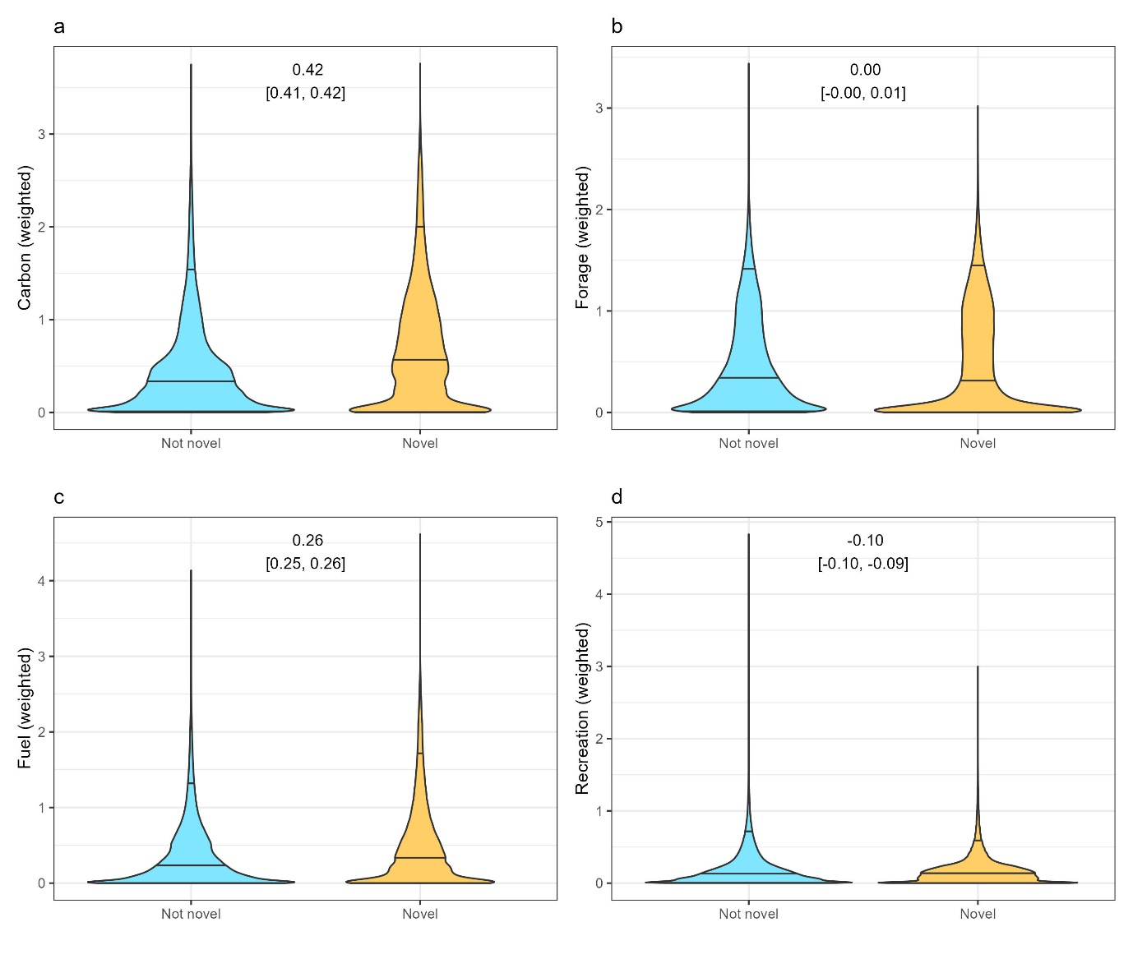
Supplementary figure 16 | Expected ecosystem services provisioning varies between areas with and without very high climate novelty. Ecosystem service provisioning for four key ecosystem services is shown for areas that are considered “highly novel” (a novelty score of 0.66 or above) and “lower novelty” (a novelty score below 0.66) with respect to climate novelty only. Ecosystem service provisioning is scaled between 0-1, before being multiplied by the logged rural population to create a weighted value, and is the product of an ensemble modelling approach. Horizontal lines on each plot mark the 95th, 50th, and 5th quantile. Labels at the top of each panel show the effect size (Hedge’s G) for each comparison (not novel against novel).
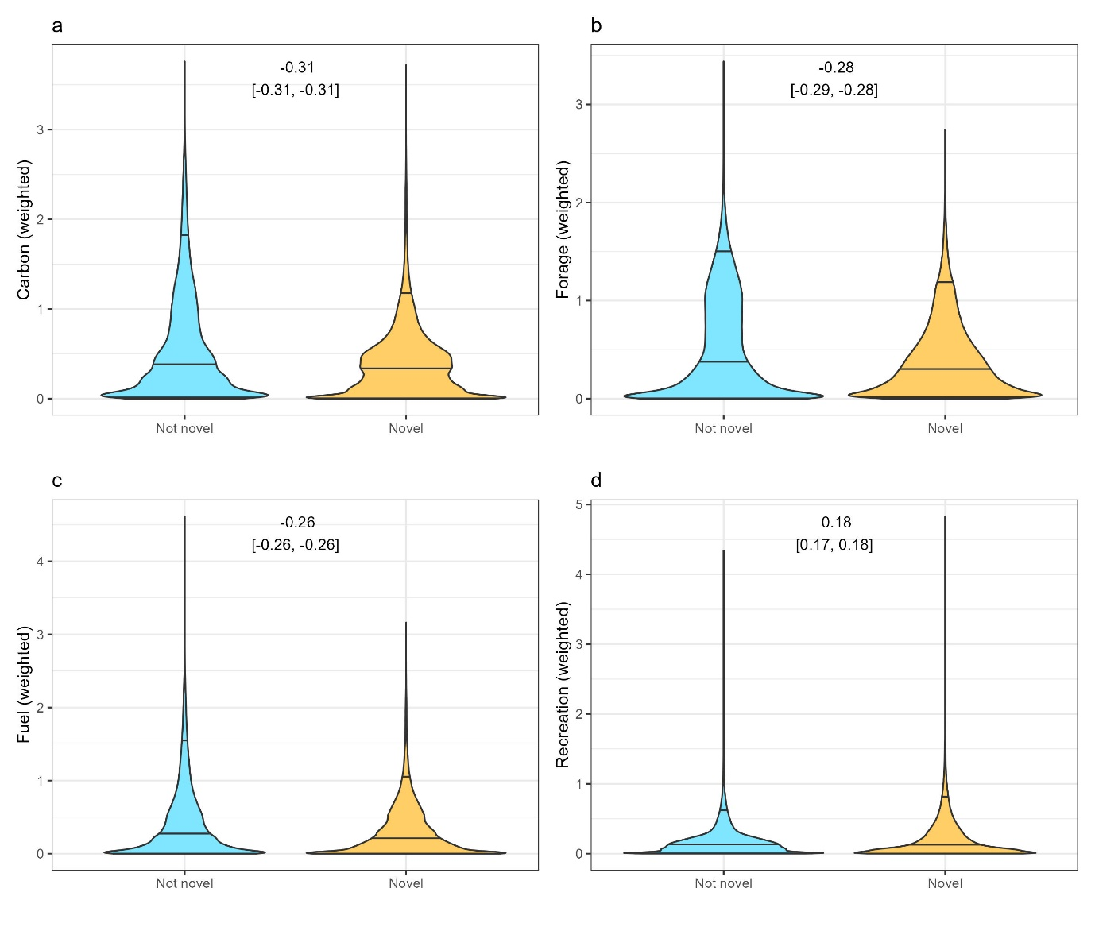
Supplementary figure 17 | Expected ecosystem services provisioning is varies between areas with and without very high mammal defaunation novelty. Ecosystem service provisioning for four key ecosystem services is shown for areas that are considered “highly novel” (a novelty score of 0.5 or above) and “lower novelty” (a novelty score below 0.5) with respect to defaunation novelty only. Ecosystem service provisioning is scaled between 0-1, before being multiplied by the logged rural population to create a weighted value, and is the product of an ensemble modelling approach. Horizontal lines on each plot mark the 95th, 50th, and 5th quantile. Labels at the top of each panel show the effect size (Hedge’s G) for each comparison (not novel against novel).
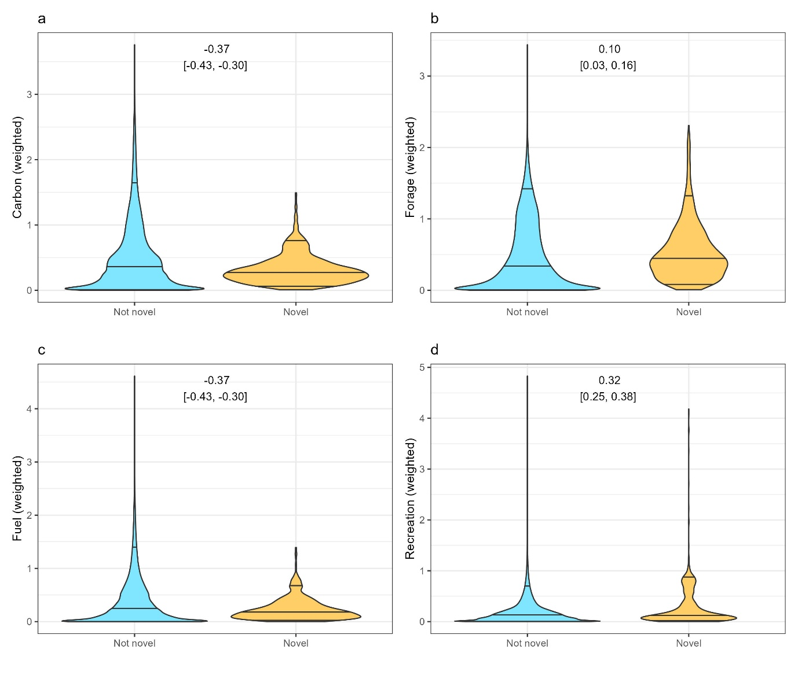
Supplementary figure 18 | Expected ecosystem services provisioning varies between areas with and without very high floristic disruption novelty. Ecosystem service provisioning for four key ecosystem services is shown for areas that are considered “highly novel” (a novelty score of 0.25 or above) and “lower novelty” (a novelty score below 0.25) with respect to floristic disruption novelty only. Ecosystem service provisioning is scaled between 0-1, before being multiplied by the logged rural population to create a weighted value, and is the product of an ensemble modelling approach. Horizontal lines on each plot mark the 95th, 50th, and 5th quantile. Labels at the top of each panel show the effect size (Hedge’s G) for each comparison (not novel against novel).

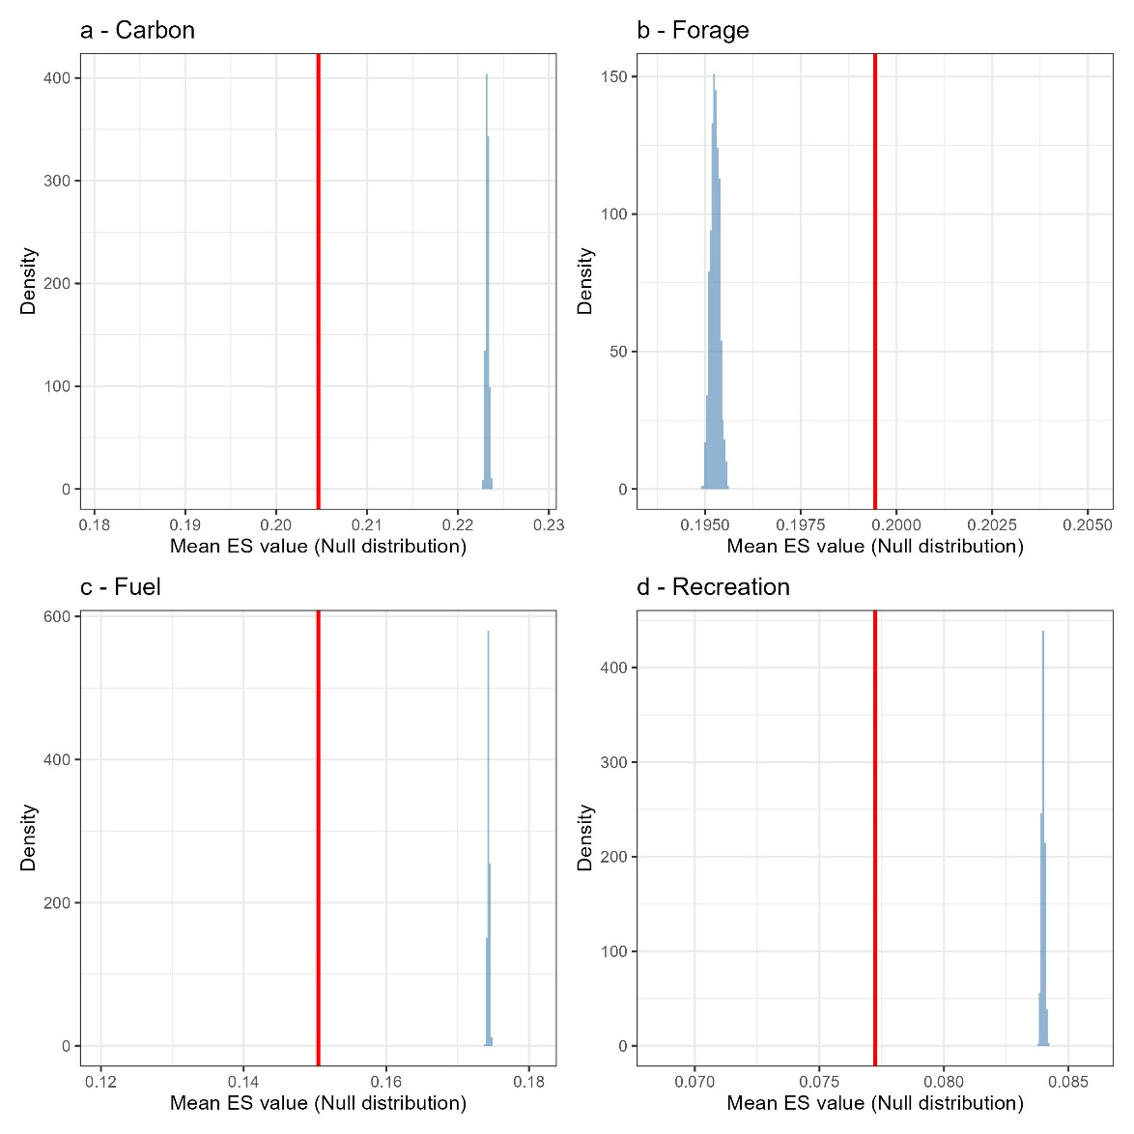
Supplementary Figure 19 | Ecosystem service provisioning within highly novel areas is different than expected by random. Shown on each plot is the observed mean (red vertical line) within novel cells (novelty score >0.33) compared to a randomised null distribution (blue histogram), where the novelty value of cells was randomly shuffled. Ecosystem service provisioning is scaled between 0-1 and is the product of an ensemble modelling approach. Four ecosystem services are shown: a, aboveground carbon, b, forage production, c, fuelwood, and d, recreation. For all but forgaging production, the global mean is to the left and outside the null distribution, showing that it is significantly lower than expected by random. Note, however, the small range on the x-axis, reflecting the small effect size.
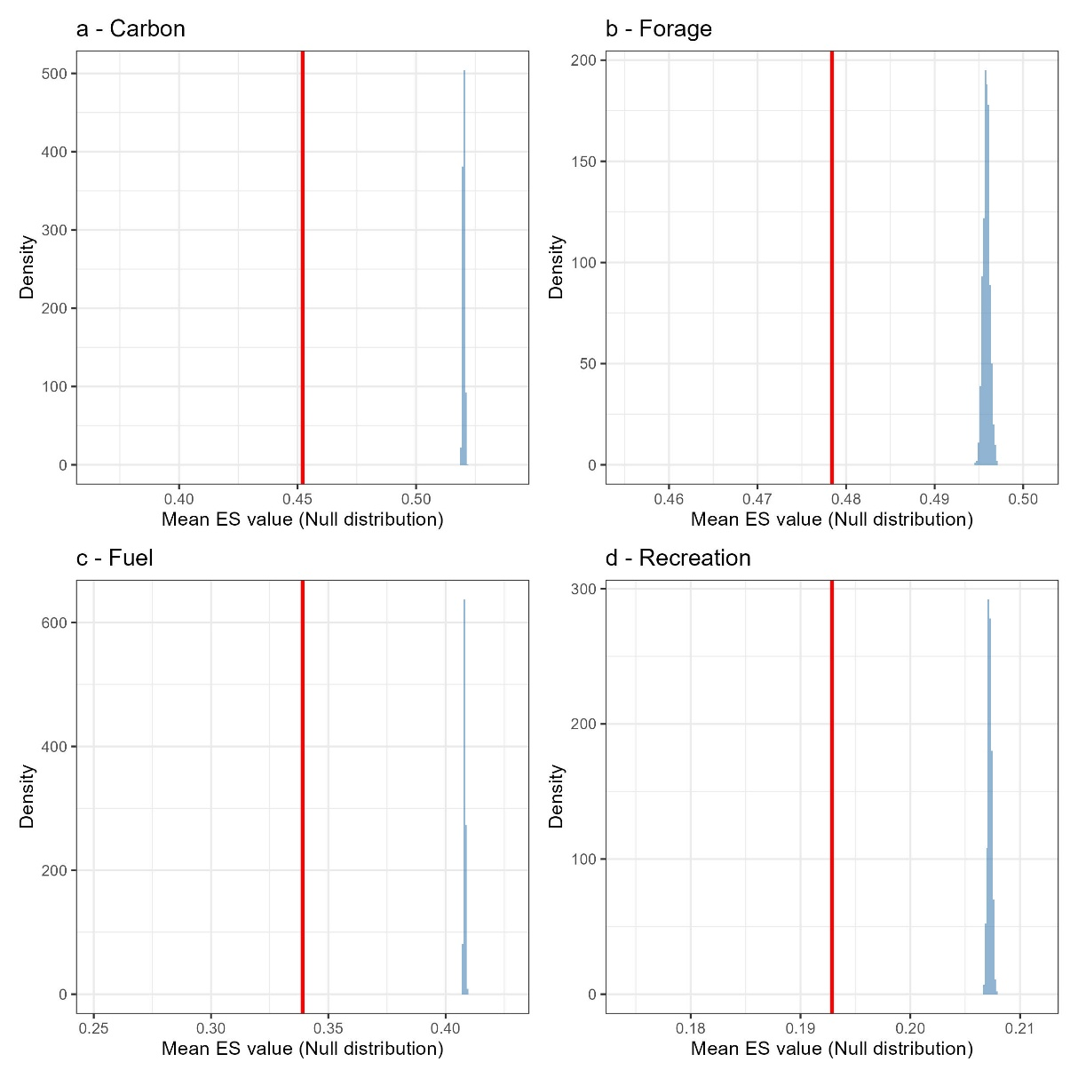
Supplementary Figure 20 | Ecosystem service provisioning within highly novel areas is different than expected by random. Shown on each plot is the observed mean (red vertical line) within novel cells (novelty score >0.33) compared to a randomised null distribution (blue histogram), where the novelty value of cells was randomly shuffled. Ecosystem service provisioning is scaled between 0-1, before being multiplied by the logged rural population to create a weighted value and is the product of an ensemble modelling approach. Four ecosystem services are shown: a, aboveground carbon, b, forage production, c, fuelwood, and d, recreation. For all ecosystem services, the global mean is to the left and outside the null distribution, showing that it is significantly lower than expected by random. Note, however, the small range on the x-axis, reflecting the small effect size.

