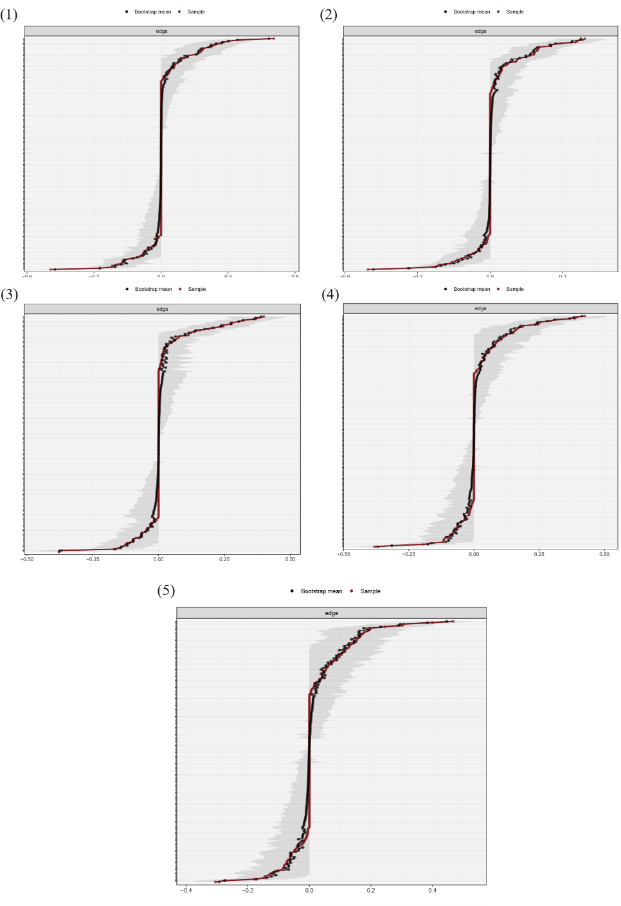
Supplementary Figure S1. Bootstrap 95% confidence intervals (grey areas) for edge weights in the contemporaneous networks at T1-T5. Red lines indicate estimated edge weights.
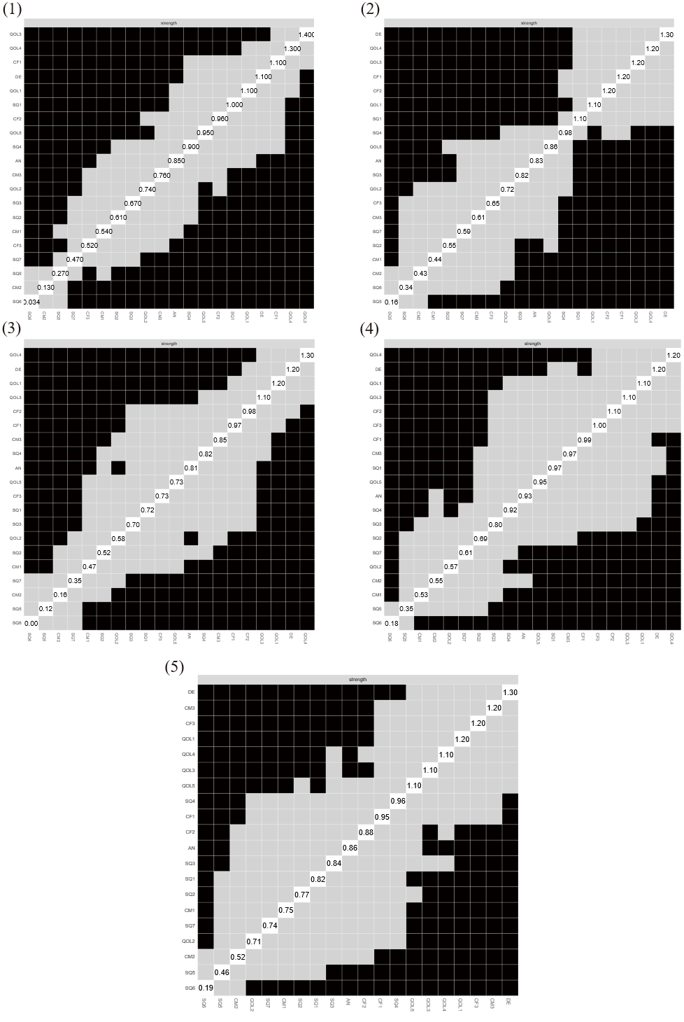
Supplementary Figure S2. Difference tests for strength centrality in the contemporaneous networks at T1-T5.
Black squares indicate statistically significant differences between nodes (two-sided alpha = 0.05).
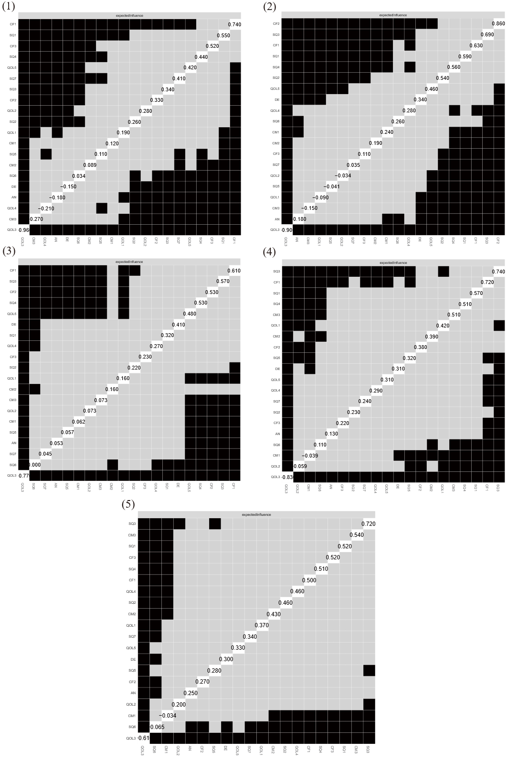
Supplementary Figure S3. Difference tests for expected influence (EI) in the contemporaneous networks at T1-T5.
Black squares indicate statistically significant differences between nodes (two-sided alpha = 0.05).
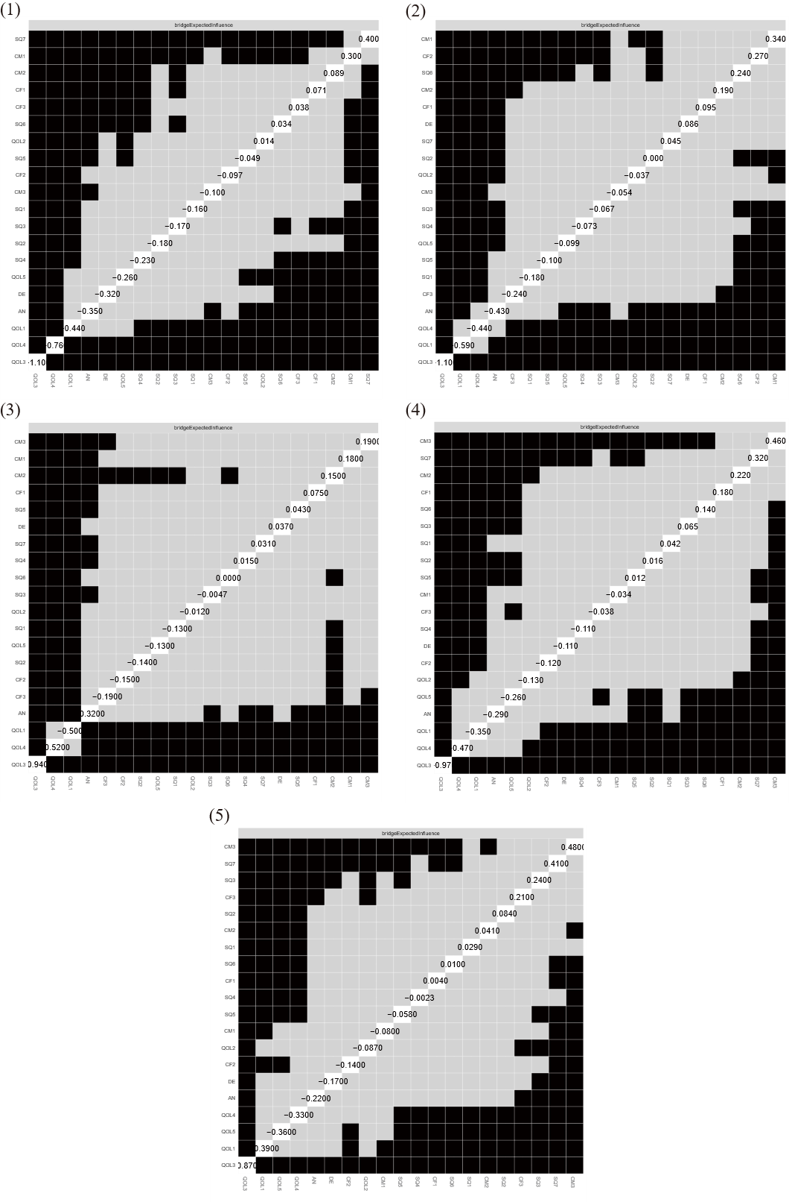
Supplementary Figure S4. Difference tests for bridge expected influence (bEI) in the contemporaneous networks at T1-T5.
Black squares indicate statistically significant differences between nodes (two-sided alpha = 0.05).

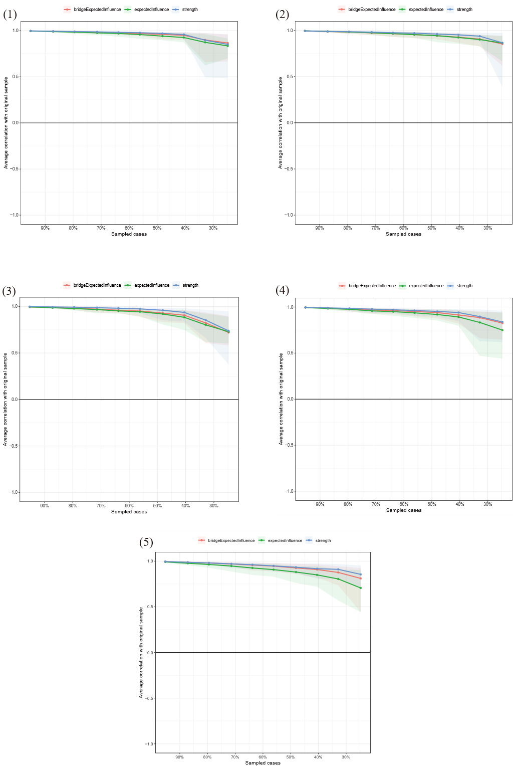
Supplementary Figure S5. Case-dropping bootstrap analysis of the stability of strength, expected influence, and bridge expected influence in the contemporaneous networks at T1-T5.
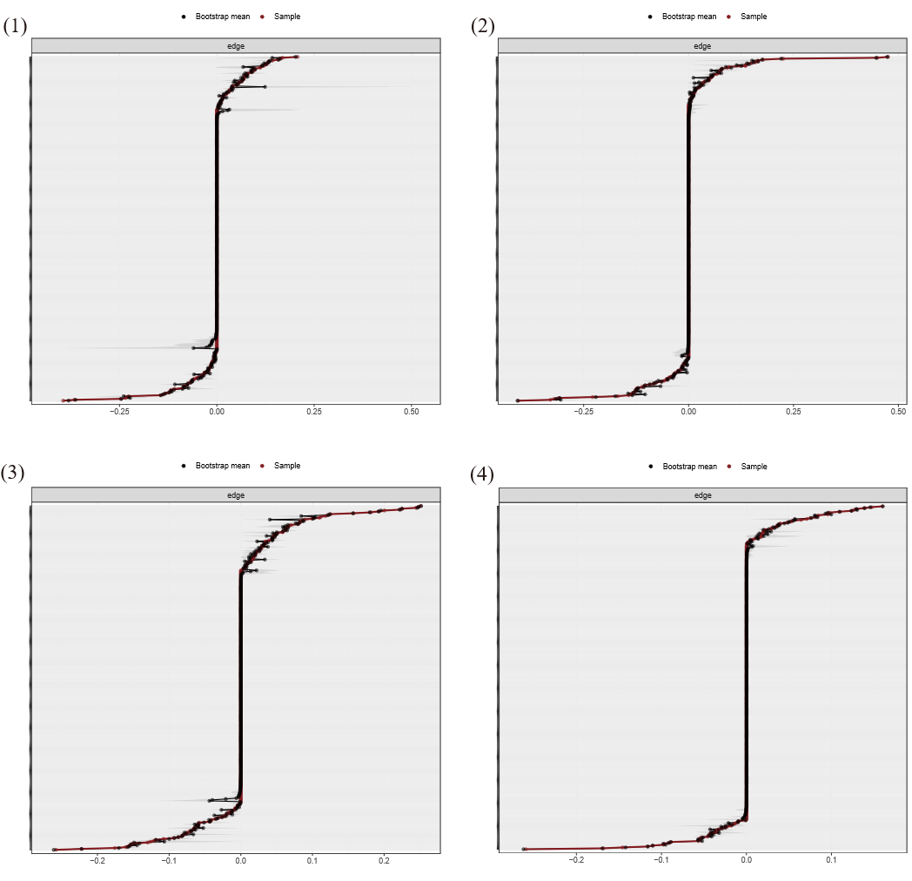
Supplementary Figure S6. Bootstrap 95% confidence intervals (grey areas) for edge weights in the cross-lagged panel networks across the four intervals (T1 to T2, T2 to T3, T3 to T4, and T4 to T5).
Red lines indicate estimated edge weights.

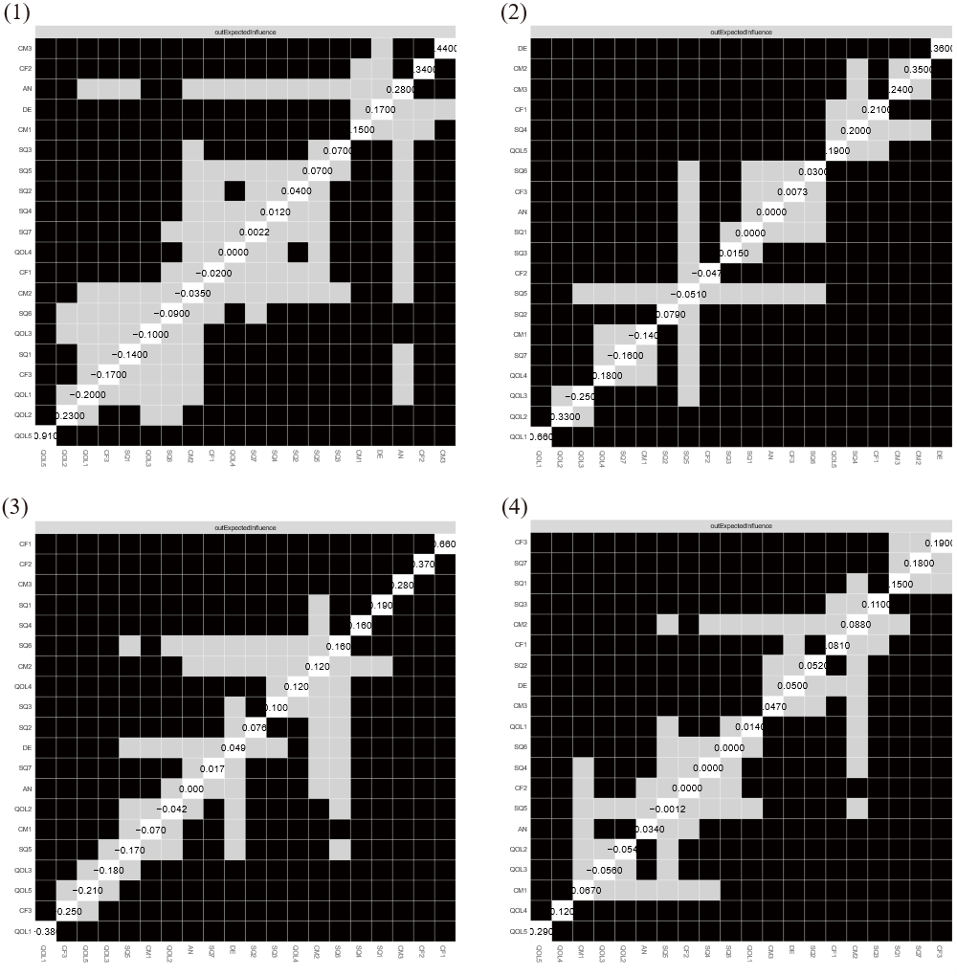
Supplementary Figure S7. Difference tests for out-expected influence (out-EI) in the cross-lagged panel networks across the four intervals.
Black squares indicate statistically significant differences between nodes (two-sided alpha = 0.05).

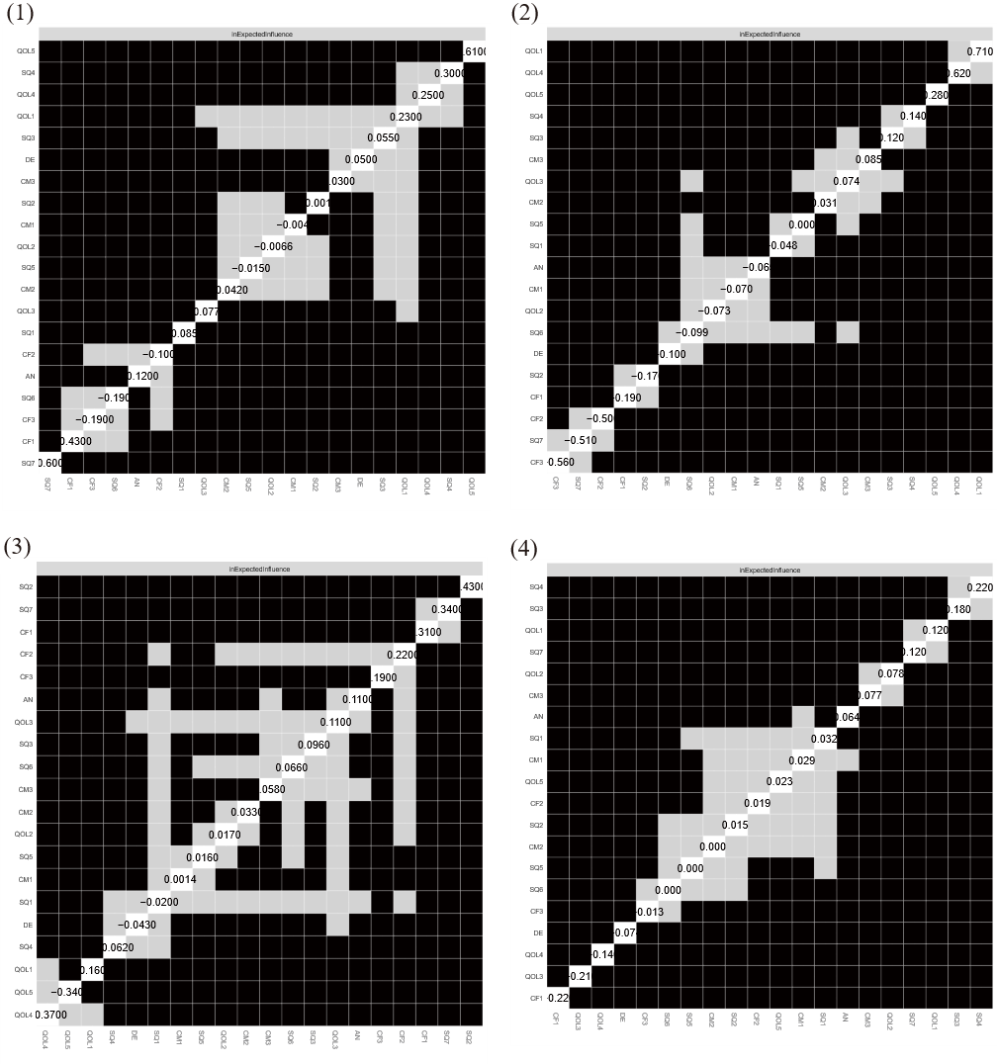
Supplementary Figure S8. Difference tests for in-expected influence (in-EI) in the cross-lagged panel networks across the four intervals.
Black squares indicate statistically significant differences between nodes (two-sided alpha = 0.05).

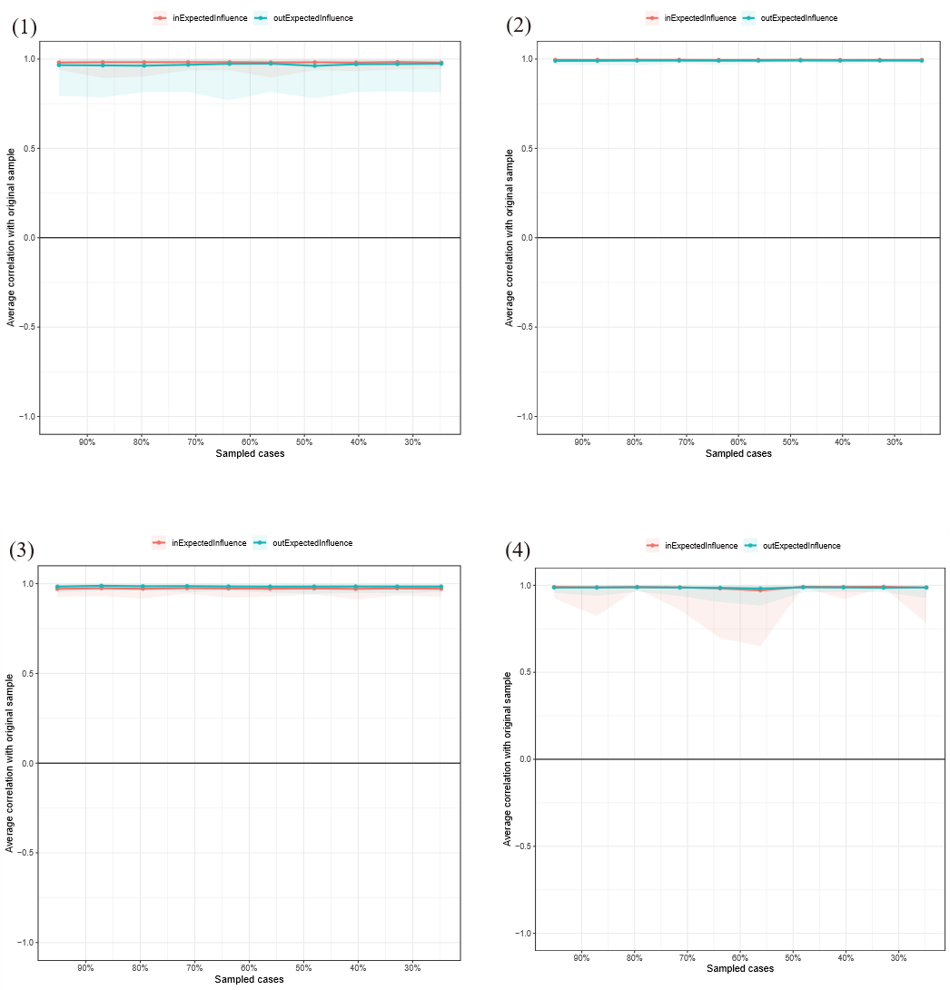

Supplementary Figure S9. Case-dropping bootstrap analysis of the stability of out-expected influence and in-expected influence in the cross-lagged panel networks across the four intervals.

