Appendix A: Dynamic Rupture Simulation Details

A.1 Boundary Integral Equation Method
We use the BIEM framework of Xu et al. (2015) to simulate spontaneous dynamic rupture on circular faults in a homogeneous elastic full-space. The method solves the elastodynamic equations on the fault surface under a slip-weakening friction law:
τ(D) = τs - (τs - τd)D/Dc for D < Dc
τ(D) = τd for D ≥ Dc
where τ is shear stress, D is slip, τs is static friction, τd is dynamic friction, and Dc is the critical slip-weakening distance. The initial stress is uniform, with shear stress τ0 and normal stress σn. A circular nucleation zone of radius Ra, where the initial stress exceeds static friction, starts the rupture.
Three dimensionless parameters govern the behaviour: the normalized effective stress drop T̂e = (τ0 - τd)/(τs - τd), the normalized critical slip distance D̂c = Dcμ/[Ra(τs - τd)], and the normalized background stress S = (τ0 - τd)/(τd - τr), with μ the shear modulus and τr the residual stress outside the nucleation zone.

A.2 Training Dataset Generation
Varying T̂e and D̂c systematically gives ruptures across the whole phase diagram: fast non-self-arresting (high T̂e, low D̂c), self-arresting (low T̂e, low D̂c), and slow self-arresting (high D̂c). From each simulation we take: (1) the direct stress drop σdir, area-weighted over the fault surface; (2) the spectral parameters fc and M0, fit from the displacement spectra; and (3) the correction factor kcorr =k₀·(1/Ceff)^(1/3) , with Ceff back-calculated from σdir, fc, and M0 (eq. A1).
$C_{eff}= σ_{dir}*\frac{16}{7}*\frac{r^{3}}{M_{0}}$ (eq. A1)
Where r = k*Vs/fc. The source time function adopted in the numerical simulation, combined with the joint inversion framework of P- and S-waves implemented for natural earthquake processing, leads to a scenario where S-wave amplitudes are significantly larger than those of P-waves. For this specific reason, Madariaga's k-value of 0.21 is accordingly selected for the subsequent calculation.
The training set holds 12,393 events spanning Mw 2.40 to 6.90, split 56.9% self-arresting to 43.1% non-self-arresting, with self-arresting kcorr ranging 0.03 to 0.73 (nearly log-normal) and source spectra of variable length (50 to 2000 sampling points).

A.3 Data Preprocessing
Source spectra vary in length because the frequency sampling range depends on magnitude. We normalize and interpolate with a physics-informed pipeline: (1) normalize frequency by corner frequency (fnorm = f/fc) and the spectrum by seismic moment (Snorm = S/M0); (2) resample uniformly in log-frequency over 512 points; (3) form the model inputs X1 = log1₀(Snorm) and X2 = log1₀(fnorm). This strips out the magnitude-dependent scaling and matches the log-normal distributions these parameters tend to follow.

Appendix B: Deep Learning Architecture and Training

B.1 Model Architecture
The model is a multi-task CNN-Transformer hybrid with 790,211 parameters, pairing convolutional feature extraction for local spectral structure with Transformer attention for long-range frequency dependencies. Figure B1 presents the whole working flow.
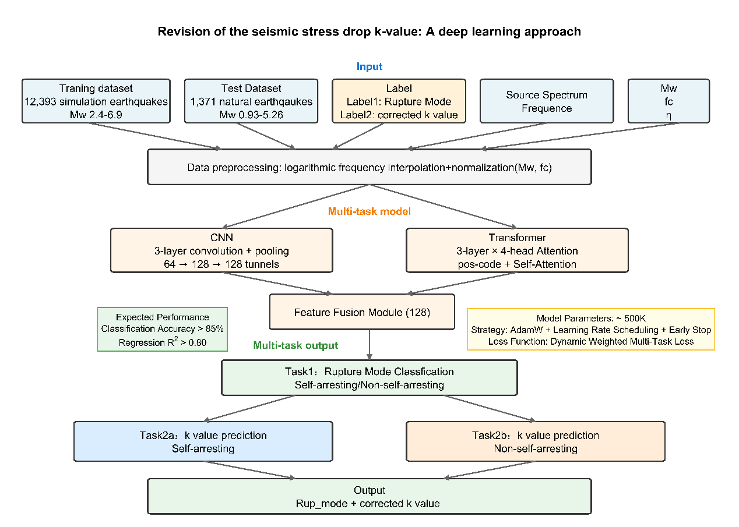
Figure B1. Deep-learning model flowchart

The spectrum encoder runs three 1D convolutional layers (2→64→128→128 channels, kernel sizes 7, 5, 3) with batch normalization, ReLU, max pooling, and dropout (0.1); three pooling steps take the sequence from 512 down to 64. Its output goes into a Transformer encoder with sinusoidal positional encoding and three stacked layers, each with multi-head self-attention (4 heads), a feed-forward network (hidden dim 512), residual connections, layer normalization, and dropout (0.1). Adaptive average pooling collapses the sequence to a fixed 128-dimensional vector.
Auxiliary features (Mw, log1₀(fc), log1₀(η)) run through a two-layer MLP (3→64→64) with ReLU and dropout. The 128-dim spectrum encoding and the 64-dim auxiliary encoding concatenate into a 192-dim fused vector, which a further two-layer MLP (192→256→128) processes.
The classification head (rupture mode) is two layers (128→64→2) with ReLU, dropout, and softmax. The regression head (k-value correction) is two layers (128→64→1) with ReLU, dropout, and an exponential transform (kpred = 10^ypred).

B.2 Training Strategy
We use an uncertainty-weighted multi-task loss (Kendall et al., 2018) with learnable parameters: Ltotal = e^(-α)Lcls + α + e^(-β)Lreg + β, where α and β are learnable log-variances that balance the classification (cross-entropy) and regression (MSE in log-space) terms on their own.
Optimization runs AdamW at learning rate 1×10-3, weight decay 1×10-4, with ReduceLROnPlateau scheduling (patience 5, decay 0.5, floor 1×10-6) and early stopping (patience 20). We use a batch size of 64, up to 100 epochs, and a 70/15/15 train/validation/test split with stratified sampling that preserves the rupture mode distribution.
Convergence is clean: the validation loss bottoms out (2.0245) at epoch 15, with early stopping at epoch 35, and the dynamic weighting keeps either task from taking over the optimization.

C1. Data Processing and Source Time Function Recovery

C1.1 Overview
We employ the empirical Green's function (EGF) method to extract source time functions (STFs) and source spectra from natural earthquake recordings. This approach effectively removes propagation path effects and instrument responses by deconvolving a smaller event (EGF event) from a larger target event recorded at the same station, assuming both events share similar source locations and mechanisms.

C1.2 Preprocessing

C1.2.1 Seismic Data Collection
For each target earthquake, we identify suitable EGF events satisfying the following criteria:
Spatial proximity: epicentral distance < 0.5 km (or < 0.005° in fault length scale)
Magnitude separation: 3 ≥ ΔM ≥ 0.5 (considered our research object – specific to small events) to ensure the EGF event approximates an impulsive source

C1.2.2 Header Inspection and Theoretical Travel Time Calculation
Seismogram headers are systematically checked for completeness and accuracy. Manual picking of effective signal time windows is time-consuming and requires relevant expertise; hence, accurate theoretical travel times can provide guidance for arrival time determination. Using the TauP toolkit combined with a local velocity model (e.g., the velocity model used in this processing of Yangbi earthquake data is from Yang et al., 2020, GJI) allows us to calculate relatively accurate theoretical travel times and store them in the header of SAC files for subsequent calculations.

C1.3 Time Window Selection and Signal Preprocessing

C1.3.1 Target and EGF Time Windows
After completing the preceding preprocessing, the P-wave onset is manually picked based on theoretical travel times and visualized waveform data, and a time window of a certain length is allocated. In this processing workflow, the P-wave time window is set to ‌4 seconds‌. The arrival times of small earthquakes for the empirical Green's function (EGF) do not require manual picking. After selecting the P-wave time window of the corresponding target earthquake, a 10-second time window centered on the previously calculated theoretical arrival time is defined for cross-correlation. Finally, the time window with the same length as the target signal and the maximum cross-correlation coefficient is selected as the P-wave signal of EGF.

C1.3.2 Preprocessing Steps
Prior to deconvolution, both target and EGF waveforms undergo:
Baseline correction: linear trend removal
Bandpass filtering;
Tapering: 5% cosine taper applied to both ends of the time window;
Normalization: amplitude normalization to maximum absolute value;
Quality control rule No.1 (QC1): traces with SNR < 3.0 are excluded from further analysis.
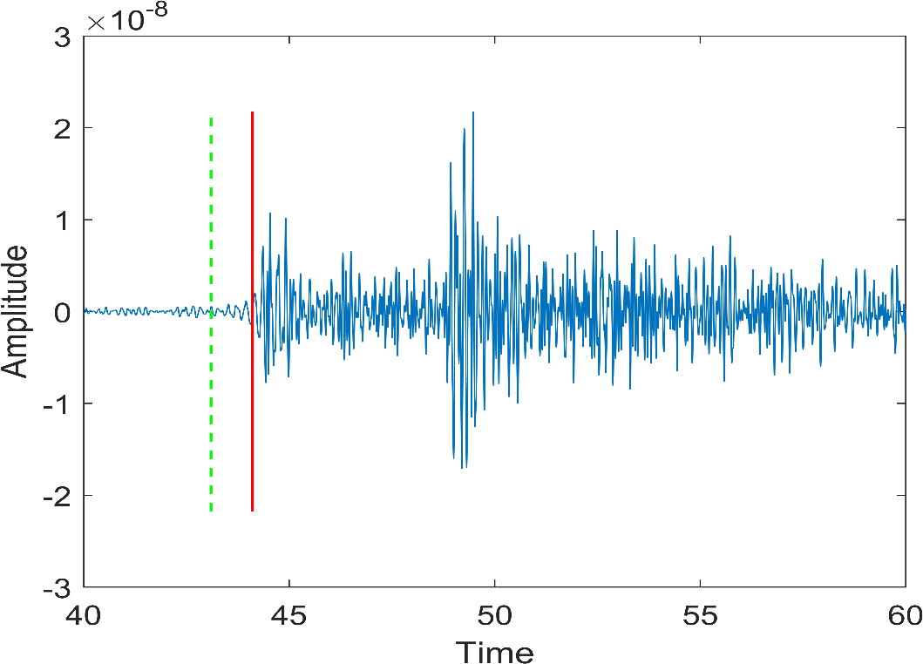
Figure C1. Signal-Noise-Ratio schematic diagram

C1.4 Empirical Green's Function Deconvolution

C1.4.1 Deconvolution in Frequency Domain
The STF is recovered through spectral division in the frequency domain:
STF(f) = [Target(f) / EGF(f)] × W(f)
where:
Target(f) and EGF(f) are Fourier transforms of windowed target and EGF waveforms
W(f) is a water-level stabilization factor to avoid division by small spectral amplitudes:
W(f) = EGF*(f) / [|EGF(f)|² + ε]
with ε = 0.01 × max(|EGF(f)|²) as the water-level threshold.
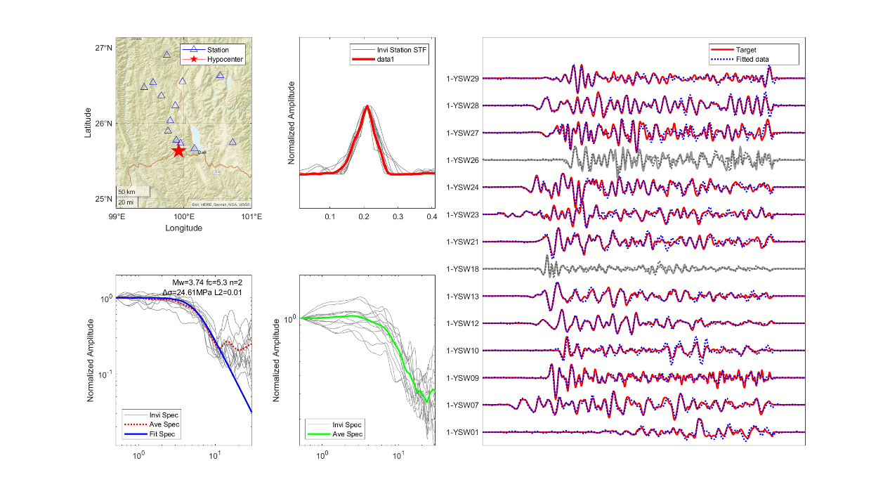
Figure C2. Observational data processing through EGF method

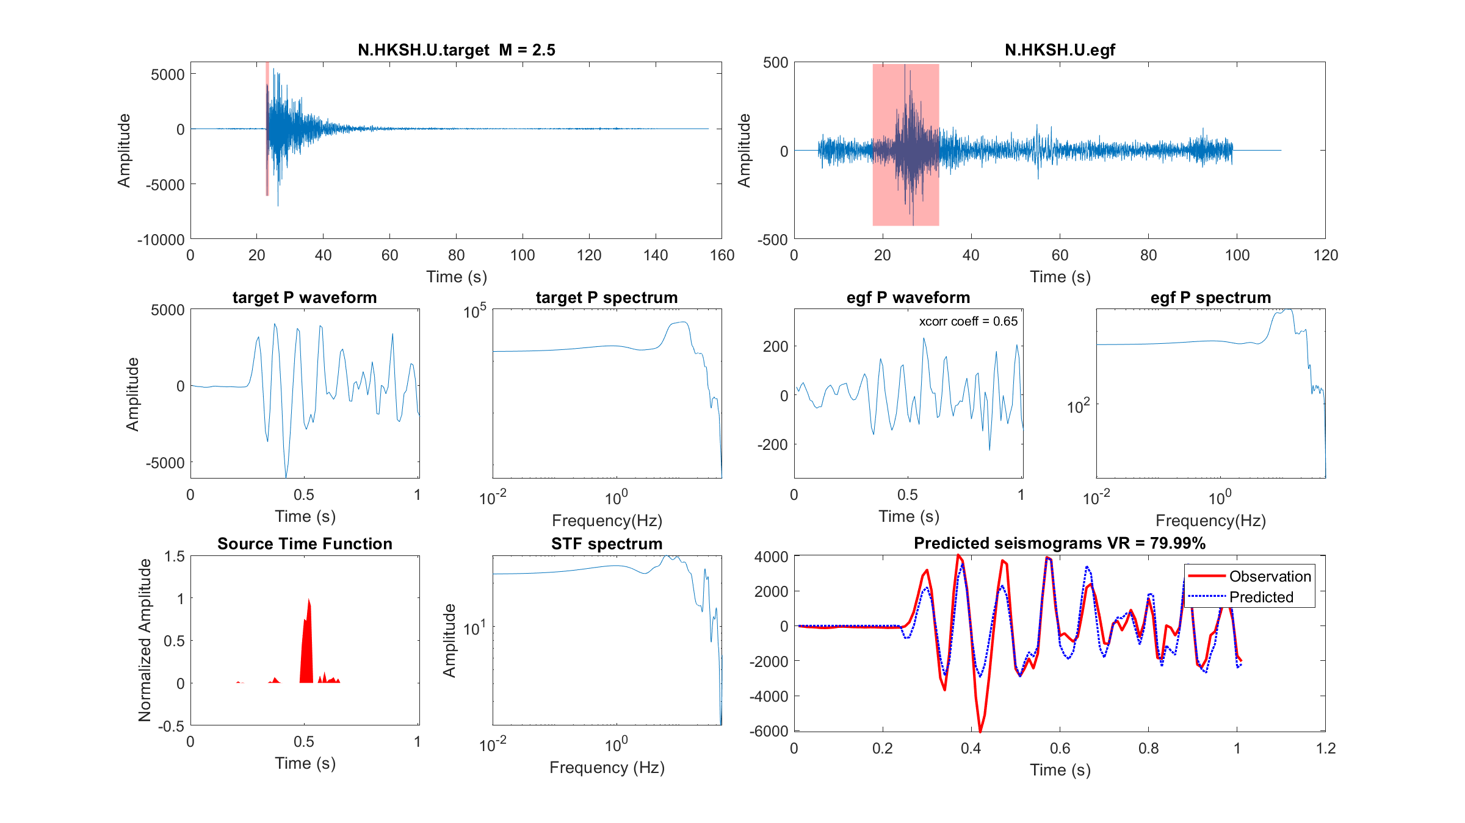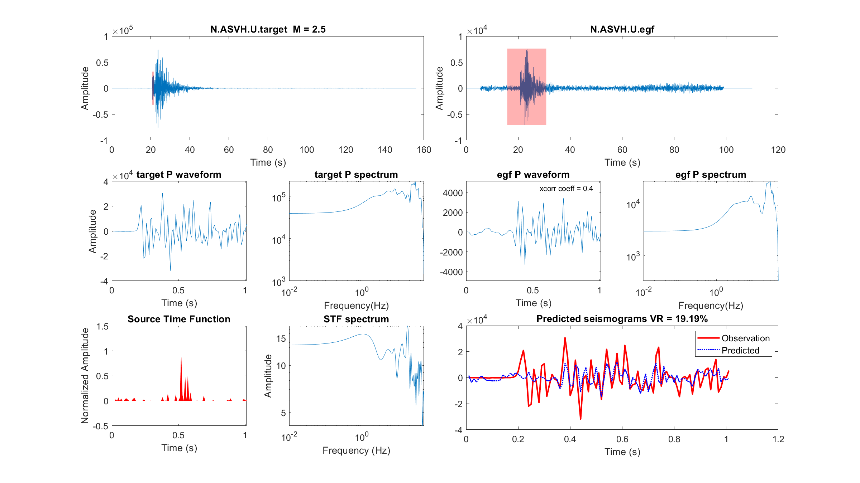
Figure C3. Quality Control Rule 2: The Forward Modeling VR should be over 60%

C1.4.2 Multi-Window Spectral Analysis
To improve stability and assess uncertainty, we apply multi-taper spectral analysis using:
3–5 orthogonal Slepian tapers (time-bandwidth product NW = 4)
Frequency-dependent coherence weighting to down-weight poorly correlated frequency bands
Median stacking of STFs from multiple stations to suppress station-specific noise

C1.5 Quality Control and Validation

C1.5.1 Forward Modeling Check
The reliability of each recovered STF is validated by forward convolution:
Synthetic_Target = STF ⊗ EGF
We compute the variance reduction (VR) and cross-correlation coefficient (CC) between the synthetic and observed target waveforms:
VR = [1 - Σ(obs - syn)² / Σ(obs)²] × 100%
QC2: Traces with VR < 60% or CC < 0.7 are rejected.

C1.5.2 Consistency Check
We assess the consistency of STFs across different EGF event choices (to evaluate sensitivity to EGF selection).

C1.6 Source Parameter Estimation

C1.6.1 Median STF and Source Duration
From the ensemble of accepted STFs (typically 5–20 per event), we compute a representative STF using median averaging to suppress outliers. Source duration is measured as:
T50: time interval containing 50% of total moment release
T95: time interval containing 95% of total moment release

C1.6.2 Source Spectral Analysis
The displacement spectrum of the median STF is computed and fitted with a Brune source model:
|Ω(f)| = Ω₀ / [1 + (f/f_c)²]^n
where:
Ω₀: low-frequency spectral level (proportional to seismic moment)
f_c: corner frequency
n: spectral decay rate (n ≈ 2 for Brune model)

C1.6.3 Derived Source Parameters
From the spectral fitting, we extract:
Seismic moment: M₀ = 4πρvs³r × Ω₀ / (R_θφ × F_s)
Moment magnitude: M_w = (2/3)log₁₀(M₀) - 6.07
Stress drop: Δσ = (7/16) × M₀ / r³, where source radius r = (k× v_s) / (2π × f_c)
Radiated energy: E_R = ∫ |v̇(f)|² df, where v̇ is the velocity spectrum
where ρ = 2800 kg/m³ (average crustal density), vs = 3.5 km/s (S-wave velocity), R_θφ is the radiation pattern coefficient, and F_s is the free-surface amplification factor.

C1.6.4 Grid Search for Optimal Corner Frequency
For robust corner frequency estimation, we perform a grid search over the parameter space:
f_c range: 0.05–20 Hz
n range: 0.1–3.0
The optimal parameters are determined by minimizing the L2 misfit between observed and modeled spectra over the frequency band with coherence > 0.7.

C2. Uncertainty Quantification
Uncertainties in source parameters are estimated through bootstrapping resampling: 1000 bootstrap samples from the STF ensemble. Final uncertainties are reported as the combined effect of all three sources, typically expressed as 1σ confidence intervals.

C3. Software and Computational Environment
All data processing and deconvolution analyses are performed using custom-coded scripts under Matlab2022b environment. Theoretical travel times are calculated using TauP (Crotwell et al., 1999). Spectral analysis was performed using the multitaper method revised from F90 Multitaper library by Prieto et al., (2009)

References
Crotwell, H. P., Owens, T. J., & Ritsema, J. (1999). The TauP Toolkit: Flexible seismic travel-time and ray-path utilities. Seismological Research Letters, 70(2), 154-160.
Kendall, A., Gal, Y., & Cipolla, R. (2018). Multi-task learning using uncertainty to weigh losses for scene geometry and semantics. In Proceedings of the IEEE conference on computer vision and pattern recognition (pp. 7482-7491).
Prieto, G. A., Parker, R. L., & Vernon Iii, F. L. (2009). A Fortran 90 library for multitaper spectrum analysis. Computers & Geosciences, 35(8), 1701-1710.
Yang, Y., Yao, H., Wu, H., Zhang, P., & Wang, M. (2020). A new crustal shear-velocity model in Southwest China from joint seismological inversion and its implications for regional crustal dynamics. Geophysical Journal International, 220(2), 1379-1393.

