Fig. S1. Interpretable Survival Tree Based on Decision Tree Model

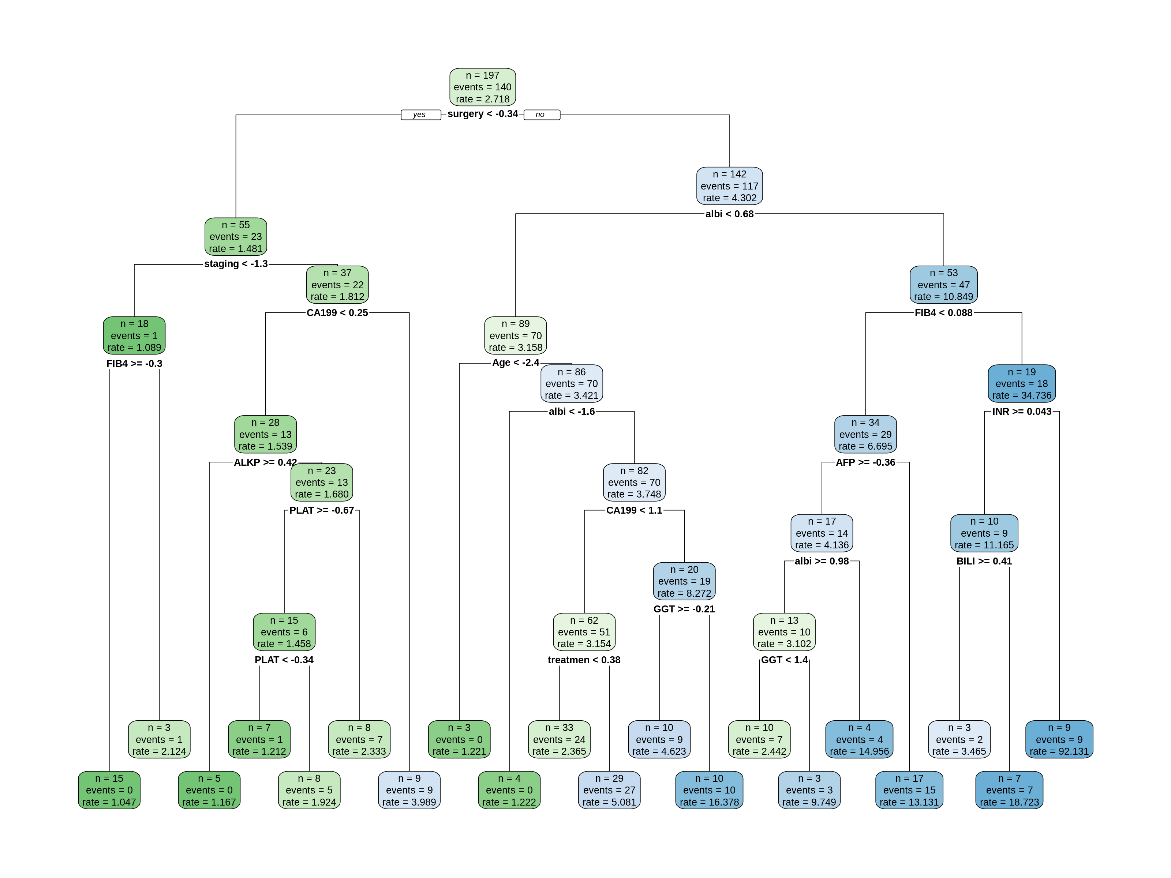

Table S1. Hyperparameter Setting
RSF | XGBoost | Decision Tree | Logistic Regression
N_tree = 1000 | Max_depth = 3 | CP = 0.01 | Step_AIC
Mtry = 5 | Min_Child_Weight = 30 | Min_split = 20 | K = 6.184
Node_size = 15 | Gamma = 0.15 | Max_depth = 30
Nsplit = 10 | Lamda = 1 | Min_bucket = 7
 | Alpha = 0.5 | Split =15
 | Subsample = 0.7 | Leaves = 16
 | Colsample_bytree = 0.7 | Max_depth = 6
 | Eta = 0.025

Table S2. Performance of the predictive models for the overall survival (OS) of CCA in training cohort
Model | AUC (95%CI) | P-value | Accuracy | Precision | Recall | F1-score | C-Index
XGboost | 0.763  (0.717-0.809) | 7.01e-03 | 67.2% | 88.3% | 59.6% | 71.1% | 0.739
Random survival forest | 0.830  (0.793-0.868) | 1.16e-11 | 74.4% | 89.0% | 71.1% | 79.1% | 0.831
Decision tree | 0.810  (0.769 - 0.851) | 9.58e-10 | 74.0% | 89.3% | 69.8% | 78.3% | 0.787
Logistic Regression  Cox PH | 0.771  (0.726-0.816)  0.674  (0.616-0.732) | 3.46e-05  4.24e-09 | 74.6%  69.2% | 73.6%  79.4% | 97.6%  75.1% | 83.9%  77.2% | 0.737  0.676

Table S3 Performance of the predictive models for the time-dependant AUROC of CCA in the training cohort

Model | 1-Year | 2-Year | 3-Year | 4-Year | 5-Year
XGboost | 0.796 | 0.806 | 0.806 | 0.813 | 0.803
Random survival forest | 0.906 | 0.913 | 0.908 | 0.917 | 0.913
Decision tree | 0.874 | 0.845 | 0.859 | 0.935 | 0.929
Logistic Regression  CoxPH | 0.799  0.728 | 0.795  0.752 | 0.804  0.752 | 0.813  0.853 | 0.801  0.833

