Supplementary materials
Table S1. Benchmark comparison of prediction models for adsorption efficiency
Model | Main setting | CV R² | Test R² | Test MAE (%) | Test RMSE (%) | Generalization gap
Linear regression | Multivariate linear fitting of adsorbent type, dosage, pH, temperature, reaction time | 0.68 | 0.62 | 9.5 | 11.2 | 0.06
Polynomial regression (Degree 2) | Degree-2 polynomial fitting of input variables | 0.78 | 0.73 | 6.8 | 8.5 | 0.05
SVR | RBF kernel, regularization parameter C=1, gamma=0.1 | 0.87 | 0.84 | 3.8 | 4.8 | 0.03
Random forest | 100 decision trees, max depth=10, random state=42 | 0.90 | 0.88 | 2.8 | 4.0 | 0.02
XGBoost / LightGBM | Learning rate=0.1, n_estimators=100, max depth=6 | 0.92 | 0.90 | 2.3 | 3.4 | 0.02
BP neural network | 3-layer network (5 inputs →12 hidden neurons →1 output), Adam optimizer (lr=0.001, 1000 iterations) | 0.932 | 0.930 | 2.1 | 3.2 | 0.005

Table S2. comparison of research types of modified biochar for adsorption of water ions
Type Of Study | Biomass Raw Materials | Modification Method | Target Ion | Core Performance Indicators | Data Driven/Optimization Approach | Main Conclusions
Study On Unmodified Biochar | Various agricultural wastes (rice husk, corn straw, etc.) | nothing | Na⁺ | Maximum adsorption capacity 12.8 mg/g | nothing | The type of raw material significantly affects the adsorption isotherm characteristics and ion binding mode
Study On Single Acid Modified Biochar | Not clear | Sulfuric acid modification | Na⁺ | Adsorption efficiency is about 75% | nothing | Acid modification can improve Na ＋ removal effect, but the parameter rule is not fully explained
Study On Iron Modified Biochar (No Optimization) | Not clear | Fe modification | Se | Adsorption capacity prediction R²=0.92 | Single machine learning model | Machine learning can effectively predict the adsorption performance of Fe modified biochar
Research On Multi Modified Biochar (No Data Driven) | Various biochar | Not clear | Emerging pollutants | Adsorption capacity prediction R²=0.91 | nothing | Multi modification can improve the adsorption capacity of complex system, but it does not involve the collaborative removal of salt
Recovery Of Other Modified Biochar Resources | Not clear | Ca/Mg co modification | P | Phosphorus recovery efficiency 85% | Life cycle assessment (LCA) | Modified biochar can achieve resource recovery, but not for salt ions
This Study | Corn straw | Fe modification | Na⁺/ca²⁺/mg²⁺ | The adsorption capacity was 25.3 mg/g (0.1g/l dosing), and the optimized efficiency was 91.8% | BP neural network+particle swarm optimization (PSO) | The performance of Fe modified biochar is the best, bp+pso realizes multi parameter reverse optimization, taking into account the performance and cost-effectiveness (57.4%/yuan)

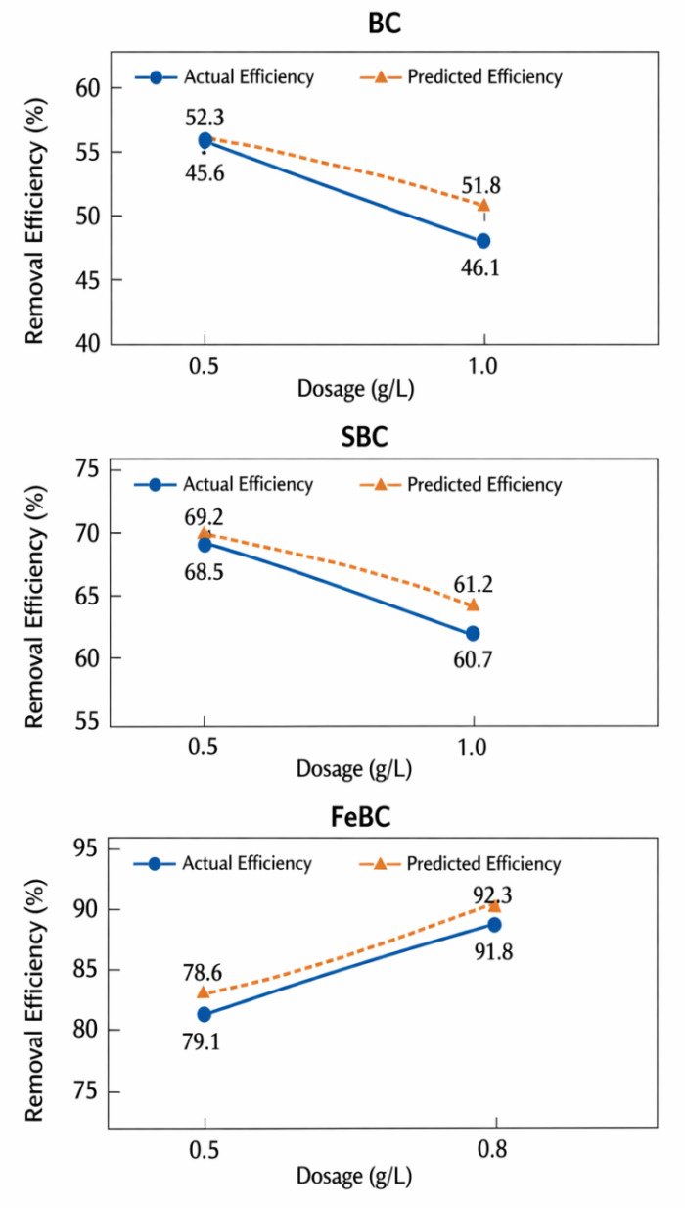
Figure S1. comparison chart of adsorbent efficiency

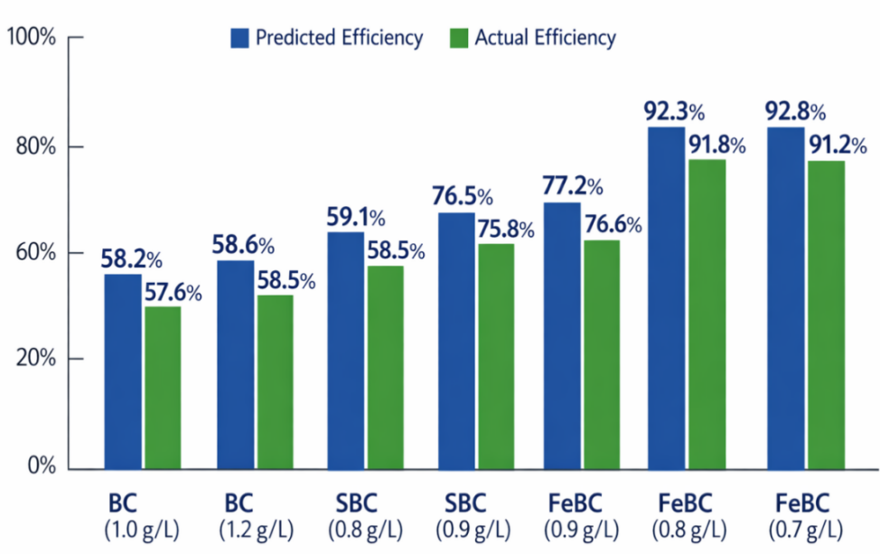
Figure S2. best conditions and validation efficiency chart
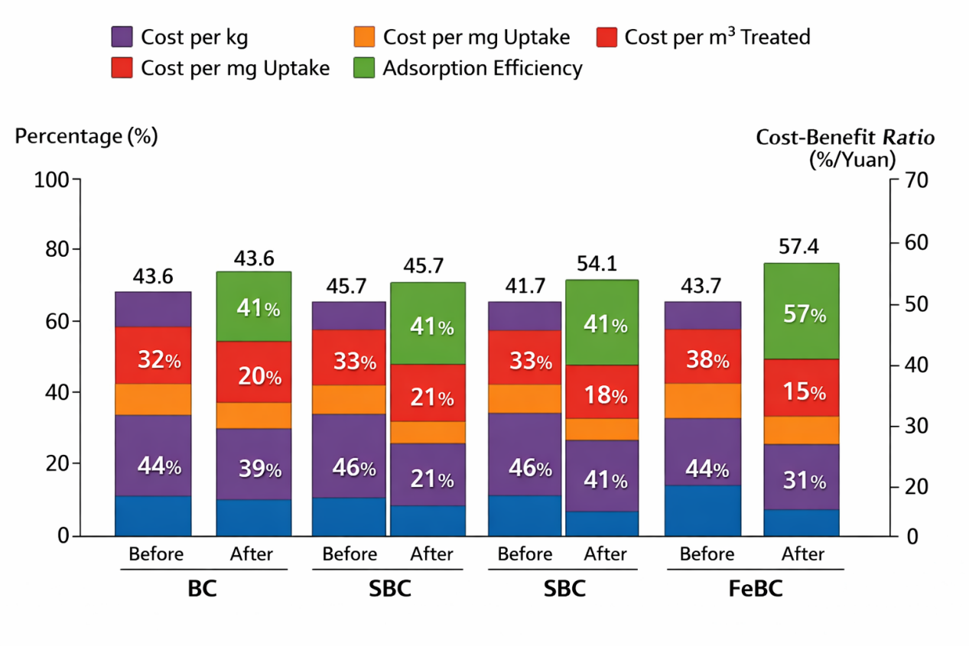
Figure S3. effect comparison before and after adsorbent optimization

