Supplementary material
Table S1. Concentration of volatile compounds (µg/L) in wine resulting from different treatments
Compounds* | RI | OO | LP | O4L1 | O1L1 | O1L4
Esters
Ethyl acetate | ~900 | 9985.22±157.34a | 12163.46±153.22d | 10236.91±137.39a | 10742.26±187.07b | 11084.05±208.43c
Ethyl propanoate | ~900 | 291.88±10.91a | 272.30±16.65a | 276.49±15.12a | 290.85±19.71a | 281.20±18.33a
Ethyl butyrate | ~1000 | 322.31±11.86b | 332.96±10.33b | 293.11±7.25a | 404.50±9.51d | 358.21±6.54c
Butyl acetate | 1063 | 14.03±1.17a | 15.18±0.96a | 14.41±0.85a | 14.61±0.77a | 13.94±0.68a
Isoamyl acetate | 1119 | 26.12±1.02c | 17.71±0.79b | 26.13±0.91c | 15.49±0.44a | 17.07±0.62b
Butyl butanoate | 1206 | 3.62±0.22bc | 3.94±0.25cd | 2.98±0.17a | 4.26±0.19d | 3.51±0.21b
Ethyl hexanoate | 1234 | 339.18±24.01a | 352.44±26.09a | 364.25±22.08ab | 408.62±35.02bc | 423.16±33.52c
Ethyl heptanoate | 1345 | 64.24±5.44c | 58.25±3.37b | 47.15±1.75a | 57.09±1.87b | 52.93±2.68ab
Ethyl lactate | 1347 | 9.05±0.51ab | 8.94±0.47ab | 8.67±0.28a | 9.60±0.45b | 11.80±0.44c
Ethyl 2-hexenoate | 1354 | 0.97±0.02d | 0.74±0.01a | 1.02±0.01e | 0.81±0.01b | 0.94±0.02c
Methyl octanoate | 1377 | 15.62±1.07c | 12.66±0.92b | 17.21±1.18c | 13.20±0.61b | 10.56±0.68a
Ethyl 2-hydroxybutanoate | 1396 | 12.72±1.20a | 15.23±1.49b | 13.23±0.77ab | 14.31±1.37ab | 15.43±1.09b
Ethyl octanoate | 1437 | 170.51±14.40a | 162.49±15.84a | 208.36±11.93b | 183.22±9.62ab | 202.32±15.10b
Methyl nonanoate | 1486 | 14.20±1.13d | 12.72±1.05cd | 11.32±1.07bc | 9.30±0.74a | 10.59±0.75ab
Ethyl nonanoate | 1514 | 1.30±0.06c | 2.13±0.07e | 0.98±0.06a | 1.66±0.08d | 1.14±0.02b
Isoamyl lactate | 1574 | 62.70±4.22b | 48.84±2.73a | 50.52±2.73a | 67.05±5.91b | 60.60±4.92b
Methyl decanoate | 1594 | 3.24±0.19a | 4.33±0.36c | 4.24±0.26bc | 3.79±0.27b | 4.12±0.22bc
Ethyl decanoate | 1635 | 1195.93±94.08ab | 1302.86±83.33b | 1078.04±78.72a | 1360.75±92.56b | 1265.19±93.41b
Isoamyl octanoate | 1662 | 34.55±1.27c | 40.19±1.06d | 29.21±1.87b | 28.11±1.14b | 23.55±1.36a
Ethyl benzoate | 1670 | 12.25±1.19bc | 13.40±1.20cd | 10.89±1.12ab | 9.83±0.88a | 14.66±1.14d
Diethyl succinate | 1683 | 34.05±1.84ab | 45.47±2.29c | 31.55±1.54a | 43.85±1.62c | 36.04±1.43b
Ethyl 9-decenoate | 1700 | 90.38±7.91ab | 96.17±8.71ab | 101.61±10.06bc | 112.07±1.98c | 83.94±6.96a
Ethyl undecanoate | 1731 | 6.56±0.54a | 8.44±0.63c | 6.93±0.42a | 8.01±0.58bc | 7.12±0.45b
Methyl salicylate | 1778 | 20.63±1.73b | 18.13±1.14a | 16.38±0.41a | 17.29±0.97a | 17.24±1.53a
Ethyl 2-phenylacetate | 1791 | 4.86±0.21bc | 5.26±0.43c | 4.48±0.42ab | 4.65±0.35abc | 3.99±0.28a
Ethyl dodecanoate | 1848 | 227.36±12.94b | 285.72±13.89c | 295.36±11.39c | 198.66±13.82a | 228.02±20.07b
Ethyl 3-methylbutanoate | 1987 | 88.63±6.79a | 122.35±9.06d | 91.11±5.33ab | 112.24±10.53cd | 105.49±7.51bc
2-Phenylethyl hexanoate | 2174 | 11.87±0.82b | 9.57±0.59a | 14.04±1.07c | 13.84±1.05c | 9.64±0.74a
Alcohols
Ethanol | ~900 | 2396.64±13.99b | 2633.05±12.76d | 2079.37±15.68a | 2620.84±15.76d | 2456.09±12.47c
Propanol | ~1000 | 18125.64±91.05e | 1529.08±21.95a | 12223.04±41.57c | 13218.43±50.67d | 11118.95±67.22b
Isobutanol | 1097 | 10233.53±91.92c | 11289.92±110.32d | 9936.63±62.10b | 8942.03±65.46a | 11378.44±100.93d
1-Butanol | 1148 | 268.19±19.60bc | 190.64±18.69a | 287.65±28.67c | 238.75±11.13b | 174.23±8.29a
2-Methylbutanol | 1189 | 14.80±1.05a | 19.60±1.48b | 15.67±2.16a | 19.37±1.16b | 16.75±0.99a
Isoamyl alcohol | 1216 | 31042.73±179.29e | 28353.32±207.30c | 19322.10±99.13a | 29514.36±160.16d | 27394.36±161.19b
2-Hexanol | 1226 | 7.88±0.53ab | 8.99±0.80b | 6.34±0.66a | 8.90±1.44b | 6.94±0.84b
1-Pentanol | 1251 | 18.18±1.47a | 26.85±1.20c | 22.47±1.59b | 21.79±1.88b | 18.23±1.49a
2-Heptanol | 1316 | 96.71±7.39a | 135.04±10.74c | 113.89±9.28ab | 99.46±10.35a | 130.12±11.15bc
1-Hexanol | 1355 | 1435.02±102.64c | 1327.17±105.21bc | 1229.94±89.57ab | 1096.20±55.48a | 1248.56±103.40ab
(Z)-3-Hexen-1-ol | 1390 | 43.64±2.94a | 56.79±1.86b | 86.34±1.59d | 94.5±3.21e | 66.94±2.12c
(Z)-2-Hexen-1-ol | 1393 | 93.35±2.83a | 119.46±10.80b | 120.14±9.41b | 109.51±7.27b | 95.79±2.11a
1-Heptanol | 1458 | 149.70±12.16ab | 155.76±12.87ab | 169.66±10.23bc | 182.17±11.57c | 135.24±9.08a
2-Ethyl-1-hexanol | 1492 | 86.39±8.86bc | 76.02±3.51ab | 91.78±8.83c | 70.36±3.24a | 83.73±5.79bc
2-Nonanol | 1518 | 19.84±0.88bc | 22.15±1.23c | 15.84±0.86a | 18.61±0.61ab | 19.59±2.94bc
2,3-Butanediol | 1544 | 251.76±15.69a | 259.82±14.87ab | 282.31±13.42b | 253.94±11.24a | 268.87±13.04ab
1-Octanol | 1562 | 185.12±14.67cd | 143.56±11.05ab | 203.56±15.79d | 126.27±13.26a | 165.56±10.98bc
1-Nonanol | 1664 | 116.34±9.97ab | 109.35±10.52a | 132.94±10.98bc | 152.99±17.97c | 116.64±6.02ab
1-Decanol | 1768 | 109.41±4.41c | 95.35±4.77b | 91.84±8.87b | 78.26±2.03a | 99.97±6.01bc
Benzyl alcohol | 1883 | 103.73±10.42b | 96.40±6.69ab | 82.96±3.05a | 97.49±7.96ab | 106.72±9.30b
2-Phenylethanol | 1918 | 18745.84±132.20d | 14907.74±107.55b | 13829.40±130.83a | 17813.06±162.41c | 20714.41±160.72e
1-Dodecanol | 1974 | 22.32±2.94a | 25.45±4.30ab | 35.55±2.25d | 33.24±2.77cd | 28.33±1.04bc
Acids
Acetic acid | 1461 | 3735.02±41.64c | 4026.20±61.48e | 3112.17±19.21a | 3829.94±21.57d | 3545.56±51.40
Propanoic acid | 1550 | 35.19±2.50a | 47.81±3.84b | 36.50±2.09a | 48.41±1.72b | 38.31±2.30a
Butyric acid | 1637 | 387.97±22.89bc | 425.35±29.42c | 336.70±20.63a | 432.53±31.07c | 376.84±19.71ab
Hexanoic acid | 1858 | 935.82±79.16ab | 1041.33±83.17b | 1257.43±94.88c | 1186.72±70.45c | 869.06±56.08a
Octanoic acid | 2067 | 1051.62±90.54a | 950.43±76.57a | 1268.19±101.75b | 978.12±75.25a | 1084.88±90.73a
Nonanoic acid | 2174 | 15.57±1.54 | 12.84±1.75a | 15.08±0.95ab | 16.67±0.49b | 14.31±0.88ab
n-Decanoic acid | 2280 | 111.23±10.99b | 93.56±8.50a | 86.68±4.46a | 125.45±9.84b | 86.92±7.95a
Aldehydes
3-Methyl-butanal | ~900 | 35.29±1.18a | 32.28±1.10a | 39.67±2.94b | 42.07±1.44b | 35.52±1.51a
Hexanal | 1106 | 84.04±3.36c | 63.25±1.47ab | 66.06±1.19b | 60.24±3.28a | 68.10±2.80b
Octanal | 1269 | 11.55±0.71b | 9.33±0.84a | 10.30±0.69ab | 10.04±0.41a | 9.44±0.73a
Furfural | 1469 | 2.57±0.01e | 2.05±0.01d | 1.15±0.01a | 1.90±0.01c | 1.33±0.01b
Decanal | 1501 | 13.49±1.01ab | 15.25±1.23bc | 11.44±0.87a | 18.57±1.58d | 16.45±0.78c
4-Ethylbenzaldehyde | 1513 | 6.47±0.05a | 8.02±0.07d | 6.84±0.04b | 7.40±0.05c | 8.24±0.05e
Benzaldehyde | 1527 | 42.09±2.96c | 33.65±1.76b | 45.27±3.16c | 29.02±1.35a | 37.36±2.55b
Undecanal | 1638 | 2.72±0.02a | 3.80±0.02d | 3.43±0.02c | 4.09±0.03e | 2.96±0.01b
Phenylacetaldehyde | 1649 | 18.12±1.07b | 17.91±1.05b | 15.91±0.82a | 18.37±0.68b | 18.47±0.37b
Ketones
2,3-Butanedione | ~900 | 19.34±1.32d | 16.73±1.27c | 10.26±1.85a | 13.20±1.15b | 15.86±1.17c
2,3-Pentanedione | ~1000 | 187.67±16.84ab | 172.04±18.86a | 208.68±16.55b | 216.70±16.64b | 197.07±12.08ab
3-Hydroxy-2-butanone | 1287 | 96.32±5.69bc | 78.62±4.70a | 69.52±4.68a | 105.93±8.55c | 90.63±6.21b
2-Nonanone | 1484 | 319.38±22.73b | 279.42±17.45a | 330.12±22.54b | 258.01±20.13a | 275.53±20.16a
Terpenes
Limonene | 1188 | 31.18±1.42b | 22.51±1.05a | 20.41±1.48a | 22.09±1.05a | 29.75±1.85b
Linalool | 1553 | 3.81±0.02a | 5.37±0.05e | 4.55±0.04b | 4.70±0.02 | 4.93±0.03d
Geraniol | 1854 | 51.31±3.89bc | 42.95±2.91a | 47.47±1.41ab | 53.49±2.50c | 44.97±2.54a
Citronellol | 1771 | 5.46±0.03a | 8.44±0.05e | 7.37±0.04c | 5.98±0.04b | 8.35±0.06d
4-Terpineol | 1604 | 34.73±1.89a | 52.56±2.94c | 42.45±2.87b | 36.70±3.24a | 46.80±2.19b
α-Terpineol | 1700 | 4.30±0.04b | 5.14±0.04c | 3.83±0.02a | 5.87±0.04d | 5.09±0.03c
β-Damascenone | 1821 | 1.93±0.01c | 1.78±0.02a | 1.84±0.01b | 2.11±0.02e | 2.05±0.01d
Lactones
Dihydrofuran-2(3H)-one | 1633 | 14.17±1.17a | 15.67±1.48 | 16.45±0.81a | 14.20±1.41a | 16.23±1.45a
5-Pentyldihydrofuran-2(3H)-one | 2030 | 1.91±0.04a | 3.24±0.11d | 2.45±0.05b | 2.72±0.08c | 2.66±0.04c
*Different superscript letters within a row denote significant differences (p < 0.05) among wine samples.
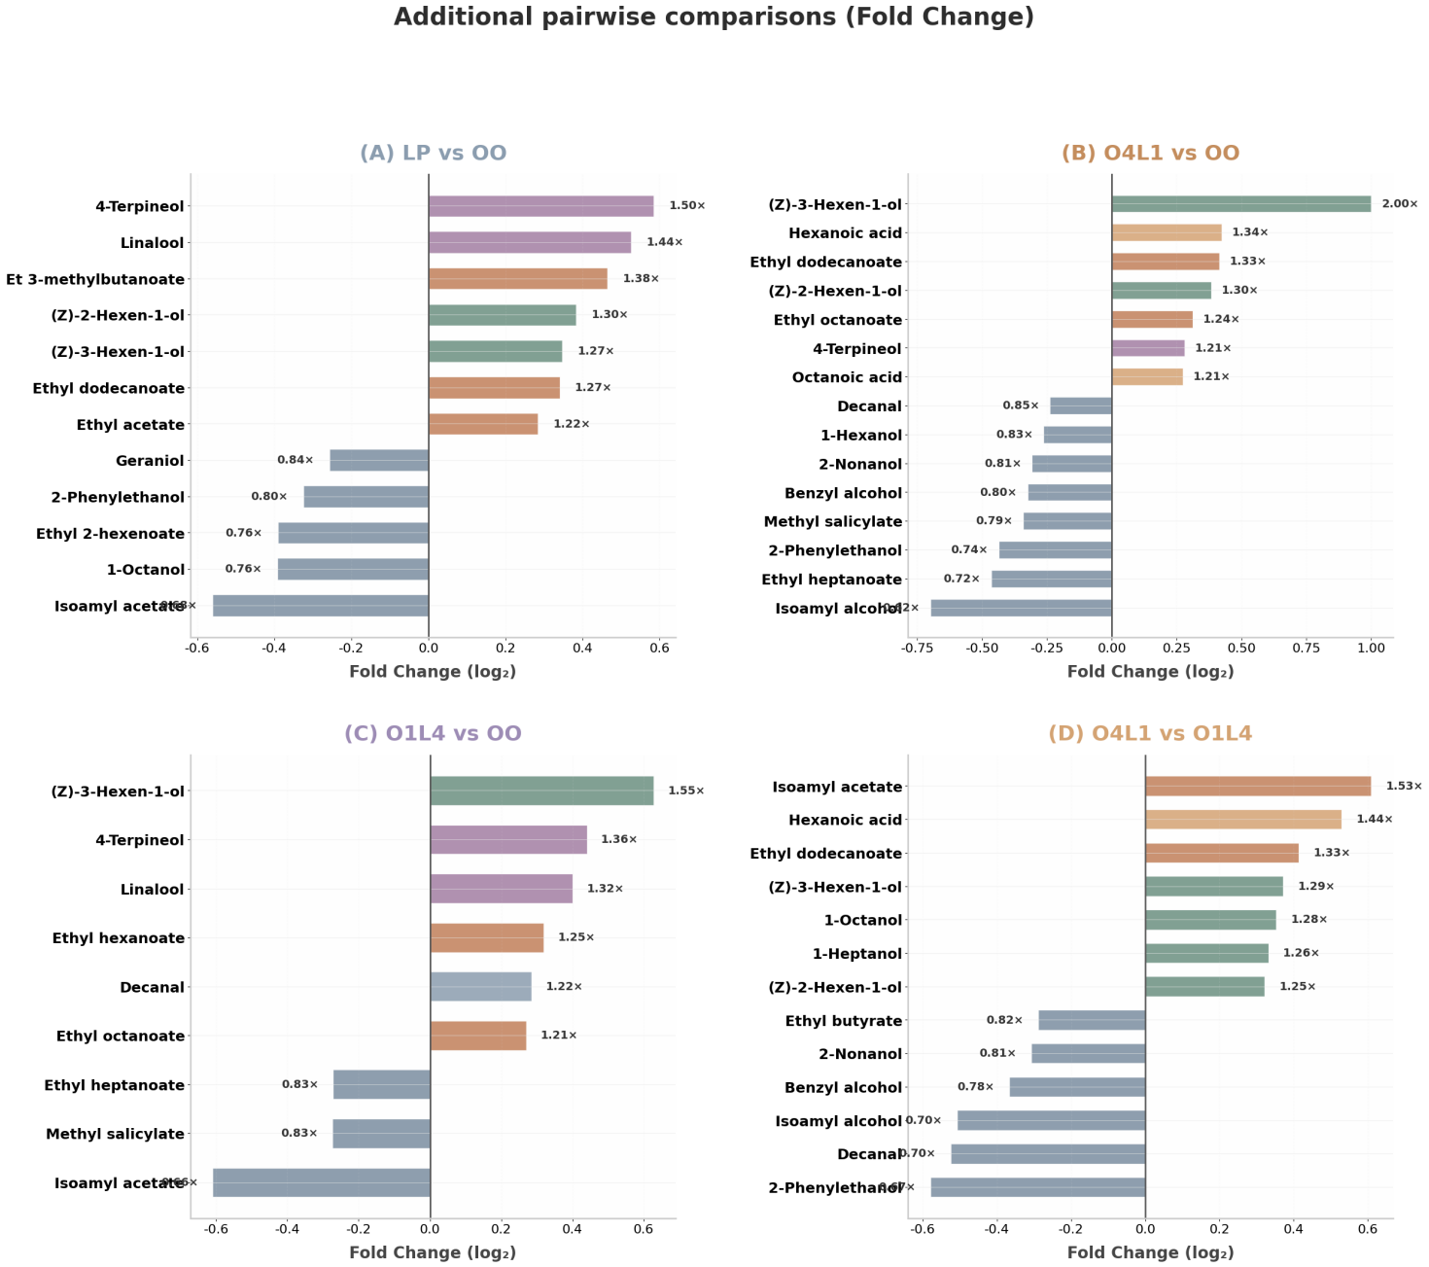
Fig. S1. Additional fold change comparisons of OAV-active volatile compounds across different treatments. (A) LP vs. OO; (B) O4L1 vs. OO; (C) O1L4 vs. OO; (D) O4L1 vs. O1L4.

