Appendix S1. Supporting Information to “Leaving a trace: a meta-analysis of the legacy effects of invasive species”
This appendix includes:
Fig. S1. Flow chart of dataset.
Table S1. List of studies included.
Table S2. Effect sizes by legacy type and associated categories.
Table S3. Effect sizes by biological legacy effects and duration.
Table S4. Effect sizes by biogeochemical legacy effects and duration.

Fig. S1. Flow chart of our dataset.
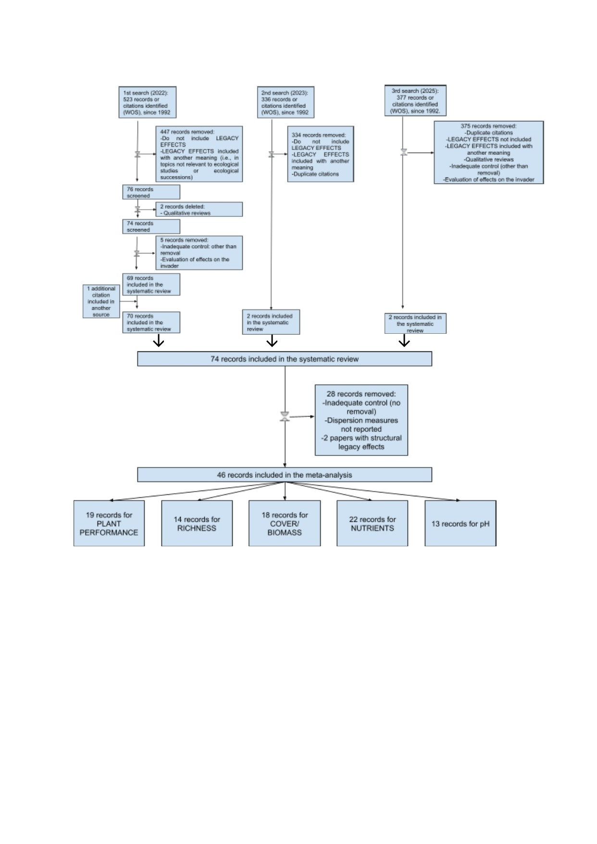

Table S1: List of the 46 publications used in the meta-analysis, with information on herbivore type and effect type of observations extracted from each study. Full references are archived together with the datasets in the Figshare research repository at https://doi.org/10.6084/m9.figshare.32772483
Author | Year | Title | Journal | Legacy type | Categories
Afzal et al. | 2024 | Persistence of root exudates of sorghum bicolor and Solidago canadensis: Impacts on invasive and native species. | Plants | Biological | Plant performance
 |  |  |  | Biogeochemical | Nutrients
Allen et al. | 2018 | Intraspecific variation in indirect plant–soil feedbacks influences a wetland plant invasion. | Ecology | Biological | Cover or biomass
Ahmad et al. | 2021 | Invasion shadows in soil system overshadow the restoration of invaded ecosystems: Implications for invasive plant management. | Ecological Engineering | Biological | Richness and Cover or biomass
 |  |  |  | Biogeochemical | Nutrients and pH
Anthony et al. | 2019 | Fungal communities do not recover after removing invasive Alliaria petiolata (garlic mustard). | Biological Invasions | Biological | Richness
 |  |  |  | Biogeochemical | Nutrients and pH
Broadbent et al. | 2017 | Invasive N-fixer impacts on litter decomposition driven by changes to soil properties not litter quality. | Ecosystems | Biogeochemical | Nutrients and pH
Carter et al. | 2019 | Scotch broom (Cytisus scoparius) modifies microenvironment to promote nonnative plant communities. | Biological Invasions | Biological | Cover or biomass
 |  |  |  | Biogeochemical | Nutrients
Connell et al. | 2021 | Plant legacies and soil microbial community dynamics control soil respiration. | Soil Biology and Biochemistry | Biological | Plant performance
 |  |  |  | Biogeochemical | Nutrients
Crocker et al. | 2017 | Soil conditioning effects of Phragmites australis on native wetland plant seedling survival. | Ecology and Evolution | Biological | Plant performance
Dickie et al. | 2014 | Belowground legacies of Pinus contorta invasion and removal result in multiple mechanisms of invasional meltdown. | AoB plants | Biological | Cover or biomass
 |  |  |  | Biogeochemical | Nutrients and pH
Elgersma et al. | 2012 | Microbial-mediated feedbacks of leaf litter on invasive plant growth and interspecific competition. | Plant and Soil | Biological | Plant performance
Fahey & Flory | 2022 | Soil microbes alter competition between native and invasive plants. | Journal of Ecology | Biological | Plant performance
Fuselier et al. | 2017 | Invasive species management impacts on native and nonnative ferns in an urban forest spore bank. | Castanea | Biological | Richness and Cover or biomass
 |  |  |  | Biogeochemical | pH
Gallego et al. | 2023 | Legacy effects after seven years of afforestation with Pinus taeda in a natural grassland. | Restoration Ecology | Biological | Richness
Geddes et al. | 2014 | Effects of invasive Typha× glauca on wetland nutrient pools, denitrification, and bacterial communities are influenced by time since invasion. | Aquatic Ecology | Biological | Richness
 |  |  |  | Biogeochemical | Nutrients
Grman & Suding | 2010 | Within‐year soil legacies contribute to strong priority effects of exotics on native California grassland communities. | Restoration Ecology | Biological | Cover or biomass
Grove et al. | 2012 | Direct and indirect effects of allelopathy in the soil legacy of an exotic plant invasion. | Plant Ecology | Biological | Plant performance
 |  |  |  | Biogeochemical | Nutrients and pH
Hagan et al. | 2013 | Cogongrass (Imperata cylindrica) invasion and eradication: implications for soil nutrient dynamics in a longleaf pine sandhill ecosystem. | Invasive Plant Science and Management | Biogeochemical | Nutrients and pH
Holdredge & Bertness | 2011 | Litter legacy increases the competitive advantage of invasive Phragmites australis in New England wetlands | Biological Invasions | Biological | Cover or biomass
Hughes et al. | 2012 | Recovery of native forest after removal of an invasive tree, Falcataria moluccana, in American Samoa. | Biological Invasions | Biological | Richness and Cover or biomass
Jones et al. | 2019 | Shrub establishment favoured and grass dominance reduced in acid heath grassland systems cleared of invasive Rhododendron ponticum. | Scientific Reports | Biological | Plant performance
Jordan et al. | 2011 | Evidence of qualitative differences between soil-occupancy effects of invasive vs. native grassland plant species. | Invasive Plant Science and Management | Biological | Cover or biomass
 |  |  |  | Biogeochemical | Nutrients and pH
Kuebbing et al. | 2016 | Co‐occurring nonnative woody shrubs have additive and non‐additive soil legacies. | Ecological Applications | Biological | Plant performance
Le Roux et al. | 2024 | The impacts of invasive African olive on native Australian legumes via altered soil conditions do not persist as legacy effects. | Plant and Soil | Biological | Plant performance and Cover or biomass
Maclean et al. | 2018 | Understorey plant community composition reflects invasion history decades after invasive Rhododendron has been removed. | Journal of Applied Ecology | Biological | Richness and Cover or biomass
 |  |  |  | Biogeochemical | Nutrients and pH
Maoela et al. | 2016 | Invasion, alien control and restoration: Legacy effects linked to folivorous insects and phylopathogenic fungi. | Austral Ecology | Biological | Plant performance
Meisner et al. | 2012 | Reciprocal effects of litter from exotic and congeneric native plant species via soil nutrients. | PLoS One | Biological | Plant performance
Nsikani et al. | 2021 | Soil nitrogen availability favours the growth but not germination of secondary invaders after clearing invasive Acacia saligna. | South African Journal of Botany | Biological | Plant performance
Nsikani et al. | 2017 | Acacia saligna's soil legacy effects persist up to 10 years after clearing: Implications for ecological restoration. | Austral Ecology | Biogeochemical | Nutrients and pH
Parsons & Becker | 2021 | Invasion by Ammophila arenaria alters soil chemistry, leaving lasting legacy effects on restored coastal dunes in California. | Invasive Plant Science and Management | Biogeochemical | Nutrients and pH
Pharo & Lindenmayer | 2009 | Biological legacies soften pine plantation effects for bryophytes | Biodiversity and Conservation | Biological | Richness
Pickett et al. | 2019 | Legacy effects of invasive grass impact soil microbes and native shrub growth. | Invasive Plant Science and Management | Biological | Plant performance
 |  |  |  | Biogeochemical | Nutrients
Rodríguez-Echeverría et al. | 2013 | The effect of soil legacy on competition and invasion by Acacia dealbata Link. | Plant Ecology | Biological | Plant performance
Rook et al. | 2011 | Responses of prairie vegetation to fire, herbicide, and invasive species legacy. | Northwest Science | Biological | Richness and Cover or biomass
Rout et al. | 2013 | Ecological impacts of the invasive grass Sorghum halepense on native tallgrass prairie. | Biological Invasions | Biological | Plant performance
Sample et al. | 2019 | Increase in nonnative understorey vegetation cover after nonnative conifer removal and passive restoration. | Austral Ecology | Biological | Cover or biomass
Shannon et al. | 2014 | Plant-soil feedbacks between invasive shrubs and native forest understory species lead to shifts in the abundance of mycorrhizal fungi. | Plant and Soil | Biological | Plant performance
Singh et al. | 2022 | Spotted knapweed (Centaurea stoebe) creates a soil legacy effect by modulating soil elemental composition in a semi-arid grassland ecosystem. | Journal of Environmental Management | Biological | Cover or biomass
 |  |  |  | Biogeochemical | Nutrients
Slesak et al. | 2022 | Removal of invasive Scotch broom increases its negative effects on soil chemistry and plant communities. | Oecologia | Biological | Richness and Cover or biomass
 |  |  |  | Biogeochemical | Nutrients
Stanbury et al. | 2018 | Legacy issues in post‐pine (Pinus pinaster) restoration environments: Weeds compromise seedling growth and function more than edaphic factors. | Land Degradation & Development | Biological | Plant performance
 |  |  |  | Biogeochemical | Nutrients and pH
Szitár et al. | 2014 | Recovery of inland sand dune grasslands following the removal of alien pine plantation. | Biological Conservation | Biological | Richness and Cover or biomass
 |  |  |  | Biogeochemical | Nutrients and pH
Unger et al. | 2022 | Immediate and long-term effects of invasive plant species on soil characteristics. | Soil Ecology Letters | Biogeochemical | Nutrients
Vilà & Gimeno | 2007 | Does invasion by an alien plant species affect the soil seed bank? | Journal of Vegetation Science | Biological | Plant performance and Richness
Von Holle et al. | 2013 | Ecosystem legacy of the introduced N2-fixing tree Robinia pseudoacacia in a coastal forest. | Oecologia | Biological | Richness and Cover or biomass
 |  |  |  | Biogeochemical | Nutrients
Wei et al. | 2023 | Plant growth ability, rather than phylogenetic relatedness, predicts the effect of soil biota from an abandoned field on native and exotic plants. | Journal of Plant Ecology | Biological | Plant performance
Wiener et al. | 2020 | Effects of invasive N2-fixing Acacia mearnsii on sediment nutrient concentrations in mountain streams: implications of sediment geochemistry for ecosystem recovery. | Catena | Biogeochemical | Nutrients
Zeidler et al. | 2022 | Homogenization of bryophyte species after alpine grassland restoration. | Journal of Environmental Management | Biological | Richness

Table S2. Mean effect size (lnRR), 95% confidence intervals, p-value, number of observations (N), I² (%), Cochran’s Q (Q), publication bias (Egger's test) and Fail-safe N (Rosenthal) for the legacy effects grouped by legacy type (biological legacies and biogeochemical legacies) and associated categories (plant performance, richness, cover or biomass, nutrients and pH). Asterisks indicate significance levels: p < 0.05 (*), p < 0.01 (**), p < 0.001 (***); n.s. = not significant.

Type of legacy | Categories | lnRR | 95% CI | p-value | N | I² (%) | Q | Publication bias  (Egger's test) | Fail-safe N (Rosenthal)
Biological | Plant performance | 0.0420 | [0.0219, 0.0621] | <.0001(***) | 400 | 90.3 | Q = 4113.6704, df = 399,  p < 0.0001) | Yes (p <0.0001) | 1452
Biological | Richness | 0.0089 | [-0.0669, 0.0848] | 0.8172 (n.s.) | 45 | 99.944 | Q = 7894.2101, df = 44,  p < .0001) | No (p = 0.1446) | -
Biological | Cover or biomass | -0.3359 | [-0.5112, -0.1606] | 0.0002(***) | 88 | 88.79 | Q = 6234.8521, df = 87,  p < .0001). | No (p = 0.9283) | -
Biogeochemical | Nutrients | 0.0309 | [-0.0971, 0.159] | 0.6360 (n.s.) | 82 | 98.76 | Q = 6532.0032, df = 81,  p < .0001). | Yes (p <0.0001) | 0
Biogeochemical | pH | 0.0358 | [0.0114, 0.0601] | 0.0040 (**) | 33 | 97.74 | Q = 1414.1941, df = 32,  p < .0001). | No (p = 0.7165) | -

Table S3. Mean effect size (lnRR), 95% confidence intervals, p-value, number of observations (N), I² (%), Cochran’s Q (Q), publication bias (Egger's test) and Fail-safe N (Rosenthal) for the biological legacy effects grouped by associated categories (plant performance, richness and cover or biomass) and legacies duration (short-term: < 5 years; long-term: > 5 years). Asterisks indicate significance levels: p < 0.05 (*), p < 0.01 (**), p < 0.001 (***); n.s. = not significant.

Categories | Duration | lnRR | 95% CI | p-value | N | I² (%) | Q | Publication bias  (Egger's test) | Fail-safe N (Rosenthal)
Plant performance | Short-term | -0.0137 | [-0.0319, 0.0046] | 0.1421(n.s.) | 285 | 85.37 | Q = 1941.8643, df = 284,  p < 0.0001) | Yes (p <0.0001) | 2013
Plant performance | Long-term | 0.2560 | [0.1699, 0.3421] | <.0001(***) | 115 | 93.45 | Q = 1740.8830, df = 114,  p < 0.0001) | No (p = 0.3159) | -
Richness | Short-term | -0.0140 | [-0.1205, 0.0926] | 0.7975 (n.s.) | 22 | 98.15 | Q = 1137.2136, df = 21,  p < 0.0001) | No (p= 0.5495) | -
Richness | Long-term | 0.0348 | [-0.0717, 0.1413] | 0.5217 (n.s.) | 23 | 99.63 | Q = 5972.8756, df = 22,  p < 0.0001) | No (p=0.0140) | -
Cover or biomass | Short-term | -0.2292 | [-0.3629, -0.0954] | 0.0008 (***) | 45 | 94.85 | Q = 892.4502, df = 46,  p < 0.0001) | No (p=0.7776) | -
Cover or biomass | Long-term | -0.4882 | [-0.8699, -0.1066] | 0.0122 (*) | 41 | 99.25 | Q = 5303.3655, df = 40,  p < 0.0001) | No (p=0.5466) | -

Table S4. Mean effect size (lnRR), 95% confidence intervals, p-value, number of observations (N), I² (%), Cochran’s Q (Q), publication bias (Egger's test) and Fail-safe N (Rosenthal) for the biogeochemical legacy effects grouped by associated categories (nutrients and pH) and legacies duration (short-term: < 5 years; long-term: > 5 years). Asterisks indicate significance levels: p < 0.05 (*), p < 0.01 (**), p < 0.001 (***); n.s. = not significant.

Categories | Duration | lnRR | 95% CI | p-value | N | I² (%) | Q | Publication bias  (Egger's test) | Fail-safe N (Rosenthal)
Nutrients | Short-term | -0.0785 | [-0.2194, 0.0624] | 0.2747 (n.s.) | 56 | 98.82 | Q = 4675.0514, df = 55,  p < 0.0001) | Yes (p=0.0087) | 538
Nutrients | Long-term | 0.3422 | [0.0111, 0.6733] | 0.0428 (*) | 26 | 98.63 | Q = 1829.0927, df = 25,  p < 0.0001) | Yes (p=0.0275) | 496
pH | Short-term | 0.0186 | [-0.0027, 0.0400] | 0.0786 (n.s.) | 21 | 96.70 | Q = 606.6994, df = 20,  p < 0.0001) | No (p=0.5129) | -
pH | Long-term | 0.0653 | [-0.0144, 0.1449] | 0.1081 (n.s.) | 12 | 98.12 | Q = 583.8607, df = 11,  p < 0.0001) | No (p=0.4962) | -

