Electronic Supporting Information
A novel insight into mechanism of derangement of coagulation balance: interactions of quantum dots with coagulation-related proteins
Lingyan Zhang^{1,2}, Yingting Wu³, Xingling Luo¹, Tianjiang Jia¹, Kexin Li¹, Lihong Zhou¹, Zhen Mao¹ and Peili Huang^{1,}

SI1. Characterization of CdTe QDs and CdTe/ZnS QDs
Fig. S1 UV-Vis absorption spectra and fluorescence emission spectra of (A) CdTe QDs and (B) CdTe/ZnS QDs.

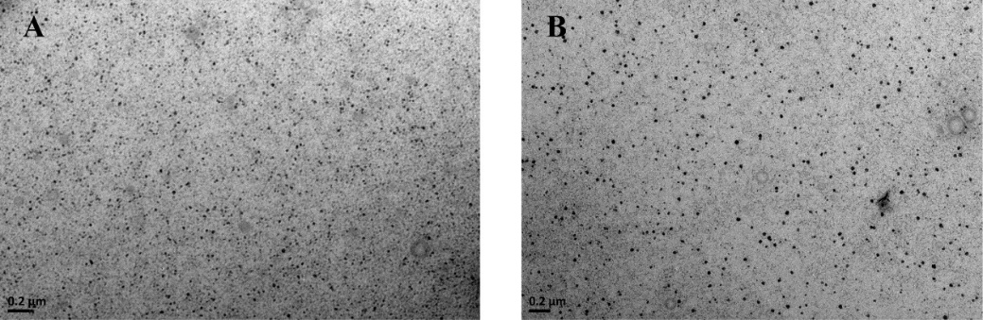
Fig. S2 TEM images of (A) CdTe QDs and (B) CdTe/ZnS QDs. Scale bar = 0.2 μm.
SI2. QDs induced derangement of coagulation balance
At day 3, day 7 and day 14, no statistically significant changes of PT, APTT and TT in rats were observed of both CdTe QDs-treated groups and CdTe/ZnS QDs-treated groups (Fig. S3).
For coagulation factors (Fig. S4), FXa still decreased in each dosage group of CdTe/ZnS QDs (P<0.05) at day 3. For fibrinolytic factors (Fig. S5), PLG decreased remarkably in 15 μmol/kg bw group of CdTe/ZnS QDs (P<0.001) at day 3, and the level of PLG is still lower in 5 μmol/kg bw group and 15 μmol/kg bw group of CdTe/ZnS QDs (P<0.01) at day 7. What’s more, the level of t-PA was still higher in 15 μmol/kg bw group of CdTe/ZnS QDs (P<0.001) at day3. For anticoagulation factors (Fig. S6), no significant changes were observed for tissue factor pathway inhibitor (TFPI) and antithrombin III (AT-III) in each dosage group of CdTe QDs and CdTe/ZnS QDs at each point in time of observation (P>0.05).
Fig. S3 Effects of CdTe QDs (A) and CdTe/ZnS QDs (B) on coagulation function at three points-in-time. Each value represents the mean ± standard deviation (SD) (n = 6). Comparing to the values of control group and dose group by two-way ANOVA with Bonferroni’s multiple comparison test.
Fig. S4 Effects of CdTe QDs (A) and CdTe/ZnS QDs (B) on coagulation factors at three points-in-time. Each value represents the mean ± standard deviation (SD) (n = 6). * P < 0.05, ** P < 0.01, comparing to the values of control group and dose group by two-way ANOVA with Bonferroni’s multiple comparison test.
Fig. S5 Effects of CdTe QDs (A) and CdTe/ZnS QDs (B) on fibrinolytic factors at three points-in-time. Each value represents the mean ± standard deviation (SD) (n = 6). ** P < 0.01, *** P < 0.001, comparing to the values of control group and dose group by two-way ANOVA with Bonferroni’s multiple comparison test.

Fig. S6 Effects of CdTe QDs (A) and CdTe/ZnS QDs (B) on anticoagulation factors at three points-in-time. Each value represents the mean ± standard deviation (SD) (n = 6). Comparing to the values of control group and dose group by two-way ANOVA with Bonferroni’s multiple comparison test.

Correspondence: huangpl@ccmu.edu.cn ¹School of Public Health, Capital Medical University, No.10 Xitoutiao You An Men, Beijing 100069, China ²School of Public Health, Baotou Medical College, 31# Jianshe Road, Donghe District, Baotou 014040, China ³Core Facility Center, Capital Medical University, No.10 Xitoutiao You An Men, Beijing 100069, China

