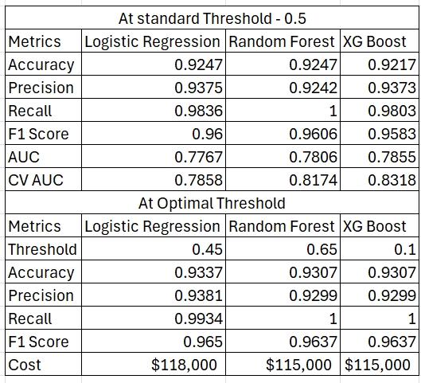
Table 1. Performance Metric Evaluation at the default threshold of 0.5 and at their respective optimal threshold
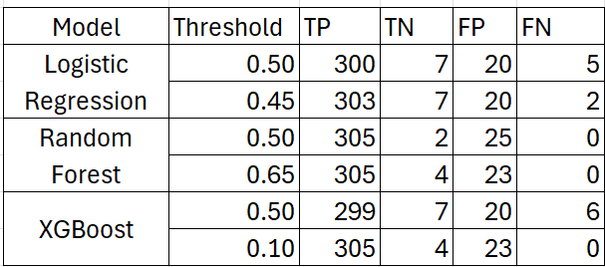
Table 2. Confusion Matrices at the default and Optimal Thresholds

