Supplementary Figures and Tables:
Probability distribution and percentile levels of Hazard Quotient (HQ) for groundwater exposure using Monte Carlo simulation:
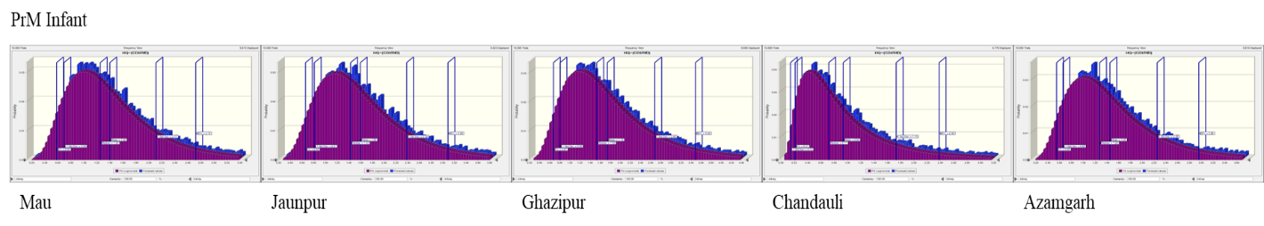
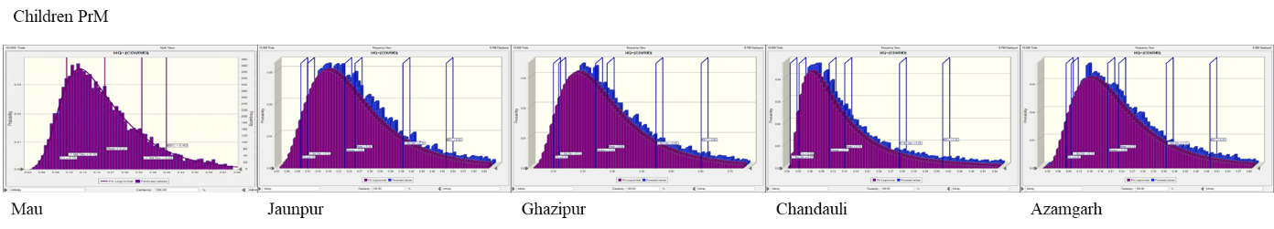
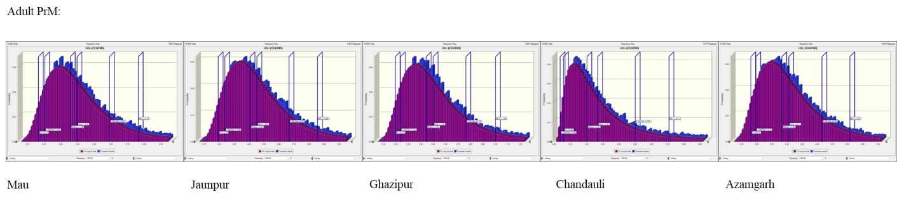
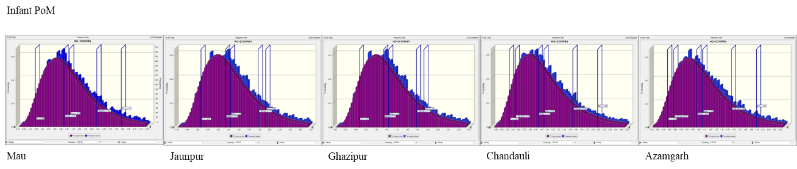
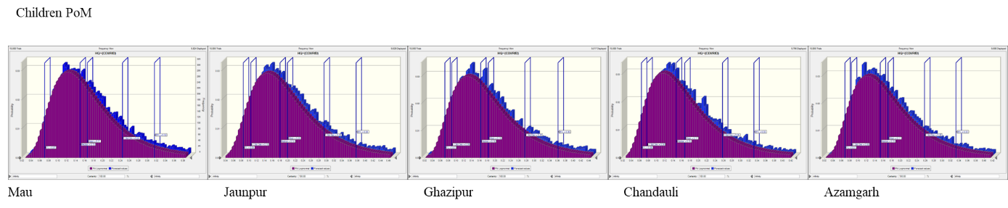
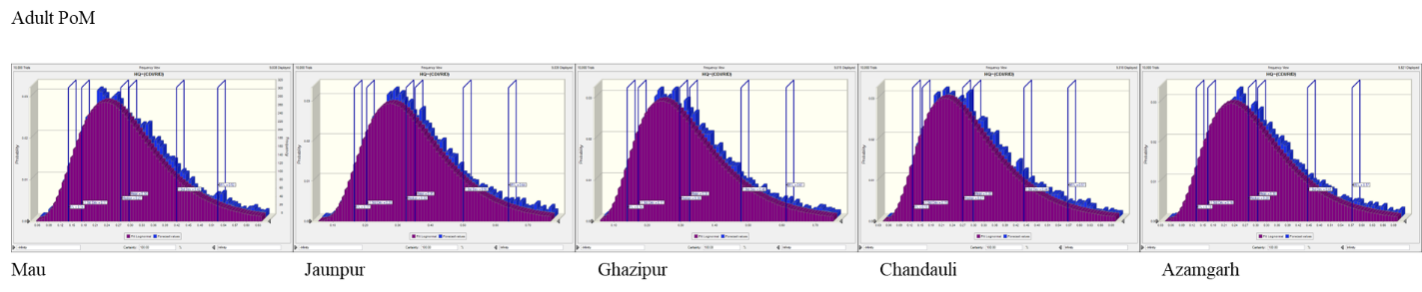
Fig. S1. Probability graph of HQ of all selected districts for all 3 age groups in PrM and PoM.

Table S1. Result of HQ based on deterministic approach of different location of study area in PrM and PoM
 | HQ (PRM) |  |  | HQ (POM)
Location | Infant | Children | Adult | Infant | Children | Adult
Mau | 1.98 | 2.22 | 1.13 | 1.46 | 1.65 | 0.83
Jaunpur | 2.24 | 2.52 | 1.29 | 1.74 | 2.95 | 1
Azamgarh | 2.04 | 2.3 | 1.17 | 1.5 | 1.65 | 0.84
Ghazipur | 2.45 | 2.76 | 1.41 | 1.5 | 1.8 | 0.92
Chandauli | 1.32 | 1.48 | 0.76 | 1.47 | 1.66 | 0.85

Table S2. Result of HQ based on probabilistic approach of different location of study area in PrM and PoM
PRM |  |  |  |  |  |  |  | POM
Location | Groups | 0.05% | Mean | 0.95% | Min. | Max. | Std. Dev. | 0.05% | Mean | 0.95% | Min. | Max. | Std. Dev.
Mau | HQ (Infant) | 0.58 | 1.4 | 2.72 | 0.2 | 8.92 | 0.71 | 0.48 | 1.04 | 1.86 | 0.22 | 5.36 | 0.44
 | HQ (Children) | 0.1 | 0.21 | 0.36 | 0.02 | 1.16 | 0.11 | 0.07 | 0.17 | 0.32 | 0.03 | 0.73 | 0.08
 | HQ (Adult) | 0.17 | 0.4 | 0.76 | 0.06 | 1.9 | 0.19 | 0.14 | 0.3 | 0.52 | 0.06 | 1.19 | 0.12
Jaunpur | HQ (Infant) | 0.66 | 1.59 | 3.09 | 0.27 | 8.4 | 0.79 | 0.56 | 1.24 | 2.24 | 0.21 | 7.66 | 0.54
 | HQ (Children) | 0.1 | 0.26 | 0.52 | 0.04 | 1.52 | 0.14 | 0.08 | 0.2 | 0.38 | 0.04 | 1.08 | 0.09
 | HQ (Adult) | 0.19 | 0.45 | 0.86 | 0.07 | 2.13 | 0.21 | 0.17 | 0.35 | 0.64 | 0.05 | 1.41 | 0.15
Azamgarh | HQ (Infant) | 0.55 | 1.45 | 2.96 | 0.19 | 8.45 | 0.8 | 0.46 | 1.06 | 1.99 | 0.21 | 4.69 | 0.49
 | HQ (Children) | 0.08 | 0.23 | 0.49 | 0.02 | 1.63 | 0.13 | 0.07 | 0.17 | 0.33 | 0.02 | 0.94 | 0.09
 | HQ (Adult) | 0.16 | 0.41 | 0.81 | 0.05 | 2.47 | 0.22 | 0.13 | 0.3 | 0.57 | 0.04 | 1.48 | 0.14
Ghazipur | HQ (Infant) | 0.67 | 1.74 | 3.48 | 0.28 | 11.3 | 0.94 | 0.49 | 1.12 | 2.15 | 0.17 | 6.15 | 0.54
 | HQ (Children) | 0.1 | 0.28 | 0.6 | 0.03 | 1.61 | 0.17 | 0.07 | 0.18 | 0.36 | 0.02 | 1.01 | 0.09
 | HQ (Adult) | 0.19 | 0.5 | 1 | 0.05 | 3.58 | 0.26 | 0.14 | 0.33 | 0.61 | 0.06 | 1.35 | 0.15
Chandauli | HQ (Infant) | 0.14 | 0.93 | 2.38 | 0.05 | 14.17 | 0.8 | 0.43 | 1.04 | 1.98 | 0.17 | 6.22 | 0.51
 | HQ (Children) | 0.03 | 0.15 | 0.4 | 0 | 2.94 | 0.14 | 0.06 | 0.17 | 0.33 | 0.03 | 1.03 | 0.09
 | HQ (Adult) | 0.06 | 0.27 | 0.71 | 0.01 | 4.41 | 0.23 | 0.13 | 0.3 | 0.57 | 0.04 | 1.4 | 0.14
Table S3. Result of sensitivity analysis of different age group in five locations in pre- and post-monsoon seasons using MCS
 |  | Pre-monsoon
 |  | F⁻ (ppm) | Ingestion rate (L/day) | Exposure frequency (day/year) | Body weight (Kg)
Mau | Infant | 54.7 | 29.9 | 8 | -7.4
 | Children | 46.5 | 21.6 | 7.5 | -24.4
 | Adult | 56.5 | 19.7 | 9.3 | -14.5
Jaunpur | Infant | 52.6 | 31.3 | 8.7 | -7.3
 | Children | 44.6 | 22.3 | 8.2 | -25
 | Adult | 54.1 | 22.3 | 8.9 | -14.7
Azamgarh | Infant | 60.3 | 26.3 | 7.1 | -6.3
 | Children | 53 | 20.5 | 6.9 | -19.6
 | Adult | 62.1 | 19.2 | 7 | -11.7
Ghazipur | Infant | 60.9 | 25 | 7.8 | -6.4
 | Children | 50.6 | 19.8 | 7.7 | -21.9
 | Adult | 63.4 | 18.3 | 7.2 | -11.1
Chandauli | Infant | 81.5 | 12.2 | 3.8 | -2.5
 | Children | 78.8 | 9 | 2.7 | -9.6
 | Adult | 83.7 | 8.4 | 2.8 | -5.1
 |  | Post-monsoon
 |  | F- (ppm) | Ingestion rate (L/day) | Exposure frequency (day/year) | Body weight (Kg)
Mau | Infant | 38.5 | 40.5 | 11.8 | -9.2
 | Children | 32.2 | 26.6 | 9.4 | -31.9
 | Adult | 38.6 | 29.7 | 12.9 | -18.8
Jaunpur | Infant | 40.6 | 40.3 | 10.4 | -8.6
 | Children | 33.4 | 26.9 | 9.1 | -30.6
 | Adult | 40.5 | 28.7 | 12.2 | -18.6
Azamgarh | Infant | 47.9 | 33.9 | 9.4 | -8.8
 | Children | 41.2 | 23.7 | 9.3 | -25.8
 | Adult | 50.9 | 23.9 | 10 | -15.3
Ghazipur | Infant | 49.9 | 33.9 | 9.2 | -7.1
 | Children | 41.8 | 22.6 | 9.3 | -26.3
 | Adult | 50.7 | 23.6 | 9.8 | -15.9
Chandauli | Infant | 50.6 | 32.5 | 9.6 | -7.3
 | Children | 43.7 | 22.9 | 8.2 | -26.3
 | Adult | 53.5 | 22.4 | 10.3 | -13.8

