Supplementary materials

1. Linear mixed-effect model formulas:
(1) Mean-amplitude_{i} = β0 + β1*cluster_{i} + β2*PANSS_{i} + β3*cluster_{i} *PANSS_{i} + b1* PANSS_{i} + b0+ ε_{i}
For participant i, with β1-3 being the fixed-effect coefficients for cluster (coded by a dummy variable for frontal and central clusters), PANSS and group*PANSS interaction. The b1 term is the random slope varying by participant, b0 is the normally distributed random effect, and ε_{i} is the normally distributed observation error.
(2) ERP_{i} = β0 + β1*group_{i} + β2*D-prime_{i} + β3*group_{i} *D-prime_{i} + b1* D-prime_{i} + b0+ ε_{i}
For participant i, with β1-3 being the fixed-effect coefficients for group (coded by a dummy variable), D-prime and group*D-prime interaction. The b1 term is the random slope varying by participant, b0 is the normally distributed random effect, and ε_{i} is the normally distributed observation error.

2. Supplementary tables

Inclusion criteria (for inpatients with schizophrenia)  - A diagnosis of schizophrenia according to the diagnostic and statistical manual of mental disorders (DSM5)  - A clinical global impression (CGI) score ≥ 4 pts (“moderately ill” or worse)  - Indication to an antipsychotic treatment  - Informed consent as documented by signature | Exclusion criteria (for patients with schizophrenia)  - Age below 18 and beyond 65 years  - Concomitant substance use disorder, according to DSM5 criteria  - Concomitant medication with antidepressant and/or mood stabilizers  - Other clinically significant concomitant disease states (e.g., renal failure, hepatic dysfunction, cardiovascular disease, major neurological disorders)  - Known or suspected non-compliance to treatment in the inpatient setting  Exclusion criteria (for healthy control)  - History of mental illness  - Concomitant substance use disorder, according to DSM5 criteria  - Other clinically significant concomitant disease states (e.g., renal failure, hepatic dysfunction, cardiovascular disease, major neurological disorders)

Supplementary Table S1: Inclusion and exclusion criteria for patients and healthy controls.

Antipsychotic | Dose [mg] | n | Double Medication (n) | Type (n)
Brexpiprazole (Br) | 1 | 2
Cariprazine (Ca) | 6 ± 0 [6-6] | 2 | 2 | Cl (1); Ol (1)
Clozapine (Cl) | 316,7 ± 76.4 [250-400] | 3 | 2 | Pa(1); Ca(1)
Haloperidol (Ha) | 15,3 ± 5,5 [10-20] | 4
Olanzapine (Ol) | 7,5 ± 3,5 [5-10] | 2 | 1 | Ca(1)
Paliperidone (Pa) | 6,5 ± 2,3 [3-9] | 6 | 1 | Cl(1)
Quetiapine (Qu) | 800 | 1
Risperidone (Ri) | 3,4 ± 1,6 [1-6] | 7
Risperidone dose equivalents* | 6,1 ± 3,7 [1-12,5] | 23 | 3

Supplementary table S2: Antipsychotic medication taken by inpatients, initiated <72h before EEG recording. Mean dosage in [mg] with standard deviation and range; number of participants taking each molecule, with the number of participants taking a second antipsychotic molecule (3 participants in total). Risperidone equivalent according to the Defined Daily Doses method, double medication was included in the calculation (Leucht et al, 2016).

Within-Subject
 |  | Type III Sum of Squares | df | Mean Square | F | p | Partial η² | Hedge's g
 | ROI (Frontal / Central) | 4,20 | 1 | 4,20 | 3,77 | 0,058 | 0,079
 | Spatial * Group | 7,65 | 1 | 7,65 | 6,87 | 0,012 | 0,135 | 0,777
 | Error(time) | 48,99 | 44 | 1,11
Between-Subject

 | Intercept | 90,78 | 1 | 90,78 | 23,90 | 0 | 0,352
 | Group (Cntrl / Schz) | 0,46 | 1 | 0,46 | 0,12 | 0,731 | 0,003
 | Error | 167,10 | 44 | 3,80

Supplementary Table S3: Repeated measure ANOVA using anteriority (frontal and central ROI) as within-subject factor and group (controls, n=23, and acute patients, n=23) as between-subject factor. Significant effects highlighted in bold. ROI: Region of interest.

Risperidone dose-equivalent
 |  | Nogo N2 (Fz) | r | p | NoGo P3 (Cz) | r | p | Go N2 (Fz) | r | p | Go P3 (Cz) | r | p
 | Mean amplitude |  | -0.078 | .730 |  | -0.158 | .482 |  | -0.142 | .528 |  | -0.072 | .749 (S)
 | Peak latency |  | -0.094 | .676 |  | -0.098 | .665 |  | 0.090 | .691 |  | 0.056 | .803
 | Peak latency variability |  | 0.310 | .160 |  | -0.096 | .670 |  | 0.076 | .735 (S) |  | -0.218 | .329 (S)

Supplementary Table S4: Correlations between risperidone dose-equivalent antipsychotic medication (defined daily dose method, DDD, Leucht et al, 2016) and ERP components, within acute inpatients. Significant effects highlighted in bold. Bonferroni corrected alpha=.017. Pearson correlation used, unless distribution was not normal (Spearman correlation used, indicated with an S).

PANSS Total
 |  | Nogo N2 (Fz) | r | p | NoGo P3 (Cz) | r | p | Go N2 (Fz) | r | p | Go P3 (Cz) | r | p
 | Mean amplitude |  | 0.135 | .143 |  | 0.430 | .040 (S) |  | 0.389 | .066 |  | 0.254 | .242 (S)
 | Peak latency |  | -0.325 | .131 |  | -0.018 | .935 |  | -0.129 | .556 |  | -0.116 | .600
 | Peak latency variability |  | 0.411 | 0.051 |  | -0.002 | .994 (S) |  | -0.040 | .858 (S) |  | -0.161 | .464 (S)

Supplementary Table S5: Correlations between PANSS total score and ERP components, within acute patients. Significant effects highlighted in bold. Bonferroni corrected alpha=.017. Pearson correlation used, unless distribution was not normal (Spearman correlation used, indicated with an S).

Illness Duration (years)
 |  | Nogo N2 (Fz) | r | p | NoGo P3 (Cz) | r | p | Go N2 (Fz) | r | p | Go P3 (Cz) | r | p
 | Mean amplitude |  | 0.335 | .127 |  | 0.027 | .906 |  | 0.252 | .257 |  | -0.069 | .760 (S)
 | Peak latency |  | 0.224 | .316 |  | 0.010 | .966 |  | 0.288 | .194 |  | -0.000 | .999
 | Peak latency variability |  | -0.051 | .823 |  | 0.667 | <.001 |  | 0.580 | .005 (S) |  | 0.735 | <.001 (S)

Supplementary Table S6: Correlations between illness duration (in years) and ERP components, within acute patients (n=23). Significant effects highlighted in bold. Bonferroni corrected alpha=.017. Pearson correlation used, unless distribution was not normal (Spearman correlation used, indicated with an S).

D-prime
 | Nogo | N2 (Fz) | β (D-prime) | p | β (Group interaction) | p | P3 (Cz) | β (D-prime) | p | β (Group interaction) | p
 | Mean amplitude |  | -0.593 | .009 | 0.109 | .106 |  | 0.800 | .007 | -0.591 | .142
 | Peak latency |  | 2.712 | .928 | -1.96 | .386 |  | -25.5 | .004 | 8.43 | .114
 | Peak latency variability |  | -0.302 | .201 | -0.029 | .752 |  | -0.148 | .237 | -0.596 | .285

 | Go | Go N2 (Fz) | β (D-prime) | P-val | β (Group interaction) | P-val | Go P3 (Cz) | β (D-prime) | P-val | β (Group interaction) | P-val
 | Mean amplitude |  | -0.203 | .505 | 0.333 | .418 |  | 0.779 | .015 | -0.534 | .219
 | Peak latency |  | -2.69 | .038 | -7.65 | .307 |  | -21.8 | .100 | 19.2 | .130
 | Peak latency variability |  | -0.190 | <.001 | -0.429 | .191 |  | -0.306 | .001 | -0.559 | .261

Supplementary Table S7: Linear mixed model effects, with group and D-prime (behavioral ability to discriminate between stimuli) as fixed factors, predicting ERP components. Significant effects highlighted in bold. Bonferroni corrected alpha=.017. Effects of D-prime and of D-prime*group interaction on the ERP metrics are reported.

3. Supplementary figures

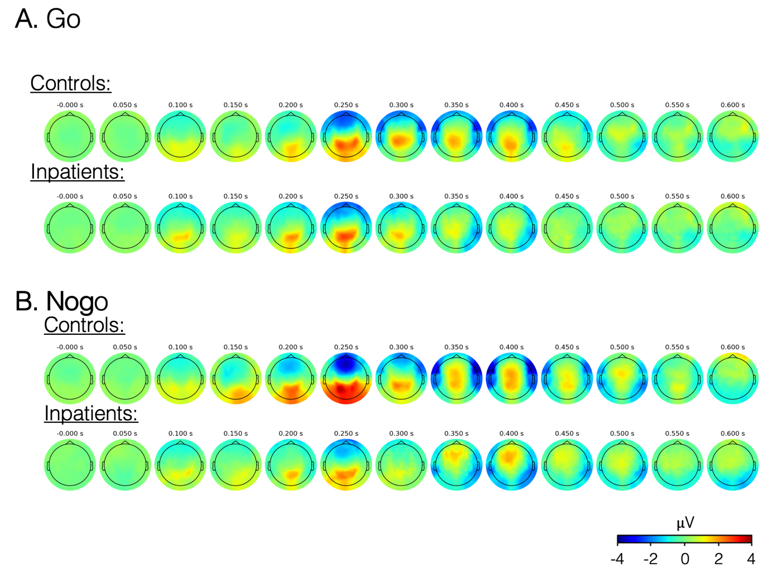
Supplementary Figure S1: The grand-averaged topographical maps for each group, averaged within each successive 50 ms window between 0–600ms post-stimulus in the Go (A) and Nogo (B) conditions.

