Supplemental Online Content

eAppendix 1. Detailed search strategies.
eTable 1. Publication source, design, and data-status details
eTable 2. Eligibility criteria and imaging-selection details
eTable 3. Baseline disease burden and analysis populations
eTable 4. Previous treatment and metastatic-history details
eTable 5. Treatment regimen, exposure, and comparator details
eTable 6. Additional efficacy endpoints from study-level extraction
eTable 7. Patient-reported, pain, and opioid-related outcomes
eTable 8. Additional safety outcomes
eTable 9. Summary of analysis-ready effect-size dataset used for forest plots
eTable 10. RoB 2.0 judgments for supportive endpoints by randomized trial.
eTable 11. Subgroup-stratified sensitivity analysis summary.
eFigure 1. Post-chemo / late-line mCRPC forest plots (PFS/rPFS, OS, PSA50, ORR).
eFigure 2. Taxane-naive mCRPC forest plots (PFS/rPFS, OS, PSA50, ORR).
eFigure 3. mHSPC upfront intensification forest plots (PFS/rPFS, OS, ORR).
eFigure 4. mHSPC sensitivity-analysis forest plots (PFS/rPFS, ORR).
eFigure 5. Oligometastatic/oligorecurrent HSPC forest plots (PFS/rPFS, PSA50).
eFigure 6. Docetaxel-comparator chemotherapy-naive mCRPC forest plots (PFS/rPFS, PSA50).
eFigure 7. Evidence distribution summary across included clinical subgroups.
eFigure 8. Grade >=3 adverse event forest plots.
eFigure 9. Risk-of-bias summary for included randomized trials.
eFigure 10. Overall PFS/rPFS funnel plot.

eAppendix 1. Detailed search strategies
Searches were designed for randomized studies evaluating prostate-specific membrane antigen radioligand therapy in prostate cancer. Searches were run from database inception through June 17, 2026. No language restriction was applied at the search stage.
Core concept blocks
Concept | Terms
Population | "prostate cancer" OR "prostatic neoplasm*" OR mCRPC OR CRPC OR mHSPC OR "hormone-sensitive prostate cancer" OR "castration-resistant prostate cancer"
Target | PSMA OR "prostate-specific membrane antigen" OR "prostate specific membrane antigen"
Therapy | "radioligand therap*" OR "radionuclide therap*" OR "targeted radionuclide therap*" OR "radiopharmaceutical therap*" OR theranostic* OR lutetium OR "lutetium-177" OR "177Lu" OR "Lu-177" OR "Lu PSMA" OR "Lu-PSMA" OR "PSMA-617" OR Pluvicto OR PNT2002 OR "PSMA-I&T" OR "PSMA I&T" OR actinium OR "actinium-225" OR "225Ac"
Study design | random* OR trial OR "clinical trial" OR "phase 2" OR "phase II" OR "phase 3" OR "phase III" OR interventional OR prospective

PubMed/MEDLINE
Platform | PubMed
Search date | Inception to June 17, 2026
Search strategy | (("Prostatic Neoplasms"[Mesh] OR "prostate cancer"[tiab] OR "prostatic cancer"[tiab] OR "prostatic neoplasm*"[tiab] OR "prostate neoplasm*"[tiab] OR mCRPC[tiab] OR CRPC[tiab] OR mHSPC[tiab] OR "metastatic castration-resistant prostate cancer"[tiab] OR "metastatic castration resistant prostate cancer"[tiab] OR "castration-resistant prostate cancer"[tiab] OR "hormone-sensitive prostate cancer"[tiab] OR "hormone sensitive prostate cancer"[tiab]) AND ("Prostate-Specific Membrane Antigen"[Mesh] OR PSMA[tiab] OR "prostate-specific membrane antigen"[tiab] OR "prostate specific membrane antigen"[tiab]) AND ("radioligand therapy"[tiab] OR "radioligand therapies"[tiab] OR "radioligand treatment"[tiab] OR "radionuclide therapy"[tiab] OR "targeted radionuclide therapy"[tiab] OR "radiopharmaceutical therapy"[tiab] OR theranostic*[tiab] OR lutetium[tiab] OR "lutetium-177"[tiab] OR "177Lu"[tiab] OR "Lu-177"[tiab] OR "Lu PSMA"[tiab] OR "Lu-PSMA"[tiab] OR "LuPSMA"[tiab] OR "PSMA-617"[tiab] OR Pluvicto[tiab] OR PNT2002[tiab] OR "PSMA-I&T"[tiab] OR "PSMA I&T"[tiab] OR actinium[tiab] OR "actinium-225"[tiab] OR "225Ac"[tiab]) AND (randomized controlled trial[pt] OR controlled clinical trial[pt] OR clinical trial[pt] OR random*[tiab] OR randomised[tiab] OR randomized[tiab] OR trial[tiab] OR "phase 2"[tiab] OR "phase II"[tiab] OR "phase 3"[tiab] OR "phase III"[tiab] OR interventional[tiab] OR prospective[tiab]))
Limits/notes | Fields: MeSH and title/abstract. No language restriction. Animal-only records can be removed during screening if needed.

Cochrane CENTRAL
Platform | Cochrane Library, CENTRAL
Search date | Inception to June 17, 2026
Search strategy | ([mh "Prostatic Neoplasms"] OR ("prostate cancer" OR "prostatic cancer" OR "prostatic neoplasm*" OR "prostate neoplasm*" OR mCRPC OR CRPC OR mHSPC OR "metastatic castration-resistant prostate cancer" OR "castration-resistant prostate cancer" OR "hormone-sensitive prostate cancer"):ti,ab,kw) AND ([mh "Prostate-Specific Membrane Antigen"] OR (PSMA OR "prostate-specific membrane antigen" OR "prostate specific membrane antigen"):ti,ab,kw) AND (("radioligand therap*" OR "radioligand treatment" OR "radionuclide therap*" OR "targeted radionuclide therap*" OR "radiopharmaceutical therap*" OR theranostic* OR lutetium OR "lutetium-177" OR "177Lu" OR "Lu-177" OR "Lu PSMA" OR "Lu-PSMA" OR LuPSMA OR "PSMA-617" OR Pluvicto OR PNT2002 OR "PSMA-I&T" OR "PSMA I&T" OR actinium OR "actinium-225" OR "225Ac"):ti,ab,kw)
Limits/notes | CENTRAL already focuses on clinical trials; an additional randomized filter is not required.

Scopus
Platform | Scopus
Search date | Inception to June 17, 2026
Search strategy | TITLE-ABS-KEY("prostate cancer" OR "prostatic cancer" OR "prostatic neoplasm*" OR "prostate neoplasm*" OR mCRPC OR CRPC OR mHSPC OR "metastatic castration-resistant prostate cancer" OR "metastatic castration resistant prostate cancer" OR "castration-resistant prostate cancer" OR "hormone-sensitive prostate cancer" OR "hormone sensitive prostate cancer") AND TITLE-ABS-KEY(PSMA OR "prostate-specific membrane antigen" OR "prostate specific membrane antigen") AND TITLE-ABS-KEY("radioligand therap*" OR "radioligand treatment" OR "radionuclide therap*" OR "targeted radionuclide therap*" OR "radiopharmaceutical therap*" OR theranostic* OR lutetium OR "lutetium-177" OR "177Lu" OR "Lu-177" OR "Lu PSMA" OR "Lu-PSMA" OR LuPSMA OR "PSMA-617" OR Pluvicto OR PNT2002 OR "PSMA-I&T" OR "PSMA I&T" OR actinium OR "actinium-225" OR "225Ac") AND TITLE-ABS-KEY(random* OR trial OR "clinical trial" OR "phase 2" OR "phase II" OR "phase 3" OR "phase III" OR interventional OR prospective)
Limits/notes | Fields: title, abstract, keywords. Export all records with DOI, abstract, and citation metadata.

Web of Science Core Collection
Platform | Web of Science
Search date | Inception to June 17, 2026
Search strategy | TS=("prostate cancer" OR "prostatic cancer" OR "prostatic neoplasm*" OR "prostate neoplasm*" OR mCRPC OR CRPC OR mHSPC OR "metastatic castration-resistant prostate cancer" OR "metastatic castration resistant prostate cancer" OR "castration-resistant prostate cancer" OR "hormone-sensitive prostate cancer" OR "hormone sensitive prostate cancer") AND TS=(PSMA OR "prostate-specific membrane antigen" OR "prostate specific membrane antigen") AND TS=("radioligand therap*" OR "radioligand treatment" OR "radionuclide therap*" OR "targeted radionuclide therap*" OR "radiopharmaceutical therap*" OR theranostic* OR lutetium OR "lutetium-177" OR "177Lu" OR "Lu-177" OR "Lu PSMA" OR "Lu-PSMA" OR LuPSMA OR "PSMA-617" OR Pluvicto OR PNT2002 OR "PSMA-I&T" OR "PSMA I&T" OR actinium OR "actinium-225" OR "225Ac") AND TS=(random* OR trial OR "clinical trial" OR "phase 2" OR "phase II" OR "phase 3" OR "phase III" OR interventional OR prospective)
Limits/notes | Field: Topic Search (TS). Include all document types relevant to articles, early access, proceedings papers, and meeting abstracts if protocol permits.

ClinicalTrials.gov
Platform | ClinicalTrials.gov advanced search
Search date | Inception to June 17, 2026
Search strategy | Condition/disease: prostate cancer Other terms: (PSMA OR "prostate-specific membrane antigen" OR "prostate specific membrane antigen") AND ("radioligand therapy" OR "radionuclide therapy" OR "targeted radionuclide therapy" OR lutetium OR "lutetium-177" OR "177Lu" OR "Lu-177" OR "PSMA-617" OR Pluvicto OR PNT2002 OR "PSMA-I&T" OR actinium OR "actinium-225" OR "225Ac") Study type: Interventional studies Status: All studies Phase: Phase 1/2, Phase 2, Phase 2/3, Phase 3, Phase 4 Manual screen: randomized allocation, prospective comparative design, or randomized phase 2/3 trial
Limits/notes | Registry results should be screened manually for randomized allocation, disease setting, intervention, comparator, endpoints, and availability of posted results.

eTable 1. Publication source, design, and data-status details
Study | Trial | Journal/year | Country/sites | Phase/design | Funding/sponsor | Source ID | Data status | Data cutoff/notes
Sartor et al., 2021 | VISION | N Engl J Med; 2021 | North America/Europe; 84 | P3; open-label; 2:1 | Endocyte, a Novartis company | DOI 10.1056/NEJMoa2107322; PMID 34161051; NCT03511664 | NR | NR
Hofman et al., 2021 | TheraP | Lancet; 2021 | Australia; 11 | P2; open-label/unblinded; 1:1 | Australian and New Zealand Urogenital and Prostate Cancer Trials Group; Prostate Cancer. | DOI 10.1016/S0140-6736(21)00237-3; PMID 33581798; NCT03392428 | NR | NR
Morris et al., 2024 | PSMAfore | Lancet; 2024 | North America/Europe; 74 | P3; open-label; BICR for radiographic endpoints; 1:1 | Novartis | DOI 10.1016/S0140-6736(24)01653-2; PMID 39293462; NCT04689828 | NR | NR
SPLASH, 2024 | SPLASH | ESMO Congress 2024/Lantheus primary analysis press release; 2024 | US/Canada/Europe/UK; NR | P3; open-label; rPFS and ORR by BICR/central assessment; 2:1 | Lantheus/POINT Biopharma | NCT04647526 | Conference/press-release data; full manuscript pending; sensitivity/evidence-map source | Conference/press-release data; full manuscript pending
Emmett et al., 2024 | ENZA-p | Lancet Oncol; 2024 | Australia; 15 | P2; open-label; 1:1 | Prostate Cancer Research Alliance, St Vincent's Clinic Foundation, GenesisCare, Roy. | DOI 10.1016/S1470-2045(24)00135-9; PMID 38621400; NCT04419402 | NR | NR
Satapathy et al., 2022 | Satapathy chemotherapy-naive mCRPC trial | Eur J Nucl Med Mol Imaging; 2022 | India; 1 | P2; open-label; 1:1 | Investigator-initiated | DOI 10.1007/s00259-021-05618-3; PMID 34842950; CTRI/2019/12/022282 | NR | NR
Chi et al., 2025 | CCTG PR.21/PLUDO | Annals of Oncology, ESMO 2025 abstract LBA89; 2025 | Canada; Multicentre; exact number NR | P2; open-label; 1:1 | Novartis; Canadian Cancer Society Grant #400396 | DOI 10.1016/j.annonc.2025.09.105; NCT04663997 | Conference/press-release data; full manuscript pending; sensitivity/evidence-map source | NR Data from uploaded Annals of Oncology ESMO 2025 LBA89 abstract, DOI 10.1016/j.annonc.2025.
Azad et al., 2024 | UpFrontPSMA | Lancet Oncol; 2024 | Australia; 11 | P2; open-label; neither pts nor investigators were masked; 1:1 | Prostate Cancer Research Alliance; US Department of Defence | DOI 10.1016/S1470-2045(24)00440-6; PMID 39293461; NCT04343885 | NR | NR
Satapathy et al., 2025 | CONSOLIDATE | J Nucl Med; 2025 | India; 1 | P2; open-label; 1:1 | Investigator-initiated; no potential conflict of interest reported | DOI 10.2967/jnumed.125.269913; PMID 40404393; CTRI/2021/01/030267 | NR | NR
Tagawa et al., 2025 | PSMAddition | ESMO Congress 2025 oral presentation; 2025 | International; NR | P3; open-label; BIRC assessment for rPFS/rPD; 1:1 | Novartis; presentation supported by Novartis | NCT04720157 | Conference/press-release data; full manuscript pending; sensitivity/evidence-map source | 2025-01-13 Data from Tagawa Oral LBA6 ESMO 2025 presentation, data cutoff 13 Jan 2025; median.
Prive et al., 2026 | BULLSEYE | Lancet Oncol; 2026 | Netherlands/Cyprus; 4 centers: 3 academic hospitals in the Netherlands and 1 community. | P2; open-label; 1:1 | Dutch Prostate Cancer Foundation and Novartis | DOI 10.1016/S1470-2045(25)00762-4; PMID 41926960; NCT04443062 | NR | NR
Kishan et al., 2025 | LUNAR | J Clin Oncol; 2025 | USA; 1 | P2; open-label; no blinded central reads; 1:1 | Lantheus; National Institutes of Health | DOI 10.1200/JCO-25-01553; PMID 41223345; NCT05496959 | NR | NR
Abbreviations: NCT, ClinicalTrials.gov identifier; NR, not reported.

eTable 2. Eligibility criteria and imaging-selection details
Study | Disease stage | Disease setting | Prior therapy requirements | PSMA PET | FDG PET | Key inclusion | Key exclusion | Screening/imaging counts
Sartor et al., 2021 | PSMA-positive mCRPC | Progressive mCRPC after >=1 ARPI and 1-2 taxane regimens | ARPI: Yes; taxane: Yes, 1-2 taxane regimens; docetaxel: Yes/mostly | 68Ga-PSMA-11 PET >=1 metastatic lesion with uptake > liver and no protocol-defined PSMA-negative exclusionary lesion | No | Adult mCRPC with >=1 metastatic lesion, progression after >=1 ARPI and 1-2 taxane regimens, PSMA-positive 68Ga-PSMA-11 PET/CT, ECOG 0-2. | Protocol-defined PSMA-negative lesions; control/SoC excluded cytotoxic chemotherapy, immunotherapy, radium-223, and investigational drugs | Screened 1179; PSMA PET: 1003; positive lesion: 954; exclusionary lesion: 87; imaging eligible: 869
Hofman et al., 2021 | PSMA-positive mCRPC | Progressive mCRPC after docetaxel, suitable for cabazitaxel, selected by PSMA and FDG PET | ARPI: Allowed; 91% in each arm had prior enzalutamide or abiraterone; taxane: Yes | 68Ga-PSMA-11 PET plus 18F-FDG PET/CT PSMA-positive disease with SUVmax >=20 at one disease site and >10 at all other. | Yes | Men with mCRPC previously treated with docetaxel; progressive disease by PCWG3 PSA criteria; cabazitaxel considered next appropriate. | Low PSMA uptake or FDG-positive/PSMA-negative discordant disease; inadequate organ function or other protocol exclusions | Screened 291; PSMA PET: 291; positive lesion: NR; exclusionary lesion: NR; imaging eligible: NR
Morris et al., 2024 | PSMA-positive taxane-naive mCRPC | Progressive mCRPC after one prior ARPI; candidate for ARPI change and appropriate to delay taxane chemotherapy | ARPI: Yes; one prior ARPI progression; taxane: No | 68Ga-PSMA-11 PET >=1 PSMA-positive metastatic lesion with uptake > liver and no exclusionary PSMA-negative lesions. | No | Adults with PSMA-positive mCRPC; one progression on prior ARPI as most recent therapy; candidate for ARPI change | Prior chemotherapy for CRPC or HSPC except limited adjuvant/neoadjuvant taxane; recent immunotherapy except sipuleucel-T; recent. | Screened 585; PSMA PET: 547; positive lesion: NR; exclusionary lesion: NR; imaging eligible: 505
SPLASH, 2024 | PSMA-positive mCRPC | PSMA-expressing mCRPC after progression on an ARPI; pts refused or were not eligible for chemotherapy | ARPI: Yes; progression on ARPI therapy; taxane: No | NR PSMA-expressing/PSMA-positive mCRPC; detailed PET threshold NR in uploaded press release | NR | PSMA-expressing mCRPC; progression on ARPI therapy; refused or not eligible for chemotherapy | NR | Screened NR; PSMA PET: NR; positive lesion: NR; exclusionary lesion: NR; imaging eligible: NR
Emmett et al., 2024 | PSMA-positive mCRPC | High-risk first-line mCRPC with at least two risk factors for early progression on enzalutamide | ARPI: No for mCRPC; prior abiraterone for hormone-sensitive disease permitted; taxane: No | 68Ga-PSMA-11 PET SUVmax >=15 at >=1 disease site and SUVmax >=10 at all larger measurable dz sites not affected by. | No for eligibility | Men >=18 years; mCRPC; no prior docetaxel or ARPI for mCRPC | Other active malignancies within 5 years; seizures or predisposing conditions; significant sarcomatoid/spindle cell/neuroendocrine. | Screened 220; PSMA PET: 220; positive lesion: NR; exclusionary lesion: 40/220 excluded for low PSMA expression; imaging eligible: 180/220 were.
Satapathy et al., 2022 | Chemotherapy-naive PSMA-positive mCRPC | Chemotherapy-naive mCRPC with high PSMA expression on 68Ga-PSMA-11 PET/CT; prior NAADs allowed | ARPI: No; taxane: No; docetaxel: No | 68Ga-PSMA-11 PET At least 80% of lesions >=1.5 times liver uptake and no lesion uptake less than liver | No | Biopsy-proven adenocarcinoma prostate; castration-resistant disease; metastatic dz on 68Ga-PSMA-11 PET/CT with significant PSMA expression | Sarcomatous, spindle-cell, or small-cell differentiation; Sjogren syndrome | Screened 45; PSMA PET: 45; positive lesion: NR; exclusionary lesion: 5 excluded for insufficient PSMA expression; imaging eligible: 40
Chi et al., 2025 | Chemotherapy-naive, PSMA-PET-positive mCRPC progressing after ARPI therapy | mCRPC progressing after ARPI therapy; PSMA-PET positive; chemotherapy-naive for mCRPC | ARPI: Yes; progressing after ARPI therapy; taxane: No for mCRPC | PSMA PET; tracer NR in abstract PSMA-PET positive mCRPC | No/NR | Chemotherapy-naive, PSMA-PET positive mCRPC progressing after ARPI therapy | NR | Screened NR; PSMA PET: NR; positive lesion: NR; exclusionary lesion: NR; imaging eligible: NR
Azad et al., 2024 | De-novo high-volume mHSPC | De-novo high-volume mHSPC with PSMA-avid disease and no major FDG-positive/PSM... | ARPI: No; taxane: No; docetaxel: No | 68Ga-PSMA-11 PET PSMA-avid disease with SUVmax >15 and high-volume metastases on 68Ga-PSMA-11 PET | Yes | Prostate adenocarcinoma without clinically significant neuroendocrine differentiation or small-cell histology; age >=18 years; <=4 weeks. | Extensive FDG-positive PSMA-negative disease; low PSMA uptake; low-volume disease on PSMA PET | Screened 166; PSMA PET: NR; positive lesion: NR; exclusionary lesion: 36/166 excluded after PET-CT scans due to low uptake, low-volume disease.
Satapathy et al., 2025 | Synchronous high-volume mHSPC with residual nonprogressive PSMA-positive disease after ADT plus docetaxel | Synchronous high-volume mHSPC; post-ADT plus docetaxel residual nonprogressive PSMA-positive disease | ARPI: No; taxane: Yes; prior docetaxel in mHSPC setting before randomization | 68Ga-PSMA-11 PET VISION criteria: at least one residual lesion uptake greater than normal liver and no measurable dz. | No | Biopsy-proven prostate adenocarcinoma; de-novo/synchronous high-volume metastatic dz by CHAARTED; ADT plus up to 6 cycles docetaxel 75. | Sarcomatous/spindle cell/neuroendocrine/small cell differentiation; PSA <=0.2 ng/mL or PSA progression after docetaxel; complete response. | Screened 48; PSMA PET: NR; positive lesion: NR; exclusionary lesion: 3 pts excluded for low PSMA expression; imaging eligible: 30 randomized pts.
Tagawa et al., 2025 | PSMA-positive mHSPC | Untreated or minimally treated PSMA-positive mHSPC appropriate for ADT + ARPI | ARPI: No; up to 45 days ADT/ARPI for metastatic dz allowed before entry; taxane: No | 68Ga-PSMA-11 PET >=1 PSMA-positive metastatic lesion on 68Ga-PSMA-11 PET | No | Male pts with untreated or minimally treated mHSPC, ECOG PS 0-2, >=1 PSMA-positive metastatic lesion on 68Ga-PSMA-11 PET/CT, appropriate. | NR | Screened 1529; PSMA PET: 1420; positive lesion: NR; exclusionary lesion: NR; imaging eligible: NR
Prive et al., 2026 | Oligometastatic/oligorecurrent HSPC | Biochemically recurrent HSPC after radical prostatectomy or radiotherapy; <=5 PSMA-expressing metastases; not. | ARPI: No; taxane: No; docetaxel: No | 18F-PSMA-1007 or 18F-DCFPyL PET/CT At least one lesion with SUVmax >=15 and <=5 metastases; excluded lesions >1 cm. | No | Men >=18 years; recurrent HSPC after radical prostatectomy or radiotherapy; ECOG 0-1 | Eligible for salvage radiotherapy or surgery; lesions >1 cm without PSMA uptake; visceral metastases | Screened 78; PSMA PET: 78; positive lesion: NR; exclusionary lesion: 4 excluded for low PSMA expression; imaging eligible: NR
Kishan et al., 2025 | Oligorecurrent HSPC | Oligorecurrent HSPC with one to five lesions on PSMA PET/CT; all lesions treatable with... | ARPI: No; taxane: No; docetaxel: No | 68Ga-PSMA or 18F tracer at screening; follow-up scans used 68Ga-PSMA-11 in the 177Lu+SBRT arm One to five lesions. | No | orHSPC with 1-5 PSMA PET/CT lesions and all sites treatable with SBRT | Castration-resistant disease; ADT within 6 months of enrollment; de novo metastatic dz | Screened 100; PSMA PET: NR; positive lesion: NR; exclusionary lesion: NR; imaging eligible: 92 enrolled/randomized
Long narrative fields were shortened for readability; values remain RLT/control where applicable.

eTable 3. Baseline disease burden and analysis populations
Study | Analysis populations | Age | ECOG 0-1 | Metastases: lung/liver/LN/bone | Baseline PSA | ALP/LDH | Gleason 8-10 | Prior prostatectomy | Time since diagnosis
Sartor et al., 2021 | Rand. 831 (551/280); PFS: 581 (385/196); safety: 529/205; measurable dz: 184/64 | 70/71.5 | 510/551 (92.6%)/258/280 (92.1%) | Lung 49/551 (8.9%)/28/280 (10.0%); liver 63/551 (11.4%)/38/280 (13.6%); LN 274/551 (49.7%)/141/280 (50.4%); bone 504/551 (91.5%)/256/280. | 77.5/74.6 | ALP 105/94.5; LDH 221/224 | 324/551 (58.8%)/170/280 (60.7%) | 240/551 (43.6%)/130/280 (46.4%) | 7.4/7.4
Hofman et al., 2021 | Rand. 200 (99/101); PFS: 200 (99/101); safety: 98/85; measurable dz: 39/39 | 72/72 | 95/99 (96%)/96/101 (95%) | Lung NR; liver NR; LN 7/99 (7%) LN only/9/101 (9%) LN only; bone 90/99 (91%)/90/101 (89%) | 94/110 | ALP 111/130; LDH NR | 53/99 (54%)/50/101 (50%) | NR | NR
Morris et al., 2024 | Rand. 468 (234/234); PFS: 468 (234/234); safety: 227/232; measurable dz: 72/72 | 71/72 | 232/234 (99.1%)/230/234 (98.3%) | Lung 21/234 (9%)/23/234 (10%); liver 13/234 (6%)/7/234 (3%); LN 76/234 (32%)/73/234 (31%); bone 205/234 (88%)/203/234 (87%) | 18.4/14.9 | ALP 100/103.5; LDH 197/196.5 | 137/234 (58.5%)/110/234 (47.0%) | NR | 5.45/6.8
SPLASH, 2024 | Rand. 412 (~ 276 by 2:1 randomization; exact randomized arm count NR in uploaded source/~ 136 by 2:1 randomization; exact. | NR | NR | Lung NR; liver NR; LN NR; bone NR | NR | ALP NR; LDH NR | NR | NR | NR
Emmett et al., 2024 | Rand. 162 (83/79); PFS: 162 (83/79); safety: 81/79; measurable dz: NR/NR | 71/71 | NR | Lung NR; liver Visceral metastases 7/83 (8%)/Visceral metastases 10/79 (13%); LN NR; bone >5 bone metastases 46/83 (55%)/>5 bone metastases. | 39/33 | ALP NR; ALP >=IULN 36/83 (43%)/NR; ALP >=IULN 37/79 (47%) | NR | NR | 2.2/2.8
Satapathy et al., 2022 | Rand. 40 (20/20); PFS: 40 (20/20); safety: 20/20; measurable dz: 13/19 | 68/68 | 15/20 (75%)/14/20 (70%) | Lung 0/20 (0%)/2/20 (10%); liver 2/20 (10%)/1/20 (5%); LN Local nodes 15/20 (75%); distant nodes 8/20 (40%)/Local nodes 15/20 (75%) | 100.9/37 | ALP 185/192; LDH NR | 14/20 (70%)/12/20 (60%) | NR | 3/2
Chi et al., 2025 | Rand. 199 (100/99); PFS: NR (NR/NR); safety: NR/NR; measurable dz: NR/NR | NR | NR | Lung NR; liver NR; LN NR; bone NR | NR | ALP NR; LDH NR | NR | NR | NR
Azad et al., 2024 | Rand. 130 (63/67); PFS: NR (NR/NR); safety: 63/63; measurable dz: 32/33 | 69/69 | 63/63 (100%)/62/63 (98%) | Lung NR; liver Included within M1c; 4/62 (6%) M1c at diagnosis/Included within M1c; 6/62 (10%) M1c at diagnosis | NR | ALP NR; LDH NR | Gleason grade group reported instead/NR; Gleason grade group reported instead | NR | NR
Satapathy et al., 2025 | Rand. 30 (15/15); PFS: 30 (15/15); safety: 15/15; measurable dz: 15/15 | 69/68 | 11/15 (73%)/13/15 (87%) | Lung NR; liver NR; LN Pelvic nodes 13/15 (87%); distant nodes 10/15 (67%)/Pelvic nodes 12/15 (80%) | 2.9/1.9 | ALP NR; LDH NR | 10/15 (67%; Gleason score >7)/10/15 (67%; Gleason score >7) | NR | NR
Tagawa et al., 2025 | Rand. 1144 (572/572); PFS: NR (NR/NR); safety: 564/565; measurable dz: 224/213 | 68/68 | 571/572 (99.8%)/562/572 (98.3%) | Lung NR; liver NR; LN NR; bone 522/572 (91.3%)/521/572 (91.1%) | 12.06/11.64 | ALP NR; LDH NR | 389/572 (68.0%)/406/572 (71.0%) | NR | NR
Prive et al., 2026 | Rand. 59 (30/29); PFS: 58 (29/29); safety: 29/29; measurable dz: NR/NR | 69/72 | 29/29 (100%)/29/29 (100%) | Lung 0/29 (0%; visceral metastases excluded)/0/29 (0%; visceral metastases excluded); liver 0/29 (0% | 5.4/3.8 | ALP NR; LDH NR | 11/29 (38%)/9/29 (31%) | 22/29 (76%)/23/29 (79%) | 6/8
Kishan et al., 2025 | Rand. 92 (45/47); PFS: 87 (45/42); safety: 45/42; measurable dz: 45/42 | 69.7/70.2 | NR | Lung NR; liver NR; LN 28/45 (62.2%; N1/M1a by PSMA)/26/42 (61.9% | 1.1/1.2 | ALP NR; LDH NR | 16/45 (35.6%; ISUP grade group 4-5)/22/42 (52.4%; ISUP grade group 4-5) | NR | NR
Unless otherwise stated, paired values are reported as RLT/control.

eTable 4. Previous treatment and metastatic-history details
Study | Prior ARPI | Prior taxane | Prior docetaxel/cabazitaxel | Previous local/systemic therapy | ARPI type | Other prior-treatment fields
Sartor et al., 2021 | 1: 298/551 (54.1%)/128/280 (45.7%); 2: 213/551 (38.7%)/128/280 (45.7%); >2: 40/551 (7.3%)/24/280 (8.6%) | 1: 325/551 (59.0%)/156/280 (55.7%); 2: 220/551 (39.9%)/122/280 (43.6%) | Docetaxel 534/551 (96.9%)/273/280 (97.5%); cabazitaxel 209/551 (37.9%)/107/280 (38.2%); cabazitaxel required NR | Surgery NR; RT NR; metastatic chemo NR | NR | NR
Hofman et al., 2021 | 1: 91/99 (91%) prior abiraterone and/or enzalutamide/91/101 (91%) prior abiraterone and/or enzalutamide; 2: NR; >2: NR | 1: 99/99 (100%) docetaxel/101/101 (100%) docetaxel; 2: NR; status Post-docetaxel | Docetaxel 99/99 (100%)/101/101 (100%); cabazitaxel NR; cabazitaxel required No | Surgery NR; RT NR; metastatic chemo NR | Abiraterone and/or enzalutamide; abiraterone 21/99 (21%) abiraterone only; 21/99 (21%) both abiraterone and. | NR
Morris et al., 2024 | 1: 234/234 (100%)/234/234 (100%); 2: 0/234 (0%)/0/234 (0%); >2: 0/234 (0%)/0/234 (0%) | 1: NR; 2: NR; status Taxane-naive | Docetaxel NR; cabazitaxel NR; cabazitaxel required No | Surgery 82/234 (35%)/96/234 (41%); RT 150/234 (64%)/172/234 (74%); metastatic chemo 4/234 (2% | Abiraterone, enzalutamide, darolutamide, or apalutamide; abiraterone 119/234 (51%)/130/234 (56%) | NR
SPLASH, 2024 | 1: NR; 2: NR; >2: NR | 1: NR; 2: NR; status Pre-chemotherapy/chemotherapy not used for trial population as reported | Docetaxel NR; cabazitaxel NR; cabazitaxel required NR | Surgery NR; RT NR; metastatic chemo NR | NR | NR
Emmett et al., 2024 | 1: 12/83 (14%; prior abiraterone for hormone-sensitive disease)/9/79 (11%; prior abiraterone for hormone-sensitive disease) | 1: 44/83 (53%; early docetaxel for hormone-sensitive disease)/45/79 (57%; early docetaxel for hormone-sensitive disease) | Docetaxel 44/83 (53%; early docetaxel for hormone-sensitive disease)/45/79 (57%; early docetaxel for hormone-sensitive disease) | Surgery NR; RT NR; metastatic chemo NR | Prior abiraterone for hormone-sensitive disease permitted; enzalutamide used as study backbone; abiraterone NR | Early docetaxel HSPC 44/83 (53%)/45/79 (57%); prior abiraterone HSPC 12/83 (14%)/9/79 (11%); M1 at diagnosis 43/83.
Satapathy et al., 2022 | 1: 10/20 (50%; abiraterone only)/12/20 (60%; abiraterone only) | 1: 0/20 (0%)/0/20 (0%); 2: NR; status Chemotherapy-naive | Docetaxel 0/20 (0%)/0/20 (0%); cabazitaxel NR; cabazitaxel required No | Surgery NR; RT NR; metastatic chemo NR | Abiraterone and/or enzalutamide allowed; abiraterone NR | NR
Chi et al., 2025 | 1: NR; 2: NR; >2: NR | 1: NR; 2: NR; status Chemotherapy-naive mCRPC | Docetaxel NR; cabazitaxel NR; cabazitaxel required NR | Surgery NR; RT NR; metastatic chemo NR | NR | NR
Azad et al., 2024 | 1: 0/63 (0%)/0/63 (0%); 2: NR; >2: NR | 1: 0/63 (0%) before protocol treatment/0/63 (0%) before protocol treatment; 2: NR; status Taxane-naive before trial treatment | Docetaxel 0/63 (0%) before protocol treatment/0/63 (0%) before protocol treatment; cabazitaxel NR; cabazitaxel required No | Surgery NR; RT NR; metastatic chemo NR | NR | NR
Satapathy et al., 2025 | 1: 0/15 (0%; ARPIs not administered in mHSPC setting)/0/15 (0%; ARPIs not administered in mHSPC setting) | 1: 15/15 (100%; docetaxel before randomization)/15/15 (100%; docetaxel before randomization) | Docetaxel 15/15 (100%; six cycles completed before randomization)/15/15 (100%; six cycles completed before randomization) | Surgery NR; RT NR; metastatic chemo NR | NR | Early docetaxel HSPC NR; prior abiraterone HSPC NR; M1 at diagnosis 15/15 (100%
Tagawa et al., 2025 | 1: NR; 2: NR; >2: NR | 1: NR; 2: NR; status Untreated or minimally treated mHSPC | Docetaxel NR; cabazitaxel NR; cabazitaxel required NR | Surgery NR; RT NR; metastatic chemo NR | NR | NR
Prive et al., 2026 | 1: NR; 2: NR; >2: NR | 1: NR; 2: NR; status Taxane-naive | Docetaxel NR; cabazitaxel NR; cabazitaxel required NR | Surgery 22/29 (76%; radical prostatectomy)/23/29 (79%; radical prostatectomy) | NR | NR
Kishan et al., 2025 | 1: 8/45 (17.8%; previous androgen receptor signaling inhibitor exposure)/9/42 (21.4%; previous androgen receptor signaling. | 1: NR; 2: NR | Docetaxel 3/45 (6.7%; previous chemotherapy exposure; agent not specified)/3/42 (7.1% | Surgery 33/45 (73.3%; radical prostatectomy)/30/42 (71.4%; radical prostatectomy) | NR | NR
Abbreviations: ARPI, androgen receptor pathway inhibitor; HSPC, hormone-sensitive prostate cancer; RT, radiotherapy.

eTable 5. Treatment regimen, exposure, and comparator details
Study | Intervention | Dose/interval/cycles | Exposure | Control | Concomitant ADT | Administration/supportive care
Sartor et al., 2021 | 177Lu-PSMA-617 + SOC | 7.4 GBq/200 mCi; q6w; planned 4 cycles | Exp 6.9 mo; cycles 5; median cycles NR | SOC alone Permitted hormonal treatments, bisphosphonates, radiation therapy, denosumab, glucocorticoids. | Castrate testosterone levels maintained throughout trial | NR
Hofman et al., 2021 | [177Lu]Lu-PSMA-617 IV every 6 weeks for up to six cycles; starting 8.5 GBq decreasing by 0.5 GBq per cycle to. | 6.0-8.5 GBq; starting 8.5 GBq, decreasing by 0.5 GBq each cycle; q6w | Exp NR mo; cycles 5; median cycles 5 | Cabazitaxel Cabazitaxel 20 mg/m2 every 3 weeks, maximum ten cycles | NR | NR
Morris et al., 2024 | 177Lu-PSMA-617 7.4 GBq/200 mCi +/-10% every 6 weeks for six cycles | 7.4 GBq/200 mCi +/-10%; q6w; planned Six cycles | Exp 8.41 mo; cycles 6; median cycles 6 | ARPI change Oral abiraterone or enzalutamide per local labelling; treating investigator selection | Castrate status maintained/standard mCRPC management | NR
SPLASH, 2024 | 177Lu-PNT2002 6.8 GBq every 8 weeks for up to 4 cycles | 6.8 GBq; q8w; planned Up to 4 cycles | Exp NR mo; cycles NR; median cycles NR | ARPI change NR | NR | NR
Emmett et al., 2024 | Enzalutamide 160 mg orally daily plus 177Lu-PSMA-617 7.5 GBq IV at weeks 2 and 8, with additional doses at. | 7.5 GBq; Every 6-8 weeks; adaptive dosing | Exp 13.4 mo; cycles NR; 9/83 up to two doses, 5/83 three doses, 67/83 four doses | Enzalutamide Enzalutamide 160 mg orally daily | Ongoing castration implied by mCRPC standard care | NR
Satapathy et al., 2022 | 177Lu-PSMA-617 6.0-7.4 GBq/cycle every 8 weeks, up to four cycles | 6.0-7.4 GBq; q8w; planned Up to four cycles | Exp NR mo; cycles NR; median cycles NR | Docetaxel Docetaxel 75 mg/m2 IV q3wk up to 10 cycles; prednisone 5 mg twice daily | Yes; continued ADT to maintain castrate testosterone unless prior orchiectomy | NR
Chi et al., 2025 | 177Lu-PSMA-617 7.4 GBq IV every 6 weeks for maximum 6 cycles | 7.4 GBq; q6w; planned 6 | Exp NR mo; cycles NR; median cycles NR | Docetaxel NR | NR | NR
Azad et al., 2024 | Two cycles of 177Lu-PSMA-617 7.5 GBq every 6 weeks, followed 6 weeks later by six cycles of docetaxel 75. | 7.5 GBq; q6w for 177Lu-PSMA-617; every 3 weeks for docetaxel | Exp NR mo; cycles 2; median cycles 2 cycles 177Lu-PSMA-617 completed by all pts in RLT arm | Docetaxel + ADT Docetaxel 75 mg/m² intravenously every 3 weeks for six cycles plus continuous ADT | Yes; continuous ADT in both groups | NR
Satapathy et al., 2025 | 177Lu-PSMA-617 ~7.4 GBq per cycle (+/-10%) IV over 1-2 minutes, 2 cycles at 6-week intervals, plus. | 7.4 GBq +/-10%; q6w; planned Two cycles | Exp NR mo; cycles 2; median cycles 2 | Protocol-permitted SOC alone Continuation of ADT; oral calcium and vitamin D3 | Yes | 177Lu-PSMA-617 ~7.4 GBq/cycle (+/-10%) IV over 1-2 min, 2 cycles 6 weeks apart; <=90 days from last docetaxel to first.
Tagawa et al., 2025 | 177Lu-PSMA-617 7.4 GBq +/-10% every 6 weeks for 6 cycles plus ADT + ARPI | 7.4 GBq +/-10%; q6w; planned 6 | Exp NR mo; cycles NR; median cycles NR | ADT + ARPI NR | NR | NR
Prive et al., 2026 | Two cycles of 7.4 GBq 177Lu-PSMA-617 every 6 weeks; two additional cycles if residual PSMA-expressing disease. | 7.4 GBq; q6w; planned 2 cycles initially | Exp NR mo; cycles 4; median cycles 4 | Deferred ADT with active monitoring No immediate treatment; active monitoring for disease progression with. | No concomitant ADT; ADT was deferred unless initiated after progression | Two cycles of 7.4 GBq every 6 weeks; two additional cycles if residual PSMA-expressing disease and no grade >=3.
Kishan et al., 2025 | Two cycles of 177Lu-PNT2002 6.8 GBq/cycle, 8 weeks apart, then SBRT to all lesions | 6.8 GBq +/-10%; 8 weeks +/-1 week between cycles; planned 2 cycles | Exp NR mo; cycles NR; median cycles NR | SBRT alone SBRT to all lesions; typically 1, 3, or 5 fractions of 16-18 Gy, 9-12 Gy, or 6-8 Gy | No routine ADT; ADT within 6 months excluded | NR
Abbreviations: ADT, androgen deprivation therapy; GBq, gigabecquerel.

eTable 6. Additional efficacy endpoints from study-level extraction
Study | OS HR; median | rPFS/PFS HR; median | SSE/time-to-event | PSA endpoints | Radiographic response | Other progression endpoints
Sartor et al., 2021 | HR 0.62 (0.52-0.74); p=<0.001 | rPFS HR 0.4 (0.29-0.57); p=<0.001 | SSE/death HR 0.5 (0.4-0.62); events 256/385 (66%)/137/196 (70%) | PSA50 177/385 (46.0%)/14/196 (7.1%); PSA90 NR/NR; any PSA decline NR/NR | ORR 94/184 (51.1%)/2/64 (3.1%); DCR NR/NR; CR 17/184 (9.2%)/0/64 (0%) | PFS2/next-line PFS HR NR; time to chemo HR NR
Hofman et al., 2021 | HR 0.97 (0.7-1.35); p=0.99 | rPFS HR 0.64 (0.46-0.88); p=0.007 | SSE/death HR NR; events NR | PSA50 65/99 (66%)/37/101 (37%); PSA90 NR/NR; any PSA decline NR/NR | ORR 19/39 (49%)/9/39 (24%); DCR NR/NR; CR NR | PFS2/next-line PFS HR NR; time to chemo HR NR
Morris et al., 2024 | HR 0.91 (0.72-1.14); p=0.2 | rPFS HR 0.49 (0.39-0.61); p=NR | SSE/death HR 0.41 (0.26-0.63); events 31/234 (13%)/68/234 (29%) | PSA50 119/234 (51%)/40/234 (17%); PSA90 NR/NR; any PSA decline NR/NR | ORR 36/72 (50%)/11/72 (15%); DCR NR/NR; CR 15/72 (21%)/3/72 (4%) | PFS2/next-line PFS HR 0.86 (0.67-1.11); time to chemo HR NR
SPLASH, 2024 | HR 1.11 (0.73-1.69); p=0.6154 | rPFS HR 0.71 (0.55-0.92); p=0.0088 | SSE/death HR NR; events NR | PSA50 35.7% among evaluable subjects with baseline PSA value/14.6% among evaluable subjects with baseline PSA. | ORR 38.1% by BICR; confirmed and unconfirmed ORR/12.0% by BICR; confirmed and unconfirmed ORR | PFS2/next-line PFS HR NR; time to chemo HR NR
Emmett et al., 2024 | HR 0.55 (0.36-0.84); p=0.0053 | rPFS HR 0.68 (0.45-1.03); p=NR | SSE/death HR NR; events NR | PSA50 77/83 (93%)/54/79 (68%); PSA90 65/29/83/79; any PSA decline NR/NR | ORR NR; DCR NR/NR; CR NR | PFS2/next-line PFS HR NR; time to chemo HR NR
Satapathy et al., 2022 | HR NR; final OS publication reports medians and log-rank p values, not overall HR | rPFS HR NR; p=NR | SSE/death HR NR; events NR | PSA50 10/20 (50%) ITT; 9/15 (60%) per protocol/8/20 (40%); PSA90 NR/NR | ORR 5/13 (39%) ITT; 5/11 (46%) per protocol/6/19 (32%); DCR NR/NR | PFS2/next-line PFS HR NR; time to chemo HR NR
Chi et al., 2025 | HR 1.64 (1.14-2.35); p=0.02 two-sided | rPFS HR 1.02 (0.77-1.35); p=0.54 one-sided | SSE/death HR NR; events NR | PSA50 53%/32%; PSA90 NR/NR; any PSA decline NR/NR | ORR 16% in pts with measurable dz/8% in pts with measurable dz; DCR NR/NR; CR NR | PFS2/next-line PFS HR NR; time to chemo HR NR
Azad et al., 2024 | HR 0.83 (0.38-1.83); p=0.646 | rPFS HR 0.58 (0.32-1.05); p=0.067 | SSE/death HR NR; events NR | PSA50 NR; PSA90 NR/NR; any PSA decline NR/NR | ORR 30/32 (97%)/24/33 (83%); DCR NR/NR; CR NR | PFS2/next-line PFS HR NR; time to chemo HR NR
Satapathy et al., 2025 | HR NR; OS immature and planned for later analysis | rPFS HR 0.5 (0.2-1.25); p=0.116 | SSE/death HR NR; events NR | PSA50 10/15 (67%; PSA decline >=50% at 6 months from Supplemental Figure 1)/7/15 (47%; PSA decline >=50% at 6. | ORR 8/15 (53%)/1/15 (7%); DCR NR/NR; CR 2/15 (13%)/1/15 (7%) | PFS2/next-line PFS HR NR; time to chemo HR NR
Tagawa et al., 2025 | HR 0.84 (0.63-1.13); p=0.125 | rPFS HR 0.72 (0.58-0.9); p=0.002 | SSE/death HR NR; events NR | PSA50 NR; PSA90 NR/NR; any PSA decline NR/NR | ORR 85.3% (95% CI 79.9-89.6); measurable soft tissue disease/80.8% (95% CI 74.8-85.8); measurable soft tissue. | PFS2/next-line PFS HR NR; time to chemo HR NR
Prive et al., 2026 | HR NR; p=NR | rPFS HR NR; p=NR | SSE/death HR NR; events NR | PSA50 24/29 (83%)/0/29 (0%); PSA90 15/NR/29/NR; any PSA decline NR/NR | ORR NR; DCR NR/NR; CR NR | PFS2/next-line PFS HR NR; time to chemo HR NR
Kishan et al., 2025 | HR NR; p=NR | rPFS HR NR; p=NR | SSE/death HR NR; events NR | PSA50 23/45 (52%)/13/42 (31%); PSA90 NR/NR; any PSA decline NR/NR | ORR NR; no standard RECIST ORR reported/NR; no standard RECIST ORR reported | PFS2/next-line PFS HR NR; time to chemo HR NR
Values are RLT/control where paired. HR values are shown with 95% CIs when available.

eTable 7. Patient-reported, pain, and opioid-related outcomes
Study | FACT-P total | FACT-P TOI | BPI-SF pain | EQ-5D-5L | Opioid/PPI pain | Other QoL notes
Sartor et al., 2021 | Prespec HR 0.54 (0.45-0.66); med 5.7/2.2 | HR NR; med NR | Prespec HR 0.52 (0.42-0.63); med 6.9/2.6 | Prespec HR 0.65 (0.54-0.78); med 1/0.5 | Time to opioid HR NR; PPI pain response NR/NR | NR
Hofman et al., 2021 | Prespec HR NR (NR); med NR | HR NR; med NR | Prespec HR NR (NR); med NR | Prespec HR NR (NR); med NR | Time to opioid HR NR; PPI pain response 29/18/48/42 | NR
Morris et al., 2024 | Prespec HR 0.61 (0.50-0.75); med 7.46/4.27 | HR 0.66 (0.53-0.8); med 7.46/4.4 | Prespec HR 0.72 (0.59-0.88); med 5.03/3.65 | Prespec HR 0.67 (0.54-0.82); med 6.28/3.88 | Time to opioid HR NR; PPI pain response NR/NR | 10.1016/S1470-2045(25)00189-5
SPLASH, 2024 | Prespec HR NR (NR); med NR | HR NR; med NR | Prespec HR NR (NR); med NR | Prespec HR NR (NR); med NR | Time to opioid HR 0.64 (0.42-0.98); PPI pain response NR/NR | NR
Emmett et al., 2024 | Prespec HR NR (NR); med NR | HR NR; med NR | Prespec HR NR (NR); med NR | Prespec HR NR (NR); med NR | Time to opioid HR NR; PPI pain response 19/8/31/30 | 10.1016/S1470-2045(25)00009-9
Satapathy et al., 2022 | Prespec HR NR (NR); med NR | HR NR; med NR | Prespec HR NR (NR); med NR | Prespec HR NR (NR); med NR | Time to opioid HR NR; PPI pain response NR/NR | NR
Chi et al., 2025 | Prespec HR NR (NR); med NR | HR NR; med NR | Prespec HR NR (NR); med NR | Prespec HR NR (NR); med NR | Time to opioid HR NR; PPI pain response NR/NR | NR
Azad et al., 2024 | Prespec HR NR (NR); med NR | HR NR; med NR | Prespec HR NR (NR); med NR | Prespec HR NR (NR); med NR | Time to opioid HR NR; PPI pain response NR/NR | NR
Satapathy et al., 2025 | Prespec HR NR (NR); med NR | HR NR; med NR | Prespec HR NR (NR); med NR | Prespec HR NR (NR); med NR | Time to opioid HR NR; PPI pain response NR/NR | NR
Tagawa et al., 2025 | Prespec HR NR (NR); med NR | HR NR; med NR | Prespec HR NR (NR); med NR | Prespec HR NR (NR); med NR | Time to opioid HR NR; PPI pain response NR/NR | NR
Prive et al., 2026 | Prespec HR NR (NR); med NR | HR NR; med NR | Prespec HR NR (NR); med NR | Prespec HR NR (NR); med NR | Time to opioid HR NR; PPI pain response NR/NR | NR
Kishan et al., 2025 | Prespec HR NR (NR); med NR | HR NR; med NR | Prespec HR NR (NR); med NR | Prespec HR NR (NR); med NR | Time to opioid HR NR; PPI pain response NR/NR | NR
FACT-P, Functional Assessment of Cancer Therapy-Prostate; TOI, Trial Outcome Index; BPI-SF, Brief Pain Inventory-Short Form; PPI, present pain intensity.

eTable 8. Additional safety outcomes
Study | Any AE / G3+ AE | Fatigue / dry mouth | GI events | Hematologic events | Renal/creatinine | Neurologic/muscle events | Treatment-related death
Sartor et al., 2021 | Any 519/529 (98.1%)/170/205 (82.9%); G3+ 279/529 (52.7%)/78/205 (38.0%) | Fatigue any 228/529 (43.1%)/47/205 (22.9%); G3+ 31/529 (5.9%)/3/205 (1.5%); dry mouth any 205/529 (38.8%)/1/205 (0.5%) | Nausea any 187/529 (35.3%)/34/205 (16.6%); G3+ 7/529 (1.3%)/1/205 (0.5%); diarrhea any 100/529 (18.9%)/6/205 (2.9%) | Anemia any 168/529 (31.8%)/27/205 (13.2%); G3+ 68/529 (12.9%)/10/205 (4.9%); thrombocytopenia G3+ 42/529 (7.9%)/2/205 (1.0%) | Renal any NR/529/205; G3+ NR; creatinine increased any 28/5 | Cognitive disturbance G3+ NR; muscle weakness any NR; memory impairment any NR | NR
Hofman et al., 2021 | Any 85/98 (87%)/79/85 (93%); G3+ 32/98 (33%)/45/85 (53%) | Fatigue any 74/98 (76%)/64/85 (75%); G3+ 5/98 (5%)/3/85 (4%); dry mouth any 59/98 (60%)/18/85 (21%) | Nausea any 40/98 (41%)/29/85 (34%); G3+ 1/98 (1%)/0/85 (0%); diarrhea any 19/98 (19%)/48/85 (56%) | Anemia any 27/98 (28%)/18/85 (21%); G3+ 8/98 (8%)/7/85 (8%); thrombocytopenia G3+ 11/98 (11%)/0/85 (0%) | Renal any NR/NR; G3+ NR; creatinine increased any NR | Cognitive disturbance G3+ NR; muscle weakness any NR; memory impairment any NR | NR
Morris et al., 2024 | Any 224/227 (99%)/228/232 (98%); G3+ 80/227 (35%)/114/232 (49%) | Fatigue any 54/227 (23.8%)/59/232 (25.4%); G3+ 1/227 (0.4%)/4/232 (1.7%); dry mouth any 135/227 (59.5%)/6/232 (2.6%) | Nausea any 74/227 (32.6%)/29/232 (12.5%); G3+ 0/227 (0%)/1/232 (0.4%); diarrhea any 38/227 (16.7%)/23/232 (9.9%) | Anemia any 62/227 (27.3%)/45/232 (19.4%); G3+ 14/227 (6.2%)/16/232 (6.9%); thrombocytopenia G3+ 5/227 (2.2%)/2/232 (0.9%) | Renal any 14/19/227/232; G3+ 2/8; creatinine increased any 10/7 | Cognitive disturbance G3+ NR; muscle weakness any NR; memory impairment any NR | NR
SPLASH, 2024 | Any NR; G3+ NR | Fatigue any NR; G3+ NR; dry mouth any NR | Nausea any NR; G3+ NR; diarrhea any NR | Anemia any NR; G3+ NR; thrombocytopenia G3+ NR | Renal any NR/NR; G3+ NR; creatinine increased any NR | Cognitive disturbance G3+ NR; muscle weakness any NR; memory impairment any NR | NR
Emmett et al., 2024 | Any NR; G3+ 37/81 (46%)/35/79 (44%) | Fatigue any 62/81 (77%)/55/79 (70%); G3+ 2/81 (2%)/2/79 (3%); dry mouth any 33/81 (41%)/8/79 (10%) | Nausea any 39/81 (48%)/24/79 (30%); G3+ 0/81 (0%)/0/79 (0%); diarrhea any NR | Anemia any 12/81 (15%)/4/79 (5%); G3+ 3/81 (4%)/0/79 (0%); thrombocytopenia G3+ 1/81 (1%) | Renal any NR/NR; G3+ NR; creatinine increased any NR | Cognitive disturbance G3+ 1/0; muscle weakness any 2/2; memory impairment any 5/5 | NR
Satapathy et al., 2022 | Any NR; G3+ 6/20 (30%)/10/20 (50%) | Fatigue any 9/20 (45%)/7/20 (35%); G3+ 0/20 (0%)/0/20 (0%); dry mouth any 12/20 (60%)/0/20 (0%) | Nausea any 4/20 (20%; nausea/vomiting)/7/20 (35%; nausea/vomiting) | Anemia any 14/20 (70%)/15/20 (75%); G3+ 5/20 (25%)/4/20 (20%); thrombocytopenia G3+ 2/20 (10%)/1/20 (5%) | Renal any 1/4/20/20; G3+ 0/1; creatinine increased any NR | Cognitive disturbance G3+ NR; muscle weakness any NR; memory impairment any NR | NR
Chi et al., 2025 | Any NR; G3+ 13% treatment-related grade 3/4 AEs/34% treatment-related grade 3/4 AEs | Fatigue any NR; G3+ NR; dry mouth any NR | Nausea any NR; G3+ NR; diarrhea any NR | Anemia any NR; G3+ NR; thrombocytopenia G3+ NR | Renal any NR/NR; G3+ NR; creatinine increased any NR | Cognitive disturbance G3+ NR; muscle weakness any NR; memory impairment any NR | 2 docetaxel treatment-related deaths
Azad et al., 2024 | Any NR; G3+ 18/63 (29% | Fatigue any 37/63 (59%)/35/63 (56%); G3+ 2/63 (3%)/0/63 (0%); dry mouth any 23/63 (37%)/0/63 (0%) | Nausea any 15/63 (24%)/15/63 (24%); G3+ 0/63 (0%)/0/63 (0%); diarrhea any 14/63 (22%)/16/63 (25%) | Anemia any 6/63 (10%)/1/63 (2%); G3+ 2/63 (3%)/0/63 (0%); thrombocytopenia G3+ 0/63 (0%)/0/63 (0%) | Renal any NR/NR; G3+ NR; creatinine increased any NR | Cognitive disturbance G3+ NR; muscle weakness any NR; memory impairment any NR | NR
Satapathy et al., 2025 | Any 10/15 (67%)/8/15 (53%); G3+ 0/15 (0%)/0/15 (0%) | Fatigue any 4/15 (27%)/0/15 (0%); G3+ 0/15 (0%)/0/15 (0%); dry mouth any 2/15 (13%)/0/15 (0%) | Nausea any NR; G3+ NR; diarrhea any NR | Anemia any 7/15 (47%)/5/15 (33%); G3+ 0/15 (0%)/0/15 (0%); thrombocytopenia G3+ 0/15 (0%)/0/15 (0%) | Renal any 1/0/15/15; G3+ 0/0; creatinine increased any 1/0 | Cognitive disturbance G3+ NR; muscle weakness any NR; memory impairment any NR | NR
Tagawa et al., 2025 | Any 555/564 (98.4%)/546/565 (96.6%); G3+ 286/564 (50.7%)/243/565 (43.0%) | Fatigue any 196/564 (34.8%)/158/565 (28.0%); G3+ 6/564 (1.1%)/6/565 (1.1%); dry mouth any 258/564 (45.7%)/21/565 (3.7%) | Nausea any 193/564 (34.2%)/53/565 (9.4%); G3+ 1/564 (0.2%)/0/565 (0%); diarrhea any NR | Anemia any 153/564 (27.1%)/75/565 (13.3%); G3+ 28/564 (5.0%)/15/565 (2.7%); thrombocytopenia G3+ 10/564 (1.8%)/3/565 (0.5%) | Renal any 40/26/564/565; G3+ 9/5; creatinine increased any NR | Cognitive disturbance G3+ NR; muscle weakness any NR; memory impairment any NR | NR
Prive et al., 2026 | Any NR; G3+ 4/29 (14%) | Fatigue any 17/29 (59%; G3+ 0/29 (0%)/0/29 (0%); dry mouth any 22/29 (76%)/3/29 (10%) | Nausea any 17/29 (59%; G3+ 0/29 (0%)/0/29 (0%); diarrhea any 4/29 (14%)/3/29 (10%) | Anemia any 7/29 (24%)/7/29 (24%; G3+ 0/29 (0%)/0/29 (0%); thrombocytopenia G3+ 0/29 (0%)/0/29 (0%) | Renal any NR/NR; G3+ NR; creatinine increased any NR | Cognitive disturbance G3+ NR; muscle weakness any NR; memory impairment any NR | NR
Kishan et al., 2025 | Any NR; G3+ 3/45 (6.7%; only grade 3 lymphopenia)/2/42 (4.8% | Fatigue any 29 events reported (grade 1:27; G3+ NR; dry mouth any 3/45 (6.8% | Nausea any NR; G3+ NR; diarrhea any 5/45 (11.1% | Anemia any 14/45 (31.1%; G3+ 0/45 (0%)/0/42 (0%); thrombocytopenia G3+ 0/45 (0%)/0/42 (0%) | Renal any 0/1/45/42; G3+ 0/0; creatinine increased any NR | Cognitive disturbance G3+ NR; muscle weakness any NR; memory impairment any NR | NR
AE, adverse event; G3+, grade 3 or higher; TRAE, treatment-related adverse event.

eTable 9. Summary of analysis-ready effect-size dataset used for forest plots
Clinical subgroup | Included trials | Primary progression evidence | Supportive endpoints retained | Reviewer-facing note
Established late-line mCRPC | VISION; TheraP | PFS/rPFS HRs 0.40 and 0.64; pooled subgroup estimate shown in eTable 11. | OS, PSA50, ORR, grade >=3 AE, pain/QoL. | Full row-level extraction retained outside the Word supplement.
Taxane-naive mCRPC after ARPI | PSMAfore; SPLASH | rPFS HRs 0.49 and 0.71. | OS, PSA50, ORR, grade >=3 AE, QoL/pain. | SPLASH remains conference/company-source evidence.
First-line/high-risk mCRPC combination | ENZA-p | PFS/PSA-PFS signal favored RLT; rPFS estimate also summarized in eTable 6. | OS, PSA response, pain response, grade >=3 AE. | Single-study subgroup; avoid overinterpretation.
Chemotherapy-naive mCRPC vs docetaxel | CCTG PR.21/PLUDO; Satapathy mCRPC | No clear PFS/rPFS advantage versus docetaxel. | OS, PSA50, ORR, grade >=3 AE. | Active comparator subgroup; interpreted separately.
mHSPC upfront/intensification | UpFrontPSMA; CONSOLIDATE; PSMAddition | PFS/rPFS estimates favored RLT-based intensification overall. | OS, PSA response, ORR, grade >=3 AE. | Includes one phase 3 conference presentation.
Oligometastatic/oligorecurrent HSPC | BULLSEYE; LUNAR | PFS favored PSMA-RLT strategies but heterogeneity was substantial. | PSA50 and safety endpoints. | Exploratory subgroup; small trials only.

This table provides a concise reviewer-facing summary of the model-ready dataset; complete row-level extraction is retained in the analysis workbook.
NR indicates not reported. Paired values are RLT/control unless otherwise indicated.

eTable 10. RoB 2.0 judgments for supportive endpoints by randomized trial
Outcome-specific assessment for OS, response endpoints, and grade ≥3 adverse events; PFS/rPFS assessed separately
RCT | Endpoint | D1 | D2 | D3 | D4 | D5 | Overall | Reason for judgment
VISION | OS | Low | Some concerns | Low | Low | Low | Some concerns | Objective endpoint; open-label care/subsequent therapy may affect interpretation.
VISION | Response (PSA50/ORR) | Low | Some concerns | Low | Some concerns | Low | Some concerns | Published response data; ORR limited to measurable-dz subsets.
VISION | Safety (grade ≥3 AE) | Low | Some concerns | Low | Some concerns | Low | Some concerns | Published safety data; open-label AE ascertainment/attribution.
TheraP | OS | Low | Some concerns | Low | Low | Low | Some concerns | Objective endpoint; open-label care/subsequent therapy may affect interpretation.
TheraP | Response (PSA50/ORR) | Low | Some concerns | Low | Some concerns | Low | Some concerns | Published response data; ORR limited to measurable-dz subsets.
TheraP | Safety (grade ≥3 AE) | Low | Some concerns | Low | Some concerns | Low | Some concerns | Published safety data; open-label AE ascertainment/attribution.
PSMAfore | OS | Low | Some concerns | Some concerns | Low | Some concerns | Some concerns | Immature/preliminary OS; crossover/subsequent therapy limits inference.
PSMAfore | Response (PSA50/ORR) | Low | Some concerns | Low | Some concerns | Low | Some concerns | Published response data; ORR limited to measurable-dz subsets.
PSMAfore | Safety (grade ≥3 AE) | Low | Some concerns | Low | Some concerns | Low | Some concerns | Published safety data; open-label AE ascertainment/attribution.
SPLASH | OS | Low | Some concerns | Some concerns | Low | Some concerns | Some concerns | Immature/preliminary OS; crossover/subsequent therapy limits inference.
SPLASH | Response (PSA50/ORR) | Low | Some concerns | Some concerns | Some concerns | Some concerns | Some concerns | Preliminary/incomplete public response data.
SPLASH | Safety (grade ≥3 AE) | Low | Some concerns | Some concerns | Some concerns | Some concerns | Some concerns | Preliminary safety data; limited AE granularity/attribution.
ENZA-p | OS | Low | Some concerns | Low | Low | Low | Some concerns | Published RCT; OS supportive due to open-label sequencing/event maturity.
ENZA-p | Response (PSA50/ORR) | Low | Some concerns | Low | Some concerns | Low | Some concerns | Published response data; ORR limited to measurable-dz subsets.
ENZA-p | Safety (grade ≥3 AE) | Low | Some concerns | Low | Some concerns | Low | Some concerns | Published safety data; open-label AE ascertainment/attribution.
PR21/PLUDO | OS | Some concerns | Some concerns | Some concerns | Low | Some concerns | Some concerns | Conference-level OS with limited public detail.
PR21/PLUDO | Response (PSA50/ORR) | Some concerns | Some concerns | Some concerns | Some concerns | Some concerns | Some concerns | Preliminary/incomplete public response data.
PR21/PLUDO | Safety (grade ≥3 AE) | Some concerns | Some concerns | Some concerns | Some concerns | Some concerns | Some concerns | Preliminary safety data; limited AE granularity/attribution.
Satapathy | OS | Some concerns | Some concerns | Some concerns | Low | Some concerns | Some concerns | Small/recent RCT; limited mature OS data.
Satapathy | Response (PSA50/ORR) | Some concerns | Some concerns | Some concerns | Some concerns | Some concerns | Some concerns | Small/subset-based response assessment.
Satapathy | Safety (grade ≥3 AE) | Some concerns | Some concerns | Some concerns | Some concerns | Some concerns | Some concerns | Small trial; limited AE-window/attribution detail.
CONSOLIDATE | OS | Some concerns | Some concerns | Some concerns | Low | Some concerns | Some concerns | Small/recent RCT; limited mature OS data.
CONSOLIDATE | Response (PSA50/ORR) | Some concerns | Some concerns | Some concerns | Some concerns | Some concerns | Some concerns | Small/subset-based response assessment.
CONSOLIDATE | Safety (grade ≥3 AE) | Some concerns | Some concerns | Some concerns | Some concerns | Some concerns | Some concerns | Small trial; limited AE-window/attribution detail.
PSMAddition | OS | Low | Some concerns | Some concerns | Low | Some concerns | Some concerns | Immature/preliminary OS; crossover/subsequent therapy limits inference.
PSMAddition | Response (PSA50/ORR) | Low | Some concerns | Some concerns | Some concerns | Some concerns | Some concerns | Preliminary/incomplete public response data.
PSMAddition | Safety (grade ≥3 AE) | Low | Some concerns | Some concerns | Some concerns | Some concerns | Some concerns | Preliminary safety data; limited AE granularity/attribution.
UpFrontPSMA | OS | Low | Some concerns | Low | Low | Low | Some concerns | Published RCT; OS supportive due to open-label sequencing/event maturity.
UpFrontPSMA | Response (PSA50/ORR) | Low | Some concerns | Low | Some concerns | Low | Some concerns | Published response data; ORR limited to measurable-dz subsets.
UpFrontPSMA | Safety (grade ≥3 AE) | Low | Some concerns | Low | Some concerns | Low | Some concerns | Published safety data; open-label AE ascertainment/attribution.
BULLSEYE | OS | Some concerns | Some concerns | Some concerns | Low | Some concerns | Some concerns | Small/recent RCT; limited mature OS data.
BULLSEYE | Response (PSA50/ORR) | Some concerns | Some concerns | Some concerns | Some concerns | Some concerns | Some concerns | Small/subset-based response assessment.
BULLSEYE | Safety (grade ≥3 AE) | Some concerns | Some concerns | Some concerns | Some concerns | Some concerns | Some concerns | Small trial; limited AE-window/attribution detail.
LUNAR | OS | Some concerns | Some concerns | Some concerns | Low | Some concerns | Some concerns | Small/recent RCT; limited mature OS data.
LUNAR | Response (PSA50/ORR) | Some concerns | Some concerns | Some concerns | Some concerns | Some concerns | Some concerns | Small/subset-based response assessment.
LUNAR | Safety (grade ≥3 AE) | Some concerns | Some concerns | Some concerns | Some concerns | Some concerns | Some concerns | Small trial; limited AE-window/attribution detail.
Notes: Judgments follow the Cochrane RoB 2.0 domain structure and are outcome-specific. D1, bias arising from randomization; D2, deviations from intended interventions; D3, missing outcome data; D4, outcome measurement; D5, selective reporting. PFS/rPFS was evaluated separately as the primary progression endpoint. Supportive-endpoint judgments emphasize OS maturity, crossover/subsequent therapy, response subset restrictions, and AE reporting granularity. No high-risk judgment was assigned because available information did not indicate a clear domain-level high risk.
Abbreviations: AE, adverse event; ORR, objective response rate; OS, overall survival; PFS, progression-free survival; PSA50, prostate-specific antigen decline of at least 50%; RCT, randomized clinical trial; RoB 2.0, Cochrane risk-of-bias tool for randomized trials; rPFS, radiographic progression-free survival.

eTable 11. Subgroup-stratified sensitivity analysis summary
PFS/rPFS robustness checks performed within each prespecified clinical subgroup
Clinical subgroup | Sensitivity set | Included trials | k | Pooled PFS/rPFS HR (95% CI) | I² | Interpretation
Late-line mCRPC (post-ARPI and post-taxane) | Main subgroup estimate | TheraP; VISION | 2 | 0.51 (0.32-0.80) | 74.2% | favorable progression signal retained.
 | Full-publication only | TheraP; VISION | 2 | 0.51 (0.32-0.80) | 74.2% | Result unchanged after restriction to full publications.
 | Phase III only | VISION | 1 | 0.40 (0.29-0.56) | — | Single-study phase III estimate; favorable signal retained.
 | 177Lu-PSMA-617 only | TheraP; VISION | 2 | 0.51 (0.32-0.80) | 74.2% | Result unchanged after ligand restriction.
Taxane-naive mCRPC after ARPI | Main subgroup estimate | PSMAfore; SPLASH | 2 | 0.59 (0.41-0.84) | 78.0% | favorable progression signal retained.
 | Full-publication only | PSMAfore | 1 | 0.49 (0.39-0.61) | — | Signal persisted after excluding SPLASH conference/company data.
 | Phase III only | PSMAfore; SPLASH | 2 | 0.59 (0.41-0.84) | 78.0% | Phase III-only estimate remained favorable.
 | 177Lu-PSMA-617 only | PSMAfore | 1 | 0.49 (0.39-0.61) | — | Signal persisted after excluding non-PSMA-617 ligand data.
First-line/high-risk mCRPC combination | Main subgroup estimate | ENZA-p | 1 | 0.43 (0.29-0.63) | — | Single-study estimate; favorable signal retained.
 | Full-publication only | ENZA-p | 1 | 0.43 (0.29-0.63) | — | Single-study full-publication estimate; favorable signal retained.
 | Phase III only | No eligible trial | 0 | Not estimable | — | No phase III trial available within this subgroup.
 | 177Lu-PSMA-617 only | ENZA-p | 1 | 0.43 (0.29-0.63) | — | Single-study PSMA-617 estimate; favorable signal retained.
Chemotherapy-naive mCRPC vs docetaxel | Main subgroup estimate | CCTG PR.21/PLUDO; Satapathy mCRPC | 2 | 1.00 (0.77-1.30) | 0.0% | No robust favorable progression signal versus docetaxel.
 | Full-publication only | Satapathy mCRPC | 1 | 0.90 (0.46-1.77) | — | Single-study estimate was imprecise and crossed unity.
 | Phase III only | No eligible trial | 0 | Not estimable | — | No phase III trial available within this subgroup.
 | 177Lu-PSMA-617 only | CCTG PR.21/PLUDO; Satapathy mCRPC | 2 | 1.00 (0.77-1.30) | 0.0% | No robust favorable progression signal after ligand restriction.
mHSPC upfront/intensification | Main subgroup estimate | CONSOLIDATE; PSMAddition; UpFrontPSMA | 3 | 0.69 (0.57-0.84) | 0.0% | favorable progression signal retained.
 | Full-publication only | CONSOLIDATE; UpFrontPSMA | 2 | 0.58 (0.37-0.89) | 0.0% | Signal persisted after excluding PSMAddition conference data.
 | Phase III only | PSMAddition | 1 | 0.72 (0.58-0.90) | — | Single phase III estimate; favorable signal retained.
 | 177Lu-PSMA-617 only | CONSOLIDATE; PSMAddition; UpFrontPSMA | 3 | 0.69 (0.57-0.84) | 0.0% | Result unchanged after ligand restriction.
Oligometastatic/oligorecurrent HSPC | Main subgroup estimate | BULLSEYE; LUNAR | 2 | 0.17 (0.03-0.85) | 90.5% | Favorable signal retained, but substantial heterogeneity limits robustness.
 | Full-publication only | BULLSEYE; LUNAR | 2 | 0.17 (0.03-0.85) | 90.5% | Full-publication estimate remained favorable but highly heterogeneous.
 | Phase III only | No eligible trial | 0 | Not estimable | — | No phase III trial available within this subgroup.
 | 177Lu-PSMA-617 only | BULLSEYE | 1 | 0.07 (0.03-0.17) | — | Single-study estimate; exploratory inference only.
Notes: Random-effects inverse-variance models were used on log HRs. Sensitivity checks were conducted within each clinical subgroup, not by globally regrouping all trials. When k = 1, the estimate represents the single reported trial effect and I² is not applicable. When k = 0, the sensitivity set was not estimable in that subgroup. These analyses assess robustness of subgroup-specific PFS/rPFS estimates and should not be interpreted as randomized head-to-head comparisons.
Abbreviations: ARPI, androgen receptor pathway inhibitor; CI, confidence interval; HR, hazard ratio; HSPC, hormone-sensitive prostate cancer; I², inconsistency statistic; mCRPC, metastatic castration-resistant prostate cancer; PFS, progression-free survival; PSMA-RLT, prostate-specific membrane antigen radioligand therapy; rPFS, radiographic progression-free survival.

eFigure 1. Post-chemo / late-line mCRPC forest plots
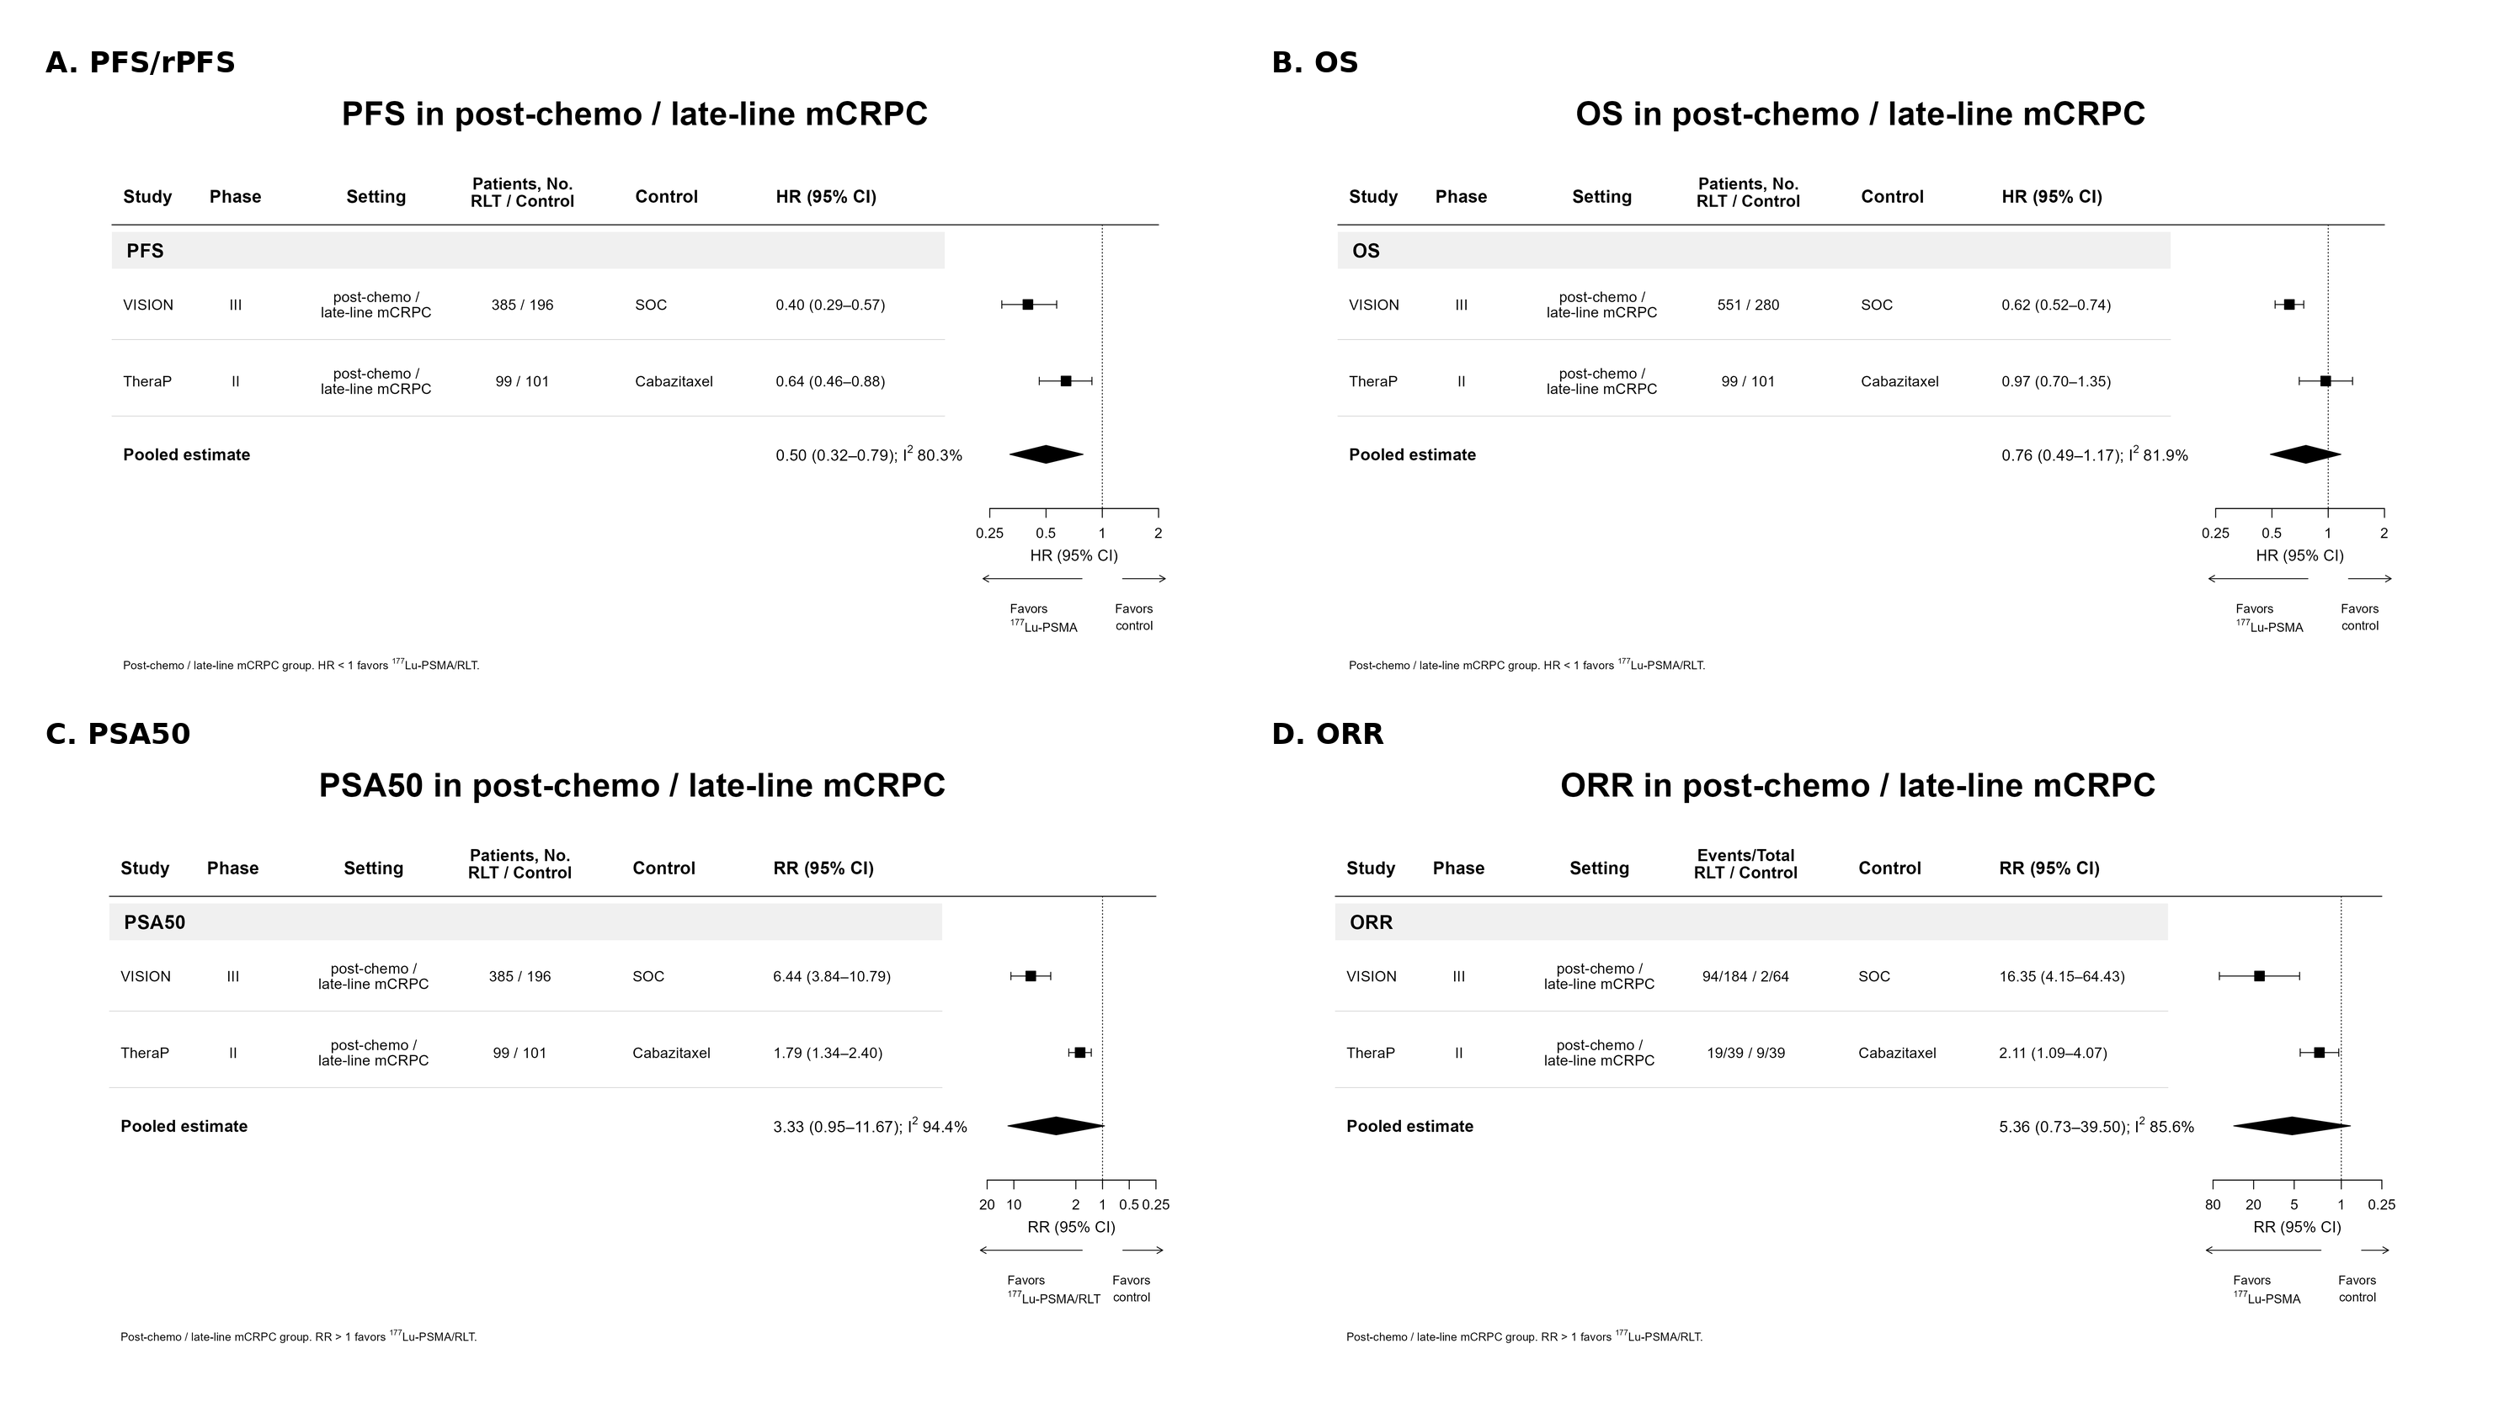

eFigure 2. Taxane-naive mCRPC forest plots
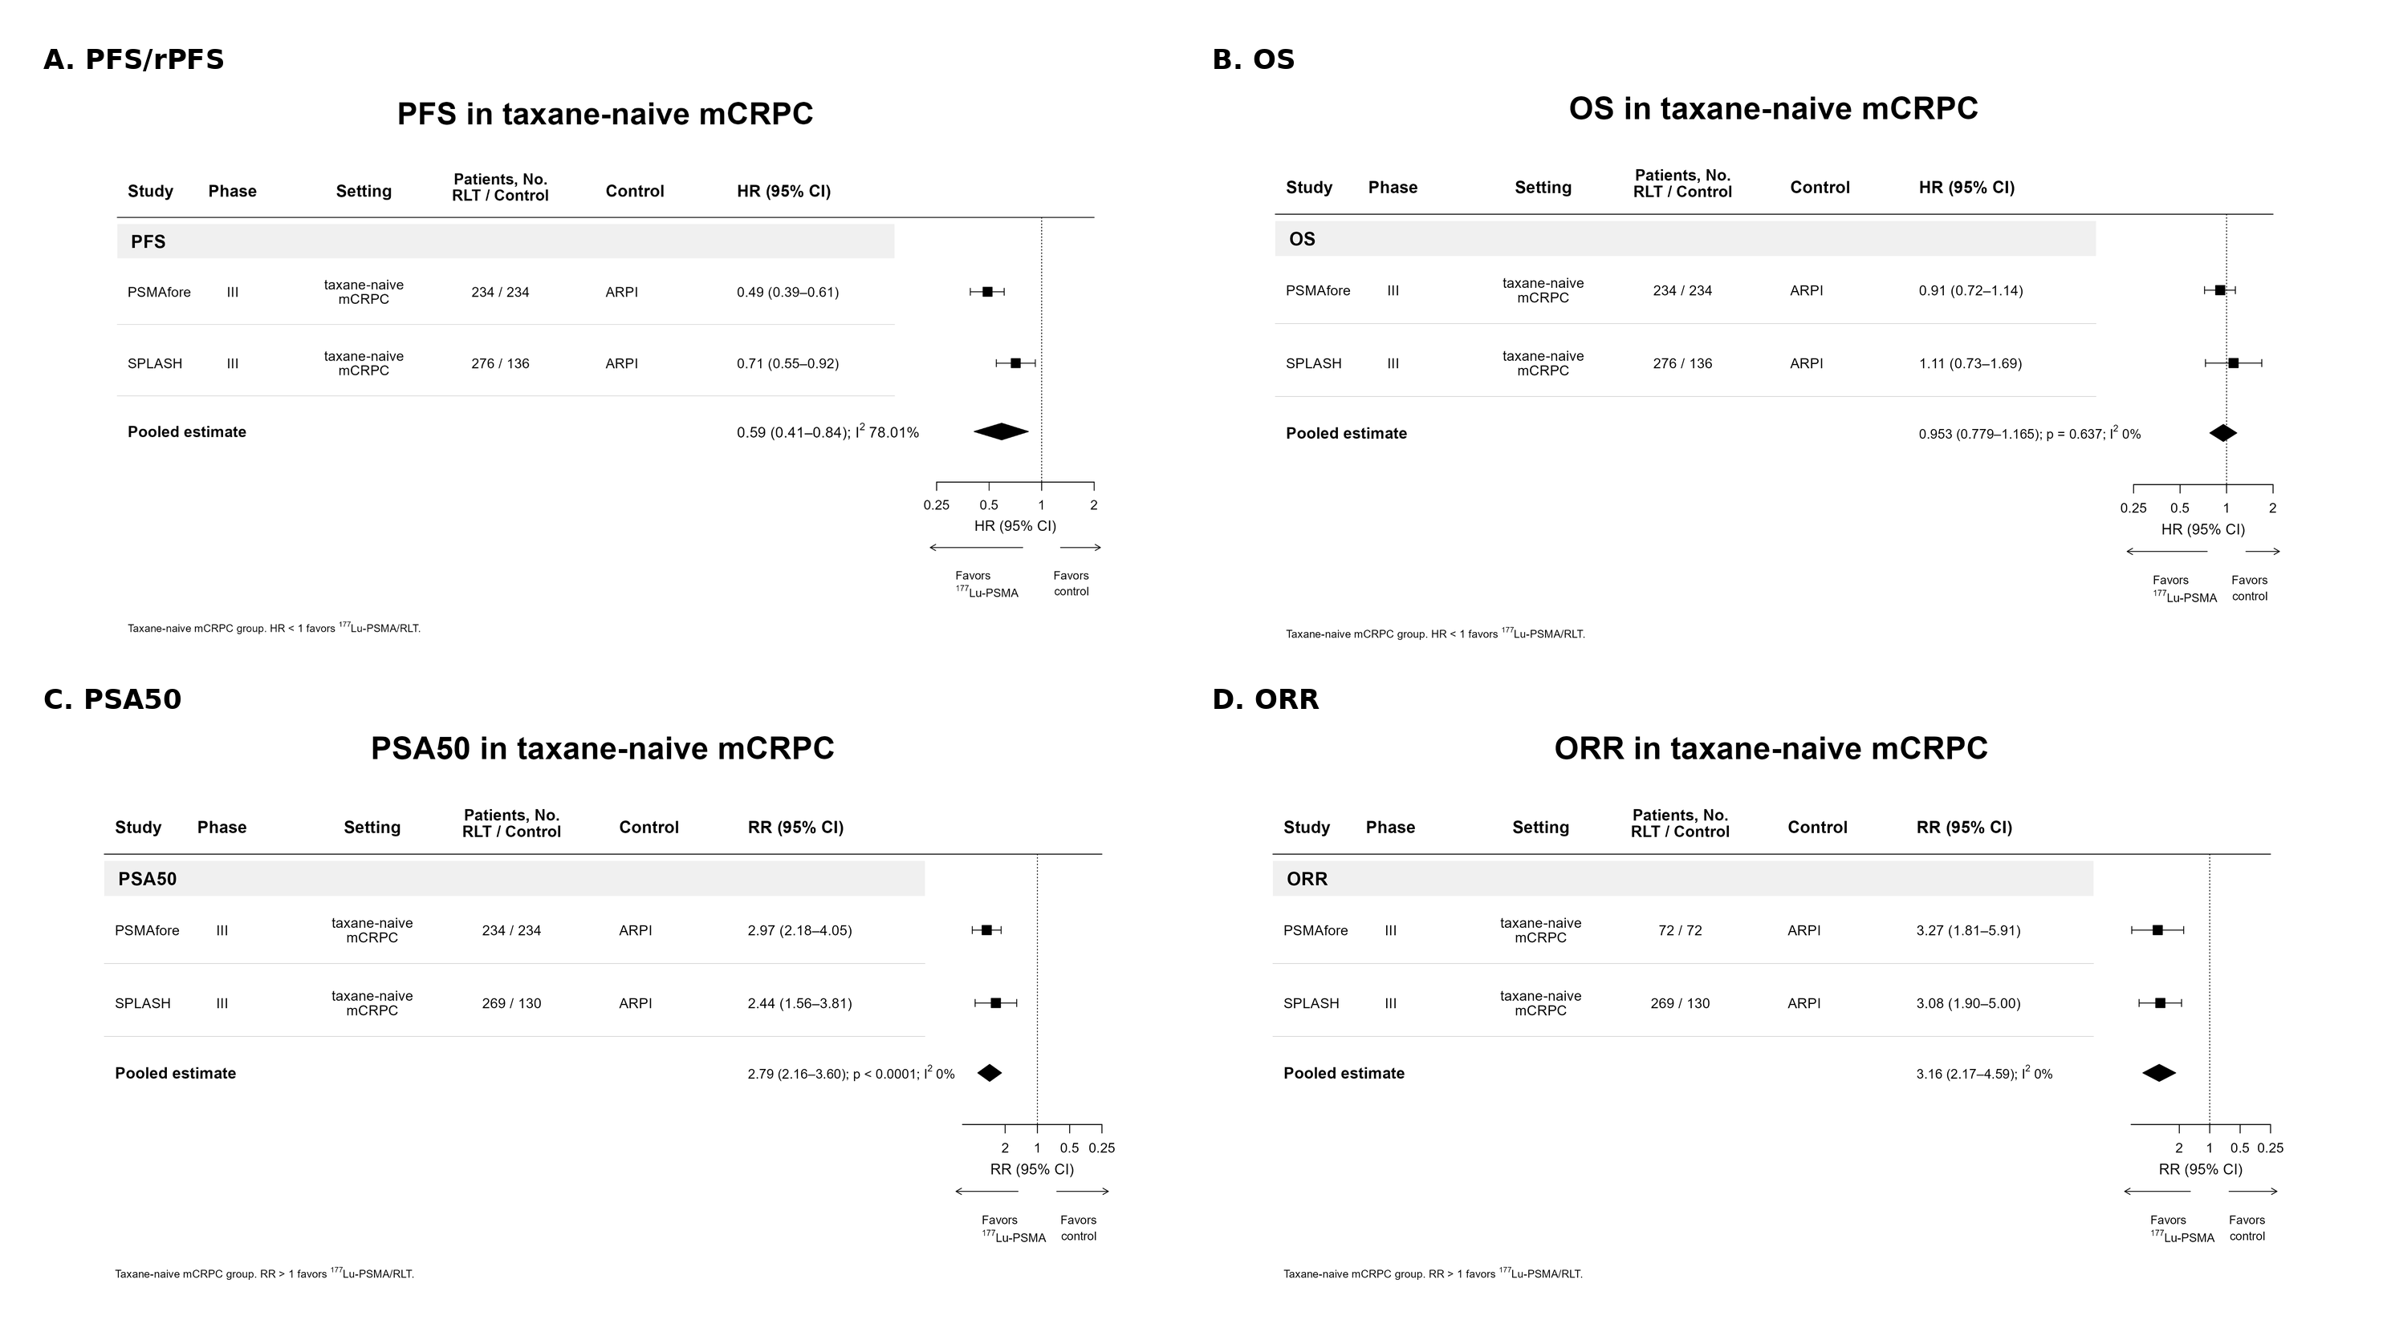

eFigure 3. mHSPC upfront intensification forest plots
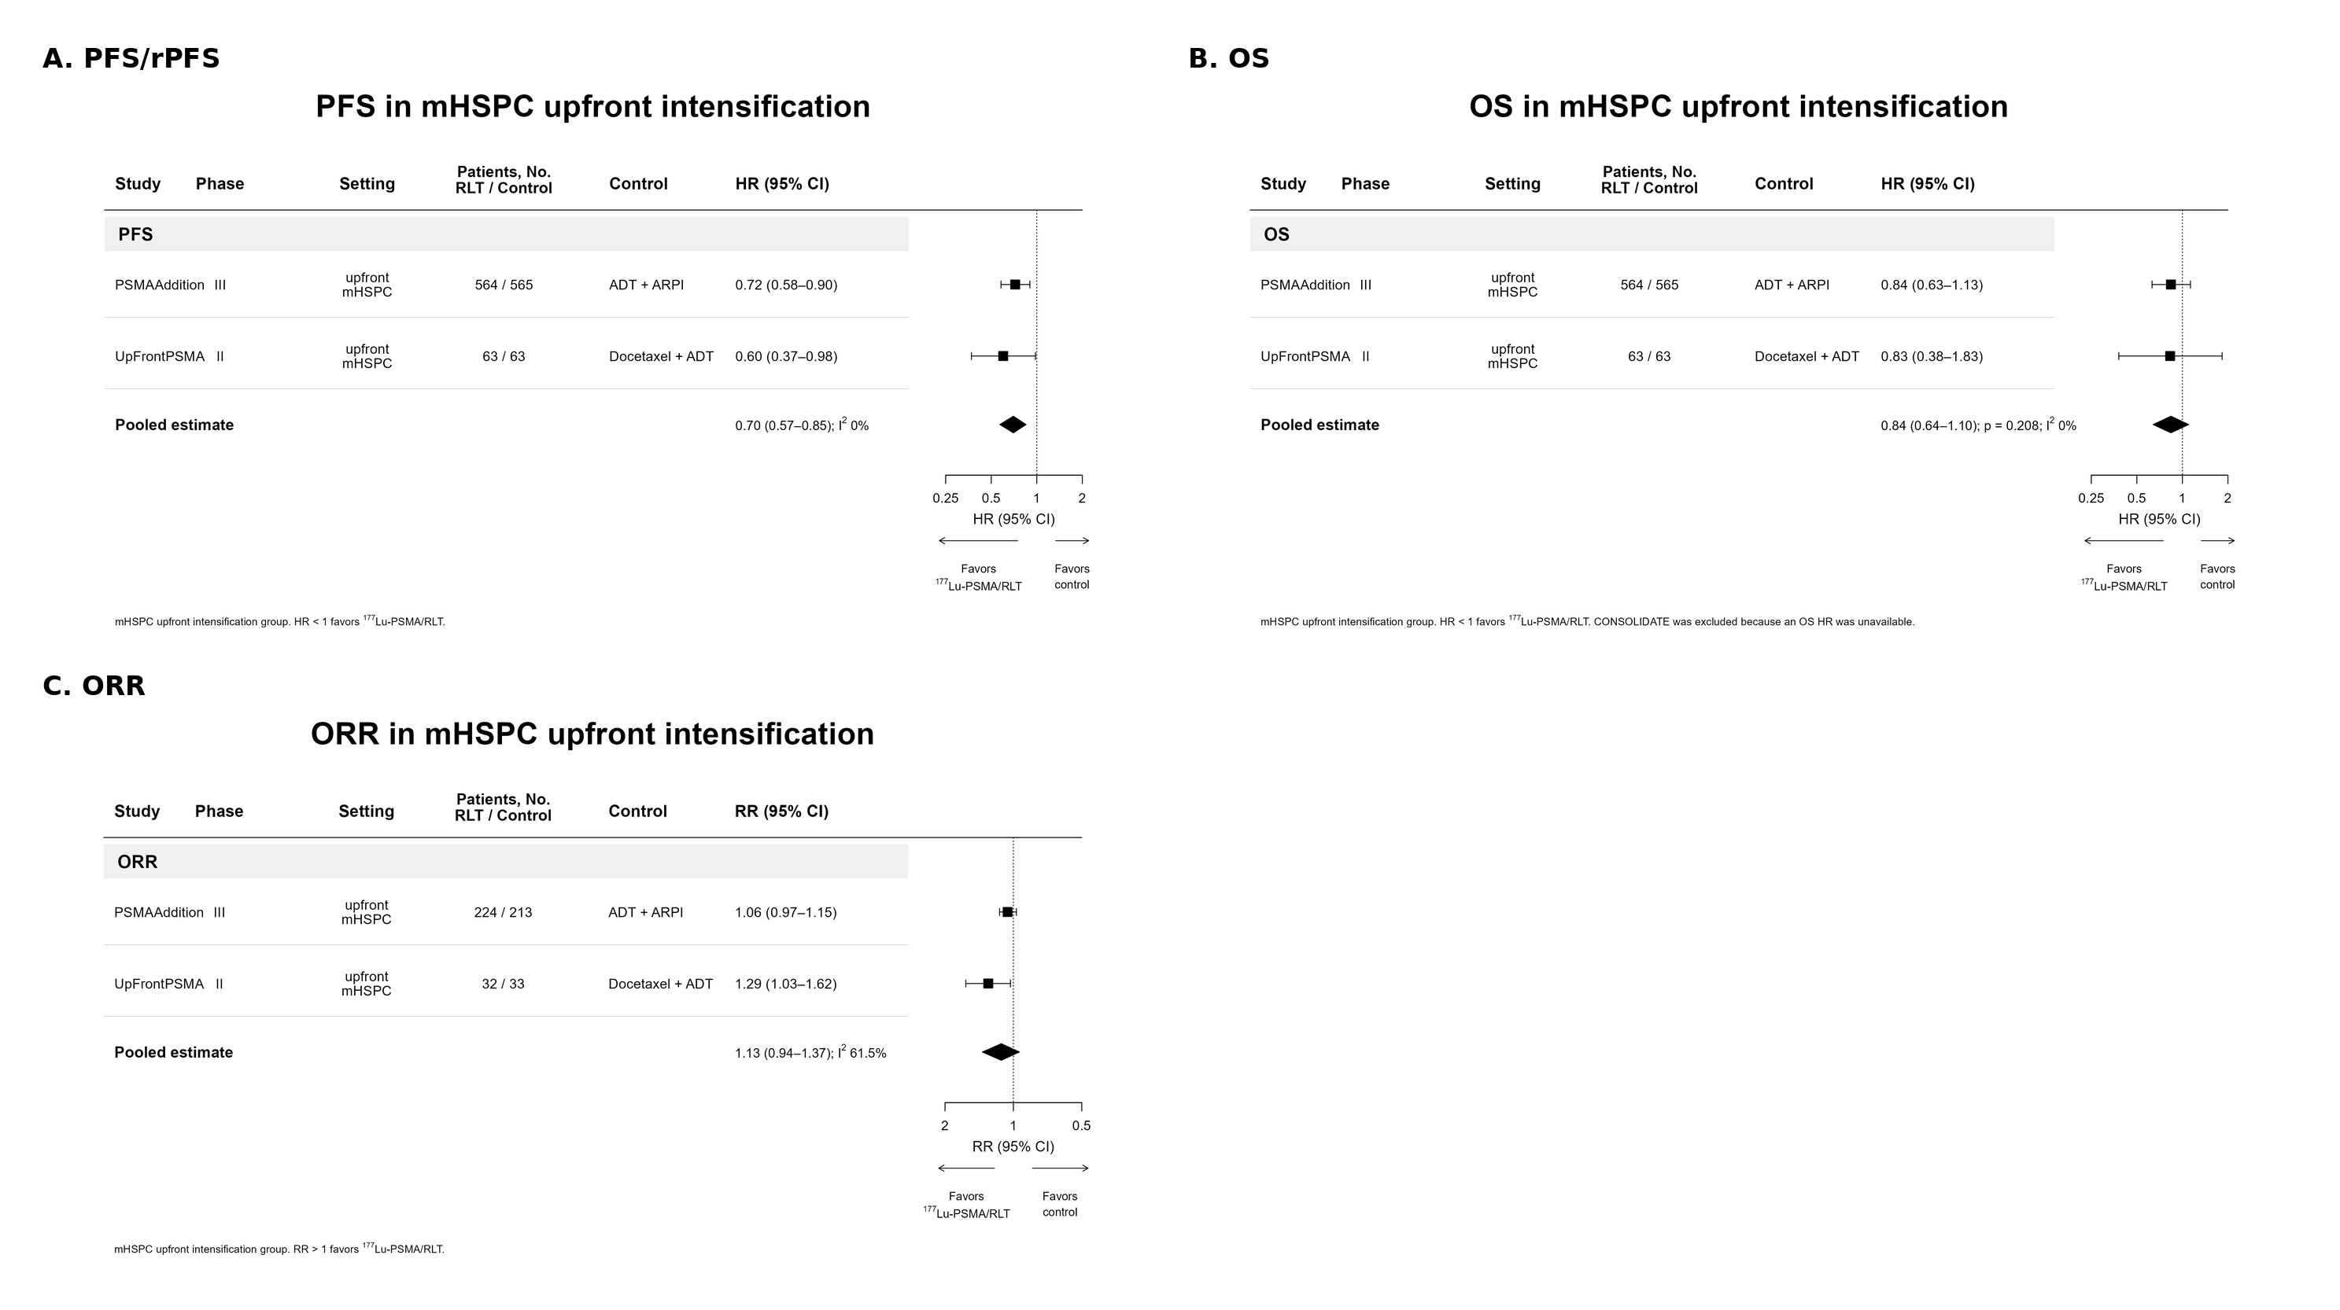

eFigure 4. mHSPC sensitivity-analysis forest plots
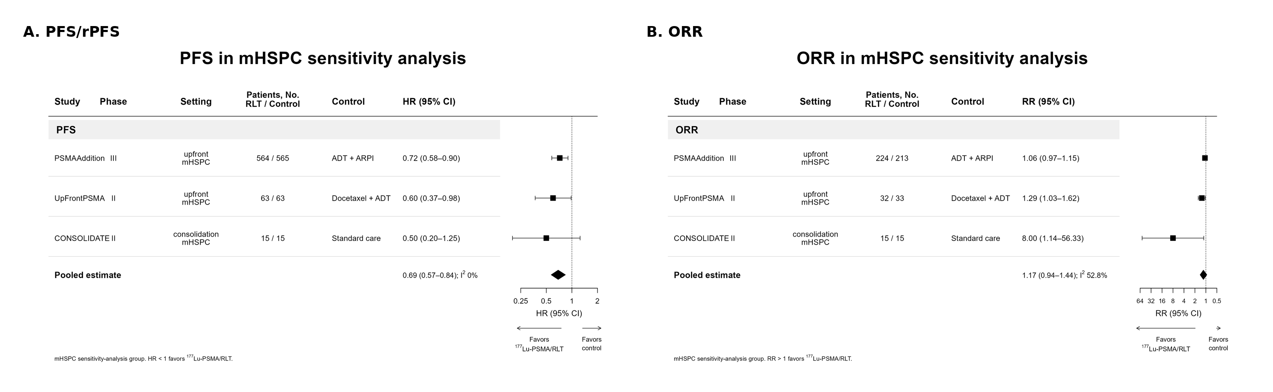

eFigure 5. Oligometastatic/oligorecurrent HSPC forest plots
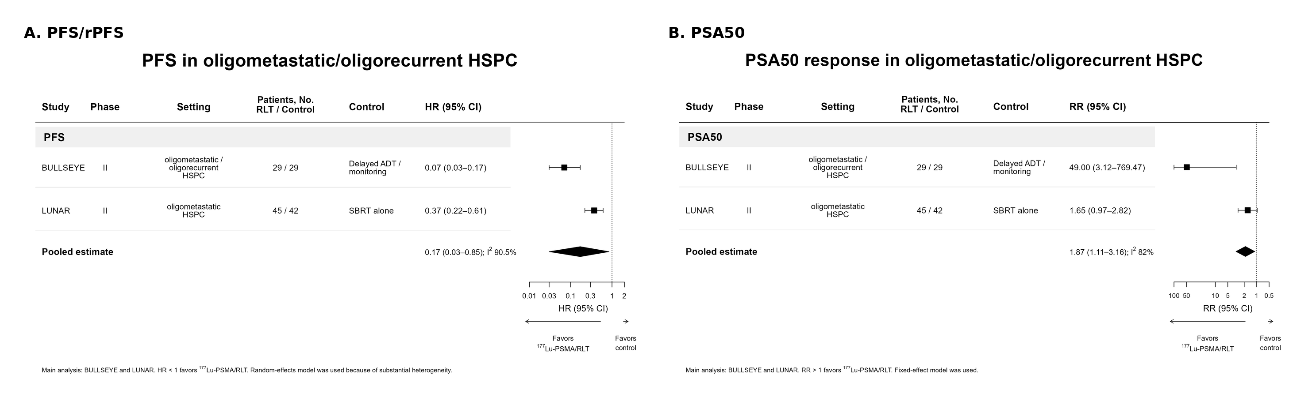

eFigure 6. Docetaxel-comparator chemotherapy-naive mCRPC forest plots
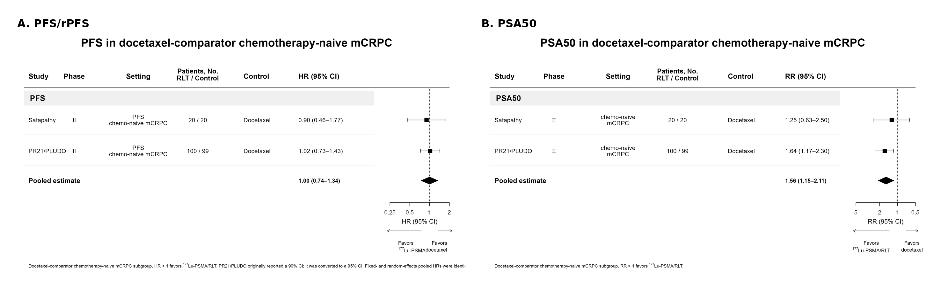

eFigure 7. Evidence distribution summary across included clinical subgroups
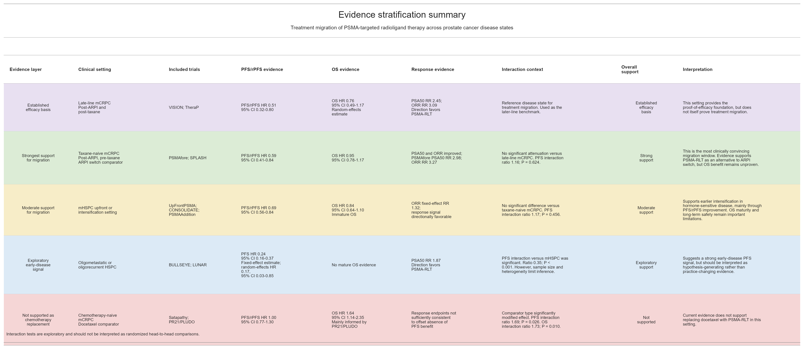

eFigure 8. Grade >=3 adverse event forest plots
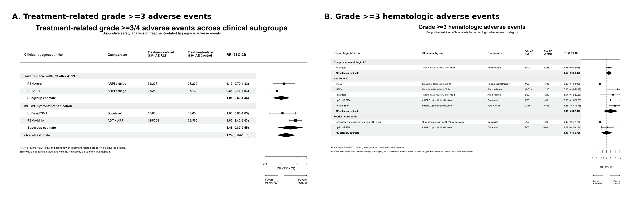

eFigure 9. Risk-of-bias summary for included randomized trials
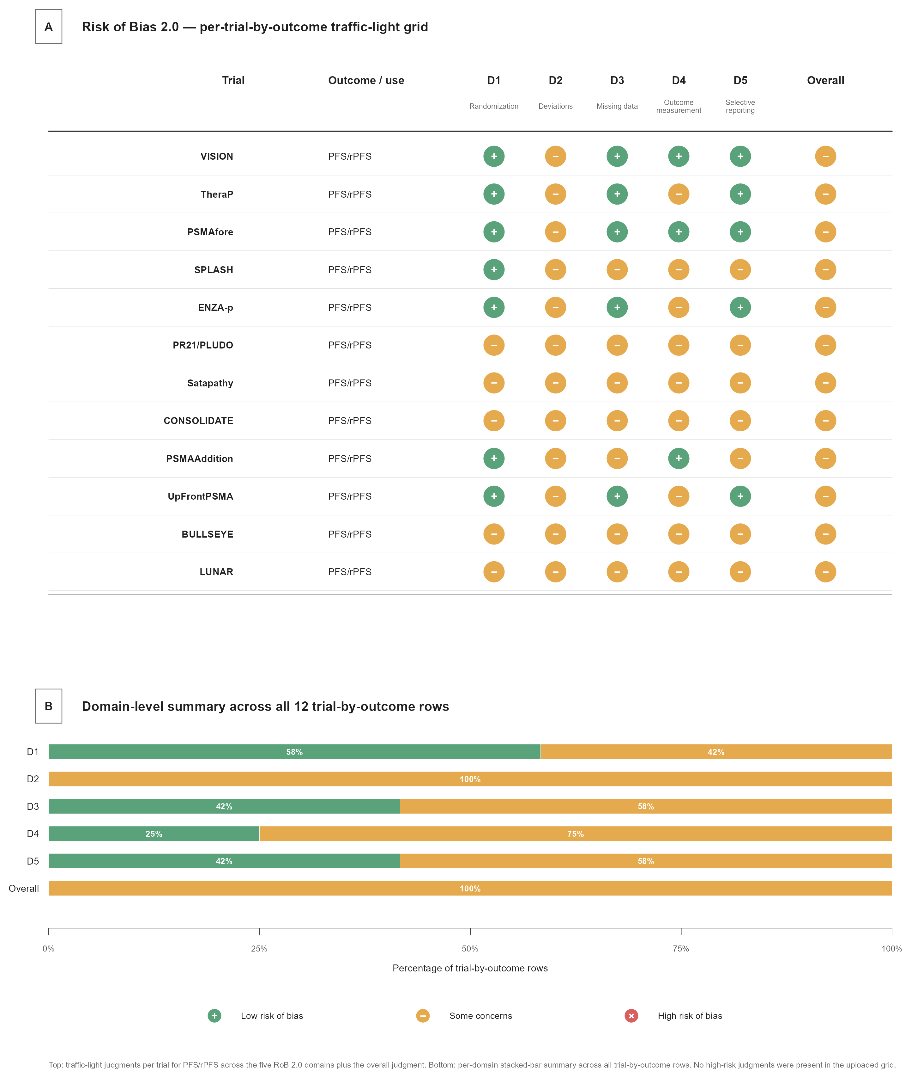

eFigure 10. Overall PFS/rPFS funnel plot
