Supplementary Tables
Supplementary Table 1. Students’ perceptions of knowledge, relevance, and interest in common geriatric medicine topics and skills.
Question | Topic | Perceived Knowledge – Mean (SD) | Perceived Relevance –Mean (SD) | Perceived Interest –Mean (SD)
2.1 | Healthy ageing | 2.8 (0.9) | 3.8 (0.9) | 3.6 (1.0)
2.2 | Resilience and diversity | 2.6 (0.8) | 3.6 (0.9) | 3.6 (1.0)
2.3 | Biology of ageing | 3.1 (0.9) | 3.5 (0.9) | 3.6 (1.0)
2.4 | Frailty | 2.8 (0.9) | 3.6 (0.9) | 3.5 (1.0)
2.5 | CGA | 2.9 (0.9) | 3.5 (1.0) | 3.5 (1.0)
2.6 | Falls and mobility | 2.9 (0.9) | 3.8 (1.0) | 3.6 (1.0)
2.7 | Bone health | 3.0 (0.9) | 4.0 (0.9) | 3.8 (0.9)
2.8 | Sarcopenia | 2.5 (0.9) | 3.7 (0.9) | 3.6 (0.9)
2.9 | Delirium | 2.9 (1.0) | 3.7 (1.0) | 3.8 (1.0)
2.10 | Depression | 3.2 (0.9) | 3.8 (1.0) | 3.8 (1.0)
2.11 | MCI and Dementia: screening | 3.1 (0.9) | 3.8 (0.9) | 3.8 (1.0)
2.12 | Dementia: management of BPSD | 2.9 (0.9) | 3.8 (1.0) | 3.8 (1.0)
2.13 | Assessing cognitive status | 2.9 (1.1) | 3.6 (1.1) | 3.6 (1.1)
2.14 | Assessing functional capacity | 2.7 (1.1) | 3.5 (1.1) | 3.5 (1.0)
2.15 | Assessing capacity to consent | 2.8 (0.9) | 3.7 (1.0) | 3.6 (1.0)
2.16 | Advance healthcare directives | 2.8 (0.9) | 3.6 (1.0) | 3.5 (1.1)
2.17 | Palliative & End of Life care | 2.9 (0.9) | 3.6 (1.1) | 3.6 (1.1)
2.18 | Chronic Pain | 2.9 (0.9) | 3.8 (1.0) | 3.8 (1.1)
2.19 | Geriatric rehabilitation | 2.5 (0.9) | 3.4 (1.0) | 3.4 (1.1)
2.20 | Orthogeriatrics | 2.5 (1.0) | 3.4 (1.1) | 3.3 (1.1)
2.21 | Oncogeriatrics | 2.6 (1.0) | 3.6 (1.0) | 3.5 (1.1)
2.22 | Gerodontology | 2.1 (1.1) | 3.0 (1.2) | 3.0 (1.2)
2.23 | Nutritional assessment and malnutrition | 2.6 (0.9) | 3.5 (1.0) | 3.5 (1.1)
2.24 | Dysphagia | 2.7 (0.9) | 3.4 (1.0) | 3.4 (1.1)
2.25 | Polypharmacy and deprescribing | 2.7 (0.9) | 3.7 (1.1) | 3.7 (1.1)
2.26 | Urinary and faecal incontinence | 2.9 (0.9) | 3.5 (1.0) | 3.5 (1.1)
2.27 | Hearing and vision impairments | 2.8 (0.9) | 3.5 (1.0) | 3.4 (1.1)
2.28 | Skin care and pressure ulcers | 2.9 (0.9) | 3.5 (1.0) | 3.5 (1.1)
2.29 | Ageism | 2.8 (1.0) | 3.4 (1.1) | 3.4 (1.1)
2.30 | Abuse of older people | 2.6 (1.0) | 3.5 (1.1) | 3.6 (1.1)
2.31 | Assessing older people in ED | 2.8 (0.9) | 3.8 (1.0) | 3.8 (1.1)
2.32 | Communication – Older people & caregivers | 2.9 (0.9) | 3.8 (1.0) | 3.7 (1.1)
2.33 | Communication – Older people & caregivers | 3.1 (0.9) | 3.9 (1.0) | 3.6 (1.2)
2.34 | Overall knowledge | 2.9 (0.8)

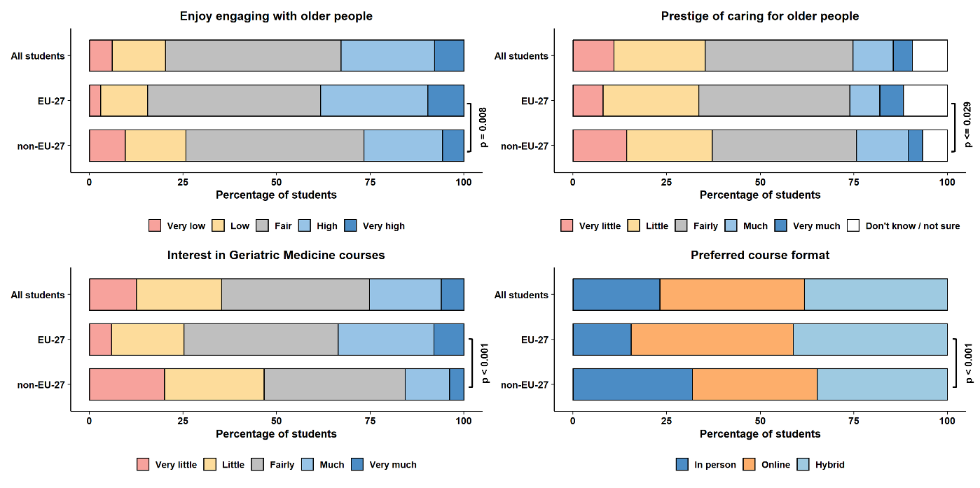
Supplementary Figure 1. Medical students’ attitudes and interests in geriatric medicine

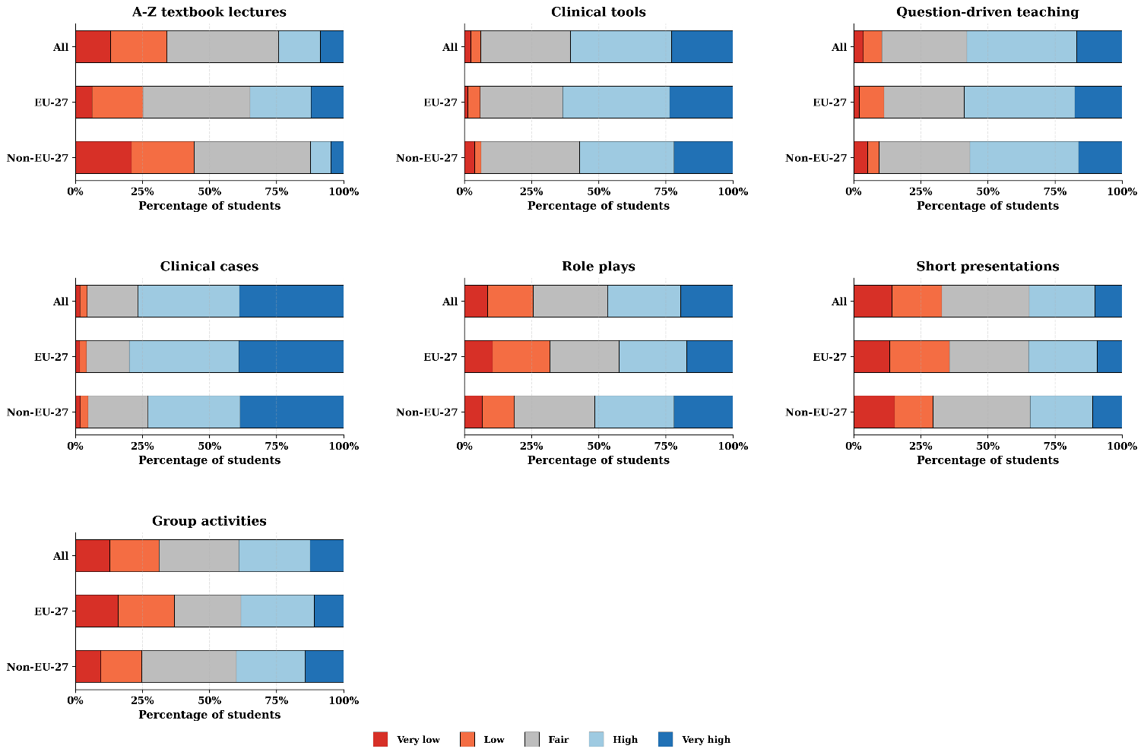
Supplementary Figure 2. Medical students’ perceived effectiveness of teaching methods

