Graphical Abstract

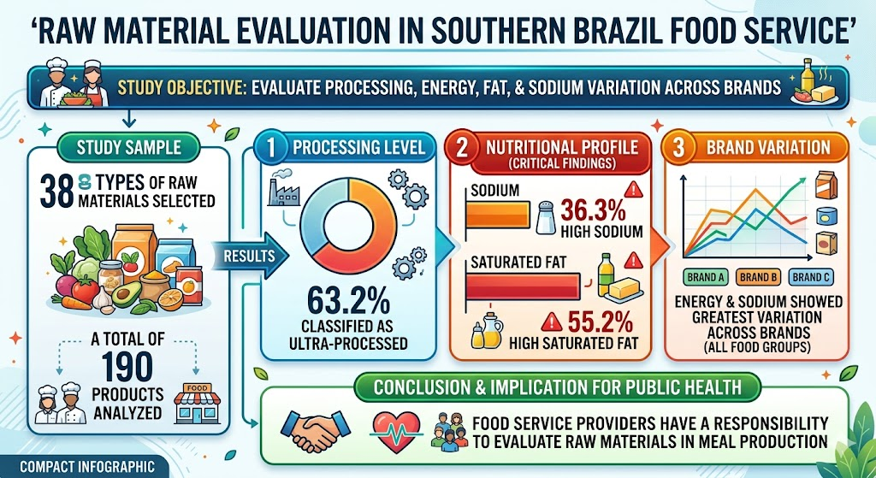
Source: Created with the aid of artificial intelligence (Gemini).

