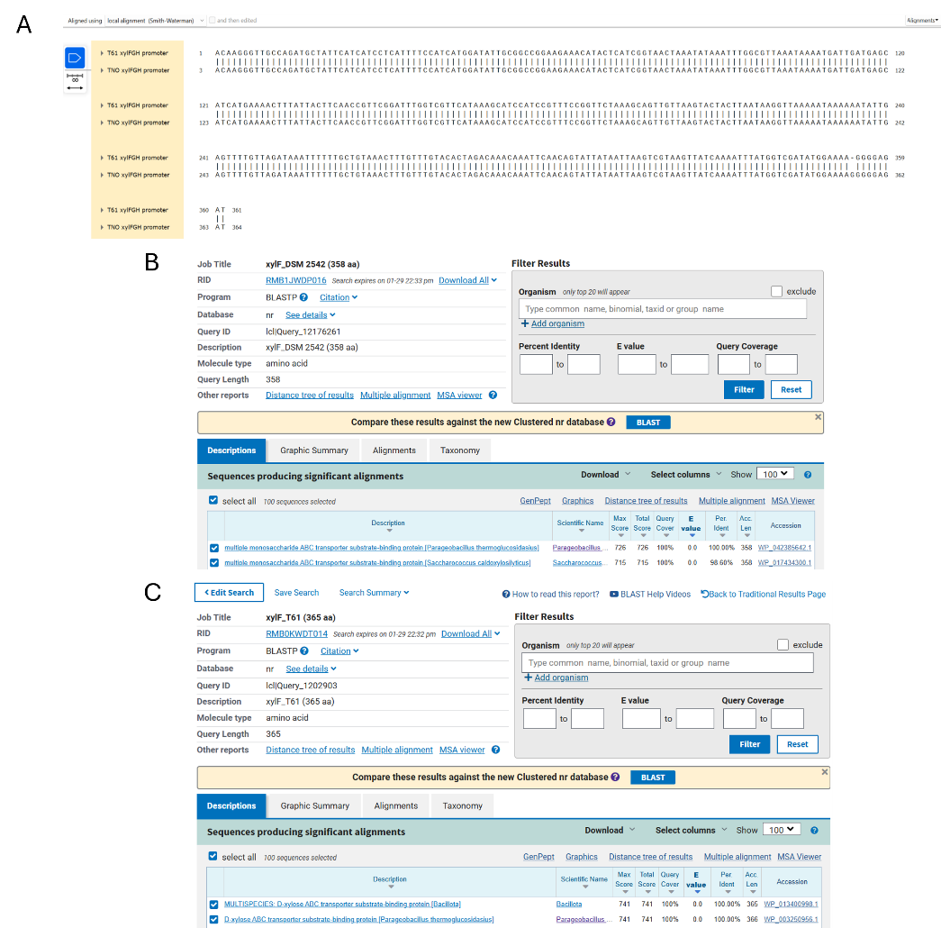
Figure S1 – Sequence comparison of xylFGH promoter and xylF coding sequence. (A) Alignment of xylFGH promoters from DSM 2542 and T-61 (similar to TNO-0.9.020) strains was done using the Smith-Waterman alignment tool in SnapGene software showing a 99.72% identity with only one nucleotide gap difference. (B,C) BlastP of XylF present in T-61 showed similarity to xylose transporters, whereas XylF, which is encoded by AOT_13435 in DSM 2542 was seemingly a more general monosaccharide transporter.

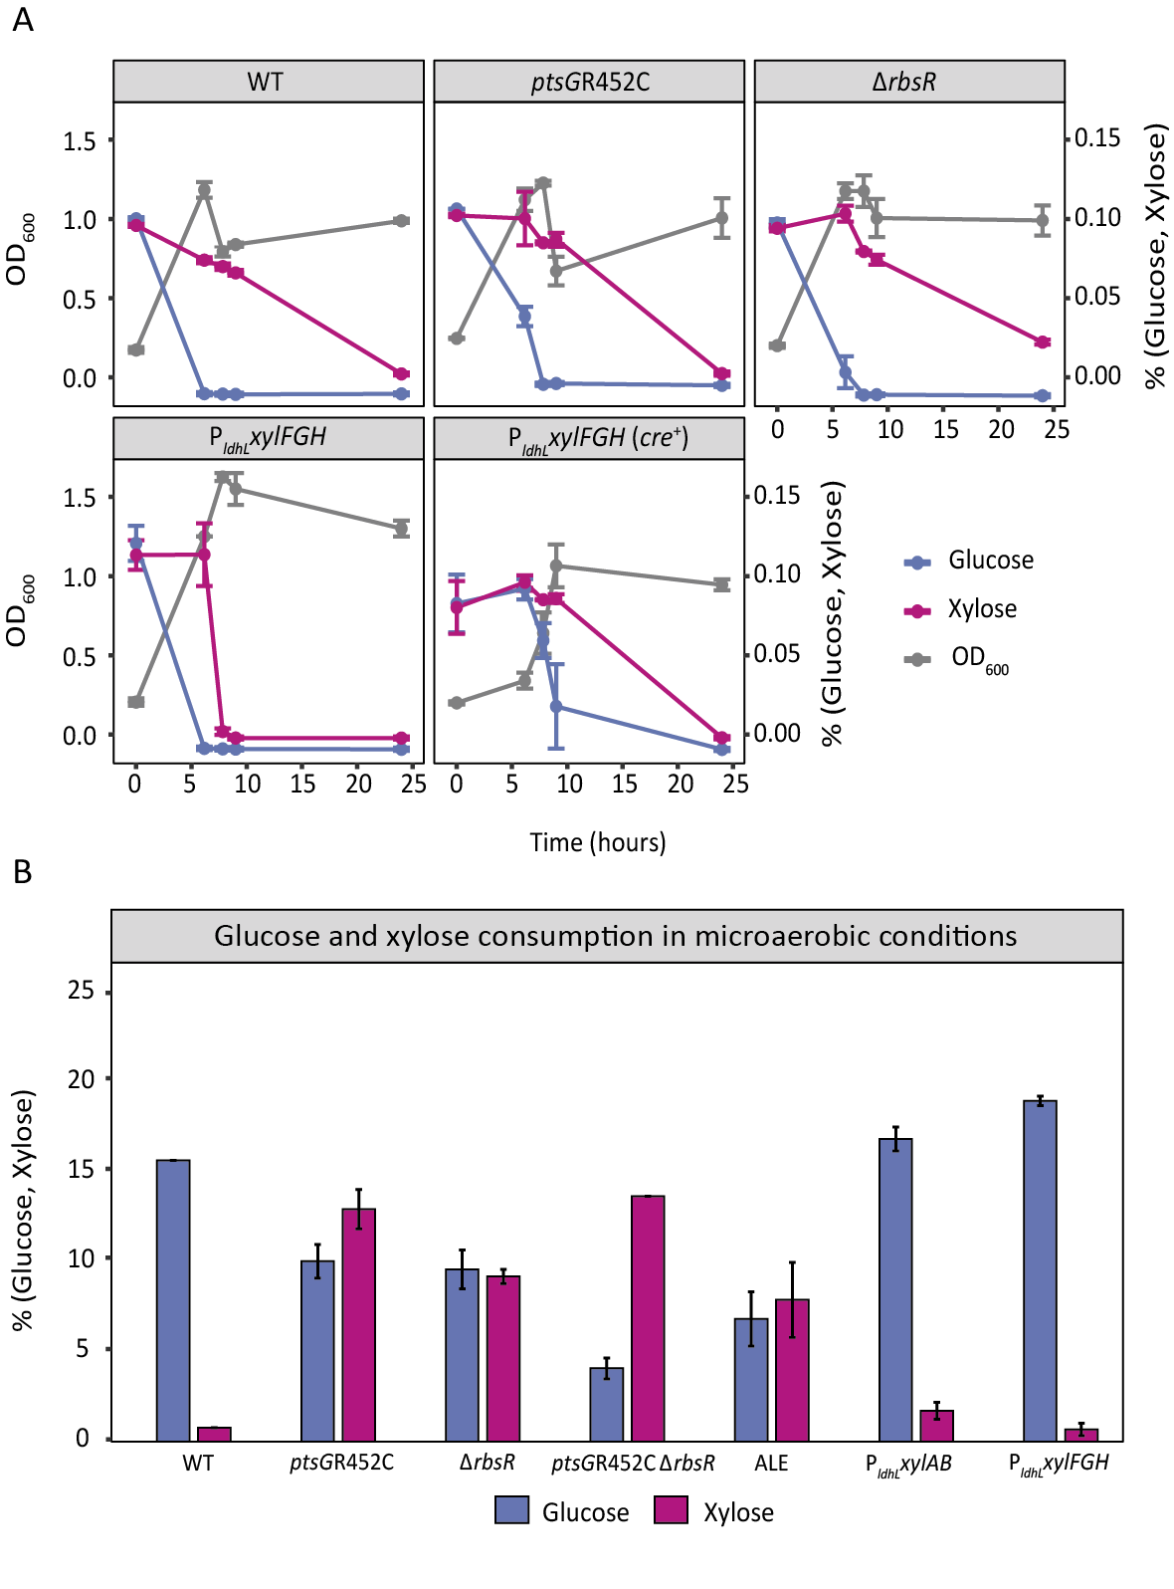

Figure S2 – P. thermoglucosidasius DSM 2542 reverse engineered and overexpressing xylAB/xylFGH mutants in glucose-xylose tube cultivations. (A) Monitoring of OD₆₀₀, glucose and xylose concentrations in aerobic cultivations (3 mL working volume in 17 mL rounded-bottom tubes) for WT, ptsGR452C, ΔrbsR, P_{ldhL} xylFGH without the cre sequence, and P_{ldhL} xylFGH (cre⁺) with the cre sequence intact. Cultivations were run in duplicates. (B) Percentage of glucose-xylose consumption for reverse engineered mutants, P_{ldhL} xylFGH (without the cre sequence) as well as P_{ldhL} xylAB, which were cultivated in tubes containing 1% (w/v) glucose and 1% xylose (w/v). Cultivations were run in duplicates.

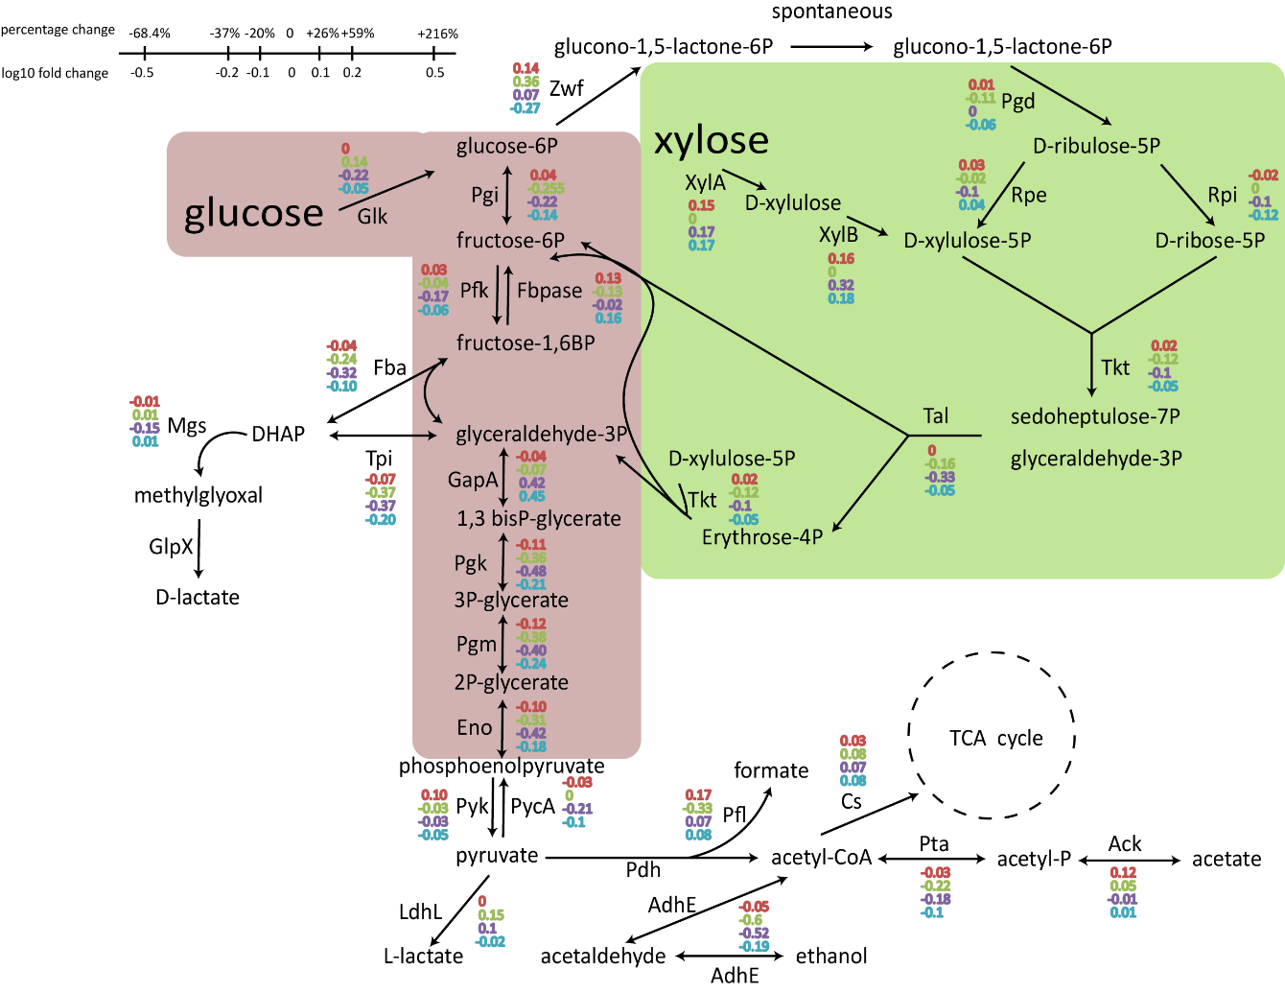
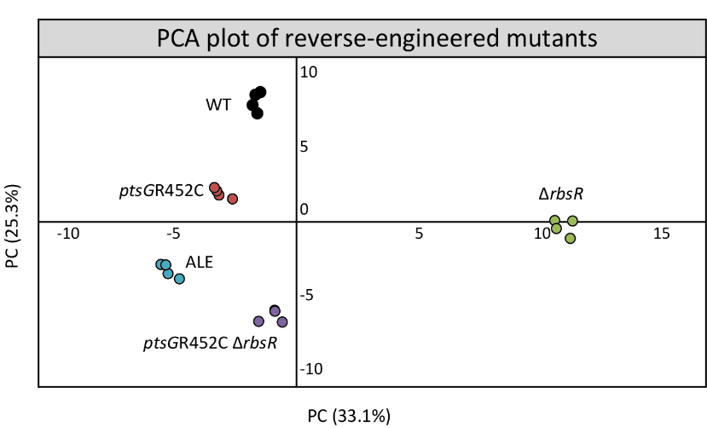
Figure S3 – Differential expression of enzymes related to the glycolysis, pentose phosphate and fermentation pathways. Protein intensity values as detected in ptsGR452C, ΔrbsR, ptsGR452C ΔrbsR and ALE were normalized against the WT values and are represented here as log₁₀ transformed fold changes.

Figure S4 – PCA plot of the proteome dataset. All mutants displayed significant biological variability and minimum variance across the four replicates used for the analysis.

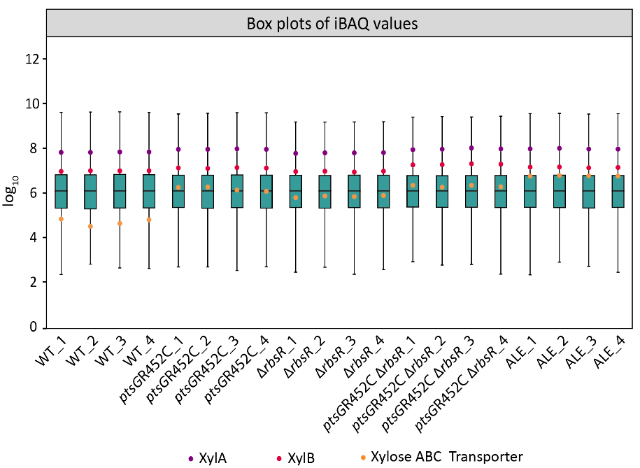

Figure S5 – Protein intensity box plots highlighting xylose-related proteins. iBAQ intensity values were used to construct box plots. Highlighted are the values of XylA, XylB, and the extracellular binding protein of xylose ABC transporter.
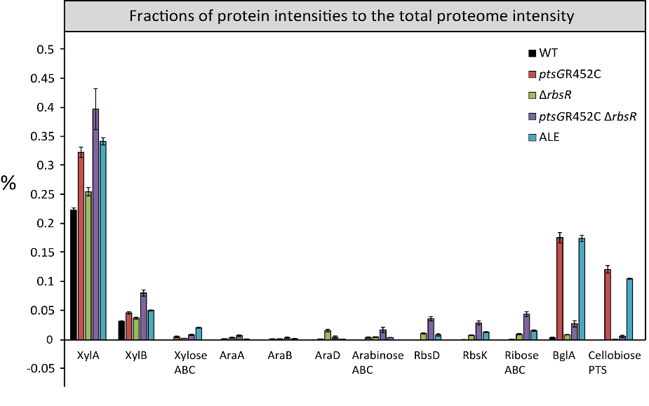

Figure S6 – Protein intensity fraction of enzymes and transporters. WT, ptsGR452C, ΔrbsR, ptsGR452C ΔrbsR and ALE strains were processed in quadruplicates and iBAQ data were used to calculate the intensity fractions of enzymes and transporter proteins relative to the total proteome intensity.

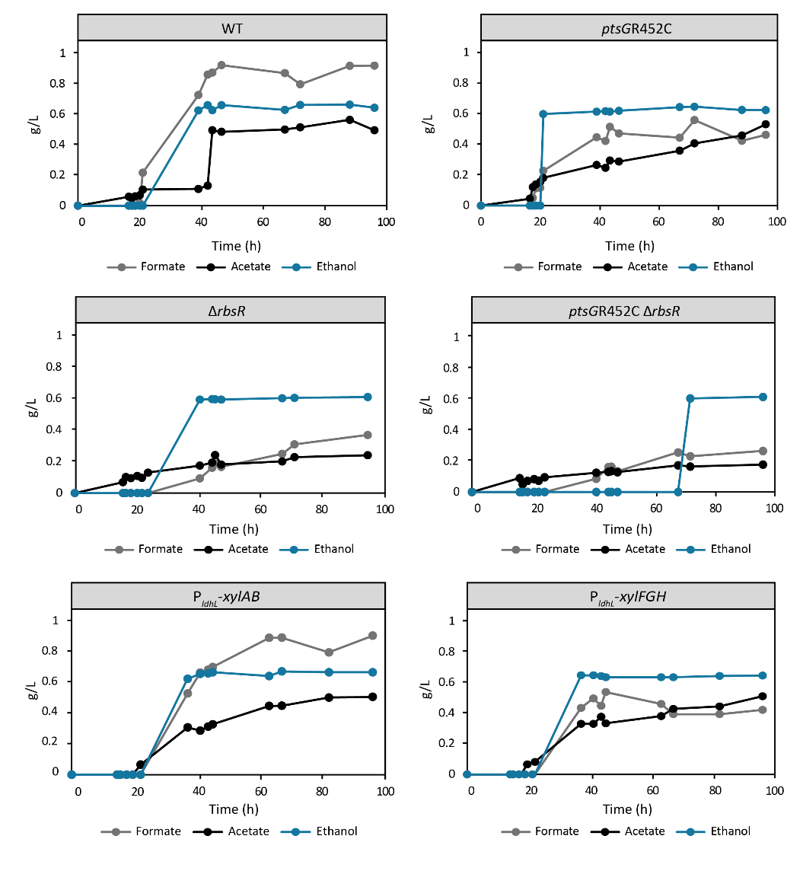

Figure S7 – Formate, acetate and ethanol levels detected in fermenter cultivations.

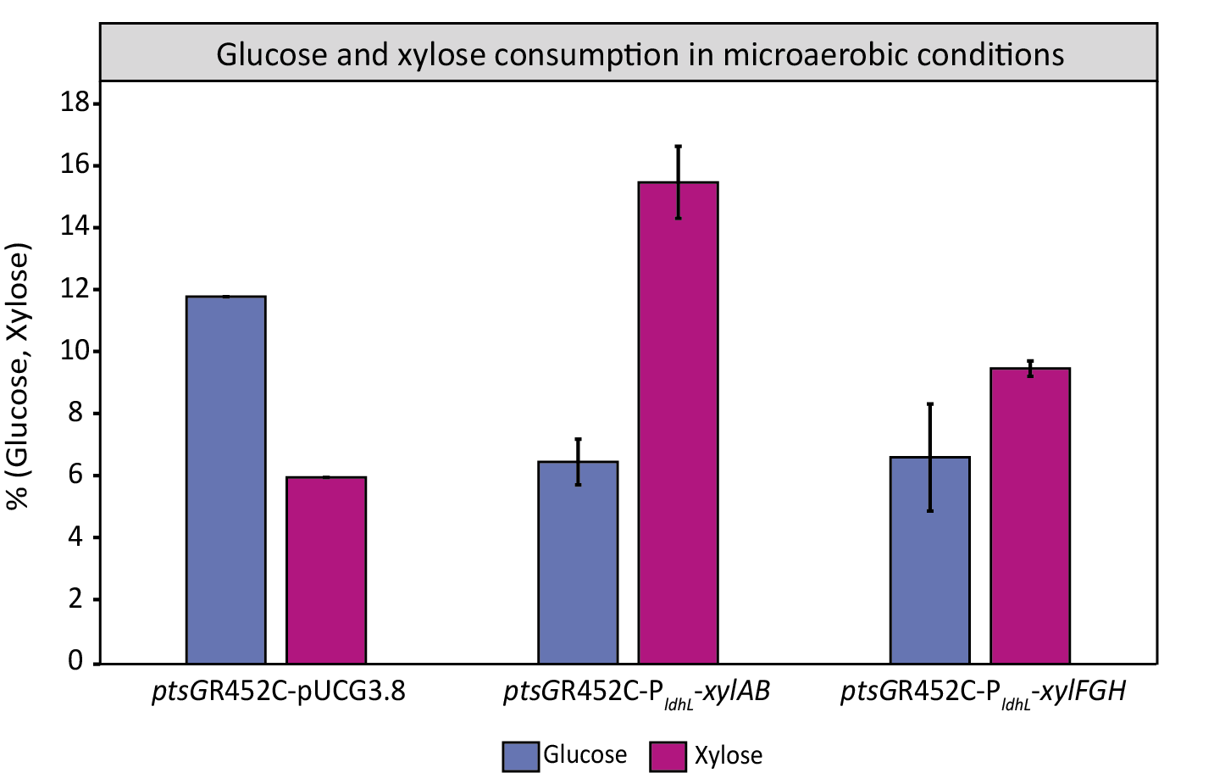
Figure S8 – Microaerobic tube fermentations of ptsGR452C overexpressing xylAB or xylFGH. ptsGR452C equipped with an empty plasmid pUCG3.8 (ptsGR452C-pUCG3.8) and ptsGR452C overexpressing xylAB (ptsGR452C-P_{ldhL} xylAB) or xylFGH without the cre element (ptsGR452C-P_{ldhL} xylFGH) were cultivated in TMM containining 1% (w/v) glucose and 1% xylose (w/v) at 55°C. Cultivations were run in duplicates

Table S1 – Primers used in this study.
Primer sequence | Name | Number | Description
GGATTCTAGATAAGGAGTGATTCGAatgccttattttgacaacatc | xylAB-fw1 | 36281 | To construct pUCG3.8-P_{ldhL}-xylAB-dbt
ctttcgttttatttgatgcctggcctagctccgaaatgc | xylAB-rv1 | 36285 | To construct pUCG3.8-P_{ldhL}-xylAB-dbt
gctgatgttgtcaaaataaggcatTCGAATCACTCCTTATCTAG | xylAB-fw2 | 36282 | To construct pUCG3.8-P_{ldhL}-xylAB-dbt
cgtgaattgttcgctagtgattatgtacatttc | xylAB-rv2 | 36283 | To construct pUCG3.8-P_{ldhL}-xylAB-dbt
atgtacataatcactagcgaacaattcac | xylAB-fw3 | 36284 | To construct pUCG3.8-P_{ldhL}-xylAB-dbt
gaaaattaaaagcatttcggagctaggccaggcatcaaataaaac | xylAB-rv3 | 36286 | To construct pUCG3.8-P_{ldhL}-xylAB-dbt
GTTAAATAAAATGATTttATgagcatcatgaaaac | xylF-(-cre)-fw1 | 35734 | To construct xylFGH (-cre)  fragment
ccttgtttAttCccgctttcGttttgcttagcaacatcctg | xylF-(-cre)-rv1 | 35800 | To construct xylFGH (-cre)  fragment
aCgaaagcggGaaTaaacaagggg | xylFGH-(-cre)-fw1 | 35732 | To construct xylFGH (-cre)  fragment
CTAAAATCTTCAAAACACCGATGAA | xylFGH-(-cre)-rv1 | 35735 | To construct xylFGH (-cre)  fragment
GCGGGACGGGAGCTGAGTGCTCCCGTTGTTTGCCGCGGCGTCTGTCATGAAATGGACAAACAATAGTCAAACAATCGCCACAATCGCGCATGCATTGCGGTGCGCCTTTCGCGTAAAATATTTATATGAAAGTGTTCGCATTATATTGAGGGAGGATTCTAGATAAGGAGTGATTCGA | P_{ldhL}, synthetic fragment | N/A
gccaggcatcaaataaaacgaaaggctcagtcgaaagactgggcctttcgttttatctgttgtttgtcggtgaacgctctctactagagtcacactggctcaccttcgggtgggcctttctgcgtttatacaattgt | dbt, transcription terminator | N/A
AATTCGAGCTCGCGGGAC | P_{ldhL}-fw1 | 35971 | To construct pUCG3.8-P_{ldhL}-xylFGH (+cre),  xylFGH (+cre) amplified from T-61 isolate, PldhL-RBS-pheB from PldhL synthetic fragment
gcagaactaatcatttttattgcctttttcatTCGAATCACTCCTTATCTAGAATC | P_{ldhL}-rv1 | 35972
aaaaaggcaataaaaatgattagttctgc | xylFGH-(-cre)-fw1 | 35973
GTCGGGTACCCttagttagttcggcttttactcg | xylFGH-(-cre)-rv1 | 35974
AATTCGAGCTCGCGGGAC | P_{ldhL}-fw1 | 35971 | To construct pUCG3.8-P_{ldhL}-xylFGH (-cre), xylFGH (-cre) amplified from  xylFGH (-cre) fragment
gcagaactaatcatttttattgcctttttcatTCGAATCACTCCTTATCTAGAATC | P_{ldhL}-rv1 | 35972
aaaaaggcaataaaaatgattagttctgc | xylFGH-(-cre)-fw1 | 35973
GTCGGGTACCCttagttagttcggcttttactcg | xylFGH-(-cre)-rv1 | 35974
GAcGTTAAtGGTCAtAAATTTTCTGTAC | sfGFP-cre1-fw1 | 37489 | To construct  pUCG3.8-P_{xylFGH}-sfGFP, used as template pUCG3.8-P_{xylFGHv1}-sfGFP (Supplementary File)
GTACAGAAAATTTaTGACCaTTAACgTCACC | sfGFP-cre1-rv1 | 37490
GAAAGGAATTGACTTTAAAGAAGATGG | sfGFP-cre2-fw1 | 37491
CCATCTTCTTTAAAGTCAATTCCTTTCAATTC | sfGFP-cre2-rv1 | 37492
ctcttgcattcaacatatctatgc | pUCG3.8-sfGFP-bb-fw | 37493
gcatagatatgttgaatgcaagag | pUCG3.8-sfGFP-bb-rv | 37494
gatagaagaattattgatttttgttg | Pxylab_sfGFP_cre_removed_fw | 37541 | To construct  pUCG3.8-P_{xylAB}-sfGFP, used as template pUCG3.8-P_{xylFGH}-sfGFP and genomic DNA of T-61 isolate
ggcaaattcctcctattaataaatg | Pxylab_sfGFP_cre_removed_rv | 37542
catttattaataggaggaatttgccATGTCAAAAGGAGAAGAACTTTTTAC | sfGFP_bb_cre_removed_rv | 37543
caacaaaaatcaataattcttctatccatagctgtttcctgtgtg | sfGFP_bb_cre_removed_fw | 37544
GCTCGGTACCTGTCACTTGTTTCGTGCCGAC | RF-ptsGR452C-rv | 30948 | To construct LF₁₀₀₀-ptsGR452C-RF₁₀₀₀
CATCACACGTTTGTGTGTTTCTGTC | RF-ptsGR452C-fw | 30950 | To construct LF₁₀₀₀-ptsGR452C-RF₁₀₀₀
ATTCGAGCTCATTGAGCAAAGTGCCGTTG | LF-ptsGR452C-fw | 30949 | To construct LF₁₀₀₀-ptsGR452C-RF₁₀₀₀
GACAGAAACACACAAACGTGTGATG | LF-ptsGR452C-rv | 30951 | To construct LF₁₀₀₀-ptsGR452C-RF₁₀₀₀
GCTCGGTACCTGTCACTTG | ptsGR452C-OE-fw | 30983 | To construct LF₁₀₀₀-ptsGR452C-RF₁₀₀₀
ATTCGAGCTCATTGAGCAAAG | ptsGR452C-OE-rv | 30984 | To construct LF₁₀₀₀-ptsGR452C-RF₁₀₀₀
GATCAGGTACCttcggtcttccggcgg | ptsGR452C-fw | 31460 | To construct pNW33n-LF-ptsGR452C-RF, amplified from LF₁₀₀₀-ptsGR452C-RF₁₀₀₀
GCATAAGAGCTCcgtccccttgttgtacg | ptsGR452C-fw | 31461
GTGAAATTGAATTCGAGCTCCgcaaatcgcaatgcagaagcataagaatgagc | LF-rbsR-fw | 30331 | To construct LF₁₀₀₀-rbsR-RF₁₀₀₀
aacagtaatcaccggtttcgtcatcattcgtccccatttttatatgtaaccgg | LF-rbsR-rv | 30332 | To construct LF₁₀₀₀-rbsR-RF₁₀₀₀
atgacgaaaccggtgattactgtt | RF-rbsR-fw | 30333 | To construct LF₁₀₀₀-rbsR-RF₁₀₀₀
ATGATGGGCGTGGTCGGGTACCCattcggaatcggcagaccgcag | RF-rbsR-rv | 30334 | To construct LF₁₀₀₀-rbsR-RF₁₀₀₀
GTGAAATTGAATTCGAGCTCCG | rbsR-OE-fw | 3-463 | To construct LF₁₀₀₀-rbsR-RF₁₀₀₀
ATGATGGGCGTGGTCG | rbsR-OE-rv | 30464 | To construct LF₁₀₀₀-rbsR-RF₁₀₀₀
CAGTCAGAGCTCaacgacttcgtcagttc | rbsR-fw | 33386 | To construct pNW33n-LF-rbsR-RF, amplified from LF₁₀₀₀-rbsR-RF₁₀₀₀
CTGACTGGTACCtcctaaaattgtttctccttgc | rbsR-rv | 33387
actttatgcttccggctcg | pUCG3.8_seq_fw | 34144 | To do colony PCR on pUCG3.8 plasmid for confirmation of insert presence
ccatatgcggtgtgaaatac | pUCG3.8_seq_rv | 34145
tcaggaaacagctatgaccg | pMM7_seq_fw | 37297 | To do colony PCR on pMM7 plasmid for confirmation of insert presence
ttgtaaaacgacggccagtg | pMM7_seq_rv | 37298
ggcggaaatcccttcactag | rbsR_KO_fw | 31076 | Check for rbsR knock-out
gctgcaaaaaaagtgagaag | rbsR_KO_rv | 31077 | Check for rbsR knock-out
cgtttatgacagggaaattcccg | ptsG_seq_fw | 32612 | Confirmation of ptsGR452C mutation

R script for calculation of growth rates
library(tidyverse)
data_path <- "insert the folder path here that contains the csv files of the data"
output_path <- "insert the folder path here for the output graph"

od_conversion_factor <- 3.6 # Factor to convert microplate OD to 1-cm cuvette OD
window_size <- 100 # Number of data points per sliding window
min_od_change <- 0.05 # Minimum OD change required to analyze a curve
min_R_squared <- 0.8 # Minimum R² for a valid exponential phase fit
min_doublings <- 1.5 # Minimum population doublings in the window (1.5 * ln(2))
control_strain <- "WT" # Name of the control strain for statistical comparison

get_max_linear_rate <- function(t, od) {
total_change <- max(od, na.rm = TRUE) - min(od, na.rm = TRUE)
if(total_change < min_od_change) return(0)

valid_data <- data.frame(t = t, od = od) %>% filter(od > 0)
valid_data$log_od <- log(valid_data$od)

if(nrow(valid_data) < window_size) return(NA)

max_slope <- 0

for(i in 1:(nrow(valid_data) - window_size + 1)) {
chunk <- valid_data[i : (i + window_size - 1), ]
if(sd(chunk$log_od) == 0) next

fit <- lm(log_od ~ t, data = chunk)
slope <- coef(fit)[2]
r_squared <- summary(fit)$r.squared

time_span <- chunk$t[nrow(chunk)] - chunk$t[1]
log_increase <- slope * time_span
required_increase <- min_doublings * log(2)

if(!is.na(slope) && slope > max_slope &&
!is.na(r_squared) && r_squared > min_R_squared &&
log_increase >= required_increase) {
max_slope <- slope
}
}
return(max_slope)
}

process_growth_file <- function(file_name, substrate_name) {
file_path <- file.path(data_path, file_name)
raw <- read.csv(file_path, check.names = FALSE)
colnames(raw)[1] <- "time"

long_data <- raw %>%
mutate(across(-time, ~ . * od_conversion_factor)) %>%
pivot_longer(-time, names_to = "Sample", values_to = "OD")

results <- long_data %>%
group_by(Sample) %>%
summarise(Mu_Max = get_max_linear_rate(time, OD)) %>%
mutate(Substrate = substrate_name)

return(results)
}

results_glc <- process_growth_file("name of the file for glucose results")
results_xyl <- process_growth_file("name of the file for xylose results")
results_glcxyl <- process_growth_file("name of the file for glucose+xylose results")

all_results <- bind_rows(results_glc, results_xyl, results_glcxyl)

control_strain <- "WT"

clean_data <- all_results %>%
mutate(Strain_Base = str_remove(Sample, "\\.\\d+$"))

stats_results <- data.frame()
unique_substrates <- unique(clean_data$Substrate)

print("RUNNING STATISTICS")

for(sub in unique_substrates) {
sub_data <- clean_data %>% filter(Substrate == sub)

if(n_distinct(sub_data$Strain_Base) < 2) next

anova_model <- aov(Mu_Max ~ Strain_Base, data = sub_data)
tukey_out <- TukeyHSD(anova_model)
tukey_df <- as.data.frame(tukey_out$Strain_Base)
tukey_df$comparison <- rownames(tukey_df)

sub_stats <- tukey_df %>%
filter(grepl(control_strain, comparison)) %>%
rowwise() %>%
mutate(

Strain_Base = str_remove(comparison, paste0("-", control_strain)),
Strain_Base = str_remove(Strain_Base, paste0(control_strain, "-")),

stars = case_when(
`p adj` < 0.001 ~ "***",
`p adj` < 0.01 ~ "**",
`p adj` < 0.05 ~ "*",
TRUE ~ ""
),
Substrate = sub
) %>%
select(Strain_Base, Substrate, stars)

stats_results <- rbind(stats_results, sub_stats)
}

final_summary <- clean_data %>%
group_by(Strain_Base, Substrate) %>%
summarise(
Mean_Mu = mean(Mu_Max, na.rm = TRUE),
SD_Mu = sd(Mu_Max, na.rm = TRUE),
.groups = "drop"
) %>%
left_join(stats_results, by = c("Strain_Base", "Substrate")) %>%
mutate(stars = ifelse(is.na(stars), "", stars))

final_summary$Graph_Title <- "Maximum Specific Growth Rates"

strain_labels <- c(
"WT" = "WT",
"ALE" = "ALE",

# ptsG in italics, R452C normal
"ptsGR452C" = expression(italic("ptsG") * "R452C"),

# Delta symbol, then rbsR in italics
"rbsR KO" = expression(Delta * italic("rbsR")),

# Combined: ptsG italic + R452C, then a space (~), then Delta + rbsR italic
"ptsGR452C rbsR KO" = expression(italic("ptsG") * "R452C" ~ Delta * italic("rbsR"))
)

growth_plot <- ggplot(final_summary, aes(x = Strain_Base, y = Mean_Mu, fill = Substrate)) +

geom_bar(stat = "identity", color = "black", size = 0.6,
position = position_dodge(width = 0.8), width = 0.7) +

geom_errorbar(aes(ymin = Mean_Mu - SD_Mu, ymax = Mean_Mu + SD_Mu),
width = 0.2, color = "black", size = 0.6,
position = position_dodge(width = 0.8)) +

geom_text(aes(y = Mean_Mu + SD_Mu, label = stars),
position = position_dodge(width = 0.8),
vjust = -0.5, size = 5, fontface = "bold") +

scale_fill_manual(values = c("Glucose" = "#ADD8E6", "Xylose" = "#CD5C5C", "Glucose + Xylose" = "#BD9")) +

facet_grid(. ~ Graph_Title) +
labs(y = expression(paste("μmax (", h^-1, ")")), x = NULL, fill = "Substrate") +
scale_y_continuous(expand = expansion(mult = c(0, 0.15))) +

scale_x_discrete(labels = strain_labels) +

theme_classic() +
theme(
panel.border = element_rect(color = "black", fill = NA, size = 1.5),
axis.line = element_blank(),
panel.background = element_rect(fill = "white", color = NA),
plot.margin = margin(10, 10, 10, 10),
axis.text.y = element_text(color = "black", size = 11),
axis.text.x = element_text(color = "black", size = 10, angle = 45, hjust = 1),
strip.background = element_rect(fill = "grey85", color = "black", size = 0.8),
strip.text = element_text(face = "bold", size = 10),
legend.position = "right"
)

print(growth_plot)

output_path <- paste0(work_folder, "---name of the graph---.png")

ggsave(output_path,
plot = growth_plot,
width = 7,
height = 5,
dpi = 600)

print(paste("Saved to:", output_path))

