Supplementary materials

Section 1. Detailed site description
The soil was characterized as Plaggic Anthrosol (IUSS Working Group WRB 2022), affected by a long history of agricultural use. Soil analyses revealed exceptionally high P concentrations ranging from 2500 mg kg⁻¹ in the topsoil to 250 mg kg⁻¹ in the subsoil. The high P concentrations are the result of ages of organic matter transfer from sods and excrements that were spread on the fields (IUSS Working Group WRB 2022). The high P values together with the low non-acid cation saturation (30% on average) and OC values > 1 are the diagnostics for a plaggic horizon. The percentage of clay, silt and sand were, respectively: between 4.0 and 5.2, 67.4 and 71.4, 24.3 and 28.3, and not significantly different among rows and columns.
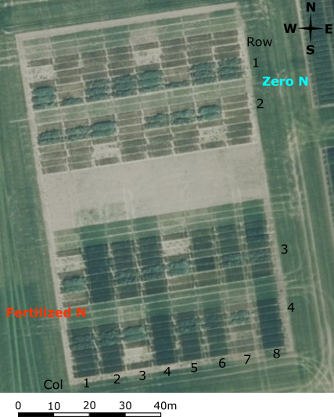
Figure S1 Aerial view of the experimental field. The aerial view of the field experiment split into two blocks: the standard N (fertilized according to regional standard recommendations) and the zero N (no N fertilizer applied).
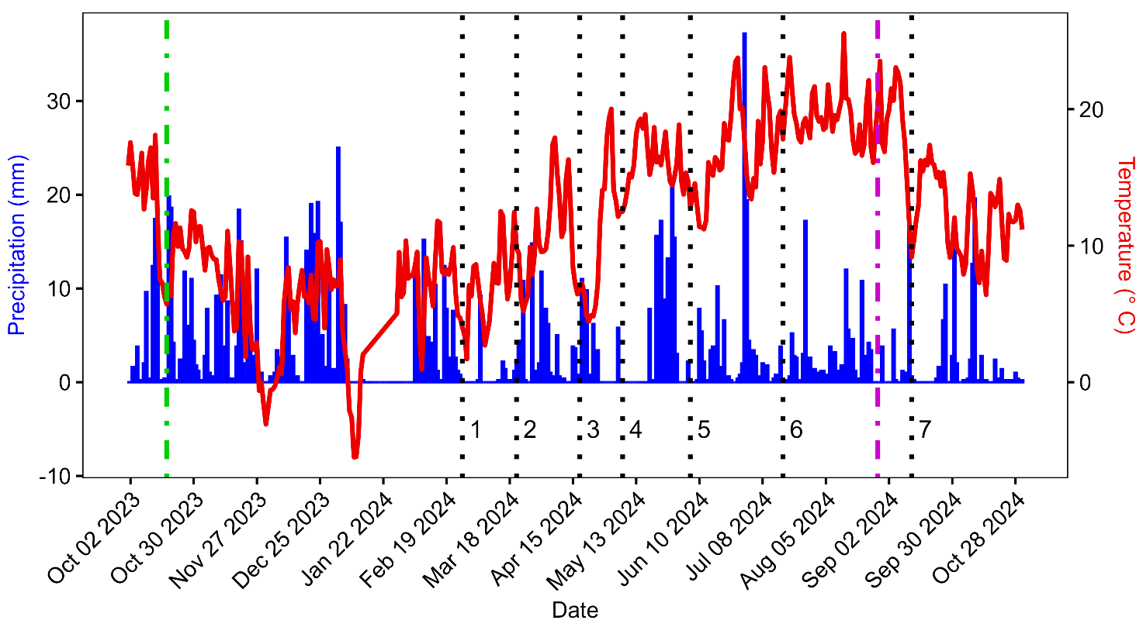
Figure S2 Climograph from the Asendorf climate station. The dotted lines indicate the sampling times. The green and the magenta lines mark the seeding and the harvesting dates, respectively. There was a short interruption of data logging between 14th and 28th of January 2024 due to technical reasons.
Section 2. Soil texture evaluation
The soil texture in the different plots was evaluated with the soiltexture R package (Moeys, 2010) based on the World Reference Base classification system (IUSS Working Group WRB 2022). No relevant significant differences were observed between rows or column (Fig. S5).
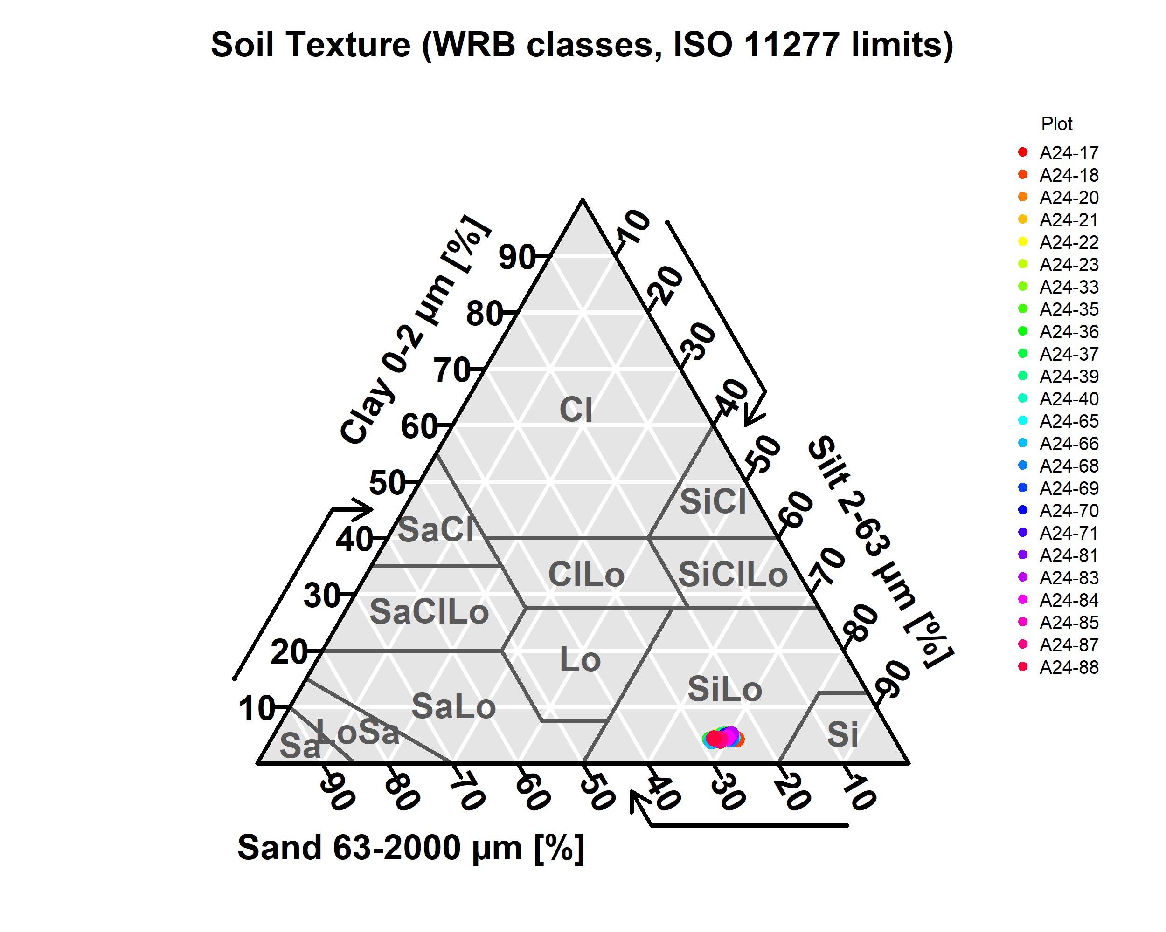
Fig. S3 The soil texture of the experimental site. The above image reports the soil texture of the 24 plots used in the experiment according to the World Reference Base classification system (Moeys 2010; IUSS Working Group WRB. (2022) 2022). No relevant differences were observed across the rows or columns. The soil was classified as a silt loam (SiLo).
Section 3. Modified version of the traditional chloroform fumigation extraction method
Before the current experimentation, new recovery factors for microbial biomass C (MBC) and N (MBN) were calculated for the method developed by (Wachendorf and Joergensen 2011). To do so, soil samples were collected from two different locations in Lower Saxony (Germany). One location (Asendorf) was the same where the main experiment described in this paper was conducted. The second location (Frielingen, Lower Saxony, Germany) was the site of a long-term experiment.
Upon collection, the soil had been cultivated with different crops, as reported in related Excel file. Other soil physicochemical properties are also reported there. Four replicates for each treatment were collected. The samples were stored at 4°C for 14 days before starting the comparison of the two methodologies. For each sample, an aliquot (10 g for the fumigated and 10 g for the non-fumigated) were used for the extraction of the MBC and MBN with the traditional (Brookes et al. 1985; Vance et al. 1987) and the modified version of the method (Wachendorf and Joergensen 2011). The differences in the dissolved organic C and the total N in fumigated and unfumigated samples were measured (DOC_{difference} and TN_{difference}). MBC and MBN for the traditional method were calculated by dividing the obtained values by 0.45 and 0.54, respectively (Brookes et al. 1985; Vance et al. 1987). To calculate the new recovery coefficients, the MBC and MBN values obtained with the traditional method (labelled as “desiccator”) were plotted against the DOC_{difference} and TN_{difference} obtained from the modified version of the protocol (labelled as “direct”), respectively. The results are reported in the Fig. S3 and S4.
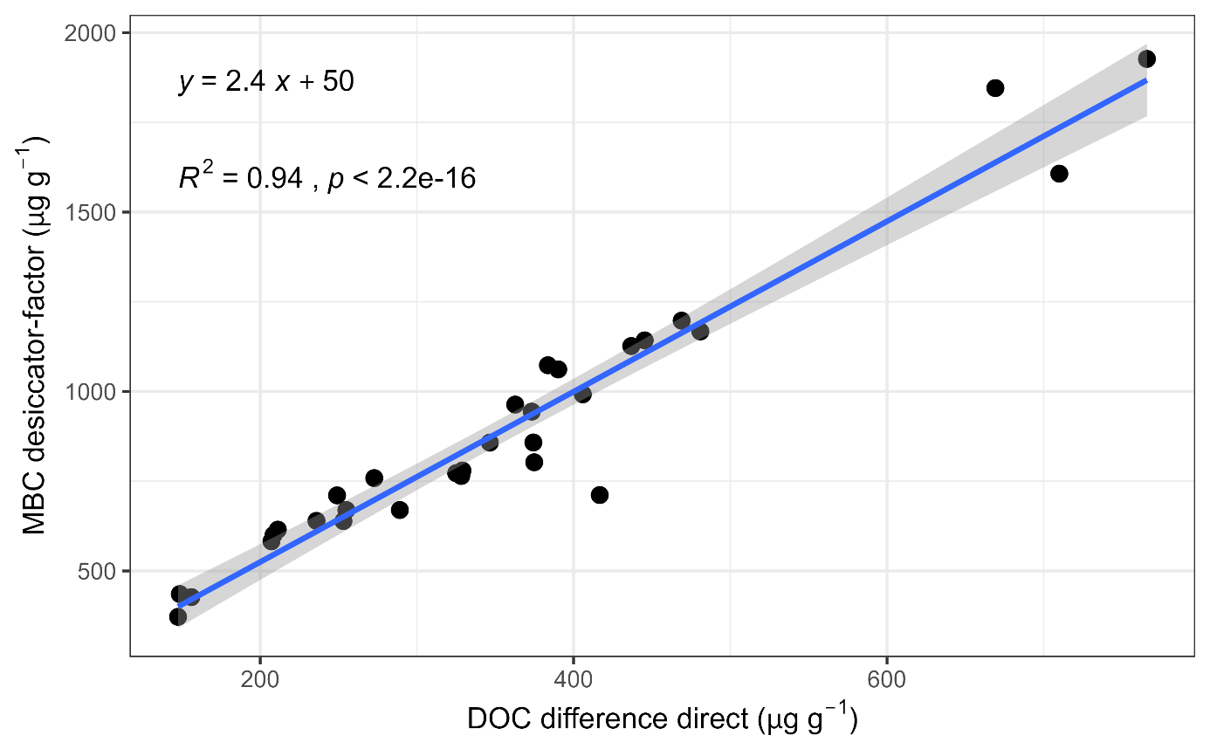
Fig. S4 The correlation between the microbial biomass C measured with the two methods. This plot reports the correlation between the microbial biomass C (MBC) measured with the traditional method as a function of the differences in the dissolved organic C (DOC) obtained with the modified version of the method described by Wachendorf and Joergensen (2011). The new correlation coefficient equation is reported in the left corner of the plot.
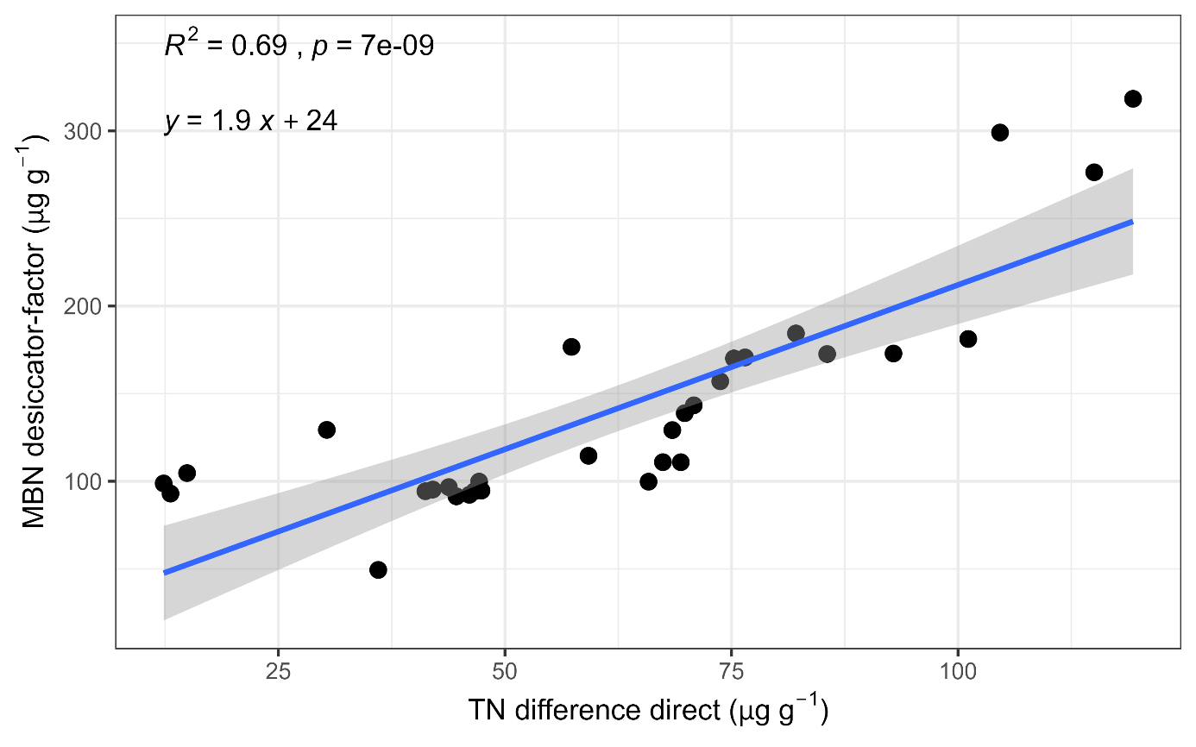
Fig. S5 The correlation between the microbial biomass N measured with the two methods. This plot reports the correlation between the microbial biomass N (MBN) measured with the traditional method as a function of the differences in the total N (TN) obtained with the modified version of the method described by Wachendorf and Joergensen (2011). The new correlation coefficient equation is reported in the left corner of the plot.
Section 4. Soil heterogeneity
Significant differences in some edaphic factors were observed across rows and columns at the sampling time 1 within the first three soil layers (0−10, 10−30, and 30−60 cm). The water content, the δ¹⁵N, the available potassium (K), and the plant-available zinc (Zn) were significantly different across rows (Fig. S4a, c, f, h). The organic C (OC) and the plant-available calcium (Ca) were significantly different across columns (Fig. S4b and d). The plant-available iron (Fe) and plant-manganese (Mn) were significantly different across columns and rows (Fig. S4e and g).
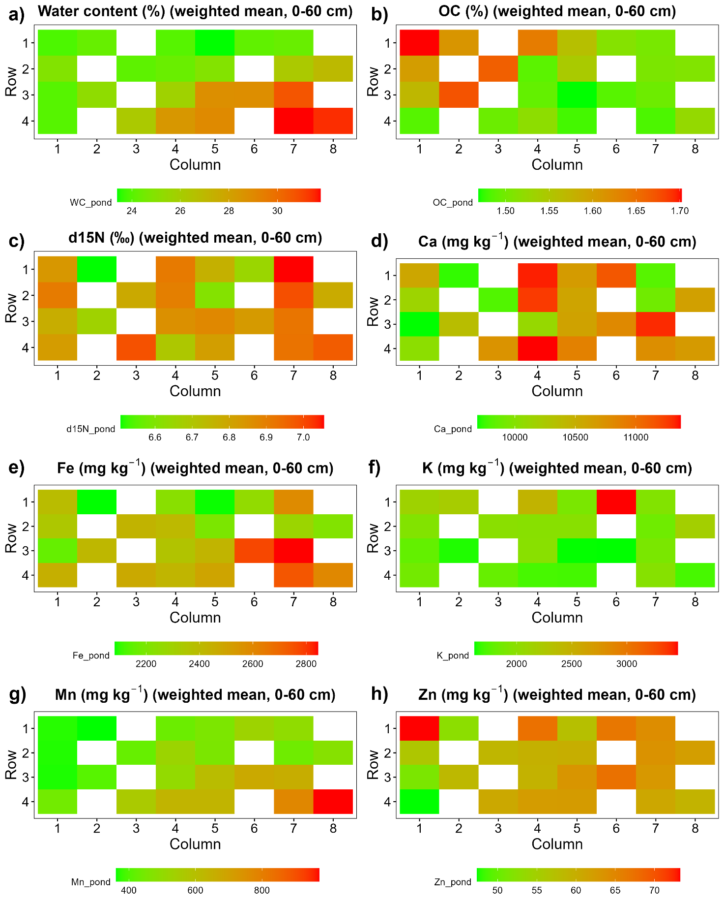
Fig. S6 The soil heterogeneity at the beginning of the experiment. The above plots represent the differences across plots in the variables that were significantly different across rows and/or columns (p < 0.05). The values are the weighted means across the first three sampling depths (0−10, 10−30, and 30−60 cm).

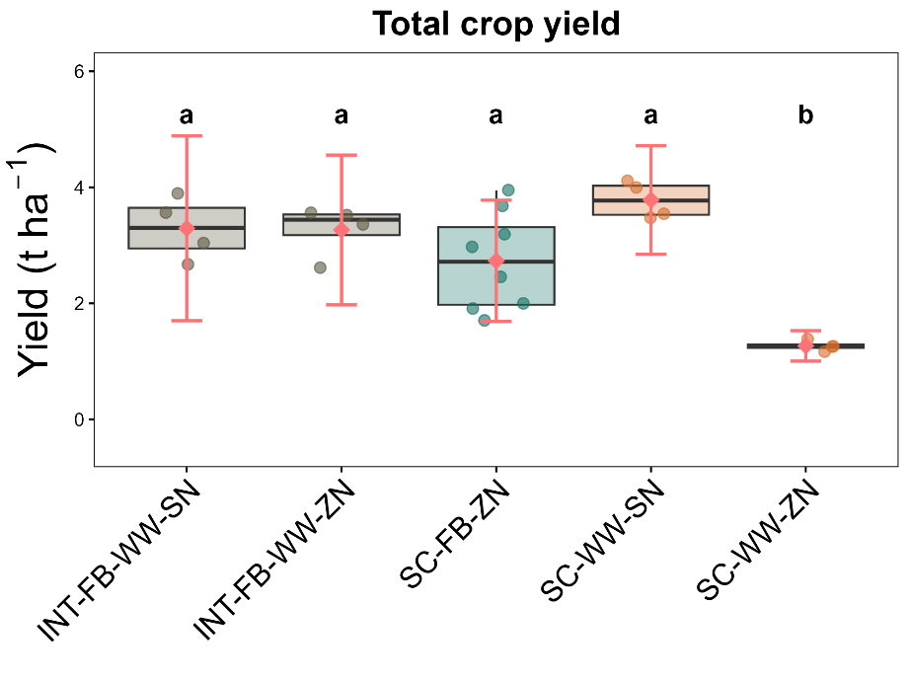
Fig. S7 The grain yields per hectare measured as the total yield. The plot represents the grain yields per hectare as the total yield. INT-FB-WW-SN denotes intercropping – standard N; INT-FB-WW-ZN denotes intercropping – zero N; SC-FB-ZN denotes sole-cropped fava bean – zero N; SC-WW-SN denotes sole-cropped wheat – standard N; SC-WW-ZN denotes sole-cropped wheat – zero N. The red dots represent the estimated marginal means, while the red lines represent their 95% confidence intervals. Different letters indicate significant differences among the groups (P < 0.05).
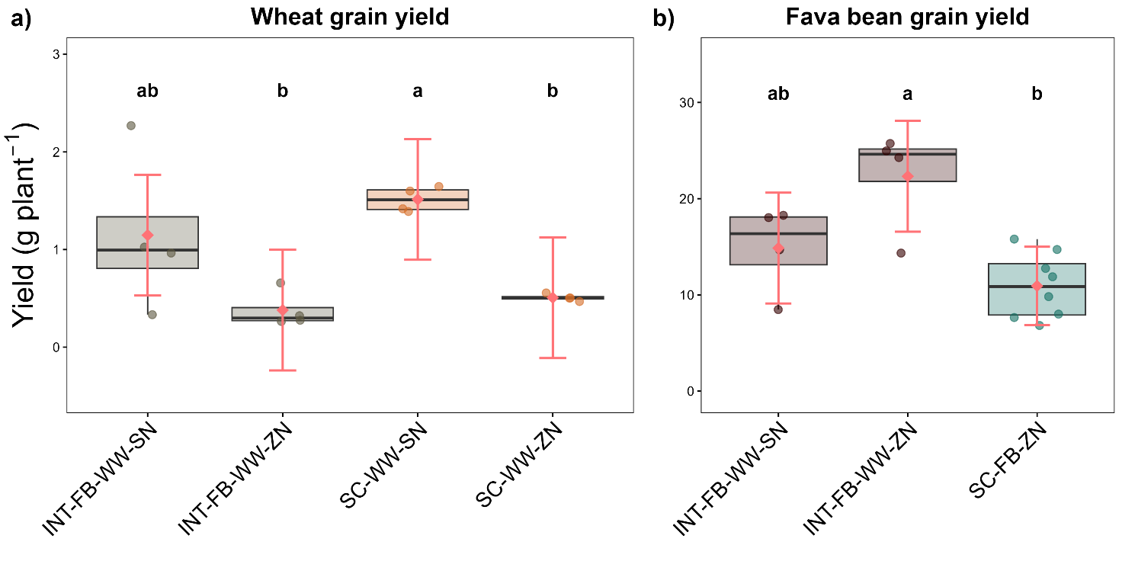
Fig. S8 The grain yields per plant measured separately for each species. The plots represent the grain yields per plant for the wheat (a) and the sole-cropped fava bean (b). INT-FB-WW-SN denotes intercropping – standard N; INT-FB-WW-ZN denotes intercropping – zero N; SC-FB-ZN denotes sole-cropped fava bean – zero N; SC-WW-SN denotes sole-cropped wheat – standard N; SC-WW-ZN denotes sole-cropped wheat – zero N. The red dots represent the estimated marginal means, while the red lines represent their 95% confidence intervals. Different letters indicate significant differences among the groups (P < 0.05). The scales on the y axes are different.
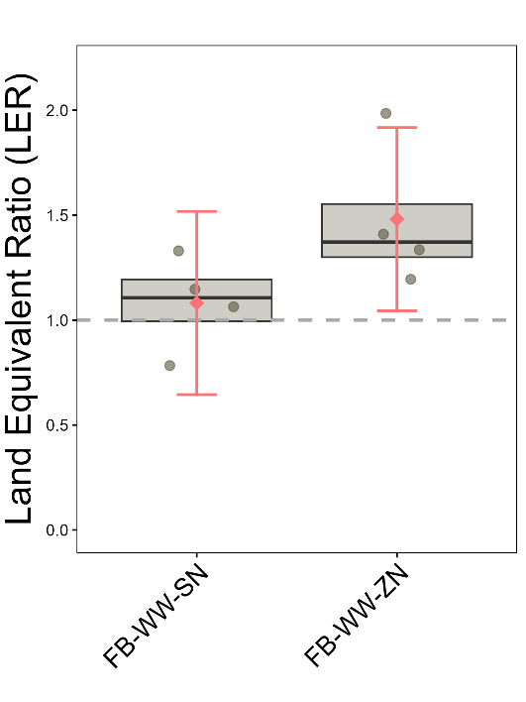
Fig. S9 The Land Equivalent Ratio (LER). The plots represent the grain yield Land Equivalent Ratio (LER). FB-WW-SN denotes intercropping – standard N; FB-WW-ZN denotes intercropping – zero N. The red dots represent the estimated marginal means, while the red lines represent their 95% confidence intervals. Different letters indicate significant differences among the groups (P < 0.05).
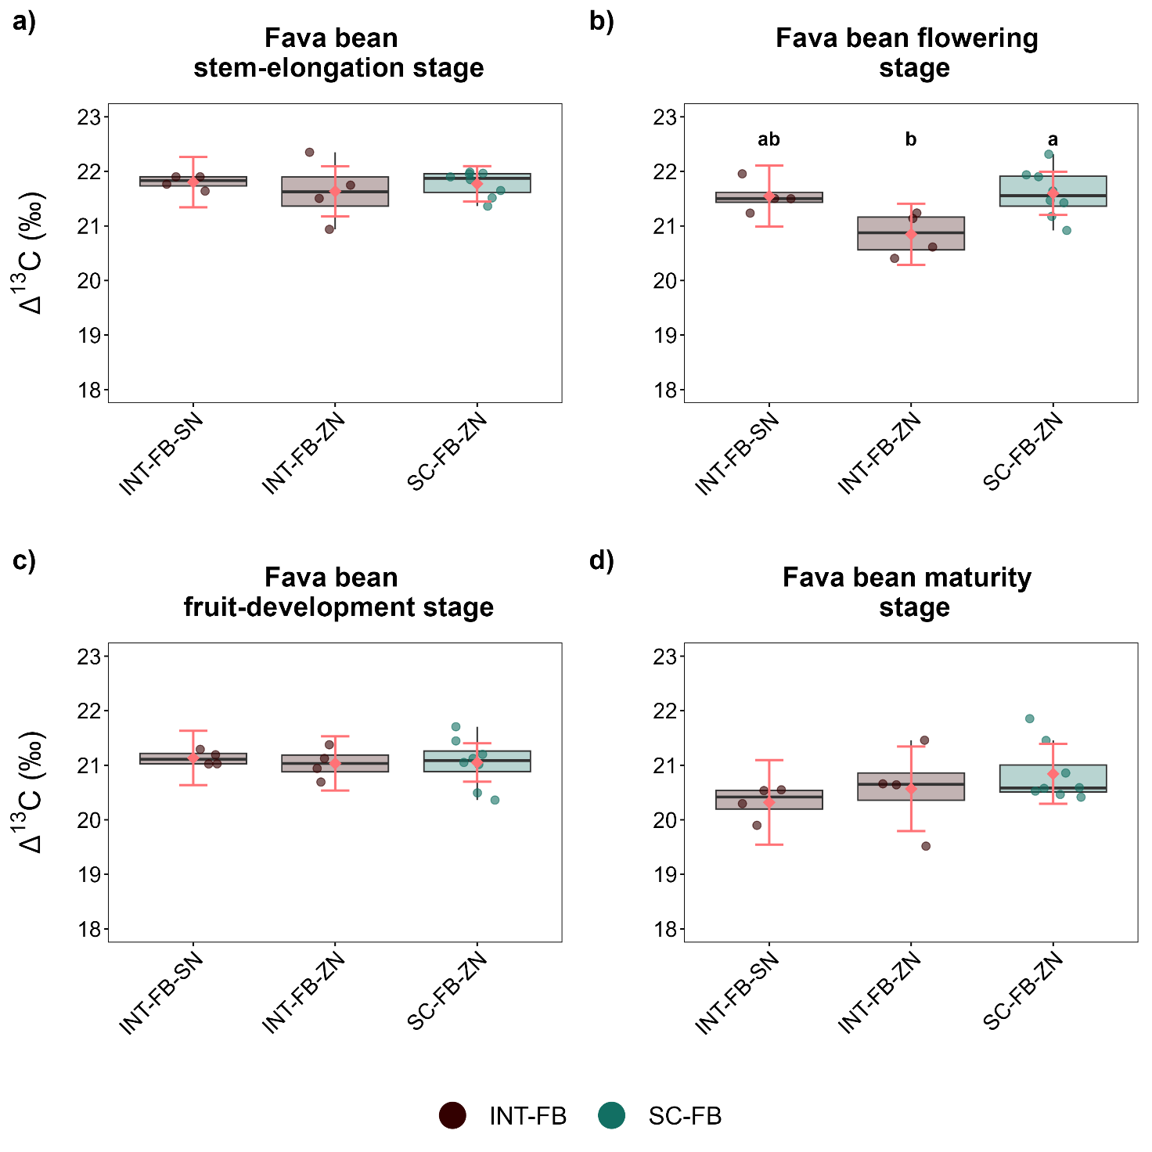
Fig. S10 The fava bean biomass ∆¹³C throughout the four phenological stages. The above plot reports the fava bean biomass ∆¹³C in the early stem-elongation (a), flowering (b), fruit-development (c), and maturity stages (d). INT-FB-SN denotes intercropped fava bean – standard N; INT-FB-ZN denotes intercropped fava bean – zero N; SC-FB-ZN denotes sole-cropped fava bean – zero N. The red dots represent the estimated marginal means, while the red lines represent their 95% confidence intervals. Different letters indicate significant differences among the groups (P < 0.05).
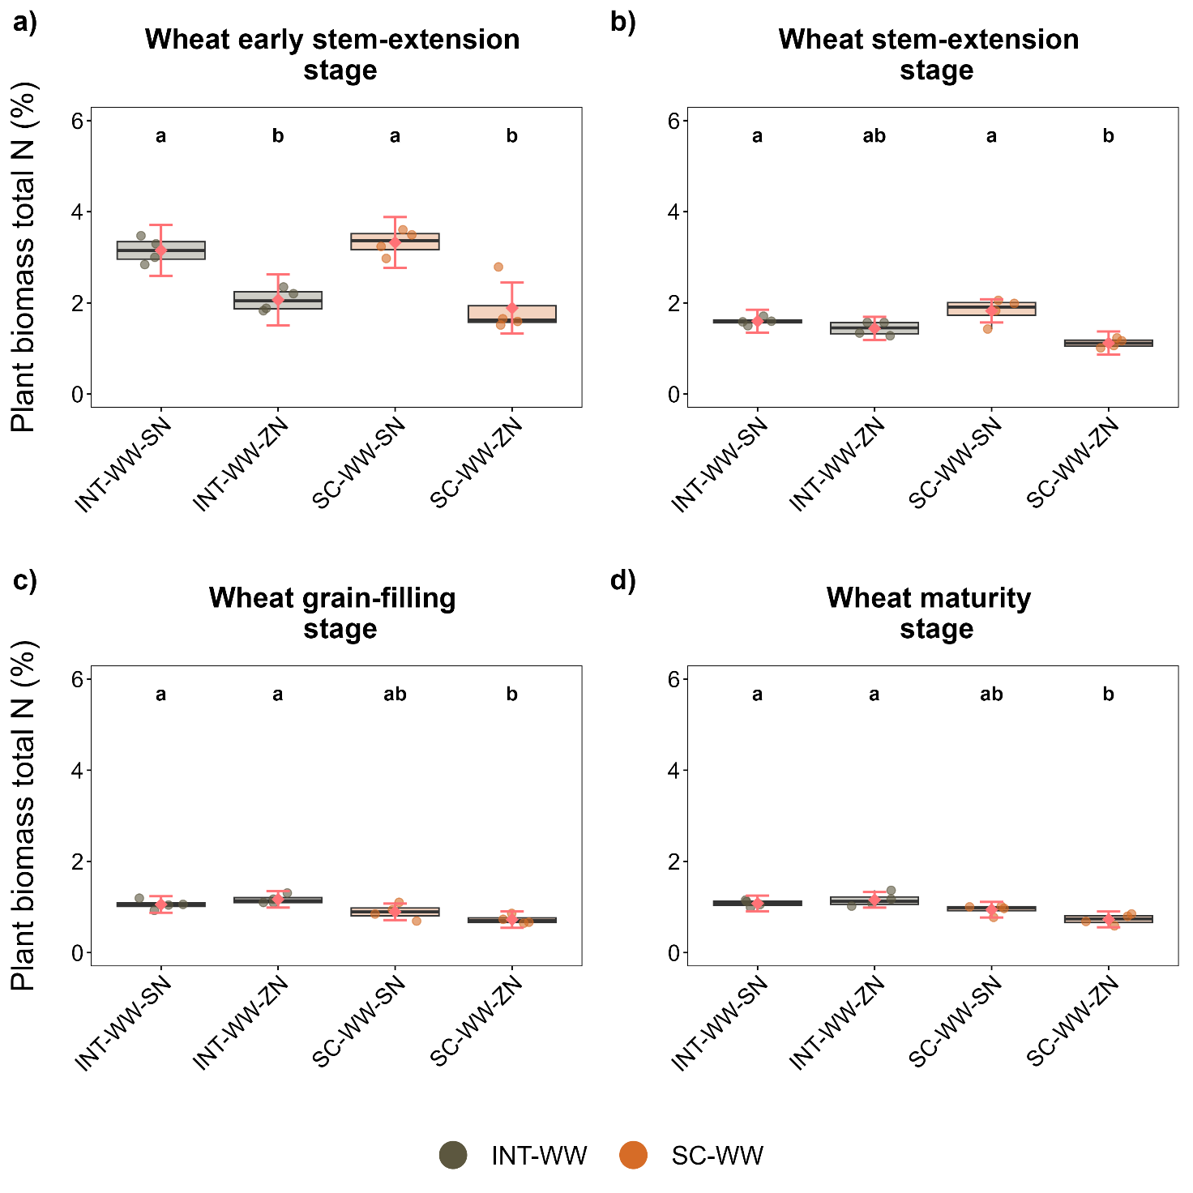
Fig. S11 The wheat biomass total N throughout the four phenological stages. The above plot reports the wheat biomass total N (TN) in the early stem-extension (a), stem-extension (b), grain-filling (c), and maturity stages (d). INT-WW-SN denotes intercropped wheat – standard N; INT-WW-ZN denotes intercropped wheat – zero N; SC-WW-SN denotes sole-cropped wheat – standard N; SC-WW-ZN denotes sole-cropped wheat – zero N. The red dots represent the estimated marginal means, while the red lines represent their 95% confidence intervals. Different letters indicate significant differences among the groups (P < 0.05).
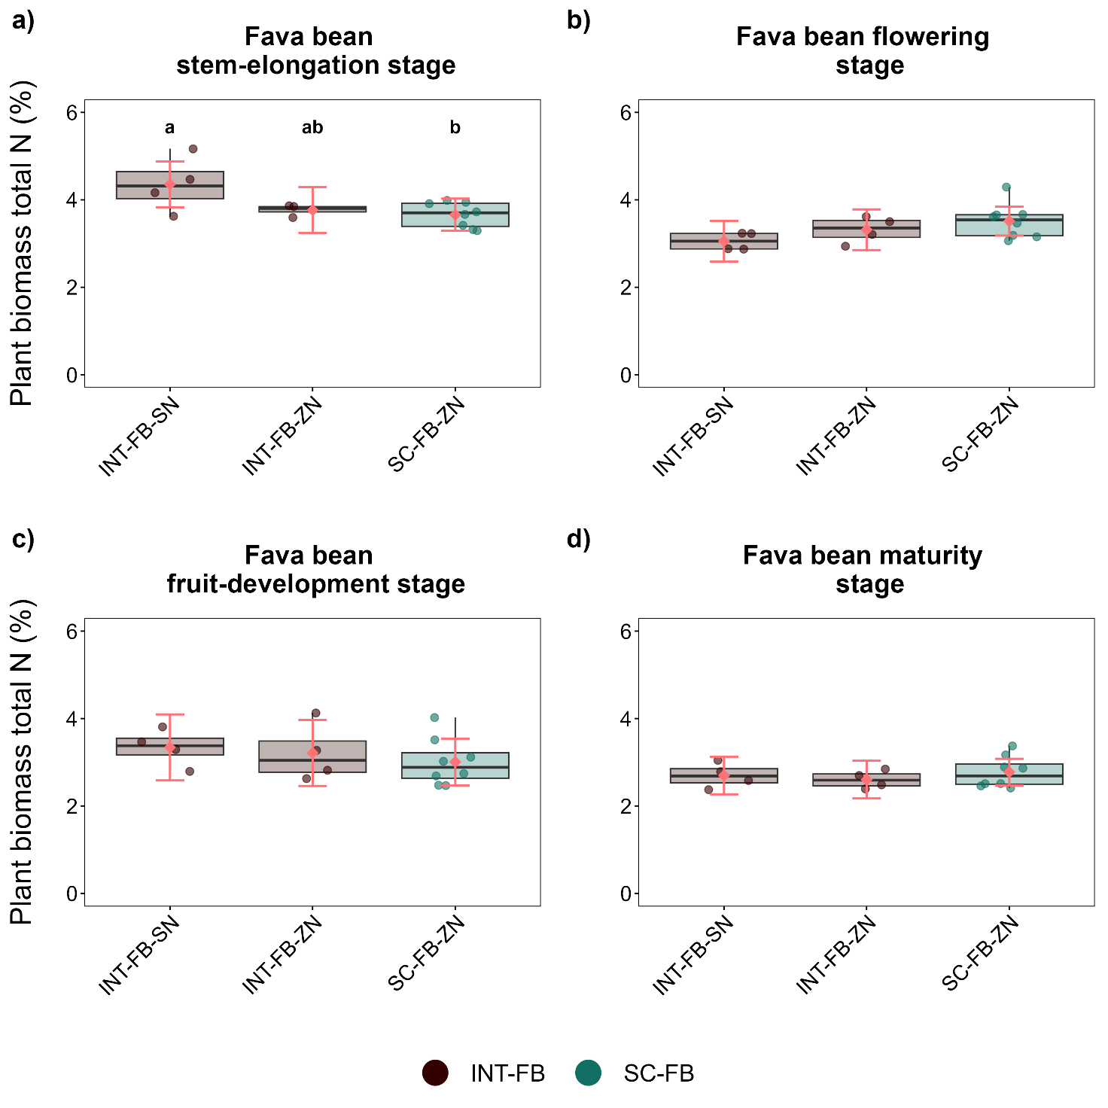
Fig. S12 The fava bean biomass total N throughout the four phenological stages. The above plot reports the fava bean total N (TN) in the stem-elongation (a), flowering (b), fruit-development (c), and maturity stages (d). INT-FB-SN denotes intercropped fava bean – standard N; INT-FB-ZN denotes intercropped fava bean – zero N; SC-FB-ZN denotes sole-cropped fava bean – zero N. The red dots represent the estimated marginal means, while the red lines represent their 95% confidence intervals. Different letters indicate significant differences among the groups (P < 0.05).
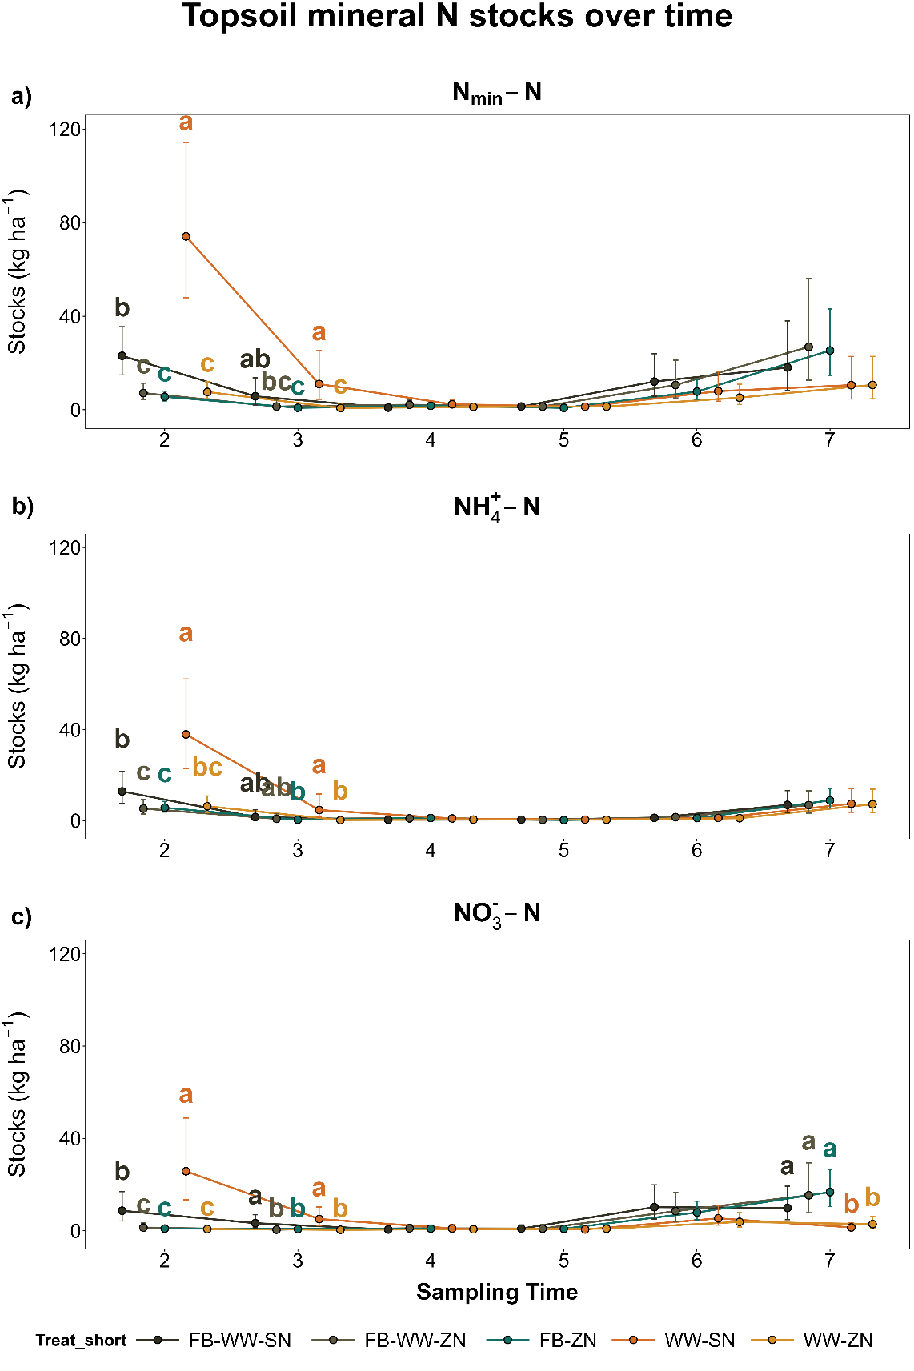
Fig. S13 The mineral N, ammonium, and nitrate stocks in the topsoil across the whole season. The plot reports the mineral N (N_{min}-N), the ammonium-N (NH₄⁺-N), and nitrate-N (NO₃⁻-N) stocks in the topsoil from the sampling time 2 to 7. The abbreviations of the treatments are as follows: FB-WW-SN denotes intercropping – standard N; FB-WW-ZN denotes intercropping – zero N; FB-ZN denotes sole-cropped fava bean – zero N; WW-SN denotes sole-cropped wheat – standard N; WW-ZN denotes sole-cropped wheat – zero N. The dots represent the estimated marginal means, while the lines represent their 95% confidence intervals. Different letters indicate significant differences among the groups (P < 0.05).
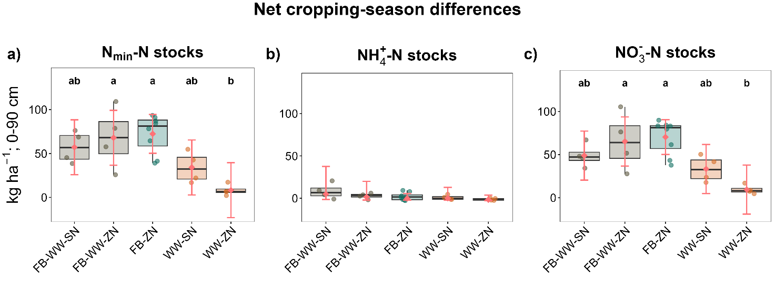
Fig. S14 The mineral N, ammonium, and nitrate stock differences in the post-harvest phase in the 0−90 cm soil profile. The plot reports the mineral N (N_{min}-N), the ammonium-N (NH₄⁺), and nitrate-N (NO₃⁻-N) stock differences in the first 90 cm of soil between the end and the beginning of the season. The abbreviations of the treatments are as follows: FB-WW-SN denotes the intercropping – standard N; FB-WW-ZN denotes intercropping – zero N; FB-ZN denotes sole-cropped fava bean – zero N; WW-SN denotes sole-cropped wheat – standard N; WW-ZN denotes sole-cropped wheat – zero N. The red dots represent the estimated marginal means, while the red lines represent their 95% confidence intervals. Different letters indicate significant differences among the groups (P < 0.05).
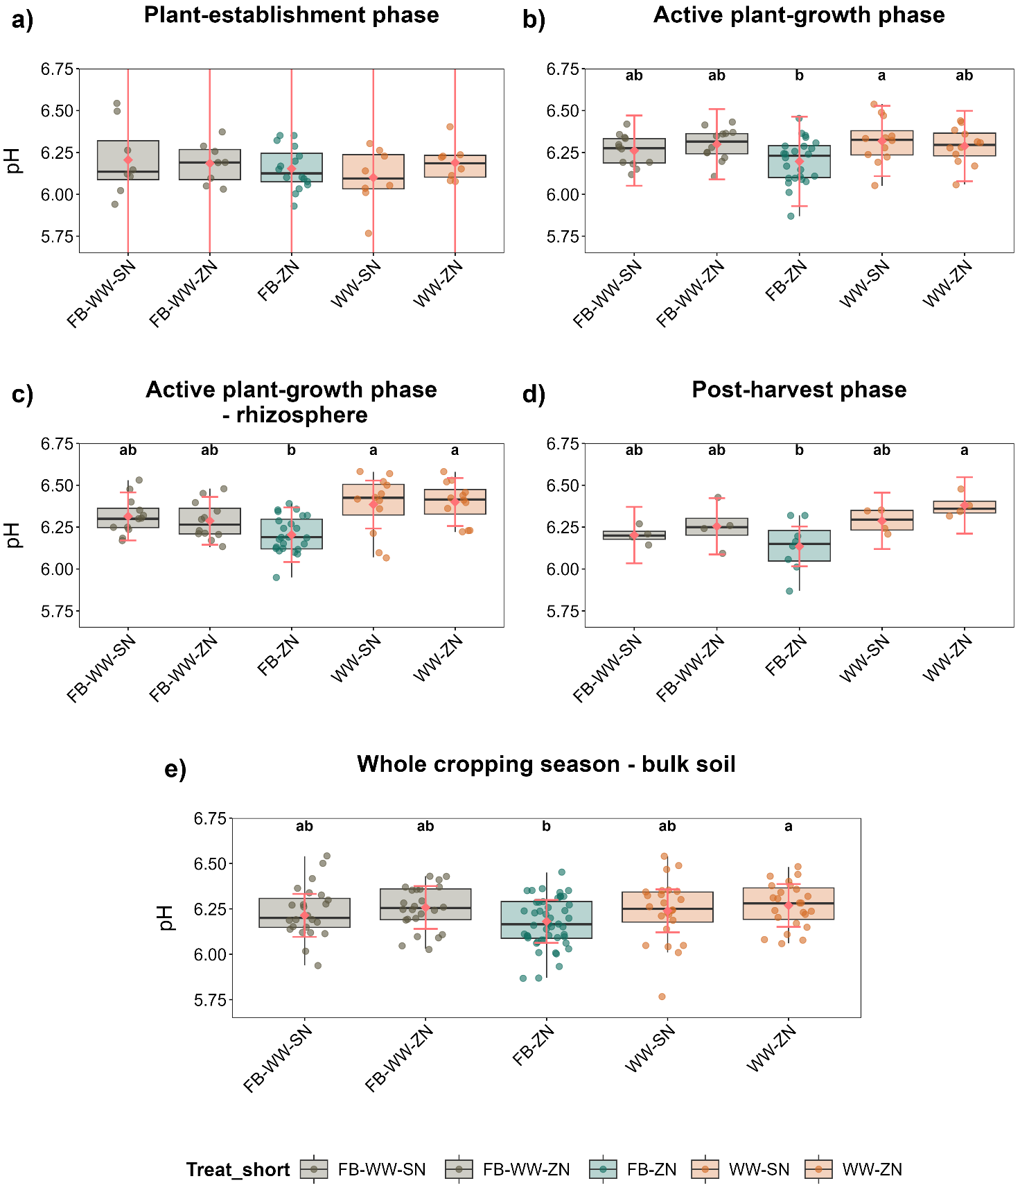
Fig. S15 The topsoil pH in the bulk soil across the whole cropping season and in the rhizosphere in the active plant-growth period. The figure reports the topsoil pH in the plant-establishment phase (a), the active plant-growth phase in both the bulk (b) and the rhizosphere soil (c), the post-harvest phase (d), and over the whole cropping season in the bulk soil (e). The abbreviations of the treatments are as follows: FB-WW-SN denotes intercropping – standard N; FB-WW-ZN denotes intercropping – zero N; FB-ZN denotes sole-cropped fava bean – zero N; WW-SN denotes sole-cropped wheat – standard N; WW-ZN denotes sole-cropped wheat – zero N. The red dots represent the estimated marginal means, while the red lines represent their 95% confidence intervals. Different letters indicate significant differences among the groups (P < 0.05).
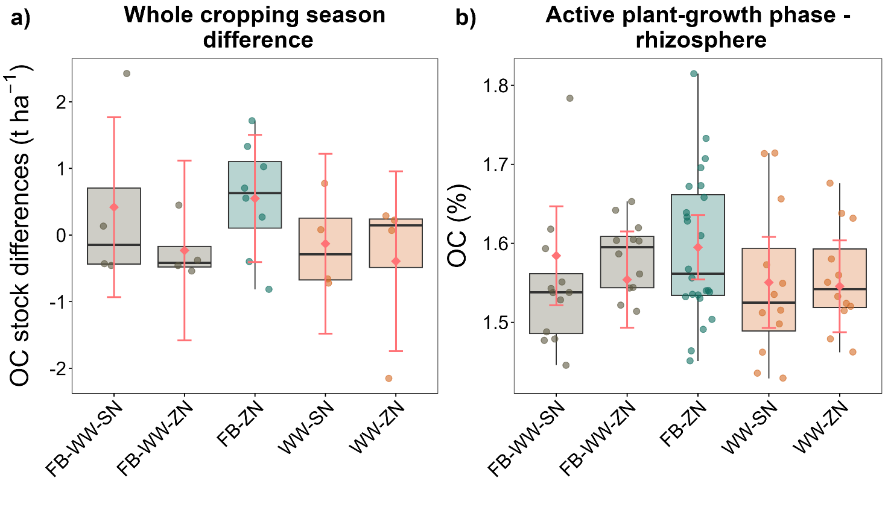
Fig. S16 The topsoil organic C differences in the bulk soil and the organic C concentration in the rhizosphere. The figure reports the topsoil organic C (OC) stock differences in the bulk soil between the end and the beginning of the season (a), and the rhizosphere OC concentration in the active plant-growth phase. The abbreviations of the treatments are as follows: FB-WW-SN denotes intercropping – standard N; FB-WW-ZN denotes intercropping – zero N; FB-ZN denotes sole-cropped fava bean – zero N; WW-SN denotes sole-cropped wheat – standard N; WW-ZN denotes sole-cropped wheat – zero N. The red dots represent the estimated marginal means, while the red lines represent their 95% confidence intervals. Different letters indicate significant differences among the groups (P < 0.05).
Table S1 The soil element stocks across the whole cropping season. The table below reports the stocks of plant-available nutrients, such as the mineral N (N_{min}-N), ammonium-N (NH₄⁺), nitrate-N (NO₃⁻-N), total N (TN), as well as phosphorus (P), potassium (K), calcium (Ca), magnesium (Mg), micronutrients, such as iron (Fe), manganese (Mn), copper (Cu), and zinc (Zn), the element aluminum (Al), and the microbial biomass C and N stocks (MBC and MBN) in the plant-establishment phase, the active plant-growth phase, the post-harvest phase, and over the whole cropping season in the bulk soil. The abbreviations of the treatments are as follows: FB-WW-SN denotes intercropping – standard N; FB-WW-ZN denotes intercropping – zero N; FB-ZN denotes sole-cropped fava bean – zero N; WW-SN denotes sole-cropped wheat – standard N; WW-ZN denotes sole-cropped wheat – zero N. The reported values indicate the estimated marginal mean ± standard error. Different letters indicate significant differences among the groups (P < 0.05).
Variable | Phase | FB-WW-SN | FB-WW-ZN | FB-ZN | WW-SN | WW-ZN
TN | Overall | 1.96 ± 0.04 | 1.96 ± 0.04 | 2.01 ± 0.04 | 1.98 ± 0.04 | 1.95 ± 0.04
TN | Plant-establishment phase | 1.83 ± 0.11 | 1.9 ± 0.11 | 1.93 ± 0.11 | 2.02 ± 0.11 | 1.93 ± 0.11
TN | Active plant-growth phase | 2.01 ± 0.03 | 1.98 ± 0.03 | 2.01 ± 0.02 | 1.96 ± 0.03 | 1.95 ± 0.03
TN | Post-harvest phase | 1.99 ± 0.03 b | 2.06 ± 0.03 ab | 2.12 ± 0.02 a | 1.99 ± 0.03 b | 2.02 ± 0.03 ab
NH₄⁺-N | Overall | 2.22 ± 1.13 ab | 1.95 ± 1 ab | 1.83 ± 0.96 ab | 3.56 ± 1.72 a | 1.69 ± 0.92 b
NH₄⁺-N | Plant-establishment phase | 4.91 ± 4.86 ab | 2.44 ± 2.76 bc | 2.02 ± 2.41 c | 13.33 ± 12.12 a | 2.11 ± 2.49 bc
NH₄⁺-N | Active plant-growth phase | 0.6 ± 0.25 | 0.91 ± 0.3 | 0.78 ± 0.26 | 0.76 ± 0.27 | 0.66 ± 0.26
NH₄⁺-N | Post-harvest phase | 6.81 ± 1.58 | 6.97 ± 1.61 | 8.85 ± 1.41 | 7.13 ± 1.64 | 7.46 ± 1.71
NO₃⁻-N | Overall | 3.92 ± 1.7 a | 2.56 ± 1.18 a | 2.51 ± 1.14 a | 3.43 ± 1.83 ab | 1.26 ± 0.74 b
NO₃⁻-N | Plant-establishment phase | 5.41 ± 1.59 a | 0.84 ± 0.25 b | 0.83 ± 0.22 b | 11.74 ± 4.49 a | 0.55 ± 0.19 b
NO₃⁻-N | Active plant-growth phase | 2.17 ± 1.59 | 2.33 ± 1.67 | 2.17 ± 1.57 | 1.68 ± 1.35 | 1.44 ± 1.23
NO₃⁻-N | Post-harvest phase | 9.86 ± 4.45 ab | 15.34 ± 6.7 a | 16.74 ± 5.15 a | 1.42 ± 0.99 b | 2.86 ± 1.58 ab
N_{min}-N | Overall | 6.16 ± 2.97 a | 4.72 ± 2.27 a | 4.64 ± 2.23 a | 7.02 ± 3.64 ab | 3.08 ± 1.63 b
N_{min}-N | Plant-establishment phase | 11.09 ± 8.51 a | 3.2 ± 2.91 b | 2.99 ± 2.74 b | 24.54 ± 19.01 a | 2.73 ± 2.57 b
N_{min}-N | Active plant-growth phase | 2.71 ± 1.74 | 3.2 ± 1.97 | 3.04 ± 1.87 | 2.47 ± 1.63 | 2.08 ± 1.45
N_{min}-N | Post-harvest phase | 17.08 ± 4.51 ab | 25.61 ± 6.63 ab | 29.53 ± 5.38 a | 8.81 ± 2.44 b | 10.24 ± 2.8 b
P | Overall | 2784.31 ± 56.39 | 2879.68 ± 56.53 | 2918.32 ± 47.61 | 2791.4 ± 55.75 | 2800.22 ± 55.76
P | Plant-establishment phase | 2892.59 ± 151.83 | 2889.59 ± 151.99 | 2903.83 ± 141.76 | 2924.07 ± 151.07 | 2842.27 ± 151.07
P | Active plant-growth phase | 2729.19 ± 68.8 | 2857.06 ± 69.05 | 2937.92 ± 51.97 | 2735.5 ± 67.63 | 2781.6 ± 67.64
P | Post-harvest phase | 2733.07 ± 78.72 | 2927.69 ± 79.06 | 2888.5 ± 54.49 | 2693.79 ± 77.1 | 2771.95 ± 77.11
K | Overall | 2209.57 ± 152.9 bc | 2546.59 ± 162.5 abc | 2544.18 ± 127.34 ab | 2047.13 ± 155.19 c | 2840.08 ± 150.19 a
K | Plant-establishment phase | 2549.59 ± 237.06 ab | 2733.89 ± 247.93 ab | 2589.74 ± 209.13 ab | 2228.05 ± 239.64 b | 3060.2 ± 234.02 a
K | Active plant-growth phase | 1885.89 ± 110.24 c | 2385.32 ± 146.39 b | 2304.59 ± 119.97 b | 1801.71 ± 222.92 bc | 2829.31 ± 117.77 a
K | Post-harvest phase | 2221.38 ± 162.9 | 3217.39 ± 662.96 | 3155.19 ± 363.95 | 2056.38 ± 217.15 | 2548.19 ± 184.38
Ca | Overall | 13662.57 ± 201.03 b | 13903.12 ± 200.24 ab | 13705.74 ± 163.08 b | 14395.57 ± 201.8 a | 13677.07 ± 200.95 b
Ca | Plant-establishment phase | 14222.77 ± 290.39 | 13982.53 ± 289.48 | 14068.87 ± 248.05 | 14470.4 ± 291.27 | 14259.4 ± 290.3
Ca | Active plant-growth phase | 13436.44 ± 253.52 b | 13728 ± 253.52 ab | 13418.79 ± 179.27 b | 14531.31 ± 253.52 a | 13057.68 ± 253.52 b
Ca | Post-harvest phase | 13032.51 ± 381 | 14344.96 ± 381 | 13679.77 ± 269.41 | 14092.24 ± 381 | 14550.88 ± 381
Mg | Overall | 837.49 ± 51.69 | 857.69 ± 52.18 | 828.49 ± 49.52 | 844.96 ± 51.48 | 901.5 ± 51.5
Mg | Plant-establishment phase | 1010.1 ± 41.77 | 954.76 ± 44.23 | 954.51 ± 28.84 | 975.79 ± 40.7 | 1043.76 ± 40.78
Mg | Active plant-growth phase | 779.77 ± 47.76 | 839.93 ± 48.8 | 790.11 ± 43 | 792.02 ± 47.32 | 852.44 ± 47.35
Mg | Post-harvest phase | 651.16 ± 34.15 | 740.62 ± 34.15 | 686.49 ± 24.15 | 734.94 ± 34.15 | 772.05 ± 34.15
Fe | Overall | 2942.48 ± 97.81 ab | 2726.91 ± 97.7 bc | 2925.53 ± 88.16 ab | 3048.97 ± 97.94 a | 2682.72 ± 98.61 c
Fe | Plant-establishment phase | 2909.92 ± 279.77 | 2623.31 ± 279.6 | 2771.9 ± 263.98 | 3010.37 ± 279.98 | 2633.02 ± 281.11
Fe | Active plant-growth phase | 2915.75 ± 107.56 ab | 2783.4 ± 107.42 ab | 2983.12 ± 94.03 a | 3040.94 ± 107.74 a | 2704.45 ± 108.67 b
Fe | Post-harvest phase | 3087.79 ± 132.42 | 2764.63 ± 132.05 | 3060.04 ± 93.26 | 3150.26 ± 132.89 | 2716.96 ± 135.32
Cu | Overall | 48.45 ± 0.94 | 48.03 ± 0.92 | 48.77 ± 0.9 | 48.73 ± 1.25 | 47.57 ± 0.89
Cu | Plant-establishment phase | 48.32 ± 2.19 | 45.87 ± 2.18 | 46.69 ± 2 | 49.49 ± 2.19 | 46.52 ± 2.18
Cu | Active plant-growth phase | 48.08 ± 1.04 | 48.85 ± 1.04 | 49.85 ± 0.86 | 48.31 ± 1.04 | 47.92 ± 1.04
Cu | Post-harvest phase | 49.61 ± 1.05 | 49.89 ± 1.04 | 49.9 ± 0.74 | 48.31 ± 1.05 | 48.59 ± 1.04
Mn | Overall | 570.96 ± 24.36 ab | 560.35 ± 24.47 ab | 600.25 ± 20.27 a | 601.97 ± 24.72 a | 518.92 ± 24.12 b
Mn | Plant-establishment phase | 528.91 ± 44.35 | 527.76 ± 44.69 | 583.7 ± 31.19 | 622.14 ± 45.43 | 507.68 ± 43.63
Mn | Active plant-growth phase | 595.07 ± 37.83 ab | 597.95 ± 37.93 ab | 621.72 ± 34.45 a | 604.21 ± 38.14 ab | 531.35 ± 37.62 b
Mn | Post-harvest phase | 582.7 ± 31.98 | 512.71 ± 32.23 | 568.92 ± 22.49 | 554.91 ± 32.76 | 504.13 ± 31.46
Zn | Overall | 80.11 ± 1.62 a | 73.15 ± 1.48 bc | 75.64 ± 1.05 ab | 80.56 ± 1.47 a | 68.55 ± 1.49 c
Zn | Plant-establishment phase | 79.04 ± 3.41 ab | 71.85 ± 3.2 ab | 73.43 ± 2.58 ab | 82.47 ± 3.18 a | 67.59 ± 3.21 b
Zn | Active plant-growth phase | 81.05 ± 2.18 a | 72.81 ± 1.98 ab | 76.45 ± 1.37 a | 79.75 ± 1.96 a | 68.61 ± 1.99 b
Zn | Post-harvest phase | 76.01 ± 3.99 | 78.42 ± 3.99 | 78.31 ± 2.82 | 77.87 ± 3.99 | 71.99 ± 3.99
Al | Overall | 12212.68 ± 259.32 | 12415.88 ± 260.14 | 12516.57 ± 233.24 | 12288.67 ± 267.26 | 12461.31 ± 268.39
Al | Plant-establishment phase | 12191.84 ± 748.62 | 11835.43 ± 748.62 | 11975.38 ± 712.84 | 11982 ± 748.62 | 12298.3 ± 748.62
Al | Active plant-growth phase | 12035.81 ± 220.05 | 12740 ± 221.85 | 12753.34 ± 156.22 | 12349.36 ± 237.16 | 12627.64 ± 239.54
Al | Post-harvest phase | 12755.31 ± 293.35 | 12749.72 ± 293.35 | 12815.22 ± 207.43 | 12273.78 ± 293.35 | 12765.72 ± 293.35
MBC | Overall | 314.29 ± 13.61 | 293.09 ± 13.35 | 315.66 ± 11.82 | 314.73 ± 13.15 | 315.45 ± 13.17
MBC | Plant-establishment phase | 317.74 ± 14.59 | 311.34 ± 14.59 | 341.87 ± 10.31 | 312.81 ± 14.59 | 348.34 ± 14.59
MBC | Active plant-growth phase | 305.69 ± 12.95 | 282 ± 12.95 | 290.56 ± 9.15 | 308.08 ± 12.95 | 289.7 ± 12.95
MBC | Post-harvest phase | 334.34 ± 20.09 | 289.11 ± 20.09 | 338.53 ± 14.21 | 338.46 ± 20.09 | 326.61 ± 20.09
MBN | Overall | 70.15 ± 2.14 | 66.72 ± 2.12 | 69.59 ± 1.91 | 70.96 ± 2.11 | 70.09 ± 2.08
MBN | Plant-establishment phase | 71.4 ± 2.61 | 68.9 ± 2.55 | 72.07 ± 2.09 | 73.32 ± 2.53 | 72.71 ± 2.48
MBN | Active plant-growth phase | 68.47 ± 2.99 | 64.49 ± 2.96 | 66.5 ± 2.7 | 67.22 ± 2.94 | 67.09 ± 2.91
MBN | Post-harvest phase | 72.7 ± 3.42 | 69.05 ± 3.31 | 73.92 ± 2.28 | 77.45 ± 3.27 | 73.87 ± 3.16

Table S2 The soil element concentration in the rhizosphere during the active plant-growth phase. The table below reports the concentration of plant-available nutrients, such as the mineral N (N_{min}-N), ammonium-N (NH₄⁺), nitrate-N (NO₃⁻-N), total N (TN), as well as phosphorus (P), potassium (K), calcium (Ca), magnesium (Mg), micronutrients, such as iron (Fe), manganese (Mn), copper (Cu), and zinc (Zn), and the element aluminum (Al) in the active plant-growth phase in the rhizosphere soil. The abbreviations of the treatments are as follows: FB-WW-SN denotes intercropping – standard N; FB-WW-ZN denotes intercropping – zero N; FB-ZN denotes sole-cropped fava bean – zero N; WW-SN denotes sole-cropped wheat – standard N; WW-ZN denotes sole-cropped wheat – zero N. The reported values indicate the estimated marginal mean ± standard error. Different letters indicate significant differences among the groups (P < 0.05).
Variable | FB-WW-SN | FB-WW-ZN | FB-ZN | WW-SN | WW-ZN
TN | 0.15 ± 0.002 | 0.15 ± 0.002 | 0.15 ± 0.002 | 0.15 ± 0.002 | 0.15 ± 0.002
NH₄⁺-N | 0.86 ± 0.479 | 0.84 ± 0.474 | 1.02 ± 0.511 | 0.87 ± 0.483 | 0.88 ± 0.486
NO₃⁻-N | 1.78 ± 1.575 | 1.84 ± 1.608 | 1.8 ± 1.57 | 1.31 ± 1.311 | 1.16 ± 1.226
N_{min}-N | 2.4 ± 1.914 | 2.6 ± 2.028 | 2.79 ± 2.113 | 2.09 ± 1.736 | 1.95 ± 1.661
P | 1999.36 ± 69.533 | 2060.96 ± 70.195 | 2094.91 ± 60.376 | 1934.68 ± 69.3 | 2072.2 ± 69.249
K | 2055.05 ± 262.778 b | 2235.44 ± 299.255 ab | 2017.71 ± 238.22 b | 1987.47 ± 404.62 ab | 2574.66 ± 296.36 a
Ca | 9661.84 ± 260.164 | 9588.18 ± 260.164 | 9462.02 ± 210.515 | 10090.46 ± 260.164 | 9674.53 ± 260.164
Mg | 615.88 ± 29.938 | 644.05 ± 32.08 | 576.96 ± 21.763 | 662.21 ± 29.796 | 675.3 ± 29.585
Fe | 2093.79 ± 88.59 ab | 1967.6 ± 88.092 b | 2162.14 ± 79.273 a | 2153.9 ± 88.256 ab | 2004.11 ± 89.024 ab
Cu | 35.05 ± 1.407 | 34.83 ± 1.402 | 36 ± 1.318 | 33.9 ± 1.402 | 35.4 ± 1.402
Mn | 442.81 ± 20.69 ab | 441.42 ± 22.588 abc | 485.6 ± 20.763 a | 401.89 ± 26.527 bc | 392.47 ± 18.272 c
Zn | 60.31 ± 1.884 a | 53.49 ± 1.743 ab | 56.38 ± 1.26 ab | 57.23 ± 1.732 ab | 52.5 ± 1.748 b
Al | 8935.5 ± 255.125 ab | 9178.15 ± 255.125 ab | 9307.64 ± 233.492 a | 8694.46 ± 255.125 b | 9476.18 ± 255.125 a

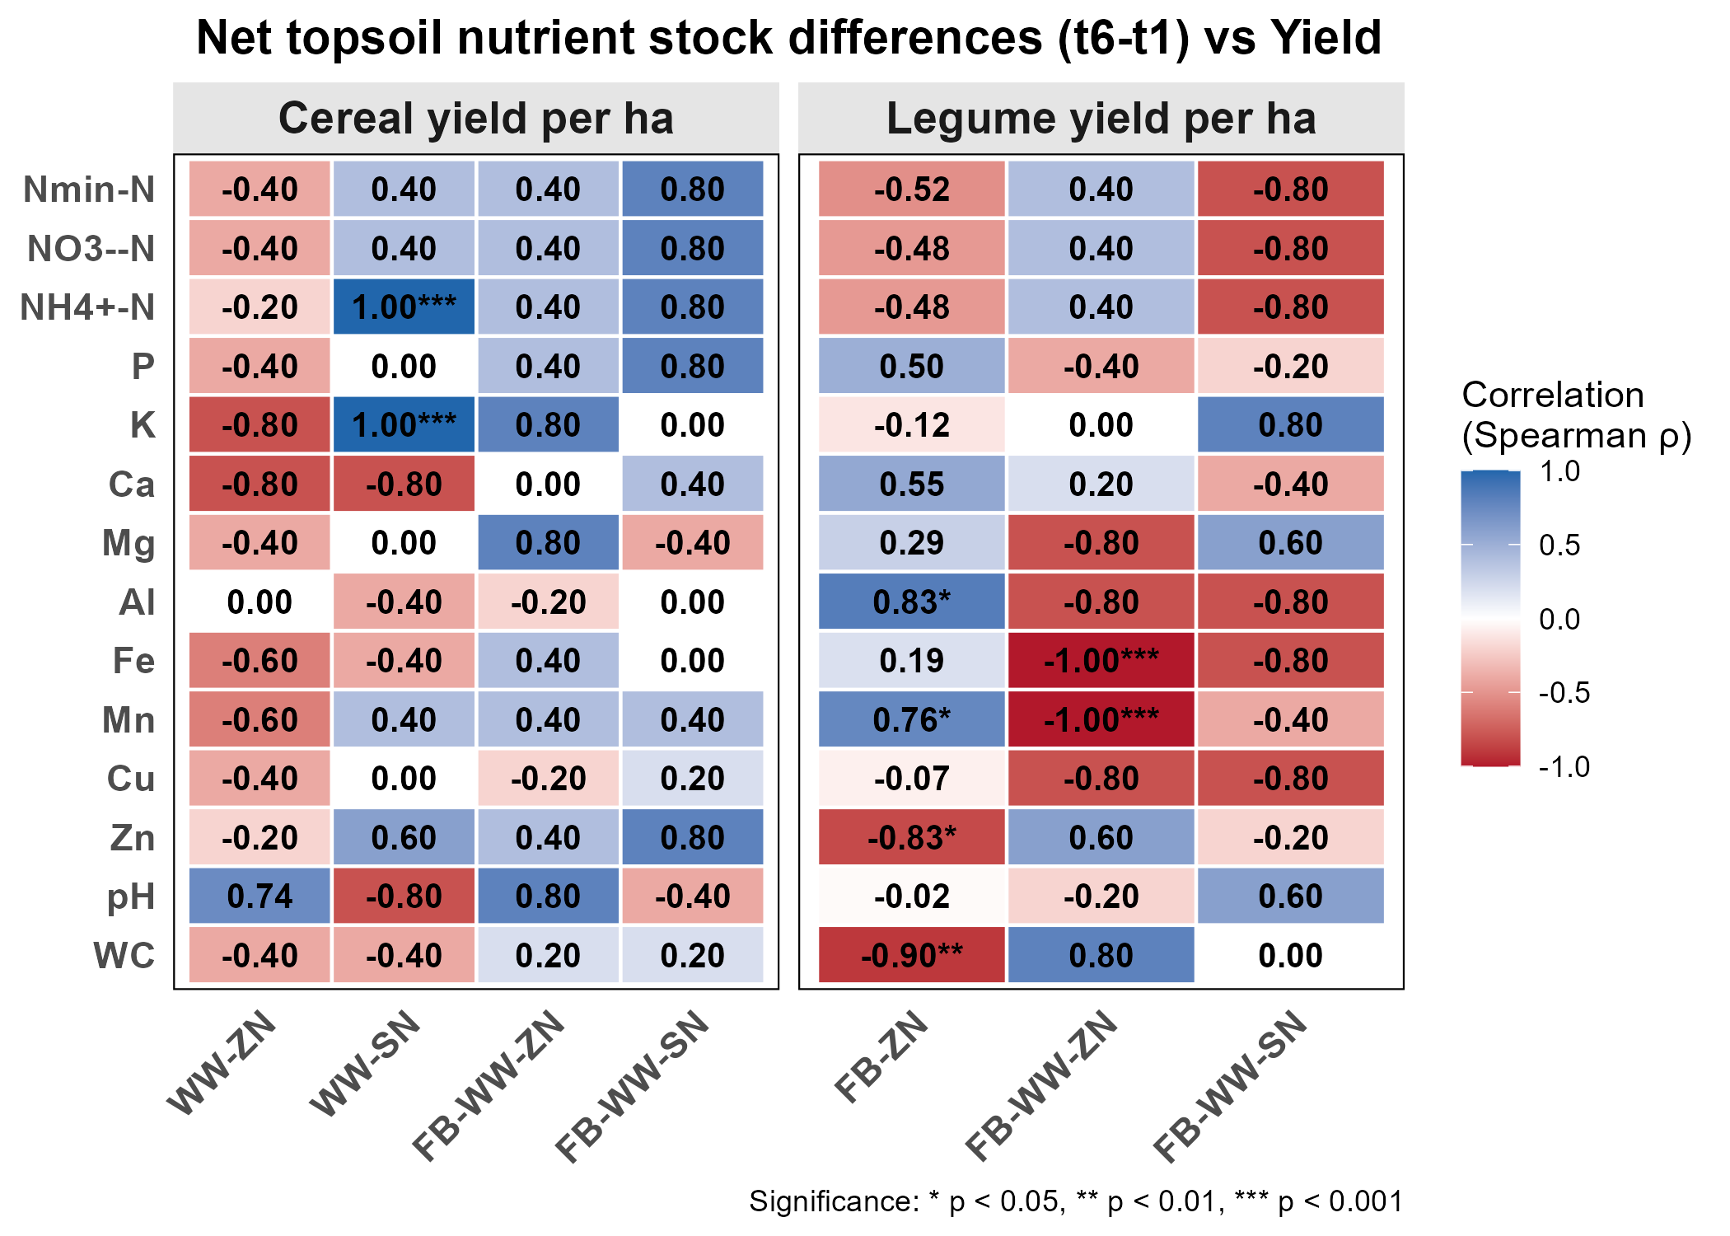
Fig. S17 The matrix of the correlation between the crop yield and the nutrient stock changes. The plot reports the Spearman correlation values between the grain yield and the net nutrient stock changes in the topsoil between the crop maturity and the beginning of the experiment, and the mean pH and water content (WC) among the sampling times 2 and 6. The abbreviations of the treatments are as follows: FB-WW-SN denotes intercropping – standard N; FB-WW-ZN denotes intercropping – zero N; FB-ZN denotes sole-cropped fava bean – zero N; WW-SN denotes sole-cropped wheat – standard N; WW-ZN denotes sole-cropped wheat – zero N.
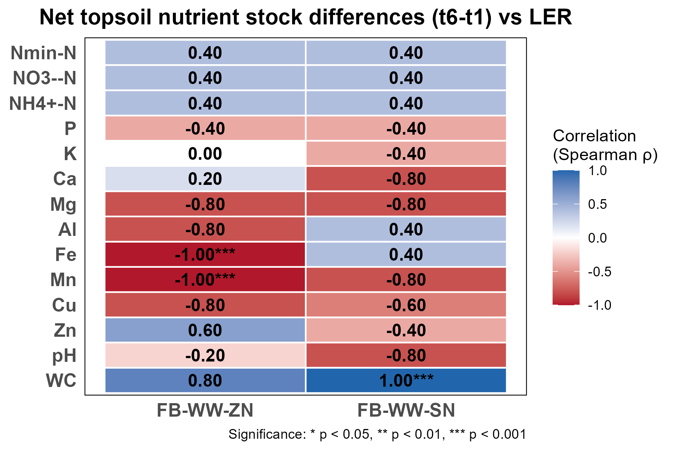
Fig. S18 The matrix of correlation between the Land Equivalent Ratio and nutrient stock changes. The plot reports the Spearman correlation values between the Land Equivalent Ratio (LER) and the net nutrient stock changes in the topsoil between the crop maturity and the beginning of the experiment, and the mean pH and water content (WC) among the sampling times 2 and 6. The abbreviations of the treatments are as follows: FB-WW-SN denotes intercropping – standard N; FB-WW-ZN denotes intercropping – zero N.
Table S3 The soil biochemical properties in the bulk soil across the whole cropping season and in the rhizosphere in the active plant-growth period. The table below reports the soil biochemical properties in the plant-establishment phase, the active plant-growth phase in both the bulk and the rhizosphere soil, the post-harvest phase, and over the whole cropping season in the bulk soil. The table reports the β-glucosidase (BG), the N-acetyl-β-d-glucosaminidase (NAG), and the acid and alkaline phosphatase (ACP and ALP) activities, the microbial biomass C and N concentration (MBC and MBN) and their ratio (MBC:MBN), and the microbial C Use Efficiency (CUE). The microbial biomass C and N and the CUE in the rhizosphere soil were measured only in the crop maturity stage. The abbreviations of the treatments are as follows: FB-WW-SN denotes intercropping – standard N; FB-WW-ZN denotes intercropping – zero N; FB-ZN denotes sole-cropped fava bean – zero N; WW-SN denotes sole-cropped wheat – standard N; WW-ZN denotes sole-cropped wheat – zero N. The reported values indicate the estimated marginal mean ± standard error. Different letters indicate significant differences among the groups (P < 0.05).
Variable | Phase | FB-WW-SN | FB-WW-ZN | FB-ZN | WW-SN | WW-ZN
ACP | Overall | 455.17 ± 20.87 | 458.43 ± 20.71 | 458.35 ± 16.88 | 474.01 ± 20.35 | 424.02 ± 20.34
ACP | Plant-establishment phase | 442.97 ± 52.44 | 542.37 ± 51.66 | 442.45 ± 46.54 | 456.53 ± 51.63 | 440.01 ± 51.63
ACP | Active plant-growth phase - bulk soil | 467.28 ± 28.41 | 434.08 ± 27.64 | 460.52 ± 22.3 | 492.4 ± 27.61 | 411.4 ± 27.61
ACP | Active plant-growth phase - rhizosphere | 513.66 ± 36.7 | 464.56 ± 36.56 | 481.36 ± 33.5 | 491.45 ± 36.26 | 447.91 ± 36.25
ACP | Post-harvest phase | 433.1 ± 36.41 | 417.55 ± 35.01 | 463.01 ± 10.09 | 438.46 ± 16.4 | 442.6 ± 11.71
ALP | Overall | 168.52 ± 9.98 a | 146.11 ± 10.15 abc | 121.8 ± 3.96 c | 142.96 ± 6.88 ab | 132.51 ± 4.9 bc
ALP | Plant-establishment phase | 157.09 ± 15.63 | 143.87 ± 15.25 | 125.77 ± 12.69 | 144.64 ± 15.24 | 136.86 ± 15.24
ALP | Active plant-growth phase - bulk soil | 189.12 ± 11.75 a | 152.83 ± 11.41 ab | 122.14 ± 8.98 b | 150.72 ± 11.39 ab | 129.47 ± 11.4 b
ALP | Active plant-growth phase - rhizosphere | 174.65 ± 11.75 a | 155.43 ± 11.33 ab | 129.21 ± 8.24 b | 176.43 ± 11.31 a | 146.51 ± 11.31 ab
ALP | Post-harvest phase | 126.13 ± 11.53 | 131.14 ± 11.53 | 114.5 ± 8.15 | 116.06 ± 11.53 | 132.61 ± 11.53
BG | Overall | 128.53 ± 5.81 a | 113.9 ± 5.71 ab | 116.25 ± 4.54 ab | 121.3 ± 5.5 ab | 107.31 ± 5.53 b
BG | Plant-establishment phase | 119.36 ± 6.3 | 102.62 ± 6.15 | 105.39 ± 4.34 | 116.27 ± 5.85 | 98.84 ± 5.88
BG | Active plant-growth phase - bulk soil | 136.5 ± 8.94 | 118.56 ± 8.75 | 118.48 ± 6.53 | 125.41 ± 8.36 | 112.24 ± 8.41
BG | Active plant-growth phase - rhizosphere | 151.63 ± 12.44 | 122.98 ± 12.23 | 136.94 ± 9.87 | 141.71 ± 11.81 | 117.14 ± 11.86
BG | Post-harvest phase | 120.28 ± 10.1 | 124.7 ± 10.1 | 131.15 ± 7.14 | 118.93 ± 10.1 | 110.24 ± 10.1
NAG | Overall | 37.61 ± 2.49 | 41.21 ± 2.72 | 37.86 ± 2.13 | 39.45 ± 2.61 | 40.95 ± 2.71
NAG | Plant-establishment phase | 35.37 ± 4.23 | 35.27 ± 4.22 | 34.17 ± 3.57 | 38.56 ± 4.61 | 40.27 ± 4.8
NAG | Active plant-growth phase - bulk soil | 39.53 ± 3.14 | 48.43 ± 3.83 | 40.73 ± 2.36 | 41.32 ± 3.28 | 45.68 ± 3.62
NAG | Active plant-growth phase - rhizosphere | 50 ± 6.3 | 49.72 ± 5.54 | 45.68 ± 5.01 | 43.68 ± 5.15 | 52.86 ± 7.86
NAG | Post-harvest phase | 34.38 ± 2.94 | 36.46 ± 3.03 | 37.21 ± 2.07 | 35.88 ± 2.82 | 31.02 ± 2.47
CUE | Overall | 0.17 ± 0.01 b | 0.19 ± 0.01 ab | 0.18 ± 0.01 ab | 0.18 ± 0.01 ab | 0.2 ± 0.01 a
CUE | Plant-establishment phase | 0.17 ± 0.01 b | 0.18 ± 0.01 ab | 0.18 ± 0.01 ab | 0.18 ± 0.01 ab | 0.22 ± 0.01 a
CUE | Active plant-growth phase - bulk soil | 0.18 ± 0.01 | 0.19 ± 0.01 | 0.19 ± 0.01 | 0.19 ± 0.01 | 0.2 ± 0.01
CUE | Plant maturity - rhizosphere | 0.23 ± 0.03 | 0.21 ± 0.03 | 0.19 ± 0.02 | 0.17 ± 0.03 | 0.2 ± 0.03
CUE | Post-harvest phase | 0.18 ± 0.01 | 0.17 ± 0.01 | 0.17 ± 0.01 | 0.18 ± 0.01 | 0.18 ± 0.01
MBC | Overall | 233.02 ± 10.08 | 219.9 ± 9.98 | 233.64 ± 8.79 | 232.55 ± 9.76 | 234.93 ± 9.78
MBC | Plant-establishment phase | 239.22 ± 10.78 | 230.56 ± 10.78 | 253.15 ± 7.62 | 231.21 ± 10.78 | 258.24 ± 10.78
MBC | Active plant-growth phase - bulk soil | 229.66 ± 15.22 | 208.96 ± 15.09 | 215.17 ± 13.68 | 227.7 ± 14.83 | 214.91 ± 14.86
MBC | Plant maturity - rhizosphere | 246.94 ± 6.14 | 257.77 ± 6.03 | 258.81 ± 14.08 | 242.63 ± 6.96 | 236.46 ± 5.16
MBC | Post-harvest phase | 239.96 ± 15.52 | 223.85 ± 15.11 | 250.35 ± 10.1 | 250.04 ± 14.28 | 245.68 ± 14.38
MBN | Overall | 54.59 ± 1.63 | 50.13 ± 2.13 | 52.47 ± 1.62 | 53.82 ± 1.69 | 52.45 ± 1.82
MBN | Plant-establishment phase | 54.02 ± 2.22 | 52.19 ± 2.49 | 54.02 ± 1.91 | 55.6 ± 1.95 | 54.22 ± 2.12
MBN | Active plant-growth phase - bulk soil | 54.72 ± 2.42 | 47.67 ± 3.63 | 49.91 ± 2.82 | 50.36 ± 3.14 | 50.09 ± 3.13
MBN | Plant maturity - rhizosphere | 47.41 ± 4.45 | 54.38 ± 2.99 | 52.26 ± 2.43 | 53.89 ± 3.09 | 51.57 ± 3.58
MBN | Post-harvest phase | 55.28 ± 2.49 | 52.52 ± 2.96 | 55.92 ± 1.61 | 58.45 ± 1.83 | 55.06 ± 2.36
MBC/MBN | Overall | 4.44 ± 0.1 | 4.33 ± 0.1 | 4.51 ± 0.09 | 4.44 ± 0.1 | 4.48 ± 0.1
MBC/MBN | Plant-establishment phase | 4.3 ± 0.16 | 4.61 ± 0.17 | 4.68 ± 0.14 | 4.33 ± 0.16 | 4.82 ± 0.18
MBC/MBN | Active plant-growth phase - bulk soil | 4.54 ± 0.17 | 4.15 ± 0.16 | 4.41 ± 0.14 | 4.49 ± 0.17 | 4.27 ± 0.16
MBC/MBN | Plant maturity - rhizosphere | 6.76 ± 0.95 | 4.78 ± 0.71 | 5.07 ± 0.53 | 4.53 ± 0.68 | 4.59 ± 0.68
MBC/MBN | Post-harvest phase | 4.4 ± 0.12 | 4.34 ± 0.12 | 4.49 ± 0.08 | 4.49 ± 0.12 | 4.48 ± 0.12

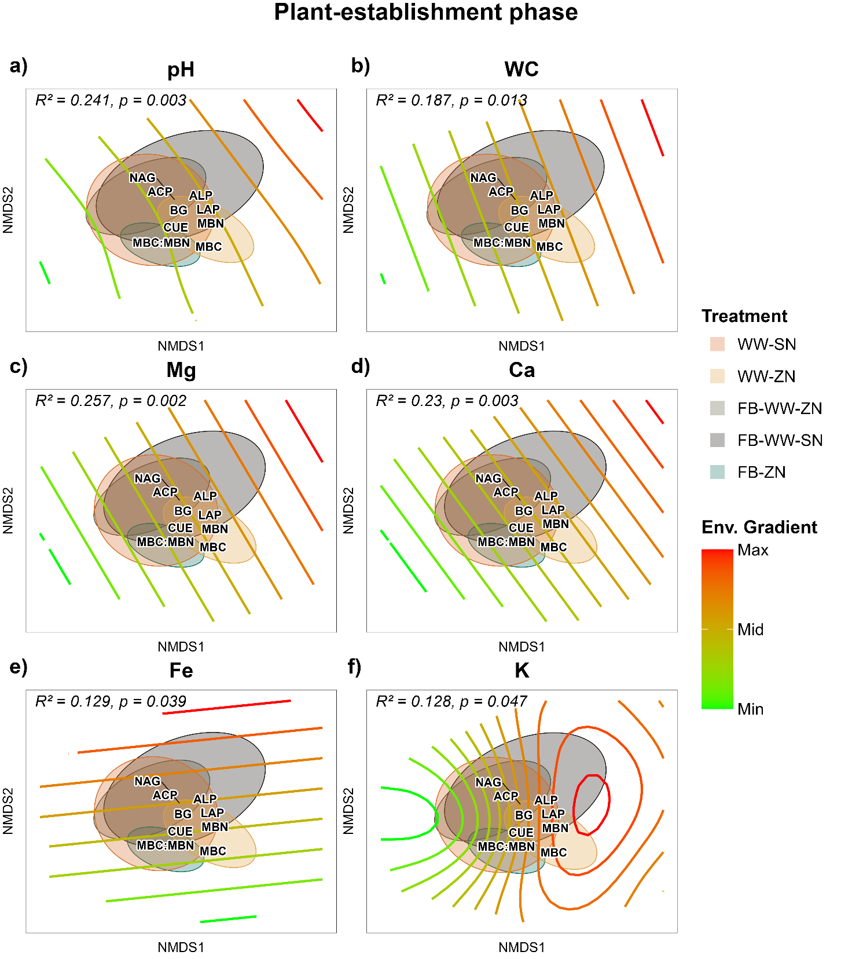
Fig. S19 The edaphic factors driving the NMDS ordination in the plant-establishment phase. The above plot reports the NMDS ordination of the soil biochemical properties in the plant-establishment phase and the gradients of the significantly correlated edaphic properties (p ≤ 0.05). The abbreviations of the treatments are as follows: FB-WW-SN denotes intercropping – standard N; FB-WW-ZN denotes intercropping – zero N; FB-ZN denotes sole-cropped fava bean – zero N; WW-SN denotes sole-cropped wheat – standard N; WW-ZN denotes sole-cropped wheat – zero N. The ellipses represent the 95% confidence intervals of the centroid. The absence of letters indicates the lack of significant differences among the treatment groups.
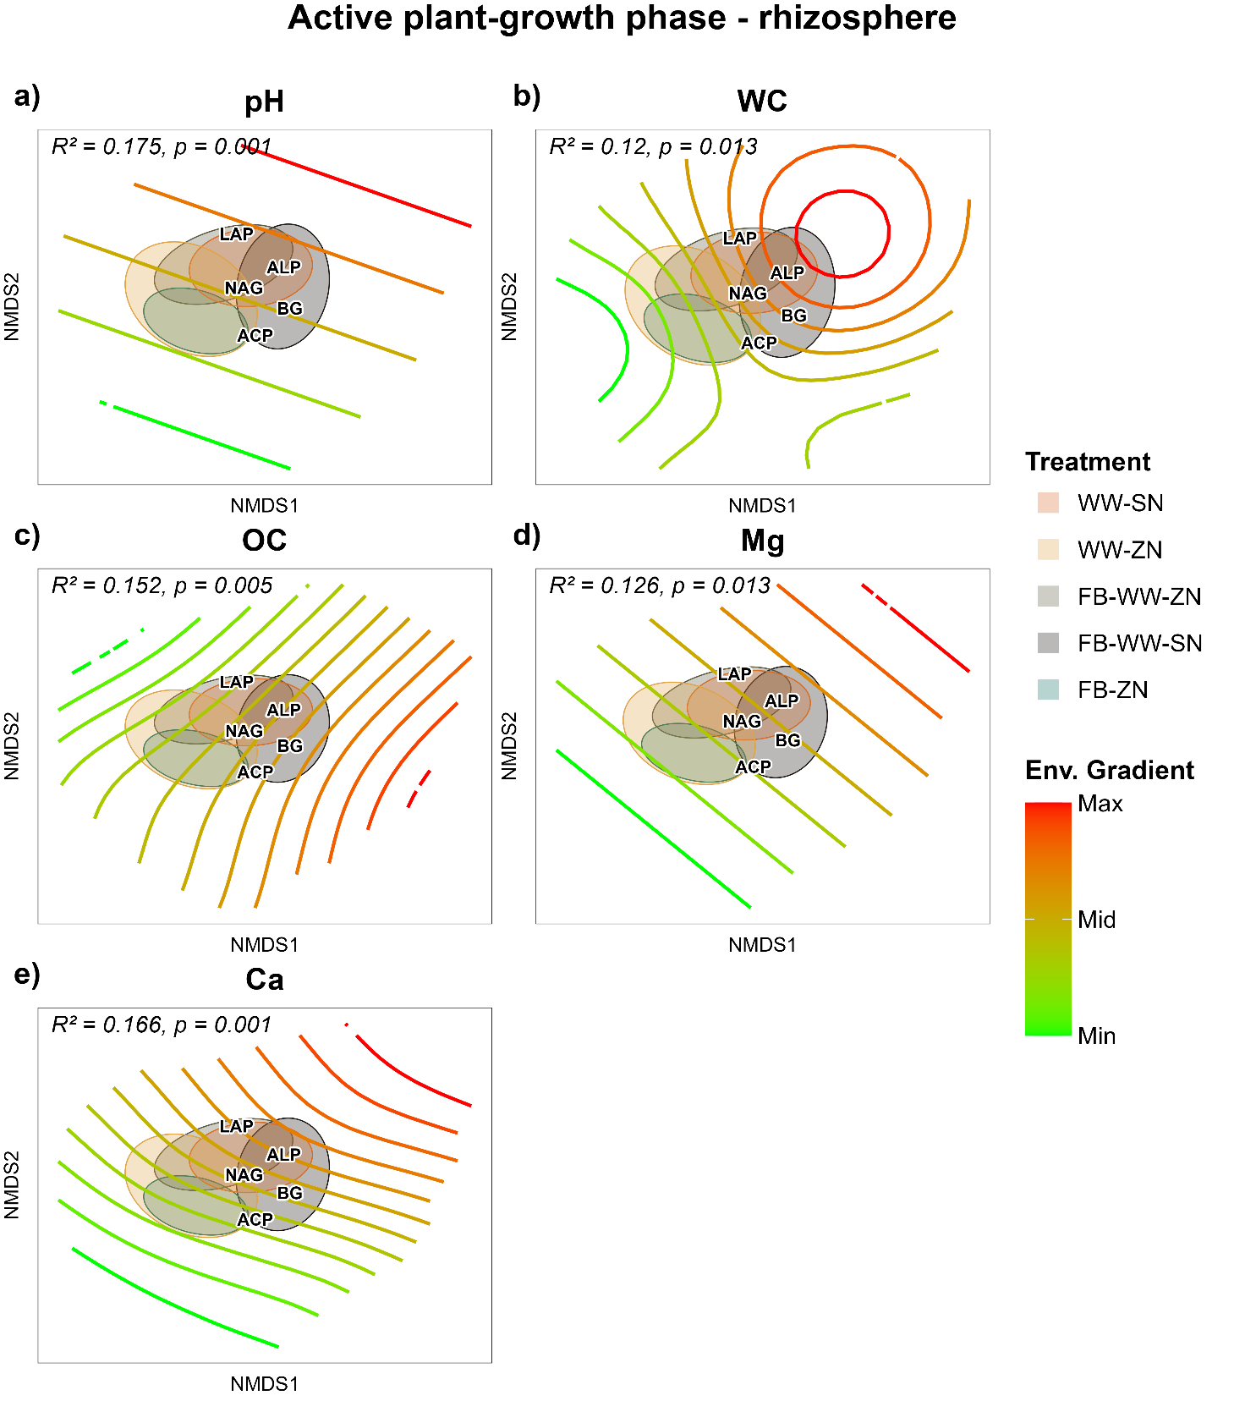
Fig. S20 The edaphic factors driving the NMDS ordination in the active plant-growth phase in the rhizosphere. The above plot reports the NMDS ordination of the soil biochemical properties in the active plant-growth phase and the gradients of the significantly correlated edaphic properties (p ≤ 0.05). The abbreviations of the treatments are as follows: FB-WW-SN denotes intercropping – standard N; FB-WW-ZN denotes intercropping – zero N; FB-ZN denotes sole-cropped fava bean – zero N; WW-SN denotes sole-cropped wheat – standard N; WW-ZN denotes sole-cropped wheat – zero N. The ellipses represent the 95% confidence intervals of the centroid. The absence of letters indicates the lack of significant differences among the treatment groups.
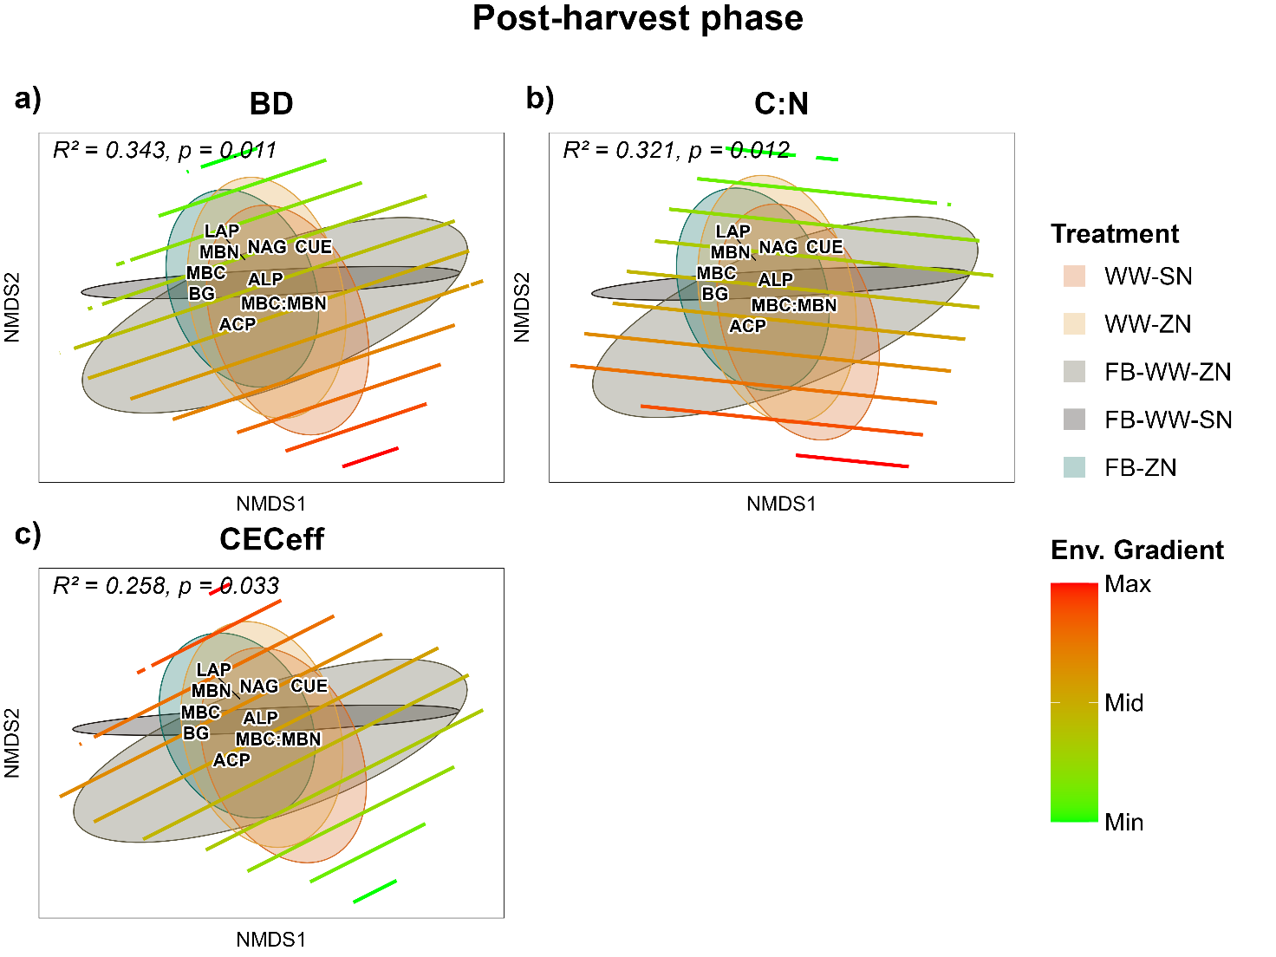
Fig. S21 The edaphic factors driving the NMDS ordination in the post-harvest phase. The above plot reports the NMDS ordination of the soil biochemical properties in the post-harvest phase and the gradients of the significantly correlated edaphic properties (p ≤ 0.05). The abbreviations of the treatments are as follows: FB-WW-SN denotes intercropping – standard N; FB-WW-ZN denotes intercropping – zero N; FB-ZN denotes sole-cropped fava bean – zero N; WW-SN denotes sole-cropped wheat – standard N; WW-ZN denotes sole-cropped wheat – zero N. The ellipses represent the 95% confidence intervals of the centroid. The absence of letters indicates the lack of significant differences among the treatment groups.
Fig. S22 The correlation between the soil biochemical and physicochemical properties. The plot reports the Spearman correlation between the soil biochemical and physicochemical properties. The asterisks indicate the significance level, while the color gradients indicate the strength and the direction of the correlations.

References
Brookes PC, Landman A, Pruden G, Jenkinson DS (1985) Chloroform fumigation and the release of soil nitrogen: A rapid direct extraction method to measure microbial biomass nitrogen in soil. Soil Biology and Biochemistry 17:837–842. https://doi.org/https://doi.org/10.1016/0038-0717(85)90144-0
IUSS Working Group WRB. (2022) (2022) World Reference Base for Soil Resources. International soil classification system for naming soils and creating legends for soil maps. (4th ed.). International Union of Soil Sciences (IUSS).
Moeys J (2010) soiltexture: Functions for Soil Texture Plot, Classification and Transformation. 1.5.3
Vance ED, Brookes PC, Jenkinson DS (1987) An extraction method for measuring soil microbial biomass C. Soil Biology and Biochemistry 19:703–707. https://doi.org/https://doi.org/10.1016/0038-0717(87)90052-6
Wachendorf C, Joergensen RG (2011) Mid-term tracing of 15N derived from urine and dung in soil microbial biomass. Biology and Fertility of Soils 47:147–155. https://doi.org/10.1007/s00374-010-0516-2

