SUPPLEMENTAL MATERIAL
Modeled Soil Configuration and Parameterization
Soil hydraulic properties for the soil at H.J. Andrews was approximated with the HYDRUS-1D built-in ROSETTA DLL (Dynamically Linked Library) software which implements pedotransfer functions that predict van Genuchten¹ water retention parameters and the saturated hydraulic conductivity (K_{s}). The values used within the pedotransfer function where 27, 35, and 38% sand, silt, and clay, respectively, and a porosity of 60% (these are the same values cited in Brooks et al.²). The estimated VWC_{sat} was 0.55 cm³cm⁻³ and K_{s} was 65.64 cm d⁻¹. The root-mean-square error (RMSE) of the observed and modeled VWC_{bulk} was 0.06 cm³cm⁻³. We used multiple techniques to estimate the soil hydraulic parameters based on observed hydraulic properties at H.J. Andrews and the VWC time series from Brooks et al.², this included inverse modeling and a large Monte Carlo analysis. Based on RMSE, ROSETTA DLL outperformed all techniques and was computationally efficient. It is important to note the objective was not to replicate the observed time series perfectly. No soil evaporation or root water uptake was simulated, as to drive all isotopic differences between soil domains from the parameterized soil physics.

Modeled Input Precipitation Datasets
We generated precipitation isotope time-series which reflected the average and variance of the δ²H ratio and its correlation with precipitation depth over time. Observed δ²H in precipitation was sampled in 5 mm increments over the study period¹, but the model required input data on 15-minute increments. Accordingly, the observed time series was downscaled, using the statistical downscaling method described by Finkenbiner et al.³, to correspond with the observed 15-minute precipitation data (H.J. Andrews PRIMNET database⁴, Fig. 1a). The total input precipitation amount for the 100 days was 101.5 cm. The statistical downscaling method decomposed the observed precipitation isotope ratio time series into its deterministic and stochastic components. δ²H ratios were simulated from a Gaussian distribution using the observed mean of -66.7 ‰, standard deviation of 21.5 ‰, and Pearson correlation coefficient (ρ), ρ(precipitation (cm), δ²H ratio (‰)), of -0.16. The generated precipitation isotope time series had seasonality effects removed as to drive separations strictly from soil properties or amount effects. Ten unique 15-minute δ²H time series were generated for each model configuration and each time series captured the statistics of the sampled precipitation (Fig. 1a). We chose to simulate ten time series of δ²H ratios as to not tie results to one specific input time series. Additionally, an ensemble size of ten time series was chosen due to the lengthy computational time of each model (~5 min), the amount of time required to process, manipulate, and analyze the output files, and the size of the HYDRUS-1D input/output files (~100-150 MB).

Modeled Initial Conditions
The soil water's initial δ²H concentration was unknown and we decided to set it equal the average weighted precipitation. The 100-day time series was repeated three times to remove the effects of the initial condition of the soil’s isotopic concentration, and the final 100 days (days 200-300) were analyzed in the presented results. To explore the effects of changing the initial condition of the isotopic concentration of the soil water, we changed the soil's initial condition to a very high δ²H value of +200 ‰. The mobile soil water decreases to average soil water concentrations observed in other model configurations presented in this paper within the 200-day period. Immobile soil water takes much longer, most likely a function of the mass transfer rate between the mobile and immobile domains, and eventually decreases to the average soil water concentrations observed in other model configurations. Therefore, we concluded that changing the initial condition would have minimal impact on the presented results.

Table S1 | The linear regression, p-value, Pearson correlation coefficient, and Spearman correlation coefficient for the isotopic separation between water pools and VWC_{bulk}.
 | Linear Regression | p-value | Pearson | Spearman
 | Mobile - Immobile Water v. VWC_{bulk} (cm³cm⁻³)
H_{f}H_{ω} | y = 3.4x - 1.5 | 5.00E-03 | 0.15 | 0.13
L_{f}H_{ω} | y = 6.5x - 2.8 | 1.69E-08 | 0.30 | 0.28
H_{f}L_{ω} | y = 3.2x - 1.5 | 2.00E-02 | 0.13 | 0.09
L_{f}L_{ω} | y = 6.6x - 2.9 | 3.60E-08 | 0.30 | 0.27
 | Drainage - Mobile Water v. VWC_{bulk} (cm³cm⁻³)
0_{f}1_{ω} | y = -7.6x + 3.5 | 2.06E-06 | -0.26 | -0.23
H_{f}H_{ω} | y = 12.2x - 5.4 | 1.61E-12 | 0.38 | 0.37
L_{f}H_{ω} | y = 2.2x - 0.9 | 1.90E-01 | 0.07 | 0.11
H_{f}L_{ω} | y = 15.2x - 6.6 | 7.97E-15 | 0.41 | 0.42
L_{f}L_{ω} | y = 2.7x - 1.1 | 1.20E-01 | 0.09 | 0.12
 | Drainage - Immobile Water v. VWC_{bulk} (cm³cm⁻³)
H_{f}H_{ω} | y = 15.6x - 6.9 | 3.60E-20 | 0.48 | 0.47
L_{f}H_{ω} | y = 8.7x - 3.7 | 1.25E-09 | 0.33 | 0.35
H_{f}L_{ω} | y = 18.4x - 8.1 | 5.53E-22 | 0.50 | 0.50
L_{f}L_{ω} | y = 9.3x - 4.0 | 9.21E-10 | 0.33 | 0.35

Table S2 | The linear regression, p-value, Pearson correlation coefficient, and Spearman correlation coefficient for the isotopic separation between water pools at the end of a day and daily accumulated precipitation.
 | Linear Regression | p-value | Pearson | Spearman
 | Mobile - Immobile Water v. Precipitation (cm)
H_{f}H_{ω} | y = -0.001x - 0.1 | 8.89E-01 | -0.03 | -0.21
L_{f}H_{ω} | y = 0.01x - 0.2 | 4.03E-01 | 0.15 | 0.33
H_{f}L_{ω} | y = -0.002 - 0.2 | 7.75E-01 | -0.05 | 0.17
L_{f}L_{ω} | y = 0.004 - 0.3 | 4.32E-01 | 0.14 | 0.33
 | Drainage - Mobile Water v. Precipitation (cm)
0_{f}1_{ω} | y = -0.01x + 0.5 | 5.25E-01 | -0.12 | -0.34
H_{f}H_{ω} | y = 0.02x - 0.8 | 1.48E-02 | 0.42 | 0.36
L_{f}H_{ω} | y = 0.01x - 0.2 | 1.22E-01 | 0.28 | 0.06
H_{f}L_{ω} | y = 0.02x - 0.8 | 1.48E-02 | 0.42 | 0.43
L_{f}L_{ω} | y = 0.01x - 0.2 | 1.23E-01 | 0.27 | 0.07
 | Drainage - Immobile Water v. Precipitation (cm)
H_{f}H_{ω} | y = 0.02x - 0.9 | 2.00E-02 | 0.40 | 0.54
L_{f}H_{ω} | y = 0.02x - 0.4 | 1.00E-02 | 0.44 | 0.37
H_{f}L_{ω} | y = 0.02x - 1.0 | 2.00E-02 | 0.40 | 0.54
L_{f}L_{ω} | y = 0.02x - 0.4 | 1.40E-02 | 0.42 | 0.37

Table S3 | The linear regression, p-value, Pearson correlation coefficient, and Spearman correlation coefficient for the isotopic separation between water pools and drainage.
 | Linear Regression | p-value | Pearson | Spearman
 | Mobile - Immobile Water v. Drainage (cm)
H_{f}H_{ω} | y = 0.1x - 0.2 | 2.20E-02 | 0.13 | 0.18
L_{f}H_{ω} | y = 0.2x - 0.4 | 3.54E-05 | 0.23 | 0.34
H_{f}L_{ω} | y = 0.2x - 0.4 | 6.00E-02 | 0.10 | 0.14
L_{f}L_{ω} | y = 0.1x - 0.3 | 3.19E-05 | 0.23 | 0.33
 | Drainage - Mobile Water v. Drainage (cm)
0_{f}1_{ω} | y = -0.2x + 0.7 | 2.50E-04 | -0.20 | -0.25
H_{f}H_{ω} | y = 0.4x -1.0 | 5.21E-12 | 0.37 | 0.40
L_{f}H_{ω} | y = 0.1x - 0.1 | 5.70E-02 | 0.06 | 0.09
H_{f}L_{ω} | y = 0.5x -1.1 | 2.25E-12 | 0.37 | 0.39
L_{f}L_{ω} | y = 0.1x - 0.1 | 3.05E-01 | 0.57 | 0.11
 | Drainage - Immobile Water v. Drainage (cm)
H_{f}H_{ω} | y = 0.5x - 1.2 | 7.41E-18 | 0.45 | 0.56
L_{f}H_{ω} | y = 0.2x - 0.4 | 6.73E-06 | 0.25 | 0.36
H_{f}L_{ω} | y = 0.6x - 1.4 | 1.83E-17 | 0.45 | 0.52
L_{f}L_{ω} | y = 0.2x - 0.5 | 9.35E-06 | 0.24 | 0.37

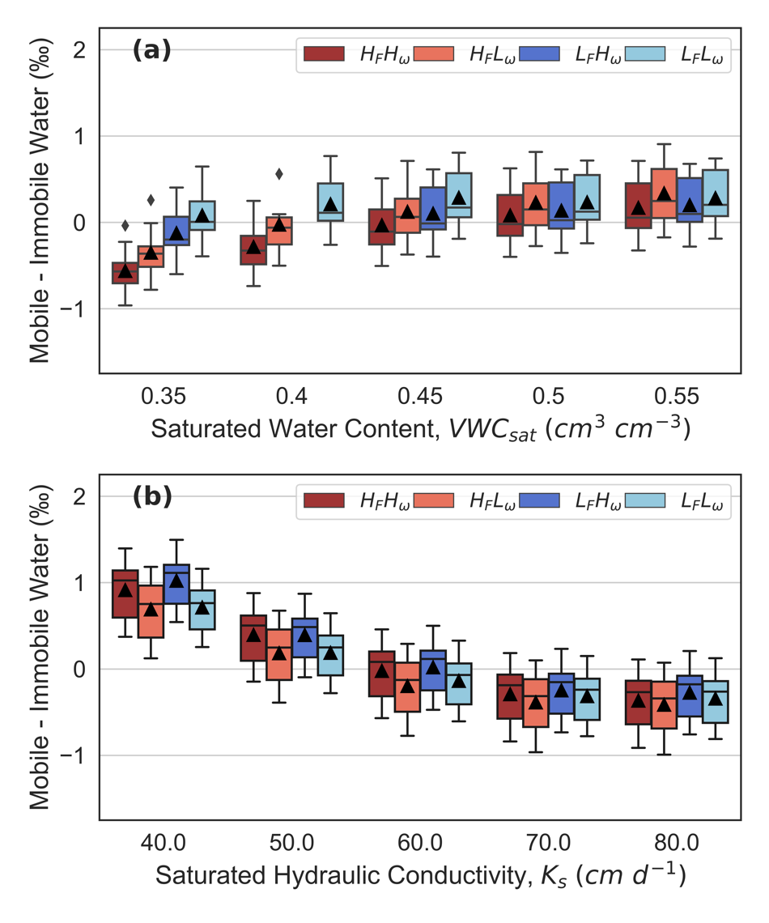
Figure S1 | The influence of modeled soil hydraulic parameters on average δ²H difference between mobile and immobile soil water. Each boxplot represents flux and volumetrically weighted averaged differences and the black triangles indicate the mean calculated from 10 simulations. The missing boxplot at 0.40 cm³cm⁻³ indicates where Hydrus model configurations failed to converge.
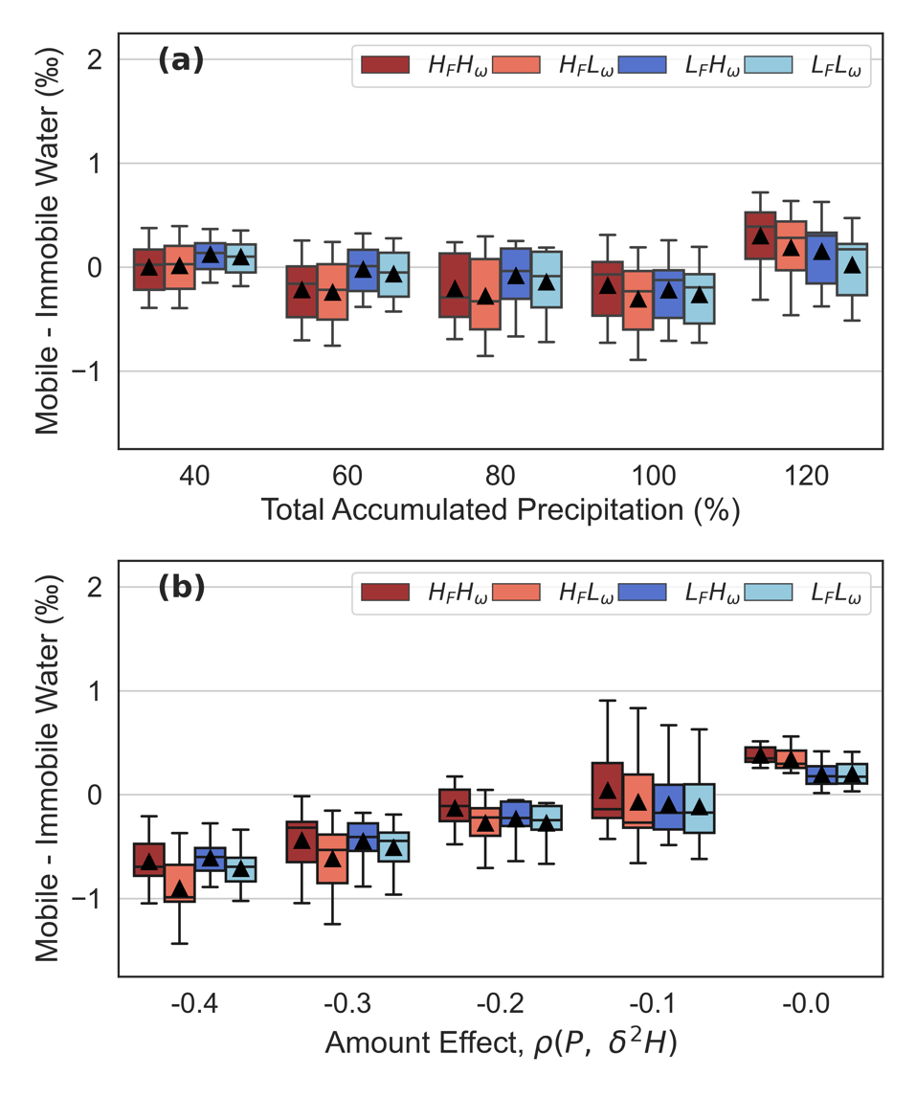
Figure S2 | The influence of modeled climate parameters on average δ²H difference between mobile and immobile soil water. (a) illustrates the effects of increasing or decreasing the total input precipitation and (b) demonstrates the influence of adjusting the strength of the Pearson correlation coefficient between precipitation amount and its δ²H concentration. Each boxplot represents flux and volumetrically weighted averaged differences and the black triangles indicate the mean calculated from 10 simulations.

REFERENCES
1. van Genuchten, M.T. A closed-form equation for predicting the hydraulic conductivity of unsaturated soils. Soil Science Society of America Journal 44, 892-898 (1980). https://doi.org/10.2136/sssaj1980.03615995004400050002x
2. Brooks, J. R., Barnard, H., Coulombe, R. et al. Ecohydrologic separation of water between trees and streams in a Mediterranean climate. Nature Geosci 3, 100–104 (2010). https://doi.org/10.1038/ngeo722
3. Finkenbiner, C.E., Good, S.P., Allen, S.T., Fiorella, R.P., and Bowen, G.J. A statistical method for generating temporally downscaled geochemical tracers in precipitation. J Hydrometerol 22, 1473-1486 (2021). https://doi.org/10.1175/JHM-D-20-0142.1
4. Daly, C. and McKee, W.A. Meteorological data from benchmark stations at the Andrews Experimental Forest, 1957 to present ver 36. Environmental Data Initiative (2019). https://doi.org/10.6073/pasta/c021a2ebf1f91adf0ba3b5e53189c84f (Accessed 2021-04-21).

