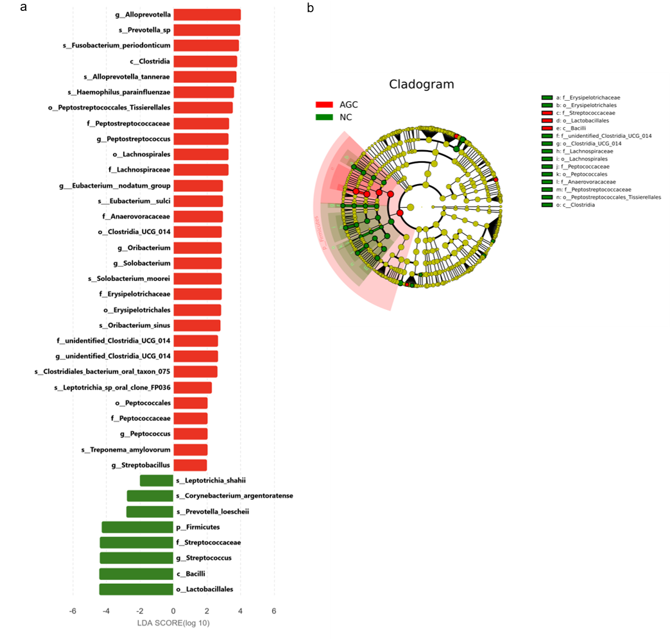
Supplementary Figure S1. Pairwise LEfSe analysis comparing the NC and AGC groups.
(a) Histogram of the LDA scores for differentially abundant taxa; (b) Cladogram demonstrating the taxonomic hierarchical structure of the oral microbiota.
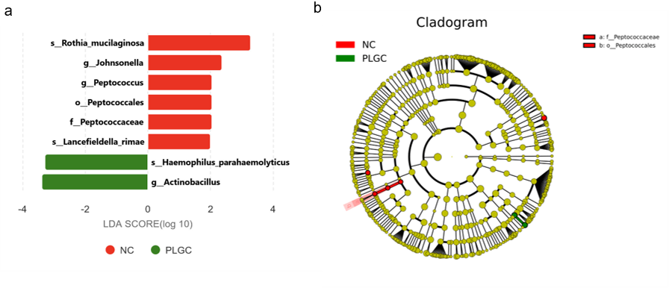
Supplementary Figure S2. Pairwise LEfSe analysis comparing the NC and PLGC groups.
(a) Histogram of the LDA scores for differentially abundant taxa; (b) Cladogram demonstrating the taxonomic hierarchical structure of the oral microbiota.

