Enhancing Urban Food System Resilience through Urban Spatial Resources: A Case Study of Stockholm City
Abdur Rashid Jamalzi¹, Vivek Anand Voora¹, Cameron Kennett^{1, 2}, Michael Alan Martin^{1, 2*}
¹ IVL Swedish Environmental Research Institute, PO Box 210 60, Stockholm, SE-100 31, Sweden
² KTH Royal Institute of Technology, Department of Sustainable Development, Environmental Science and Engineering, Stockholm, Sweden.

*Corresponding author. E-mail address: michael.martin@ivl.se (Michael A Martin).

Table S1. Crop-specific yield assumptions (kg m⁻² year⁻¹) used for estimating annual vegetables production potential scenarios.
Crop | Yield  (kg m⁻² year⁻¹) | Production context | Source
Tomatoes | 35.0 | High-latitude greenhouse production in northern Sweden | Ljungqvist et al. (2021)
Cucumbers | 30.0 | Commercial greenhouse production | Ottosson & Hansson, 1981
Lettuce | 41 | Controlled-environment hydroponic cultivation | Barbosa et al. (2015)
Bell peppers | 30.0 | Commercial greenhouse production | Dutch Greenhouse Industry Report
Basil | 16.25 | Hydroponic cultivation systems, 3.36 kg/m² per harvest. | Malik, O. H. (2021)
Kale | 19.6 | Aquaponic production systems | Afolabi, 2019
Potatoes | 4.36 | Swedish field production (national statistics) | Statistics Sweden (SCB), 2022
Carrots | 6.20 | Swedish field production averages | Selina Wamucii. (2023)
Beets | 7.25 | Swedish field crop yield averages | Statistics Sweden (SCB), 2025
Leeks | 2.10 | Northern European field production averages | Statistics Norway

Table S2. Potential spatial resources for urban agriculture in Stockholm City.
District Name | Potential Rooftops for Commercial Agriculture (ha) | Potential Rooftops for Small-scale Agriculture (ha) | Gardens  (ha) | Arable  (ha) | Parking lots 10% (ha)
Bromma | 104.12 | 25.73 | 69.5 | 21.5 | 6.3
Enskede-Årsta-Vantör | 50.78 | 35.52 | 15.4 | 0 | 5.8
Farsta | 19.92 | 20.07 | 23.1 | 0 | 6.7
Hägersten-Älvsjö | 63.91 | 24.38 | 3.1 | 0 | 5.7
Hässelby-Vällingby | 19.09 | 20.25 | 10.6 | 8.6 | 5.3
Järva | 80.25 | 30.72 | 40.7 | 74.4 | 10.6
Kungsholmen | 16.31 | 3.45 | 0.4 | 0 | 0.6
Norra innerstaden | 37.87 | 22.23 | 4.7 | 23.0 | 4.7
Södermalm | 10.33 | 7.91 | 11.7 | 0 | 1.1
Skarpnäck | 7.19 | 7.14 | 98.8 | 0 | 2.1
Skärholmen | 16.18 | 19.01 | 1.3 | 0 | 4.2
Total | 425.95 | 216.41 | 279.3 | 127.5 | 53.2

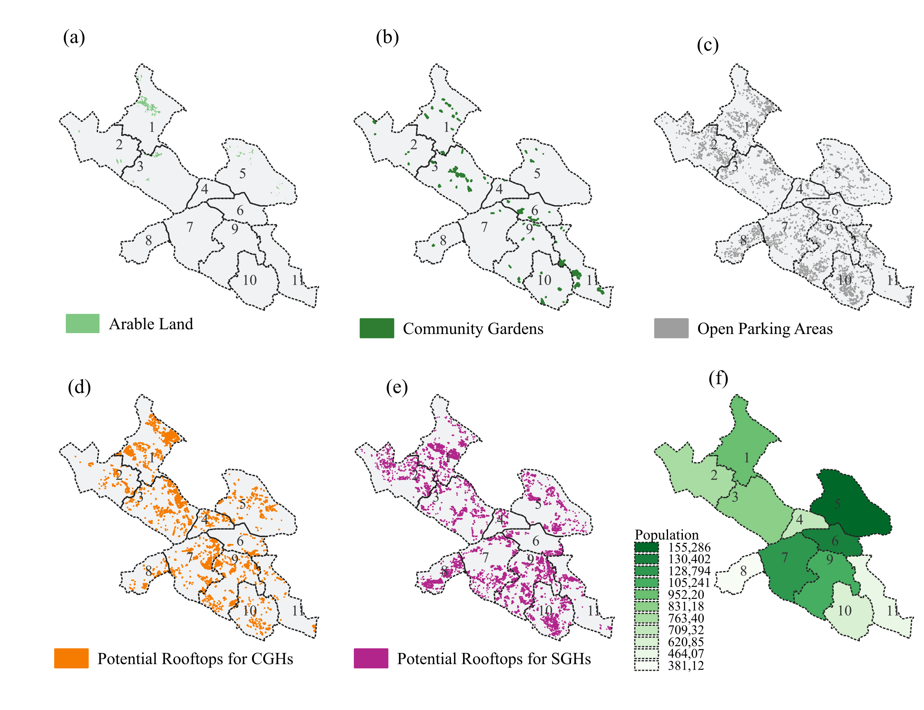Fig. S1. (a) Arable land, (b) community garden, (c) open parking lots, (d) potential rooftops for commercial urban agriculture, (e) potential rooftops for small-scale urban agriculture, and (f) population per district.
Table S3. District-level population, per capita vegetable consumption, and estimated annual vegetable demand in Stockholm.
District Name | Number of People | Veg. conpt kg/person/year | Veg Demand (t)
Bromma | 83 118 .00 | 86.59 | 7,197
Enskede-Årsta-Vantör | 105 241 .00 | 86.59 | 9,113
Farsta | 62 085 .00 | 86.59 | 5,376
Hägersten-Älvsjö | 128 794 .00 | 86.59 | 11,152
Hässelby-Vällingby | 76 340 .00 | 86.59 | 6,610
Järva | 95 220 .00 | 86.59 | 8,245
Kungsholmen | 70 932 .00 | 86.59 | 6,142
Norra innerstaden | 155 286 .00 | 86.59 | 13,446
Södermalm | 130 402 .00 | 86.59 | 11,292
Skarpnäck | 46 407 .00 | 86.59 | 4,018
Skärholmen | 38 112 .00 | 86.59 | 3,300
Total | 991 937 .00 |  | 85,892

Table S4. Estimated vegetable production in Stockholm City.
District Name | Tomatoes (t) | Cucumber (t) | Lettuce (t) | Bell peppers (t) | Basil (t) | Kale (t) | Potatoes (t) | Carrots (t) | Beets (t) | Leeks (t) | SSR %
Bromma | 11,910 | 10,209 | 11,162 | 2,042 | 1,106 | 5,336 | 1,601 | 1,128 | 659.5 | 191.0 | 630.0
Enskede-Årsta-Vantör | 8,059 | 6,908 | 7,553 | 1,382 | 748 | 3,611 | 271 | 191 | 111.6 | 32.3 | 316.8
Farsta | 4,086 | 3,502 | 3,829 | 700 | 379 | 1,831 | 407 | 287 | 167.6 | 48.5 | 283.5
Hägersten-Älvsjö | 8,220 | 7,046 | 7,704 | 1,409 | 763 | 3,683 | 55 | 39 | 22.8 | 6.6 | 259.6
Hässelby-Vällingby | 3,909 | 3,350 | 3,663 | 670 | 363 | 1,751 | 338 | 238 | 139.4 | 40.4 | 218.8
Järva | 10,635 | 9,116 | 9,967 | 1,823 | 988 | 4,765 | 2,025 | 1,427 | 834.0 | 241.6 | 507.2
Kungsholmen | 1,784 | 1,529 | 1,672 | 306 | 166 | 799 | 8 | 5 | 3.1 | 0.9 | 102.1
Norra innerstaden | 5,673 | 4,863 | 5,317 | 973 | 527 | 2,542 | 487 | 343 | 200.7 | 58.1 | 156.0
Södermalm | 1,695 | 1,453 | 1,588 | 291 | 157 | 759 | 206 | 145 | 84.7 | 24.5 | 56.7
Skarpnäck | 1,438 | 1,232 | 1,347 | 246 | 133 | 644 | 1,738 | 1,225 | 716.1 | 207.4 | 222.2
Skärholmen | 3,448 | 2,956 | 3,231 | 591 | 320 | 1,545 | 22 | 16 | 9.2 | 2.7 | 367.9
Total | 60,858 | 52,164 | 57,032 | 10,433 | 5,651 | 27,264 | 7,158 | 5,043 | 2,949 | 854

Table S5. Estimated demand of vegetables per district of Stockholm.
District Name | Demand (tonns)
District Name | Tomatoes | Cucumber | Lettuce | Bell Paper | Basil | Kale | Potatoes | Carrots | Beets | Leeks
Bromma | 654 | 510 | 408 | 194 | 87 | 411 | 3,874 | 867 | 136 | 57
Enskede-Årsta-Vantör | 828 | 645 | 517 | 245 | 111 | 520 | 4,905 | 1,098 | 173 | 72
Farsta | 489 | 381 | 305 | 145 | 65 | 307 | 2,894 | 648 | 102 | 42
Hägersten-Älvsjö | 1,014 | 790 | 632 | 300 | 135 | 636 | 6,003 | 1,343 | 211 | 88
Hässelby-Vällingby | 601 | 468 | 375 | 178 | 80 | 377 | 3,558 | 796 | 125 | 52
Järva | 749 | 584 | 468 | 222 | 100 | 470 | 4,438 | 993 | 156 | 65
Kungsholmen | 558 | 435 | 348 | 165 | 74 | 350 | 3,306 | 740 | 116 | 48
Norra innerstaden | 1,222 | 952 | 762 | 362 | 163 | 767 | 7,238 | 1,620 | 255 | 106
Södermalm | 1,026 | 799 | 640 | 304 | 137 | 644 | 6,078 | 1,360 | 214 | 89
Skarpnäck | 365 | 284 | 228 | 108 | 49 | 229 | 2,163 | 484 | 76 | 32
Skärholmen | 300 | 234 | 187 | 89 | 40 | 188 | 1,776 | 398 | 63 | 26
Total | 7,807 | 6,081 | 4,870 | 2,311 | 1,042 | 4,900 | 46,234 | 10,346 | 1,627 | 675

References
Afolabi, K. A. (2019). Productivity of kale (Brassica oleracea var. acephala) and Nile tilapia in aquaponic systems.
Barbosa, G., Gadelha, F., Kublik, N., Proctor, A., Reichelm, L., Weissinger, E., Wohlleb, G., & Halden, R. (2015). Comparison of Land, Water, and Energy Requirements of Lettuce Grown Using Hydroponic vs. Conventional Agricultural Methods. International Journal of Environmental Research and Public Health, 12(6), 6879–6891. https://doi.org/10.3390/ijerph120606879
Ljungqvist, P., et al. (2021). High-latitude greenhouse tomato production in northern Sweden.
Martin, M., & Molin, E. (2018). Assessing the energy and environmental performance of vertical hydroponic farming. Sustainability, 10(11), 4124. https://doi.org/10.3390/su10114124
Malik, O. H. (2021). Urban farming: Production comparison of basil and oak leaf lettuce in two hydroponic growing systems. http://urn.kb.se/resolve?urn=urn:nbn:se:slu:epsilon-s-16403
Ottosson, L., & Hansson, A. (1981). Cucumber production in greenhouses in Sweden. Acta Horticulturae, 118, 21–27. https://doi.org/10.17660/ActaHortic.1981.118.4
Statistics Norway. (2020). Yield of various horticultural crops. https://www.ssb.no
Statistics Sweden (SCB). (2022). Production of potatoes. https://www.scb.se/en/finding-statistics/statistics-by-subject-area/agriculture-forestry-and-fishery/agricultural-production/production-of-potatoes/
Statistics Sweden (SCB). (2025). Standard yields of other crops. https://www.scb.se/en/finding-statistics/statistics-by-subject-area/agriculture-forestry-and-fishery/agricultural-production/standard-yields/
Selina Wamucii. (2023). Carrot production statistics for Sweden. https://www.selinawamucii.com/insights/prices/sweden/carrots/
Dutch Greenhouse Industry. (2023). Green pepper production and yield benchmarks. https://growpro.dutchgreenhouses.com

