Supplementary Material: Nociceptive Responses and Resting-State Functional Connectivity of the Human Midbrain Tegmentum

Primary Antibodies
Antibody | FOXP1 | OPRM1 | NOP | TH
Manufacturer | Abcam | Proteintech | Thermo Fisher | Pel-Freeze
Host | Rabbit | Rabbit | Rabbit | Sheep
Catalogue number | AB16645 | 27625-1-AP | PA5-26321 | P60101-150
Supplemental Table S1: Primary Antibodies for Human Post-Mortem Analysis

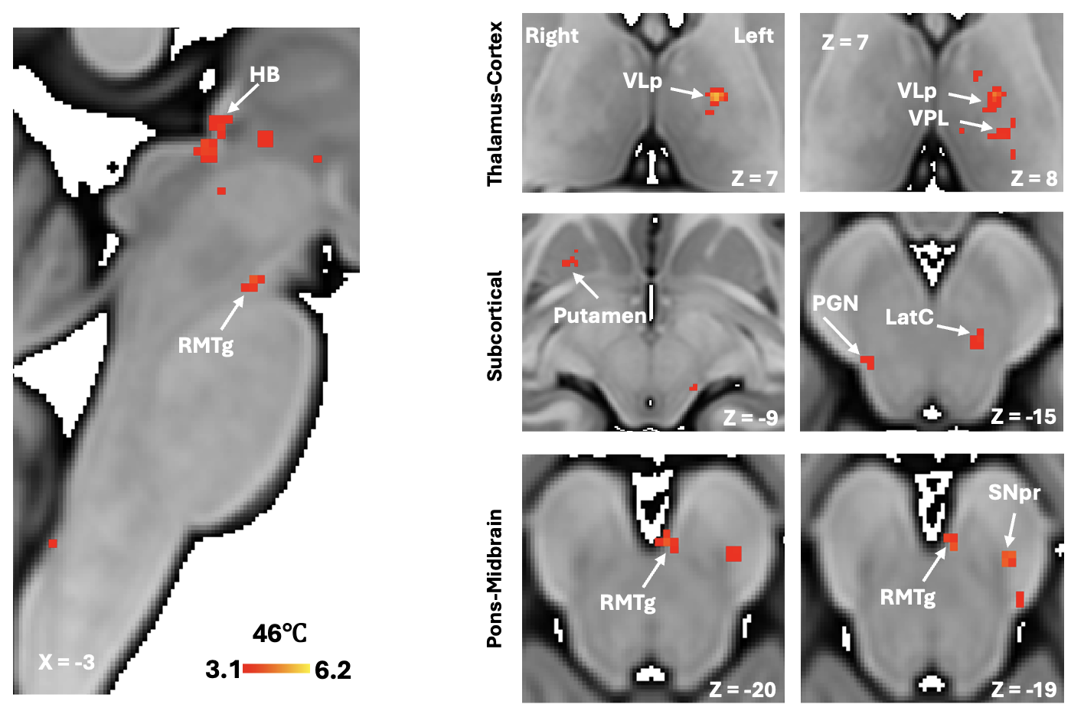
Supplemental Figure 1. 7T Thermal Stimulation (46℃) fMRI in HCs. Group level activation for 46℃ (N=20) stimulation overlayed on an MNI template brain (z-stat threshold 3.1). Clusters of activation for 46℃ noxious stimulation yielding a mean pain rating of 6.02 ± 2.04 (0-10 pain scale) in the thalamus, striatum and pons-midbrain shown in the axial plane. LatC (Lateral Cluster); RMTg (Rostromedial Tegmental Nucleus); PGN (Parabigeminal Nucleus); SNpr (Substantia Nigra pars reticulata); VLp Thalamus (Ventral Lateral Nucleus, Posterior division of the Thalamus); VPL (Ventral Posterolateral Nucleus of the Thalamus).
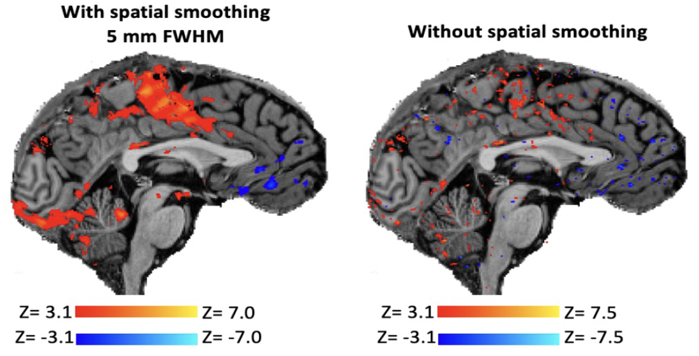
Supplemental Figure 2. Single-Subject Pain fMRI Responses in a HC at 7T. Pain stimuli (46°C, 30 seconds off/10 seconds on, 5 repetitions) were applied to the dorsum of the right-hand during fMRI acquisition at 7T. Single-subject, BOLD activation was detected independent of application of spatial smoothing. Statistical maps are superimposed on the subject specific MPRAGE. AlI BOLD activation maps were thresholded at z > 3.1. This paradigm robustly elicits activation (orange-yellow regions) in a well-established pain matrix, specifically in sensorimotor cortex, cingulate cortex, thalamus, cerebellum as well as expected deactivation (blue-light blue regions) within the default-mode network. This example single-subject evoked pain fMRI response mimics responses reported in the pain fMRI literature (Davis et al. 2017; Tinnermann et al. 2021; Tinnermann et al. 2017).

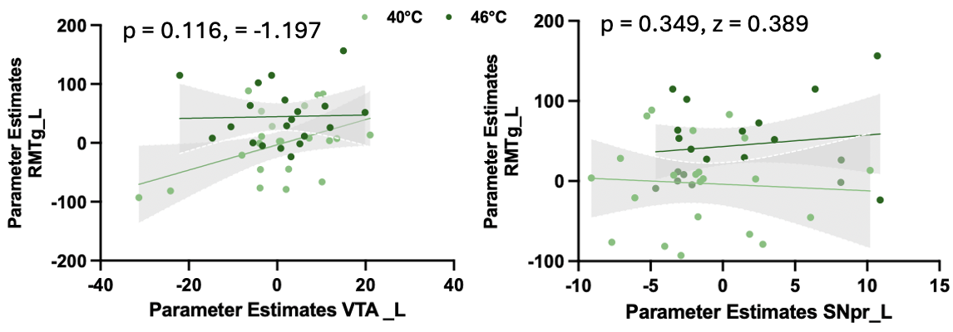
Supplemental Figure 3. Associations between Brainstem Nuclei Activation with 7T Thermal Stimulation (46℃ vs. 40℃) fMRI in HCs. Significant changes in RMTg- VTA or RMTg-SNpc correlations and between 40°C vs. 46°C stimulations were not observed.
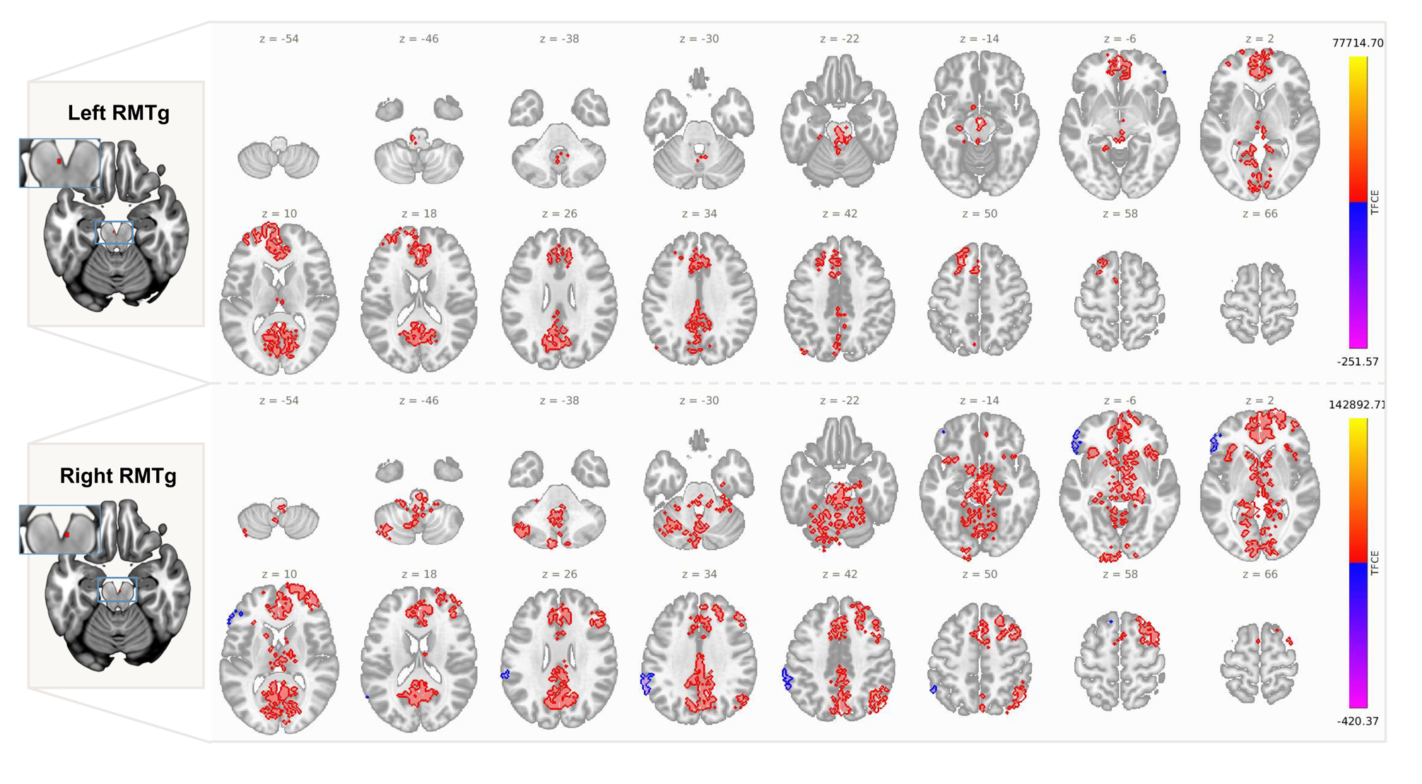Supplemental Figure 4. Whole-brain seed-based correlation maps for the left and right RMTg. Axial slices showing significant TFCE-corrected clusters (p-FWE < 0.05, 5,000 permutations, voxel threshold < 0.001) for the left RMTg seed (top) and right RMTg seed (bottom), spanning z = −54 to z = +66 (MNI coordinates). Seed locations are shown on the left as zoomed coronal insets (red dot) overlaid on an axial slice. Positive connectivity is displayed in red-yellow; negative connectivity is displayed in blue-purple. RMTg (rostromedial tegmental nucleus); TFCE (threshold-free cluster enhancement).

Supplementary Table S2. Whole-brain seed-based correlation clusters for the left RMTg seed (TFCE, p-FWE < 0.05, 5,000 permutations). Clusters < 20 voxels omitted. Peak TFCE score reported for primary cluster only.
Region | Peak MNI (x,y,z) | Peak TFCE | p-FWE | Voxels
Brainstem / PAG (unlabeled) | 0, -12, -2 | 77,715 | 0.000 | 2,089
Precuneus | -2, -62, +24 | — | 0.000 | 1,352
Paracingulate gyrus (left) | -6, +38, +22 | — | 0.000 | 693
Posterior cingulate cortex | -2, -42, +26 | — | 0.000 | 666
Anterior cingulate cortex | +2, +34, +16 | — | 0.000 | 581
Superior frontal gyrus (left) | -18, +26, +48 | — | 0.000 | 455
Paracingulate gyrus (right) | +10, +38, +20 | — | 0.000 | 439
Middle frontal gyrus (left) | -46, +18, +38 | — | 0.000 | 332
Frontal pole (right) | +22, +64, 0 | — | 0.001 | 259
Intracalcarine cortex (right) | +12, -76, +8 | — | 0.000 | 250
Intracalcarine cortex (left) | -10, -74, +8 | — | 0.000 | 246
Lateral occipital cortex (left) | -40, -74, +40 | — | 0.000 | 223
Thalamus (left) | -8, -18, +6 | — | 0.000 | 221
Thalamus (right) | +8, -18, +4 | — | 0.000 | 196
Hippocampus (left) | -24, -26, -10 | — | 0.000 | 148
Cerebellum VI (left) | -24, -54, -22 | — | 0.000 | 147
Cerebellum IX (right) | +8, -48, -46 | — | 0.000 | 131
Cerebellum IV/V (left) | -16, -46, -16 | — | 0.000 | 122
Parahippocampal gyrus (left) | -22, -34, -16 | — | 0.000 | 88
Vermis IV/V | -2, -54, -10 | — | 0.000 | 78
Cerebellum VI (right) | +14, -66, -20 | — | 0.000 | 78
Hippocampus (right) | +22, -20, -14 | — | 0.000 | 75
Frontal medial cortex | 0, +50, -10 | — | 0.000 | 67
Vermis IX | 0, -54, -34 | — | 0.000 | 65
Cerebellum IV/V (right) | +16, -44, -20 | — | 0.000 | 60
Vermis VIII | -2, -64, -32 | — | 0.000 | 58
Caudate (left) | -14, +14, +4 | — | 0.000 | 57
Vermis VI | +2, -64, -18 | — | 0.000 | 53
Nucleus accumbens (left) | -8, +10, -6 | — | 0.000 | 32
Nucleus accumbens (right) | +8, +12, -6 | — | 0.000 | 21

Supplementary Table S3. Whole-brain seed-based correlation clusters for the right RMTg seed (TFCE, p-FWE < 0.05, 5,000 permutations). Clusters < 50 voxels omitted. Peak TFCE score reported for primary cluster only.
Region | Peak MNI (x,y,z) | Peak TFCE | p-FWE | Voxels
Brainstem / PAG (unlabeled) | +4, -22, -22 | 142,893 | 0.000 | 2,463
Precuneus | +2, -62, +28 | — | 0.000 | 1,951
Frontal pole (right) | +24, +54, +14 | — | 0.000 | 1,342
Posterior cingulate cortex | +2, -40, +26 | — | 0.000 | 1,022
Middle frontal gyrus (right) | +40, +20, +46 | — | 0.000 | 864
Anterior cingulate cortex | +2, +30, +16 | — | 0.000 | 839
Paracingulate gyrus (right) | +8, +38, +22 | — | 0.000 | 821
Brainstem (labeled) | +0, -32, -26 | — | 0.000 | 674
Lateral occipital cortex (right) | +44, -66, +42 | — | 0.000 | 508
Paracingulate gyrus (left) | -8, +38, +20 | — | 0.000 | 470
Cerebellum Crus II (left) | -30, -72, -38 | — | 0.000 | 419
Frontal pole (left) | -36, +50, +6 | — | 0.000 | 404
Superior frontal gyrus (right) | +20, +22, +54 | — | 0.000 | 401
Cerebellum VI (left) | -22, -58, -24 | — | 0.000 | 313
Cerebellum VI (right) | +22, -56, -24 | — | 0.000 | 288
Cerebellum Crus I (left) | -30, -70, -28 | — | 0.000 | 273
Thalamus (right) | +8, -16, +8 | — | 0.000 | 266
Angular gyrus (right) | +48, -54, +44 | — | 0.000 | 224
Cerebellum IV/V (left) | -14, -46, -16 | — | 0.000 | 214
Supramarginal gyrus (left) | -62, -34, +36 | — | 0.000 | 200
Thalamus (left) | -10, -18, +4 | — | 0.000 | 200
Insular cortex (left) | -34, +18, -6 | — | 0.000 | 167
Cerebellum IX (left) | -6, -52, -44 | — | 0.000 | 162
Supramarginal gyrus (left, posterior) | -60, -48, +34 | — | 0.000 | 156
Vermis IV/V | 0, -52, -8 | — | 0.000 | 151
Inferior frontal gyrus pars tri (left) | -52, +30, +4 | — | 0.000 | 147
Hippocampus (right) | +24, -24, -12 | — | 0.000 | 144
Cerebellum IV/V (right) | +18, -46, -20 | — | 0.000 | 143
Hippocampus (left) | -24, -28, -10 | — | 0.000 | 137
Frontal orbital cortex (left) | -34, +26, -6 | — | 0.000 | 122
Insular cortex (right) | +36, +18, -6 | — | 0.000 | 121
Frontal orbital cortex (right) | +36, +24, -8 | — | 0.000 | 112
Vermis VI | +2, -66, -18 | — | 0.000 | 134
Vermis IX | 0, -54, -36 | — | 0.000 | 75
Vermis VIII | +2, -64, -32 | — | 0.000 | 74
Caudate (left) | -12, +14, +2 | — | 0.000 | 79
Caudate (right) | +10, +14, +4 | — | 0.000 | 69
Nucleus accumbens (left) | -8, +12, -6 | — | 0.000 | 40
Nucleus accumbens (right) | +8, +14, -6 | — | 0.000 | 37

Supplemental Table S4. ROI-to-ROI connectivity with the bilateral RMTg (p-FDR < 0.05, whole-matrix corrected). T-statistics from one-sample t-tests, df = 77. * p-FWE < 0.05 but marginal (T < 3.0). — denotes connection not reaching p-FDR < 0.05. ns = not significant.
Region | Left RMTg T | Right RMTg T
Brainstem | 14.64 | 14.15
SN pars compacta (left / right) | 10.14 / 5.96 | 7.08 / 3.96
VTA (left / right) | 5.23 / 5.40 | 5.93 / 6.09
SN pars reticulata (left / right) | 4.64 / 3.97 | 3.51 / 4.36
Red Nucleus (left / right) | 4.83 / 3.18 | 4.09 / 4.06
Habenula (right) | 4.47 | 3.81
Nucleus accumbens (left) | 6.07 / 5.10 | 7.46 / 7.08
Hippocampus (left / right) | 5.84 / 4.18 | 7.31 / 5.60
Thalamus (left / right) | 8.24 / 6.76 | 8.59 / 5.38
Pallidum (left / right) | 3.73 / 2.88 | 4.75 / 4.34
Caudate (left / right) | 4.25 / 2.51 | 4.51 / 4.75
Anterior Cingulate Cortex (left / right) | 8.93 / 8.48 | 10.14 / 9.87
Paracingulate Gyrus (left / right) | 10.97 / 6.78 | 12.21 / 7.21
Medial Prefrontal Cortex (Default Mode Network) | 8.00 | 8.50
Posterior Cingulate / Precuneus | 5.84 / 4.50 | 6.64 / 4.91
Medial Prefrontal Cortex (left / right) | 6.31 / 4.35 | 3.36 / 6.50
Anterior Cingulate Cortex (Salience Network) | 7.25 | 7.21
VLp Thalamus (left / right) | 4.64 / 4.33 | 7.09 / 2.58

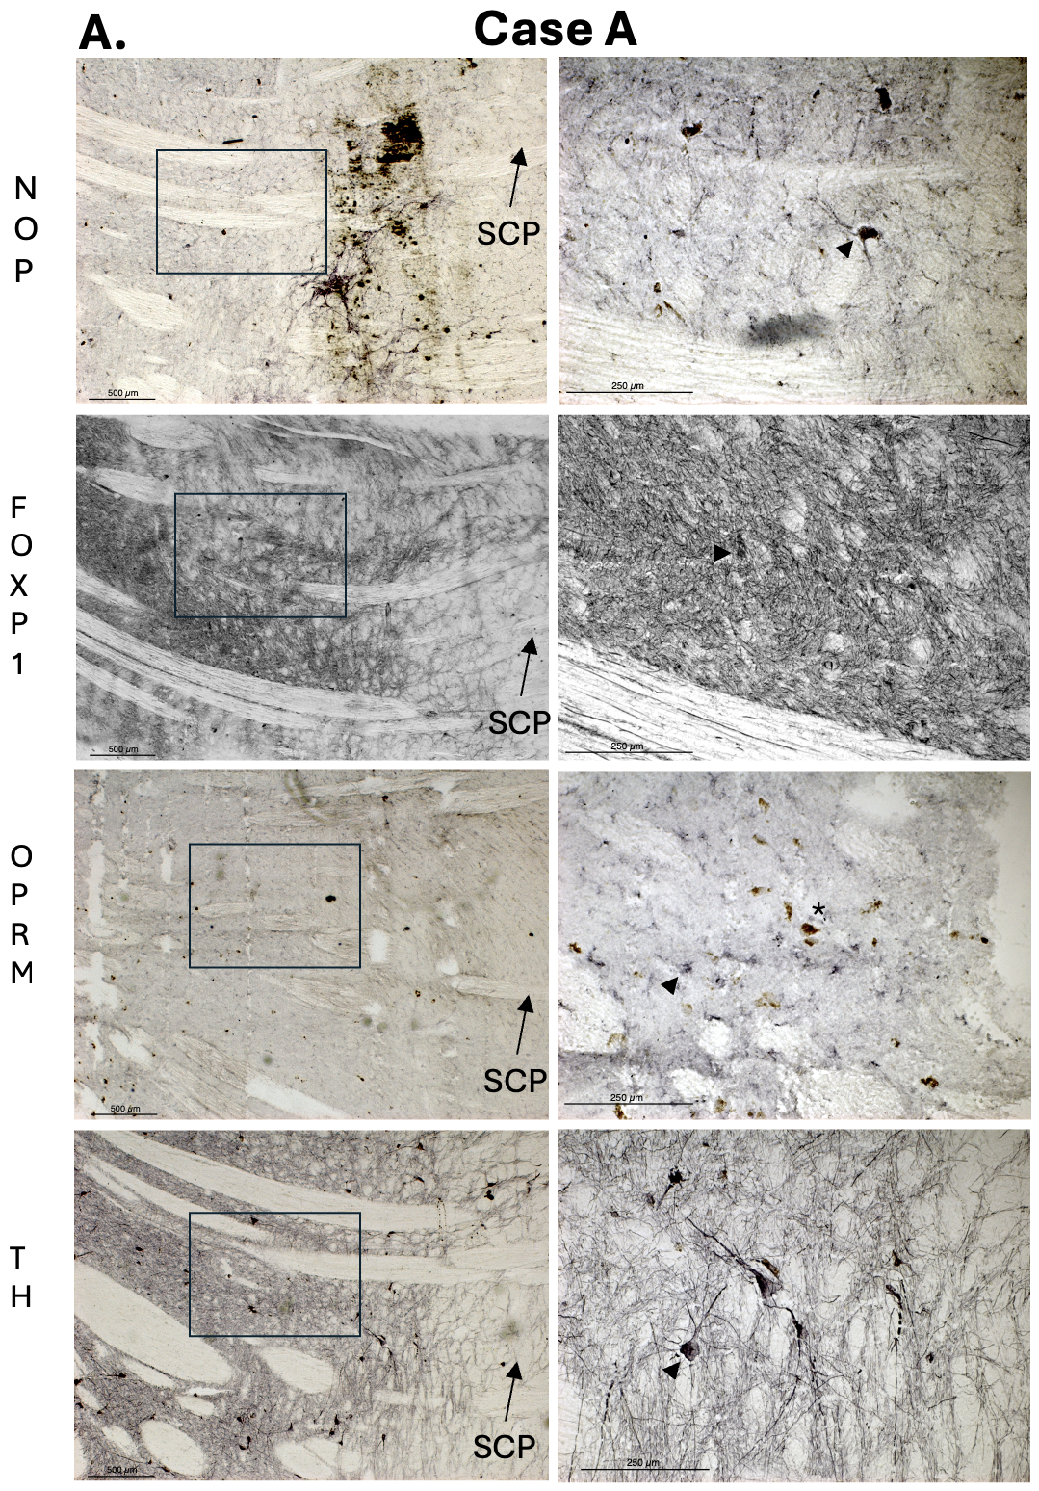
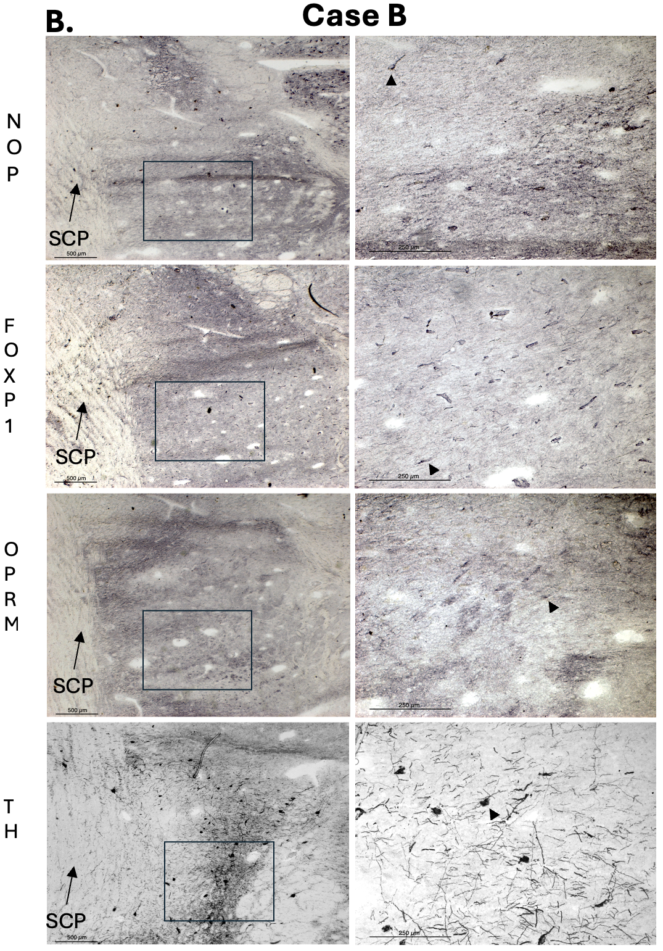
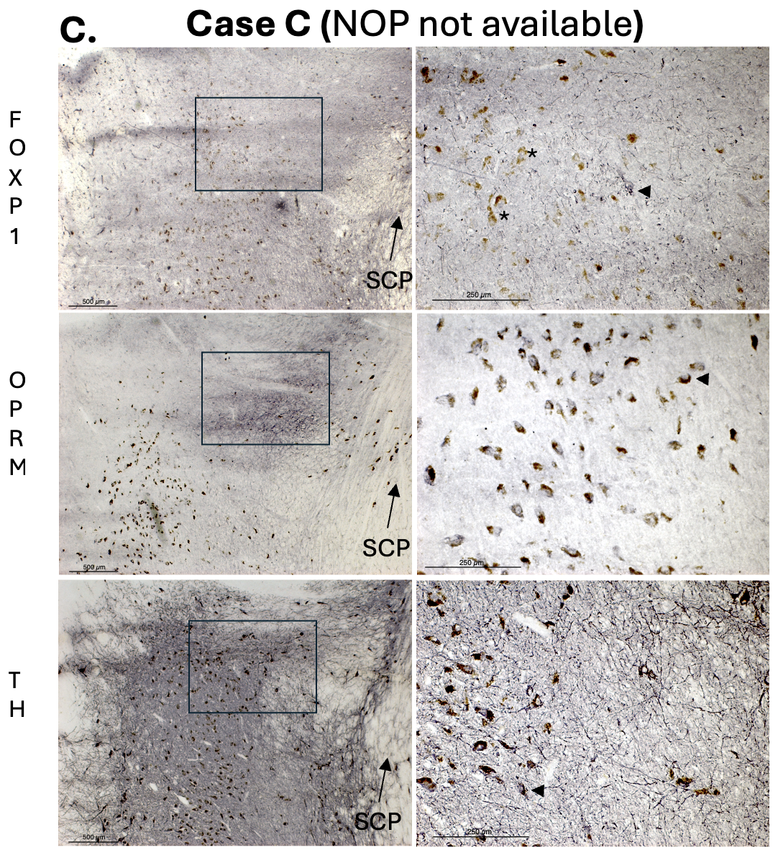

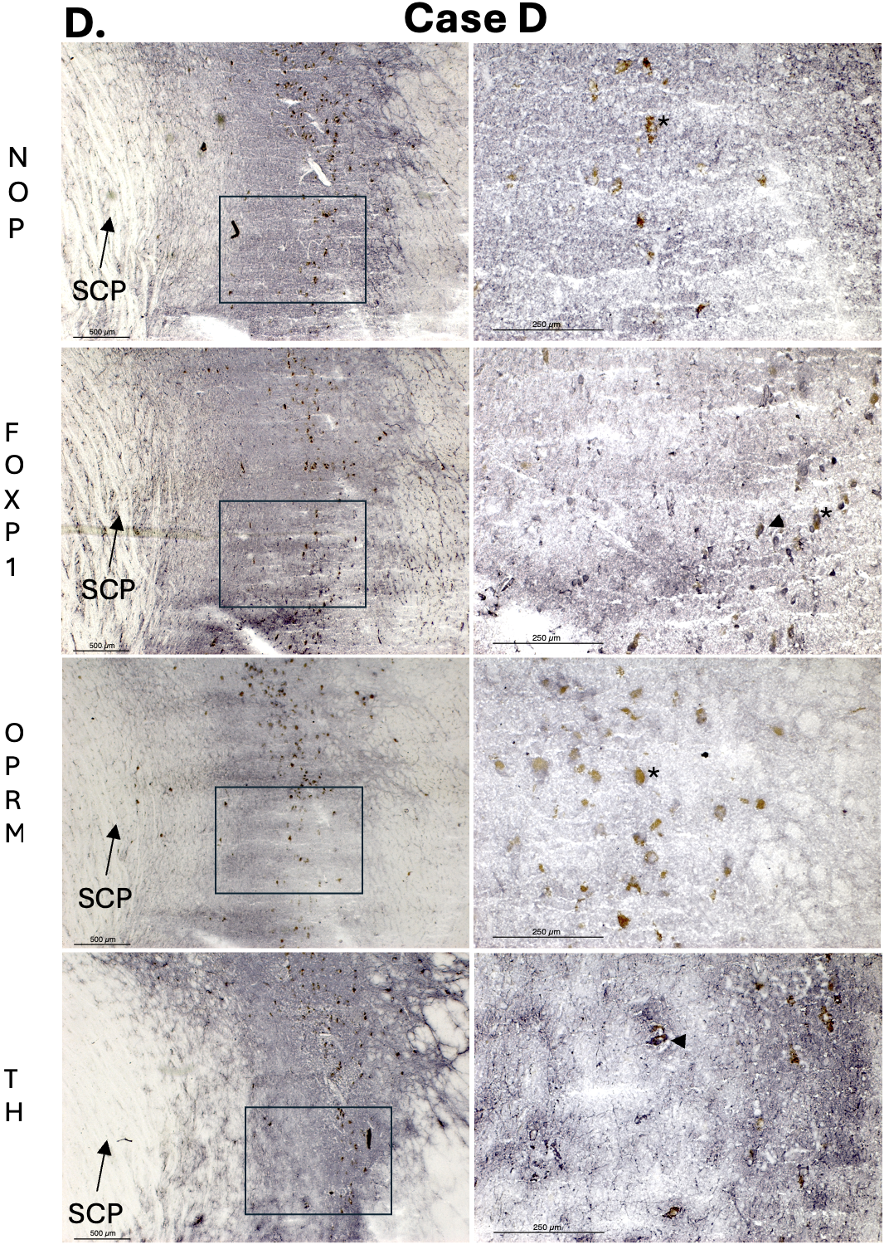
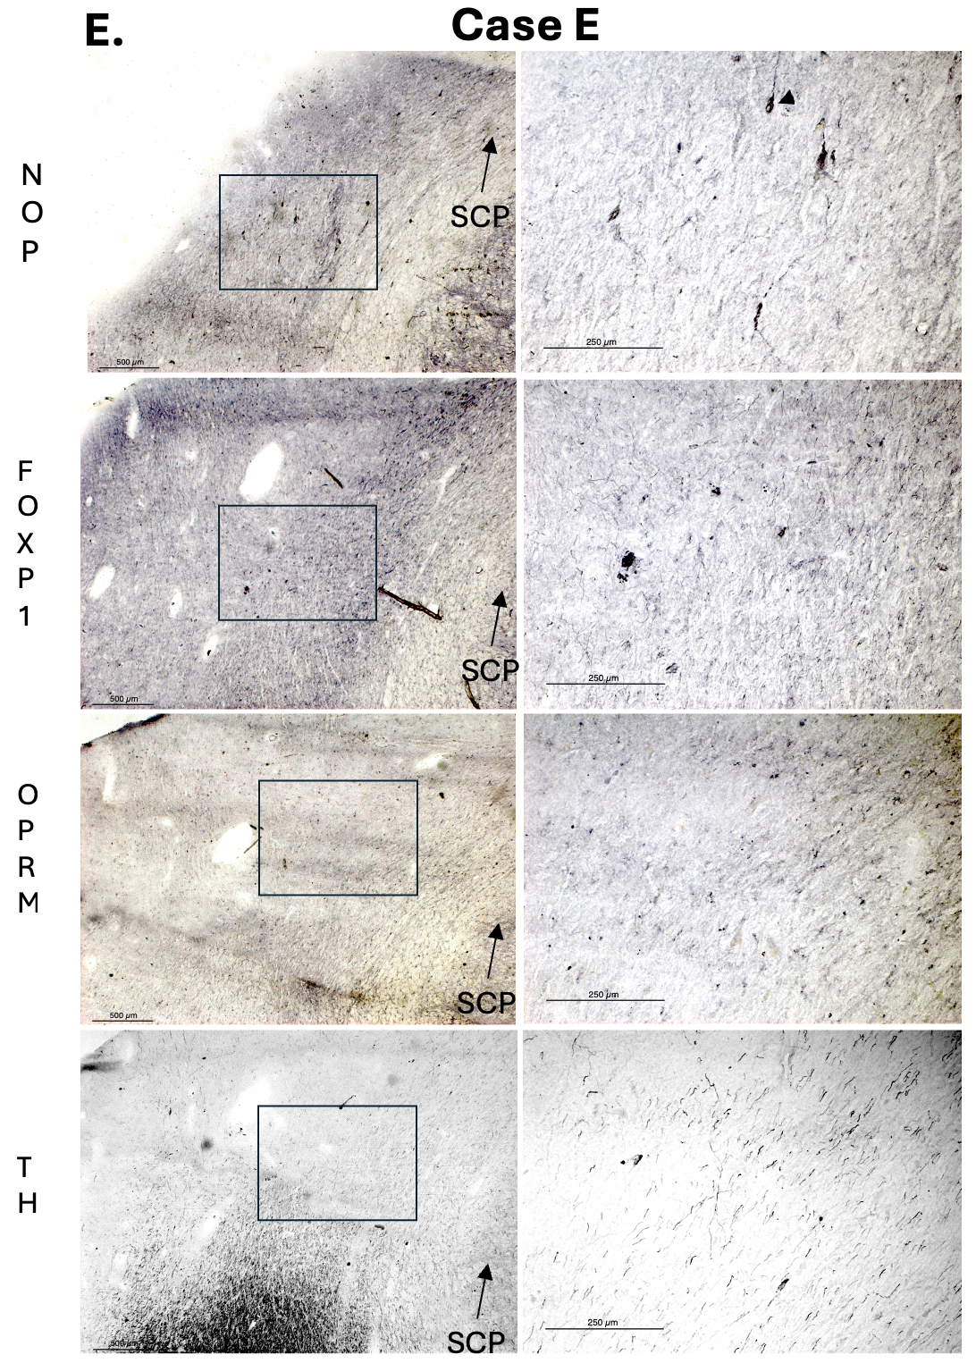
Supplemental Figure 4. Postmortem Assessment of the Putative Human RMTg. Representative images from human postmortem brain tissue (n = 5; Cases A-E) illustrate the expected location of the RMTg. Immunohistochemical staining highlights cells positive for Nociceptin (NOP), FOXP1, Opioid Receptor µ (OPRM), and Tyrosine Hydroxylase (TH). In the left panels, the decussation of the superior cerebellar peduncle is shown alongside the predicted location of the RMTg, as defined by our imaging data and prior studies in other species. The right panels depict the nearest neighboring cells expressing each of the candidate RMTg markers and TH. Notably, their spatial distribution varies substantially across cases, consistent with a diffuse neuronal organization within this region. Arrowheads show examples of immunolabeled neurons; asterisks mark non-specific staining resulting from lipofuscin. Scale bars: 250 um
References
Davis KD, Flor H, Greely HT, Iannetti GD, Mackey S, Ploner M, Pustilnik A, Tracey I, Treede RD, Wager TD (2017) Brain imaging tests for chronic pain: medical, legal and ethical issues and recommendations. Nat Rev Neurol 13 (10):624–638. doi:10.1038/nrneurol.2017.122
Tinnermann A, Buchel C, Cohen-Adad J (2021) Cortico-spinal imaging to study pain. Neuroimage 224:117439. doi:10.1016/j.neuroimage.2020.117439
Tinnermann A, Geuter S, Sprenger C, Finsterbusch J, Buchel C (2017) Interactions between brain and spinal cord mediate value effects in nocebo hyperalgesia. Science 358 (6359):105–108. doi:10.1126/science.aan1221

