Supplementary Information for
Sensitive chemoselectivity of cellulose nanocrystal films
Wenna Ge,ª Zhixin Feng,ª Fusheng Zhang,^{b} Xiangge Bai,ª Shile Feng,^{a,}* Yahua Liu ^{a,}*
ªKey Laboratory for Precision & Non-traditional Machining Technology of Ministry of Education, Dalian University of Technology, Dalian 116024, China
^{b}CAS Key Laboratory of Separation Science for Analytical Chemistry, Dalian Institute of Chemical Physics, Chinese Academy of Sciences, Dalian 116023, China

*Correspondence should be addressed to S.F. (fengshile@dlut.edu.cn) and Y.L. (yahualiu@dlut.edu.cn)
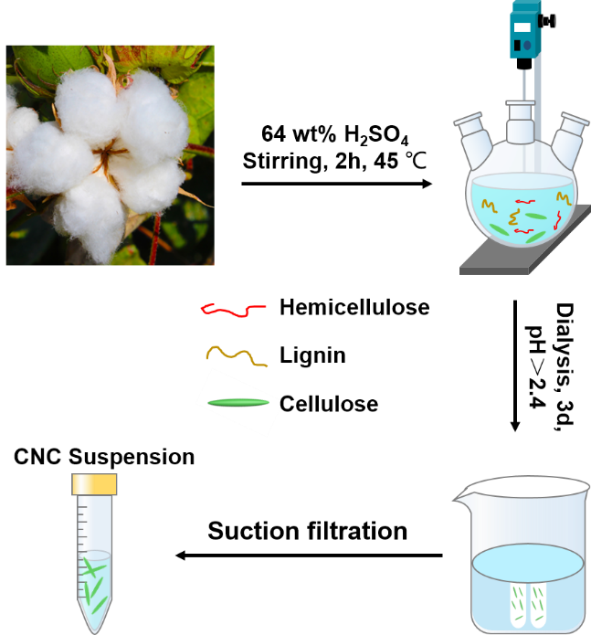
Fig. S1 Diagram showing the cellulose hydrolysis with sulfuric acid.
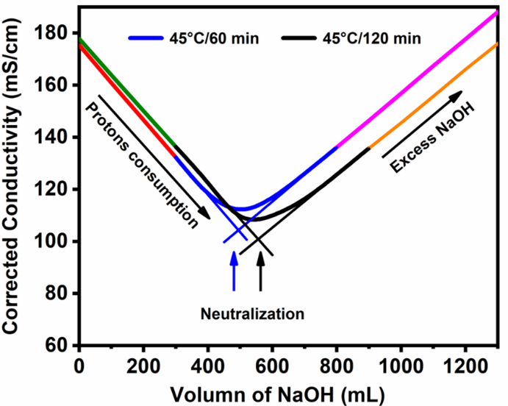
Fig. S2 Corrected conductivity as a function of NaOH volume. There were two distinct linear regimes: the initial conductivity decreased with added NaOH because the protons associated with the sulfate ester groups were consumed; subsequently, the conductivity increased after all the charged groups had been neutralized. By conductometric titration of the acidic particles against dilute sodium hydroxide solution, sulfur content in solution can be quantified.
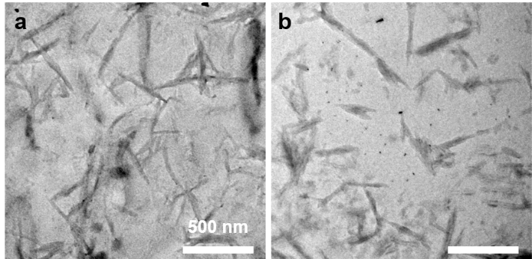
Fig. S3 TEM image of the CNC suspension. (a) The hydrolysis time is about 120 minutes. (b) The hydrolysis time is about 150 minutes. At the same temperature, the size of cellulose becomes slimmer and shorter with the extension of hydrolysis time, indicating an excessive hydrolysis.
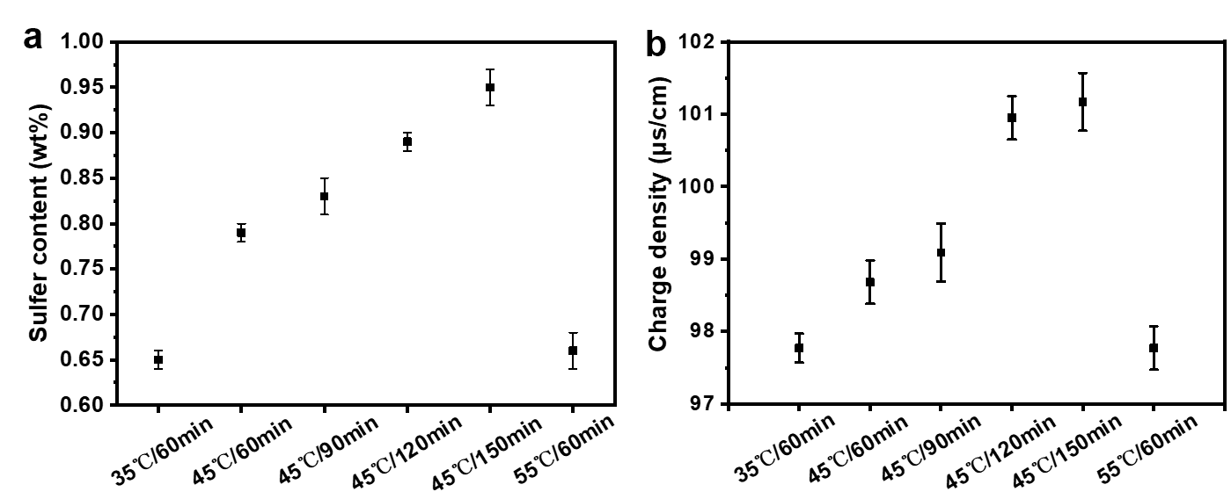
Fig. S4 Sulfur content (%S) (a) and charge density (b) under different reaction conditions. The sulfur content is calculated by Abitbol et al. (2013), %S= V_{NaOH}C_{NaOH}Mw(S)/m_{susp}C_{susp}×100%, where V_{NaOH} and C_{NaOH} are the volume and concentration of NaOH, respectively, m_{susp} and C_{susp} are the mass (mass %) and concentration (wt %) of the cellulose nanocrystal suspension, respectively, and M_{w}(S) is the atomic mass of sulfur. The result indicates that the sulfur content increased from 65.4 wt% to 94.8 wt% with different hydrolysis conditions, and the highest value is obtained at 45 °C.
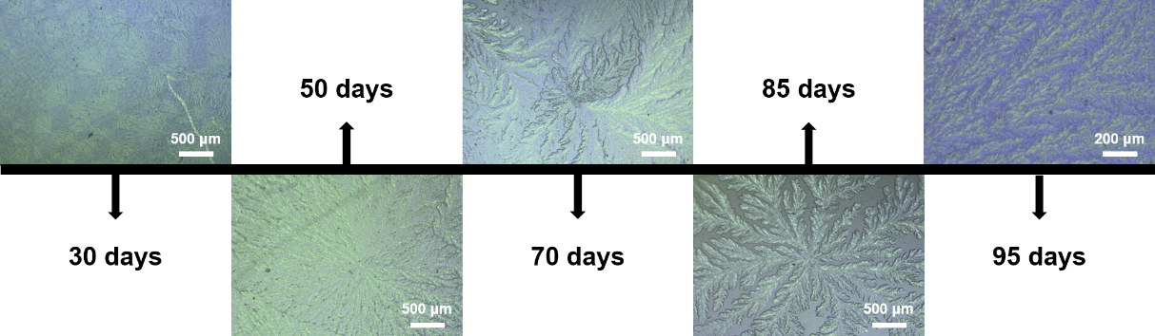
Fig. S5 The crystallization process of glucose on the surface of CNCs.
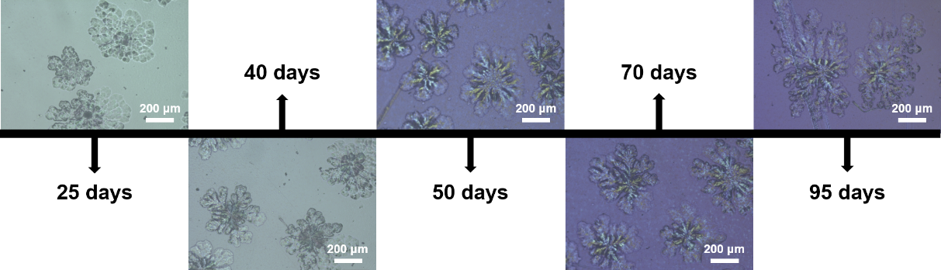
Fig. S6 The crystallization process of galactose on the surface of CNCs.
Table S1. Physicochemical Parameters of carbon film with CNCs/glucose homologs.
Samples | Monosaccharide/disaccharide  in film | Pore volume  (cm³/g) | BJH pore  diameter (nm)
1 | glucose | 0.81 | 2.7
2 | lactose | 0.82 | 2.7
3 | galactose | 0.82 | 2.8
4 | sucrose | 0.91 | 3.3
5 | none | 1.02 | 3.7

Reference
Abitbol T, Kloser E, Gray DG (2013) Estimation of the surface sulfur content of cellulose nanocrystals prepared by sulfuric acid hydrolysis. Cellulose 20:785-794. https://doi.org/10.1007/s10570-013-9871-0

