Supplementary Figure 1
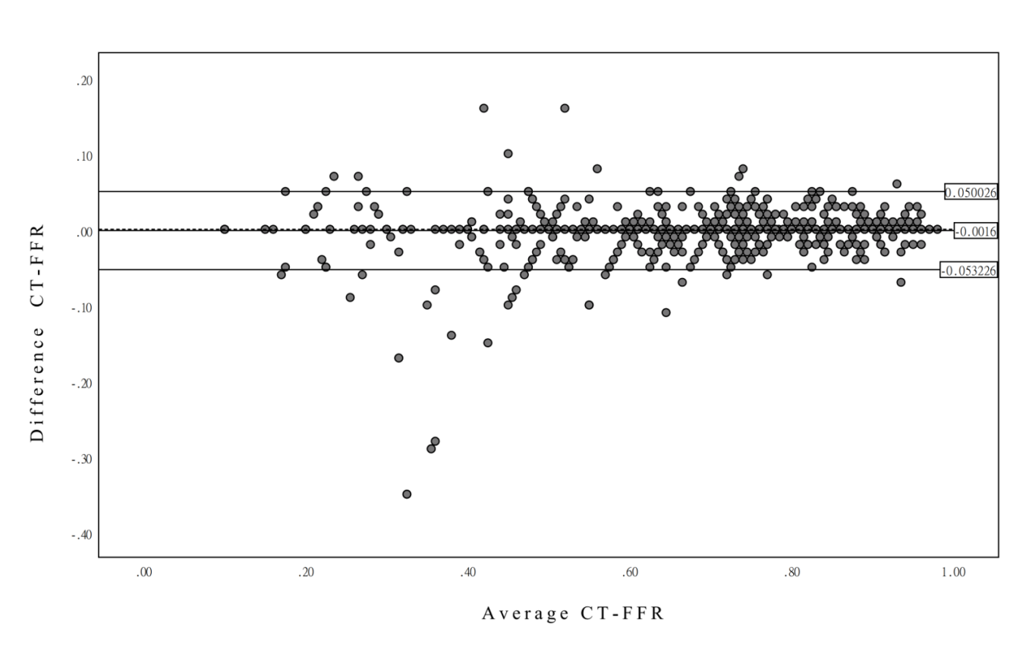
Supplementary Fig. 1 Inter-observer agreement for CT-FFR measurements.

