Supplementary materials
Supplementary table 1. Validation of Knowledge questionnaire
Original questionnaire: |  | Based on a questionnaire used by Gerodent  (Janssens et al., 2019). |  | 24 items grouped in 6 themes:  - Knowledge that enables the recognition of an unhealthy mouth.  - Knowledge that enables the recognition of inadequate oral hygiene.  - Knowledge of the correct names of structures in the mouth.  - Knowledge about association between oral health and general health.  - Knowledge about referral to the dentist.  - Knowledge about the influence of external factors on oral health.
Phase 1: Expert evaluation
Nine experts in geriatrics, nursing, dentistry, and gerodontology from Ghent University and KU Leuven |  | - Theme 3 replaced  - Irrelevant items replaced by other items  - Items added to 5 each per theme |  | - Knowledge that enables the recognition of an unhealthy mouth.  - Knowledge that enables the recognition of inadequate oral hygiene.  - Knowledge of guidelines for preventive oral care (cleaning of teeth, interdental cleaning, dental prosthesis and products).  - Knowledge about association between oral health and general health.  - Knowledge about referral to the dentist.  - Knowledge about the influence of external factors on oral health.
Phase 2: Construct validity
Layman - dentist assessment |  | - 22 undergraduate Master students dentistry  - 11 nursing students  - Haladyna method for discrimination[26]  - Items with extreme response rates (>90% or <10% correct in the nursing group) were revised or removed. |  | 40 items over 6 themes
Phase 3: Content validity
Assess clarity and ease of understanding | 6 non-dentists  - Substitution of dental jargon (tooth decay – caries)  - Clarifying definitions (e.g., periodontitis)  64 residential caregivers  - 100% correct items were replaced  - Avoidance of guessing (I don’t know option) |  | Final questionnaire: 39 items over 6 themes (Supplementary table 4)

Supplementary Table 2. Comparison of Knowledge and Attitude Scores Between Oral Health Care Team Members and Non-Members
Timepoint | Outcome | Group | Mean | SD | p-value
Baseline (T0) | Attitude | Non-member | 72.94 | 6.15 | < .001
Baseline (T0) |  | Member | 74.84 | 6.41
Baseline (T0) | Knowledge | Non-member | 14.24 | 6.52 | < .001
Baseline (T0) |  | Member | 16.66 | 6.89
Evaluation (T1) | Attitude | Non-member | 72.22 | 6.41 | < .001
Evaluation (T1) |  | Member | 74.65 | 6.32
Evaluation (T1) | Knowledge | Non-member | 15.89 | 7.41 | < .001
Evaluation (T1) |  | Member | 20.28 | 6.92
Post-implemen-tation (T2) | Attitude | Non-member | 72.69 | 6.61 | .012
Post-implemen-tation (T2) |  | Member | 75.89 | 4.90
Post-implemen-tation (T2) | Knowledge | Non-member | 17.48 | 6.51 | .004
Post-implemen-tation (T2) |  | Member | 21.55 | 7.24

Supplementary table 3 Pairwise comparisons of estimated marginal means of Knowledge and Attitude across measurement moments.
 |  | Knowledge |  |  | Attitude
Profession |  | Mean diff | p | 95% CI | Mean diff | p | 95% CI
Nurse | T0 vs T1 | -2.59 | <.001 | [-3.54,-1.65] | 0.08 | .854 | [-0.78,0.94]
 | T0 vs T2 | -3.62 | .001 | [-5.83,-1.42] | -1.34 | .173 | [-3.27,0.59]
 | T1 vs T2 | -1.03 | .377 | [-3.32,1.26] | -1.42 | .165 | [-3.42,0.58]
Nurse-aid | T0 vs T1 | -2.39 | <.001 | [-3.15,-1.64] | 0.72 | .042 | [0.03,1.41]
 | T0 vs T2 | -3.46 | <.001 | [-5.19,-1.72] | 0.18 | .816 | [-1.37,1.74]
 | T1 vs T2 | -1.06 | .246 | [-2.86,0.73] | -0.53 | .516 | [-2.14,1.07]
Speech therapist | T0 vs T1 | -4.62 | .067 | [-9.57,0.33] | 1.41 | .542 | [-3.12,5.93]
Speech therapist | T0 vs T2 | -7.40 | .069 | [-15.37,0.57] | 6.96 | .061 | [-0.32,14.25]
Speech therapist | T1 vs T2 | -2.78 | .537 | [-11.61,6.05] | 5.56 | .177 | [-2.52,13.63]
Other paramedical staff | T0 vs T1 | -0.95 | .363 | [-3.00,1.10] | 1.45 | .127 | [-0.41,3.30]
Other paramedical staff | T0 vs T2 | -4.78 | .066 | [-9.87,0.31] | -1.48 | .532 | [-6.14,3.17]
Other paramedical staff | T1 vs T2 | -3.83 | .159 | [-9.16,1.50] | -2.93 | .238 | [-7.79,1.94]
Management | T0 vs T1 | 0.47 | .797 | [-3.08,4.01] | 0.17 | .917 | [-3.06,3.41]
Management | T1 vs T2 | -7.78 | .038 | [-15.14,-0.42] | -1.03 | .764 | [-7.76,5.70]
GP/CRA | T0 vs T1 | -5.88 | .167 | [-14.21,2.46] | -3.59 | .354 | [-11.17,3.99]
GP/CRA | T0 vs T2 | -5.88 | .399 | [-19.53,7.78] | 6.41 | .313 | [-6.05,18.87]
GP/CRA | T1 vs T2 | 0.00 | 1.00 | [-15.29,15.29] | 10.00 | .161 | [-3.98,23.98]
Other | T0 vs T1 | -1.19 | .564 | [-5.23,2.85] | 0.82 | .662 | [-2.87,4.52]
Other | T0 vs T2 | -5.04 | .156 | [-12.00,1.92] | -0.71 | .827 | [-7.08,5.66]
Other | T1 vs T2 | -3.85 | .311 | [-11.30,3.60] | -1.53 | .659 | [-8.35,5.28]

Supplementary Table 4. Percentage correct answers and changes over time for individual items of the knowledge questionnaire. + suggestions for shortening the questionnaire.
 | Item (1-way translation of Dutch) | % Correct | % Change  (T0 vs T1, T2) | p-value | Justification to delete for shorter questionnaire
K1 | Aids for interdental cleaning include dental floss, toothpicks, and interdental brushes. | 73.20% | +0.80% | 0.647
K2 | Dental plaque is the main cause of bad breath. | 36.77% | –4.96% | .013
K3 | Refer the resident to a dentist for nighttime oral pain. | 54.48% | +8.46% | <.001 | Is this knowledge based or because of perceived dentist shortages?
K4 | Toothpaste is used to clean dentures. | 89.69% | +9.65% | <.001 | High baseline.
K5 | Dentures should be stored in clean water at night. | 90.73% | +8.88% | <.001 | High baseline.
K6 | Exposed roots are more prone to caries. | 73.13% | +5.92% | .002
K7 | Dentures should be rinsed after every meal. | 79.58% | +6.18% | <.001
K8 | In older adults, caries mainly occurs at the neck/root of the tooth. | 56.56% | +8.30% | <.001 | K28 is a better-formulated alternative.
K9 | Gum disease can affect blood sugar in diabetics. | 71.35% | +8.45% | <.001
K10 | Medication cannot cause dry mouth. | 89.58% | +0.76% | .720 | High baseline.
K11 | Reduced chewing has no effect on general health if nutrients are absorbed. | 70.94% | +2.47% | .290
K12 | Poor oral hygiene increases risk of pneumonia. | 72.50% | +13.74% | <.001
K13 | A healthy tongue is slightly rough with a thin white coating. | 25.10% | +4.95% | <.001 | Only relevant with images.
K14 | Chewing influences brain blood circulation. | 55.42% | +9.59% | <.001 | —
K15 | Chewing gum can stimulate saliva in dry mouth. | 77.71% | +3.92% | .022 | —
K16 | Mouthwash can replace brushing in dependent older adults. | 53.65% | +5.38% | <.001 | —
K17 | Age is the main reason for tooth loss. | 68.13% | –2.10% | .173 | T0 was better than T1.
K18 | Refer to the dentist when in doubt about the oral health of the resident. | 72.50% | +2.12% | .002 | Is this knowledge based or because of perceived dentist shortages?
K19 | Bleeding during brushing means brushing too hard. | 82.81% | +0.24% | .946 | High baseline.
K20 | Refer residents with poor hygiene to the dentist. | 48.13% | –1.75% | .003 | Is this knowledge based or because of perceived dentist shortages?
K21 | Toothpaste for this group should contain at least 1450 ppm fluoride. | 53.33% | +25.71% | <.001 | —
K22 | Tartar can also form on dentures. | 67.08% | +12.23% | <.001 | —
K23 | Refer tot he dentist for mouth pain with hot/cold food. | 77.81% | –0.08% | .031 | Is this knowledge based or because of perceived dentist shortages?
K24 | Mouthwash is more effective than a tongue scraper. | 79.79% | +11.81% | <.001 | —
K25 | Older adults need toothpaste with 1450 ppm fluoride. | 52.71% | +24.79% | <.001 | Duplicate of K21 – potential bias test.
K26 | Oral problems are usually reported by the resident. | 46.88% | +4.17% | .027 | —
K27 | Plaque mainly consists of food debris. | 34.79% | +0.24% | .005 | Relevance for daily practice questionable.
K28 | Focus brushing on the crown, where plaque accumulates. | 58.13% | +2.00% | .006 | Clearer than K8.
K29 | Wearing dentures at night increases pneumonia risk. | 40.31% | +17.23% | <.001 | —
K30 | Edentulous residents don’t need a dentist if dentures are cleaned. | 78.13% | +3.45% | <.001 | Is this knowledge based or because of perceived dentist shortages?
K31 | Light/zero drinks are safe for oral health. | 91.56% | +0.79% | .093 | High baseline.
K32 | Total sugar intake per day is more harmful than frequency. | 66.46% | +4.33% | .041 | —
K33 | Cleaning tablets have no added value over mechanical cleaning. | 27.81% | –7.18% | <.001 | Confusing double negation; rephrase.
K34 | 10 teeth are sufficient for chewing function. | 43.96% | +3.30% | .014 | Practical implications vary by resident.
K35 | Watch for oral fungal infections in denture wearers. | 73.54% | +4.34% | <.001 | —
K36 | Periodontitis can cause bone loss around teeth. | 77.81% | +5.78% | <.001 | —
K37 | Saliva helps digest food and prevents decay. | 77.81% | +3.92% | .009 | —
K38 | Brushing has no effect once decay begins. | 89.48% | +2.12% | .132 | High baseline.

Figures

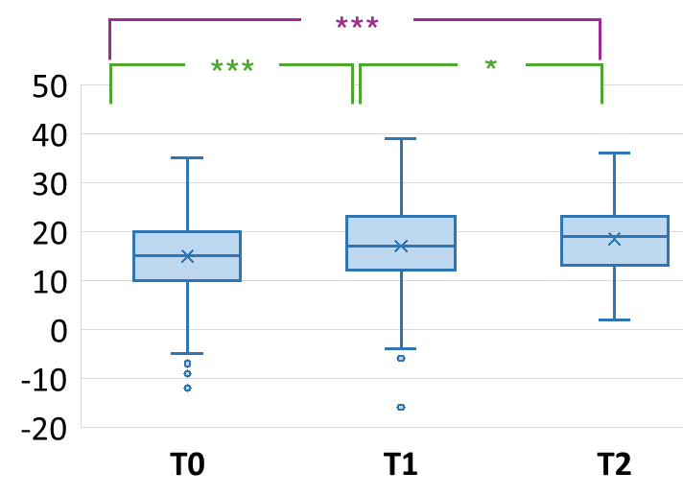
Supplementary Figure 1. Collaboration with a dentist at T0, T1 and T2
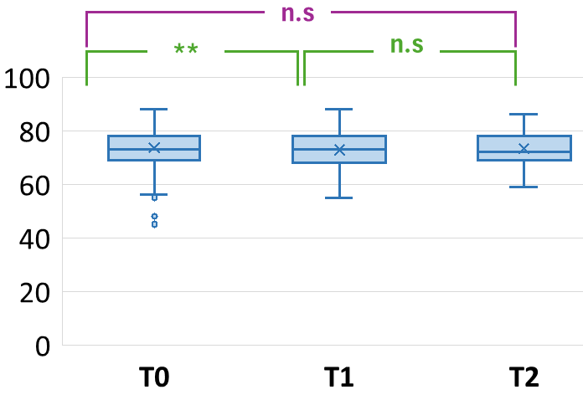
Supplementary figure 2. Total Attitude score
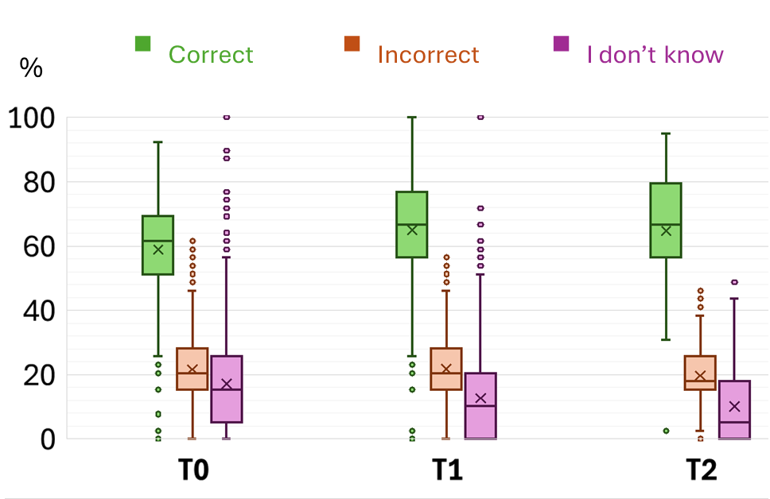
Supplementary figure 3. Knowledge Score by Response Type

