Supplementary Figure

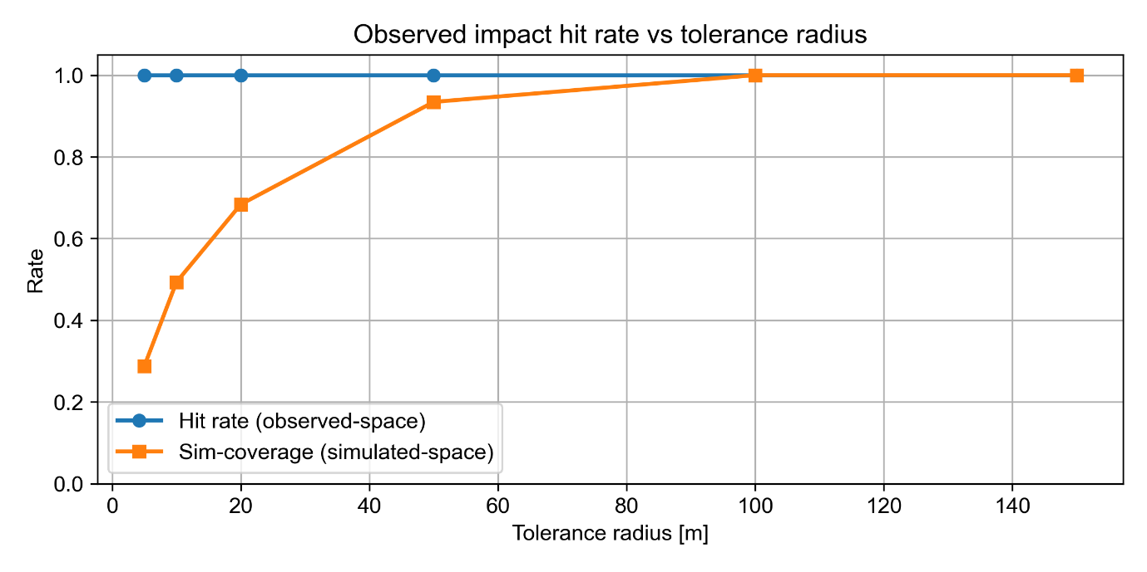Fig. Supplement 2. Spatial validation of simulated rockfall impact locations against the field-observed inventory along the RD 1091 corridor. Hit rate (blue, observed-space) denotes the proportion of the 57 observed impacts located within the tolerance radius of at least one simulated impact; simulation coverage (orange, simulated-space) denotes the proportion of simulated impacts located within the tolerance radius of at least one observed impact. The complete recovery of observed impacts at tolerance radii as small as 5 m, combined with progressive convergence of simulation coverage toward unity at 100 m, confirms that the simulation envelope spatially encompasses all observed impacts while extending beyond the locations sampled by the historical record.

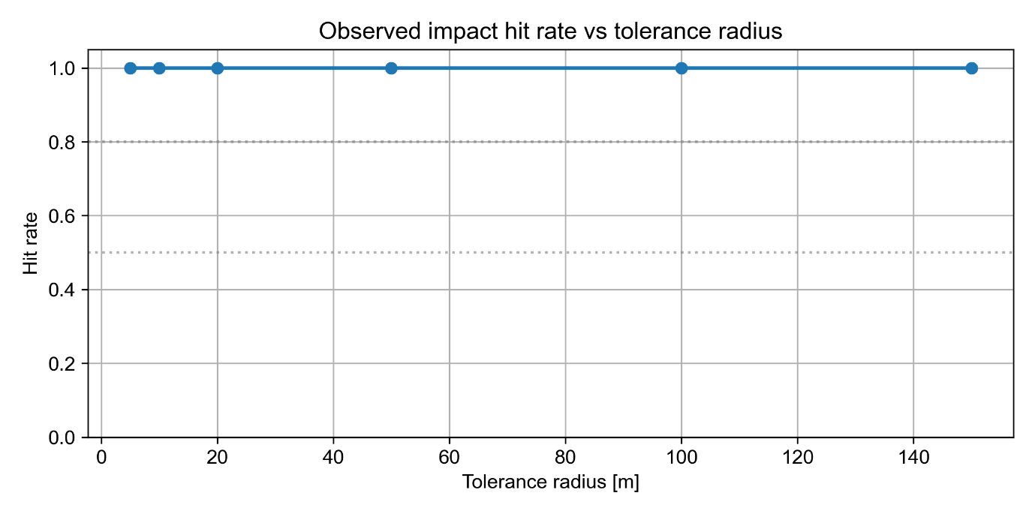 Fig. Supplement 3. Observed-impact hit rate as a function of spatial tolerance radius along the RD 1091 corridor. All 57 field-observed impacts are located within the tolerance radius of at least one simulated impact across the full range of tested tolerances (5–150 m), demonstrating complete spatial coverage of the observational record by the simulation ensemble.

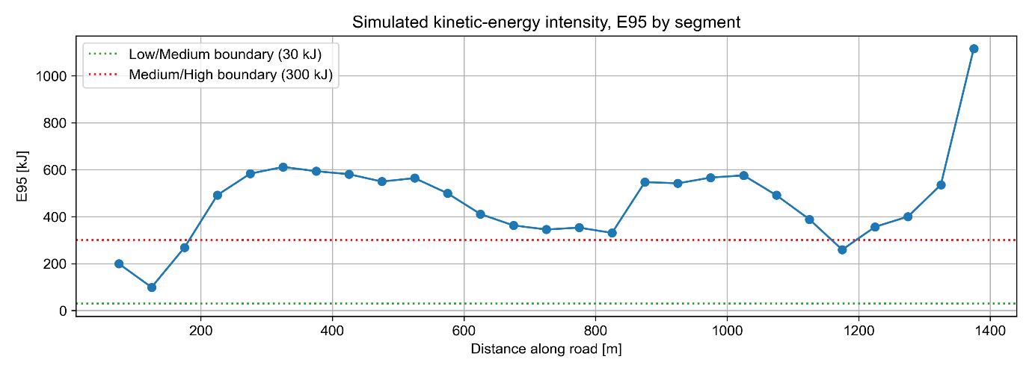
Fig. Supplement 4. Fifty-year energy-exceedance hazard profile for moderate-energy rockfall impacts (E > 300 kJ) along the 1,400 m RD 1091 corridor. The probability of at least one impact exceeding the 300 kJ energy threshold within a 50-year reference period is evaluated at 50 m intervals along the road alignment. Exceedance probability remains near zero throughout the proximal corridor (0–175 m), consistent with this section lying outside the effective runout zone of the mapped source areas, then rises sharply between 200 and 325 m to approach near-certainty across most of the remaining corridor.

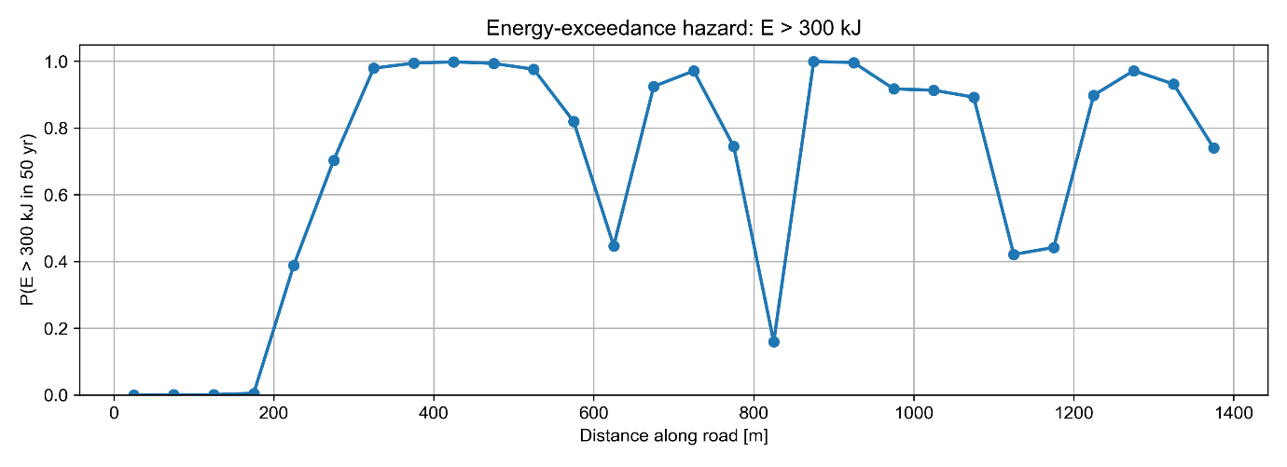
Fig. Supplement 5. Simulated 95th-percentile kinetic energy intensity (E₉₅) of rockfall impacts along the 1,400 m RD 1091 corridor. The 95th percentile of simulated impact kinetic energy is evaluated for each 50 m segment along the road alignment, characterising the upper-tail impact intensity to which the corridor is exposed.

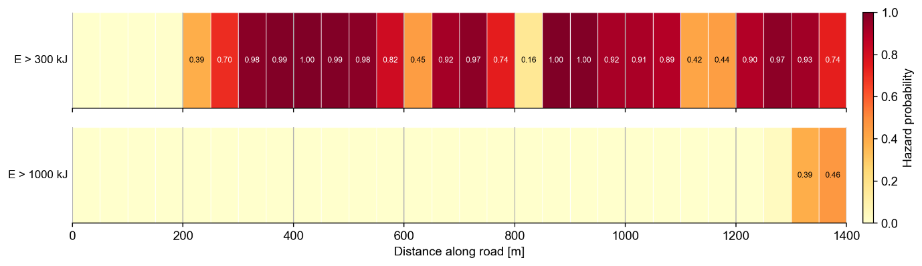
Fig. Supplement 6. Fifty-year rockfall hazard probability along the 1,400 m RD 1091 corridor, evaluated at 50 m intervals for two energy thresholds. Upper strip: probability of at least one moderate-energy impact (E > 300 kJ) within a 50-year reference period. Lower strip: probability of at least one severe-energy impact (E > 1,000 kJ) within the same period. Colour scale ranges from pale yellow (probability approaching zero) to dark red (probability approaching unity). Two principal high-energy hotspots are evident at approximately 350–500 m and 875–1,050 m along the corridor, where the probability of a severe impact substantially exceeds that of the intervening sections.
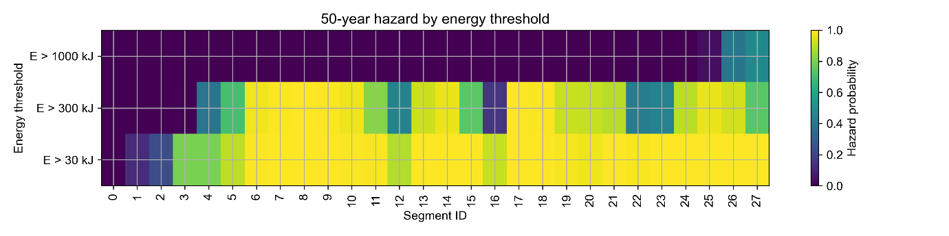
Fig. Supplement 7. Distribution of 50-year hazard classes for moderate-energy impacts (E > 300 kJ) across the 28 road segments comprising the RD 1091 corridor. Segments are classified into six categories ranging from No hazard to Very high based on the segment-wise 50-year probability of at least one moderate-energy impact. The strongly right-skewed distribution, dominated by the Very high class, indicates that the majority of the monitored corridor is subject to near-certain moderate-energy impact exposure over the reference period.

