Supplementary material
Argo float ID | Serial number | Deployment year | Deployment area | Period of operation | Displacement
795 | 6903795 | 2021 | TNBp | 30/01/2021 - 23/01/2022 | 38.3 km
812 | 6903812 | 2022 | TNBp | 01/02/2022 - 25/01/2023 | 11.9 km
101 | 5907101 | 2024 | TNBp | 25/01/2024 - 22/01/2025 | 42.8 km
793 | 6903793 | 2021 | RISp | 19/01/2021 - 26/01/2022 | 129.0 km
811 | 6903811 | 2022 | RISp | 27/01/2022 - 04/03/2023 | 74.1 km
832 | 6903832 | 2023-2024 | RISp | 27/01/2023 - 19/01/2025 | 78.7 km
580 | 3902580 | 2024 | RISp | 28/01/2024 - 25/01/2025 | 92.4 km
Supplementary table 2. Details of Argo floats used in this study. Float IDs correspond to the last three digits of their serial numbers. For each instrument, the full serial number, deployment year, deployment area and period of operation are reported. Note that no Argo floats were deployed in TNBp in 2023.
MANUELA AWS KATABATIC WIND STATISTIC
 | 2021 |  |  |  | 2022 |  |  |  | 2024
Month | N | WS | D | S | N | WS | D | S | N | WS | D | S
May | 11 | 28.0 | 24.7 | 97.3 | 14 | 28.5 | 25.3 | 126.5 | 8 | 29.7 | 27.8 | 110.5
Jun | 6 | 29.3 | 43.0 | 218.5 | 6 | 27.6 | 16.5 | 53.9 | 9 | 29.3 | 28.6 | 146.1
Jul | 11 | 28.0 | 19.0 | 72.3 | 11 | 29.4 | 38.5 | 212.2 | 11 | 28.0 | 19.9 | 84.7
Aug | 9 | 27.2 | 15.6 | 48.9 | 7 | 29.2 | 19.6 | 110.5 | 8 | 26.8 | 14.5 | 37.4
Sept | 7 | 28.2 | 21.7 | 90.9 | 8 | 27.4 | 25.3 | 85.6 | 5 | 28.1 | 24.0 | 87.8
Supplementary table 3. Monthly katabatic wind statistics at Manuela (TNBp), from May to September (2021, 2022, 2024): number of events (N), mean wind speed (WS; m s⁻¹), mean event duration (D; h), and severity (S).

LAURIE II AWS RAS WIND STATISTICS
 | 2021 |  |  |  | 2022 |  |  |  | 2023 |  |  |  | 2024
Month | N | WS | D | S | N | WS | D | S | N | WS | D | S | N | WS | D | S
May | 9 | 15.6 | 21.1 | 89.3 | 12 | 15.8 | 19.0 | 92.4 | 3 | 14.7 | 20.0 | 78.7 | 9 | 16.0 | 15.4 | 76.3
Jun | 7 | 15.3 | 14.1 | 61.4 | 9 | 15.6 | 26.7 | 122.5 | 12 | 16.4 | 16.1 | 103.6 | 12 | 16.3 | 17.2 | 92.2
Jul | 8 | 16.6 | 24.5 | 124.7 | 8 | 16.2 | 20.6 | 96.3 | 2 | 13.9 | 11.5 | 20.7 | 6 | 15.5 | 27.8 | 126.5
Aug | 4 | 14.7 | 9.0 | 24.5 | 6 | 16.5 | 21.3 | 104.3 | 1 | 15.8 | 17.0 | 64.0 | 4 | 15.3 | 21.5 | 75.1
Sept | 5 | 16.1 | 25.6 | 131.1 | 6 | 15.4 | 26.5 | 168.6 | 12 | 14.8 | 20.3 | 73.9 | 3 | 17.1 | 30.6 | 158.7
Supplementary table 4. Monthly RAS events statistics at Laurie II station (RISp) during May-September across the 2021-2024 period.

Reference period (2012-2024)
 | Manuela AWS |  |  |  | Laurie AWS
Month | N | WS | D | S | N | WS | D | S
May | 9 | 28.1 | 27.3 | 116.4 | 5 | 15.6 | 20.3 | 85.3
Jun | 9 | 28.3 | 25.5 | 111.6 | 6 | 15.6 | 18.5 | 83.7
Jul | 9 | 28.6 | 27.5 | 137.1 | 5 | 16.0 | 21.4 | 109.3
Aug | 9 | 27.8 | 23.6 | 92.0 | 6 | 15.5 | 21.9 | 102.0
Sept | 8 | 28.1 | 23.1 | 97.8 | 6 | 15.4 | 21.4 | 97.6

Supplementary table 5. Monthly mean wind statistics for the reference period (2012-2024) at Manuela and Laurie II AWS stations, including number of events (N), wind speed (WS), duration (D) and severity (S).

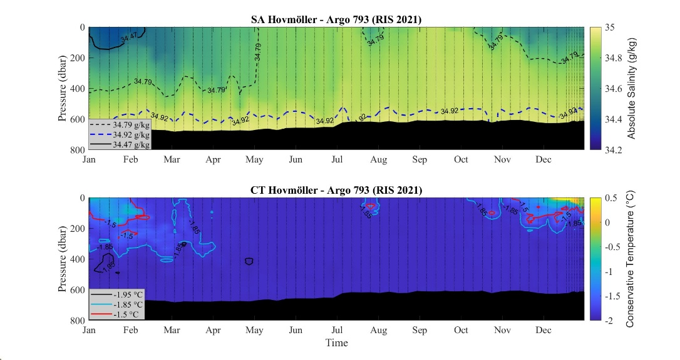
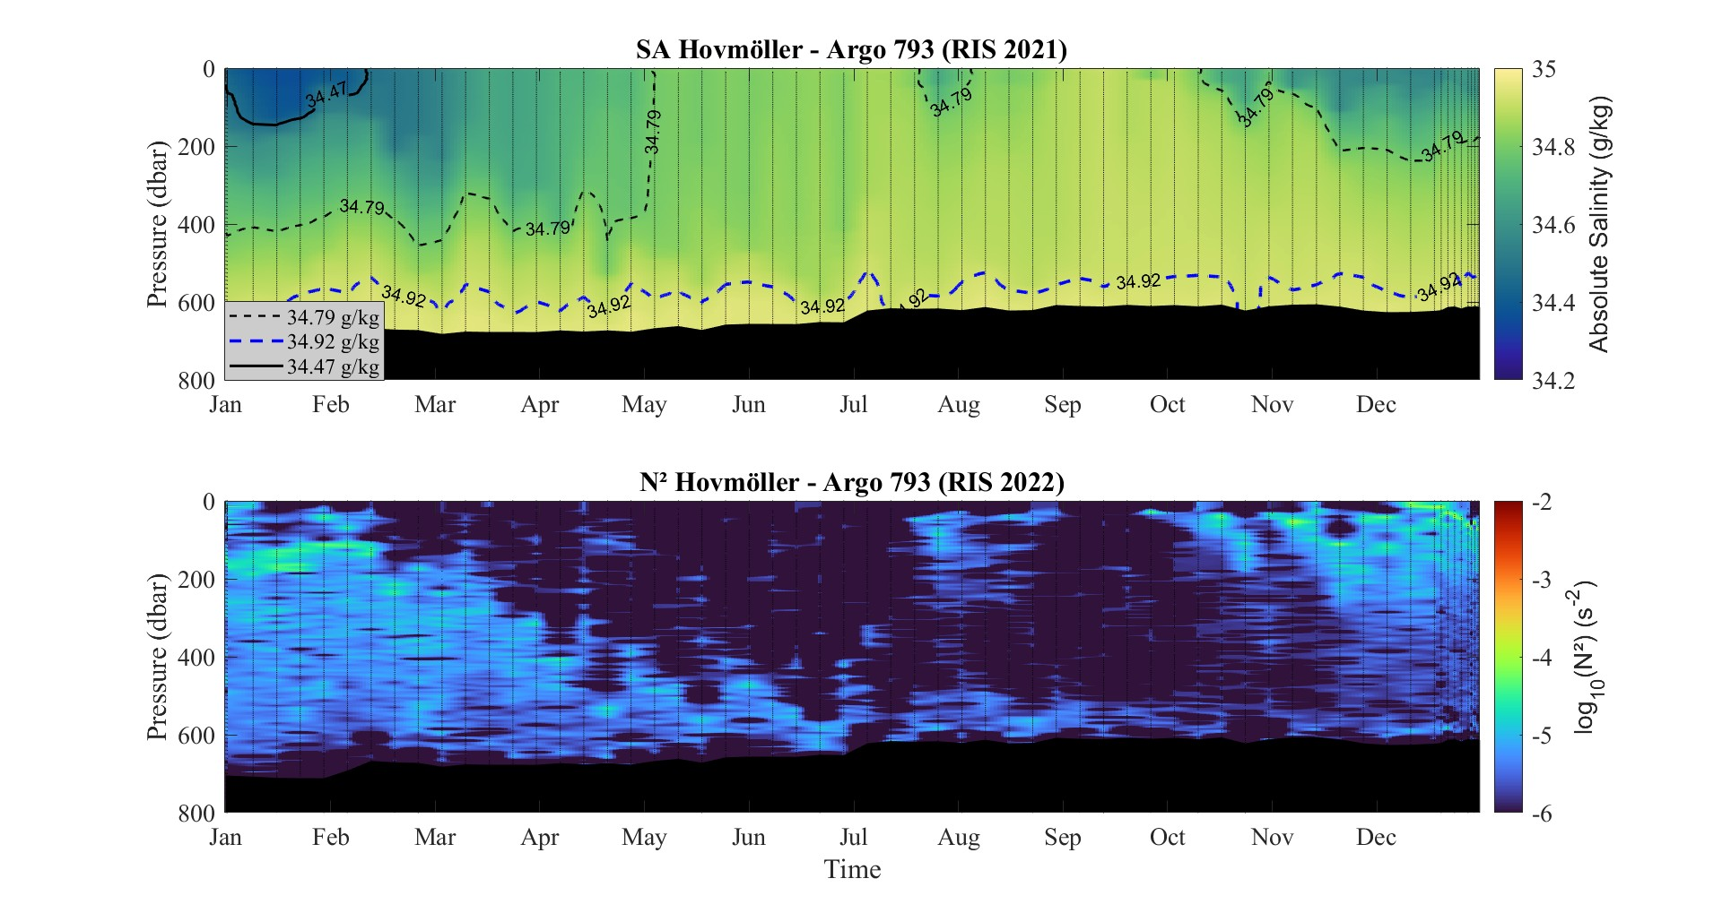
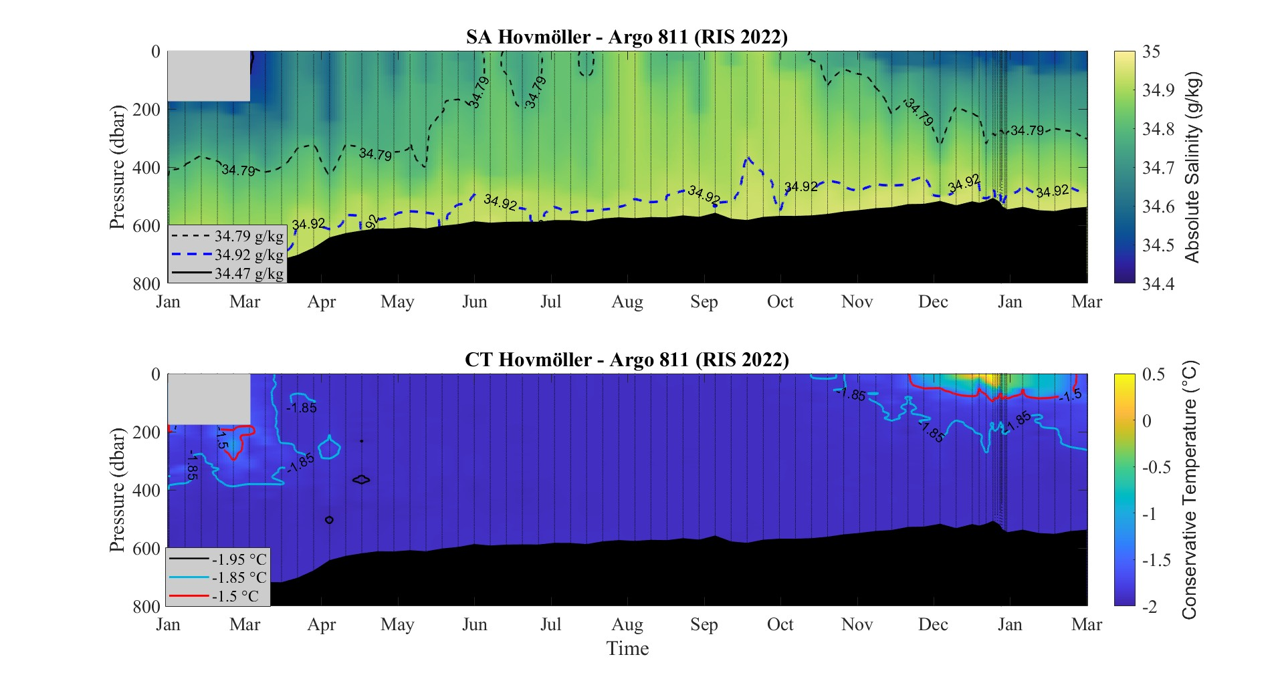
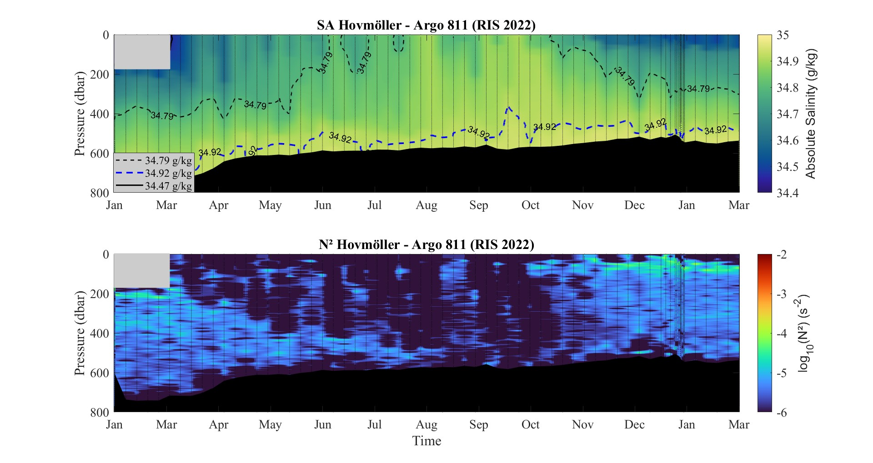
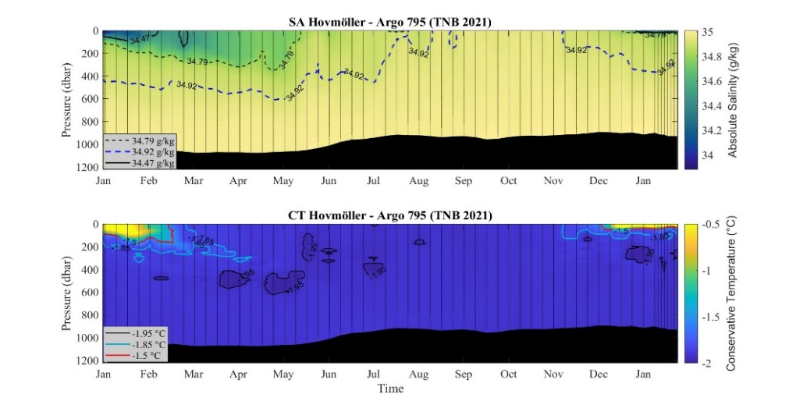
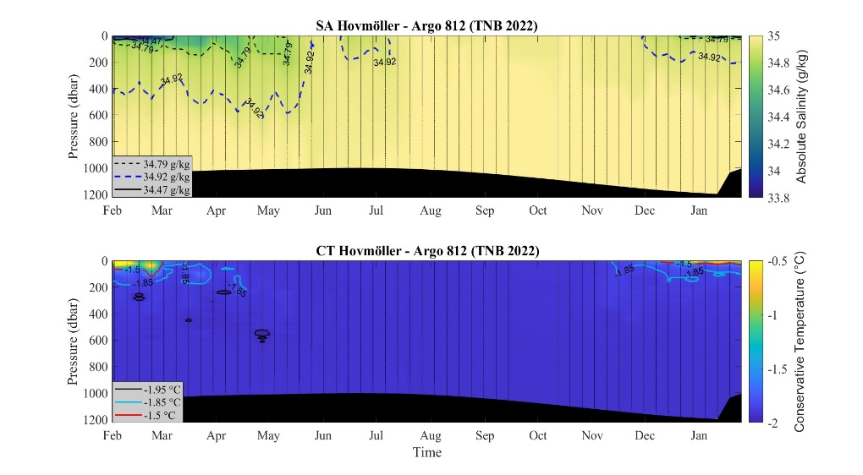
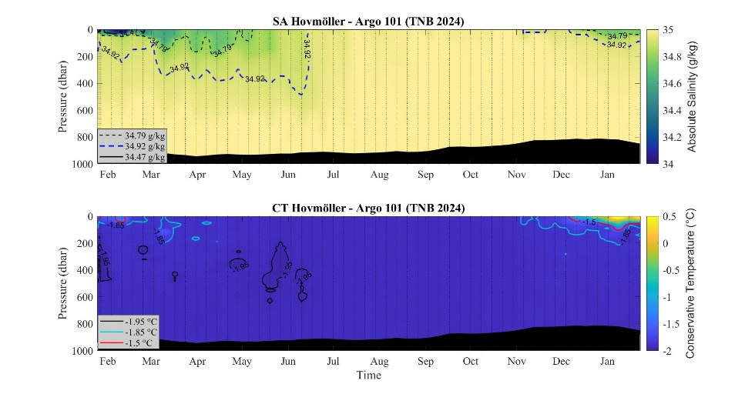
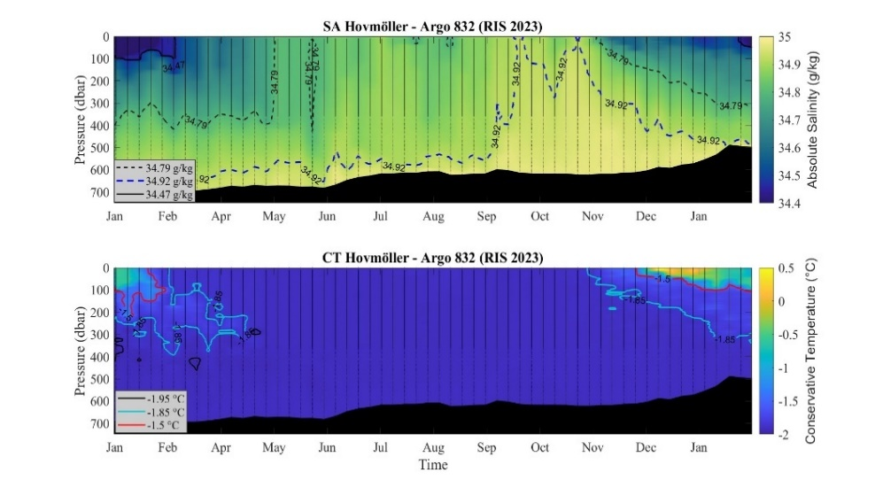
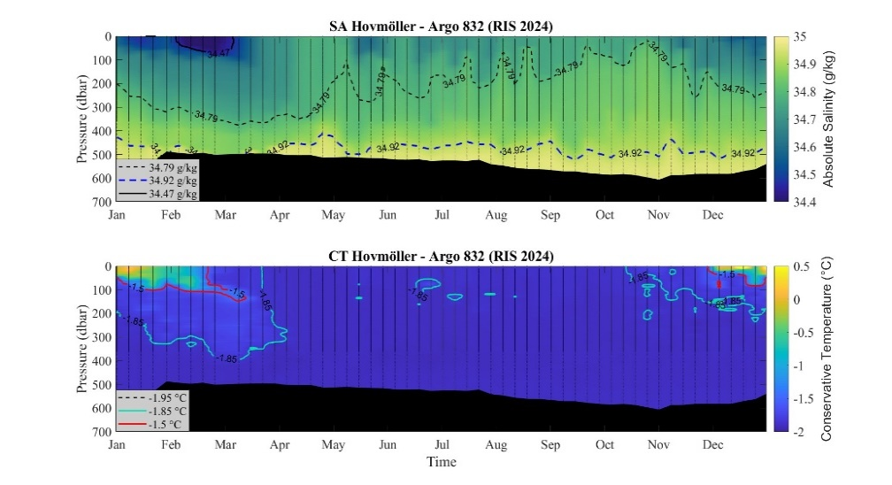
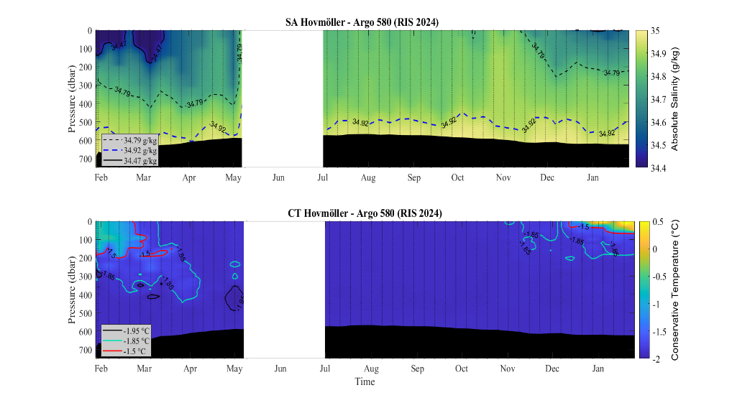
Supplementary Figure 10. Hovmöller diagrams of absolute salinity, conservative temperature and Brunt–Väisälä frequency for the Argo floats 793 (a,b,c) and 811 (d,e,f) deployed in the RISp in 2021 and 2022. The light grey polygon in the surface layer from 0 to about 200m in d-e-f indicates the presence of the Ross Ice Shelf.

b
a
c
d
e
f
a
b
c
d
e
f
Supplementary Figure 11. Hovmöller diagrams of conservative temperature for the Argo floats a) 795, b) 812, c) 101 deployed in the TNBp and d) 832 (2023), e) 832 (2024) and f) 580 deployed in the RISp. The white rectangle in f is due to a gap in data collection of the Float 580.
Figure 10. Hovmöller diagrams of absolute salinity, conservative temperature and Brunt–Väisälä frequency for the Argo floats 793 (a,b,c) and 811 (d,e,f) deployed in the RIS polynya (RISp) in 2021 and 2022. The light grey polygon in the surface layer from 0 to about 200m in the right panels indicates the presence of the Ross Ice Shelf.
Figure 12. Daily (black) and weekly (red) evolution of polynya extent (km²) for: (a) TNB in 2022, (b) RIS in 2022, (c) RIS in 2023, (d) TNB in 2024, and (e) RIS in 2024.
Supplementary Figure 12. Hovmöller diagrams of Brunt–Väisälä frequency for the Argo floats (a) 795 (2021), (b) 812 (2022) deployed in the TNBp.
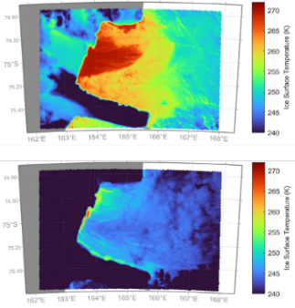
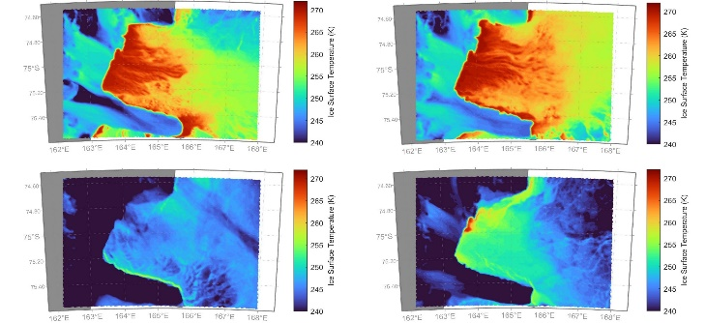
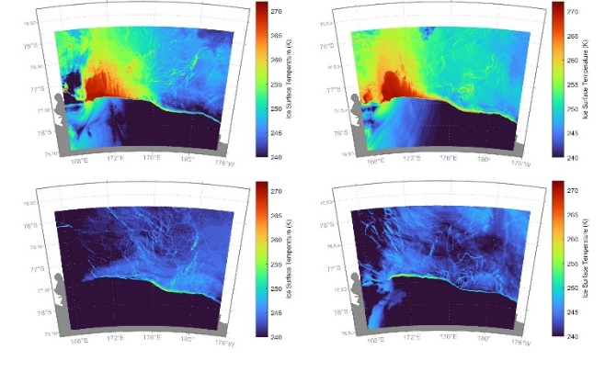
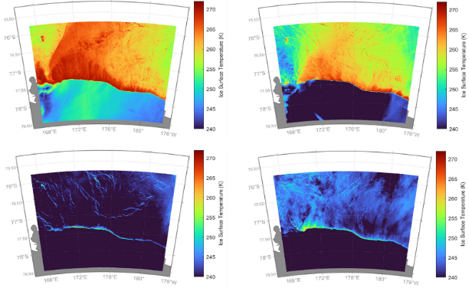
Supplementary Figure 13. Hovmöller diagrams of Brunt–Väisälä frequency for the Argo floats (a) 832 (2023), (b) 580 (2024) deployed in the RISp. The white rectangle in (b) is due to a gap in data collection of Float 580.
g
f
b
a
c
d
e
Supplementary Figure 14. Ice Surface Temperature (K) in correspondence of the maximum (top panel) and minimum (bottom panel) extent derived from satellite data in TNBp in 2021 (a), 2022 (b) and 2024 (c), and in RISp in 2021 (d), 2022 (e), 2023 (f) and 2024 (g).
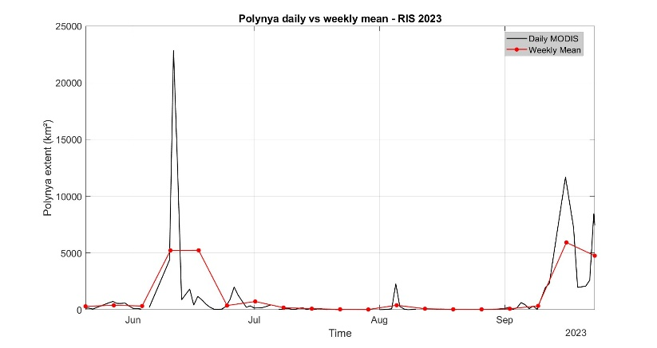
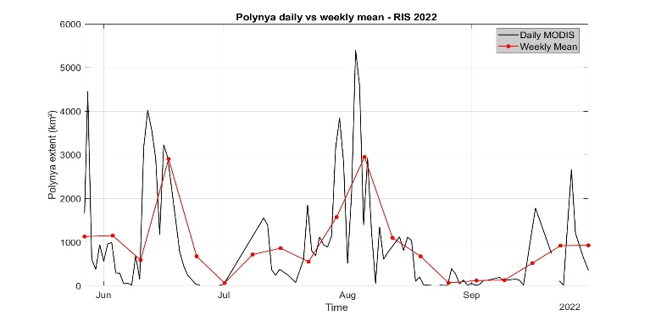
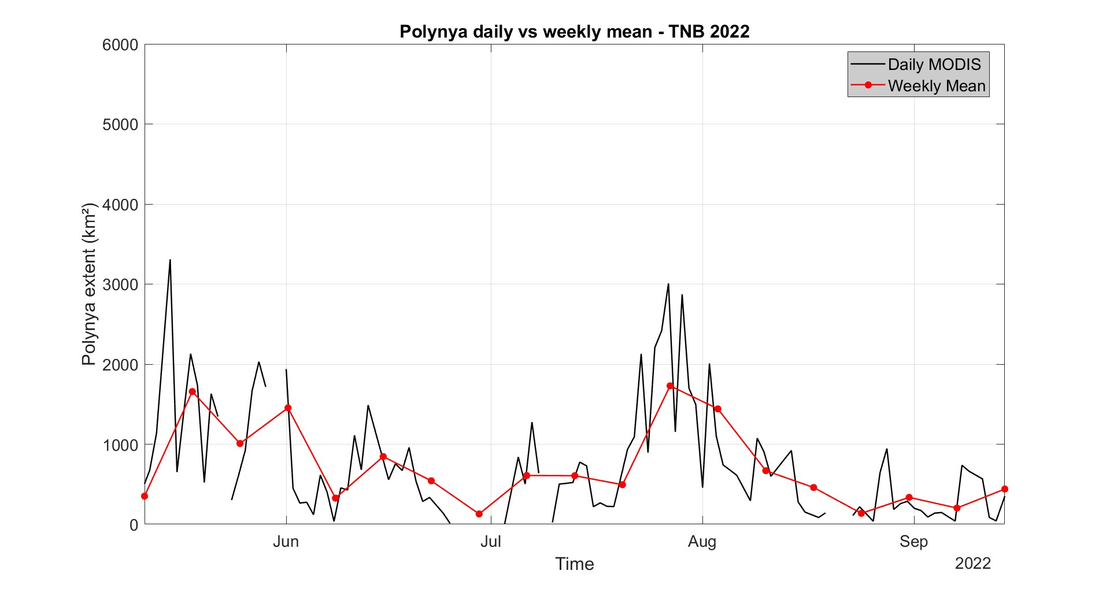
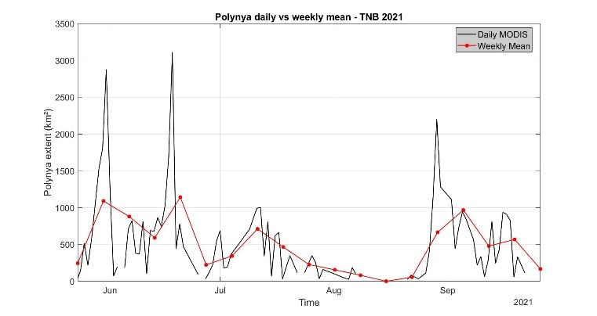
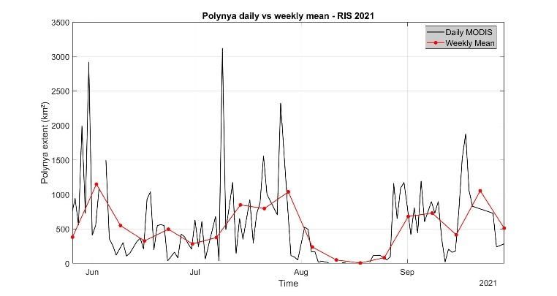
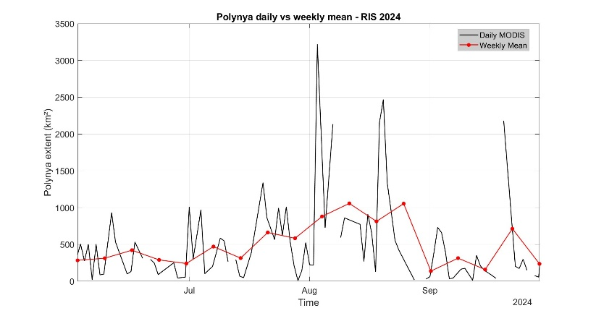
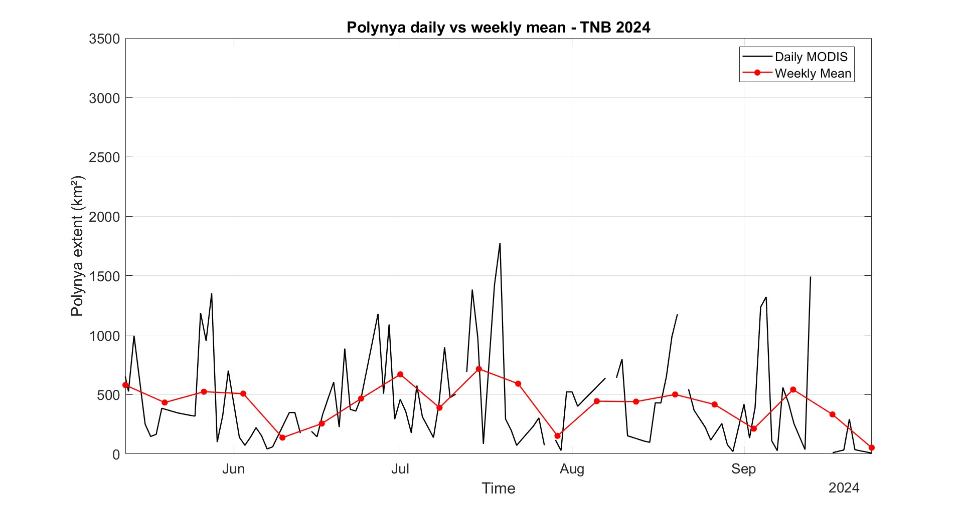
Supplementary Figure 15. Daily (black) and weekly (red) evolution of polynya extent (km²) for: (a) TNBp in 2021, (b) RISp in 2021, (c)TNBp in 2022, (d) RISp in 2022, (e) RISp in 2023, (f) TNBp in 2024, and (g) RISp in 2024.
a
b
f
g
c
e
d
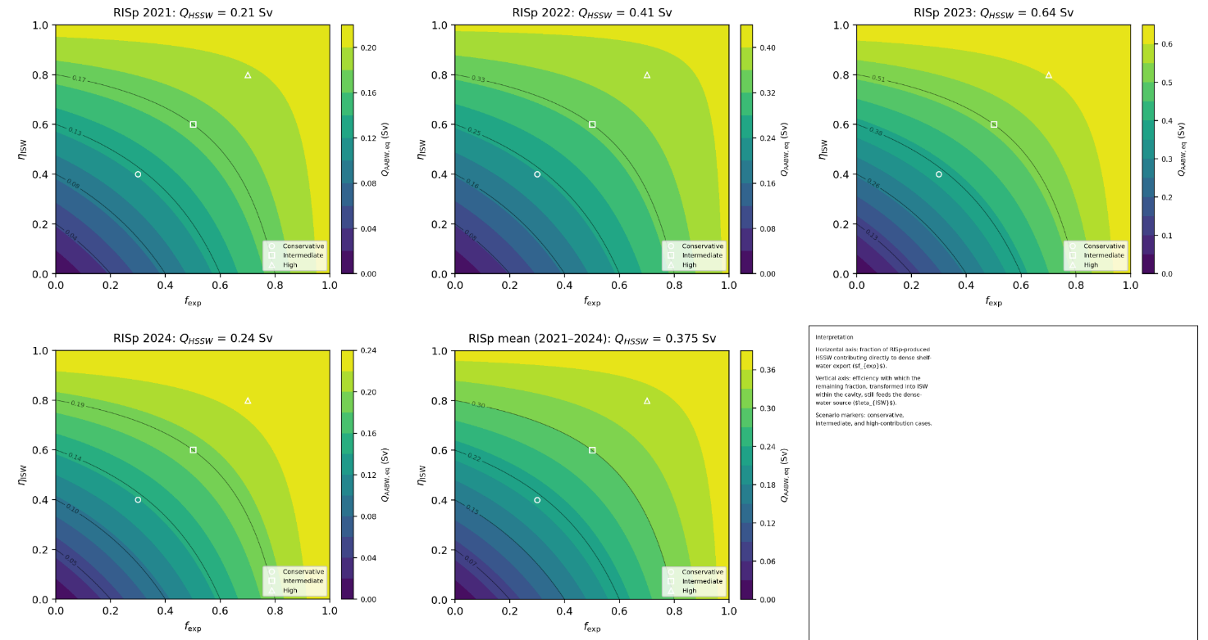
Supplementary Figure 16. Sensitivity of the RISp “AABW-equivalent” dense-water source term ($Q_{eq}$) to the fraction of HSSW exported off the shelf ($f_{exp}$) and to the efficiency of the ice-shelf–cavity (ISW) pathway ($η_{ISW}$). Markers denote conservative, intermediate, and high scenarios.

