Supplementary Material
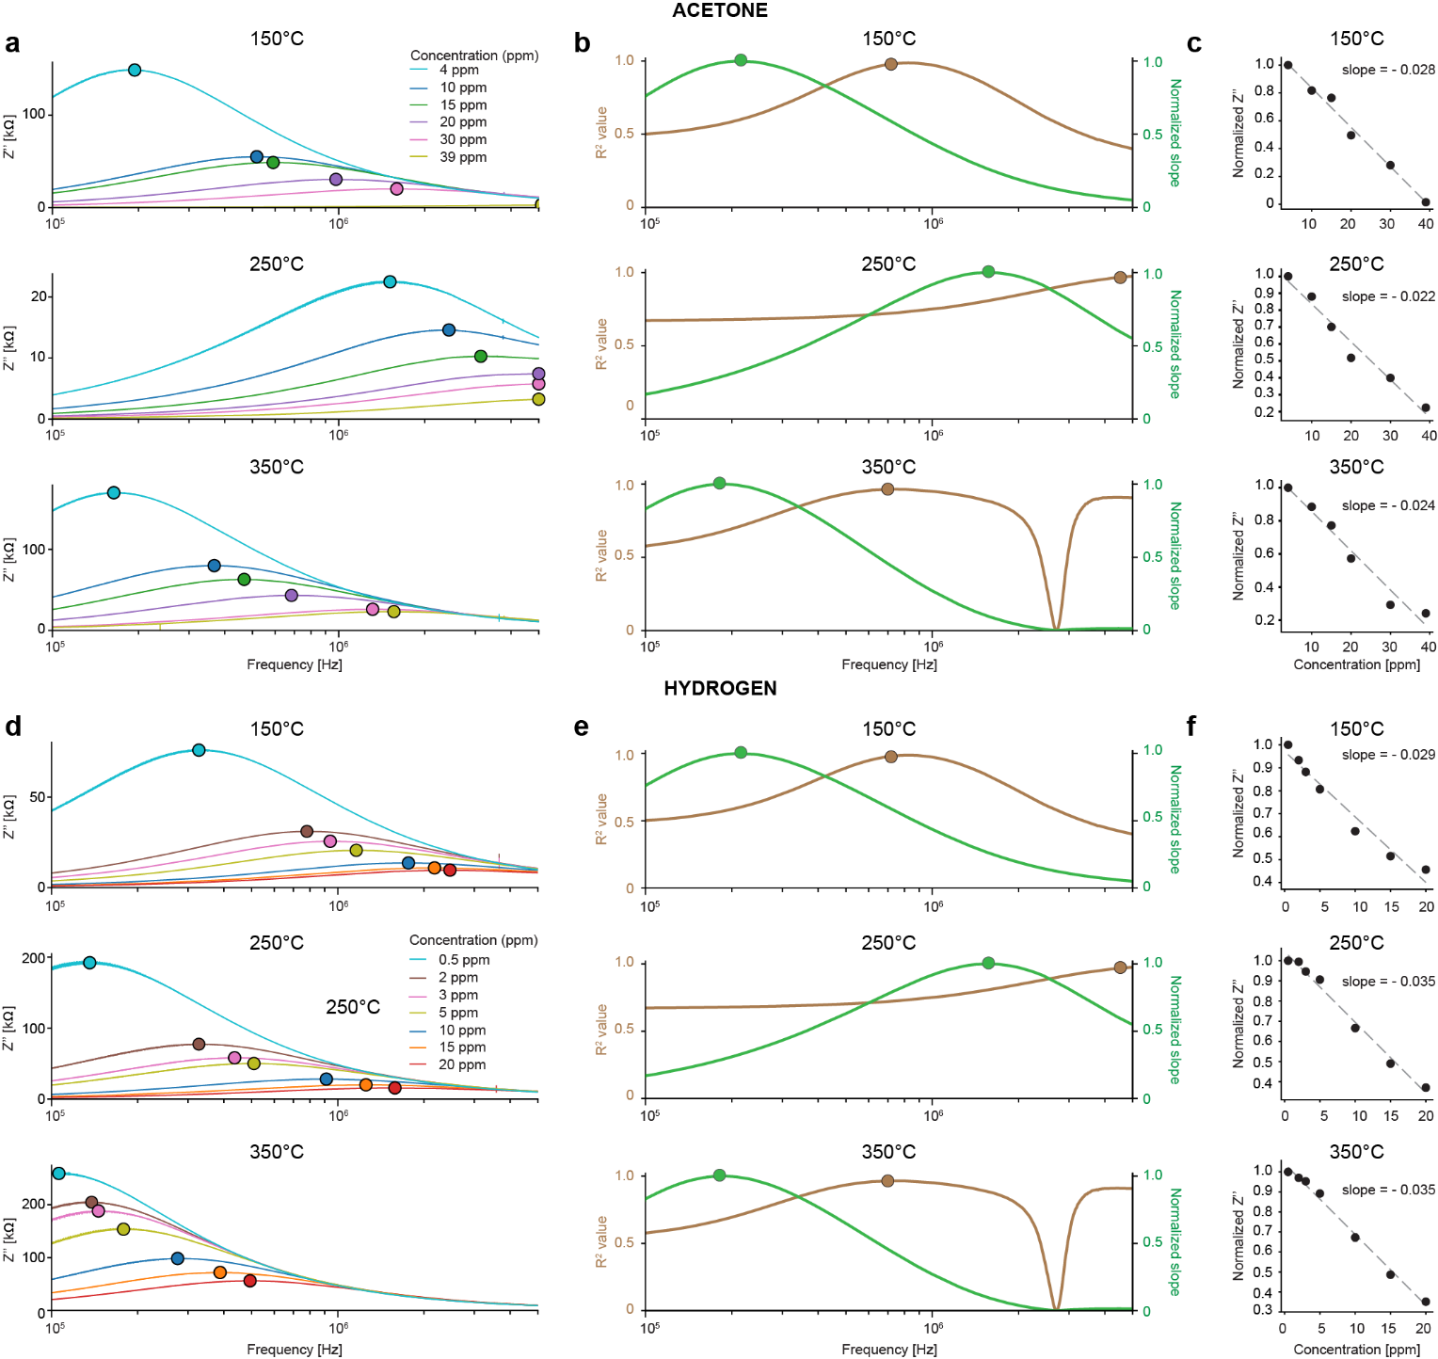

Supplementary figure 1. Temperature-dependent imaginary impedance responses (Z’’) and the corresponding optimum-frequency responses of acetone and hydrogen. (a, d) Z’’ responses measured at 150°C, 250°C, and 350°C for different concentrations of acetone and hydrogen, respectively. The colored markers indicate the Z’’ peak positions for each concentration. (b, e) Frequency-dependent R² and slope across normalized Z’’ and concentration used to identify optimum frequency (F*) at each temperature. The highlighted markers indicate the selected optimum frequencies at each operating temperature (which are 2.31 MHz at 150° C, 1.17 MHz at 250° C, 319.651kHz at 350° C for hydrogen and for acetone 4.51 MHz at 250° C, 824.64 kHz at 150°C, 695.10 kHz at 350°C. (c, f) Scatter plot showing normalized Z’’ responses as a function of gas concentration at the identified optimum frequencies. Note the linear decreasing trends for both acetone and hydrogen across all three temperatures (showing a linear decrease with increasing concentration R²= % 0.98,m=-0.028; R²= 0.96%, m=0.022-; R2 =0.96% , m=-0.024 at 150 °C, 250 °C, and 350 °C, respectively for acetone and for hydrogen R² = 0.96% ,m=-0.029; R²= 0.98%, m=-0.035; R²=0.99% , m=- 0.035 at 150 °C, 250 °C, and 350 °C, respectively). Each data point corresponds to the mean values (N=35 sweeps) of normalized Z’’$.$

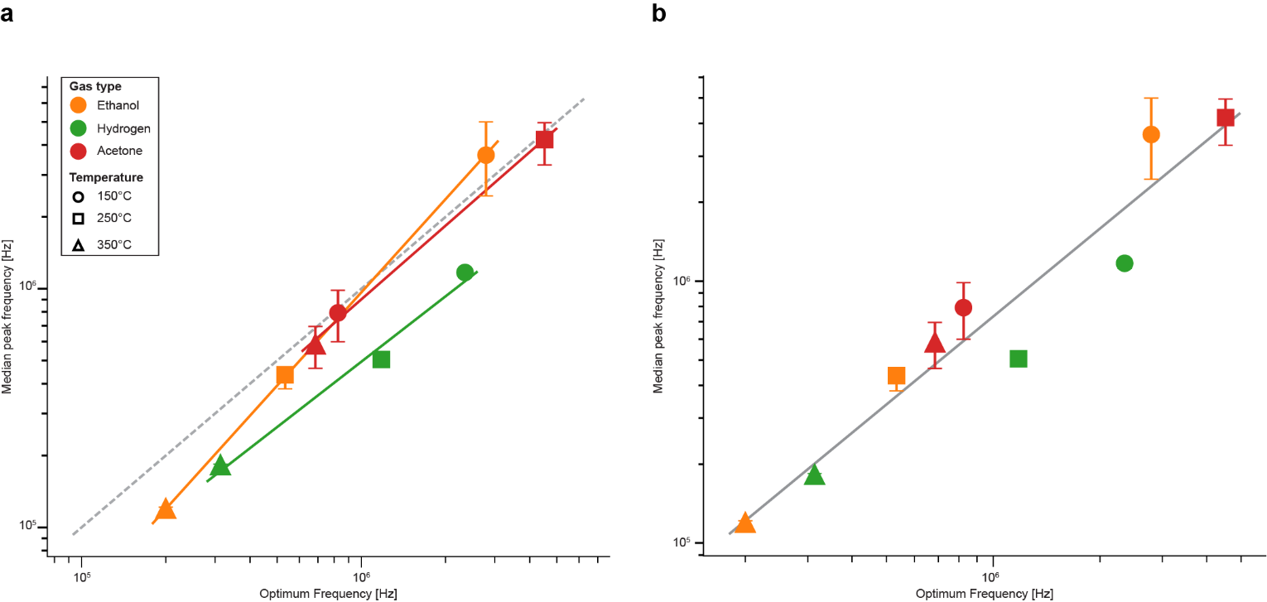
Supplementary figure 2. Relationship between selected optimum frequency and median Z’’ peak frequency across gases and temperatures. (a) Gas-specific log–log comparison between the optimum frequency and the median Z’’ peak frequency pooled across 35 sweeps and all gas concentrations at each temperature. Colors represent gas type: ethanol (orange), hydrogen (green), and acetone (red), while marker shapes indicate the operating temperature: 150°C, 250°C, and 350°C. Solid colored lines show log–log linear fits for individual gases. The dashed line represents the unit line where the optimum frequency equals the median peak frequency. Error bars indicate bootstrap 95% confidence intervals of the median peak frequency. (b) Global log–log relationship between optimum frequency and median Z’’ peak frequency obtained by fitting all gas–temperature points together. The solid grey line shows the global linear fit, with slope = 1.116 and R²=0.921, indicating a strong positive relationship.

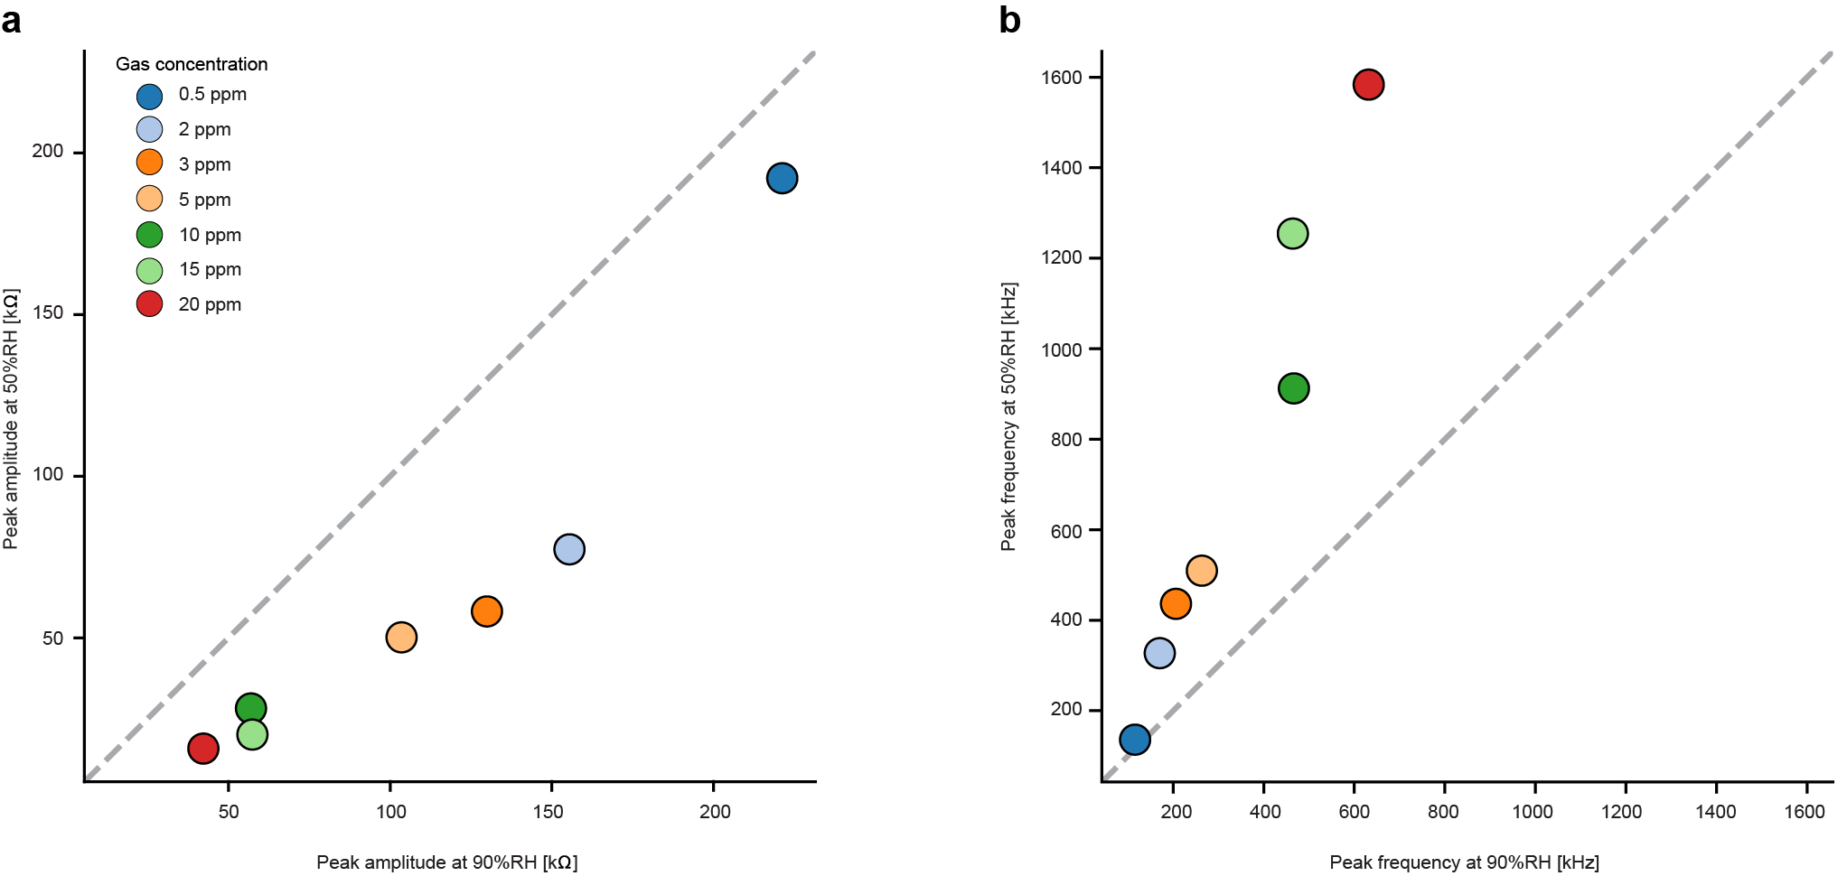
Supplementary figure 3. Humidity-induced modulation of Z’’ peak amplitude and peak-frequency response in hydrogen. (a) Comparison of Z″ peak amplitude measured at 90% RH and 50% RH for hydrogen concentrations from 0.5 to 20 ppm. Most points lie below the unity line (where the peak amplitudes at both humidity levels are equal, dashed grey), indicating a reduced peak amplitude at 50% RH compared with 90% RH. (b) Comparison of Z’’ peak frequency measured at 90% RH and 50% RH for the same hydrogen concentrations. Here most points lie above the unity line (in dashed grey), showing that the peak frequency shifts to higher values at 50% RH compared with 90% RH. Individual data points correspond to mean values computed from 35 frequency sweeps.

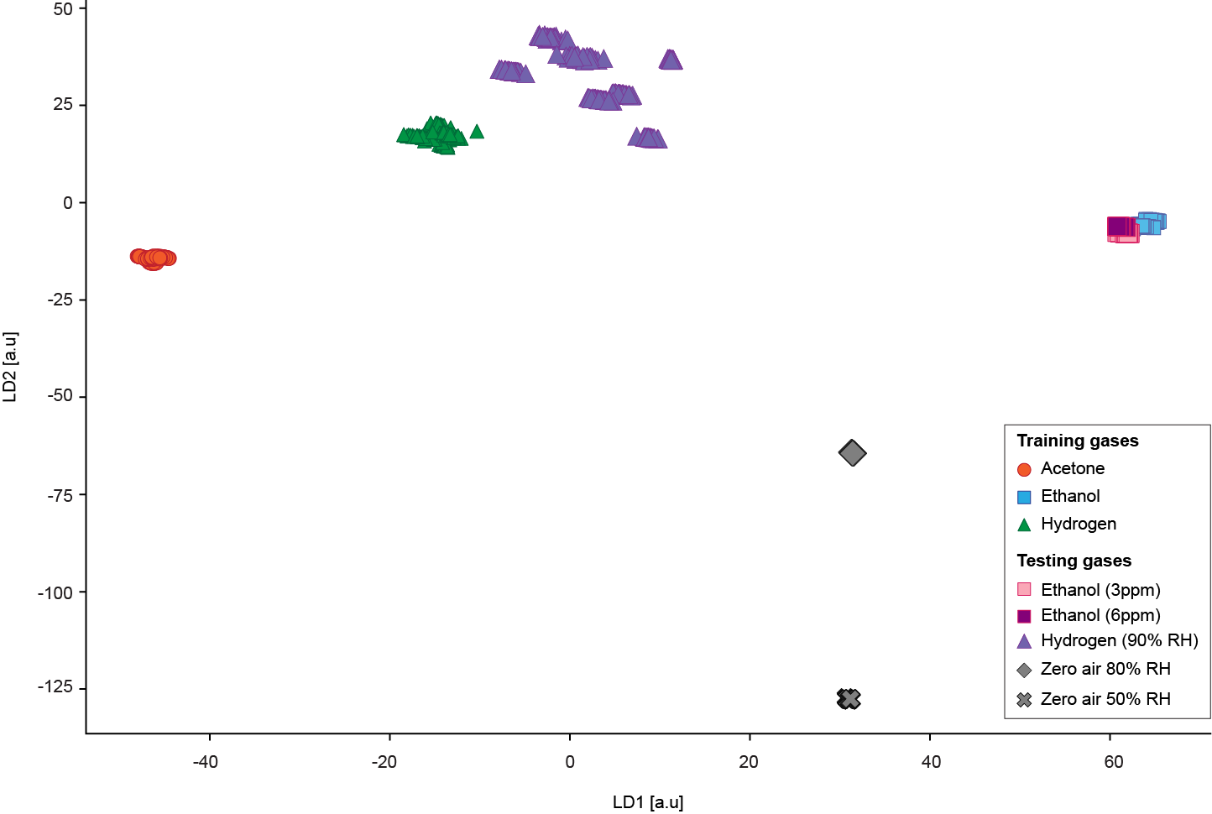
Supplementary figure 4. Linear discriminant analysis (LDA)-based discriminant mapping of EMG features for gas classification and unseen-condition testing. LDA projection of EMG-derived features ($A$, $μ$, $σ$, and $λ$) for modeling building and testing gas conditions. Model building samples of acetone, ethanol, and hydrogen form clearly separated clusters in the LD1–LD2 space. Testing samples, including ethanol at 3 ppm and 6 ppm, hydrogen at 90% RH, and zero-air conditions at 50% RH and 80% RH, are projected onto the same discriminant space to evaluate class separability and generalization under unseen concentration and humidity conditions. Each data point corresponds to an individual sweep.

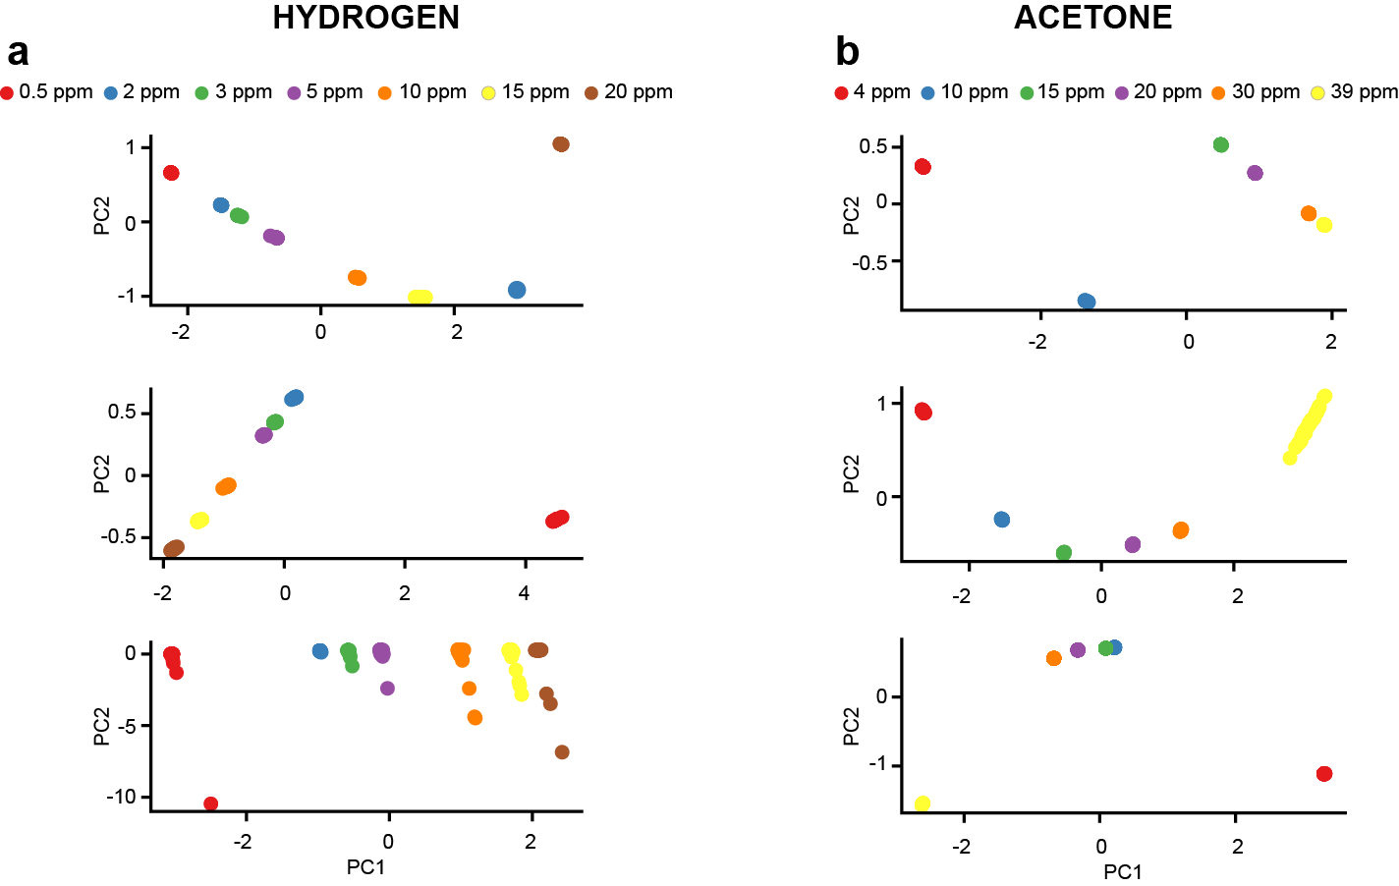
Supplementary Figure 5. LDA and PCA plots of EMG-derived impedance features for acetone and hydrogen at different operating temperatures. (a) PCA plots showing concentration-dependent changes in acetone at 150 °C, 250 °C, and 350 °C. Left column shows the supervised LDA projection in the LD1–LD2 space, while the right column shows the corresponding unsupervised PCA projection in the PC1–PC2 space (PC1/PC2 = 76.6%/22.7% at 150 °C, 90.1%/9.5% at 250 °C, and 93.9%/5.1% at 350 °C). Each marker represents one concentration condition, color-coded according to gas concentration. For acetone, the PCA explained variances were PC1/PC2 = 76.6%/22.7% at 150 °C, 90.1%/9.5% at 250 °C, and 93.9%/5.1% at 350 °C. The comparison shows that LDA provides stronger supervised separation between concentration levels than PCA by maximizing class discrimination in the EMG feature space across the three operating temperatures. (b) Same as in panel a, except for hydrogen. PC1/PC2 = 67.5%/25.0% at 150 °C, 94.7%/4.7% at 250 °C, and 88.0%/11.5% at 350 °C. Each data point corresponds to an individual sweep.

Supplementary Table 1. R² and slope of fits in Figure 4c, presenting each EMG feature relation to gas concentrations

Feature | Temp. (°C) | Gas | Concentration Points | Slope ppm/ feature | $$R^{2}$$
Amplitude (kΩ) | 150 | Acetone | 6 | -0.18 | 0.71
Amplitude (kΩ) | 150 | Ethanol | 8 | -0.38 | 0.82
Amplitude (kΩ) | 150 | Hydrogen | 7 | -0.18 | 0.48
Amplitude (kΩ) | 250 | Acetone | 6 | -1.67 | 0.70
Amplitude (kΩ) | 250 | Ethanol | 8 | -0.03 | 0.71
Amplitude (kΩ) | 250 | Hydrogen | 7 | -0.07 | 0.51
Amplitude (kΩ) | 350 | Acetone | 6 | -0.17 | 0.72
Amplitude (kΩ) | 350 | Ethanol | 8 | -0.07 | 0.98
Amplitude (kΩ) | 350 | Hydrogen | 7 | -0.08 | 0.90
Peak frequency log10(Hz) | 150 | Acetone | 6 | 15.97 | 0.90
Peak frequency log10(Hz) | 150 | Ethanol | 8 | 9.09 | 0.97
Peak frequency log10(Hz) | 150 | Hydrogen | 7 | 20.60 | 0.80
Peak frequency log10(Hz) | 250 | Acetone | 6 | 23.08 | 0.99
Peak frequency log10(Hz) | 250 | Ethanol | 8 | 8.06 | 0.95
Peak frequency log10(Hz) | 250 | Hydrogen | 7 | 14.38 | 0.76
Peak frequency log10(Hz) | 350 | Acetone | 6 | 27.37 | 0.90
Peak frequency log10(Hz) | 350 | Ethanol | 8 | 37.74 | 0.98
Peak frequency log10(Hz) | 350 | Hydrogen | 7 | 22.43 | 1.00
Sigma | 150 | Acetone | 6 | 72.58 | 0.75
Sigma | 150 | Ethanol | 8 | 40.59 | 0.96
Sigma | 150 | Hydrogen | 7 | 266.15 | 0.99
Sigma | 250 | Acetone | 6 | 93.92 | 0.99
Sigma | 250 | Ethanol | 8 | 42.81 | 0.97
Sigma | 250 | Hydrogen | 7 | 160.92 | 0.58
Sigma | 350 | Acetone | 6 | 201.66 | 0.77
Sigma | 350 | Ethanol | 8 | 338.44 | 0.42
Sigma | 350 | Hydrogen | 7 | 147.53 | 1.00
Lambda | 150 | Acetone | 6 | 0.30 | 0.19
Lambda | 150 | Ethanol | 8 | -30.87 | 0.33
Lambda | 150 | Hydrogen | 7 | -2403619.13 | 0.38
Lambda | 250 | Acetone | 6 | -1.15 | 0.86
Lambda | 250 | Ethanol | 8 | 0.09 | 0.38
Lambda | 250 | Hydrogen | 7 | 0.19 | 0.20
Lambda | 350 | Acetone | 6 | 0.41 | 0.58
Lambda | 350 | Ethanol | 8 | 80.75 | 0.96
Lambda | 350 | Hydrogen | 7 | 0.32 | 0.58

Supplementary Table 2. EMG fit parameters extracted from the first impedance sweep for ethanol, hydrogen, and acetone at all operating temperatures and gas concentrations. The table reports the fitted EMG model parameters and goodness-of-fit value $R^{2}$.

Gas | Temp (°C) | Conc. (ppm) | A | μ | σ | λ | $$R^{2}$$
Ethanol | 150 | 1 | 2.81e+04 | 6.034 | 0.515 | 50.000 | 0.9903
Ethanol | 150 | 2 | 1.9e+04 | 6.232 | 0.543 | 50.000 | 0.9916
Ethanol | 150 | 3 | 1.74e+04 | 6.276 | 0.548 | 50.000 | 0.9920
Ethanol | 150 | 4 | 1.41e+04 | 6.440 | 0.587 | 50.000 | 0.9941
Ethanol | 150 | 5 | 1.31e+04 | 6.510 | 0.604 | 50.000 | 0.9949
Ethanol | 150 | 6 | 1.22e+04 | 6.593 | 0.626 | 50.000 | 0.9956
Ethanol | 150 | 7 | 1.15e+04 | 6.645 | 0.637 | 50.000 | 0.9960
Ethanol | 150 | 8 | 9.8e+03 | 6.874 | 0.697 | 49.887 | 0.9972
Ethanol | 250 | 1 | 2.39e+05 | 4.857 | 0.318 | 2.500 | 0.9999
Ethanol | 250 | 2 | 1.26e+05 | 5.136 | 0.361 | 2.692 | 0.9994
Ethanol | 250 | 3 | 9.09e+04 | 5.290 | 0.392 | 2.974 | 0.9981
Ethanol | 250 | 4 | 8.64e+04 | 5.314 | 0.397 | 3.025 | 0.9978
Ethanol | 250 | 5 | 7.05e+04 | 5.421 | 0.419 | 3.408 | 0.9962
Ethanol | 250 | 6 | 5.57e+04 | 5.564 | 0.450 | 4.413 | 0.9940
Ethanol | 250 | 7 | 5.45e+04 | 5.585 | 0.454 | 4.711 | 0.9938
Ethanol | 250 | 8 | 4.67e+04 | 5.821 | 0.494 | 50.000 | 0.9925
Ethanol | 350 | 1 | 3.09e+05 | 4.743 | 0.291 | 2.410 | 0.9999
Ethanol | 350 | 2 | 2.92e+05 | 4.772 | 0.287 | 2.415 | 0.9999
Ethanol | 350 | 3 | 2.72e+05 | 4.805 | 0.286 | 2.426 | 0.9999
Ethanol | 350 | 4 | 2.6e+05 | 4.827 | 0.285 | 2.433 | 0.9999
Ethanol | 350 | 5 | 2.51e+05 | 4.844 | 0.285 | 2.442 | 0.9999
Ethanol | 350 | 6 | 2.24e+05 | 4.895 | 0.294 | 2.471 | 0.9999
Ethanol | 350 | 7 | 2.24e+05 | 4.895 | 0.292 | 2.469 | 0.9999
Ethanol | 350 | 8 | 2.08e+05 | 4.928 | 0.298 | 2.491 | 0.9998
Hydrogen | 150 | 0.5 | 9.82e+04 | 5.495 | 0.537 | 50.000 | 0.9890
Hydrogen | 150 | 2 | 4.06e+04 | 5.875 | 0.542 | 50.000 | 0.9914
Hydrogen | 150 | 3 | 3.37e+04 | 5.958 | 0.546 | 50.000 | 0.9919
Hydrogen | 150 | 5 | 2.75e+04 | 6.053 | 0.552 | 50.000 | 0.9926
Hydrogen | 150 | 10 | 1.9e+04 | 6.244 | 0.576 | 50.000 | 0.9943
Hydrogen | 150 | 15 | 1.58e+04 | 6.355 | 0.595 | 50.000 | 0.9952
Hydrogen | 150 | 20 | 1.43e+04 | 6.420 | 0.606 | 50.000 | 0.9956
Hydrogen | 250 | 0.5 | 2.44e+05 | 4.877 | 0.468 | 3.515 | 0.9913
Hydrogen | 250 | 2 | 1e+05 | 5.496 | 0.538 | 50.000 | 0.9889
Hydrogen | 250 | 3 | 7.49e+04 | 5.622 | 0.538 | 50.000 | 0.9899
Hydrogen | 250 | 5 | 6.58e+04 | 5.677 | 0.542 | 50.000 | 0.9904
Hydrogen | 250 | 10 | 3.7e+04 | 5.936 | 0.548 | 50.000 | 0.9917
Hydrogen | 250 | 15 | 2.72e+04 | 6.085 | 0.559 | 50.000 | 0.9932
Hydrogen | 250 | 20 | 2.19e+04 | 6.204 | 0.578 | 50.000 | 0.9943
Hydrogen | 350 | 0.5 | 2.96e+05 | 4.769 | 0.371 | 2.781 | 0.9957
Hydrogen | 350 | 2 | 2.38e+05 | 4.873 | 0.387 | 2.905 | 0.9951
Hydrogen | 350 | 3 | 2.2e+05 | 4.911 | 0.394 | 2.971 | 0.9949
Hydrogen | 350 | 5 | 1.82e+05 | 5.003 | 0.409 | 3.131 | 0.9944
Hydrogen | 350 | 10 | 1.18e+05 | 5.227 | 0.444 | 3.850 | 0.9935
Hydrogen | 350 | 15 | 8.73e+04 | 5.426 | 0.479 | 5.931 | 0.9930
Hydrogen | 350 | 20 | 6.86e+04 | 5.669 | 0.506 | 50.000 | 0.9934
Acetone | 150 | 4 | 1.78e+05 | 5.013 | 0.406 | 2.948 | 0.9949
Acetone | 150 | 10 | 6.81e+04 | 5.693 | 0.511 | 50.000 | 0.9946
Acetone | 150 | 15 | 6.13e+04 | 5.747 | 0.516 | 50.000 | 0.9951
Acetone | 150 | 20 | 3.88e+04 | 5.959 | 0.524 | 50.000 | 0.9941
Acetone | 150 | 30 | 2.67e+04 | 6.163 | 0.544 | 50.000 | 0.9941
Acetone | 150 | 39 | 8.35e+03 | 7.342 | 0.862 | 39.057 | 0.9987
Acetone | 250 | 4 | 3.18e+04 | 6.155 | 0.595 | 50.000 | 0.9905
Acetone | 250 | 10 | 2.28e+04 | 6.416 | 0.645 | 50.000 | 0.9939
Acetone | 250 | 15 | 1.85e+04 | 6.647 | 0.708 | 47.738 | 0.9964
Acetone | 250 | 20 | 1.63e+04 | 6.949 | 0.786 | 42.955 | 0.9975
Acetone | 250 | 30 | 1.56e+04 | 7.197 | 0.850 | 39.719 | 0.9981
Acetone | 250 | 39 | 1.49e+04 | 7.699 | 0.968 | 20.232 | 0.9984
Acetone | 350 | 4 | 2.07e+05 | 4.953 | 0.403 | 2.776 | 0.9962
Acetone | 350 | 10 | 1.02e+05 | 5.365 | 0.483 | 4.643 | 0.9959
Acetone | 350 | 15 | 7.94e+04 | 5.642 | 0.517 | 50.000 | 0.9955
Acetone | 350 | 20 | 5.53e+04 | 5.808 | 0.524 | 50.000 | 0.9954
Acetone | 350 | 30 | 3.45e+04 | 6.071 | 0.547 | 50.000 | 0.9930
Acetone | 350 | 39 | 3.11e+04 | 6.138 | 0.558 | 50.000 | 0.9930

Supplementary Algorithm 1. Optimum Frequency $F^{*}$ via Linearity $R^{2}$on Mean RAW $Z^{''}$with Slope Filter $γ$ and Compromise Threshold $τ$
Input: Dataset
$$D=\{(f_{i},c_{j},{\overset{‾}{Z^{''}}}_{ij})\}$$
where ${\overset{‾}{Z^{''}}}_{ij}$is the mean RAW imaginary impedance across all sweeps at frequency $f_{i}$and concentration $c_{j}$.
Compromise threshold: $τ≥0$; Minimum slope magnitude: $γ>0$, expressed in $Ω/\text{ppb}$or $Ω/\text{ppm}$, consistent with the concentration unit.
Output: Optimum frequency $F^{*}$and its corresponding $R_{\text{opt}}^{2}$

- Initialize:
$$R_{\text{opt}}^{2}←-∞,F^{*}←∅,\text{initialized}←\text{False}$$
- For each frequency $f$ in the set of unique frequencies in $D$:
2.1. Extract all concentration–response pairs at frequency $f$:
$$D_{f}←\{(c,{\overset{‾}{Z^{''}}}_{ij})∈D∣f_{i}=f\}$$
2.2. If $∣D_{f}∣<2$, skip this frequency.
2.3. Fit a linear model on the mean RAW $Z^{''}$:
$${\overset{‾}{Z^{''}}}_{Ω}=α_{f}c+β_{f}$$
2.4. Compute the coefficient of determination:
$$R_{f}^{2}$$
2.5. Apply the slope filter: If
$$∣α_{f}∣<γ$$
skip this frequency because its sensitivity is insufficient.
2.6. If no valid frequency has been initialized yet, set:
$$R_{\text{opt}}^{2}←R_{f}^{2},F^{*}←f,\text{initialized}←\text{True}$$
2.7. Otherwise, update the optimum frequency only if the current frequency improves $R^{2}$ by more than the compromise threshold:
$$R_{f}^{2}>R_{\text{opt}}^{2}+τ$$
If true, set:
$$R_{\text{opt}}^{2}←R_{f}^{2},F^{*}←f$$
- After all frequencies have been evaluated:
If no frequency satisfies the slope and linearity criteria ($\text{initialized}\text{ = }\text{False}$), return:
$$\text{“No frequency meets slope/}R^{2}\text{ criteria”}$$Otherwise, return:
$$\left(F^{*} , R_{\text{opt}}^{2}\right)$$

Supplementary Algorithm 2. EMG Fitting for Arbitrary Sweep Data (Implementation: Python 3.10.12, SciPy 1.15.3)
Input: Frequency data $F$and imaginary impedance data $Z^{''}$
Output: For each sweep $s$: fitted EMG parameters $\left(A_{s} , μ_{s} , σ_{s} , λ_{s}\right)$, coefficient of determination $R_{s}^{2}$, and fitted response ${\hat{y}}_{s}$
Step 0: EMG Model Definition
The exponentially modified Gaussian model is defined as:
$$EMG(x;A,μ,σ,λ)=A \frac{λ}{2}exp⁡\left[\frac{λ}{2}\left(2μ+λσ^{2}-2x\right)\right]erfc⁡\left[\frac{μ+λσ^{2}-x}{\sqrt{2}σ}\right]$$
where $x={log⁡}_{10}(f)$, $A$ is the amplitude-related scaling factor, $μ$ is the peak-location parameter, $σ$ controls the peak width, and $λ$ controls the asymmetry of the EMG curve.
Step 1: Normalize Input Shape
If $F$ and $Z^{''}$are one-dimensional arrays, set:
$$S=1$$
Otherwise, set $S$ equal to the number of sweeps.
Step 2: Sweep-wise Data Extraction and Validation
For each sweep:
$$s=1,…,S$$
extract the corresponding frequency and impedance vectors:
$$f_{s}←F[s,:] \\ z_{s}←Z^{''}[s,:]$$
Apply a validity mask to retain only physically meaningful and finite values:
$$M_{s}=\left\{i∣f_{s,i}>0, f_{s,i}∈R, z_{s,i}∈R\right\}$$
Then compute the logarithmic frequency vector and the corresponding valid impedance vector:
$$x_{s}={log⁡}_{10}\left(f_{s}[M_{s}]\right) \\ y_{s}=z_{s}[M_{s}]$$
If the number of valid data points is less than 10, or if the maximum value of $y_{s}$ is non-positive, skip the current sweep:
$$∣x_{s}∣<10 \text{or} max⁡(y_{s})≤0$$
Step 3: Initial Guess and Parameter Bounds
For each valid sweep, initialize the EMG parameters

$$p_{0,s}=\left[\begin{aligned}A_{0} \\ μ_{0} \\ σ_{0} \\ λ_{0}\end{aligned}\right]=\left[\begin{aligned}max⁡(y_{s}) \\ x_{s,arg max⁡(y_{s})} \\ 0.25 \\ 1.0\end{aligned}\right]$$
The fitting parameters are constrained using the following bounds:
$$Ω_{s}=\left\{\begin{aligned}0≤A≤10A_{0}, \\ x_{min}-1≤μ≤x_{max}+1, \\ {10}^{-3}≤σ≤2, \\ {10}^{-3}≤λ≤50\end{aligned}\right.$$
where:
$$x_{min}=min⁡(x_{s}) \\ x_{max}=max⁡(x_{s})$$
Step 4: Nonlinear Least-Squares EMG Fitting
The optimum EMG parameter vector for sweep $s$is obtained by solving:
$$p_{s}^{⋆}=arg⁡\underset{p∈Ω_{s}}{min⁡}\sum_{i}{{\left(y_{s,i}-EMG(x_{s,i};p)\right)}^{2}}$$
The fitted parameters are then assigned as:
$$(A_{s},μ_{s},σ_{s},λ_{s})←p_{s}^{⋆}$$
The fitted EMG response is computed as:
$${\hat{y}}_{s}=EMG\left(x_{s} ; p_{s}^{⋆}\right)$$
Step 5: Goodness-of-Fit Evaluation
For each successfully fitted sweep, compute the coefficient of determination:
$$R_{s}^{2}=1-\frac{\sum_{i}{{\left(y_{s,i} − {\hat{y}}_{s,i}\right)}^{2}}}{\sum_{i}{{\left(y_{s,i} − {\overset{ˉ}{y}}_{s}\right)}^{2}}}$$
where the mean measured response is:
$${\overset{ˉ}{y}}_{s}=\frac{1}{∣y_{s}∣}\sum_{i}{y_{s,i}}$$Final Output
After all sweeps have been processed, return:
$${\left\{(A_{s},μ_{s},σ_{s},λ_{s},R_{s}^{2},{\hat{y}}_{s})\right\}}_{s=1}^{S}$$

