Supplementary Table 1: Enrollment and Follow-up Completion Dates for All Patients
Patient ID | Group | Enrollment Date Range | Follow-up Completion Date | Remarks
1–20 | Observation Group (Autologous Great Saphenous Vein Graft) | Jan 2024 – May 2024 | May 2026 | 24-month follow-up completed
21–40 | Control Group (Prosthetic G/Traditional Upper Limb AVF) | Jan 2024 – May 2024 | May 2026 | 24-month follow-up completed
NOTE. This study consecutively enrolled 40 ESRD patients from two tertiary hospitals: Yingtan 184 Hospital (China RongTong Medical Healthcare Group Co. Ltd.) and the Second Affiliated Hospital of Jiangxi Medical College, Nanchang University. Observation group: autologous great saphenous vein transplantation; Control group: prosthetic graft or traditional upper-limb arteriovenous fistula. Enrollment period: January 2024–May 2024. All participants completed a 24-month follow-up, with the final follow-up visit in May 2026.

Supplementary Figure 1. The detailed surgical workflow and key procedural steps for both the observation and control groups
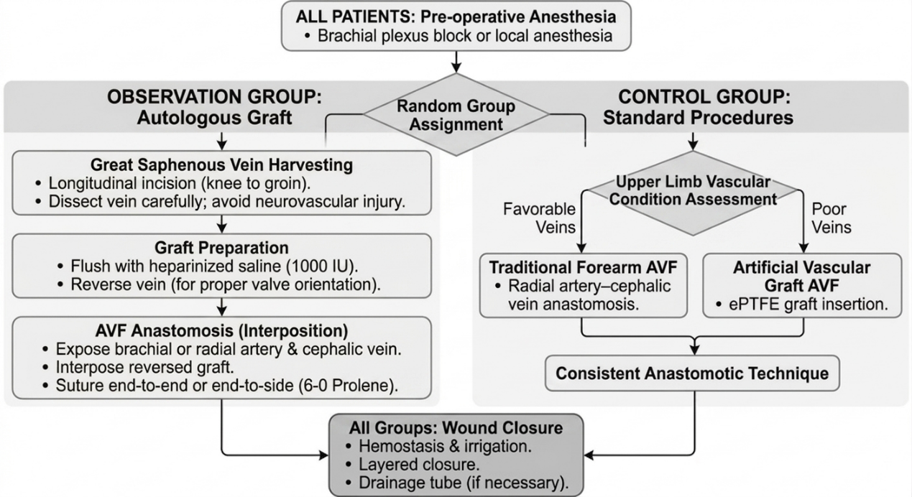
Note: The flowchart illustrates the standardized surgical protocols for the study. Patients in the Observation Group received autologous GSV transplantation, featuring a mandatory "vein reversal" step to accommodate valve orientation. The Control Group underwent either traditional forearm AVF or ePTFE graft placement based on native vascular quality. Standardized anesthesia, heparinized saline flushing, and 6-0 Prolene suturing were maintained across both groups to ensure procedural consistency.

