Supplementary Figure S1. Comparison of merging accuracy metrics among five benchmarking tools across the 150-sample population cohort
Supplementary Fig. S1 | Comparison of merging accuracy metrics among five benchmarking tools across the 150-sample population cohort. Bar plots illustrate the precision, recall, and F1 score achieved by each tool during the population-scale integration of 150 simulated long-read samples.

Supplementary Figure S2. Merging performance distributions among five tools across fifty genetic trios.

Supplementary Fig. S2 | Merging performance distributions among five tools across fifty genetic trios. Box plots represent the distributions of precision, recall, and F1 score evaluated independently across the fifty pedigree trios.

Supplementary Figure S3. Parameter sensitivity analysis of the PICO algorithm across fifty genetic trios under varying base tolerance configurations
Supplementary Fig. S3 | Parameter sensitivity analysis of the PICO algorithm across fifty genetic trios under varying base tolerance configurations. Box plots display the F1 score distributions across ten different matching evaluation distances (termed as Threshold) while shifting the internal base tolerance parameter ($baseTolerance$) from 100 bp to 1,000 bp (with a 100-bp step size) under a fixed 1,000-bp merging distance.

Supplementary Figure S4. IGV visualizations of over-merging artifacts generated by alternative tools at a relaxed distance threshold
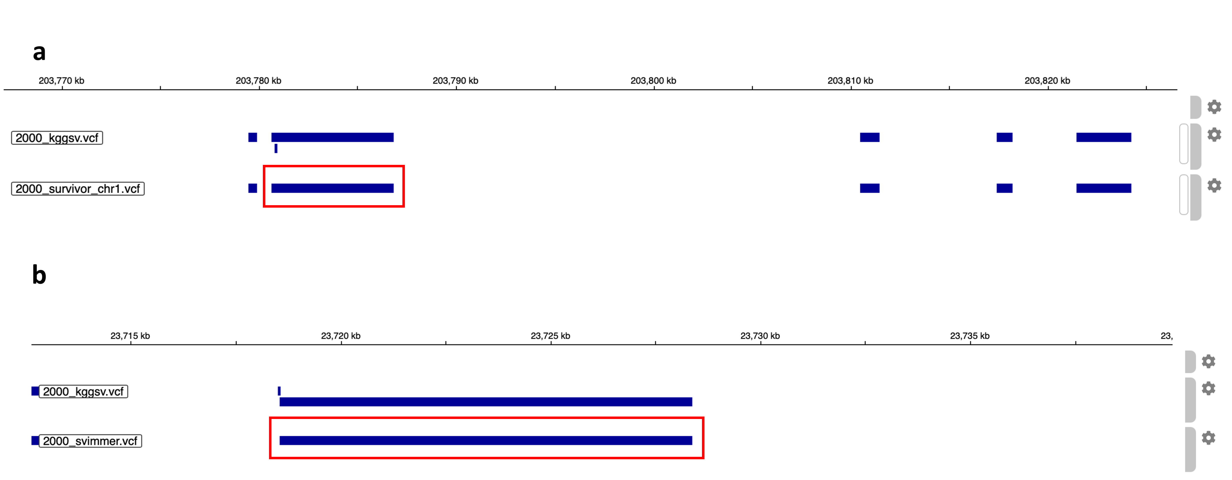
Supplementary Fig. S4 | IGV visualizations of over-merging artifacts generated by alternative tools at a relaxed distance threshold. Loci examples illustrate the erroneous collapse of distinct, adjacent structural variant (SV) alleles into a single incorrect cluster when using a wide merging threshold of 2,000 bp. (a) Representative example of the erroneous over-merging of independent adjacent deletions (DEL) by SURVIVOR on chromosome 1. (b) Representative example of the erroneous over-merging of distinct deletion alleles by svimmer on chromosome 22. These artifacts demonstrate how traditional greedy heuristics sacrifice genomic resolution and fail to resolve complex, tightly clustered multi-allelic loci under relaxed window constraints.

Supplementary Figure S5. IGV visualizations of under-merging and allele fragmentation artifacts at a stringent distance threshold
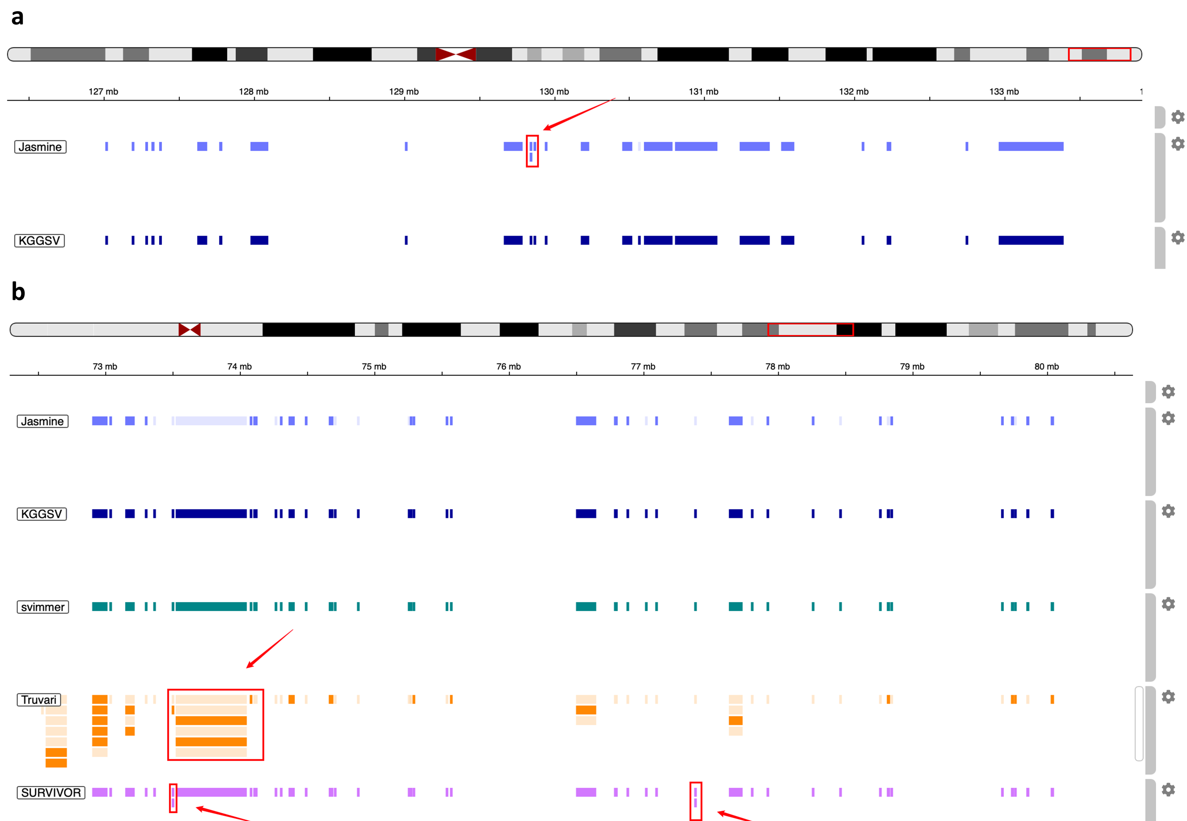
Supplementary Fig. S5 | IGV visualizations of under-merging and allele fragmentation artifacts at a stringent distance threshold. Loci examples demonstrate the failure of alternative algorithms to reconcile homologous but breakpoint-shifted SV alleles across samples when restricted to a high-resolution merging threshold of 100 bp. (a) Example of missed merging (under-merging) of a SV allele by Jasmine on chromosome 11 due to minor positioning alignment variation. (b) Example of redundant fragmentation of identical homologous alleles into separate, artificial low-frequency clusters by Truvari and SURVIVOR on chromosome 14. Such under-merging artifacts typically lead to an artificial inflation of unique variant counts and a severe underestimation of true population allele frequencies.

Supplementary Figure S6. The graphical management interfaces for PACKER

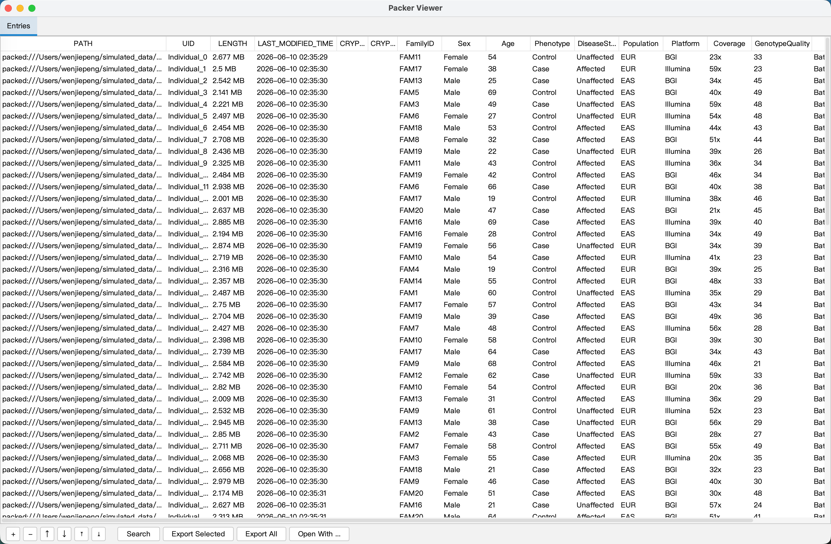
Supplementary Fig. S6 | The graphical management interfaces for PACKER.

