Supplementary Material

Epidemiological characteristics and intervention-associated transmission dynamics of the largest chikungunya fever outbreak in China

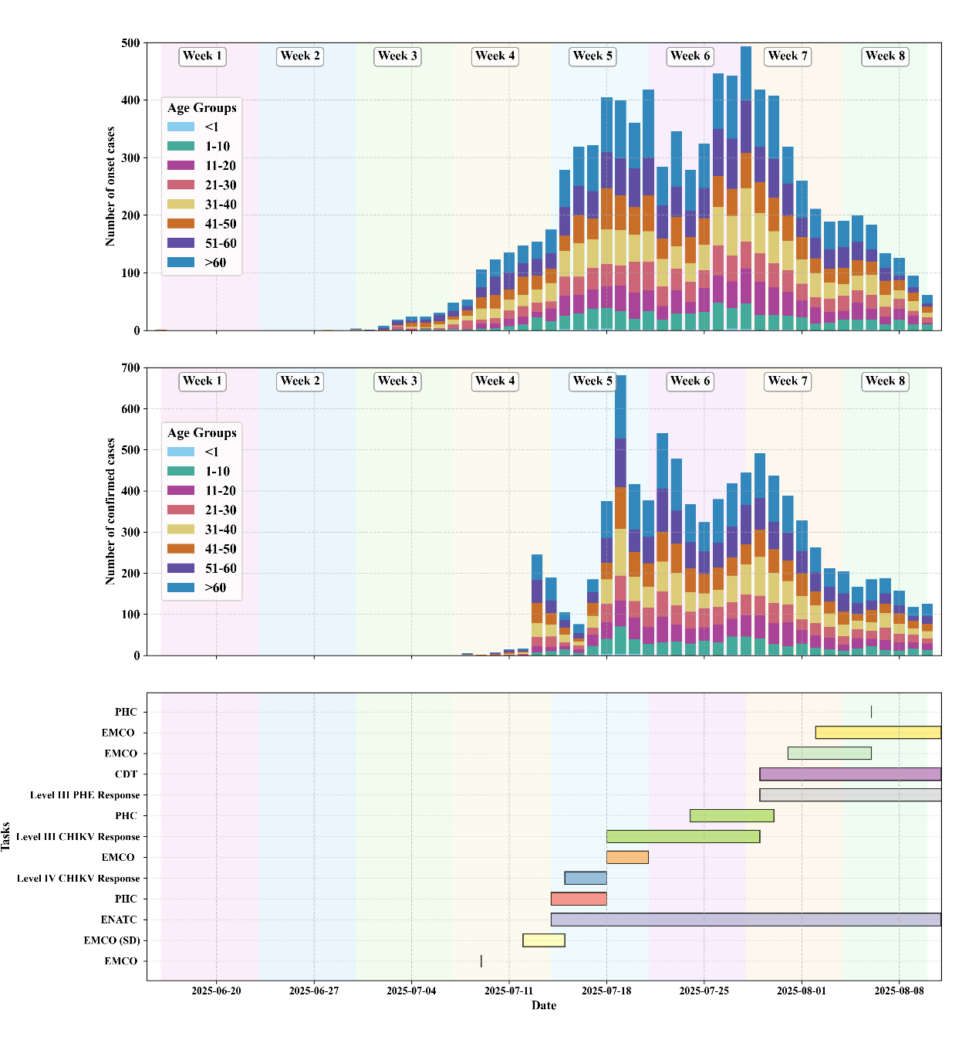
Figure S1. Epidemic curve of chikungunya fever cases categorised by age group, and the timeline for implementing key prevention and control measures in Foshan, from June 16 to August 10, 2025. The upper section displays the epidemic curve for various age groups based on the dates of onset and confirmation of cases. The lower section features a Gantt chart that outlines the timeframes for implementing different intervention measures.
SS = Sanshui District, NH = Nanhai District, CC = Chancheng District, SD = Shunde District, GM = Gaoming District, PHC = Patriotic Health Campaign, EMCO = Citywide Mosquito Eradication Operations, CDT = Launching the Civilian Disinfection Team, PHE = Public Health Emergencies, CHIKV = Chikungunya virus, ENATC = Expand nucleic acid testing capacity.

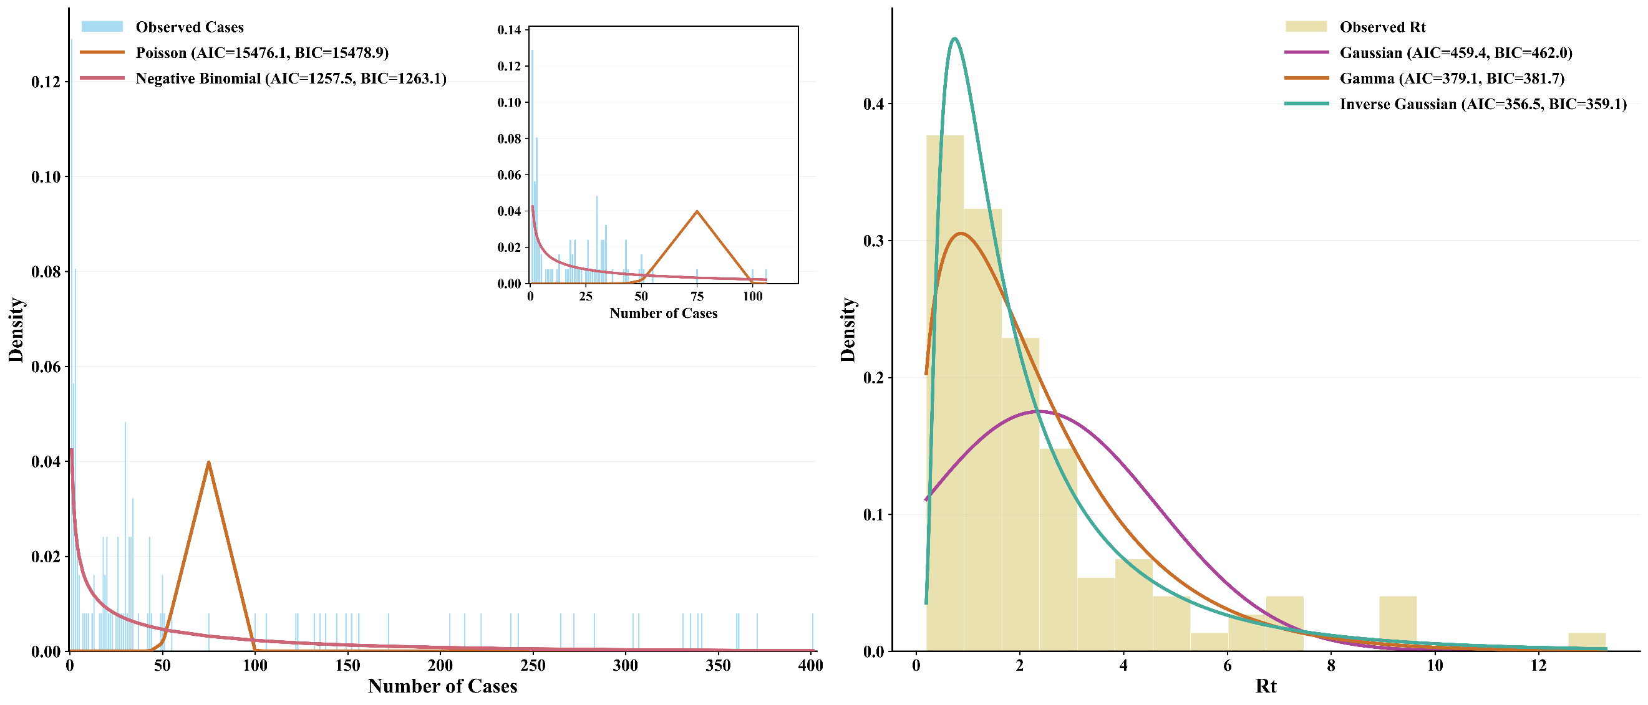
Figure S2. The distribution and fitting curve of the dependent variable in the non-lagged generalised estimating equation (GEE) model in Foshan, between 9 July and 10 August, in 2025. The left panel shows the distribution of the number of cases and its fitting curve, with the upper-right subplot displaying a focus plot within the numerical range 0–120. The right panel presents the distribution of the effective reproduction number and its fitting curve. AIC = Akaike Information Criterion, BIC = Bayesian Information Criterion, $R_{t}$ = the effective reproduction number.

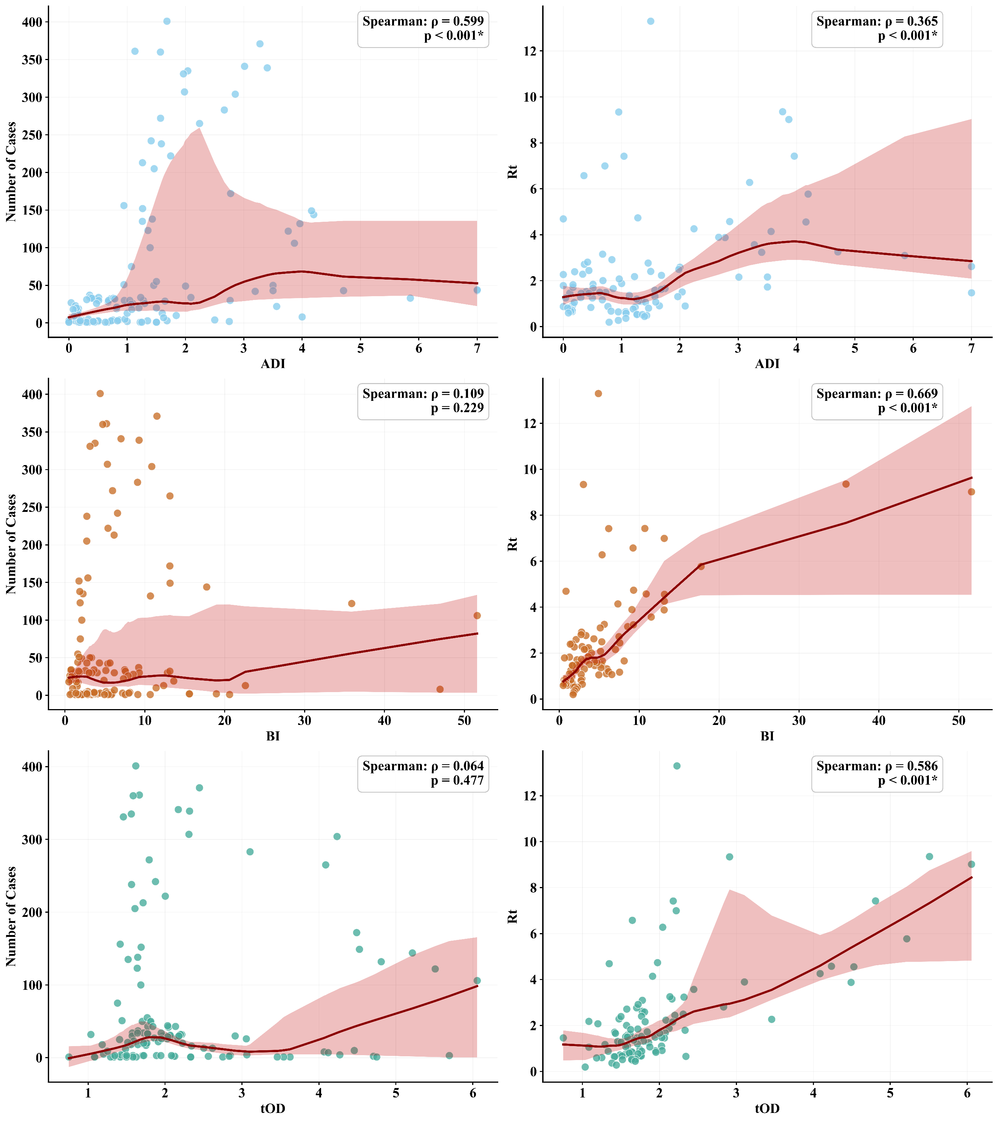
Figure S3. Scatter plots of different independent and dependent variables with their locally weighted scatterplot smoothing (LOWESS) fitted curves in the non-lagged GEE model in Foshan, between 9 July and 10 August, in 2025. $R_{t}$ = the effective reproduction number, *: p<0.05.

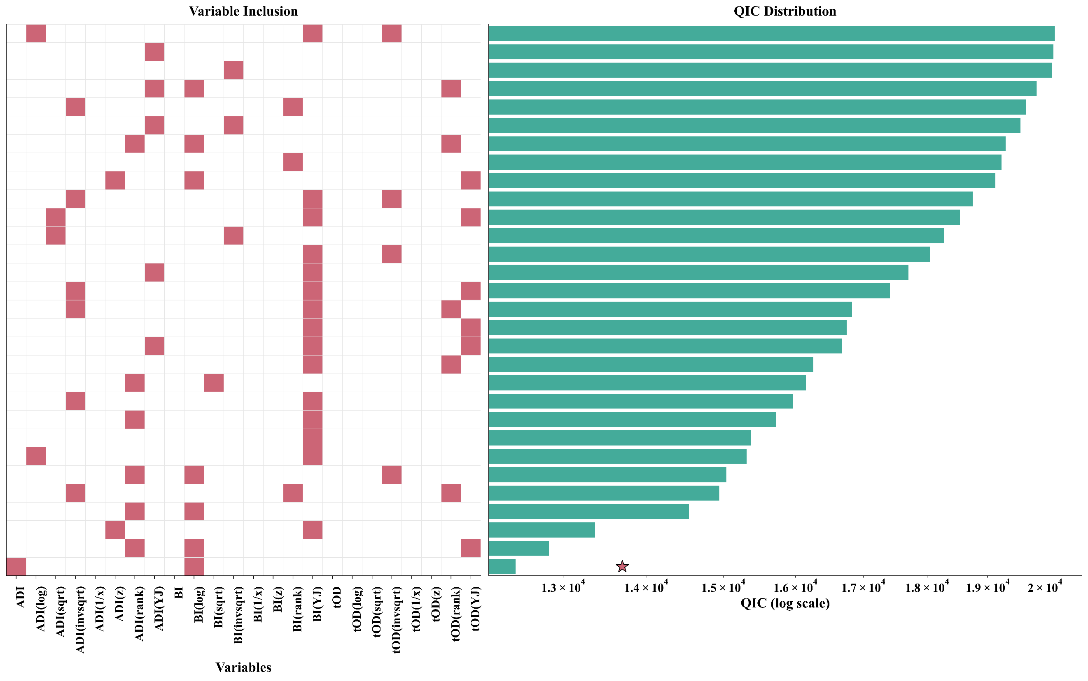
Figure S4. The logarithmic-scaled quasi-likelihood under the independence model criterion (QIC) of the top 30 non-lagged GEE model combinations for the number of cases in Foshan, between 9 July and 10 August, in 2025. A total of 322 model combinations successfully passed the collinearity test and convergence, exhibiting a QIC value lower than that of the null model. These combinations were included in the final QIC comparison. For clarity in presentation, we have visualised only the top 30 model combinations with the lowest QIC values. All the top 30 models have autoregressive structures. The best model is marked with a five-pointed star. Given the substantial disparity in the magnitude of the QIC values, we employed a logarithmic scale to represent QIC.
ADI = Adult mosquito Density Index, BI = Breteau Index, tOD = the onset-to-diagnosis interval, log = Logarithmic transformation, sqrt = Square root transformation, invsqrt = Inverse square root transformation, 1/x = reciprocal transformation, z = Z-score transformation, rank = Rank transformation, YJ = Yeo-Johnson transformation.

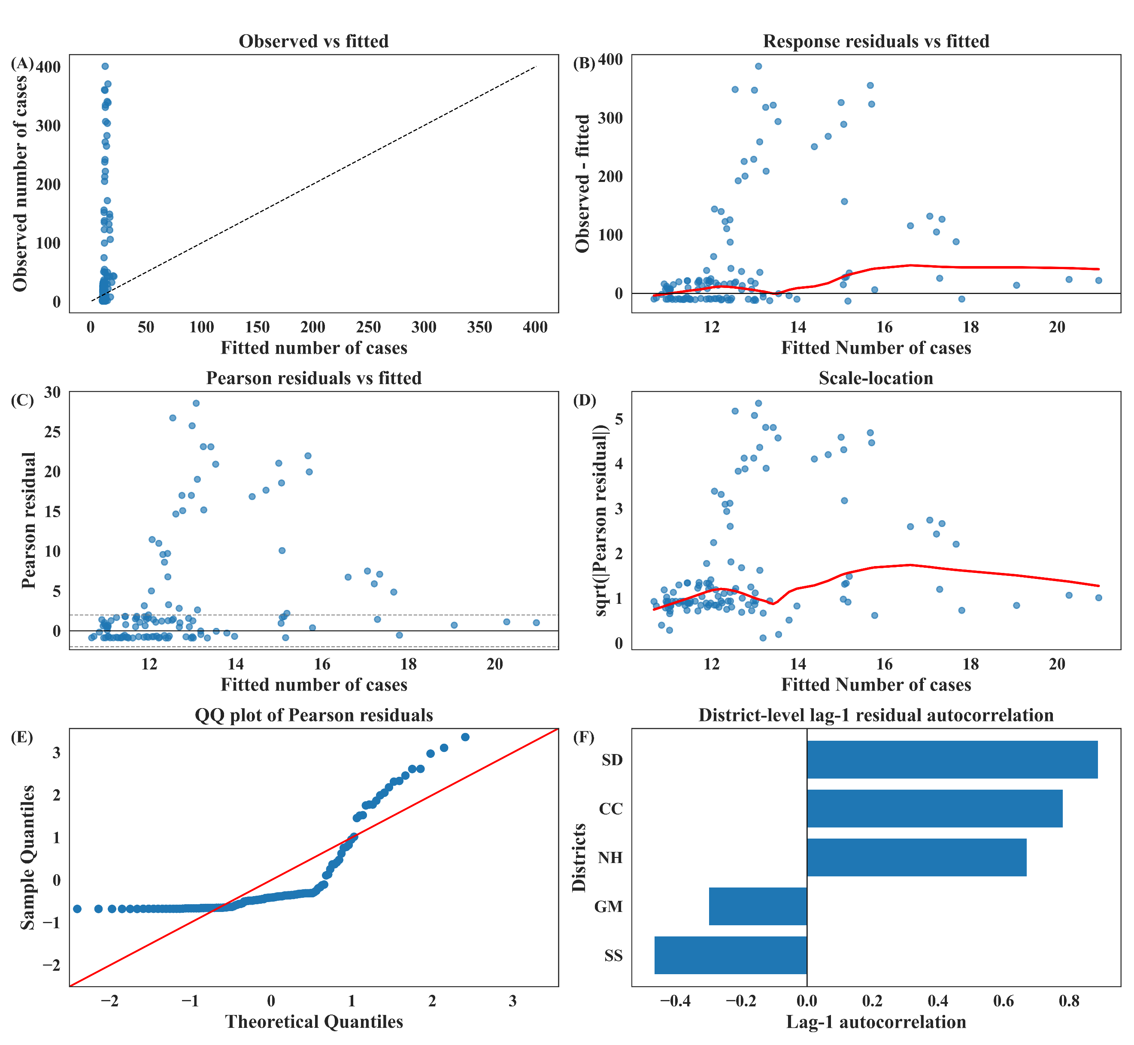
Figure S5. The residual diagnostic of the non-lagged GEE model combinations for the number of cases in Foshan, between 9 July and 10 August, in 2025. Panels show (A) observed versus fitted values with the 45-degree reference line, (B) response residuals versus fitted values with a LOWESS smoother, (C) Pearson residuals versus fitted values with reference lines at 0 and ±2, (D) scale-location plot for the square root of the absolute standardised Pearson residuals. versus fitted values with a LOWESS smoother, (E) Q-Q plot of standardised Pearson residuals, and (F) district-level lag-1 autocorrelation of Pearson residuals.
SS = Sanshui District, NH = Nanhai District, CC = Chancheng District, SD = Shunde District, GM = Gaoming District.
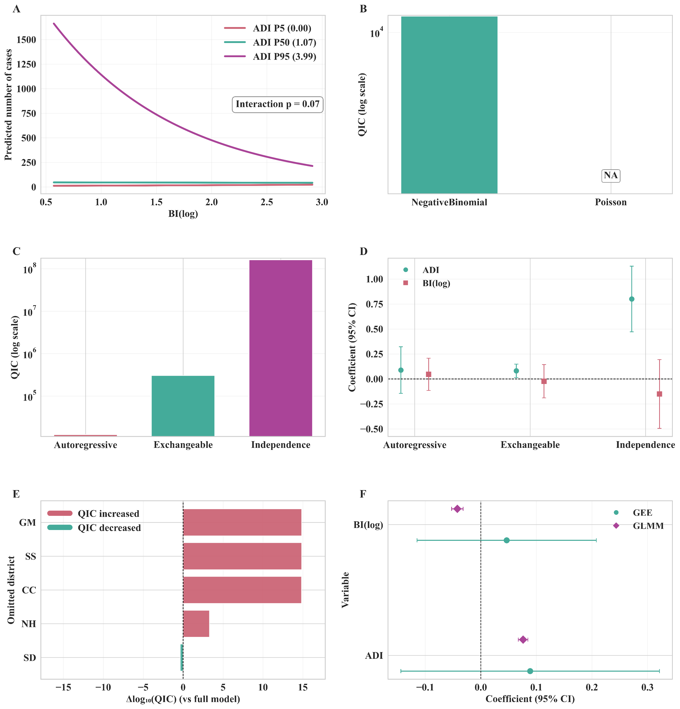
Figure S6. The interaction effect and sensitivity analysis of the non-lagged GEE model combinations for the number of cases in Foshan, between 9 July and 10 August, in 2025. (A) Interaction effect from the optimal GEE model; the centre-right displays the p-value of the Wald test. (B) Comparison of log-transformed QIC values for different family parameters in the optimal GEE model; “NA” indicate missing QIC for that family. (C) Comparison of log-transformed QIC values for different working correlation structure parameters in the optimal GEE model. (D) Comparison of coefficient sensitivity for different working correlation structure parameters for different independent variables in the optimal GEE model. (E) Log-transformed differences in QIC values for a relatively comprehensive model within the framework of leave-one-district-out sensitivity analysis. (F) Comparison of coefficient sensitivity for GEE and generalised linear mixed-effects model (GLMM).
ADI = Adult mosquito Density Index, BI = Breteau Index, log = Logarithmic transformation, SS = Sanshui District, NH = Nanhai District, CC = Chancheng District, SD = Shunde District, GM = Gaoming District.

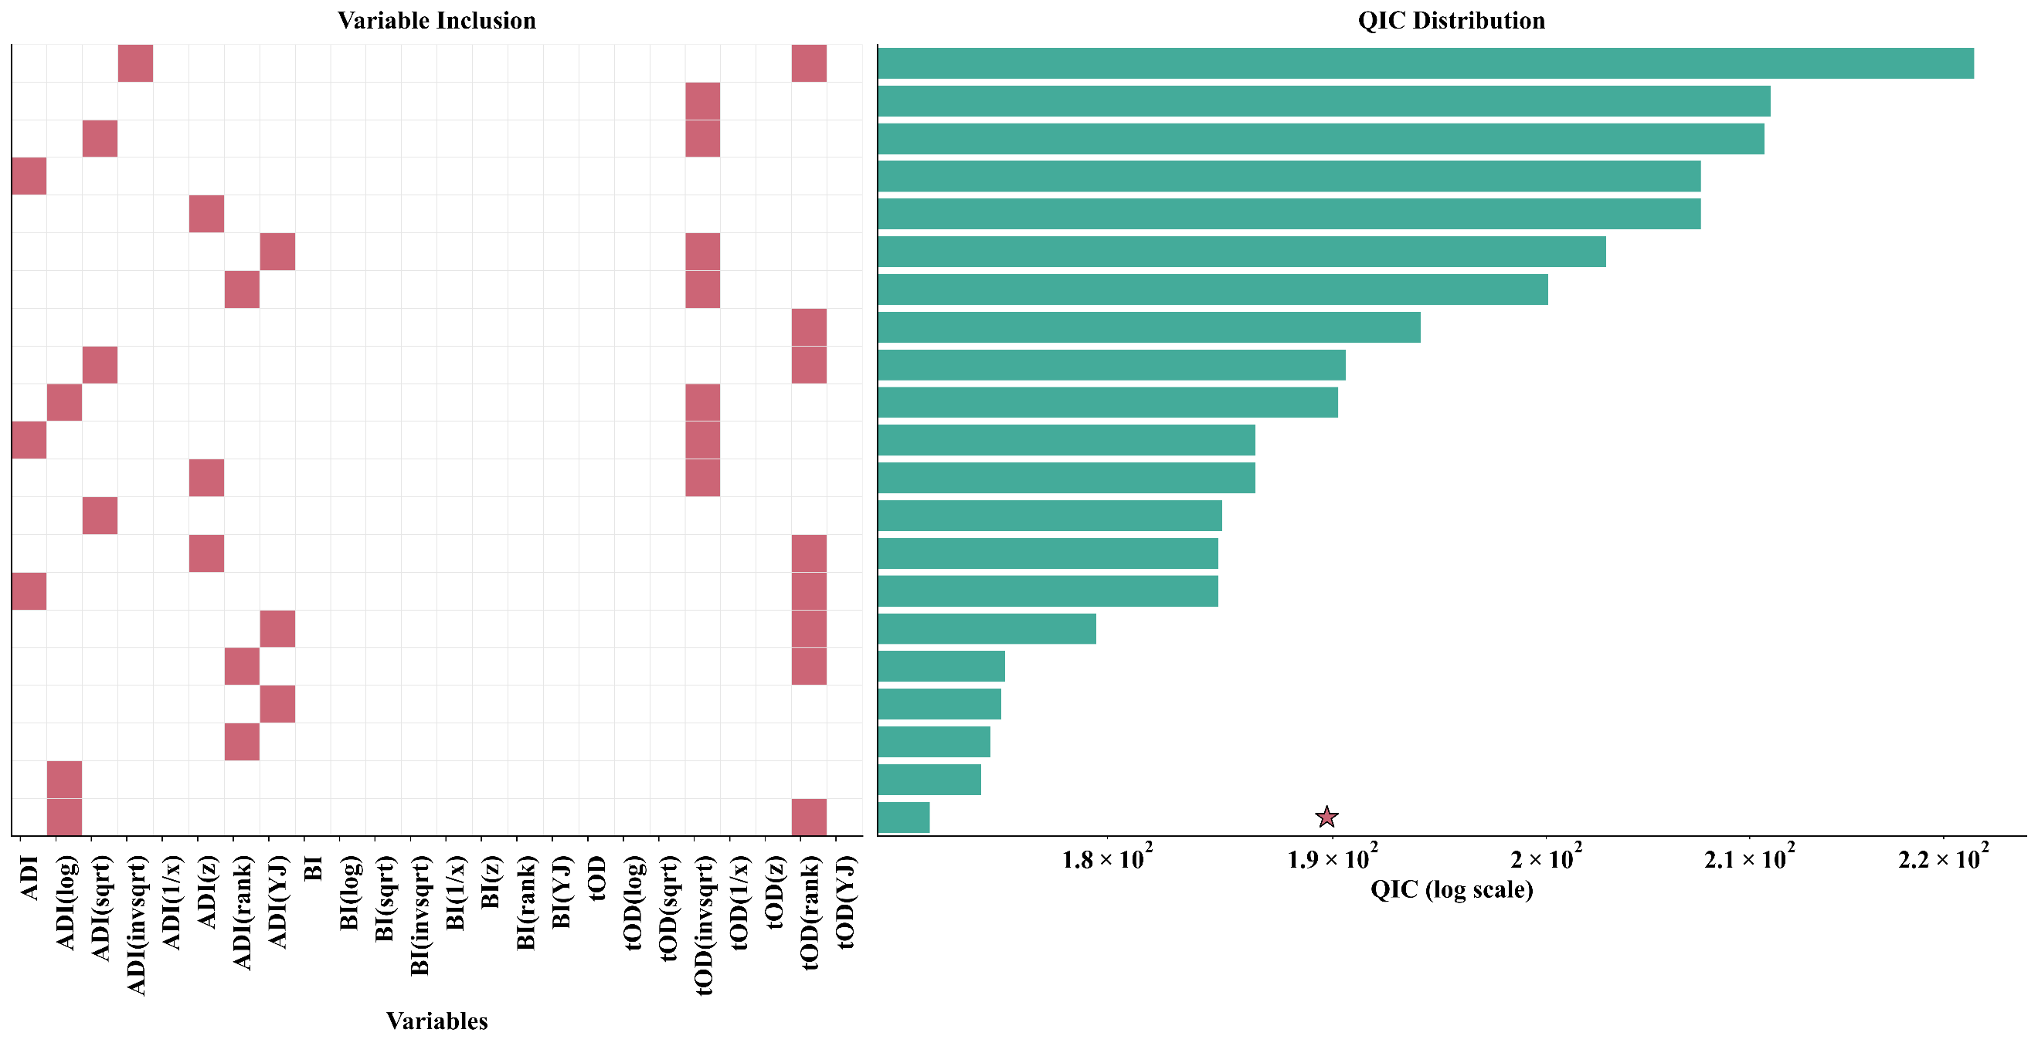
Figure S7. The logarithmic-scaled QIC of the eligible non-lagged GEE model combinations for $R_{t}$ in Foshan, between 9 July and 10 August, in 2025. A total of 21 model combinations successfully passed the collinearity test and convergence, exhibiting a QIC value lower than that of the null model. These combinations were included in the final QIC comparison. All models have autoregressive structures. The best model is marked with a five-pointed star. Given the substantial disparity in the magnitude of the QIC values, we employed a logarithmic scale to represent QIC.
ADI = Adult mosquito Density Index, BI = Breteau Index, tOD = the onset-to-diagnosis interval, log = Logarithmic transformation, sqrt = Square root transformation, invsqrt = Inverse square root transformation, 1/x = reciprocal transformation, z = Z-score transformation, rank = Rank transformation, YJ = Yeo-Johnson transformation.
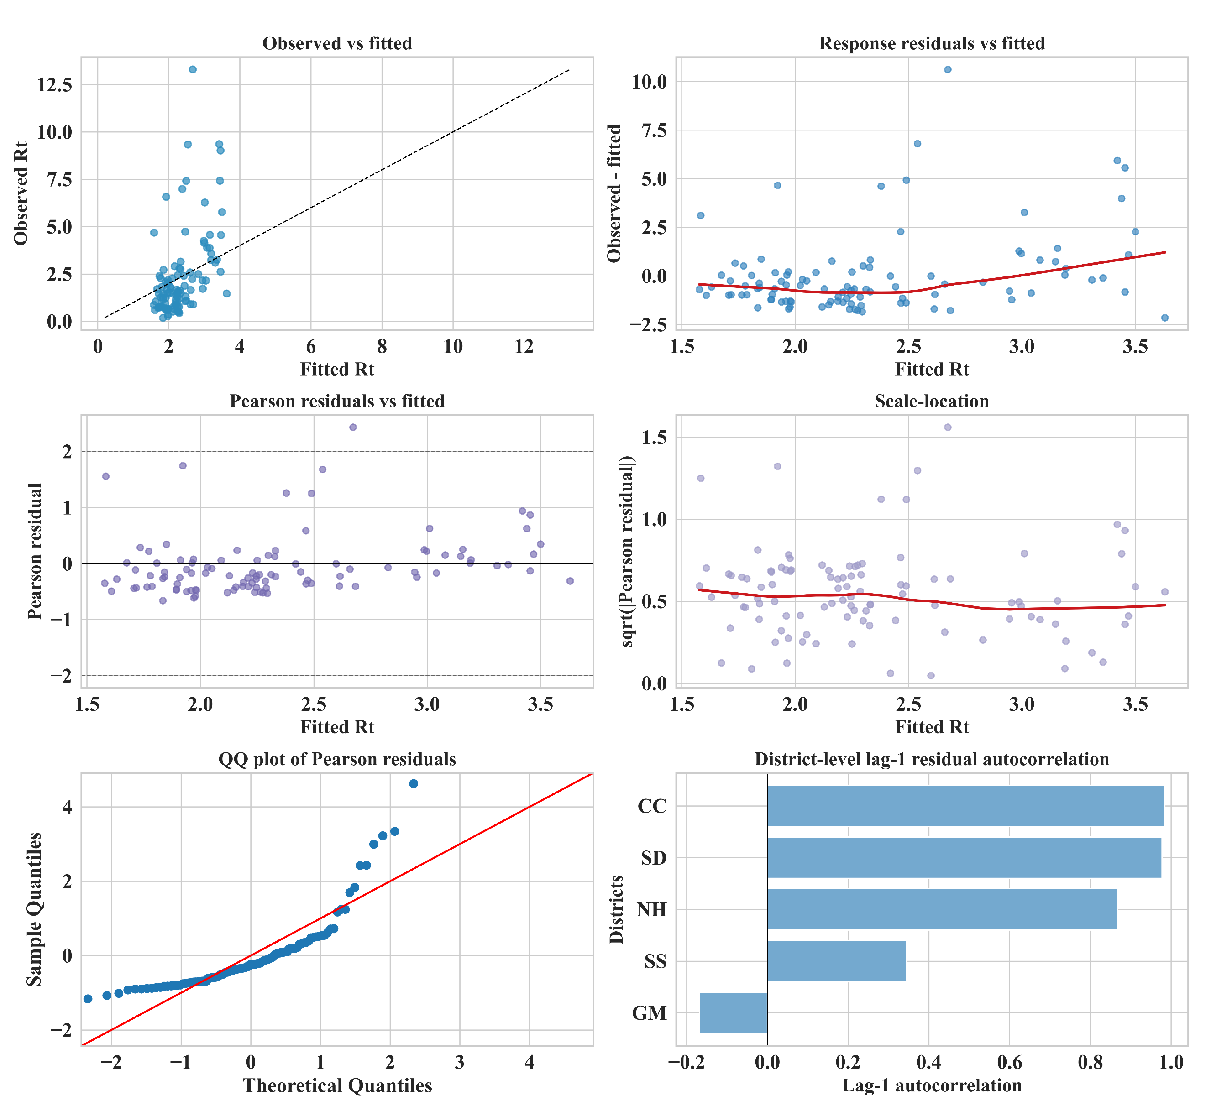
Figure S8. The residual diagnostic of the non-lagged GEE model combinations for $R_{t}$ in Foshan, between 9 July and 10 August, in 2025. Panels show (A) observed versus fitted values with the 45-degree reference line, (B) response residuals versus fitted values with a LOWESS smoother, (C) Pearson residuals versus fitted values with reference lines at 0 and ±2, (D) scale-location plot for the square root of the absolute standardised Pearson residuals. versus fitted values with a LOWESS smoother, (E) Q-Q plot of standardised Pearson residuals, and (F) district-level lag-1 autocorrelation of Pearson residuals.
SS = Sanshui District, NH = Nanhai District, CC = Chancheng District, SD = Shunde District, GM = Gaoming District.

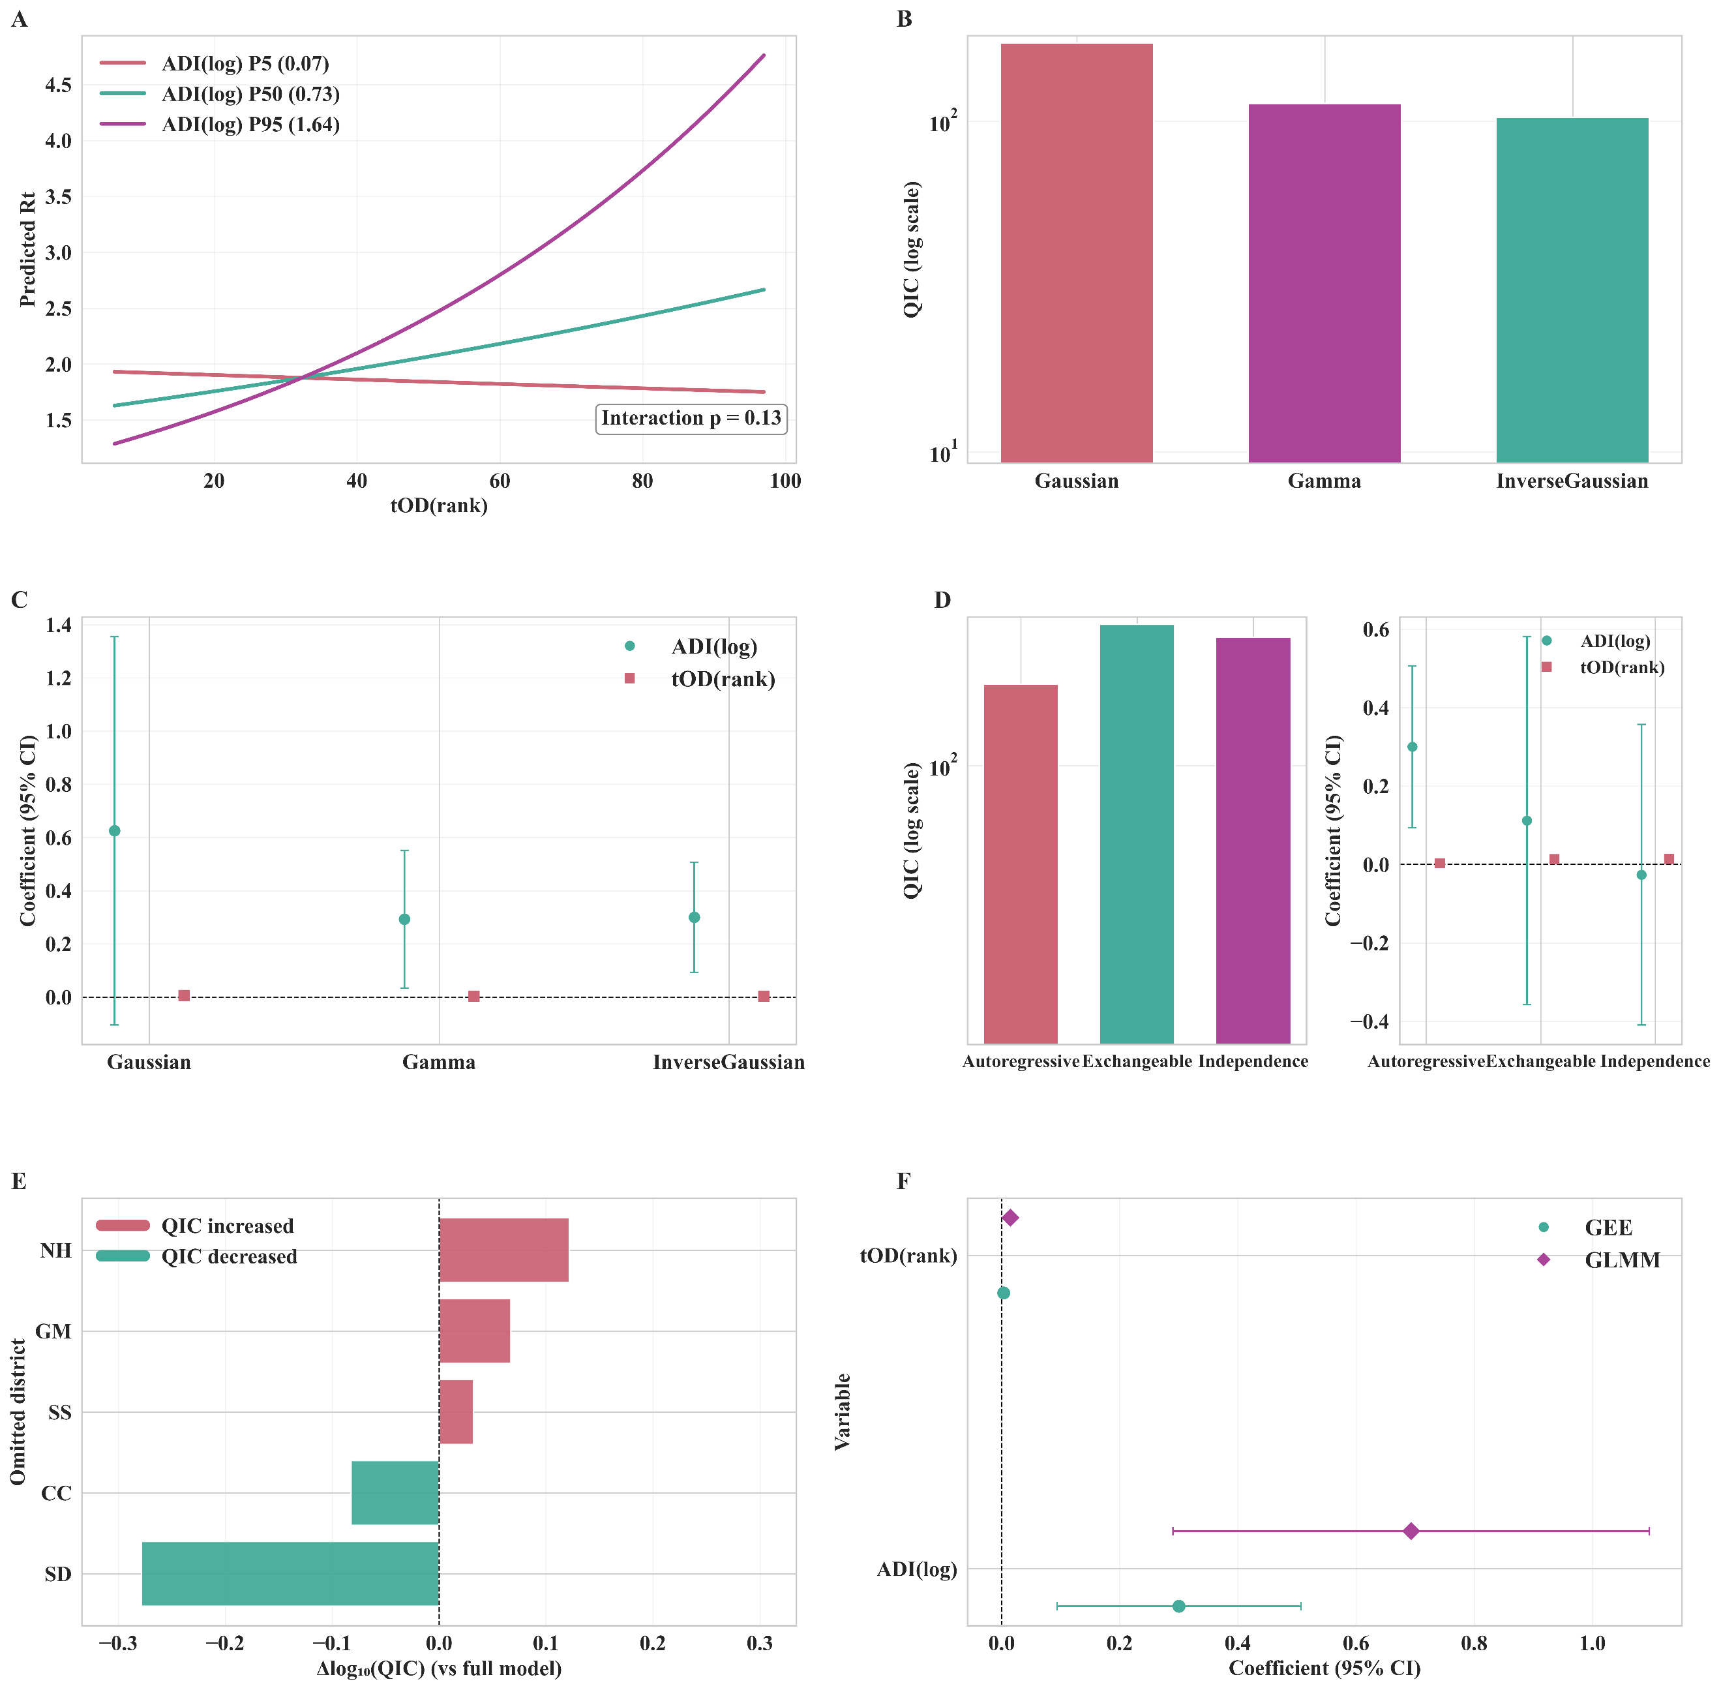
Figure S9. The interaction effect and sensitivity analysis of the non-lagged GEE model combinations for $R_{t}$ in Foshan, between 9 July and 10 August, in 2025. (A) Interaction effect from the optimal GEE model; the centre-right displays the p-value of the Wald test. (B) Comparison of log-transformed QIC values for different family parameters in the optimal GEE model. (C) Comparison of log-transformed QIC values for different family parameters in the optimal GEE model. (D) Comparison of log-transformed QIC values and coefficient sensitivity for different working correlation structure parameters for different independent variables in the optimal GEE model. (E) Log-transformed differences in QIC values for a relatively comprehensive model within the framework of leave-one-district-out sensitivity analysis. (F) Comparison of coefficient sensitivity for GEE and GLMM.
ADI = Adult mosquito Density Index, BI = Breteau Index, log = Logarithmic transformation, rank = Rank transformation, SS = Sanshui District, NH = Nanhai District, CC = Chancheng District, SD = Shunde District, GM = Gaoming District.

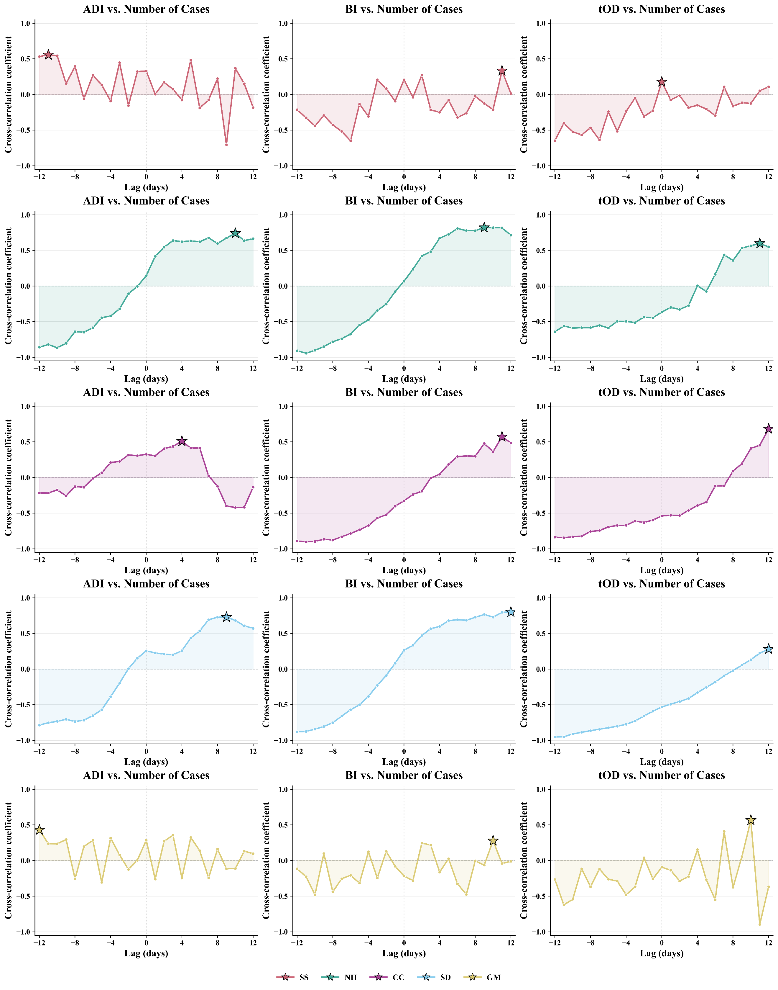
Figure S10. The cross-correlation changes between independent variables and the number of CHIKV cases for different districts, between 9 July and 10 August, in 2025. The five-pointed star indicates the optimal lag order corresponding to the highest correlation coefficient. SS = Sanshui District, NH = Nanhai District, CC = Chancheng District, SD = Shunde District, GM = Gaoming District, ADI = Adult Mosquito Density Index, BI = Breteau Index, tOD = the interval from onset to confirmation.

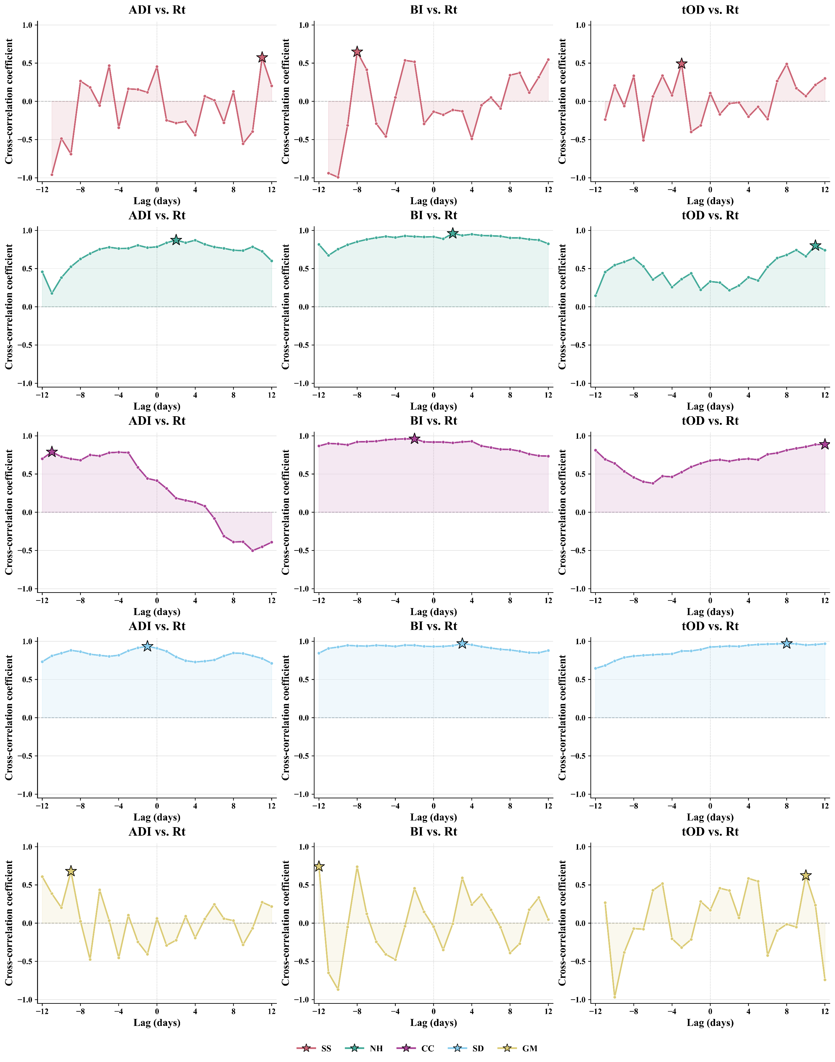
Figure S11. The cross-correlation changes between independent variables and the effective reproduction number for different districts, between 9 July and 10 August, in 2025. The five-pointed star indicates the optimal lag order corresponding to the highest correlation coefficient. SS = Sanshui District, NH = Nanhai District, CC = Chancheng District, SD = Shunde District, GM = Gaoming District, ADI = Adult Mosquito Density Index, BI = Breteau Index, tOD = the interval from onset to confirmation, $R_{t}$ = the effective reproduction number.

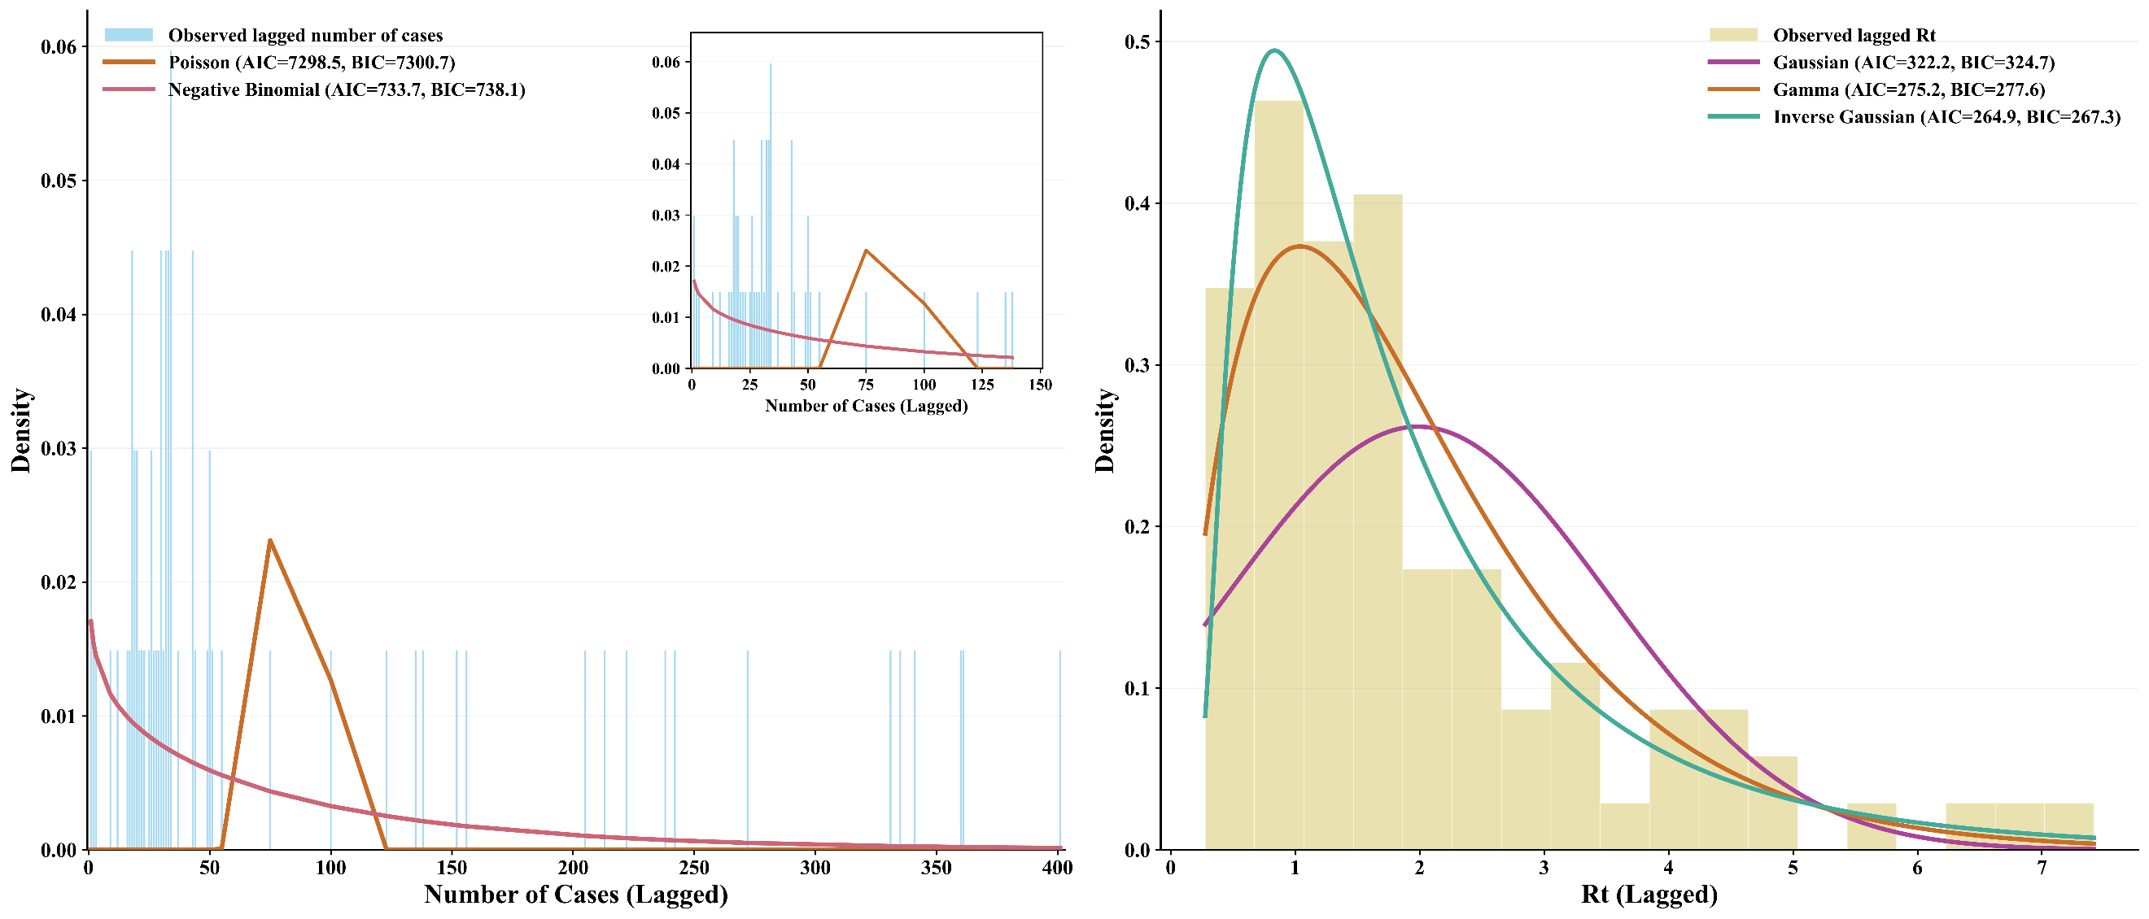
Figure S12. The distribution and fitting curve of the dependent variable in the lagged GEE model in Foshan, between 9 July and 10 August, in 2025. The left panel shows the distribution of the number of cases and its fitting curve, with the upper-right subplot displaying a focus plot within the numerical range 0–150. The right panel presents the distribution of the effective reproduction number and its fitting curve. AIC = Akaike Information Criterion, BIC = Bayesian Information Criterion, $R_{t}$ = the effective reproduction number.

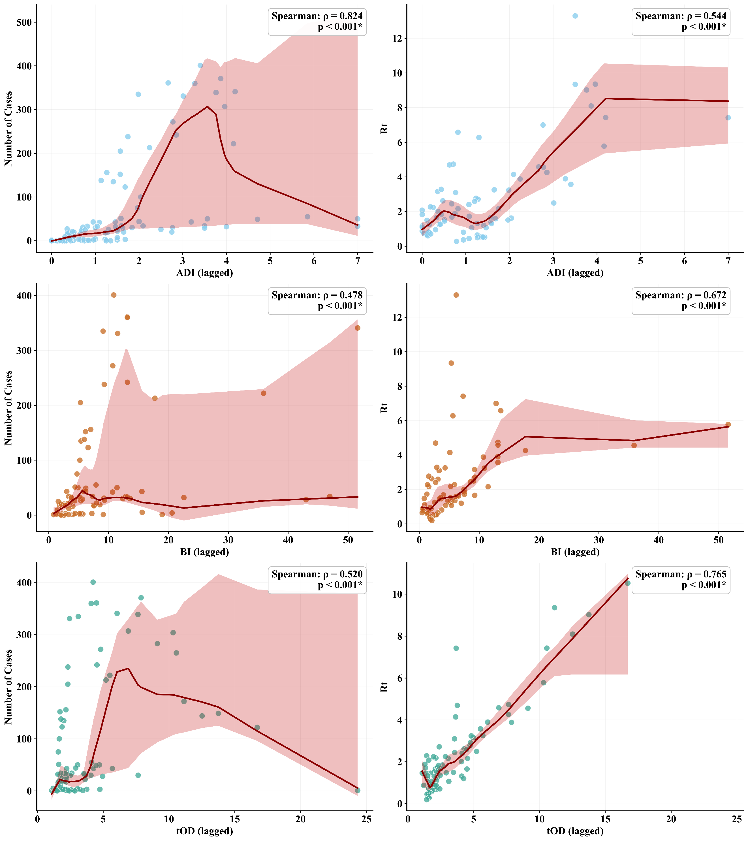
Figure S13. Scatter plots of different independent and dependent variables with their LOWESS fitted curves in the lagged GEE model in Foshan, between 9 July and 10 August, in 2025. $R_{t}$ = the effective reproduction number, *: p<0.05.

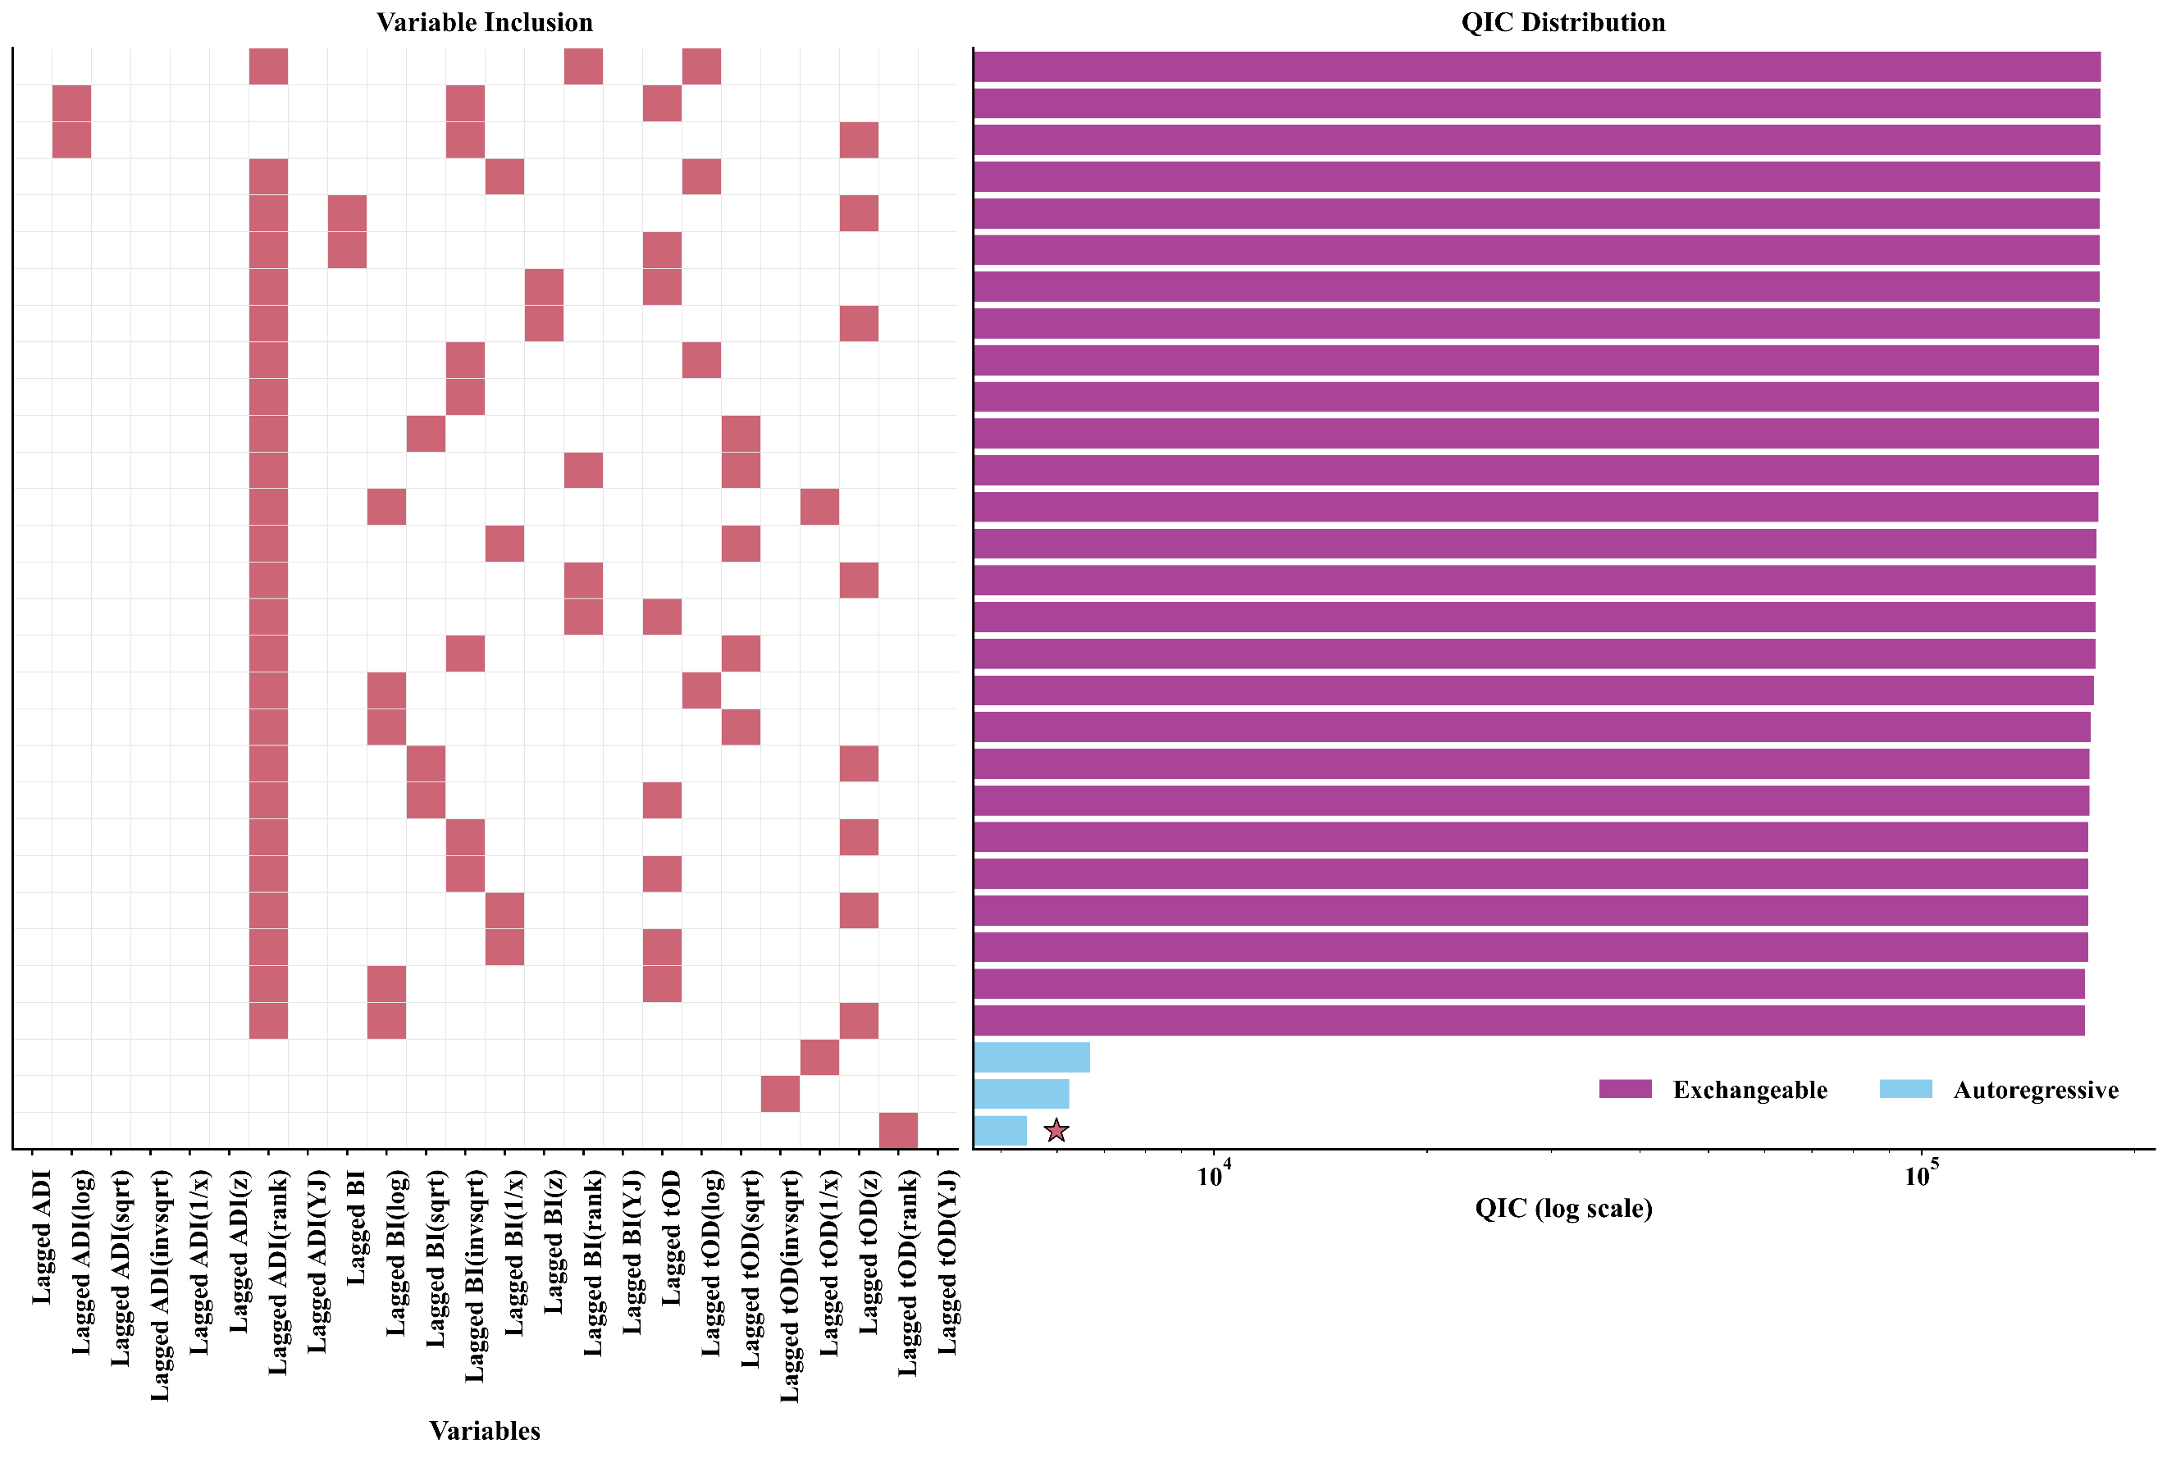
Figure S14. The logarithmic-scaled QIC of the top 30 lagged GEE model combinations for the number of cases in Foshan, between 9 July and 10 August, in 2025. A total of 501 model combinations successfully passed the collinearity test and convergence, exhibiting a QIC value lower than that of the null model. These combinations were included in the final QIC comparison. For clarity in presentation, we have visualised only the top 30 model combinations with the lowest QIC values. Of the top 30 models, 3 (10%) are autoregressive structures, and 27 (90%) are exchangeable structures. The best model is marked with a five-pointed star. Given the substantial disparity in the magnitude of the QIC values, we employed a logarithmic scale to represent QIC.
ADI = Adult mosquito Density Index, BI = Breteau Index, tOD = the onset-to-diagnosis interval, log = Logarithmic transformation, sqrt = Square root transformation, invsqrt = Inverse square root transformation, 1/x = reciprocal transformation, z = Z-score transformation, rank = Rank transformation, YJ = Yeo-Johnson transformation.

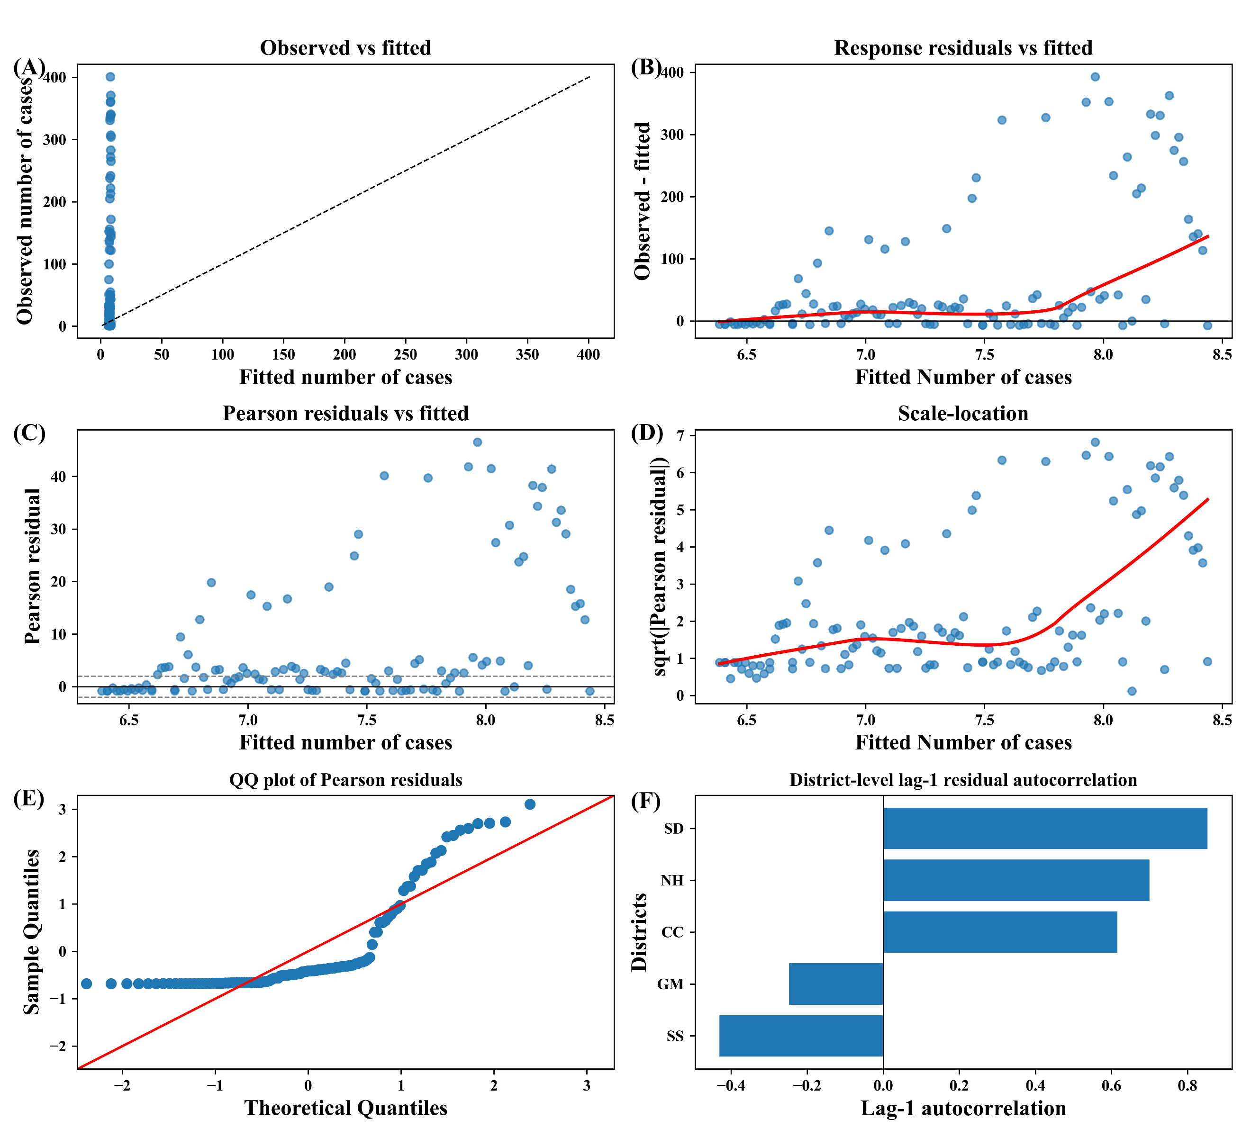
Figure S15. The residual diagnostic of the lagged GEE model combinations for the number of cases in Foshan, between 9 July and 10 August, in 2025. Panels show (A) observed versus fitted values with the 45-degree reference line, (B) response residuals versus fitted values with a LOWESS smoother, (C) Pearson residuals versus fitted values with reference lines at 0 and ±2, (D) scale-location plot for the square root of the absolute standardised Pearson residuals. versus fitted values with a LOWESS smoother, (E) Q-Q plot of standardised Pearson residuals, and (F) district-level lag-1 autocorrelation of Pearson residuals.
SS = Sanshui District, NH = Nanhai District, CC = Chancheng District, SD = Shunde District, GM = Gaoming District.

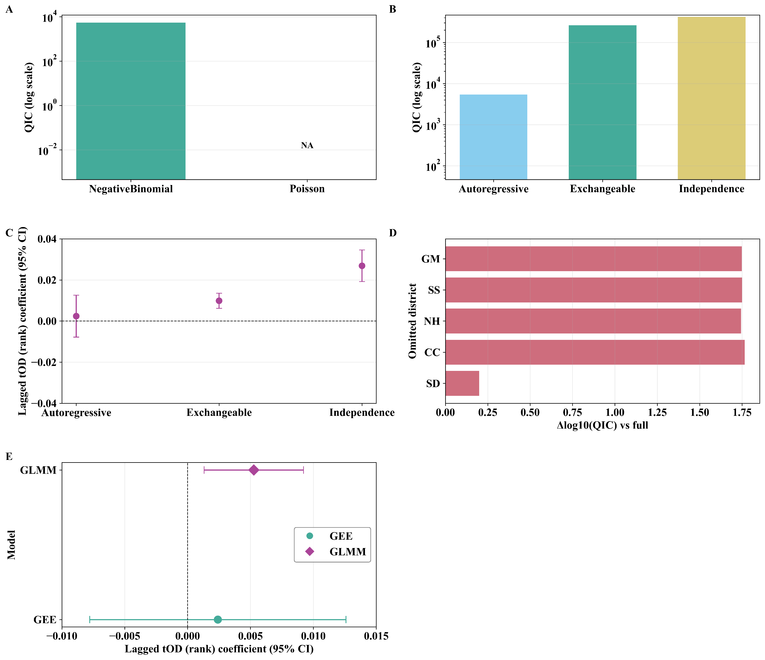
Figure S16. The interaction effect and sensitivity analysis of the lagged GEE model combinations for the number of cases in Foshan, between 9 July and 10 August, in 2025. (A) Comparison of log-transformed QIC values for different family parameters in the optimal GEE model; “NA” indicate missing QIC for that family. (B) Comparison of log-transformed QIC values for different family parameters in the optimal GEE model. (C) Comparison of coefficient sensitivity for different working correlation structure parameters for different independent variables in the optimal GEE model. (D) Log-transformed differences in QIC values for a relatively comprehensive model within the framework of leave-one-district-out sensitivity analysis. (E) Comparison of coefficient sensitivity for GEE and GLMM
ADI = Adult mosquito Density Index, BI = Breteau Index, log = Logarithmic transformation, SS = Sanshui District, NH = Nanhai District, CC = Chancheng District, SD = Shunde District, GM = Gaoming District.

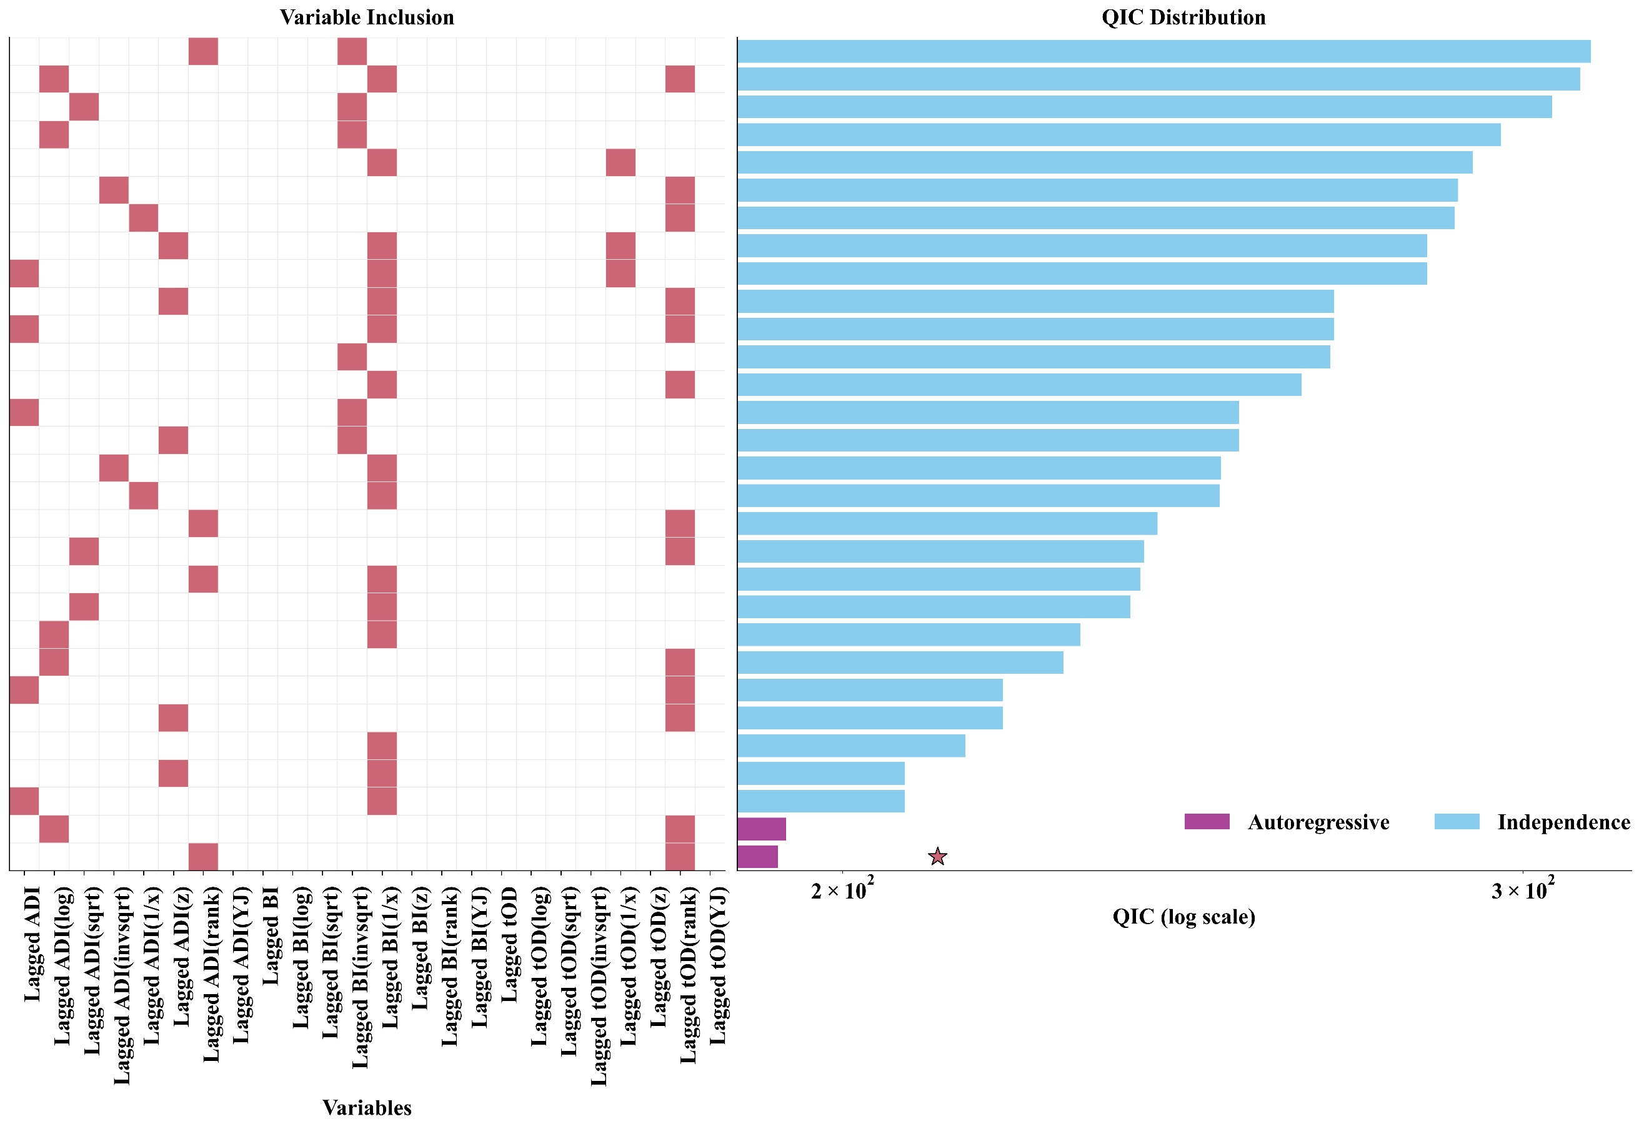
Figure S17. The logarithmic-scaled QIC of the top 30 lagged GEE model combinations for the $R_{t}$ in Foshan, between 9 July and 10 August, in 2025. A total of 470 model combinations successfully passed the collinearity test and convergence, exhibiting a QIC value lower than that of the null model. These combinations were included in the final QIC comparison. For clarity in presentation, we have visualised only the top 30 model combinations with the lowest QIC values. Of the top 30 models, 2 (6.67%) are autoregressive structures, and 28 (93.33%) are independence structures. The best model is marked with a five-pointed star. Given the substantial disparity in the magnitude of the QIC values, we employed a logarithmic scale to represent QIC.
ADI = Adult mosquito Density Index, BI = Breteau Index, tOD = the onset-to-diagnosis interval, log = Logarithmic transformation, sqrt = Square root transformation, invsqrt = Inverse square root transformation, 1/x = reciprocal transformation, z = Z-score transformation, rank = Rank transformation, YJ = Yeo-Johnson transformation.

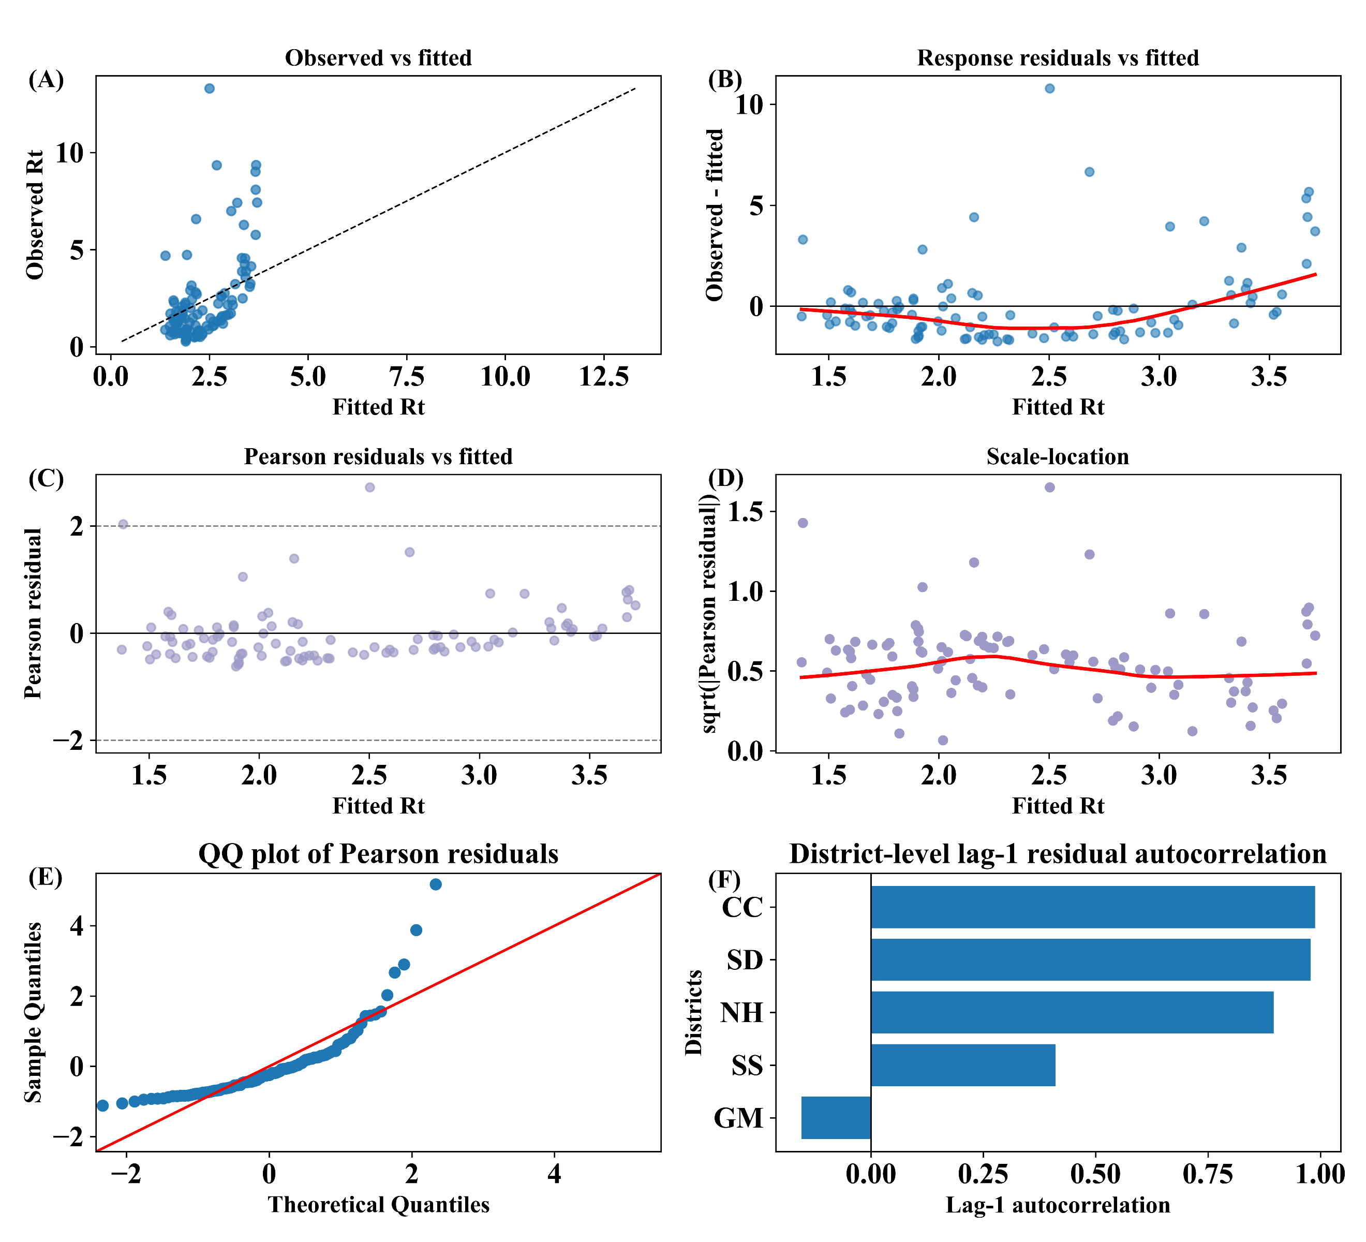
Figure S18. The residual diagnostic of the lagged GEE model combinations for $R_{t}$ in Foshan, between 9 July and 10 August, in 2025. Panels show (A) observed versus fitted values with the 45-degree reference line, (B) response residuals versus fitted values with a LOWESS smoother, (C) Pearson residuals versus fitted values with reference lines at 0 and ±2, (D) scale-location plot for the square root of the absolute standardised Pearson residuals. versus fitted values with a LOWESS smoother, (E) Q-Q plot of standardised Pearson residuals, and (F) district-level lag-1 autocorrelation of Pearson residuals.
SS = Sanshui District, NH = Nanhai District, CC = Chancheng District, SD = Shunde District, GM = Gaoming District.

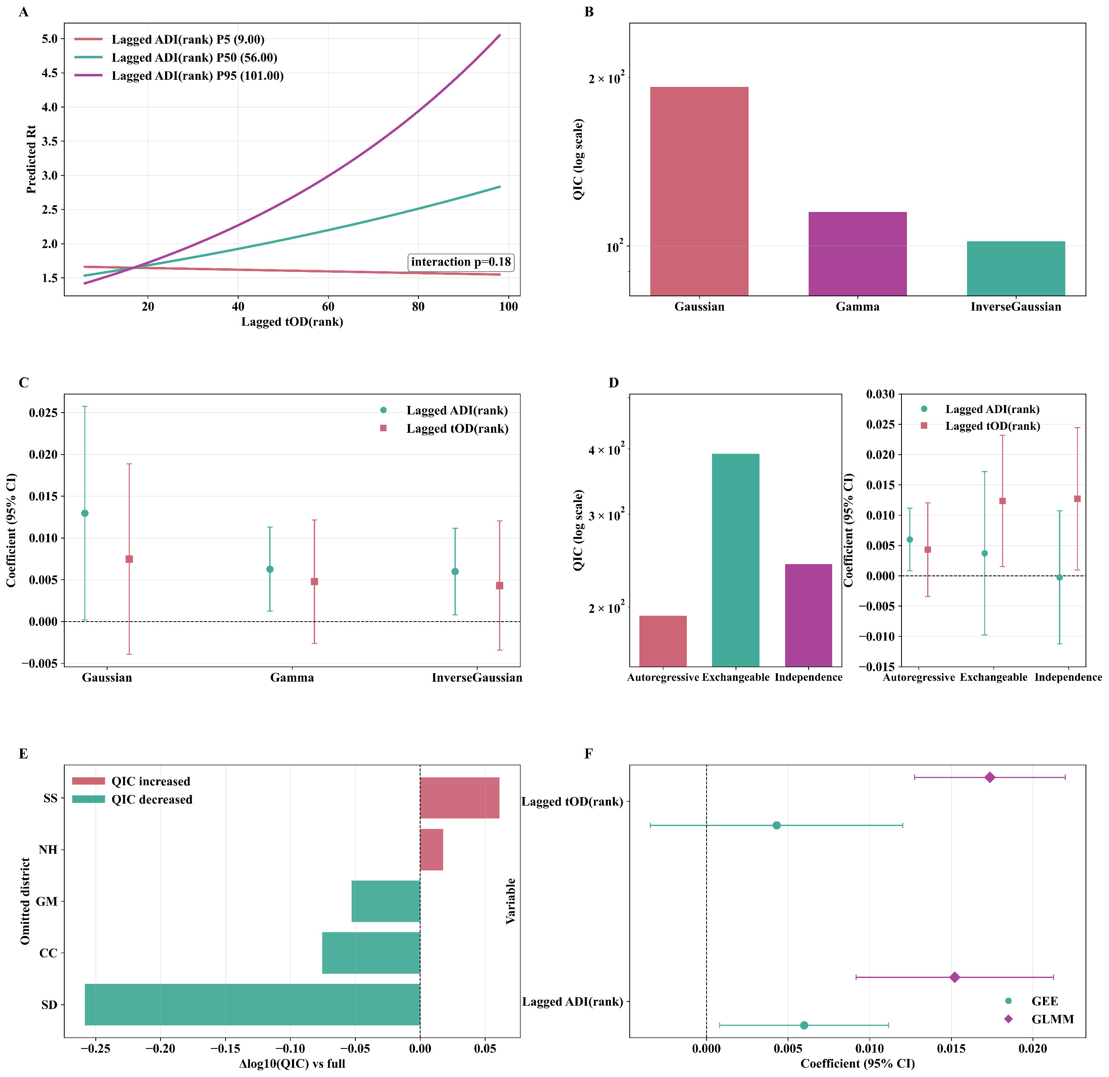
Figure S19. The interaction effect and sensitivity analysis of the lagged GEE model combinations for $R_{t}$ in Foshan, between 9 July and 10 August, in 2025. (A) The interaction effect from the optimal GEE model; the lower-right displays the p-value of the Wald test. (B) Comparison of log-transformed QIC values for different family parameters in the optimal GEE model. (C) Comparison of log-transformed QIC values for different family parameters in the optimal GEE model. (D) Comparison of log-transformed QIC values and coefficient sensitivity for different working correlation structure parameters for different independent variables in the optimal GEE model. (E) Log-transformed differences in QIC values for a relatively comprehensive model within the framework of leave-one-district-out sensitivity analysis. (F) Comparison of coefficient sensitivity for GEE and GLMM.
ADI = Adult mosquito Density Index, BI = Breteau Index, log = Logarithmic transformation, rank = Rank transformation, SS = Sanshui District, NH = Nanhai District, CC = Chancheng District, SD = Shunde District, GM = Gaoming District.

