Carbon partitioning through the pentose phosphate pathway regulates behavioral maturation in honeybees via a redox–endocrine axis

Yun-Heng Lu†, Yao-Kuang Tseng†, Wei-Chan Chang and Yueh-Lung Wu *
Department of Entomology, National Taiwan University, Taipei 106, Taiwan
† Y. H. L., and Y.K.T. contributed equally to this study.

*Correspondence
Yueh-Lung Wu
Department of Entomology, National Taiwan University
27, Lane 113, Roosevelt Rd. Sec. 4, Taipei 106, TAIWAN
Phone: +886-2-3366-5528
E-mail: runwu@ntu.edu.tw

Supplementary Figures, Materials and Methods, Tables

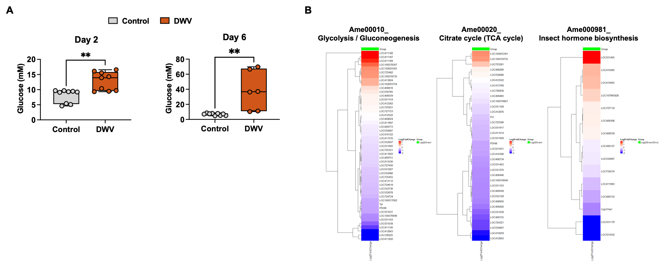

Supplementary Figure 1. Comparative analysis of glucose levels and metabolic gene expression in DWV-infected honeybees. (A) Glucose levels in honeybee bodies on Day 2 (a) and Day 6 (b) in control and DWV-infected bees (n = 6–9). (B) Heatmaps showing relative expression levels of genes associated with glycolysis/gluconeogenesis (KEGG: Ame00010), citrate cycle (KEGG: Ame00020), and insect hormone biosynthesis (KEGG: Ame00981), presented as log₂ fold changes relative to controls. Control bees were injected with 1× PBS, whereas DWV-infected bees were injected with 1 × 10^4 viral copies per bee. Relative gene expression data were normalized to the corresponding Day 2 control group. Heatmap values are presented as log₂-transformed relative expression levels. Statistical significance between control and DWV groups was determined by Student’s t-test. Data are presented as mean ± SD. Asterisks indicate statistical significance as follows: *p < 0.05, **p < 0.01, ***p < 0.001, ****p < 0.0001.
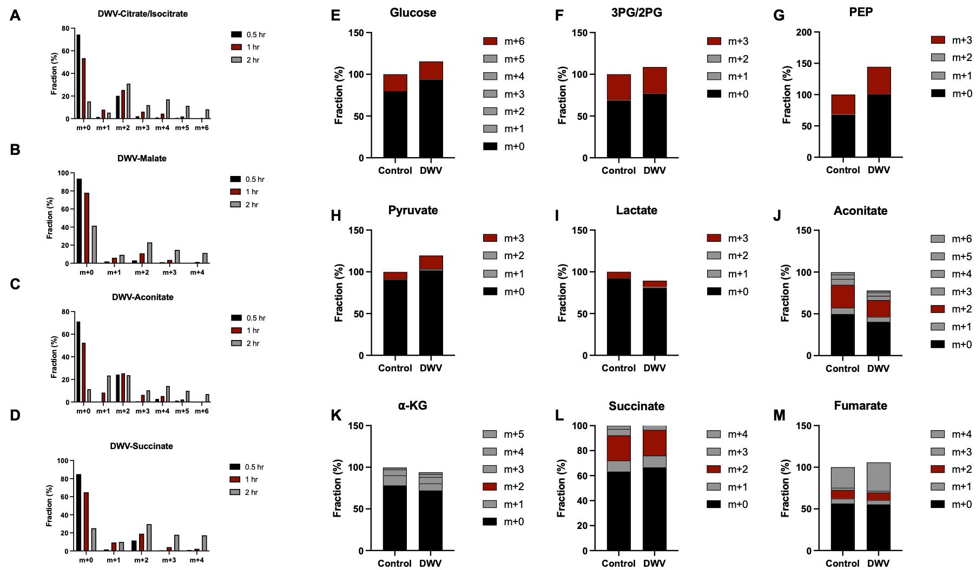

Supplementary Figure 2. Stable isotope tracing analysis of glucose-derived carbon flux in honeybees following DWV infection. (A–D) Time-resolved isotopologue distributions of tricarboxylic acid (TCA) cycle intermediates, including citrate/isocitrate, malate, aconitate, and succinate, following ¹³C-glucose feeding at 0.5, 1, and 2 h. (E–M) Isotopologue distributions of glucose-derived metabolites in control and DWV-infected honeybees following ¹³C-glucose tracing. Fractional enrichment of detected isotopologues is shown for glycolytic intermediates, including glucose, 3-phosphoglycerate/2-phosphoglycerate (3PG/2PG), phosphoenolpyruvate (PEP), pyruvate, and lactate, as well as tricarboxylic acid (TCA) cycle intermediates, including aconitate, α-ketoglutarate (α-KG), succinate, and fumarate. m+0 represents unlabeled endogenous carbon, and labeled isotopologues are shown according to the number of incorporated ¹³C atoms.

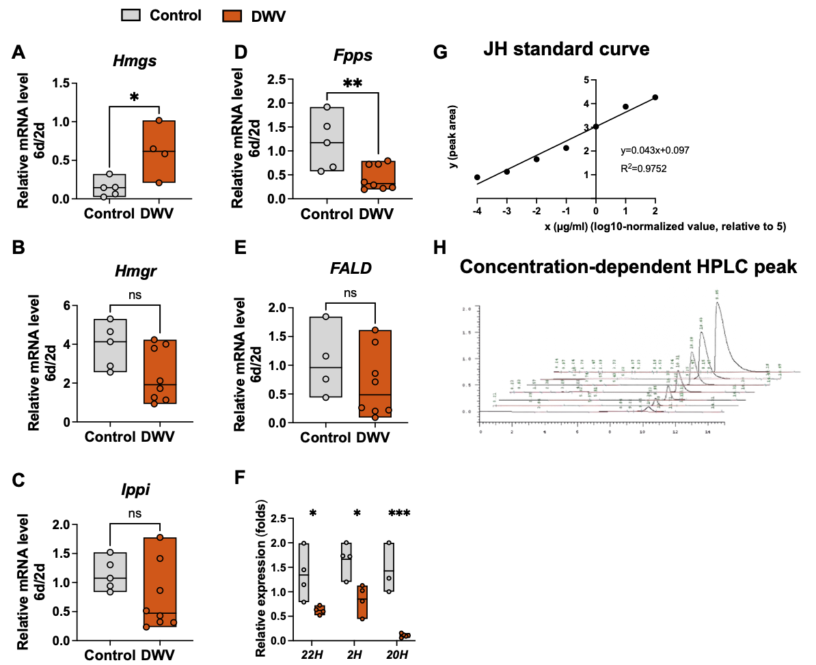
Supplementary Figure 3. Expression analysis of juvenile hormone and ecdysteroid biosynthesis-related genes and HPLC-based juvenile hormone quantification in honeybees. (A–E) Relative expression levels of juvenile hormone biosynthesis-related genes (Hmgs, Hmgr, Ippi, Fpps, and FALD) in honeybee heads on Day 6 (n = 4–8). (F) Relative expression levels of ecdysteroid biosynthesis-related genes (22H, 2H, and 20H) in honeybee bodies on Day 6 (n = 4–8). (G) Standard curve for juvenile hormone quantification by HPLC. (H) Representative HPLC chromatograms of serially diluted juvenile hormone standards. Control bees were injected with 1× PBS, and DWV-infected bees were injected with 1 × 10^4 viral copies per bee. Relative expression data were normalized to the corresponding Day 2 values within each group. Statistical significance was determined by Student’s t-test. Data are presented as mean ± SD. Asterisks indicate statistical significance as follows: *p < 0.05, **p < 0.01, ***p < 0.001.
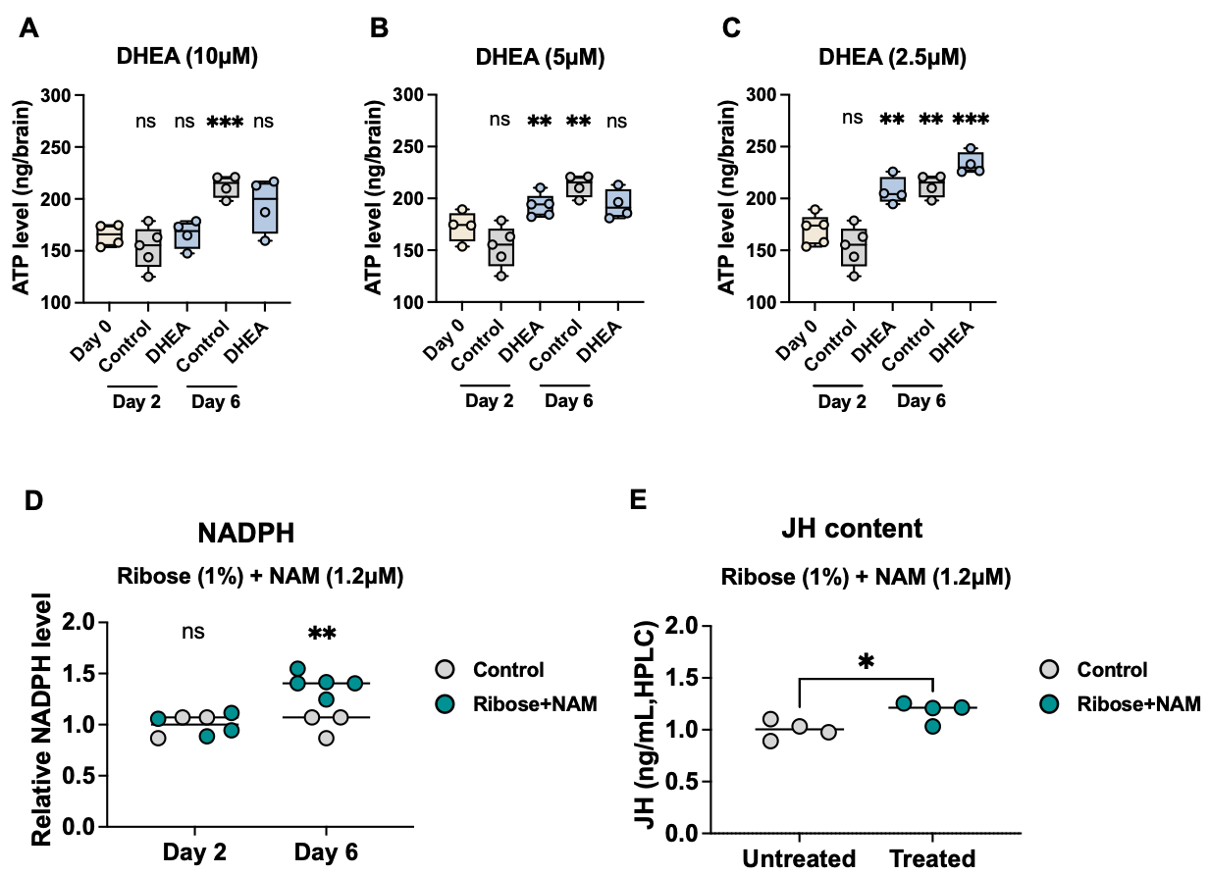

Supplementary Figure 4. Effects of DHEA and ribose plus nicotinamide supplementation on ATP, NADPH, and juvenile hormone levels in honeybees. (A–C) ATP levels in honeybee heads measured on Day 2 and Day 6 following DHEA feeding at concentrations of (A) 10 μM, (B) 5 μM, and (C) 2.5 μM (n = 4–5). ATP levels are expressed as ng per brain. (D) Relative NADPH levels in honeybee heads on Day 2 and Day 6 following ribose (1%) and nicotinamide (NAM, 1.2 μM) supplementation (n = 4–5). (E) Juvenile hormone (JH) content measured by HPLC following ribose (1%) and nicotinamide (NAM, 1.2 μM) supplementation (n = 4–5). Statistical significance between control and treatment groups was determined by Student’s t-test. Data are presented as mean ± SD. Asterisks indicate statistical significance as follows: *p < 0.05, **p < 0.01, ***p < 0.001.

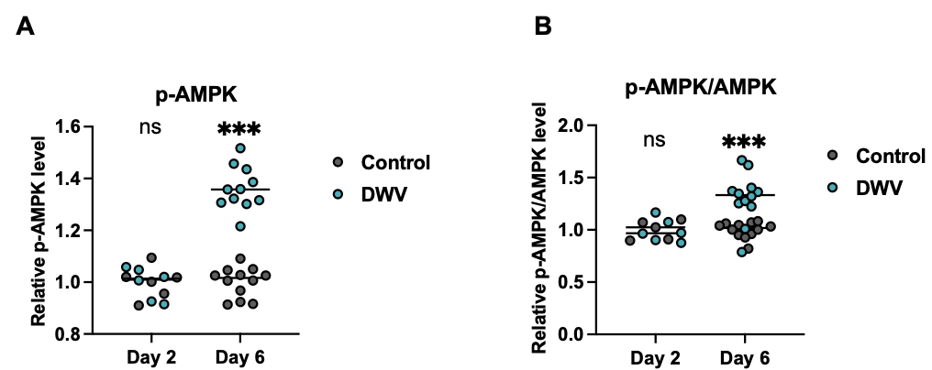

Supplementary Figure 5. Effects of DWV infection on AMPK phosphorylation and activation levels in honeybee heads. (A)Relative p-AMPK levels in the heads of Control and DWV-infected honeybees on Day 2 and Day 6 post-infection, as determined by ELISA. (B) Relative p-AMPK/AMPK ratios representing the activation status of AMPK at the indicated time points. Data are presented as scatter plots of individual biological replicates, with horizontal lines indicating the mean. Statistical significance was determined using two-way ANOVA followed by post-hoc tests: ns, non-significant; ***, compared with the time-matched control group.

Supplementary Materials and Methods

Ribose and nicotinamide supplementation assay

To determine whether enhanced pentose phosphate pathway (PPP)-related metabolite availability is sufficient to promote NADPH accumulation and juvenile hormone (JH) biosynthesis, honeybees were supplemented with ribose and nicotinamide. Newly emerged worker bees were maintained under standard rearing conditions and randomly assigned to control and supplementation groups. For metabolite supplementation, D-ribose (Sigma-Aldrich, USA) and nicotinamide (Sigma-Aldrich, USA) were dissolved in 50% (w/v) sucrose solution and administered orally by feeding. Bees were provided with the supplemented sucrose solution ad libitum throughout the experimental period, while control bees received sucrose solution alone. After the supplementation period, honeybee head tissues and hemolymph were collected for biochemical analyses. NADPH levels in head tissues were measured as described above, and juvenile hormone (JH) levels in hemolymph were quantified using HPLC and ELISA. These experiments were used to evaluate whether increased availability of PPP-associated metabolites could recapitulate the endocrine phenotype observed during DWV infection.

Measurement of AMPK Phosphorylation and Activation Status

To evaluate AMPK activation, total AMPK and phosphorylated AMPK (Thr172) levels in honeybee heads were quantified using commercial ELISA kits (AMPK alpha-1,2 and phospho-AMPK Thr172, respectively) following the manufacturer's protocols. Honeybee heads collected at 2 and 6 days post-infection (dpi) were pooled and homogenized in ice-cold protein extraction buffer supplemented with phosphatase inhibitors. The homogenates were centrifuged at 12,000 × g for 10 min at 4°C, and the supernatants were collected for downstream analysis. Equal amounts of protein from each biological replicate were assayed in parallel. Briefly, standards and samples were loaded onto antibody-coated microplates and incubated accordingly. Following washing steps, enzyme-conjugated detection antibodies and substrate solutions were added for colorimetric development. The enzymatic reaction was halted with a stop solution, and absorbance was measured at 450 nm using a microplate reader. AMPK activation status was determined by calculating the ratio of phosphorylated AMPK to total AMPK (p-AMPK/AMPK). Both relative p-AMPK levels and p-AMPK/AMPK ratios were normalized to their corresponding time-matched control groups and expressed as fold changes relative to the controls.

Supplementary Table 1. Summary of statistical significance levels (*, **, and *) shown in the heatmaps. Mean from glycolysis- and TCA cycle-related gene expression across Days 2 to Day 20 in control honeybee heads. Fold of Day 2. Student’s t-test was used for statistical analysis to determine significant differences among groups, where * indicates p < 0.05, ** indicates p < 0.01, and *** indicates p < 0.001. (Corresponding to Fig. 1B, panel a).
Gene |  | Day 4 | Day 6 | Day 8 | Day 10 | Day 12
GAPDH | Glyceraldehyde-3-phosphate dehydrogenase | ** | ** | ** | *** | *
PGK1 | Phosphoglycerate kinase | **** | *** | *** | **** | ***
PK | Pyruvate kinase | *** | *** | *** | **** | **
ID | Isocitrate dehydrogenase | ns | ns | ns | ns | *
FH | Fumarate hydratase | ns | ns | * | ns | ns
SDH | Succinate dehydrogenase | ** | ** | ** | ** | ns
SUCLA | Succinate-CoA ligase | ** | ** | *** | *** | *
Og | 2-oxoglutarate dehydrogenase | ** | ** | ** | ** | ns
Gene |  | Day 14 | Day 16 | Day 18 | Day 20
GAPDH | Glyceraldehyde-3-phosphate dehydrogenase | ns | ns | * | *
PGK1 | Phosphoglycerate kinase | * | *** | *** | ***
PK | Pyruvate kinase | * | *** | ** | ***
ID | Isocitrate dehydrogenase | ns | ** | ns | *
FH | Fumarate hydratase | ns | * | ns | ns
SDH | Succinate dehydrogenase | ns | ns | ns | ns
SUCLA | Succinate-CoA ligase | * | * | * | *
Og | 2-oxoglutarate dehydrogenase | ns | ns | ns | ns

Supplementary Table 2. Summary of statistical significance levels (*, **, and *) shown in the heatmaps. Mean from glycolysis- and TCA cycle-related gene expression across Days 2 to Day 20 in DWV-infected honeybee heads. Fold of Day 2. Student’s t-test was used for statistical analysis to determine significant differences among groups, where * indicates p < 0.05, ** indicates p < 0.01, and *** indicates p < 0.001. (Corresponding to Fig. 1B, panel b).

Gene |  | Day 4 | Day 6 | Day 8 | Day 10 | Day 12
GAPDH | Glyceraldehyde-3-phosphate dehydrogenase | ns | ns | ns | ** | **
PGK1 | Phosphoglycerate kinase | ns | ns | * | * | ***
PK | Pyruvate kinase | ns | * | * | ** | *
ID | Isocitrate dehydrogenase | ns | ns | ns | * | **
FH | Fumarate hydratase | ns | ns | ns | ns | ***
SDH | Succinate dehydrogenase | ns | ns | * | ** | **
SUCLA | Succinate-CoA ligase | ns | ns | ns | ** | *
Og | 2-oxoglutarate dehydrogenase | ns | ns | ns | * | **
Gene |  | Day 14 | Day 16 | Day 18 | Day 20
GAPDH | Glyceraldehyde-3-phosphate dehydrogenase | ** | ** | ns | ns
PGK1 | Phosphoglycerate kinase | * | ns | * | ns
PK | Pyruvate kinase | ** | ** | ** | ns
ID | Isocitrate dehydrogenase | ns | ** | ** | ns
FH | Fumarate hydratase | * | ** | ** | ns
SDH | Succinate dehydrogenase | * | * | ns | ns
SUCLA | Succinate-CoA ligase | ** | * | ** | ns
Og | 2-oxoglutarate dehydrogenase | * | * | ** | ns

Supplementary Table 3. Summary of statistical significance levels (*, **, and *) shown in the heatmaps. Mean from juvenile hormone biosynthesis-related gene expression across time points in control honeybee heads from Day 2 to Day 20. Fold of Day 2. Student’s t-test was used for statistical analysis to determine significant differences among groups, where * indicates p < 0.05, ** indicates p < 0.01, and *** indicates p < 0.001. (Corresponding to Fig. 1D, panel a).

Gene |  | Day 4 | Day 6 | Day 8 | Day 10 | Day 12
Hmgs | HMG-CoA synthase | ns | *** | **** | **** | *
Hmgr | HMG-CoA reductase | ns | * | *** | **** | ns
Ippi | Isopentenyl pyrophosphate isomerase | ns | ns | * | ns | *
Fpps | Farnesyl diphosphate | *** | ** | * | **** | ns
FALD | Farnesal dehydrogenase | ns | ** | *** | ns | ns
MFE | Methyl farnesoate epoxidase | ns | * | ns | ** | **
Gene |  | Day 14 | Day 16 | Day 18 | Day 20
Hmgs | HMG-CoA synthase | **** | *** | * | **
Hmgr | HMG-CoA reductase | ** | ns | ns | ns
Ippi | Isopentenyl pyrophosphate isomerase | ** | ns | * | ***
Fpps | Farnesyl diphosphate | *** | ** | * | **
FALD | Farnesal dehydrogenase | ns | ns | ns | *
MFE | Methyl farnesoate epoxidase | ns | ** | **** | ***

Supplementary Table 4. Summary of statistical significance levels (*, **, and *) shown in the heatmaps. Mean from juvenile hormone biosynthesis-related gene expression across time points in DWV-infected honeybee heads from Day 2 to Day 20. Fold of Day 2. Student’s t-test was used for statistical analysis to determine significant differences among groups, where * indicates p < 0.05, ** indicates p < 0.01, and *** indicates p < 0.001. (Corresponding to Fig. 1D, panel b).

Gene |  | Day 4 | Day 6 | Day 8 | Day 10 | Day 12
Hmgs | HMG-CoA synthase | *** | *** | **** | **** | **
Hmgr | HMG-CoA reductase | ns | ** | ** | ** | **
Ippi | Isopentenyl pyrophosphate isomerase | * | * | ns | ns | ****
Fpps | Farnesyl diphosphate | ** | *** | *** | *** | ***
FALD | Farnesal dehydrogenase | ns | ns | ns | ** | ***
MFE | Methyl farnesoate epoxidase | ns | ** | ns | ** | ns
Gene |  | Day 14 | Day 16 | Day 18 | Day 20
Hmgs | HMG-CoA synthase | *** | **** | *** | ****
Hmgr | HMG-CoA reductase | ** | * | ns | **
Ippi | Isopentenyl pyrophosphate isomerase | **** | **** | **** | ****
Fpps | Farnesyl diphosphate | *** | *** | ** | ***
FALD | Farnesal dehydrogenase | ** | ns | ns | *
MFE | Methyl farnesoate epoxidase | ** | ns | ns | *

Supplementary Table 5. Summary of statistical significance levels (*, **, and *) shown in the heatmaps. Mean from ecdysteroid biosynthesis-related gene expression across time points in control honeybee bodies from Day 2 to Day 20. Student’s t-test was used for statistical analysis to determine significant differences among groups, where * indicates p < 0.05, ** indicates p < 0.01, and *** indicates p < 0.001. (Corresponding to Fig. 1E, panel a).

Gene |  | Day 4 | Day 6 | Day 8 | Day 10 | Day 12
22H | 22-hydroxylase | ns | *** | ns | ns | ns
2H | 2-hydroxylase | ns | ** | ns | ns | ns
20H | 20-hydroxylase | ns | ns | ns | ns | *
Gene |  | Day 14 | Day 16 | Day 18 | Day 20
22H | 22-hydroxylase | * | * | ns | ****
2H | 2-hydroxylase | **** | ** | **** | ns
20H | 20-hydroxylase | ** | * | **** | **

Supplementary Table 6. Summary of statistical significance levels (*, **, and *) shown in the heatmaps. Mean from ecdysteroid biosynthesis-related gene expression across time points in DWV-infected honeybee bodies from Day 2 to Day 20. Student’s t-test was used for statistical analysis to determine significant differences among groups, where * indicates p < 0.05, ** indicates p < 0.01, and *** indicates p < 0.001. (Corresponding to Fig. 1E, panel b).

Gene |  | Day 4 | Day 6 | Day 8 | Day 10 | Day 12
22H | 22-hydroxylase | ns | ns | ns | ns | **
2H | 2-hydroxylase | ns | ns | ns | ns | **
20H | 20-hydroxylase | ns | ns | ns | ns | *
Gene |  | Day 14 | Day 16 | Day 18 | Day 20
22H | 22-hydroxylase | ns | ns | ns | ns
2H | 2-hydroxylase | ns | ns | ns | ns
20H | 20-hydroxylase | ns | ns | ns | *

Supplementary Table 7. Statistical comparison of metabolite abundance and isotopologue enrichment between control and DWV-infected honeybees following ¹³C-glucose tracing.

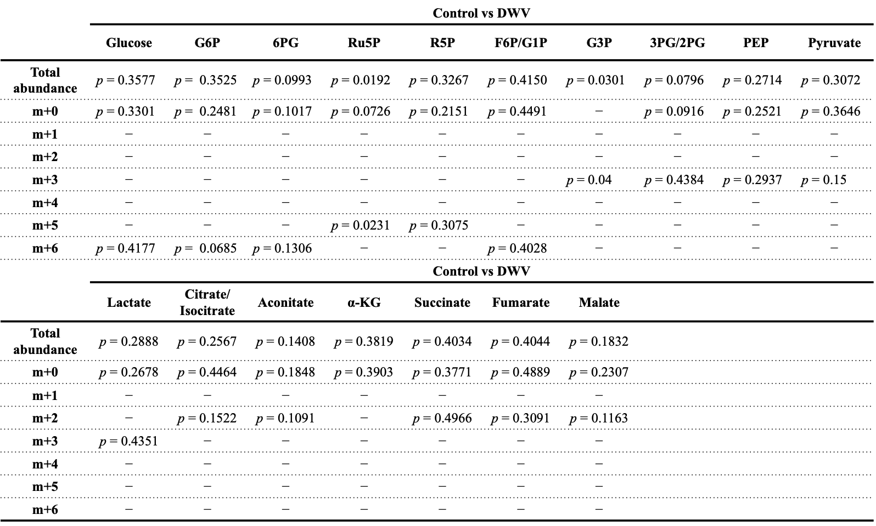

Supplementary Table 8. Primer list used for quantitative real-time PCR (qPCR).

Primer name |  | Sequence (5'-3')
18S | F | CGGCGACGCATCTTTCA
18S | R | GCGCAGAACCTACCATCGA
GAPDH | F | GAGGTTCAGCATCGGTGACA
GAPDH | R | TCAGAGGCTTGCTGCAACTTT
PGK1 | F | GGCTGGATGGGACTTGATGT
PGK1 | R | CACCAGCAGGACCATTCCATA
PK | F | CCCATACCATTTTGGCAGGC
PK | R | TGCAGTCAATCATAGTTGCGG
ID | F | AACCTTGTCATCTGGGAAGAGG
ID | R | GCGCAGTGGATACGAAATGC
FH | F | CGTAATCGCTTAAGAATCAGACTT
FH | R | TCTTCTTCATGCACGATTATGGA
SDH | F | TCGCATGCCCGTGAAGATTA
SDH | R | ACTCGTCGATTCGTTCCTGT
SUCLA | F | AGTTCTCGAATTTGTTTTGTCTGC
SUCLA | R | TCTTTGGTGACATTTTCGATTACG
Og | F | ACCTACAGGTGCTTCTAG
Og | R | GTAGCATCAAGACCAAAC
Hmgs | F | CCGTATCTTGGGTAGAAAGC
Hmgs | R | GATGATCTCACTCCACGATC
Hmgr | F | TCCTGCACAGAATGTTGGAAG
Hmgr | R | GTGCAGGAAGAATAGTTCCG
Ippi | F | GCTGAAGCTACTTTGCAGCTA
Ippi | R | GCTCGATGAAGTAAAACTTGTCC
Fpps | F | GGAAGACGAAGATCATATCACT
Fpps | R | GTTGGTTGATTTCGTCGCATG
FALD | F | ACGTCCCATTACGCTGTTGA
FALD | R | ACGCATCATTGAGAGCGACA
MFE | F | TTGTATGCCAGCAGAAGGAA
MFE | R | TTGGTTCACCACCAGTTAAGC
22H | F | TTGTGGGCATGGCTTGTGAT
22H | R | TCTAGTCAAGCCATCTCCCAA
2H | F | CGTATAGGACCAACCACGGC
2H | R | TGAATAGCAAACCGCGACGA
20H | F | CCAGTACGGTCCTTGGCTTT
20H | R | TCGACCCAGGATCAATGTGC
G6PD | F | TTTCCTACAGCACACAAGAGAA
G6PD | R | TCTCTTCAGTGGACGTTTTTCTTAC
6PGD | F | GTGTTCGGCCACTTGTTGAT
6PGD | R | AGGGCAATATCAGCACTTGGTTT

