Supplementary Material
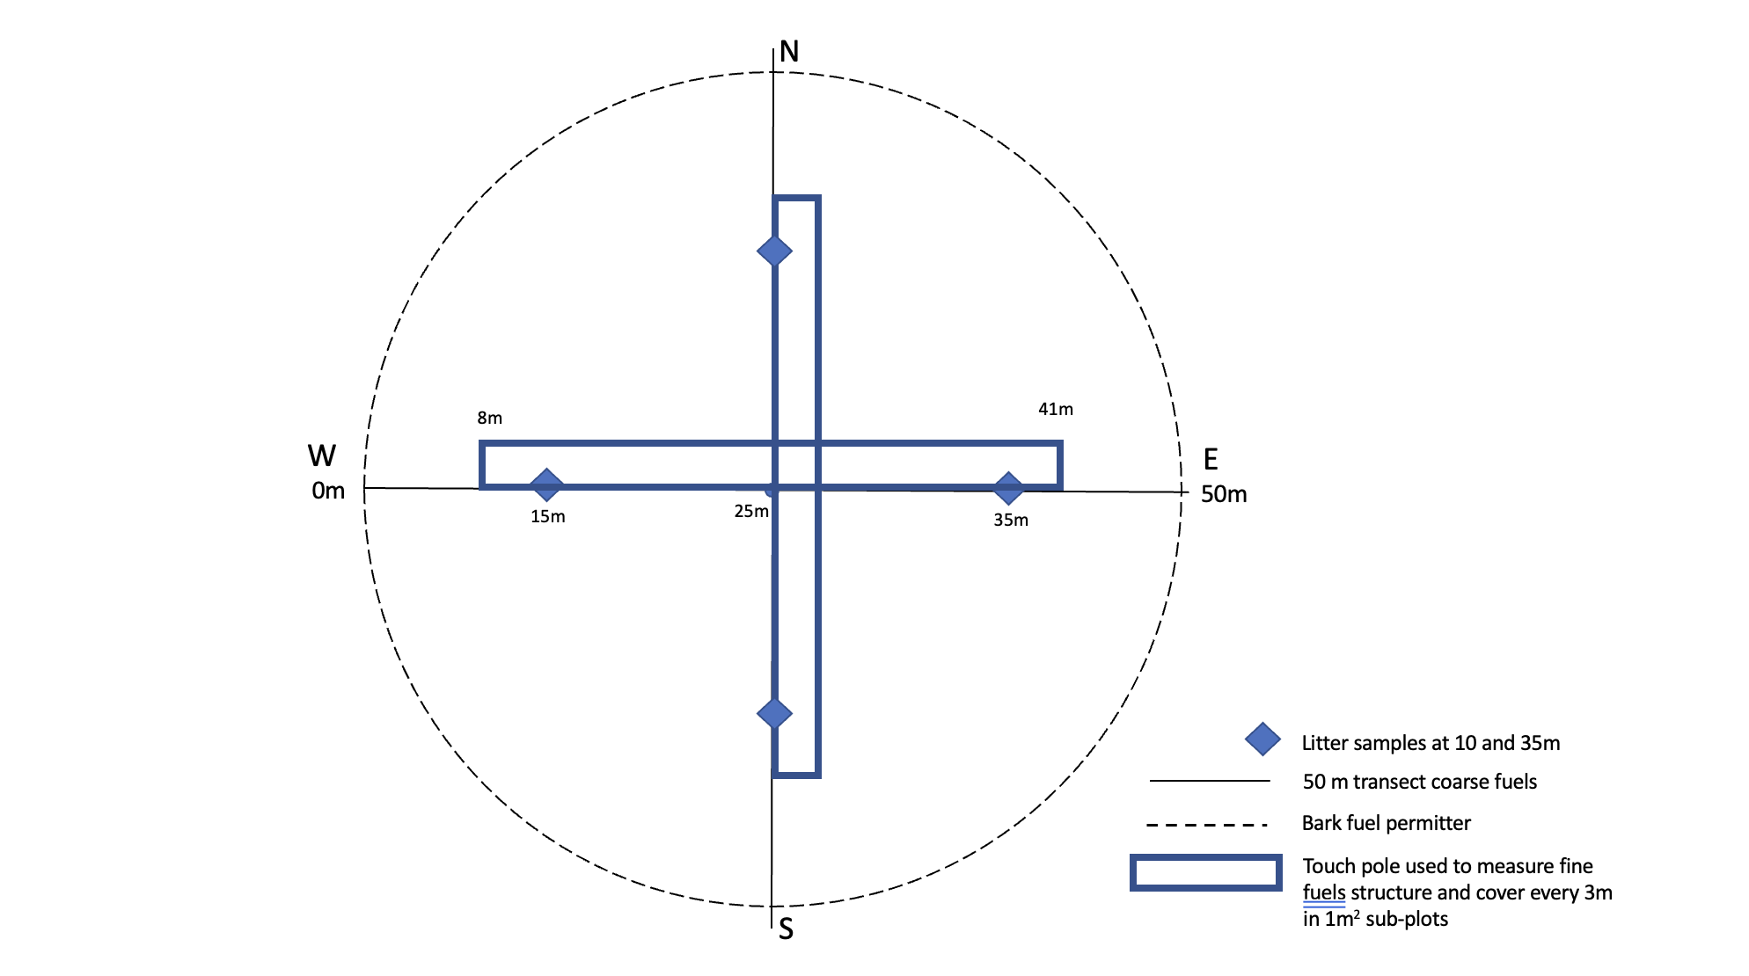
SM1:Plot layout used to undertake assessments of fuel structure and collection points for the destructive sampling of surface fuels.

