Supplementary Table S1. Application of the Kirkpatrick evaluation framework to the CRENC–IeDEA 2025 program
Kirkpatrick level | Construct | Key content areas assessed | Data type | Analysis
Level 1 — Reaction | Participant satisfaction and perceived program quality | Overall satisfaction; organisation and coordination; quality of communication; usefulness of materials and resources; effectiveness of peer-led teaching; mentorship quality; content relevance and applicability; program difficulty and pace; likelihood of recommending the program | Quantitative (5-point Likert) + qualitative (open-ended) | Descriptive statistics; Cronbach's alpha; thematic analysis
Level 2 — Learning | Self-reported research self-efficacy | Pre- and post-program self-efficacy across 14 research competency domains: formulating research questions; conducting literature reviews; understanding research ethics and GCP; selecting study designs; implementation science concepts; scientific writing (basic and advanced); bias, confounding and missing data; data analysis and interpretation; data collection and management; critical appraisal of literature; developing a research proposal; writing and submitting manuscripts; and grant writing and research funding | Quantitative (5-point Likert, paired pre–post) + qualitative (open-ended) | Wilcoxon signed-rank tests; Holm–Bonferroni correction; Cohen's d; thematic analysis
Level 3 — Behaviour | Application of skills to research practice | Research activities undertaken since joining the program; professional connections formed; mentoring or teaching of others; concrete plans to apply learning in professional practice | Quantitative (checklist) + qualitative (open-ended) | Descriptive statistics; thematic analysis
Level 4 — Results | Tangible research outputs | Research proposals written or submitted; ethics applications submitted or approved; data collection initiated; manuscripts drafted, submitted, or published; conference presentations; funding applications or awards received | Quantitative (checklist) + qualitative (open-ended) | Descriptive statistics; thematic analysis
Levels 3 and 4 are reported together in the Results because Level 4 outputs are self-reported and could not be independently verified. All survey data were collected via Microsoft Forms at program completion. Qualitative findings from open-ended items are integrated within each Kirkpatrick level in the Results section rather than reported separately.

Supplementary Table S2. Module-level relevance and teaching quality ratings across the 10 content modules (N = 42 survey respondents).

Module | Attended (n) (%) |  | Relevance (1-5) | Quality (1-5)
M1: Research Questions & Hypotheses | 37 | 88% | 4.51 | 4.49
M2: Literature Review & Synthesis | 31 | 74% | 4.55 | 4.45
M3: Research Ethics & GCP | 36 | 86% | 4.67 | 4.67
M4: Study Designs | 36 | 86% | 4.58 | 4.50
M5: Implementation Science | 32 | 76% | 4.62 | 4.47
M6: Scientific Writing I | 35 | 83% | 4.63 | 4.49
M7: Bias, Confounding & Missing Data | 34 | 81% | 4.71 | 4.50
M8: Data Analysis & Interpretation | 34 | 81% | 4.56 | 4.32
M9: Scientific Writing II | 31 | 74% | 4.61 | 4.55
M10: Data Collection & Management | 34 | 81% | 4.71 | 4.53

Ratings on a 5-point Likert scale (1 = not at all; 5 = extremely). GCP = Good Clinical Practice.

Supplementary Table S3. Pre- and post-program self-reported research self-efficacy by competency domain (N = 39–41)
Competency domain | Pre mean (SD) | Post mean (SD) | Mean change | Cohen's d | Adjusted p
Formulating research questions | 3.12 (1.00) | 4.46 (0.60) | +1.34 | 1.35 | <0.001
Conducting literature reviews | 2.98 (1.08) | 4.24 (0.73) | +1.27 | 1.46 | <0.001
Understanding research ethics and GCP | 3.38 (0.93) | 4.47 (0.72) | +1.10 | 1.22 | <0.001
Selecting study designs | 3.20 (1.01) | 4.22 (0.88) | +1.02 | 1.35 | <0.001
Implementation science concepts | 2.70 (1.07) | 3.90 (0.90) | +1.20 | 1.41 | <0.001
Scientific writing — basic | 2.62 (1.02) | 3.77 (0.87) | +1.15 | 1.37 | <0.001
Bias, confounding and missing data | 3.03 (0.99) | 3.87 (0.86) | +0.85 | 1.04 | <0.001
Data analysis and interpretation | 3.18 (0.97) | 4.00 (0.79) | +0.82 | 1.04 | <0.001
Scientific writing — advanced | 3.15 (0.95) | 4.30 (0.79) | +1.15 | 1.38 | <0.001
Data collection and management | 3.02 (0.94) | 4.24 (0.73) | +1.22 | 1.34 | <0.001
Critical appraisal of literature | 3.03 (0.93) | 4.28 (0.72) | +1.26 | 1.48 | <0.001
Developing a research proposal | 3.40 (1.01) | 4.35 (0.74) | +0.95 | 1.17 | <0.001
Writing and submitting manuscripts | 3.38 (1.08) | 4.22 (0.73) | +0.85 | 1.02 | <0.001
Grant writing and research funding | 3.23 (0.99) | 4.23 (0.71) | +1.00 | 1.16 | <0.001

Self-efficacy rated on a 5-point Likert scale (1 = very low confidence; 5 = very high confidence). Wilcoxon signed-rank tests with Holm–Bonferroni correction applied across all 14 domains. Cohen's d calculated as mean difference divided by standard deviation of paired differences. Effective N varies from 39 to 41 across domains due to missing responses handled by pairwise deletion. All p-values reported after correction. GCP = Good Clinical Practice.

Supplementary Figure S1. Percentage attendance at each of the 46 training sessions among the 55 enrolled participants.
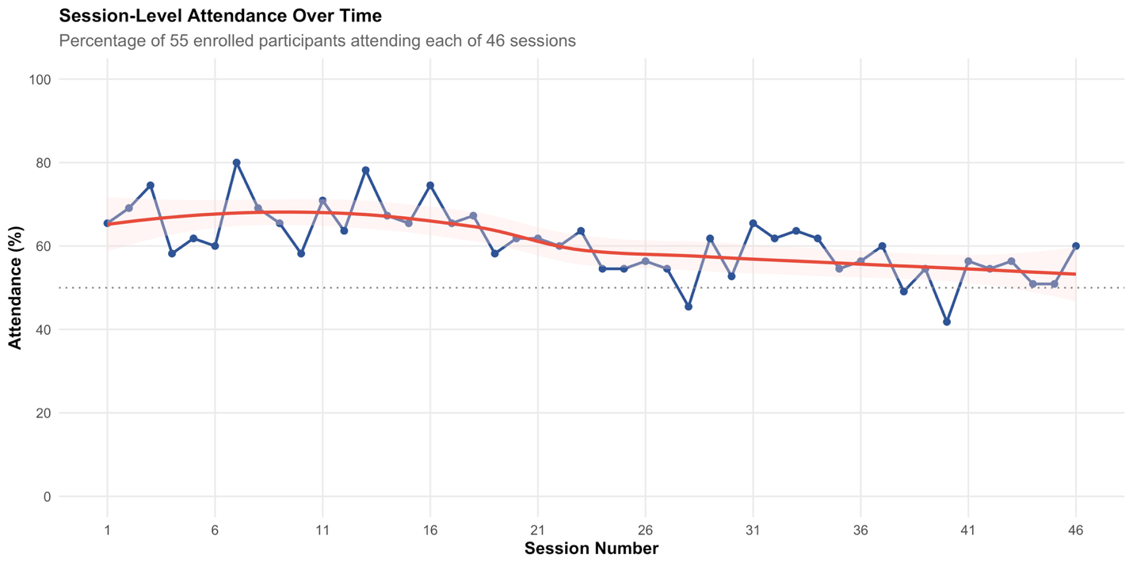

Attendance is expressed as the percentage of 55 enrolled participants attending each session. The red curve represents the smoothed attendance trajectory over time, and the horizontal dotted line denotes the 50% attendance benchmark.

Supplementary Figure S2. Distribution of participant votes for the most valuable training module.

