Integrated culture optimization and flow cytometry-guided monitoring for enhanced biomass productivity and peridinin–chlorophyll a–protein performance in Heterocapsa pygmaea

SUPPLEMENTARY MATERIALS

Supplementary Figures S1–S7 present representative flow cytometry fluorescence histograms used to support fluorescence-based physiological assessments under different environmental, nutritional, and culture medium treatments.
Figure S1 – Temperature histograms (Representative fluorescence histograms under different temperature treatments.)
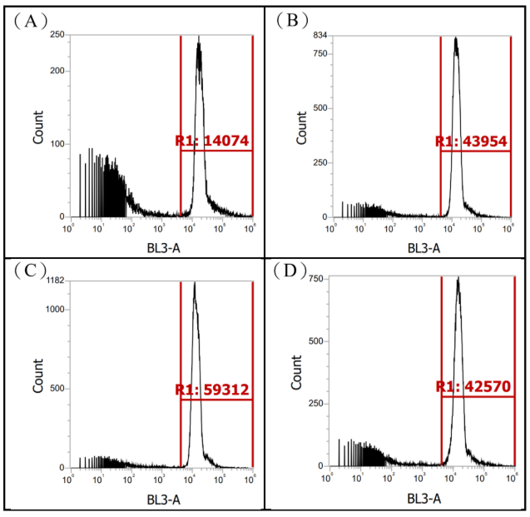

Figure S2 – Light histograms (Representative fluorescence histograms under different light intensity treatments.)
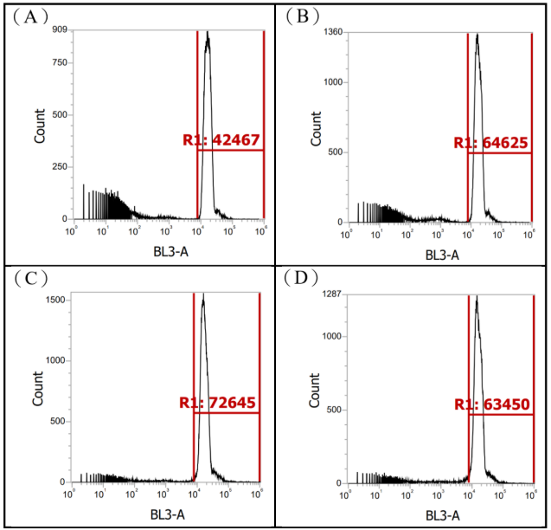

Figure S3 – Phosphorus histograms (Representative fluorescence histograms under different phosphorus treatments.)
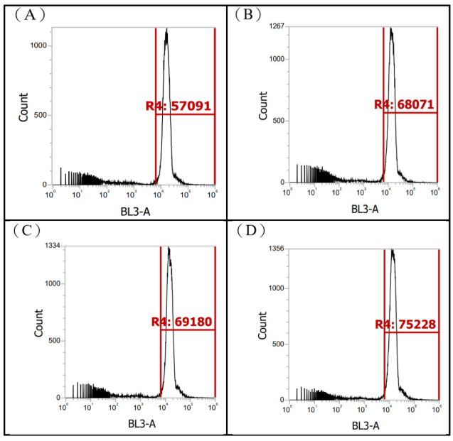

Figure S4 – Nitrogen histograms of Nitrogen form experiment (Representative fluorescence histograms under different nitrogen treatments.)
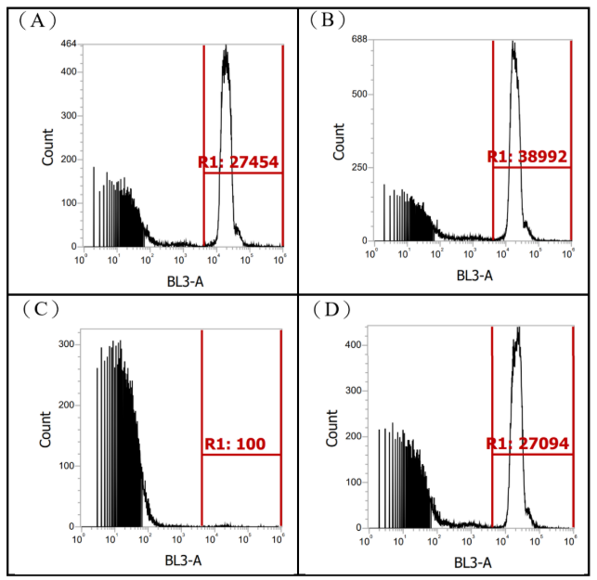

Figure S5 – Nitrogen histograms of Nitrogen source substitution experiment (Representative fluorescence histograms under different nitrogen treatments.)
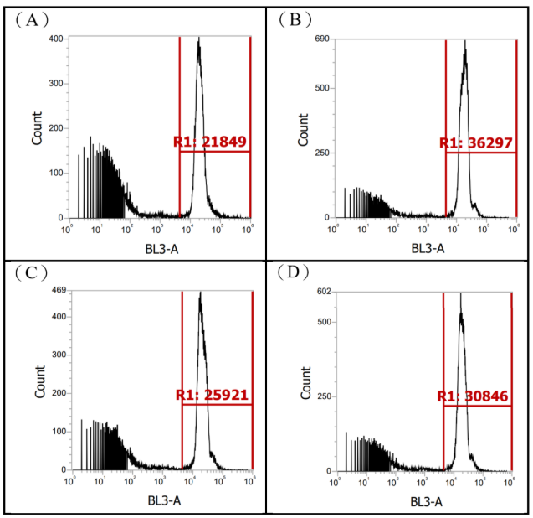

Figure S6 – Iron histograms (Representative fluorescence histograms under different iron treatments.)
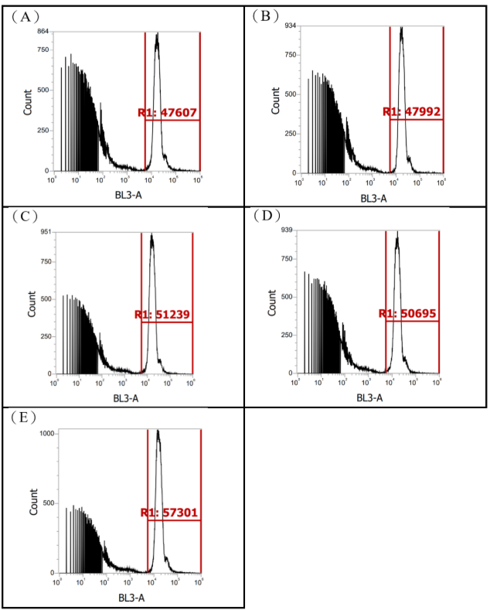

Figure S7 –C5 medium histograms (Representative fluorescence histograms under modified C5 medium conditions.)
