Supplementary Table 1. Historical fit – number of population (2004-2019)
Variable | MAPE | MSE | RMSE | R²
Number of physically active adults
Young men | 0.0476881 | 712370665 | 26690.27 | 0.9071289
Middle-aged men | 0.0802032 | 9015002051 | 94947.36 | 0.6905900
Older-aged men | 0.0420625 | 229184543 | 15138.84 | 0.9033907
Young women | 0.0930729 | 2628706826 | 51270.92 | 0.8907179
Middle-aged women | 0.0606705 | 6005229400 | 77493.42 | 0.9217196
Older-aged women | 0.0925368 | 882269579 | 29703.02 | 0.8728668
Number of low physically active adults
Young men | 0.3363570 | 356723030 | 18887.11 | 0.0297006
Middle-aged men | 0.1725178 | 3607872439 | 60065.57 | 0.4006892
Older-aged men | 0.1332931 | 264100986 | 16251.18 | 0.7388167
Young women | 0.0678260 | 69803437 | 8354.85 | 0.0002707
Middle-aged women | 0.0455778 | 409319030 | 20231.63 | 0.2025296
Older-aged women | 0.0331584 | 30094225 | 5485.82 | 0.8742858
Number of physically inactive adults
Young men | 0.2419279 | 627872143 | 25057.38 | 0.0016399
Middle-aged men | 0.0941114 | 747635887 | 27342.93 | 0.0050911
Older-aged men | 0.0967667 | 239157665 | 15464.72 | 0.8949434
Young women | 0.2166432 | 329643400 | 18156.08 | 0.2122275
Middle-aged women | 0.0488299 | 602387573 | 24543.59 | 0.3289431
Older-aged women | 0.0835817 | 474514782 | 21783.36 | 0.8785058
Abbreviations: MAPE, Mean Absolute Percent Error; MSE, Mean Square Error; RMSE, Root Mean Square Error; R², R Squared.

Supplementary Table 2. Model documentations
 | Equation | Properties | Units | Documentation
Top-Level Model:
"#_Active_Adults"[Sex, AgeGroup](t) | "#_Active_Adults"[Sex, AgeGroup](t - dt) + (net_inflow_Active_Adults[Sex, AgeGroup] + aging_in_Active_Adults[Sex, AgeGroup] + Low_Active_Progression_Rate[Sex, AgeGroup] - Active_Adults_Deaths[Sex, AgeGroup] - Active_Reversion_Rate[Sex, AgeGroup] - aging_out_Active_Adults[Sex, AgeGroup]) * dt | INIT "#_Active_Adults"[Sex, AgeGroup] = "Initial_Popn_by_sex&age_groups_18+_yrs"*Initial_Prevalence_Active_Adults | People | Number of active adults (150+ mins/week of LTPA)
"#_Least_Active_Adults"[Sex, AgeGroup](t) | "#_Least_Active_Adults"[Sex, AgeGroup](t - dt) + (net_inflow_Least_Active_Adults[Sex, AgeGroup] + aging_in_Least_Active_Adults[Sex, AgeGroup] + Low_Active_Reversion_Rate[Sex, AgeGroup] - Least_Active_Deaths[Sex, AgeGroup] - Least_Active_Progression_Rate[Sex, AgeGroup] - aging_out_Least_Active_Adults[Sex, AgeGroup]) * dt | INIT "#_Least_Active_Adults"[Sex, AgeGroup] = "Initial_Popn_by_sex&age_groups_18+_yrs"*Initial_prevalence_Least_Active_Adults | People | Number of least active adults (0-59 mins/week of LTPA)
"#_Low_Active_Adults"[Sex, AgeGroup](t) | "#_Low_Active_Adults"[Sex, AgeGroup](t - dt) + (net_inflow_Low_Active_Adults[Sex, AgeGroup] + aging_in_Low_Active_Adults[Sex, AgeGroup] + Least_Active_Progression_Rate[Sex, AgeGroup] + Active_Reversion_Rate[Sex, AgeGroup] - Low_Active_Deaths[Sex, AgeGroup] - Low_Active_Progression_Rate[Sex, AgeGroup] - Low_Active_Reversion_Rate[Sex, AgeGroup] - aging_out_Low_Active_Adults[Sex, AgeGroup]) * dt | INIT "#_Low_Active_Adults"[Sex, AgeGroup] = "Initial_Popn_by_sex&age_groups_18+_yrs"*Initial_prevalence_Low_Active_Adults | People | Number of low active adults (60-149 mins/week of LTPA)
Active_Adults_Deaths[Sex, AgeGroup] | "#_Active_Adults"*mortality_risk_Active_Adults |  | People/Years | Number of adults die from the active group every year
Active_Reversion_Rate[Sex, AgeGroup] | "#_Active_Adults"*(1-mortality_risk_Active_Adults)*Active_Reversion_Probability |  | People/Years | Number of adults transitioning from the active to low-active group every year
aging_in_Active_Adults[Male, Age_18_to_29] | 0 |  | People/Years | Number of the active adults aging into an older age group every year
aging_in_Active_Adults[Male, Age_30_to_64] | aging_out_Active_Adults[Male,Age_18_to_29] |  | People/Years | Number of the active adults aging into an older age group every year
aging_in_Active_Adults[Male, Age_65_and_plus] | aging_out_Active_Adults[Male,Age_30_to_64] |  | People/Years | Number of the active adults aging into an older age group every year
aging_in_Active_Adults[Female, Age_18_to_29] | 0 |  | People/Years | Number of the active adults aging into an older age group every year
aging_in_Active_Adults[Female, Age_30_to_64] | aging_out_Active_Adults[Female,Age_18_to_29] |  | People/Years | Number of the active adults aging into an older age group every year
aging_in_Active_Adults[Female, Age_65_and_plus] | aging_out_Active_Adults[Female,Age_30_to_64] |  | People/Years | Number of the active adults aging into an older age group every year
aging_in_Least_Active_Adults[Male, Age_18_to_29] | 0 |  | People/Years | Number of the least-active adults aging into an older age group every year
aging_in_Least_Active_Adults[Male, Age_30_to_64] | aging_out_Least_Active_Adults[Male,Age_18_to_29] |  | People/Years | Number of the least-active adults aging into an older age group every year
aging_in_Least_Active_Adults[Male, Age_65_and_plus] | aging_out_Least_Active_Adults[Male,Age_30_to_64] |  | People/Years | Number of the least-active adults aging into an older age group every year
aging_in_Least_Active_Adults[Female, Age_18_to_29] | 0 |  | People/Years | Number of the least-active adults aging into an older age group every year
aging_in_Least_Active_Adults[Female, Age_30_to_64] | aging_out_Least_Active_Adults[Female,Age_18_to_29] |  | People/Years | Number of the least-active adults aging into an older age group every year
aging_in_Least_Active_Adults[Female, Age_65_and_plus] | aging_out_Least_Active_Adults[Female,Age_30_to_64] |  | People/Years | Number of the least-active adults aging into an older age group every year
aging_in_Low_Active_Adults[Male, Age_18_to_29] | 0 |  | People/Years | Number of the low-active adults aging into an older age group every year
aging_in_Low_Active_Adults[Male, Age_30_to_64] | aging_out_Low_Active_Adults[Male,Age_18_to_29] |  | People/Years | Number of the low-active adults aging into an older age group every year
aging_in_Low_Active_Adults[Male, Age_65_and_plus] | aging_out_Low_Active_Adults[Male,Age_30_to_64] |  | People/Years | Number of the low-active adults aging into an older age group every year
aging_in_Low_Active_Adults[Female, Age_18_to_29] | 0 |  | People/Years | Number of the low-active adults aging into an older age group every year
aging_in_Low_Active_Adults[Female, Age_30_to_64] | aging_out_Low_Active_Adults[Female,Age_18_to_29] |  | People/Years | Number of the low-active adults aging into an older age group every year
aging_in_Low_Active_Adults[Female, Age_65_and_plus] | aging_out_Low_Active_Adults[Female,Age_30_to_64] |  | People/Years | Number of the low-active adults aging into an older age group every year
aging_out_Active_Adults[Male, Age_18_to_29] | "#_Active_Adults"[Male,Age_18_to_29]*(1-mortality_risk_Active_Adults[Male,Age_18_to_29])*PA_maintain_rate_Active_Adults[Male,Age_18_to_29]/12 |  | People/Years | Number of the active adults aging out of their current age group every year
aging_out_Active_Adults[Male, Age_30_to_64] | "#_Active_Adults"[Male,Age_30_to_64]*(1-mortality_risk_Active_Adults[Male,Age_30_to_64])*PA_maintain_rate_Active_Adults[Male,Age_30_to_64]/35 |  | People/Years | Number of the active adults aging out of their current age group every year
aging_out_Active_Adults[Male, Age_65_and_plus] | 0 |  | People/Years | Number of the active adults aging out of their current age group every year
aging_out_Active_Adults[Female, Age_18_to_29] | "#_Active_Adults"[Female,Age_18_to_29]*(1-mortality_risk_Active_Adults[Female,Age_18_to_29])*PA_maintain_rate_Active_Adults[Female,Age_18_to_29]/12 |  | People/Years | Number of the active adults aging out of their current age group every year
aging_out_Active_Adults[Female, Age_30_to_64] | "#_Active_Adults"[Female,Age_30_to_64]*(1-mortality_risk_Active_Adults[Female,Age_30_to_64])*PA_maintain_rate_Active_Adults[Female,Age_30_to_64]/35 |  | People/Years | Number of the active adults aging out of their current age group every year
aging_out_Active_Adults[Female, Age_65_and_plus] | 0 |  | People/Years | Number of the active adults aging out of their current age group every year
aging_out_Least_Active_Adults[Male, Age_18_to_29] | "#_Least_Active_Adults"[Male,Age_18_to_29]*(1-mortality_risk_Least_Active_Adults[Male,Age_18_to_29])*PA_maintain_rate_Least_Active_Adults[Male,Age_18_to_29]/12 |  | People/Years | Number of the least-active adults aging out of their current age group every year
aging_out_Least_Active_Adults[Male, Age_30_to_64] | "#_Least_Active_Adults"[Male,Age_30_to_64]*(1-mortality_risk_Least_Active_Adults[Male,Age_30_to_64])*PA_maintain_rate_Least_Active_Adults[Male,Age_30_to_64]/35 |  | People/Years | Number of the least-active adults aging out of their current age group every year
aging_out_Least_Active_Adults[Male, Age_65_and_plus] | 0 |  | People/Years | Number of the least-active adults aging out of their current age group every year
aging_out_Least_Active_Adults[Female, Age_18_to_29] | "#_Least_Active_Adults"[Female,Age_18_to_29]*(1-mortality_risk_Least_Active_Adults[Female,Age_18_to_29])*PA_maintain_rate_Least_Active_Adults[Female,Age_18_to_29]/12 |  | People/Years | Number of the least-active adults aging out of their current age group every year
aging_out_Least_Active_Adults[Female, Age_30_to_64] | "#_Least_Active_Adults"[Female,Age_30_to_64]*(1-mortality_risk_Least_Active_Adults[Female,Age_30_to_64])*PA_maintain_rate_Least_Active_Adults[Female,Age_30_to_64]/35 |  | People/Years | Number of the least-active adults aging out of their current age group every year
aging_out_Least_Active_Adults[Female, Age_65_and_plus] | 0 |  | People/Years | Number of the least-active adults aging out of their current age group every year
aging_out_Low_Active_Adults[Male, Age_18_to_29] | "#_Low_Active_Adults"[Male,Age_18_to_29]*(1-mortality_risk_Low_Active_Adults[Male,Age_18_to_29])*PA_maintain_rate_Low_Active_Adults[Male,Age_18_to_29]/12 |  | People/Years | Number of the low-active adults aging out of their current age group every year
aging_out_Low_Active_Adults[Male, Age_30_to_64] | "#_Low_Active_Adults"[Male,Age_30_to_64]*(1-mortality_risk_Low_Active_Adults[Male,Age_30_to_64])*PA_maintain_rate_Low_Active_Adults[Male,Age_30_to_64]/35 |  | People/Years | Number of the low-active adults aging out of their current age group every year
aging_out_Low_Active_Adults[Male, Age_65_and_plus] | 0 |  | People/Years | Number of the low-active adults aging out of their current age group every year
aging_out_Low_Active_Adults[Female, Age_18_to_29] | "#_Low_Active_Adults"[Female,Age_18_to_29]*(1-mortality_risk_Low_Active_Adults[Female,Age_18_to_29])*PA_maintain_rate_Low_Active_Adults[Female,Age_18_to_29]/12 |  | People/Years | Number of the low-active adults aging out of their current age group every year
aging_out_Low_Active_Adults[Female, Age_30_to_64] | "#_Low_Active_Adults"[Female,Age_30_to_64]*(1-mortality_risk_Low_Active_Adults[Female,Age_30_to_64])*PA_maintain_rate_Low_Active_Adults[Female,Age_30_to_64]/35 |  | People/Years | Number of the low-active adults aging out of their current age group every year
aging_out_Low_Active_Adults[Female, Age_65_and_plus] | 0 |  | People/Years | Number of the low-active adults aging out of their current age group every year
Least_Active_Deaths[Sex, AgeGroup] | "#_Least_Active_Adults"*mortality_risk_Least_Active_Adults |  | People/Years | Number of adults die from the least-active group every year
Least_Active_Progression_Rate[Sex, AgeGroup] | "#_Least_Active_Adults"*(1-mortality_risk_Least_Active_Adults)*Least_Active_Progression_Probability |  | People/Years | Number of adults transitioning from the least-active to low-active group every year
Low_Active_Deaths[Sex, AgeGroup] | "#_Low_Active_Adults"*mortality_risk_Low_Active_Adults |  | People/Years | Number of adults die from the low-active group every year
Low_Active_Progression_Rate[Sex, AgeGroup] | "#_Low_Active_Adults"*(1-mortality_risk_Low_Active_Adults)*Low_Active_Progression_Probability |  | People/Years | Number of adults transitioning from the low-active to active group every year
Low_Active_Reversion_Rate[Sex, AgeGroup] | "#_Low_Active_Adults"*(1-mortality_risk_Low_Active_Adults)*Low_Active_Reversion_Probability |  | People/Years | Number of adults transitioning from low-active to the least-active to group every year
net_inflow_Active_Adults[Male, Age_18_to_29] | Children_turning_18_Active_Adults[Male]+Net_Immigration_Active_Adults[Male,Age_18_to_29] |  | People/Years | Number of least-active people from children turning 18 years old and immigration every year
net_inflow_Active_Adults[Male, Age_30_to_64] | Net_Immigration_Active_Adults[Male,Age_30_to_64] |  | People/Years | Number of least-active people from children turning 18 years old and immigration every year
net_inflow_Active_Adults[Male, Age_65_and_plus] | Net_Immigration_Active_Adults[Male,Age_65_and_plus] |  | People/Years | Number of least-active people from children turning 18 years old and immigration every year
net_inflow_Active_Adults[Female, Age_18_to_29] | Children_turning_18_Active_Adults[Female]+Net_Immigration_Active_Adults[Female,Age_18_to_29] |  | People/Years | Number of least-active people from children turning 18 years old and immigration every year
net_inflow_Active_Adults[Female, Age_30_to_64] | Net_Immigration_Active_Adults[Female,Age_30_to_64] |  | People/Years | Number of least-active people from children turning 18 years old and immigration every year
net_inflow_Active_Adults[Female, Age_65_and_plus] | Net_Immigration_Active_Adults[Female,Age_65_and_plus] |  | People/Years | Number of least-active people from children turning 18 years old and immigration every year
net_inflow_Least_Active_Adults[Male, Age_18_to_29] | Children_turning_18_Least_Active_Adults[Male]+ Net_Immigration_Least_Active_Adults[Male,Age_18_to_29] |  | People/Years | Number of least-active people from children turning 18 years old and immigration every year
net_inflow_Least_Active_Adults[Male, Age_30_to_64] | Net_Immigration_Least_Active_Adults[Male,Age_30_to_64] |  | People/Years | Number of least-active people from children turning 18 years old and immigration every year
net_inflow_Least_Active_Adults[Male, Age_65_and_plus] | Net_Immigration_Least_Active_Adults[Male,Age_65_and_plus] |  | People/Years | Number of least-active people from children turning 18 years old and immigration every year
net_inflow_Least_Active_Adults[Female, Age_18_to_29] | Children_turning_18_Least_Active_Adults[Female]+Net_Immigration_Least_Active_Adults[Female,Age_18_to_29] |  | People/Years | Number of least-active people from children turning 18 years old and immigration every year
net_inflow_Least_Active_Adults[Female, Age_30_to_64] | Net_Immigration_Least_Active_Adults[Female,Age_30_to_64] |  | People/Years | Number of least-active people from children turning 18 years old and immigration every year
net_inflow_Least_Active_Adults[Female, Age_65_and_plus] | Net_Immigration_Least_Active_Adults[Female,Age_65_and_plus] |  | People/Years | Number of least-active people from children turning 18 years old and immigration every year
net_inflow_Low_Active_Adults[Male, Age_18_to_29] | Children_turning_18_Low_Active_Adults[Male]+Net_Immigration_Low_Active_Adults[Male,Age_18_to_29] |  | People/Years | Number of low-active people from children turning 18 years old and immigration every year
net_inflow_Low_Active_Adults[Male, Age_30_to_64] | Net_Immigration_Low_Active_Adults[Male,Age_30_to_64] |  | People/Years | Number of low-active people from children turning 18 years old and immigration every year
net_inflow_Low_Active_Adults[Male, Age_65_and_plus] | Net_Immigration_Low_Active_Adults[Male,Age_65_and_plus] |  | People/Years | Number of low-active people from children turning 18 years old and immigration every year
net_inflow_Low_Active_Adults[Female, Age_18_to_29] | Children_turning_18_Low_Active_Adults[Female]+Net_Immigration_Low_Active_Adults[Female,Age_18_to_29] |  | People/Years | Number of low-active people from children turning 18 years old and immigration every year
net_inflow_Low_Active_Adults[Female, Age_30_to_64] | Net_Immigration_Low_Active_Adults[Female,Age_30_to_64] |  | People/Years | Number of low-active people from children turning 18 years old and immigration every year
net_inflow_Low_Active_Adults[Female, Age_65_and_plus] | Net_Immigration_Low_Active_Adults[Female,Age_65_and_plus] |  | People/Years | Number of low-active people from children turning 18 years old and immigration every year
"#_Total_pop_add_all_PA_levels"[Sex, AgeGroup] | "#_Least_Active_Adults"+"#_Low_Active_Adults"+"#_Active_Adults" |  | People
Active_Reversion_Probability[Sex, AgeGroup] | 0 |  | Dimensionless
Calculated_prevalence_Active_Adults[Sex, AgeGroup] | SAFEDIV("#_Active_Adults", "#_Total_pop_add_all_PA_levels", 0) |  | Dimensionless
"Calculated_prevalence_Active_Adults_-_no_array" | SAFEDIV(SUM("#_Active_Adults"), SUM("#_Total_pop_add_all_PA_levels")) |  | Dimensionless
Calculated_prevalence_Least_Active_Adults[Sex, AgeGroup] | SAFEDIV("#_Least_Active_Adults", "#_Total_pop_add_all_PA_levels", 0) |  | Dimensionless
"Calculated_prevalence_Least_Active_Adults_-_no_array" | SAFEDIV(SUM("#_Least_Active_Adults"), SUM("#_Total_pop_add_all_PA_levels"), 0) |  | Dimensionless
Calculated_prevalence_Low_Active_Adults[Sex, AgeGroup] | SAFEDIV("#_Low_Active_Adults", "#_Total_pop_add_all_PA_levels", 0) |  | Dimensionless
"Calculated_prevalence_Low_Active_Adults_-_no_array" | SAFEDIV(SUM("#_Low_Active_Adults"), SUM("#_Total_pop_add_all_PA_levels")) |  | Dimensionless
Children_turning_18_Active_Adults[Sex] | "Historical_Children_turning_18_2004-2019"*"Prevalence_Active_Adults_18-29_yrs" |  | People/Years
Children_turning_18_Least_Active_Adults[Sex] | "Historical_Children_turning_18_2004-2019"*"Prevalence_Least_Active_Adults_18-29_yrs" |  | People/Years
Children_turning_18_Low_Active_Adults[Sex] | "Historical_Children_turning_18_2004-2019"*"Prevalence_Low_Active_Adults_18-29_yrs" |  | People/Years
"Historical_Children_turning_18_2004-2019"[Sex] | 0 |  | People/Years
"Historical_Interstate_Arrival_2004-2019"[Sex, AgeGroup] | 0 |  | People/Years
"Historical_Interstate_Departure_2004-2019"[Sex, AgeGroup] | 0 |  | People/Years
"Historical_Overseas_Arrival_2004-2019"[Sex, AgeGroup] | 0 |  | People/Years
"Historical_Overseas_Departure_2004-2019"[Sex, AgeGroup] | 0 |  | People/Years
"historical_prevalence_Active_Adults_-_by_sex/age"[Sex, AgeGroup] | 0 |  | Dimensionless
"historical_prevalence_Active_Adults_-_no_array" | 0 |  | Dimensionless
"historical_prevalence_Least_Active_Adults_-_by_sex/age"[Sex, AgeGroup] | 0 |  | Dimensionless
"historical_prevalence_Least_Active_Adults_-_no_array" | 0 |  | Dimensionless
"historical_prevalence_Low_Active_Adults_-_by_sex/age"[Sex, AgeGroup] | 0 |  | Dimensionless
"historical_prevalence_Low_Active_Adults_-_no_array" | 0 |  | Dimensionless
Historical_Total_popn[Sex, AgeGroup] | 0 |  | People
Historical_total_popn_Active_Adults[Sex, AgeGroup] | Historical_Total_popn*"historical_prevalence_Active_Adults_-_by_sex/age" |  | People
Historical_total_popn_Least_Active_Adults[Sex, AgeGroup] | Historical_Total_popn*"historical_prevalence_Least_Active_Adults_-_by_sex/age" |  | People
Historical_total_popn_Low_Active_Adults[Sex, AgeGroup] | Historical_Total_popn*"historical_prevalence_Low_Active_Adults_-_by_sex/age" |  | People
Initial_Kids_turning_18[Male] | 45633.8 |  | People
Initial_Kids_turning_18[Female] | 43756.4
"Initial_Popn_by_sex&age_groups_18+_yrs"[Male, Age_18_to_29] | 546867 |  | People
"Initial_Popn_by_sex&age_groups_18+_yrs"[Male, Age_30_to_64] | 1540951
"Initial_Popn_by_sex&age_groups_18+_yrs"[Male, Age_65_and_plus] | 393927
"Initial_Popn_by_sex&age_groups_18+_yrs"[Female, Age_18_to_29] | 535722
"Initial_Popn_by_sex&age_groups_18+_yrs"[Female, Age_30_to_64] | 1549445
"Initial_Popn_by_sex&age_groups_18+_yrs"[Female, Age_65_and_plus] | 492793
Initial_Prevalence_Active_Adults[Male, Age_18_to_29] | 0.7867 |  | Dimensionless
Initial_Prevalence_Active_Adults[Male, Age_30_to_64] | 0.6723
Initial_Prevalence_Active_Adults[Male, Age_65_and_plus] | 0.6100
Initial_Prevalence_Active_Adults[Female, Age_18_to_29] | 0.6455
Initial_Prevalence_Active_Adults[Female, Age_30_to_64] | 0.5934
Initial_Prevalence_Active_Adults[Female, Age_65_and_plus] | 0.4523
Initial_prevalence_Least_Active_Adults[Male, Age_18_to_29] | 0.0961 |  | Dimensionless
Initial_prevalence_Least_Active_Adults[Male, Age_30_to_64] | 0.1781
Initial_prevalence_Least_Active_Adults[Male, Age_65_and_plus] | 0.2099
Initial_prevalence_Least_Active_Adults[Female, Age_18_to_29] | 0.1451
Initial_prevalence_Least_Active_Adults[Female, Age_30_to_64] | 0.2043
Initial_prevalence_Least_Active_Adults[Female, Age_65_and_plus] | 0.3297
Initial_prevalence_Low_Active_Adults[Male, Age_18_to_29] | 0.1172 |  | Dimensionless
Initial_prevalence_Low_Active_Adults[Male, Age_30_to_64] | 0.1497
Initial_prevalence_Low_Active_Adults[Male, Age_65_and_plus] | 0.1801
Initial_prevalence_Low_Active_Adults[Female, Age_18_to_29] | 0.2094
Initial_prevalence_Low_Active_Adults[Female, Age_30_to_64] | 0.2023
Initial_prevalence_Low_Active_Adults[Female, Age_65_and_plus] | 0.2180
Least_Active_Progression_Probability[Sex, AgeGroup] | 0 |  | Dimensionless
Low_Active_Progression_Probability[Sex, AgeGroup] | 0 |  | Dimensionless
Low_Active_Reversion_Probability[Sex, AgeGroup] | 0 |  | Dimensionless
mortality_risk_Active_Adults[Sex, AgeGroup] | 0 |  | Per Year
mortality_risk_Least_Active_Adults[Sex, AgeGroup] | 0 |  | Per Year
mortality_risk_Low_Active_Adults[Sex, AgeGroup] | 0 |  | Per Year
Net_Arrival[Sex, AgeGroup] | "Historical_Interstate_Arrival_2004-2019"+"Historical_Overseas_Arrival_2004-2019" |  | People/Years
Net_Departure[Sex, AgeGroup] | "Historical_Interstate_Departure_2004-2019"+"Historical_Overseas_Departure_2004-2019" |  | People/Years
Net_Immigration[Sex, AgeGroup] | Net_Arrival-Net_Departure |  | People/Years
Net_Immigration_Active_Adults[Sex, AgeGroup] | Net_Immigration*Calculated_prevalence_Active_Adults |  | People/Years
Net_Immigration_Least_Active_Adults[Sex, AgeGroup] | Net_Immigration*Calculated_prevalence_Least_Active_Adults |  | People/Years
Net_Immigration_Low_Active_Adults[Sex, AgeGroup] | Net_Immigration*Calculated_prevalence_Low_Active_Adults |  | People/Years
PA_maintain_rate_Active_Adults[Sex, AgeGroup] | 1-Active_Reversion_Probability |  | Dimensionless
PA_maintain_rate_Least_Active_Adults[Sex, AgeGroup] | 1-Least_Active_Progression_Probability |  | Dimensionless
PA_maintain_rate_Low_Active_Adults[Sex, AgeGroup] | 1-Low_Active_Progression_Probability-Low_Active_Reversion_Probability |  | Dimensionless
"Prevalence_Active_Adults_18-29_yrs"[Male] | Calculated_prevalence_Active_Adults[Male,Age_18_to_29] |  | Dimensionless
"Prevalence_Active_Adults_18-29_yrs"[Female] | Calculated_prevalence_Active_Adults[Female,Age_18_to_29]
"Prevalence_Least_Active_Adults_18-29_yrs"[Male] | Calculated_prevalence_Least_Active_Adults[Male,Age_18_to_29] |  | Dimensionless
"Prevalence_Least_Active_Adults_18-29_yrs"[Female] | Calculated_prevalence_Least_Active_Adults[Female,Age_18_to_29]
"Prevalence_Low_Active_Adults_18-29_yrs"[Male] | Calculated_prevalence_Low_Active_Adults[Male,Age_18_to_29] |  | Dimensionless
"Prevalence_Low_Active_Adults_18-29_yrs"[Female] | Calculated_prevalence_Low_Active_Adults[Female,Age_18_to_29]
Model_Summary_Statistics:
Count(t) | Count(t - dt) + (Count_net_flow) * dt | INIT Count = 0 | Dimensionless | Counter for # of points
Sum_AE(t) | Sum_AE(t - dt) + (Sum_AE_net_flow) * dt | INIT Sum_AE = 0 | Units | Sum of Absolute Errors
Sum_APE(t) | Sum_APE(t - dt) + (Sum_APE_net_flow) * dt | INIT Sum_APE = 0 | Dimensionless | Sum of Absolute Percent Errors
Sum_Xi(t) | Sum_Xi(t - dt) + (Sum_Xi_net_flow) * dt | INIT Sum_Xi = 0 | Units | Sum of x's (simulated)
Sum_Yi(t) | Sum_Yi(t - dt) + (Sum_Yi_net_flow) * dt | INIT Sum_Yi = 0 | Units | Sum of y'
SumX2(t) | SumX2(t - dt) + (SumX2_net_flow) * dt | INIT SumX2 = 0 | Units*Units | Sum of x^
SumXY(t) | SumXY(t - dt) + (SumXY_net_flow) * dt | INIT SumXY = 0 | Units*Units | Sum of x*y
SumY2(t) | SumY2(t - dt) + (SumY2_net_flow) * dt | INIT SumY2 = 0 | Units*Units | Sum of y^
Count_net_flow | pick/Time_Step |  | Per Year
Sum_AE_net_flow | ABS(Xi-Yi)/Time_Step |  | Units/Years
Sum_APE_net_flow | ABS(SAFEDIV(Xi-Yi, Yi))/Time_Step |  | Per Year
Sum_Xi_net_flow | Xi/Time_Step |  | Units/Years
Sum_Yi_net_flow | Yi/Time_Step |  | Units/Years
SumX2_net_flow | Xi*Xi/Time_Step |  | Units*Units/Years
SumXY_net_flow | Xi*Yi/Time_Step |  | Units*Units/Years
SumY2_net_flow | Yi*Yi/Time_Step |  | Units*Units/Years
dif_cov | 2*Sx*Sy*(1-r) |  | Units*Units | Difference of covariances
dif_mea | (M_X-M_Y)*(M_X-M_Y) |  | Units*Units | Difference of Means (bias)
dif_var | (Sx-Sy)*(Sx-Sy) |  | Units*Units | Difference of variances
End_Time | 2019 |  | Time Units | Date of last data point
Historical | ."historical_prevalence_Least_Active_Adults_-_by_sex/age"[Female,Age_65_and_plus] |  | Units | Set equal to the historical data series.
Interval | 1 |  | Time Units | Interval between data points
M_X | SAFEDIV(Sum_Xi, Count) |  | Units | Mean of x (sum x)/n
M_Y | SAFEDIV(Sum_Yi, Count) |  | Units | Mean of y (sum y)/n
MAE_over_Mean | SAFEDIV(SAFEDIV(Sum_AE, Count), M_X) |  | Dimensionless | Mean Absolute Error as a fraction of the mean of the data  ~ :SUPPLEMENTARY
MAPE | SAFEDIV(Sum_APE, Count) |  | Dimensionless | Mean Absolute Percent Error  ~ :SUPPLEMENTARY
MSE | dif_mea+dif_var+dif_cov |  | Units*Units | Mean Square Error. The addition of the three components
MX2 | SAFEDIV(SumX2, Count) |  | Units*Units | Mean of x^2 (sum x^2)/n
Mxy | SAFEDIV(SumXY, Count) |  | Units*Units | Mean of x*y (sum x*y)/n
MY2 | SAFEDIV(SumY2, Count) |  | Units*Units | Mean of y^2 (sum y^2)/n
pick | STEP(1, Start_Time)*(1-STEP(1, End_Time+Time_Step/2))*( IF TIME/Interval = INT(TIME/Interval) THEN 1 ELSE 0 ) |  | Dimensionless | Takes a value of one for every data point available, assuming the data are available at intervals of Interval between the Start Time and End Time.
r | SAFEDIV(Mxy-(M_X*M_Y), Sx*Sy) |  | Dimensionless | Correlation coefficient. Calculated through the 'hand computation' formula.  Sterman (1984) pg. 63
"R^2" | r*r |  | Dimensionless | Correlation coefficient squared  ~ :SUPPLEMENTARY
Residuals | Yi-Xi |  | Units | Errors
RMSE | SQRT(MSE) |  | Units | Root Mean Square Error  ~ :SUPPLEMENTARY
Simulated | .Calculated_prevalence_Least_Active_Adults[Female,Age_65_and_plus] |  | Units | Set equal to the simulated data series.
Start_Time | 2004 |  | Time Units | Date of first data point
Sx | SQRT(MX2-(M_X*M_X)) |  | Units | Standard Deviation of x. Calculated using the 'hand computation'  formula  to calculate the standard deviation without prior knowledge of  the mean.  Sterman (1984), pg. 64
Sy | SQRT(MY2-(M_Y*M_Y)) |  | Units | Standard Deviation of y. Calculated using the 'hand computation'  formula  to calculate the standard deviation without prior knowledge of  the mean.  Sterman (1984), pg. 64
Time_Step | DT |  | Years
Uc | SAFEDIV(dif_cov, MSE) |  | Dimensionless | Covariance inequality proportion  ~ :SUPPLEMENTARY
Um | SAFEDIV(dif_mea, MSE) |  | Dimensionless | Bias inequality proportion  ~ :SUPPLEMENTARY
Us | SAFEDIV(dif_var, MSE) |  | Dimensionless | Variance inequality proportion  ~ :SUPPLEMENTARY
X | Historical |  | Units | The historical data input
Xi | pick*X |  | Units | The historic data series
Y | Simulated |  | Units | The simulated data series
Yi | pick*Y |  | Units | Sampled simulated variable

Supplementary Figure 1. Simulated behaviour compared with historical behaviour among total population

Appendix Figure 2. Simulated scenarios – simulated prevalence Active Adults by 2050
Appendix Figure 2A. Business-As-Usual (BAU)
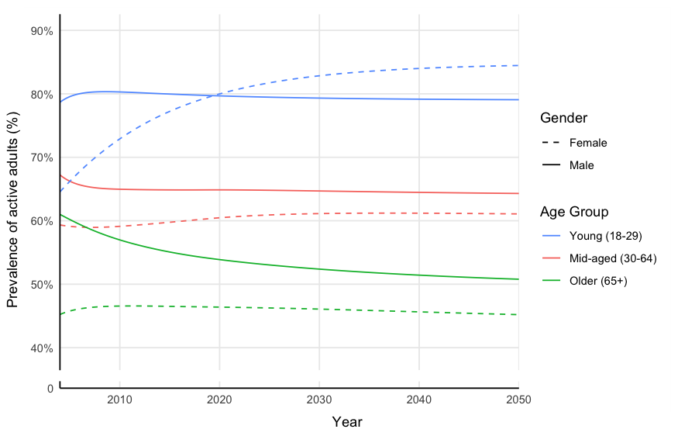

Appendix Figure 2B. Increase women’s rates by 1%
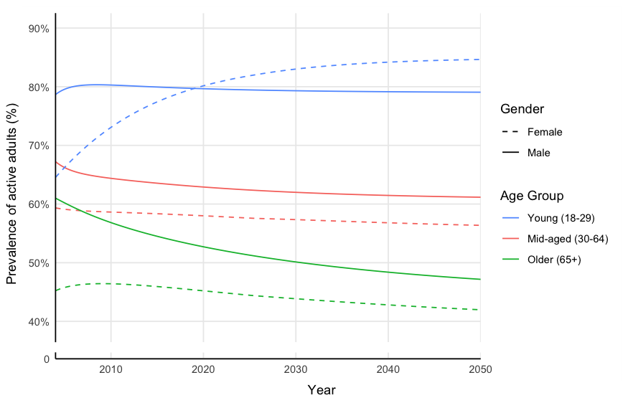

Appendix Figure 2C. Increase women’s rates by 5%
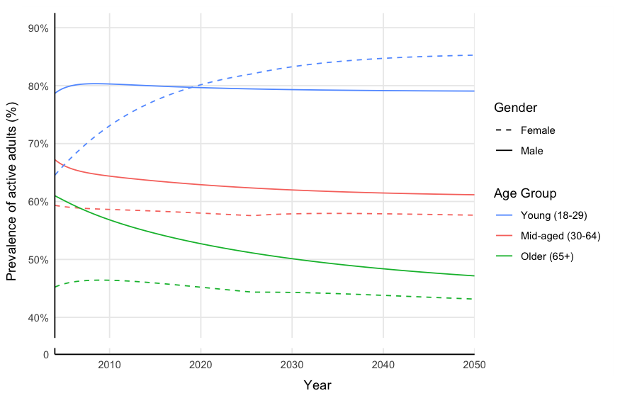

Appendix Figure 2D. Increase women’s rates by 10%
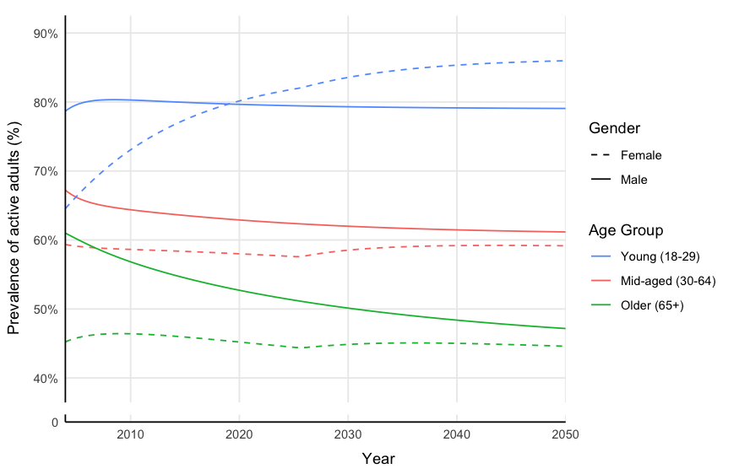

Appendix Figure 2E. Increase women’s rates by 15%
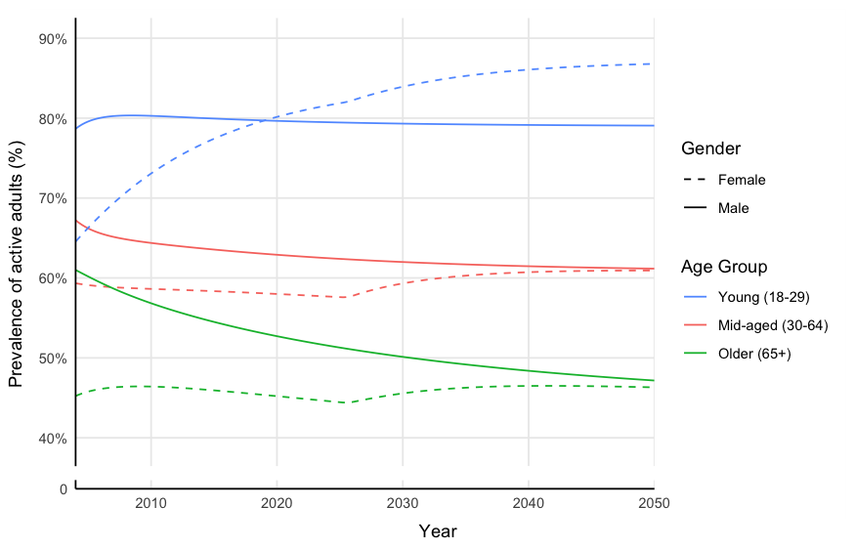

Appendix Figure 2F. Increase women’s rates by 20%
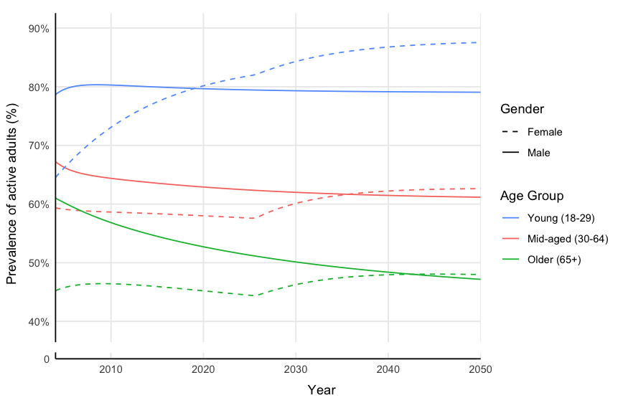

Supplementary Text 1. Extreme conditions
This test assesses whether the equation and results of the model make sense when subjected to extreme values, parameters, and policies. We examined extreme conditions for three key variables, which are initial population, mortality risk, progression and reversion probability.
Variable | Description | Simulation results | Simulations as expected
Initial population (=0) | We varied the initial population of each gender and age group to take a minimal value of 0. Under this extreme condition, we expect the number of people in any activity level to be 0. |  | Yes

Variable | Description | Simulation results | Simulations as expected
Initial population (=10,000,000) | We varied the initial population of each gender and age group to take a maximum value of 10,000,000. Under this extreme condition, we expect the number of active adults remain higher than the other two LTPA groups, due to the high initial prevalence value of active adults. We also expect the total number of young adults are decrease faster due to population aging. |  | Yes

Variable | Description | Simulation results | Simulations as expected
Mortality rate (=0) | We varied the mortality rate values of each gender and age group to take a minimal value of 0. This means that no one die and exit from the model. We expect a sharp increase for the older-aged group (65 years old and above). |  | Yes

Variable | Description | Simulation results | Simulations as expected
Mortality rate (=1) | We varied the mortality rate values of each gender and age group to take a maximum value of 1. This means that everyone dies and exits from the model every year. We expect sharp decreases to almost all LTPA levels across gender and age groups. The number of young adults will remain consistently low but not 0 after 2019, because of the number of children turning 18 years old every year. |  | Yes

Variable | Description | Simulation results | Simulations as expected
Progression probability (=0) | We varied the progression probability values of each gender and age group to take a minimum value of 0, where people don’t transition to a higher LTPA level. We expect shaper increases in number of the least-active adults, and decreases in number of active adults across all gender and age groups. |  | Yes

Variable | Description | Simulation results | Simulations as expected
Progression probability (=1) | We varied the progression probability values of each gender and age group to take a maximum value of 1, where every adult transition to a higher LTPA level though a certain proportion of the population still transition to a lower LTPA level due to BAU reversion probabilities. We expect increases in number of the active adults, and decreases in number of the least-active and low-active adults across all gender and age groups. |  | Yes

Variable | Description | Simulation results | Simulations as expected
Reversion probability (=0) | We varied the reversion probability values of each gender and age group to take a minimum value of 0, where no adult transition to a lower LTPA level. We expect sharp increases in number of the active adults, and decreases in number of the least-active and low-active adults across all gender and age groups. |  | Yes

Variable | Description | Simulation results | Simulations as expected
Reversion probability (=1) | We varied the reversion probability values of each gender and age group to take a maximum value of 1, where all adults transition to a lower LTPA level though a certain proportion of the population still transition to a higher LTPA level due to BAU progression probabilities. We expect sharp increases in number of the least-active adults, and sharp decreases in number of the active adults across all gender and age groups. |  | Yes

Supplementary Text 2. Sensitivity analyses
This test assesses whether varying the assumptions of the model changes the results and conclusion of this study. We used Stella to explore the impact of changing the constant parameters calibrated in the model by an absolute +/- 10% on four endogenous variables: least active progression probabilities, low active progression probabilities, active reversion probabilities, and low active reversion probabilities.
Variable | Description | Simulation results
Univariate sensitivity analyses
Least Active Progression Probabilities | Change by an absolute +/- 10% (across arrays)
Low Active Progression Probabilities | Change by an absolute +/- 10% (across arrays)
Active Reversion Probabilities | Change by an absolute +/- 10% (across arrays)
Low Active Reversion Probabilities | Change by an absolute +/- 10% (across arrays)
Multivariate sensitivity analysis
All progression and reversion probabilities | Change by an absolute +/- 10% (across arrays)

